RAG with LangChain
Complete Project Guide

Retrieval-Augmented Generation
Deep Theory • Full Code • Visual Diagrams • Step-by-Step
Tech Stack:
Google Gemini 2.5 Flash • LangChain • FAISS • HuggingFace Embeddings • Streamlit

Table of Contents

1. Big Picture — Intuition First

What Is This Project?
We are building a conversational AI system that can answer questions about your own documents — PDFs, text files, web pages — intelligently and accurately, using Google Gemini 2.5 Flash as the reasoning engine, FAISS as the memory, and LangChain as the orchestration layer.

Real-World Analogy
The Lawyer and the Research Assistant
Imagine you are a lawyer preparing for a case. You have 500 pages of case files. You cannot memorize all of them. So you hire a brilliant research assistant who:
1. Reads all 500 pages and writes sticky notes summarizing each section (= Embeddings)
2. Files those sticky notes in a well-organized cabinet (= FAISS Vector Database)
3. When you ask a question, finds the 3-5 most relevant sticky notes in seconds (= Retrieval)
4. Hands those notes to you so you can give a precise, grounded answer (= LLM Generation)
That research assistant IS the RAG system.

What Problem Does RAG Solve?
LLMs like Gemini have two fundamental limitations:
- Knowledge cutoff — they do not know about your private documents or recent events
- Hallucination — without grounding, they make up confident-sounding answers

RAG solves both problems by retrieving real evidence from your documents before generating any answer. The LLM never invents facts — it reads from retrieved passages.

How RAG Works — Simple Explanation
There are two phases:
- Offline (once): Your PDFs are loaded, split into chunks, converted to vectors (embeddings), and saved in FAISS
- Online (per query): Your question is embedded, matched against stored vectors, the top-4 closest chunks are retrieved and handed to Gemini along with your question

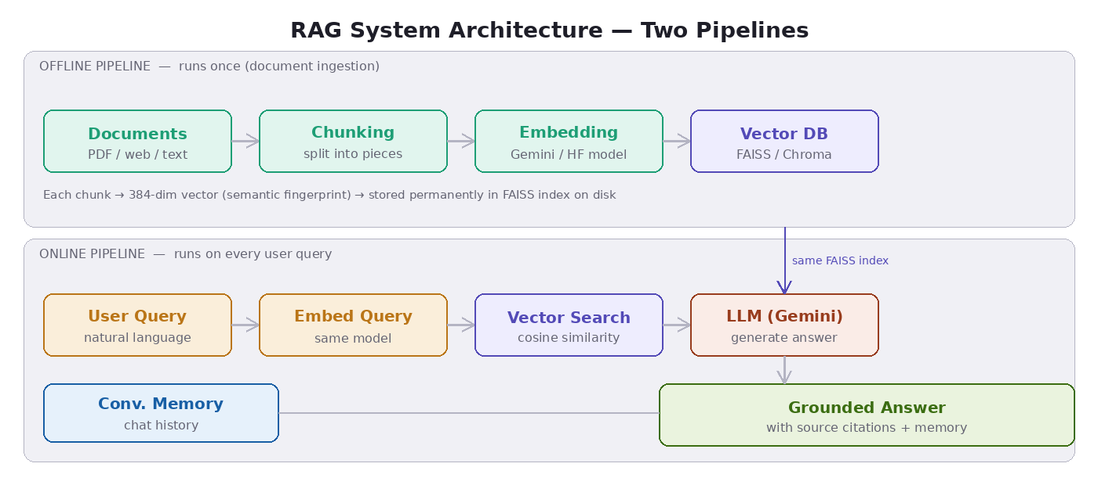
Figure 1 — RAG System Architecture: Two Pipelines (Offline Ingestion + Online Query)

2. Tech Stack — Why Each Tool Is Used
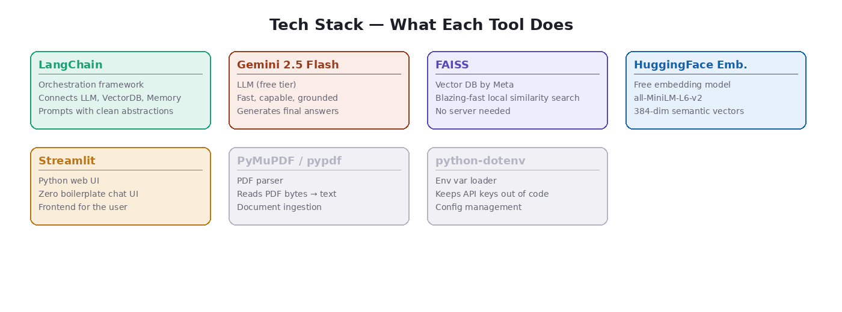
Figure 2 — Full Tech Stack Overview

Tool | What It Does & Why We Use It
LangChain | Orchestration framework — connects LLM, vector DB, memory, and prompts with clean abstractions. Without it you write 5x more boilerplate.
Google Gemini 2.5 Flash | The LLM that generates final answers. Free tier available via Google AI Studio. Fast, highly capable, supports long context.
FAISS (Facebook AI Similarity Search) | A local vector database. Blazing-fast similarity search using approximate nearest neighbor indexing. No server required, runs entirely on your machine.
HuggingFace Embeddings (all-MiniLM-L6-v2) | Free embedding model that runs locally. Converts text to 384-dimensional semantic vectors. No API key needed.
Streamlit | Python-native web UI framework. Zero-boilerplate chat interface. Builds the frontend in ~50 lines of code.
PyMuPDF / pypdf | PDF parsing libraries. Reads PDF bytes and extracts plain text for ingestion.
python-dotenv | Loads API keys from a .env file so secrets never live in code.

3. Project Structure — Files & Purpose
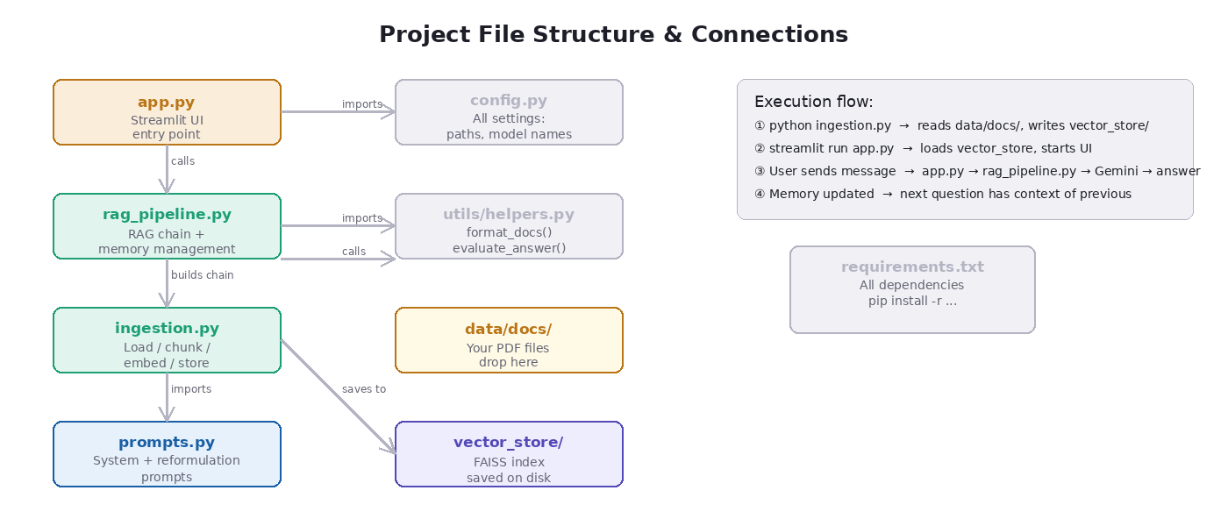
Figure 3 — Project File Structure & How Files Connect

Full Folder Tree
rag_project/
├── app.py ← Streamlit UI (entry point)
├── rag_pipeline.py ← Core RAG: retriever + LLM + memory
├── ingestion.py ← Load, chunk, embed, store documents
├── prompts.py ← All prompt templates
├── config.py ← Central config (paths, model names)
├── utils/
│ └── helpers.py ← Formatting, source extraction utilities
├── data/
│ └── docs/ ← Drop your PDFs here
├── vector_store/ ← FAISS index saved here after ingestion
├── .env ← API keys (never commit to git)
└── requirements.txt ← All dependencies

File Responsibilities
File | Purpose & Connections
app.py | Streamlit frontend. Calls rag_pipeline.py on every message. Manages session state and displays sources.
rag_pipeline.py | Builds the RAG chain with ConversationalRetrievalChain. Manages chat history. Returns answer + source citations.
ingestion.py | Offline pipeline. Reads data/docs/, splits text, embeds chunks, saves FAISS index to vector_store/. Run once.
prompts.py | Defines system prompt and question reformulation prompt. Imported by rag_pipeline.py.
config.py | Single source of truth for all settings. Imported by every module.
utils/helpers.py | format_docs() and evaluate_answer() utilities.
data/docs/ | Place your PDF and TXT files here before running ingestion.
vector_store/ | Auto-created by ingestion.py. Contains the FAISS index files.

4. Two Pipelines — Detailed Explanation

A) Offline Pipeline — Data Ingestion
This pipeline runs once. Its job is to prepare the knowledge base. Think of it as teaching the system everything about your documents so it can answer questions later without re-reading the files.

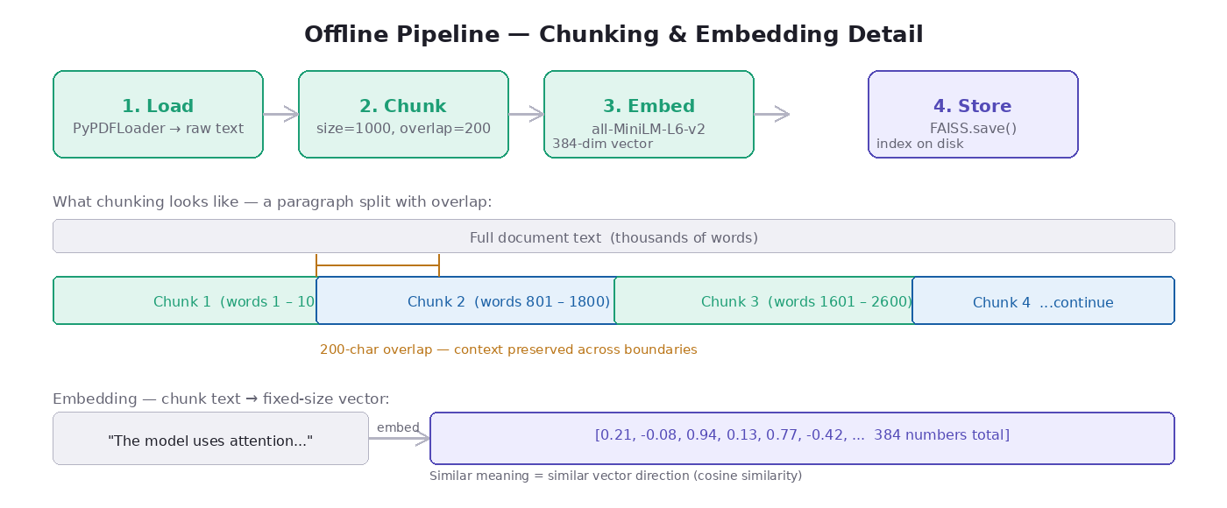
Figure 4 — Offline Pipeline: Load → Chunk → Embed → Store

Step 1: Load Documents
LangChain loaders read files from disk and convert them to Document objects (raw text + metadata like filename and page number). Supported: PDFs via PyPDFLoader, plain text via TextLoader, websites via WebBaseLoader.

Step 2: Chunking
Documents are split into overlapping chunks using RecursiveCharacterTextSplitter. Key parameters:
- chunk_size=1000 — approximately 200 words per chunk
- chunk_overlap=200 — consecutive chunks share 200 characters of text
- separators=['\n\n', '\n', '. ', ' ', ''] — tries to split at paragraph breaks first, then sentences, never mid-word

Why Overlap Matters
Imagine a key sentence split across two chunks: 'The function returns...' [END CHUNK 1] '...the result of the calculation' [START CHUNK 2]. Without overlap, both chunks lose the context. With 200-char overlap, both chunks contain the full sentence.

Step 3: Embedding
Each chunk is converted to a 384-dimensional vector using the all-MiniLM-L6-v2 model from HuggingFace. This runs locally — no API key needed. The model maps text so that semantically similar sentences produce vectors pointing in similar directions in 384-dimensional space.

Step 4: Store in FAISS
FAISS.from_documents() embeds all chunks and builds an Approximate Nearest Neighbor index. This index is saved to vector_store/ on disk so ingestion only needs to run once.

B) Online Pipeline — Query Time
This pipeline runs on every user message. It takes the user question, finds the most relevant document chunks, builds a structured prompt, and sends everything to Gemini.

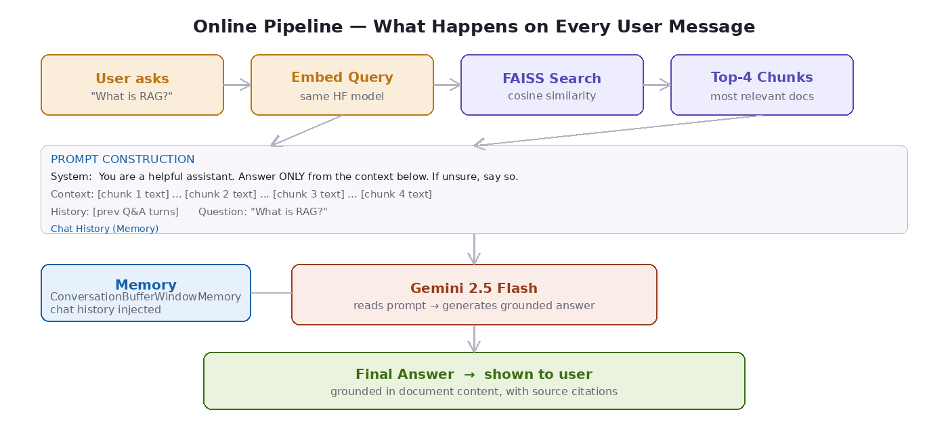
Figure 5 — Online Pipeline: Query → Embed → Search → Prompt → LLM → Answer

- Step 1: User sends a question via Streamlit chat input
- Step 2: Question reformulation (if follow-up) — Gemini rewrites ambiguous questions into standalone questions using chat history
- Step 3: Query embedding — the (reformulated) question is converted to a vector using the same HuggingFace model
- Step 4: FAISS similarity search — top-4 chunks by cosine similarity are retrieved
- Step 5: Prompt assembly — system instruction + retrieved chunks + chat history + question
- Step 6: Gemini generates a grounded answer using only the retrieved evidence
- Step 7: Answer and source citations are shown in the UI; chat history is updated

5. Core RAG Pipeline — The Story
Think of RAG as a detective story. Every question is a case, and the detective (the pipeline) follows a strict investigation procedure before delivering a verdict (the answer).

Stage | What Happens Internally
1. User asks a question | "What does the contract say about termination?" — plain natural language input via Streamlit
2. Question gets a fingerprint | The embedding model converts the question to a 384-number vector. Similar questions get similar vectors.
3. FAISS searches | Compares the query vector to every stored chunk vector using cosine similarity. Done in milliseconds even with 100,000+ chunks.
4. Top-4 chunks retrieved | The 4 most semantically similar document passages are returned with their metadata (source file, page number).
5. Prompt assembled | System instruction + retrieved chunks (the 'evidence') + chat history + user question are merged into a structured prompt.
6. Gemini reads and generates | Gemini sees real evidence from your documents and writes a grounded answer. It cannot invent facts because the system prompt forbids it.
7. Answer displayed | Streamlit renders the answer. Source citations are shown in an expandable panel. This turn is saved to chat history.

6. Code Files — Full Code & Explanation

config.py — Central Configuration
Single source of truth for all settings. Every other file imports from here. Changing a setting in one place updates the entire project.
# config.py
import os
from pathlib import Path

# ─── Paths ─────────────────────────────────────────────────────────
BASE_DIR = Path(__file__).parent
DATA_DIR = BASE_DIR / "data" / "docs"
VECTOR_STORE_DIR = BASE_DIR / "vector_store"

# ─── Embedding Model ────────────────────────────────────────────────
# Free HuggingFace model — no API key needed
EMBEDDING_MODEL = "sentence-transformers/all-MiniLM-L6-v2"

# ─── LLM ─────────────────────────────────────────────────────────────
GEMINI_MODEL = "gemini-2.5-flash" # Free tier available

# ─── Chunking ─────────────────────────────────────────────────────────
CHUNK_SIZE = 1000 # ~200 words per chunk
CHUNK_OVERLAP = 200 # Overlap to not lose context at boundaries

# ─── Retrieval ────────────────────────────────────────────────────────
TOP_K = 4 # Return 4 most relevant chunks

# ─── Memory ───────────────────────────────────────────────────────────
MAX_HISTORY_TURNS = 5 # Keep last 5 conversation turns

Why these numbers? CHUNK_SIZE=1000 is the sweet spot — large enough to contain a complete thought, small enough that retrieved chunks stay focused. TOP_K=4 balances context richness (not too little) against prompt length (not too much noise).

ingestion.py — Offline Pipeline
This is the 'teaching' script. Run it once after adding documents. It loads files, splits them, embeds each chunk, and saves the FAISS index to disk.
# ingestion.py
"""
OFFLINE PIPELINE — Run this ONCE to ingest documents.
Think of this as 'teaching' the system about your documents.
"""
import os
from pathlib import Path
from langchain_community.document_loaders import (
PyPDFLoader, DirectoryLoader, TextLoader, WebBaseLoader,
)
from langchain.text_splitter import RecursiveCharacterTextSplitter
from langchain_community.embeddings import HuggingFaceEmbeddings
from langchain_community.vectorstores import FAISS
from config import (
DATA_DIR, VECTOR_STORE_DIR,
EMBEDDING_MODEL, CHUNK_SIZE, CHUNK_OVERLAP
)

def load_documents(source: str = "directory", url: str = None):
"""Load documents from various sources."""
if source == "directory":
loader = DirectoryLoader(
str(DATA_DIR),
glob="**/*.pdf",
loader_cls=PyPDFLoader,
show_progress=True,
)
documents = loader.load()

elif source == "web":
loader = WebBaseLoader(url)
documents = loader.load()

elif source == "text":
loader = DirectoryLoader(
str(DATA_DIR), glob="**/*.txt", loader_cls=TextLoader,
)
documents = loader.load()

print(f"Loaded {len(documents)} document(s)")
return documents

def chunk_documents(documents):
"""Split documents into smaller overlapping chunks."""
splitter = RecursiveCharacterTextSplitter(
chunk_size=CHUNK_SIZE,
chunk_overlap=CHUNK_OVERLAP,
separators=["\n\n", "\n", ". ", " ", ""],
length_function=len,
)
chunks = splitter.split_documents(documents)
print(f"Created {len(chunks)} chunks from {len(documents)} documents")
return chunks

def create_embeddings():
"""Load the HuggingFace embedding model (free, local)."""
embeddings = HuggingFaceEmbeddings(
model_name=EMBEDDING_MODEL,
model_kwargs={"device": "cpu"}, # change to 'cuda' if GPU
encode_kwargs={"normalize_embeddings": True},
)
print(f"Loaded embedding model: {EMBEDDING_MODEL}")
return embeddings

def build_vector_store(chunks, embeddings):
"""Embed all chunks and store in FAISS."""
print(f"Embedding {len(chunks)} chunks... (this may take a minute)")

vector_store = FAISS.from_documents(
documents=chunks,
embedding=embeddings,
)

VECTOR_STORE_DIR.mkdir(parents=True, exist_ok=True)
vector_store.save_local(str(VECTOR_STORE_DIR))
print(f"Vector store saved to: {VECTOR_STORE_DIR}")
return vector_store

def run_ingestion(source: str = "directory", url: str = None):
"""Master function — runs the full offline pipeline."""
print("Starting ingestion pipeline...")
documents = load_documents(source, url)
if not documents:
raise ValueError(f"No documents found in {DATA_DIR}.")
chunks = chunk_documents(documents)
embeddings = create_embeddings()
vector_store = build_vector_store(chunks, embeddings)
print("Ingestion complete! You can now run app.py")
return vector_store

if __name__ == "__main__":
run_ingestion()

Key Insight: RecursiveCharacterTextSplitter
This splitter is smarter than naive 'split every N characters'. It tries paragraph breaks (\n\n) first, then sentence breaks (. ), then word boundaries — so chunks never end mid-sentence. This dramatically improves retrieval quality because each chunk is a coherent, complete thought.

prompts.py — Prompt Templates
Prompts are the instructions given to the LLM. Bad prompts = hallucinations. Good prompts = grounded, honest, citable answers. This file contains two prompts — one for generation and one for question reformulation.
# prompts.py
from langchain.prompts import ChatPromptTemplate, MessagesPlaceholder

# ─── Main RAG Prompt ────────────────────────────────────────────────
RAG_SYSTEM_PROMPT = """You are a helpful, precise AI assistant.
Your job is to answer questions STRICTLY based on the provided context.

Rules you must follow:
1. Answer ONLY from the context below. Never invent information.
2. If the answer is not in the context, say:
'I don't have enough information in the provided documents.'
3. Always be concise and direct.
4. When relevant, cite which part of the document your answer comes from.
5. If the user asks a follow-up, use the chat history.

Context from documents:
{context}
"""

RAG_PROMPT = ChatPromptTemplate.from_messages([
("system", RAG_SYSTEM_PROMPT),
MessagesPlaceholder(variable_name="chat_history"),
("human", "{question}"),
])

# ─── Question Reformulation Prompt ──────────────────────────────────
# Rewrites follow-up questions into self-contained questions
# so vector retrieval works correctly on follow-ups.
REFORMULATION_PROMPT = ChatPromptTemplate.from_messages([
("system", """Given the conversation history and the follow-up question,
reformulate the question to be fully standalone and self-contained.
Do NOT answer it — just rewrite it clearly.
If it's already standalone, return it unchanged."""),
MessagesPlaceholder(variable_name="chat_history"),
("human", "Follow-up: {question}\n\nReformulated standalone question:"),
])

rag_pipeline.py — Core RAG Chain
This is the heart of the project. It connects the vector store, the LLM, conversation memory, and prompts into a single ConversationalRetrievalChain. Every user message flows through this file.
# rag_pipeline.py
import os
from langchain_google_genai import ChatGoogleGenerativeAI
from langchain_community.embeddings import HuggingFaceEmbeddings
from langchain_community.vectorstores import FAISS
from langchain.chains import ConversationalRetrievalChain
from langchain_core.messages import HumanMessage, AIMessage
from config import VECTOR_STORE_DIR, EMBEDDING_MODEL, GEMINI_MODEL, TOP_K, MAX_HISTORY_TURNS
from prompts import RAG_PROMPT, REFORMULATION_PROMPT

def load_vector_store():
"""Load the pre-built FAISS index from disk."""
if not VECTOR_STORE_DIR.exists():
raise FileNotFoundError(
f"Vector store not found at {VECTOR_STORE_DIR}.\n"
"Run: python ingestion.py"
)
embeddings = HuggingFaceEmbeddings(
model_name=EMBEDDING_MODEL,
model_kwargs={"device": "cpu"},
encode_kwargs={"normalize_embeddings": True},
)
vector_store = FAISS.load_local(
str(VECTOR_STORE_DIR), embeddings,
allow_dangerous_deserialization=True,
)
print("Vector store loaded")
return vector_store

def build_retriever(vector_store):
"""Turn the vector store into a retriever (the 'librarian')."""
retriever = vector_store.as_retriever(
search_type="similarity",
search_kwargs={"k": TOP_K},
)
return retriever

def build_llm():
"""Load the Gemini LLM."""
api_key = os.getenv("GOOGLE_API_KEY")
if not api_key:
raise EnvironmentError("GOOGLE_API_KEY not found. Check your .env file.")
llm = ChatGoogleGenerativeAI(
model=GEMINI_MODEL,
google_api_key=api_key,
temperature=0.2, # Low = more factual, less creative
max_tokens=1024,
)
return llm

def build_rag_chain(retriever, llm):
"""
Assemble the full RAG chain with memory.
ConversationalRetrievalChain does THREE things automatically:
1. Reformulates the question using chat history
2. Retrieves relevant chunks from FAISS
3. Sends everything to the LLM for generation
"""
chain = ConversationalRetrievalChain.from_llm(
llm=llm,
retriever=retriever,
condense_question_prompt=REFORMULATION_PROMPT,
combine_docs_chain_kwargs={"prompt": RAG_PROMPT},
return_source_documents=True,
verbose=False,
)
return chain

class RAGPipeline:
"""
Clean wrapper that manages the RAG chain + conversation history.
This is what app.py instantiates and calls on every message.
"""

def __init__(self):
print("Initializing RAG pipeline...")
vector_store = load_vector_store()
retriever = build_retriever(vector_store)
llm = build_llm()
self.chain = build_rag_chain(retriever, llm)
self.chat_history = []
print("RAG pipeline ready!")

def ask(self, question: str) -> dict:
result = self.chain({
"question": question,
"chat_history": self.chat_history,
})
answer = result["answer"]
source_docs = result.get("source_documents", [])

# Extract unique citations
sources = list({
f"{doc.metadata.get('source','Unknown')} page {doc.metadata.get('page','?')}"
for doc in source_docs
})

# Update and trim history
self.chat_history.append(HumanMessage(content=question))
self.chat_history.append(AIMessage(content=answer))
max_messages = MAX_HISTORY_TURNS * 2
if len(self.chat_history) > max_messages:
self.chat_history = self.chat_history[-max_messages:]

return {"answer": answer, "sources": sources}

def clear_history(self):
self.chat_history = []

app.py — Streamlit Frontend
The entry point. Run streamlit run app.py to launch the chat interface. It initializes the RAG pipeline once per session and handles all UI logic.
# app.py
import streamlit as st
from dotenv import load_dotenv
from rag_pipeline import RAGPipeline

load_dotenv()

st.set_page_config(
page_title="DocChat — RAG System",
page_icon="📚",
layout="centered",
)
st.title("📚 DocChat — Ask Your Documents")
st.caption("Powered by Gemini 2.5 Flash + LangChain + FAISS")

# Initialize pipeline once per session (cached across reruns)
@st.cache_resource
def get_pipeline():
return RAGPipeline()

try:
pipeline = get_pipeline()
except FileNotFoundError as e:
st.error(str(e))
st.info("Run `python ingestion.py` first.")
st.stop()

if "messages" not in st.session_state:
st.session_state.messages = []

# ─── Sidebar ───────────────────────────────────────────────────────
with st.sidebar:
st.header("Settings")
if st.button("Clear conversation"):
st.session_state.messages = []
pipeline.clear_history()
st.rerun()
st.divider()
show_sources = st.toggle("Show source citations", value=True)

# ─── Chat Display ──────────────────────────────────────────────────
for msg in st.session_state.messages:
with st.chat_message(msg["role"]):
st.markdown(msg["content"])
if msg.get("sources") and show_sources:
with st.expander("Sources"):
for src in msg["sources"]:
st.markdown(f"- {src}")

# ─── Chat Input ────────────────────────────────────────────────────
if question := st.chat_input("Ask a question about your documents..."):

st.session_state.messages.append({"role": "user", "content": question})
with st.chat_message("user"):
st.markdown(question)

with st.chat_message("assistant"):
with st.spinner("Searching documents and generating answer..."):
result = pipeline.ask(question)

answer = result["answer"]
sources = result["sources"]
st.markdown(answer)

if sources and show_sources:
with st.expander("Sources"):
for src in sources:
st.markdown(f"- {src}")

st.session_state.messages.append({
"role": "assistant", "content": answer, "sources": sources,
})

utils/helpers.py — Utility Functions
# utils/helpers.py

def format_docs(docs) -> str:
"""Convert Document objects into a single context string."""
formatted = []
for i, doc in enumerate(docs, 1):
source = doc.metadata.get("source", "Unknown")
page = doc.metadata.get("page", "?")
formatted.append(
f"[Source {i} — {source}, page {page}]\n{doc.page_content}"
)
return "\n\n---\n\n".join(formatted)

def evaluate_answer(question: str, answer: str, contexts: list[str]) -> dict:
"""Simple heuristic evaluation — use RAGAS in production."""
has_answer = "don't have enough information" not in answer.lower()
context_text = " ".join(contexts).lower()
answer_words = set(answer.lower().split())
context_words= set(context_text.split())
overlap = answer_words & context_words
uses_context = len(overlap) > 10
return {
"has_answer": has_answer,
"uses_context": uses_context,
"answer_length": len(answer.split()),
}

requirements.txt
langchain>=0.2.0
langchain-community>=0.2.0
langchain-google-genai>=1.0.0
langchain-core>=0.2.0
faiss-cpu>=1.7.4
sentence-transformers>=2.7.0
streamlit>=1.35.0
python-dotenv>=1.0.0
pypdf>=4.0.0
beautifulsoup4>=4.12.0
requests>=2.31.0

7. Prompt Engineering — Deep Dive
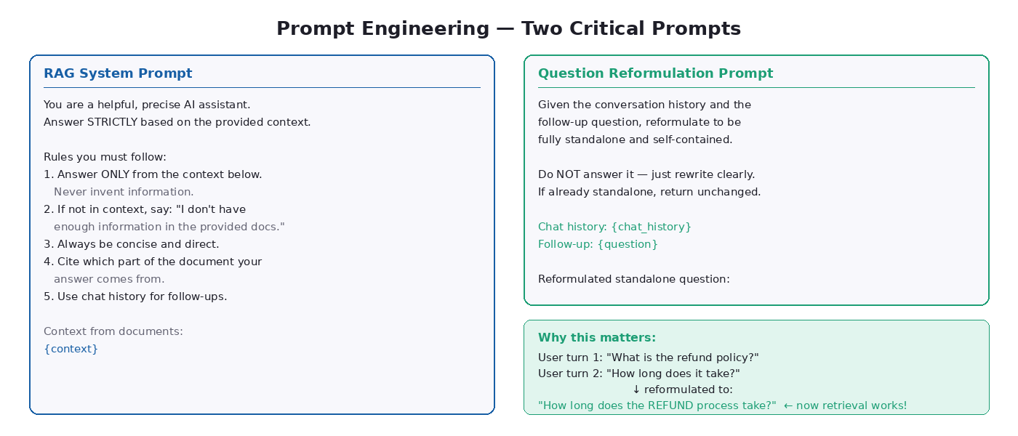
Figure 6 — Two Critical Prompts: RAG System Prompt & Reformulation Prompt

The RAG System Prompt — Design Decisions
Design Choice | Why It Matters
Answer ONLY from the context | Prevents hallucination. Without this, Gemini blends its training knowledge with your documents — impossible to know what is grounded vs invented.
If not in context, say so | Teaches honesty. Users trust a system that says 'I don't know' over one that confidently invents answers.
Cite which part of the document | Enables verification. Users can check the original source and build trust in the system over time.
MessagesPlaceholder (chat_history) | Injects previous conversation turns between the system prompt and current question. The LLM sees it as a natural continuation.
temperature=0.2 in the LLM | Low temperature = more deterministic, factual answers. High temperature = more creative but also more likely to hallucinate. For RAG, stay low.

The Reformulation Prompt — The Secret Weapon
This is the most underappreciated component. When a user asks a follow-up question, their meaning depends on context:

Why Reformulation Is Critical
User turn 1: "What is the refund policy?"
User turn 2: "How long does it take?"
Searching the vector store for 'How long does it take?' returns garbage — it's too vague.
With reformulation, Gemini first rewrites it as: 'How long does the refund process take?'
Now the retrieval is accurate and finds the right document sections.

8. Retrieval + Ranking Logic
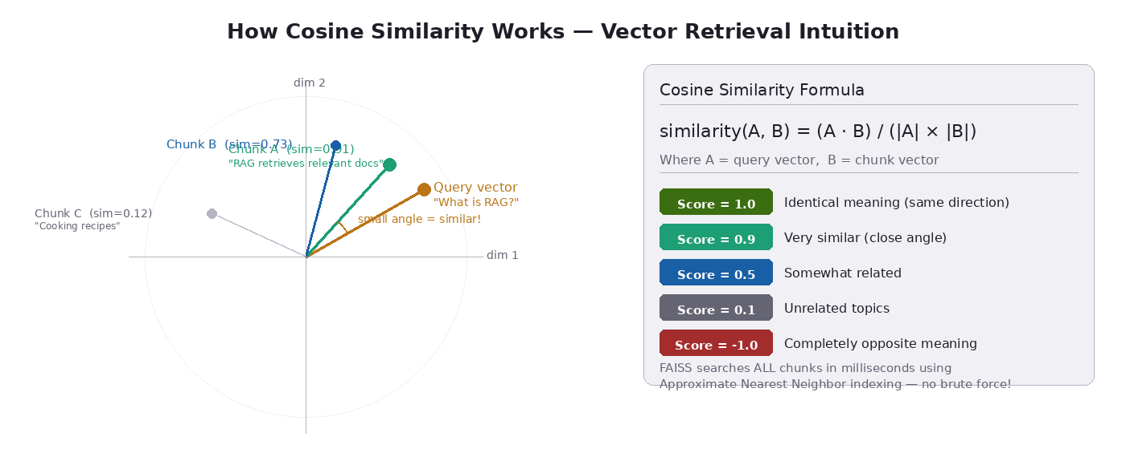
Figure 7 — Cosine Similarity: How FAISS Finds the Most Relevant Chunks

How Cosine Similarity Works
Cosine similarity measures the angle between two vectors in high-dimensional space. Vectors pointing in the same direction have similarity near 1.0. Vectors pointing in opposite directions have similarity near -1.0.

# The math — simple version:
similarity(A, B) = (A · B) / (|A| × |B|)

# Where:
# A = query vector (your question as numbers)
# B = chunk vector (a document passage as numbers)
# A · B = dot product (element-wise multiply then sum)
# |A|, |B| = magnitudes (lengths) of the vectors

# With normalize_embeddings=True, magnitudes are all 1.0
# so similarity = A · B (just the dot product)

# Score interpretation:
# 1.0 = identical meaning
# 0.9+ = very similar
# 0.5 = somewhat related
# 0.1 = barely related
# -1.0 = completely opposite meaning

Why FAISS Is Fast
FAISS uses Approximate Nearest Neighbor (ANN) indexing — not brute-force comparison. It builds an index structure that allows searching 100,000+ vectors in milliseconds. The 'approximate' part means it may occasionally miss the absolute best match, but in practice retrieval quality is excellent.

Top-K = 4 — The Sweet Spot
Top-K Value | What Happens
k = 1 | Too little context. One chunk rarely contains the full answer.
k = 4 (recommended) | Rich context. Covers the main answer and related supporting passages. Prompt stays focused.
k = 10+ | Too much noise. Irrelevant chunks confuse the LLM and dilute the relevant content. Prompt becomes very long.

Optional: Reranking
After getting top-K chunks by cosine similarity (fast but approximate), you can run a cross-encoder reranker that scores (query, chunk) pairs together — more accurate but slower. LangChain supports FlashrankRerank and CohereRerank for this purpose.

9. Example Walkthrough — End to End
Document: A 20-page research paper on transformer architectures.
User asks: "How does multi-head attention differ from single-head attention?"

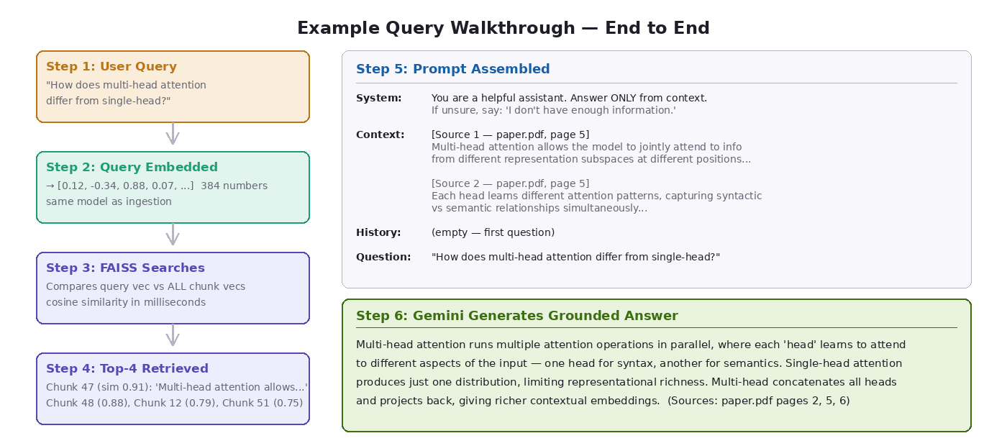
Figure 8 — Complete Query Walkthrough: from Question to Grounded Answer

Step-by-Step Trace

Step 1 — Query Embedding
The question is converted to a 384-number vector by the HuggingFace model:
question = "How does multi-head attention differ from single-head attention?"
query_vector = embed_model.encode(question, normalize_embeddings=True)
# query_vector = [0.12, -0.34, 0.88, 0.07, 0.45, -0.21, ...] (384 numbers)

Step 2 — FAISS Searches ~400 Chunks
FAISS compares the query vector to all stored chunk vectors and returns the 4 with highest cosine similarity:
# Top 4 retrieved chunks:
Chunk 47 (similarity: 0.91) — paper.pdf, page 5
'Multi-head attention allows the model to jointly attend to'
'information from different representation subspaces...'

Chunk 48 (similarity: 0.88) — paper.pdf, page 5
'Each head learns different attention patterns, capturing'
'syntactic vs semantic relationships simultaneously...'

Chunk 12 (similarity: 0.79) — paper.pdf, page 2
'Single-head attention produces one attention distribution'
'over the input sequence, which limits representational power...'

Chunk 51 (similarity: 0.75) — paper.pdf, page 6
'The concatenation of multiple heads followed by linear'
'projection allows richer representations than single-head...'

Step 3 — Prompt Assembled
System: You are a helpful assistant. Answer ONLY from the context.
If unsure, say: 'I don't have enough information...'

Context:
[Source 1 — paper.pdf, page 5]
Multi-head attention allows the model to jointly attend to
information from different representation subspaces at different positions...

[Source 2 — paper.pdf, page 5]
Each head learns different attention patterns, capturing syntactic
vs semantic relationships simultaneously...

[Source 3 — paper.pdf, page 2]
Single-head attention produces one attention distribution...

[Source 4 — paper.pdf, page 6]
Concatenation of multiple heads followed by linear projection...

Chat history: (empty — first question)

Question: How does multi-head attention differ from single-head attention?

Step 4 — Gemini Generates
Final Grounded Answer
Multi-head attention runs multiple attention operations in parallel, where each 'head' learns to attend to different aspects of the input — for example, one head might focus on syntactic relationships while another captures semantic dependencies. The outputs of all heads are concatenated and projected back to the model dimension.
Single-head attention produces just one attention distribution, which limits what the model can represent simultaneously. Multi-head attention overcomes this by effectively running attention in multiple representation subspaces at once, leading to richer contextual representations.
(Sources: paper.pdf pages 2, 5, 6)

10. Why This Design?
Design Question | Answer
Why chunking instead of feeding the whole document? | LLMs have a context window limit. A 200-page PDF will not fit. Even if it fits, LLM attention degrades on extremely long inputs. Targeted retrieval gives it only the relevant 2-4 pages.
Why a vector database instead of keyword search? | Keyword search fails on synonyms and paraphrasing. If the document says 'termination clause' and you search 'how to cancel', keyword search misses it. Vector search understands semantic meaning.
Why not just use the LLM directly (no RAG)? | Three reasons: (1) LLMs do not know your private documents, (2) they hallucinate when uncertain, (3) they cannot cite sources. RAG solves all three.
Why LangChain instead of writing from scratch? | LangChain abstracts the plumbing — loading files, building chains, managing memory, switching LLMs. Without it you write 5x more boilerplate. It also makes swapping components trivial.
Why HuggingFace embeddings (not OpenAI)? | HuggingFace all-MiniLM-L6-v2 is free, runs locally, needs no API key, and produces 384-dim vectors that are excellent for semantic search. OpenAI embeddings cost money per token.
Why FAISS instead of ChromaDB? | FAISS is faster for pure similarity search and has no dependencies. ChromaDB offers easier persistence and filtering. Both work with identical LangChain interfaces — swap freely.
Why temperature=0.2 for the LLM? | Low temperature makes Gemini more deterministic and factual. High temperature makes it creative but also more likely to hallucinate — the opposite of what we want in a grounded RAG system.

11. How to Run the Project

Step 1 — Create Project Structure
mkdir rag_project && cd rag_project
mkdir -p data/docs utils vector_store
touch app.py rag_pipeline.py ingestion.py prompts.py config.py
touch utils/helpers.py requirements.txt .env

Step 2 — Create Virtual Environment
python -m venv venv

# On macOS / Linux:
source venv/bin/activate

# On Windows:
venv\Scripts\activate

Step 3 — Install Dependencies
pip install -r requirements.txt

# This installs: langchain, langchain-community, langchain-google-genai,
# faiss-cpu, sentence-transformers, streamlit, python-dotenv, pypdf

Step 4 — Set Up API Key
# Get a free API key at: https://aistudio.google.com/
# Create .env file:
echo "GOOGLE_API_KEY=your_key_here" > .env

# IMPORTANT: Add .env to .gitignore so you never commit secrets
echo ".env" >> .gitignore

Step 5 — Add Your Documents
# Copy your PDF files into the data/docs/ folder
cp your_document.pdf data/docs/
cp another_file.pdf data/docs/

# Supported formats: .pdf, .txt, and URLs (via WebBaseLoader)

Step 6 — Run Ingestion (once)
python ingestion.py

# Expected output:
# Starting ingestion pipeline...
# Loaded 5 document(s)
# Created 183 chunks from 5 documents
# Average chunk size: 873 chars
# Loaded embedding model: sentence-transformers/all-MiniLM-L6-v2
# Embedding 183 chunks... (this may take a minute)
# Vector store saved to: ./vector_store
# Ingestion complete! You can now run app.py

Step 7 — Launch the App
streamlit run app.py

# Opens at: http://localhost:8501
# The chat interface loads, pipeline initializes (loads vector store)
# Start asking questions about your documents!

Quick Test (Python REPL)
from rag_pipeline import RAGPipeline
from dotenv import load_dotenv
load_dotenv()

p = RAGPipeline()
result = p.ask("What is the main topic of the document?")
print(result["answer"])
print(result["sources"])

12. Bonus — Advanced Tips & Production Guide

Improving Retrieval Quality

Option 1: Reranking
After initial FAISS retrieval (fast), run a cross-encoder reranker on the top-20 results to re-sort to top-4. More accurate, slightly slower.
from langchain.retrievers import ContextualCompressionRetriever
from langchain.retrievers.document_compressors import FlashrankRerank

compressor = FlashrankRerank(top_n=4)
retriever = ContextualCompressionRetriever(
base_compressor=compressor,
base_retriever=vector_store.as_retriever(search_kwargs={"k": 20}),
)

Option 2: HyDE (Hypothetical Document Embedding)
Instead of embedding the user question, ask the LLM to generate a hypothetical answer, then embed that. The hypothetical answer looks more like a document than a question, improving retrieval.
from langchain.chains import HypotheticalDocumentEmbedder

embeddings = HypotheticalDocumentEmbedder.from_llm(
llm=llm,
base_embeddings=HuggingFaceEmbeddings(model_name=EMBEDDING_MODEL),
)

Switching to ChromaDB
ChromaDB auto-persists and supports metadata filtering. The LangChain interface is nearly identical to FAISS:
from langchain_community.vectorstores import Chroma

# Creating:
vector_store = Chroma.from_documents(
chunks, embeddings, persist_directory="./chroma_db"
)
# No .save_local() needed — ChromaDB auto-persists

# Loading:
vector_store = Chroma(
persist_directory="./chroma_db",
embedding_function=embeddings,
)

# Filtering by metadata:
retriever = vector_store.as_retriever(
search_kwargs={"k": 4, "filter": {"source": "legal_doc.pdf"}}
)

Adding Response Streaming
Streaming makes the UI feel much faster — the answer appears token by token instead of all at once after a delay.
# In build_llm(), add streaming=True
llm = ChatGoogleGenerativeAI(model=GEMINI_MODEL, streaming=True)

# In app.py, replace st.markdown() with:
with st.chat_message("assistant"):
response = st.write_stream(pipeline.stream(question))

Evaluation with RAGAS
RAGAS is the standard library for evaluating RAG systems automatically:
from ragas import evaluate
from ragas.metrics import faithfulness, answer_relevancy, context_recall

# faithfulness: Is the answer grounded in the retrieved context?
# answer_relevancy: Does the answer actually address the question?
# context_recall: Did retrieval find the right chunks?

results = evaluate(
dataset=your_eval_dataset,
metrics=[faithfulness, answer_relevancy, context_recall],
)
print(results)

Common Mistakes to Avoid
Mistake | Consequence & Fix
Chunk size too small (< 200 chars) | Retrieved chunks lack context, confusing the LLM. Use chunk_size >= 500.
Chunk size too large (> 3000 chars) | Too much noise per chunk, diluting relevance scores. Keep under 1500.
Forgetting normalize_embeddings=True | Cosine similarity becomes meaningless without normalized vectors.
Top-K too high (> 8) | LLM gets overwhelmed with irrelevant chunks, answer quality drops.
Not clearing memory between sessions | History from one user's session pollutes another user's answers in multi-user deployments.
Not trimming chat history | Infinite history grows the prompt on every turn, eventually exceeding the context window.
Embedding at query time with wrong model | Always use the same model for ingestion and query-time embedding. Mixing models produces garbage retrieval.
Committing .env to git | Exposes your API key. Always add .env to .gitignore before first commit.

Scaling to Production
- Vector DB: Switch FAISS to Pinecone or Weaviate for distributed, hosted vector search with billions of chunks
- LLM: Add a fallback chain — if Gemini is unavailable, route to a local Llama model via Ollama
- Caching: Cache embeddings of common questions to avoid re-embedding identical queries
- Auth: Add user authentication so each user has isolated conversation memory
- Monitoring: Log retrieval quality metrics (similarity scores, answer latency) to a time-series database
- CI/CD: Add RAGAS evaluation to your CI pipeline so retrieval quality regressions are caught automatically

Final Tip
The single biggest impact on RAG quality — bigger than the LLM you choose, bigger than chunk size tuning — is the quality of your documents. Well-structured, clean PDFs with clear headings retrieve far better than scanned documents or poorly formatted text. If your system gives poor answers, start by improving the source documents.

Appendix — Quick Reference

All Configuration Values
Parameter | Value
EMBEDDING_MODEL | sentence-transformers/all-MiniLM-L6-v2
GEMINI_MODEL | gemini-2.5-flash
CHUNK_SIZE | 1000 characters (~200 words)
CHUNK_OVERLAP | 200 characters
TOP_K | 4 (chunks retrieved per query)
MAX_HISTORY_TURNS | 5 (conversation turns kept in memory)
temperature | 0.2 (low = factual, high = creative)
max_tokens | 1024 (max answer length)

Key Commands
# Install dependencies
pip install -r requirements.txt

# Run ingestion (after adding PDFs to data/docs/)
python ingestion.py

# Launch Streamlit app
streamlit run app.py

# Quick test without UI
python -c "from dotenv import load_dotenv; load_dotenv(); from rag_pipeline import RAGPipeline; p=RAGPipeline(); print(p.ask('Summarize the document')['answer'])"

Useful Links
LangChain Documentation: https://python.langchain.com/docs/
Google AI Studio (free Gemini API key): https://aistudio.google.com/
FAISS Documentation: https://github.com/facebookresearch/faiss
HuggingFace all-MiniLM-L6-v2: https://huggingface.co/sentence-transformers/all-MiniLM-L6-v2
RAGAS Evaluation: https://github.com/explodinggradients/ragas

