Four-Input 8-Bit Addition
Unrolled vs. Sequential vs. Pipelined Architecture
RTL Design, Verification, Synthesis and Comparative Analysis
Design Entry: SystemVerilog
Functional Verification: ModelSim, directed testbench
Synthesis: Quartus Prime Lite Edition 18.1.0
Target Device: Cyclone V (5CGXFC7C7F23C8)
Made by: Engr. Ayat Nauman Khan

1. Objective
Add four 8-bit numbers (a, b, c, d) into a 10-bit output so that the result can never overflow (maximum 4 x 255 = 1020). The adder was implemented in three architectures in SystemVerilog, simulated with a directed testbench, then synthesized in Quartus to obtain maximum clock frequency (Fmax) and resource usage. Latency and throughput are derived from the clock-cycle count and the Fmax of each design.

2. Architectures

2.1 Unrolled (non-pipelined) adder
All three additions (a+b, +c, +d) are chained combinationally between an input register stage and an output register. One new result is produced every clock cycle, but the clock period must cover three chained adders.
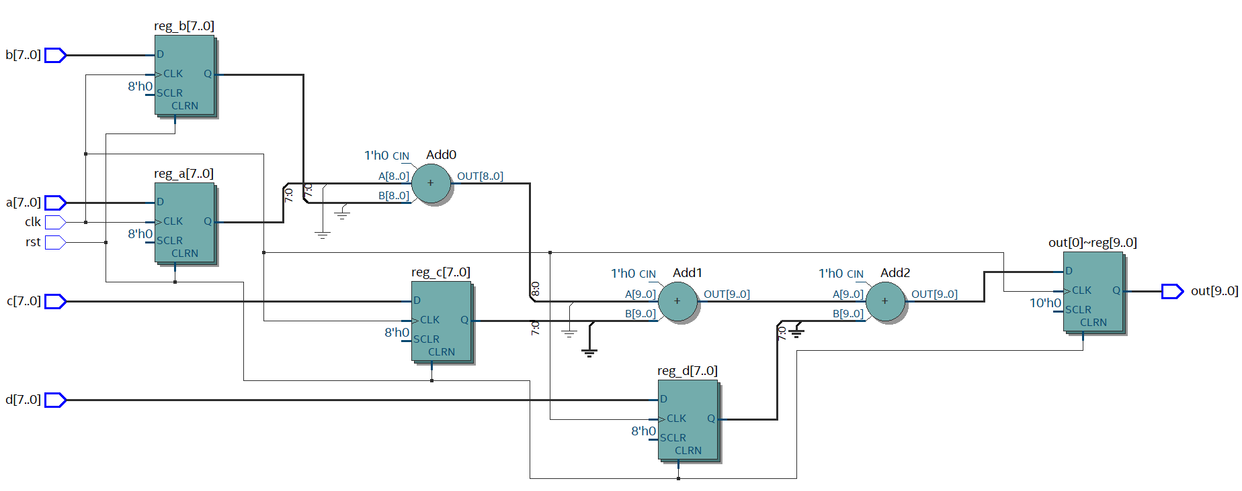
Figure 1: RTL view of the unrolled adder (registered inputs and output)
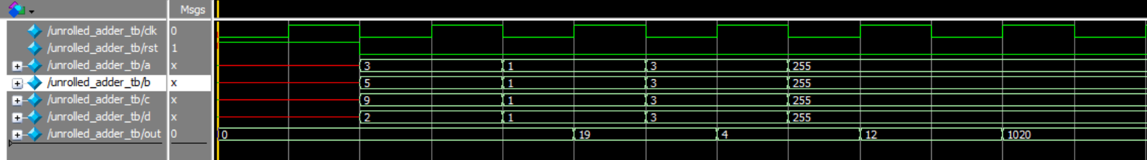
Figure 2: Simulation waveform of the unrolled adder (out = 19, 4, 12, 1020)
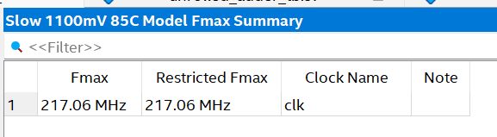
Figure 3: Fmax summary, Slow 1100mV 85C model: 217.06 MHz
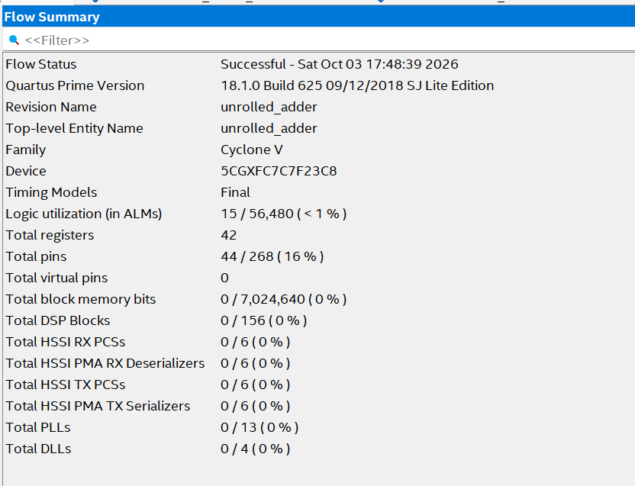
Figure 4: Flow summary (resource usage) of the unrolled adder with registered inputs and output: 15 ALMs, 42 registers

2.2 Sequential adder
A 2-bit counter selects one input per clock through a 4-to-1 multiplexer (zero-extended to 10 bits). A single adder and a 10-bit accumulator register add one operand per cycle, so only one adder is needed. The output is released when the counter reaches 3.
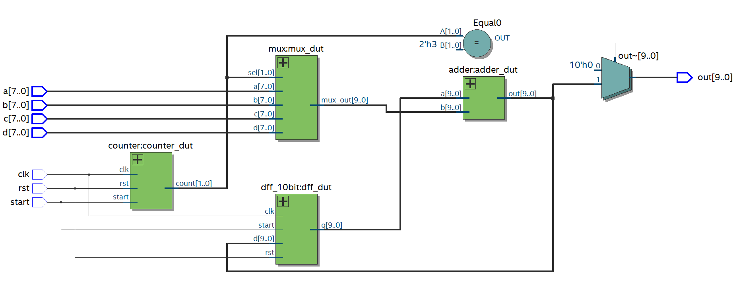
Figure 5: RTL view of the sequential adder (counter, mux, adder, accumulator register)
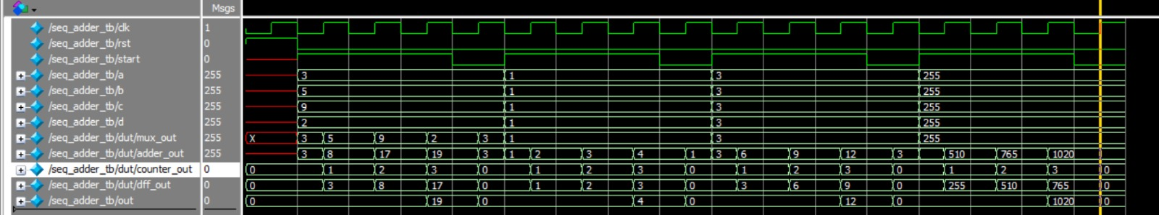
Figure 6: Simulation waveform of the sequential adder (out = 19, 4, 12, 1020)
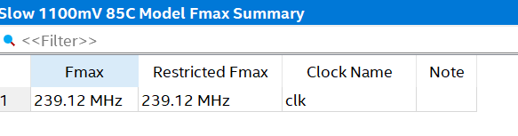
Figure 7: Fmax summary, Slow 1100mV 85C model: 239.12 MHz
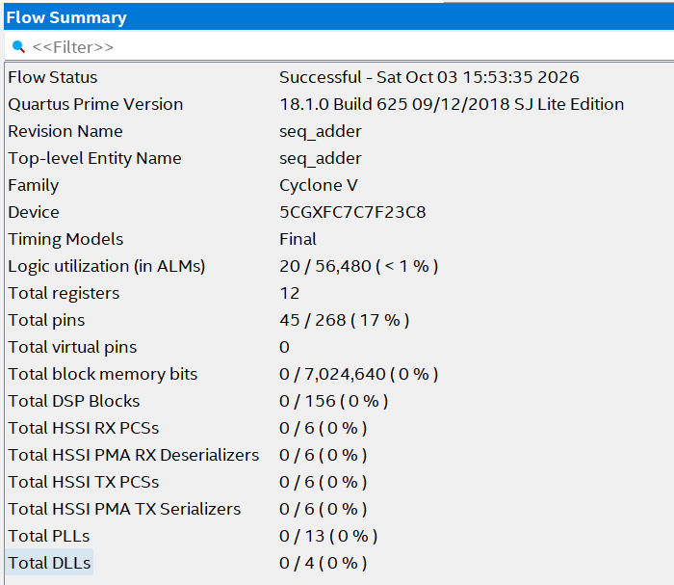
Figure 8: Flow summary (resource usage) of the sequential adder

2.3 Pipelined adder
The addition is split into three stages separated by registers: stage 1 computes a+b (while c and d are carried along), stage 2 adds c, and stage 3 adds d. Each clock period only has to cover one adder, so Fmax is the highest, and one result is produced every cycle once the pipeline is full. The cost is extra registers (53) to carry c and d forward.
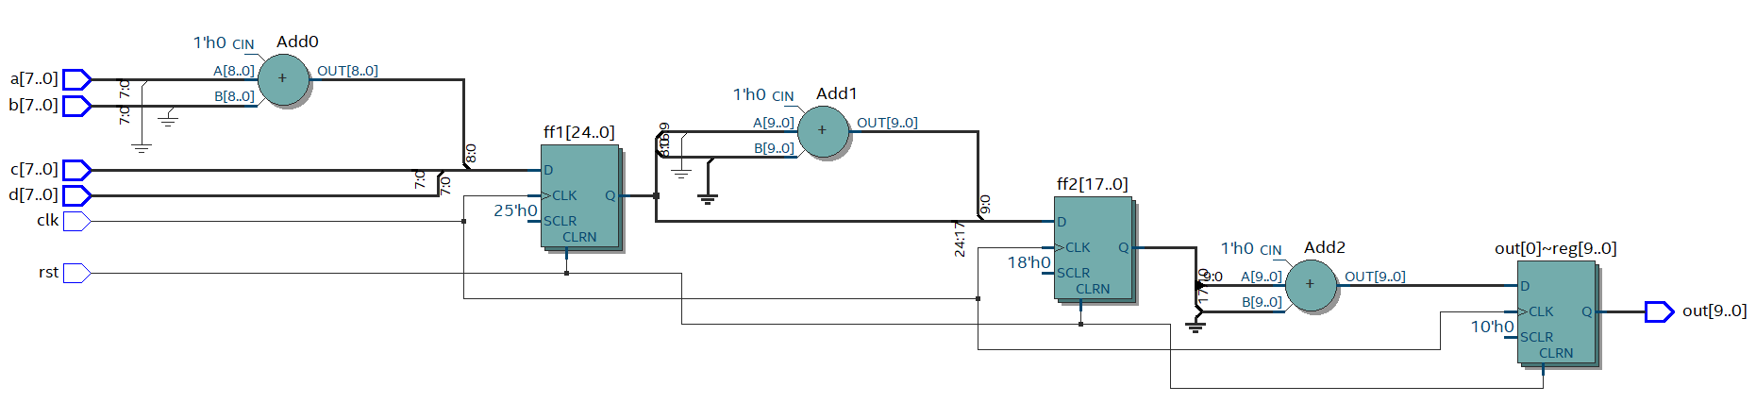
Figure 9: RTL view of the pipelined adder (ff1, ff2 and output register)
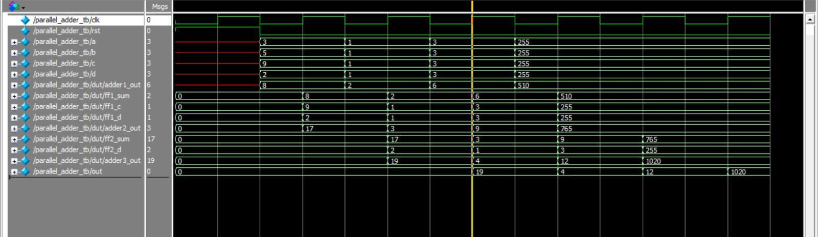
Figure 10: Simulation waveform of the pipelined adder (out = 19, 4, 12, 1020)
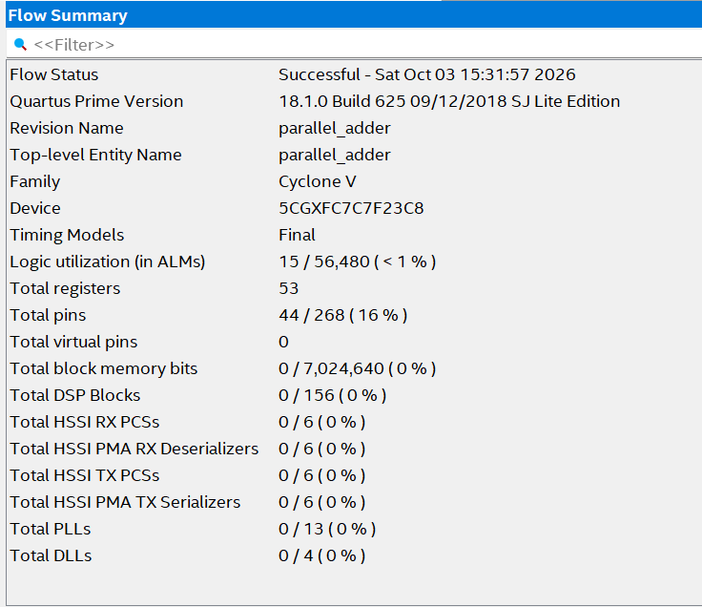
Figure 11: Flow summary (resource usage) of the pipelined adder
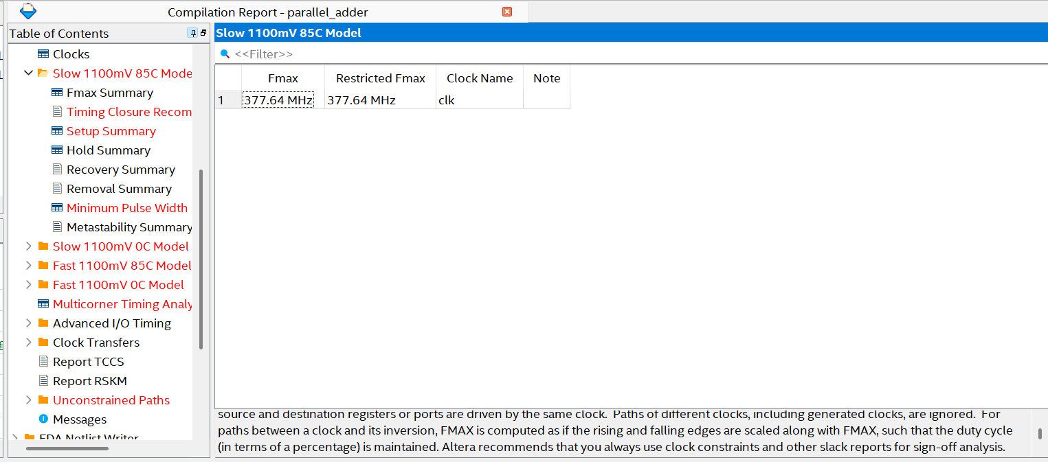
Figure 12: Fmax summary, Slow 1100mV 85C model: 377.64 MHz

3. Removing the setup violations in the pipelined design
After the first compilation with a tight clock constraint, the Timing Analyzer reported violated setup paths. The procedure used to find and remove them is below.
- Constrain the clock. Create an SDC file with a create_clock constraint on the clk port and add it in Assignments > Settings > Timing Analyzer. Without a constraint Quartus only applies a default and the slack numbers are not meaningful.
- Open the Timing Analyzer. Tools > Timing Analyzer, then run the Tasks pane items in order: Create Timing Netlist, Read SDC File, Update Timing Netlist.
- Select the worst corner. In Set Operating Conditions choose Slow 1100mV 85C Model, which normally gives the worst setup slack. Then run Report Timing / Setup: clk (or double-click Setup under the Report pane).
- Read the result. The first run reported a worst setup slack of -1.648 ns (10 of 10 paths violated). The multicorner summary showed worst-case setup slack of -1.859 ns, total negative slack (TNS) of -33.376 ns and negative minimum pulse width, so the design failed timing.
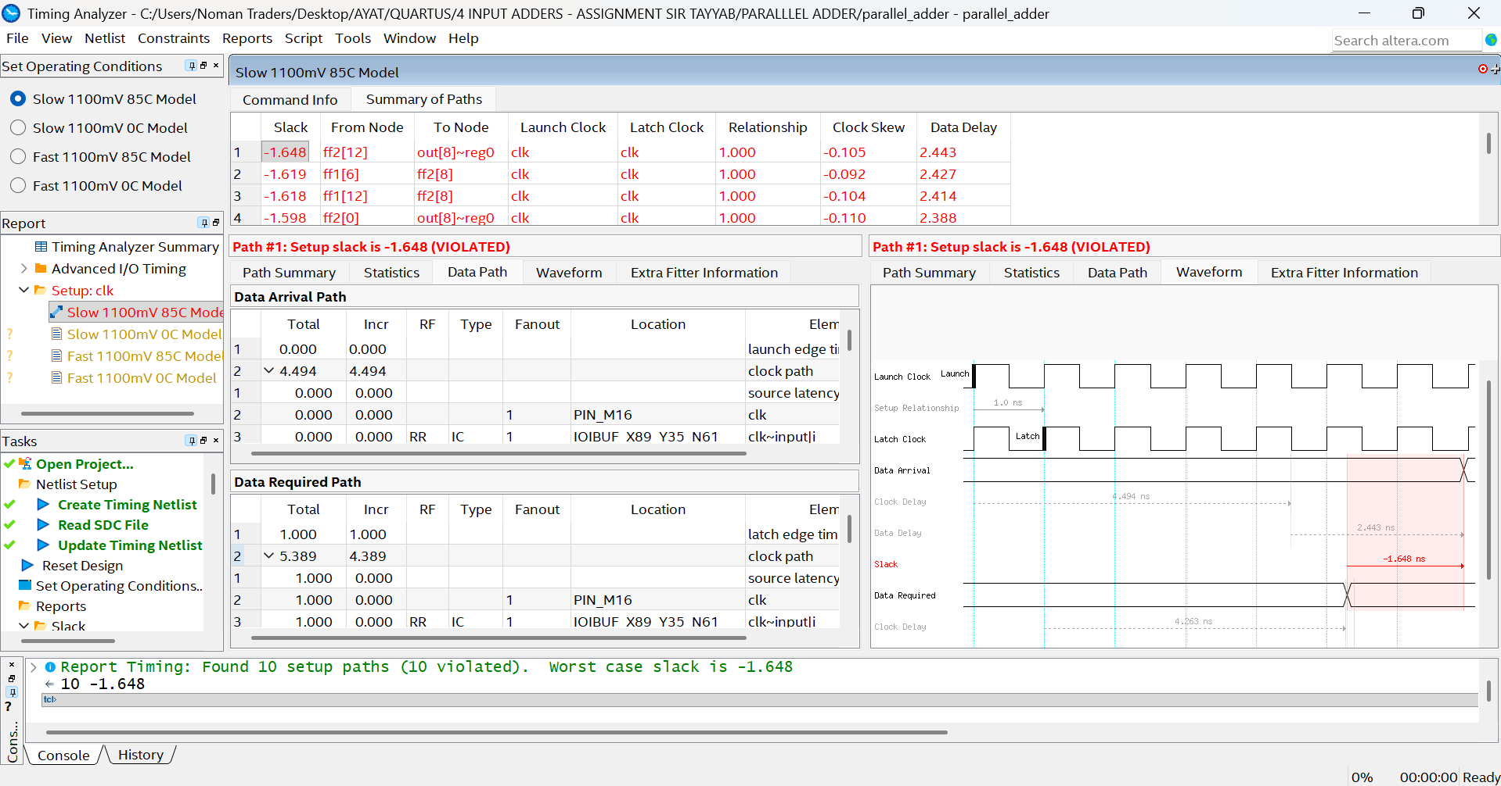
Figure 13: Timing Analyzer: setup slack -1.648 ns (VIOLATED)
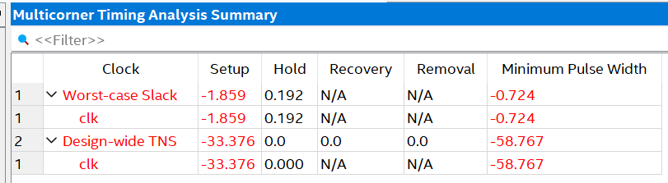
Figure 14: Multicorner Timing Analysis Summary before the fix (setup -1.859, TNS -33.376)
- Find the failing paths. In the Summary of Paths table the worst paths were ff2[12] to out[8]~reg0 and ff1[x] to ff2[8], i.e. the 10-bit adder stages. Opening the Data Path and Waveform tabs showed a launch/latch relationship of only 1.000 ns, a data delay of about 2.4 ns and clock skew of about -0.1 ns. A 2.4 ns adder path cannot meet a 1 ns requirement, so the violation came from an unrealistic clock target rather than a logic error.
- Fix the violation. The architecture was already pipelined with one adder per stage, so no further logic could be moved between registers. The clock constraint in the SDC file was relaxed to a period that the single-adder stage can achieve (3.0 ns for the run shown below) and the project was recompiled / the timing netlist updated. With a 3.000 ns relationship the worst setup slack became +0.274 ns and "Found 10 setup paths (0 violated)". Below is the TCL statement of setting the 3.00 ns frequency in the sdc file.
# Create Clock
create_clock -name {clk} -period 3.000 -waveform { 0.000 1.500 } [get_ports {clk}]
- Check the achievable Fmax. Fmax = 1 / (clock period - setup slack). For the 3.0 ns run: 1 / (3.000 - 0.274) ns = 366.84 MHz, which matches the Fmax summary. The final compilation report gave Fmax = 377.64 MHz.
- Confirm all corners. Check the multicorner summary: setup, hold and minimum pulse width are all positive and TNS = 0. In the final run the worst-case setup slack was +0.050 ns, hold slack +0.147 ns, minimum pulse width +0.587 ns and design-wide TNS 0.0.
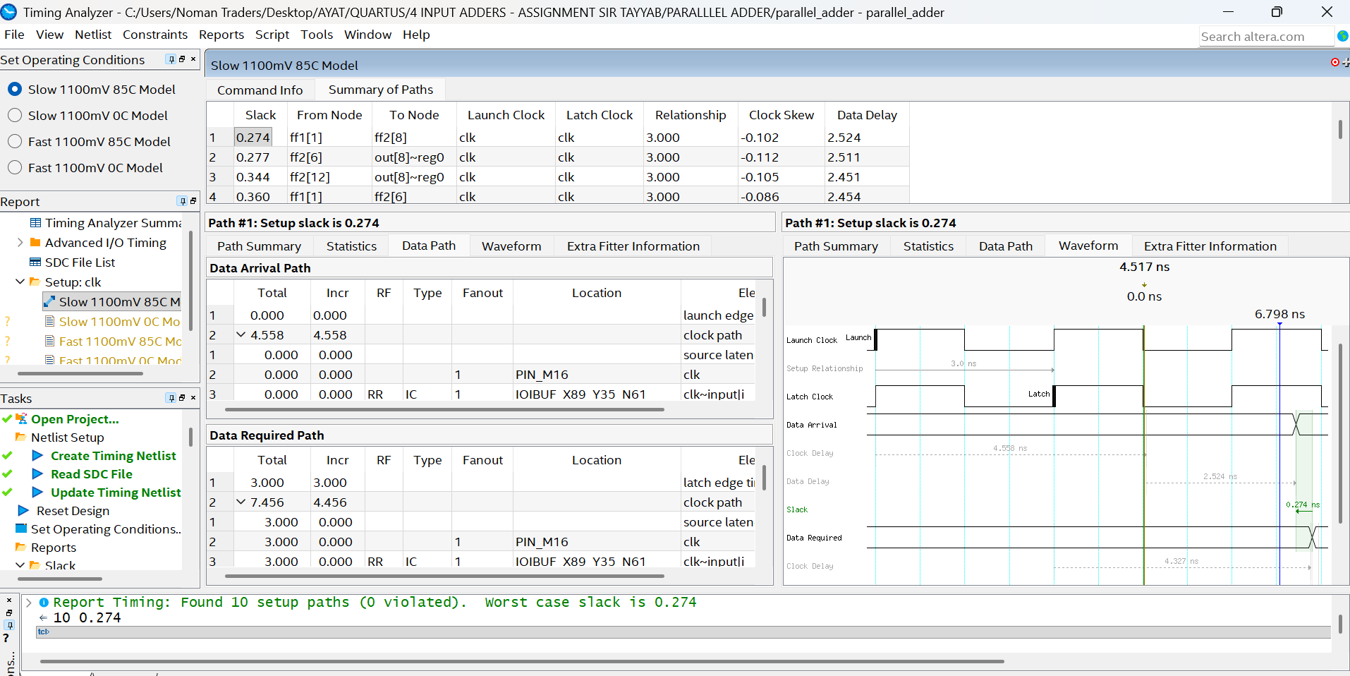
Figure 15: Timing Analyzer after the fix: setup slack +0.274 ns, 0 violated paths
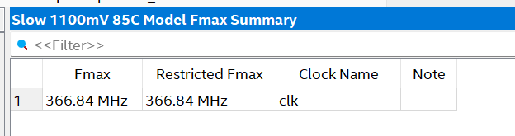
Figure 16: Fmax summary of the Timing Analyzer run with 3.0 ns constraint: 366.84 MHz
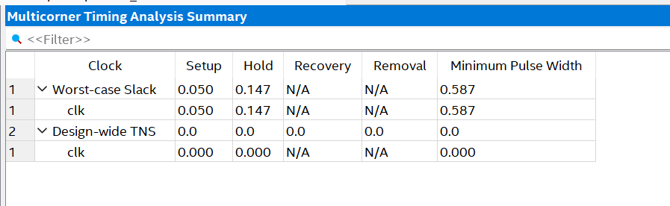
Figure 17: Multicorner Timing Analysis Summary after the fix (setup +0.050, hold +0.147, TNS 0.0)

4. Observation: Quartus Fmax covers register-to-register paths only
The first version of the unrolled adder registered only the output. Quartus reported "No paths to report" in the Fmax Summary. After the four inputs were also registered, Quartus reported Fmax = 217.06 MHz.
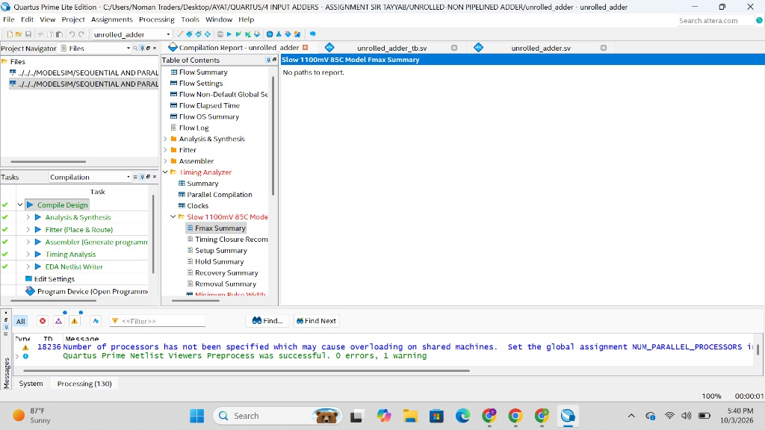
Figure 18: First attempt: output-only register, Fmax Summary shows "No paths to report"
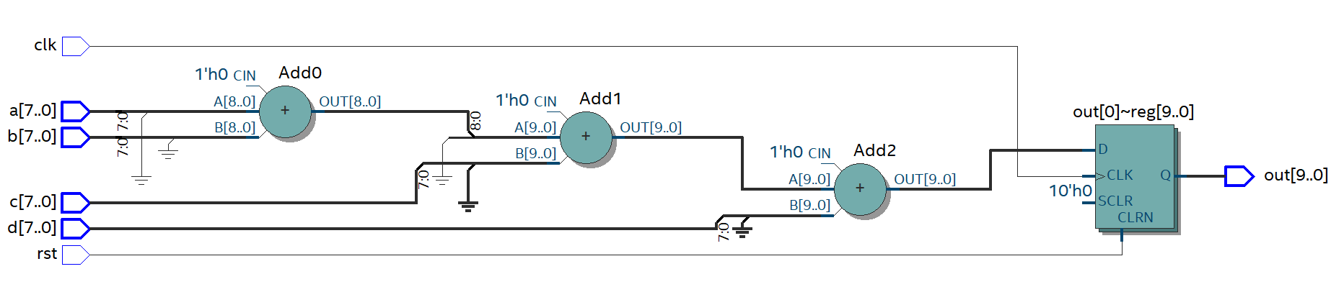
Figure 19: First attempt: RTL with unregistered inputs
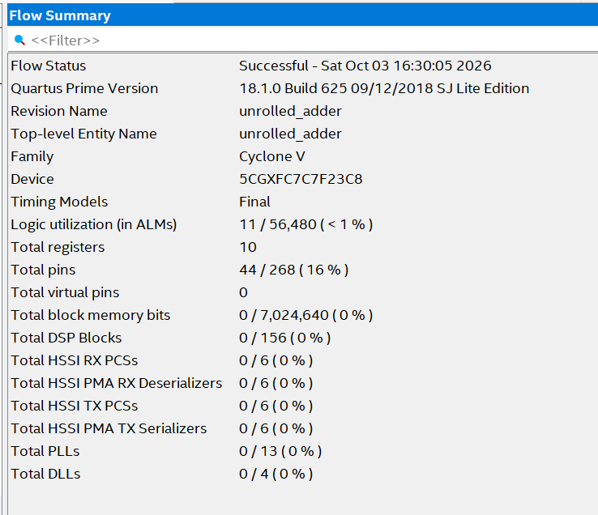
Figure 20: First attempt: flow summary (11 ALMs, 10 registers: output register only)
This shows that the Fmax Summary only analyses paths that start and end at registers clocked by the same clock (reg2reg). Paths from an input pin to a register or from a register to an output pin are I/O paths; they are not part of Fmax and are only checked when input/output delays are constrained. With unregistered inputs the only path was pin to register through the three adders, so there was no reg2reg path to report. Registering the inputs creates reg2reg paths (input registers through three adders to the output register), at the cost of extra registers. The resource summary confirms this: the output-register-only version used 11 ALMs and 10 registers, while the final registered-input version uses 15 ALMs and 42 registers.

5. Results

5.1 Synthesis results
Architecture | ALMs (LUT logic) | Registers | Fmax (MHz) | Clock period (ns)
Unrolled | 15 | 42 | 217.06 | 4.607
Sequential | 20 | 12 | 239.12 | 4.182
Pipelined | 15 | 53 | 377.64 | 2.648
ALMs are the Quartus measure of logic (Adaptive Logic Modules). The unrolled figures are for the final design with registered inputs and output: 42 registers = 4 input registers x 8 bits + a 10-bit output register.
Summary of resource usage: the sequential design needs the most logic (20 ALMs) but the fewest registers (12). The unrolled and pipelined designs both contain three adders and use the same 15 ALMs; the difference is in registers, 42 for the unrolled design versus 53 for the pipelined design.

5.2 Latency and throughput
Latency is (number of clock cycles) x (clock period). Throughput is the number of results per second: Fmax x (results per cycle).
Architecture | Latency (cycles) | Latency (ns) | Results per cycle | Throughput (M results/s)
Unrolled | 1 | 1 x 4.607 = 4.607 | 1 | 217.06
Sequential | 3 | 3 x 4.182 = 12.546 | 1/3 | 239.12 / 3 = 79.71
Pipelined | 4 | 4 x 2.648 = 10.592 | 1 | 377.64

- Unrolled: all three additions are done combinationally in one clock period, so the latency is 1 clock cycle (4.607 ns) and a new result is produced every cycle. This is the lowest latency of the three designs.
- Sequential: the three additions (a+b, then +c, then +d) are done one per clock using a single adder, so the latency is 3 clock cycles (12.546 ns) and a new result is available only every 3 cycles, giving 1/3 result per cycle. This is the highest latency of the three designs.
- Pipelined: the latency is counted as 4 clock cycles (4 x 2.648 = 10.592 ns). Because each stage holds only one adder, the clock is much faster, but the data must pass through every stage before the result appears; once the pipeline is full a new result comes out every cycle.

6. Comparison and conclusion
- Frequency: pipelined (377.64 MHz) is highest because each stage contains one adder; unrolled (217.06 MHz) is lowest because three adders are chained; sequential (239.12 MHz) is limited by the counter-mux-adder-register loop.
- Resources: the sequential design uses the most logic (20 ALMs, for the counter, 4-to-1 multiplexer and control around its single adder) but the fewest registers (12). The unrolled and pipelined designs both contain three adders and use the same 15 ALMs; the unrolled design needs 42 registers (four 8-bit input registers and a 10-bit output register) and the pipelined design needs 53, because c and d must be carried through the pipeline stages along with the partial sums.
- Latency: the unrolled design has the lowest latency (1 cycle = 4.607 ns), then the pipelined design (4 cycles = 10.592 ns), and the sequential design has the highest (3 cycles = 12.546 ns). Pipelining adds latency because the data must pass through every stage, but its fast clock keeps the time below that of the sequential design.
- Throughput: pipelined is highest (377.64 M results/s), unrolled is next (217.06), and sequential is far lower (79.71) because it produces only one result every 3 cycles.
Overall, the pipelined architecture gives the best speed (377.64 MHz, 377.64 M results/s) for the same 15 ALMs as the unrolled design and only 11 more registers (53 versus 42). The sequential architecture trades speed for a single adder, but its counter and multiplexer make it the largest in logic (20 ALMs) and it has both the highest latency (12.546 ns) and the lowest throughput (79.71 M results/s). The unrolled architecture is simple and has the lowest latency (4.607 ns), but its clock is limited by the long combinational path through three adders (217.06 MHz).

