GCD FSMD
Finite State Machine with Datapath — Design, Synthesis and Simulation
Greatest Common Divisor computed via the subtractive Euclidean algorithm
Design Entry: SystemVerilog HDL (datapath, testbench); Quartus State Machine Wizard (controller)
Functional Verification: ModelSim
Synthesis: Quartus Prime Lite Edition 18.1.0
Target Device: Cyclone V (5CGXFC7C7F23C8)

1. Assignment Objective
This report covers the design, synthesis and simulation of a hardware Greatest Common Divisor (GCD) unit built as an FSMD (Finite State Machine with Datapath). The design is split into two independently designed modules — a datapath (gcd_datapath) and a controller (controller, an FSM) — which are integrated into a single top-level module (ugcd). The design is exercised with a testbench driving multiple operand pairs, including the three pairs of particular interest for this assignment: (56, 48), (24, 24) and (39, 52), whose GCDs are 8, 24 and 13 respectively. The controller's state machine is captured graphically using Quartus's State Machine Wizard, which then auto-generates the synthesizable HDL, and Quartus's synthesizer is subsequently shown re-extracting that same state machine from the compiled netlist as a state diagram report — closing the loop between graphical entry and gate-level implementation.

1.1 What Is an FSMD?
An FSMD (Finite State Machine with Datapath) is a hardware design model that cleanly separates a digital system into two cooperating parts: a datapath, which contains the registers, arithmetic/logic units, multiplexers and comparators that actually manipulate data, and a controller, which is a pure finite state machine that sequences that datapath by asserting control signals (register-load enables, multiplexer selects) based on the current state and on status flags fed back from the datapath (here, x_lt_y and x_neq_y). The two communicate through a narrow, well-defined interface: the controller only ever sends control signals out and only ever receives status/condition flags in, while the datapath only ever receives control signals and only ever produces status flags and data outputs. This is exactly the ASMD (Algorithmic State Machine with Datapath) style of design captured by the FSMD_FLOWCHART and DATAPATH figures later in this report.

1.2 Why Is the FSMD Model Useful?
- Separation of concerns: The person designing the arithmetic (adders, comparators, muxes) does not need to think about sequencing, and the person designing the control sequencing does not need to think about bit-widths or arithmetic correctness — each can be designed, and independently debugged, on its own.
- Reusability and retargeting: The same controller design pattern (a Moore FSM sequencing loads/selects) can drive a different datapath (e.g., a different bit-width, or an entirely different algorithm) with minimal or no change, and conversely the same datapath could be sequenced by a different controller (e.g., a pipelined or a fully combinational one).
- Tool-assisted design and verification: Because the controller is a pure Moore state machine, it can be captured in a dedicated graphical tool (as done here, with Quartus's State Machine Wizard) that auto-generates correct, synthesizable HDL and lets the synthesizer independently re-derive and display the state diagram from the compiled netlist as a sanity check — precisely the workflow demonstrated in Section 4 of this report.
- Natural mapping from an algorithm: Any algorithm expressed as a sequence of "do this arithmetic operation, then branch on this condition" steps (exactly what the subtractive GCD algorithm is) maps directly onto an FSMD: each algorithmic step becomes one state, and each branch becomes a conditional state transition. Sections 2 and 3 below walk through exactly this mapping for the GCD algorithm.

2. The Subtractive Euclidean GCD Algorithm
The greatest common divisor (GCD) of two positive integers is the largest integer that divides both without a remainder. This design implements the subtractive (non-modulo) form of the Euclidean algorithm, which is well suited to hardware because it only needs a comparator and a subtractor — no divider is required:
function gcd(x, y):
while (x != y):
if (x < y): y = y - x
else: x = x - y
return x // == y, the GCD
Each pass of the while loop is one "test-then-subtract" step; the loop terminates the instant x equals y, at which point that common value is the GCD. This maps directly onto the six-state controller described in Section 4: the while (x != y) test is state3, the two branches of the if are state4/state5, and the loop-exit/result-latch is state6.

3. The Datapath (gcd_datapath)
The datapath owns all of the actual data storage and arithmetic for the design: two operand registers (x, y), an output register (d), two subtractors, two multiplexers and two comparators. It has no notion of "sequence" at all — every operation it performs, it performs continuously and combinationally; it is entirely up to the controller (Section 4) to decide, cycle by cycle, which of those combinational results should actually be latched into a register.
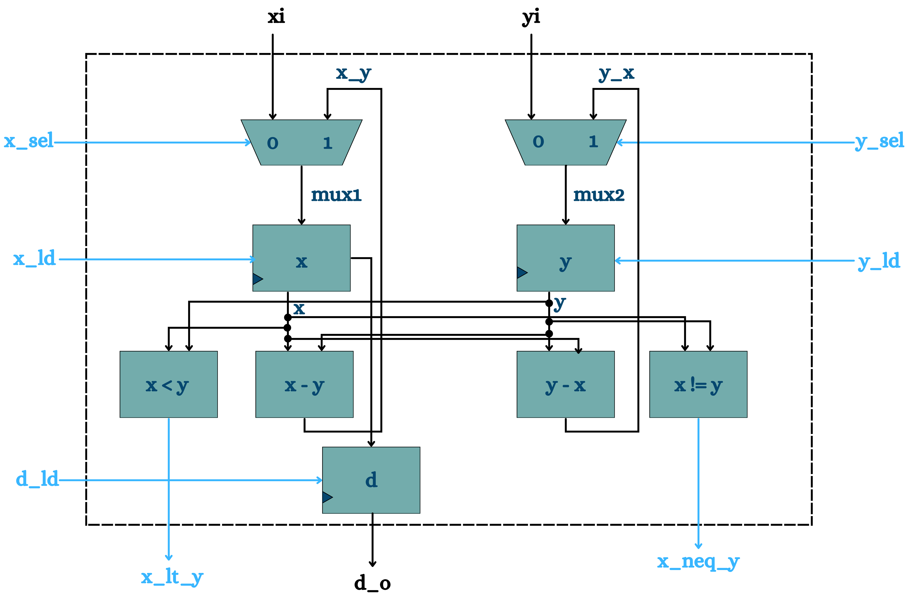
Figure 1 — Datapath architecture: muxes select between the fresh operand (xi/yi) and the subtraction feedback (x−y / y−x); registers x, y and d are loaded only when their *_ld control signal is asserted

3.1 Multiplexers — Choosing the Register's Next Value
assign mux1 = (x_sel)? x_y : xi; // mux1 feeds register x
assign mux2 = (y_sel)? y_x : yi; // mux2 feeds register y
mux1 selects between the fresh primary input xi (when x_sel = 0, used only when first loading the operands) and the subtraction result x_y = x − y (when x_sel = 1, used every time the algorithm needs to shrink x). mux2 works identically for y, selecting between yi and y_x = y − x.

3.2 Registers x, y and d
always_ff @(posedge clk or posedge rst) begin
if (rst) x <= '0;
else if (x_ld) x <= mux1;
else x <= x;
end
All three registers (x, y and d) follow this same pattern: an asynchronous reset clears them to zero, otherwise they only update when their dedicated load enable (x_ld, y_ld or d_ld) is asserted by the controller, and otherwise they simply hold their previous value. This is what lets the controller precisely dictate, one cycle at a time, exactly when a register is allowed to change — the entire notion of "state" in the algorithm lives in these three registers, driven by control signals the FSM alone decides.

3.3 Comparators and Subtractors
assign x_lt_y = (x < y) ? 1 : 0; // feeds back to the controller
assign x_neq_y = (x != y) ? 1 : 0; // feeds back to the controller
assign y_x = y - x;
assign x_y = x - y;
x_lt_y and x_neq_y are the two status flags the datapath exposes to the controller — they are exactly the two conditions the GCD algorithm's while and if statements need to branch on. Both subtractions (x_y and y_x) are computed unconditionally and continuously; only one of them is ever actually loaded into a register on a given cycle, controlled entirely by which of x_ld/x_sel or y_ld/y_sel the FSM asserts that cycle. Note that only one subtractor result is used per step (the algorithm never needs both simultaneously), so the unused one is simply discarded combinational logic that costs negligible extra area.
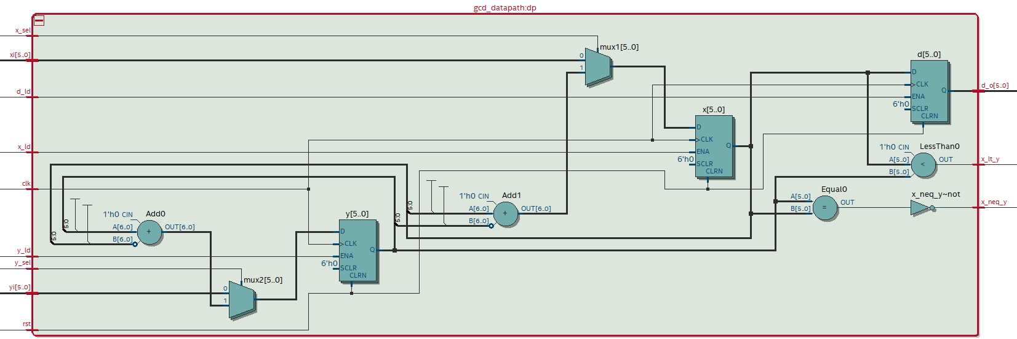
Figure 2 — RTL Viewer (Quartus) schematic of the synthesized datapath: mux1/mux2 feeding registers x/y, adders realizing the two subtractions, and the LessThan0/Equal0 comparators driving x_lt_y and x_neq_y

4. The Controller (FSM) — Design via Quartus's State Machine Wizard
Unlike the datapath, which was hand-written directly in SystemVerilog, the controller in this project was captured graphically using Quartus's built-in State Machine Wizard and then auto-generated as synthesizable SystemVerilog HDL. This section documents that graphical entry process step by step, since it is a substantially different (and, for a pure Moore FSM, considerably less error-prone) design flow than hand-writing an always_comb/always_ff state machine.

4.1 Step 1 — Create a New State Machine File
From File ▸ New inside the Quartus project, the "State Machine File" entry (alongside the more familiar Verilog/VHDL/SystemVerilog HDL File options) launches the State Machine Wizard, a dedicated graphical editor for drawing state diagrams rather than typing HDL directly.
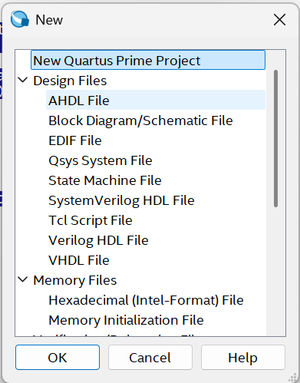
Figure 3 — Selecting "State Machine File" from Quartus's New File dialog

4.2 Step 2 — Declare the FSM's Inputs and Outputs
The wizard's Inputs and Outputs tabs are used to declare exactly the signals identified by the FSMD partitioning in Section 1.1: the five inputs the controller needs to make its decisions, and the five outputs it uses to drive the datapath.
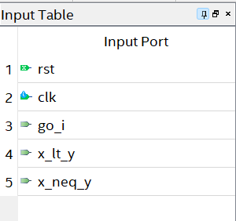
Figure 4 — Declared inputs: rst, clk, go_i, x_lt_y, x_neq_y
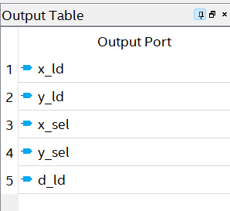
Figure 5 — Declared outputs: x_ld, y_ld, x_sel, y_sel, d_ld

4.3 Step 3 — Configure Reset Behaviour (General Tab)
The General tab fixes the reset style for the whole state machine — here, a synchronous, active-high reset — and also enables "transition to source state if not all transition conditions are specified", a convenience that keeps a state from having to explicitly enumerate a self-loop for every condition it does not otherwise handle.
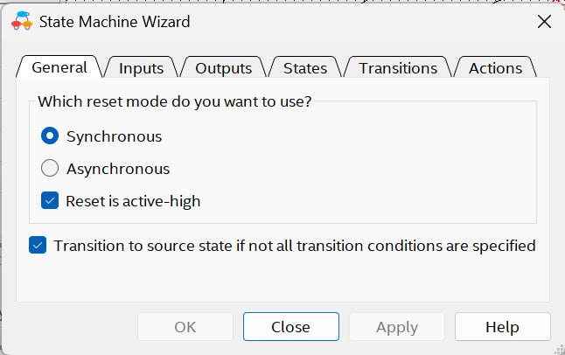
Figure 6 — Reset mode configuration: Synchronous, active-high, with implicit self-loop on unspecified conditions

4.4 Step 4 — Define the States
The States tab lists the six states of the design (state1 through state6) and marks exactly one of them — state1 — as the reset state, matching the IDLE role described in Section 4.6/Table 1.
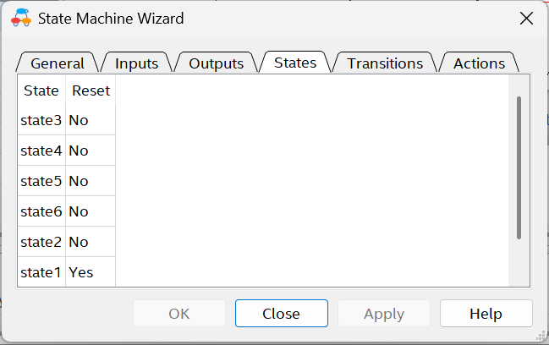
Figure 7 — The six states, with state1 designated the reset (initial) state

4.5 Step 5 — Draw Transitions and Assign Per-State Outputs (Actions)
For each state, its Outgoing Transitions are drawn to the next state(s) with a Boolean guard condition (e.g. go_i, ~go_i, (x_neq_y)&(x_lt_y)), and its Actions tab lists the Moore outputs that state holds high for as long as the FSM remains in it. Because this is a Moore machine, every output value in the Actions tab depends only on the current state, never on the inputs — the input conditions only ever decide which state comes next, not what the current state's outputs are.
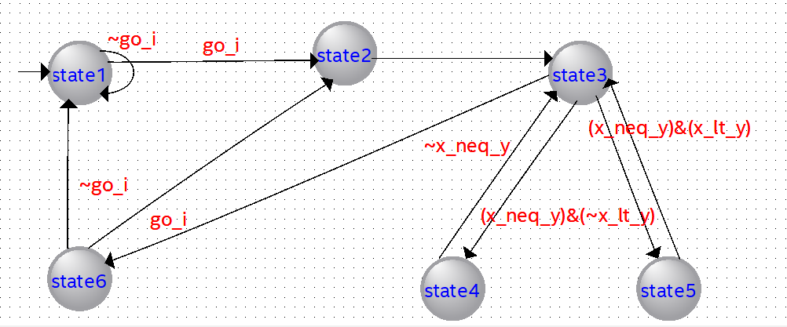
Figure 8 —State Transitions
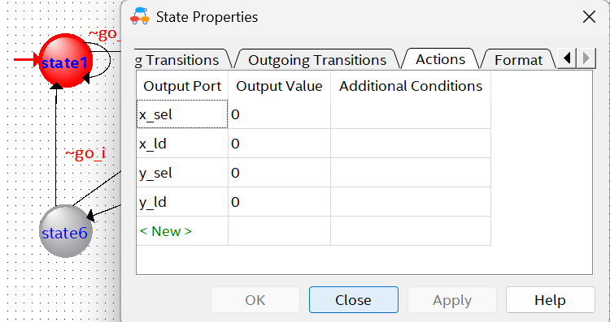
Figure 9 — state1 (IDLE): x_sel = 0, x_ld = 0, y_sel = 0, y_ld = 0 — holds here on ~go_i
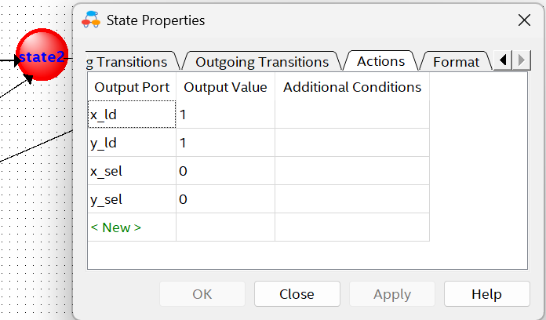
Figure 10 — state2 (LOAD): x_ld = 1, y_ld = 1, x_sel = 0, y_sel = 0 — loads xi/yi into x/y
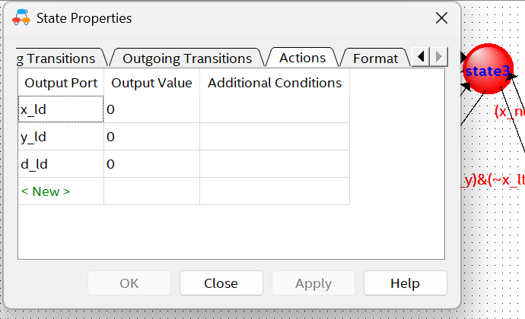
Figure 11 — state3 (TEST): x_ld = 0, y_ld = 0, d_ld = 0 — lets x_lt_y / x_neq_y settle for the next-state decision
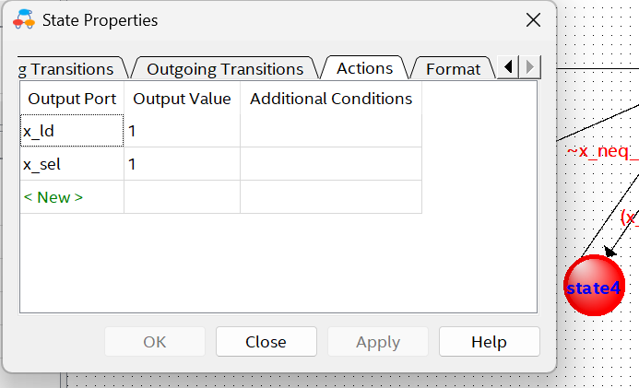
Figure 12 — state4 (SUBTRACT X): x_ld = 1, x_sel = 1 — register x is reloaded with x − y
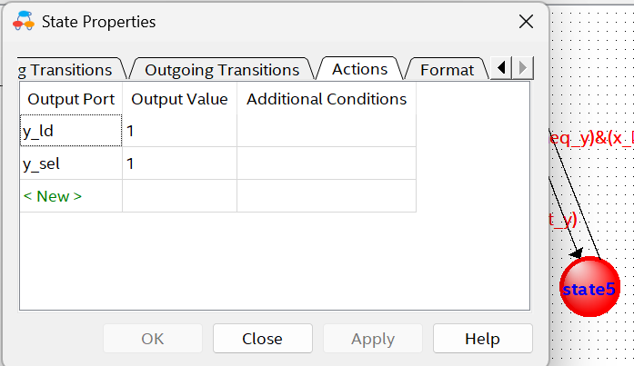
Figure 13 — state5 (SUBTRACT Y): y_ld = 1, y_sel = 1 — register y is reloaded with y − x
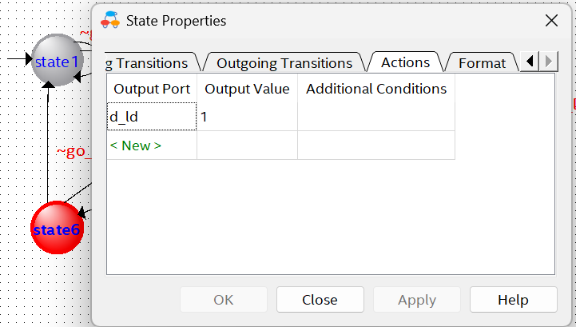
Figure 14 — state6 (DONE): d_ld = 1 — the converged value (x, which now equals y) is latched into the output register d

4.6 Step 6 — Complete State Table and Behaviour Summary
State | Moore Outputs Asserted | Role in the Algorithm
state1 | x_sel=0, x_ld=0, y_sel=0, y_ld=0 (all outputs low) | IDLE / WAIT — reset state. Holds here while go_i = 0; the moment go_i = 1 it moves on to state2.
state2 | x_sel=0, y_sel=0, x_ld=1, y_ld=1 | LOAD — registers x and y are loaded from the primary inputs xi and yi (mux1/mux2 select the '0' input, i.e. the fresh operands, not the feedback subtraction result).
state3 | x_ld=0, y_ld=0, d_ld=0 (all loads low) | TEST — no register is updated this cycle; the FSM simply lets the combinational comparators x_lt_y and x_neq_y settle so the next-state logic can branch on them.
state4 | x_ld=1, x_sel=1 | SUBTRACT X — taken when (x_neq_y) & (~x_lt_y), i.e. x ≥ y and x ≠ y. mux1 now selects the x−y feedback path, so x ← x − y.
state5 | y_ld=1, y_sel=1 | SUBTRACT Y — taken when (x_neq_y) & (x_lt_y), i.e. x < y. mux2 selects the y−x feedback path, so y ← y − x.
state6 | d_ld=1 | DONE — taken when ~x_neq_y, i.e. x = y. The common value is latched into the output register d (d ← x). From here the FSM returns to state2 if go_i is already high again (back-to-back computation) or to state1 if go_i has gone low (idle).

4.7 Step 7 — Generate HDL
Once every state's transitions and actions are defined, the wizard's Finish/Generate step emits synthesizable SystemVerilog (SystemVerilog was selected as the target HDL for this project) implementing the state register, the next-state logic and the Moore output-decode logic, ready to be compiled alongside the hand-written datapath and testbench. Because the tool generates the HDL directly from the graphical state diagram, the two are guaranteed to be consistent with one another — there is no separate hand-transcription step where a typo could introduce a mismatch between the intended diagram and the actual RTL.
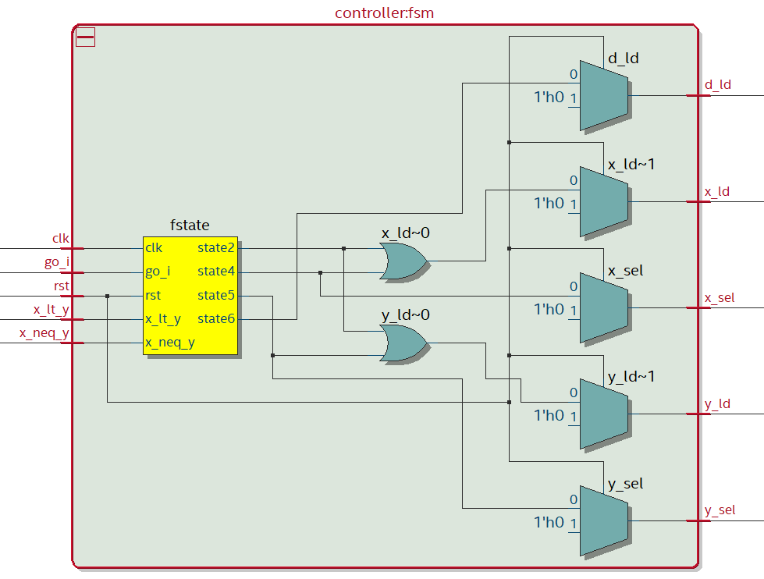
Figure 15 — RTL Viewer (Quartus) schematic of the auto-generated controller: the fstate state register together with the OR/mux output-decode logic (e.g. x_ld~0, y_ld~0) that implements the Moore outputs from Table 1

5. Synthesizer-Extracted State Machine (Sanity Check)
Because the controller is entirely encoded in HDL (albeit auto-generated), Quartus's synthesizer is able to analyze the compiled netlist and re-derive the state machine independently, without any reference to the original graphical diagram, then render it as a state diagram report. Comparing this synthesizer-extracted diagram against the original design intent (Table 1 / Figures 8–13) is a valuable sanity check: if the HDL had been hand-written and contained a bug, this extracted diagram is often where the discrepancy would first become visible.
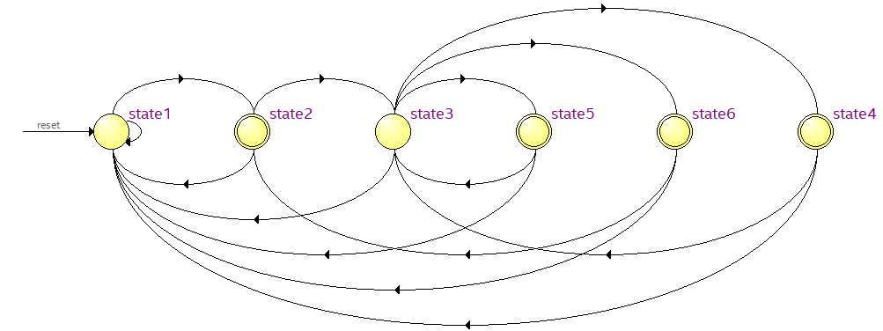
Figure 16 — State diagram as extracted by Quartus's synthesizer from the compiled controller netlist, showing all six states and their guarded transitions
This extracted diagram matches the intended design exactly: state1 self-loops on ~go_i and advances to state2 on go_i; state2 unconditionally advances to state3; state3 branches three ways on the datapath's status flags — to state5 on (x_neq_y)&(x_lt_y), to state4 on (x_neq_y)&(~x_lt_y), and to state6 on ~x_neq_y; state4 and state5 both return unconditionally to state3 (to re-test the new x or y); and state6 returns to state2 if go_i is already asserted again, or to state1 otherwise. This is precisely the control-flow required by the subtractive GCD algorithm in Section 2.

6. Design Flowcharts: FSM-Only vs. FSMD
It is instructive to look at the controller in two stages of increasing detail: first as a pure control-flow FSM flowchart (showing only decisions and control-signal assignments, with the algorithm's actual arithmetic left implicit), and then as a full FSMD flowchart that additionally annotates each state with the concrete register-transfer-level (RTL) operation it causes in the datapath (x = xi, x = x − y, d_o = d, and so on). This progression mirrors how the design was actually developed: the control skeleton first, then the datapath detail layered on top of it.

6.1 FSM Flowchart (Control Flow Only)
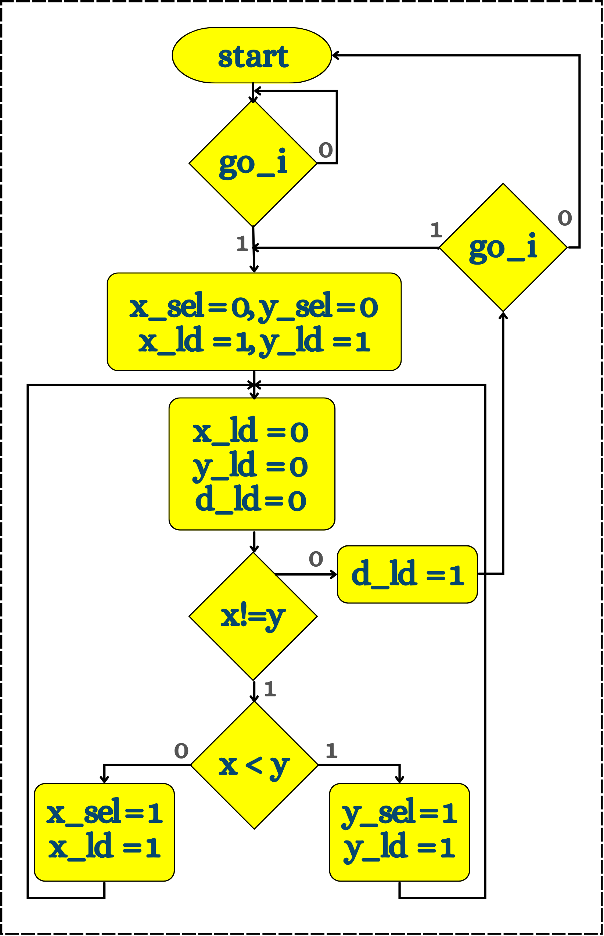
Figure 17 — Pure FSM flowchart: every box is expressed only in terms of the control signals (x_sel, x_ld, y_sel, y_ld, d_ld) that the controller asserts, with no reference yet to the actual register-transfer semantics those signals cause

6.2 FSMD Flowchart (Control Flow + Data Operations)
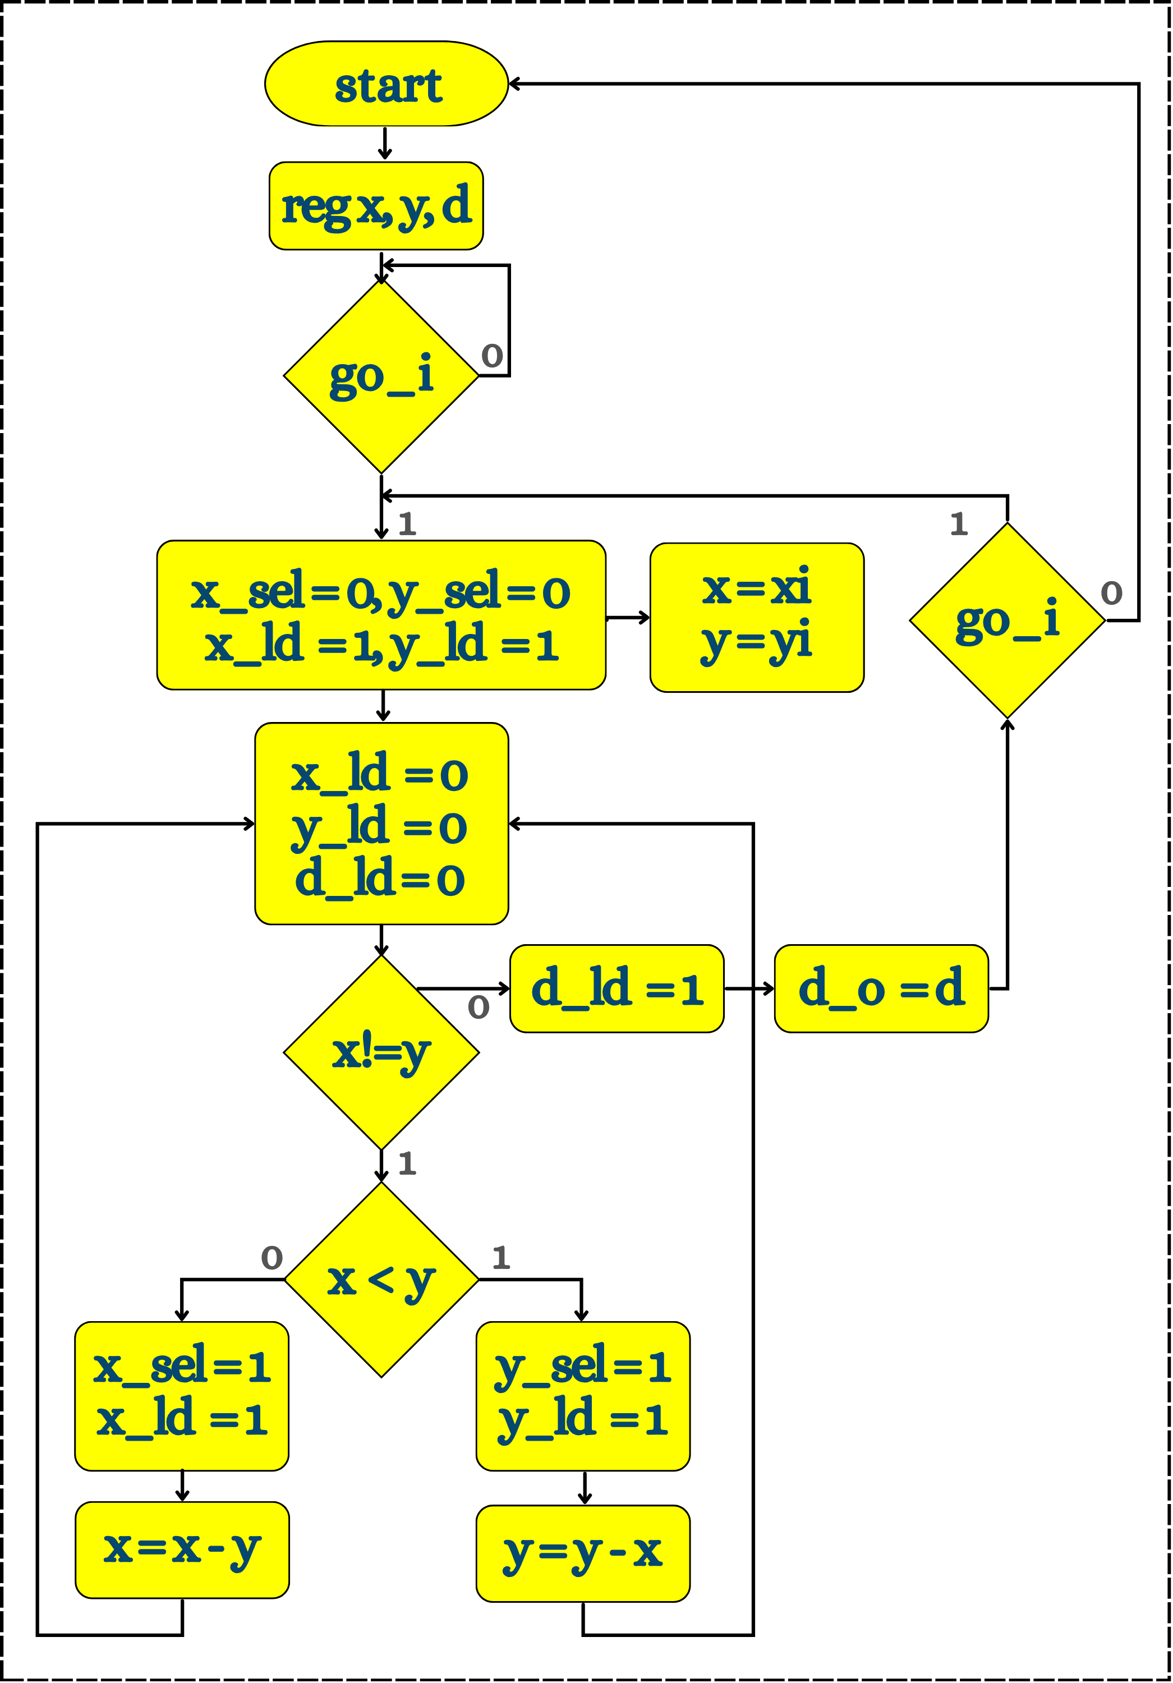
Figure 18 — FSMD flowchart: the same control skeleton as Figure 16, now annotated with the register declaration (reg x, y, d) and the concrete RTL operation each state performs on the data (x = xi; y = yi; x = x − y; y = y − x; d_o = d) — this is the complete algorithmic state machine with datapath view of the design

7. Top-Level Integration (ugcd)
The top-level module, ugcd, instantiates the controller and the datapath side by side and wires them purely through the FSMD interface described in Section 1.1: the controller's five outputs (x_ld, y_ld, x_sel, y_sel, d_ld) drive the datapath's five control inputs, and the datapath's two status outputs (x_lt_y, x_neq_y) feed back into the controller's inputs. Neither submodule connects to the other in any other way — clk, rst, go_i and xi/yi fan out from the top-level ports to both submodules (or, in the case of xi/yi, directly to the datapath), and d_o is driven straight out of the datapath as the top-level result.
Port | Direction | Description
clk | Input | System clock driving all registers in the datapath and the FSM state register.
rst | Input | Synchronous/asynchronous reset (asserted high) — clears x, y, d and forces the FSM to state1.
go_i | Input | Start strobe. Asserting go_i for one clock while in state1 (or state6) begins a new GCD computation on the current xi/yi values.
xi, yi | Input | The two 6-bit operands whose GCD is to be computed (N = 6 bits ⇒ values 0–63, ample for the (56,48), (24,24) and (39,52) test cases).
d_o | Output | The 6-bit GCD result, valid and held once the FSM reaches state6 and asserts d_ld.
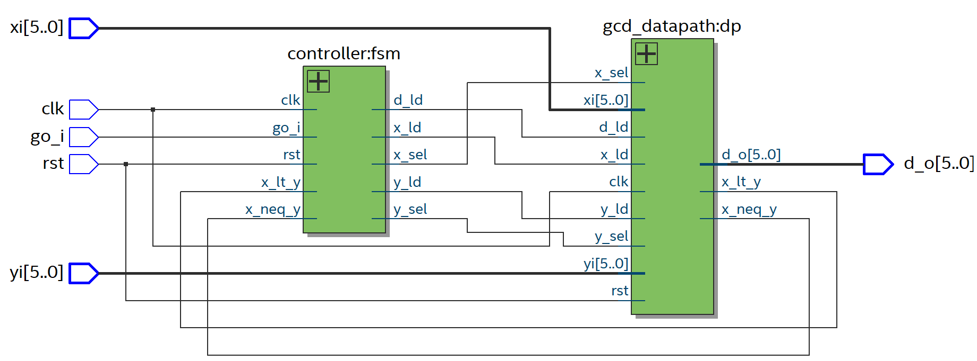
Figure 19 — RTL Viewer (Quartus) schematic of ugcd, showing controller:fsm and gcd_datapath:dp connected purely through the control/status signal interface — exactly the FSMD partitioning of Section 1.1
Based on this synthesized connectivity, the top-level module's structural instantiation is, in essence:
module ugcd #(parameter N = 6)(
input logic clk,
input logic rst,
input logic go_i,
input logic [N-1:0] xi,
input logic [N-1:0] yi,
output logic [N-1:0] d_o
);
logic x_ld, y_ld, x_sel, y_sel, d_ld;
logic x_lt_y, x_neq_y;

controller fsm (
.clk(clk), .rst(rst), .go_i(go_i),
.x_lt_y(x_lt_y), .x_neq_y(x_neq_y),
.x_ld(x_ld), .y_ld(y_ld),
.x_sel(x_sel), .y_sel(y_sel), .d_ld(d_ld)
);

gcd_datapath #(.N(N)) dp (
.clk(clk), .rst(rst), .xi(xi), .yi(yi), .d_o(d_o),
.x_sel(x_sel), .y_sel(y_sel),
.x_ld(x_ld), .y_ld(y_ld), .d_ld(d_ld),
.x_lt_y(x_lt_y), .x_neq_y(x_neq_y)
);
endmodule

8. Testbench
The testbench (ugcd_tb) instantiates ugcd, free-runs a clock (toggling every 5 ns, i.e. a 10 ns / 100 MHz period), applies a reset, and then drives a sequence of operand pairs through go_i, giving the FSM enough idle time after each pulse to complete the subtractive loop before the next pair is applied.
clk = 0; rst = 1; go_i = 0; xi = 0; yi = 0; #20;
rst = 0; #10;

xi = 6'd12; yi = 6'd4; go_i = 1; #10; go_i = 0; #100; // GCD = 4
xi = 6'd3; yi = 6'd9; go_i = 1; #10; go_i = 0; #100; // GCD = 3
xi = 6'd14; yi = 6'd7; go_i = 1; #10; go_i = 0; #100; // GCD = 7
xi = 6'd24; yi = 6'd24; go_i = 1; #10; go_i = 0; #100; // GCD = 24
xi = 6'd56; yi = 6'd48; go_i = 1; #10; go_i = 0; #170; // GCD = 8
xi = 6'd39; yi = 6'd52; go_i = 1; #10; go_i = 0; #150; // GCD = 13
$stop;
Each go_i pulse is only one clock wide — exactly matching the FSM's expectation of a single-cycle start strobe sampled in state1/state6 — after which the testbench simply waits (100–170 ns, i.e. 10–17 clock cycles, comfortably more than the handful of subtract/test iterations any of these operand pairs needs) for the FSM to work through states 2 → 3 → (4 or 5) → 3 → … → 6 and latch the result. The three pairs of specific interest for this assignment — (56, 48), (24, 24) and (39, 52) — are the final three vectors applied, with expected GCDs of 8, 24 and 13 respectively; the first three pairs ((12,4), (3,9), (14,7)) serve as additional, simpler sanity-check vectors exercising the same control paths with smaller operands.

9. Simulation Results (ModelSim)
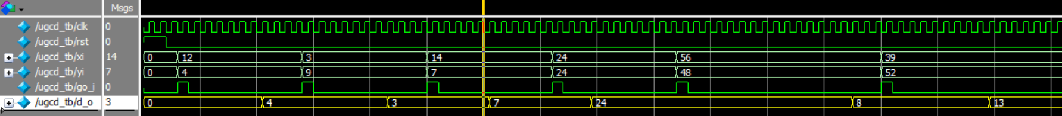
Figure 20 — ModelSim waveform: clk, rst, xi, yi, go_i and d_o across all six applied operand pairs
Reading the waveform left to right: after the initial reset pulse, each rising pulse on go_i is followed, some cycles later, by d_o updating to the correct GCD of the xi/yi pair that was active when go_i was pulsed. All six vectors resolve to the correct result, confirming both the datapath's arithmetic/comparison logic and the controller's sequencing are functioning together correctly as an integrated FSMD.
xi | yi | Expected GCD | Simulated d_o
12 | 4 | 4 | 4
3 | 9 | 3 | 3
14 | 7 | 7 | 7
24 | 24 | 24 | 24
56 | 48 | 8 | 8
39 | 52 | 13 | 13
In particular, for the three pairs of specific interest to this assignment: GCD(56, 48) resolves to 8, GCD(24, 24) resolves to 24 (the trivial case where the two inputs are already equal — the FSM passes through state3 once and goes directly to state6 without ever visiting state4 or state5), and GCD(39, 52) resolves to 13 — every one of them a bit-exact match to the value computed independently in software, confirming the FSMD's correctness for this assignment's required test cases.

10. Synthesis Results (Quartus Prime Lite 18.1.0)
The complete ugcd design (controller + datapath) was synthesized targeting a Cyclone V device (5CGXFC7C7F23C8) in Quartus Prime Lite Edition 18.1.0.
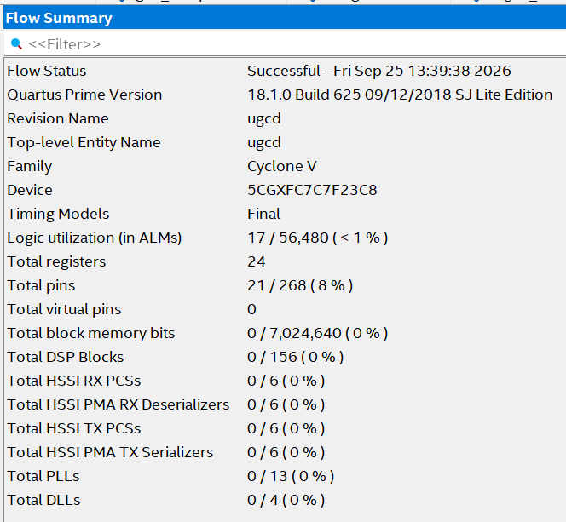
Figure 21 — Quartus Flow Summary: Logic utilization = 17 / 56,480 ALMs (< 1%); 24 registers; 21 / 268 pins (8%)
The design is extremely small — just 17 ALMs and 24 registers — which is expected: the datapath needs only three N-bit registers (x, y, d — 6 + 6 + 6 = 18 flip-flops) plus the FSM's own state register (a handful more flip-flops for 6 states), and the combinational logic is limited to two subtractors, two comparators and a small amount of Moore output-decode logic. The flow completed successfully, confirming the design is fully synthesizable and mappable onto real FPGA fabric, not just simulatable.

11. Conclusion
This assignment implemented a hardware GCD unit as a textbook example of the FSMD design style: a hand-written SystemVerilog datapath performing all arithmetic/comparison work, and a controller captured graphically via Quartus's State Machine Wizard and auto-generated into synthesizable HDL, integrated through a narrow, well-defined control/status signal interface in the ugcd top-level module. Functional simulation in ModelSim across six operand pairs — including the assignment's three pairs of interest, (56,48), (24,24) and (39,52) — produced bit-exact correct GCD results in every case, and Quartus's post-synthesis state diagram extraction independently confirmed that the compiled netlist implements exactly the six-state control flow intended by the original graphical design, closing the loop from algorithm, to graphical FSM entry, to synthesizable RTL, to verified silicon-ready netlist.

12. Tools and Environment
- HDL: SystemVerilog (hand-written datapath and testbench; Quartus-generated controller)
- Controller entry: Quartus Prime State Machine Wizard (graphical state-diagram capture → auto-generated SystemVerilog)
- Functional verification: ModelSim
- Synthesis and implementation: Quartus Prime Lite Edition, version 18.1.0 Build 625
- Target device: Intel/Altera Cyclone V, part 5CGXFC7C7F23C8
- Reported metrics: post-fit logic utilization (ALMs, registers, pins) and synthesizer-extracted state-machine diagram

