Eng. Ayat Mohamed Mohamed

ayatmohamed2372002@gmail.com

GitHub Repo: <https://github.com/Ayat237/Embedded_system_online_diploma.git>

Mastering Embedded System Online Diploma

<http://www.learn-in-depth-store.com>

Pressure Controlling system

Final First Project

Abstract

A pressure controller system aimed to control and monitor a pressure within environment ,the client want to informs the crew of a cabin with an alarm when the pressure exceeds 20 bars in the cabin

Table of Contents

1. Case Study 2

• Specification (from the client) 2

• Pressure Controller Assumptions 2

2. Method 2

3. Requirements 3

4. Space Exploration/Partitioning 4

• Microcontroller Selection: 4

5. System Analysis 4

• Analysis methods 4

I. Use Case Diagram 5

II. Activity Diagram 5

III. Sequence Diagram 6

6. System Design 6

• Design Methods 6

I. Block Diagram 7

II. State Machine Diagram 7

5) Simulation Of All State Diagrams 10

7. Files 11

I. C code running(log.txt) 11

II. Symbol Table 11

III. Section.txt 12

8. Proteus Simulation 12

# Case Study

* A ”client” expects you to deliver the software of the following system:

## Specification (from the client)

* A pressure controller informs the crew of a cabin with an alarm when the pressure exceeds 20 bars in the cabin .
* The alarm duration equals 60 seconds.
* After 60 seconds the alarm will stop.

## Pressure Controller Assumptions

* The controller set up and shutdown procedures are not modeled
* The controller maintenance is not modeled
* The pressure sensor never fails
* The alarm never fails
* The controller never faces power cut



# Method

* V-model-based development is used in this project

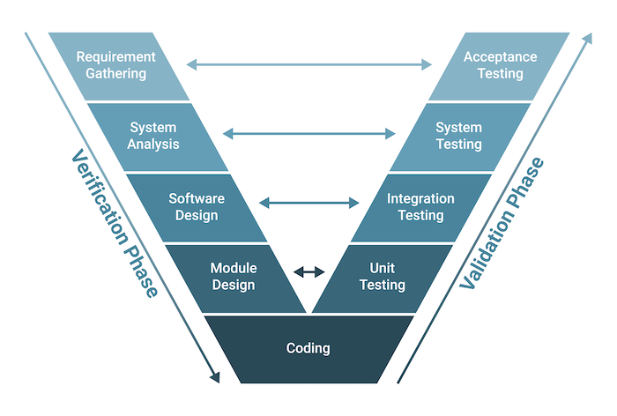

# Requirements

* Based on case study and assumptions we will define all requirements in requirement diagram
* Where a requirements diagram is a visual representation of the requirements for a system, along with the relationships between those requirements and other elements in the system model.



# Space Exploration/Partitioning

* A diagram of a diagram

  Description automatically generatedIt is a way to fined the optimal solution
* provides a starting point for implementing the cabin pressure controller system

## Microcontroller Selection:

* STM32F103 –> ARM Cortex-M3
* 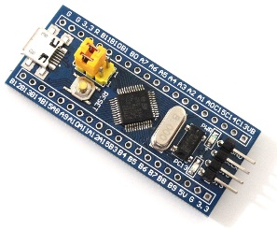Is a popular choice for embedded systems development
* It meet all requirements needed for this project due to it has high-performance, real-time processing in cost-constrained applications and can handle complex tasks



# System Analysis

* In this stage we will understand the main functionalities of the system to be designed

## Analysis methods

* System boundary and main functions → Use Case Diagram
* Relations between main functions → Activity Diagram
* Communications between main system entities and actors → Sequence Diagram

### Use Case Diagram

* Shows what the system does and who uses it

### Activity Diagram

* Activity diagrams describe the workflow behavior of a system

### Sequence Diagram

* An interaction diagram that details how operations are carried out.
* What messages are sent and when.
* Sequence diagrams are organized according to time.



# System Design

* Design is what a client wants by complies with the client requirements.

## Design Methods

* System architecture → Block Definition Diagram and Internal Block Diagram
* Behavior of the system → State Machine Diagram

### Block Diagram

### State Machine Diagram

1. Pressure Sensor Module

1. Main Algorithm

1. Alarm Monitor

1. Alarm Actuator

## Simulation Of All State Diagrams

# Files

## C code running(log.txt)

## Symbol Table

## Section.txt

# Proteus Simulation

1. Pressure value = 20

1. Pressure value = 15

1. Pressure value = 25

