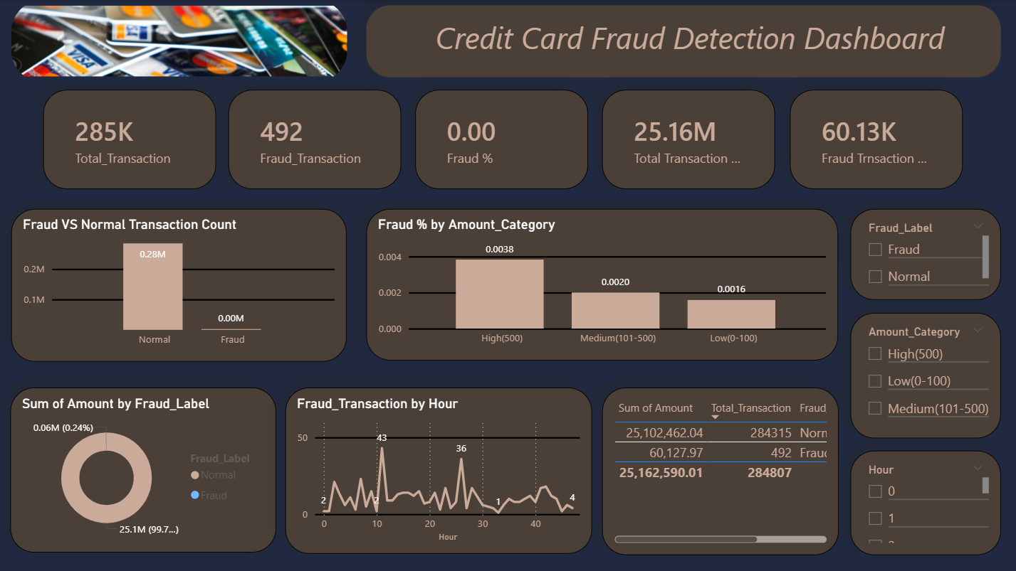

- Which amount category represents the highest fraud risk?
Answer:
The High amount category above 500 shows the highest fraud percentage (~0.0038) compared to Medium and Low categories. This indicates that higher value transactions are more likely to be fraudulent.
Insight:
Fraud risk increases as transaction amount increases
Decision:
The bank should apply stricter verification and monitoring for high value transactions

- At what hours does fraud activity peak compared to normal transactions?
Answer:
Fraud transactions are not evenly distributed over time. There are clear peaks at specific hours where fraud activity reaches its highest levels.
Insight:
Fraud tends to occur at certain times rather than randomly
Decision:
The system should enable stronger monitoring and real time alerts during high risk hours

- Is the financial impact of fraud significant despite its low frequency?
Answer:
Fraud transactions represent a very small percentage of total transactions, around 0.17%. However the total fraud amount is still significant compared to its frequency.
Insight:
Even though fraud is rare it has a noticeable financial impact
Decision:
The company should invest in fraud detection systems to reduce financial losses

