Business Requirements Document (BRD)

Appointgenix

March *2025*

*Version* 2.00

*Company Information*

# BRD

1. **Document Revisions**

|  |  |  |
| --- | --- | --- |
| **Date** | **Version Number** | **Document Changes** |
| 06/09/2022 | 1.0 | Initial Draft |
| 04/03/2025 | 2.0 | New Updates |
|  |  |  |
|  |  |  |
|  |  |  |
|  |  |  |
|  |  |  |
|  |  |  |
|  |  |  |

1. **Approvals**

|  |  |  |  |
| --- | --- | --- | --- |
| **Role** | **Name** | **Signature** | **Date** |
|  |  |  |  |
|  |  |  |  |
|  |  |  |  |
|  |  |  |  |
|  |  |  |  |
|  |  |  |  |
|  |  |  |  |
|  |  |  |  |

# BRD

1. **Introduction**
   1. **Project Summary**

### Objectives

The objective of the project (Appointgenix) is to develop new application helps user to book appointment online, this feature will reduce a lot of time and paperwork.

### Background

Project focuses on implement main feature (booking doctor appointment). This feature Will allow users to book appointment by click of button which will reduce a lot of paperwork . The following section will give more information on how features will developed .

### Business Drivers

Booking appointment manually in clinic is time consuming and have

Caused a lot of confusion, with this implementation the user can

Directly booking appointment online from anywhere.

### Project Scope

Mobile application for end user support IOS and Android using flutter works on mobile, tablet and I pad. Website Dashboard for admin and doctor using. Integration with SMS provider and google maps. App language is English and Arabic.

### In Scope Functionality

* User can create an account
* User can modify account information
* User can view his account
* User can filter by categories
* User can filter by city
* User can give permission for app to get his current location
* User can view doctors list
* User can sort doctors by (rate - distance)
* User can view doctor details
  + Doctor Name
  + Profile picture
  + Description
  + Specialty
  + Appointment fees
  + Rate
* User can book appointment
* User can select (date , time) of appointment
* User can confirm appointment
* User can receive SMS contains clinic details
* User can view all his appointments
* User can view medicines list
* User can view medicine description
* User can filter medicine categories
* User can sort medicine by ( low price to high )
* User can choose quantity of medicine
* User can order medicine
* User can pay offline
* Doctor can create an account
* Doctor can modify information
* Doctor can view his account
* Doctor can be notified with activating his account
* Doctor can create available appointments
* Doctor can receive appointments
* Admin can manage another admins accounts
* Admin can manage roles and permissions
* Admin can manage users
* Admin can manage doctors
* Admin can view appointments
* Admin can manage payment history

### Of Scope Functionality

* Request for a nurse

### 3.3 High Level Use case

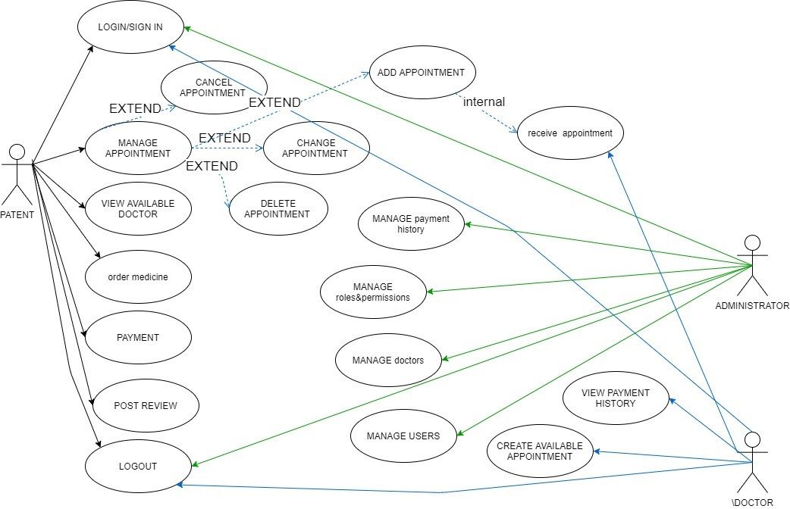

This is the high level use case that contain three types of actors:

1. ADMINISTRATOR: user has manage and control over the complete system.
2. DOCTOR: user who inherits some controls from administrator to perform certain activities.
3. PATENT: end user who would have access mobile services.
   1. **Functional Requirement**

|  |  |  |  |
| --- | --- | --- | --- |
| **REQ** | **Priority** | **Description** | **Impacted Stakeholders** |
| FR-001 | 2 | User can create account | Development team  Backend |
| FR-002 | 1 | User can filter by categories | Development team Backend  Designer |
| FR-003 | 1 | User can filter by city | Development team Backend  Designer |
| FR-004 | 1 | User can give permission for app to get his current location | Development team Backend  Google maps integration |
| FR-005 | 1 | User can view doctors list | Development team Backend  Designer |
| FR-006 | 1 | User can sort doctors by ( rate - distance ) | Development team Backend  Designer |
| FR-007 | 2 | User can view doctor details | Development team Backend  Designer |
| FR-008 | 1 | User can book appointment | Development team |
| FR-009 | 1 | User can select (date , time) of appointment | Development team Backend  Designer |
| FR-010 | 2 | User can view all his appointments | Development team Backend  Designer |
| FR-011 | 2 | User can confirm appointment | Development team Backend  Designer |

|  |  |  |  |
| --- | --- | --- | --- |
| **REQ** | **Priority** | **Description** | **Impacted Stakeholders** |
| FR-012 | 2 | User can receive SMS contains clinic details | Development team Backend  Designer  SMS provider |
| FR-013 | 1 | User can view list of medicine | Development team Backend  Designer |
| FR-014 | 2 | User can view medicine description | Development team Backend  Designer |
| FR-015 | 2 | User can filter medicine categories | Development team Backend  Designer |
| FR-016 | 2 | User can sort medicine by low price to high | Development team Backend  Designer |
| FR-017 | 1 | User can choose quantity of medicine | Development team Backend  Designer |
| FR-018 | 1 | User can order medicine | Development team  Backend |
| FR-019 | 1 | User can pay online or offline | Development team  Backend |
| FR-020 | 2 | Doctor can create account | Development team  Backend |
| FR-021 | 2 | Doctor can be notified with activating his account | Development team  Backend |
| FR-022 | 1 | Doctor can create available appointments | Development team  Backend |
| FR-023 | 1 | Doctor can receive appointments | Development team  Backend |
| FR-024 | 2 | Doctor can view payment history | Development team  Backend |

|  |  |  |  |
| --- | --- | --- | --- |
| **REQ** | **Priority** | **Description** | **Impacted Stakeholders** |
| FR-025 | 1 | Admin can manage another admins accounts | Development team  backend |
| FR-026 | 1 | Admin can manage roles and permissions | Development team  backend |
| FR-027 | 1 | admin can manage users | Development team  backend |
| FR-028 | 1 | Admin can manage doctors | Development team  Backend |
| FR-029 | 1 | Admin can manage specialties | Development team  backend |
| FR-030 | 1 | Admin can view appointments | Development team  backend |
| FR-031 | 1 | Admin can manage payment history | Development team  Backend |

* 1. **Non-Functional Requirements**

|  |  |
| --- | --- |
| **ID** | **Requirement** |
| NFR-001 | Usurers should be required to login to the application with e-mail and password |
| NFR-002 | The system should permit only authorized members who are on the list of authorized admins to do administrator’s task |
| NFR-003 | The system should display confirmation message to the users within 4 seconds after the user submits information to the system |
| NFR-004 | The error rate of users submitting their payment details at the checkout page mustn’t exceed 10 percent. |
| NFR-005 | The date format must be as follows: date.month.year. |
| NFR-006 | Security |
| NFR-007 | Reliability |
| NFR-008 | Performance |
| NFR-009 | Fast speed |

## USER SCREENS

SPLASH WELCOME

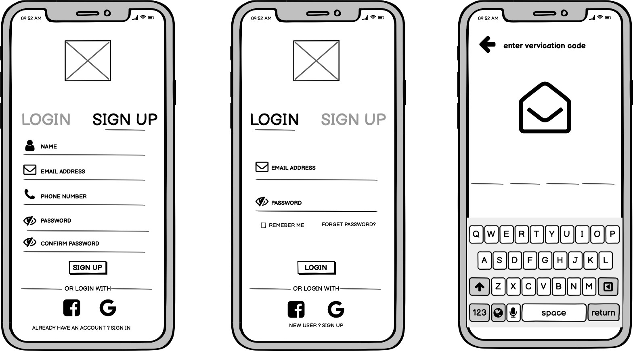

SIGN UP. LOGIN. OTP

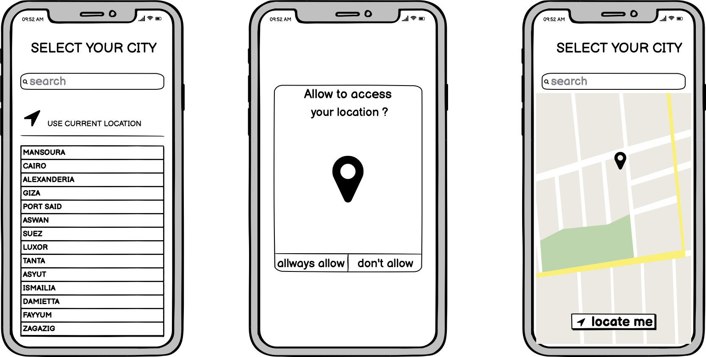LOCATION SCREENS

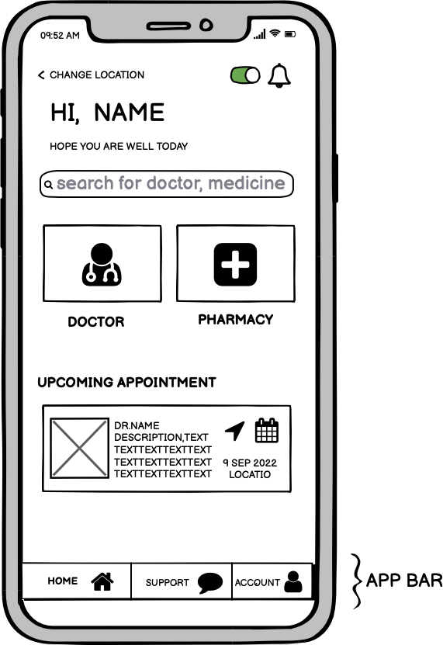 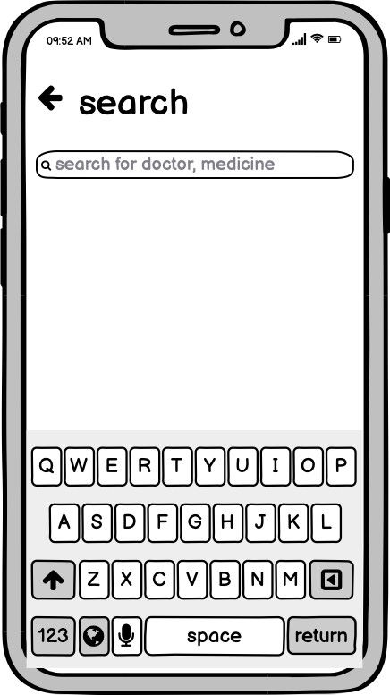 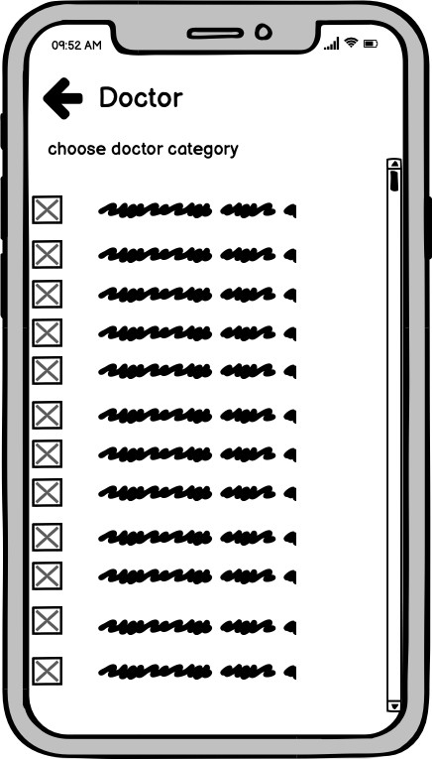

HOMEPAGE. SEARCH DOCTOR CATEGORIES AFTER SELECT DOCTOR

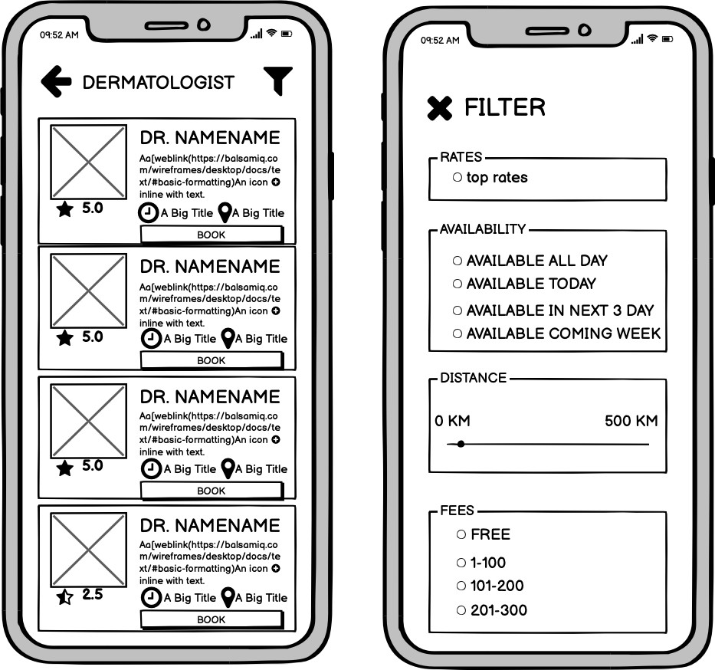

DOCTORS FILTERS

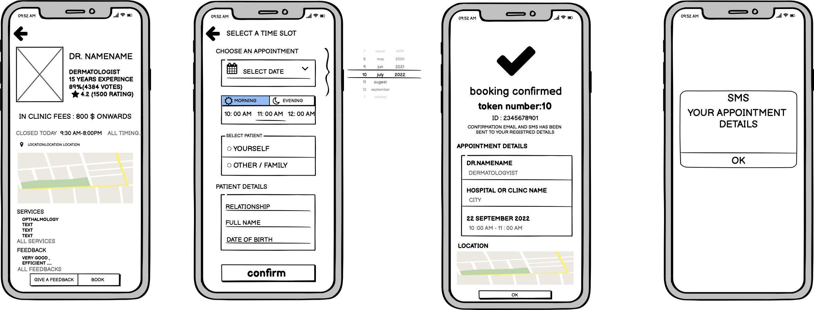

DOCTOR DETAILS DATE&TIME&INFO BOOKING CONFIRMED SMS MESSAGE DETAILS

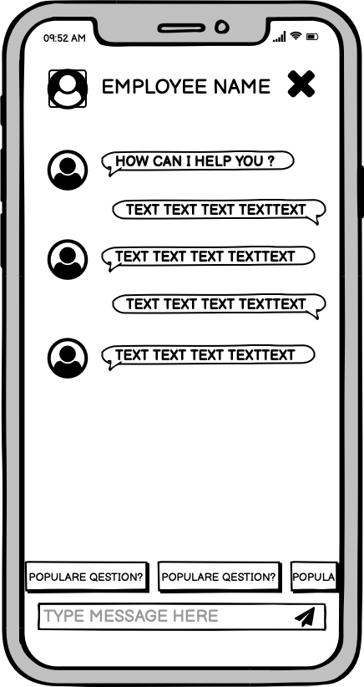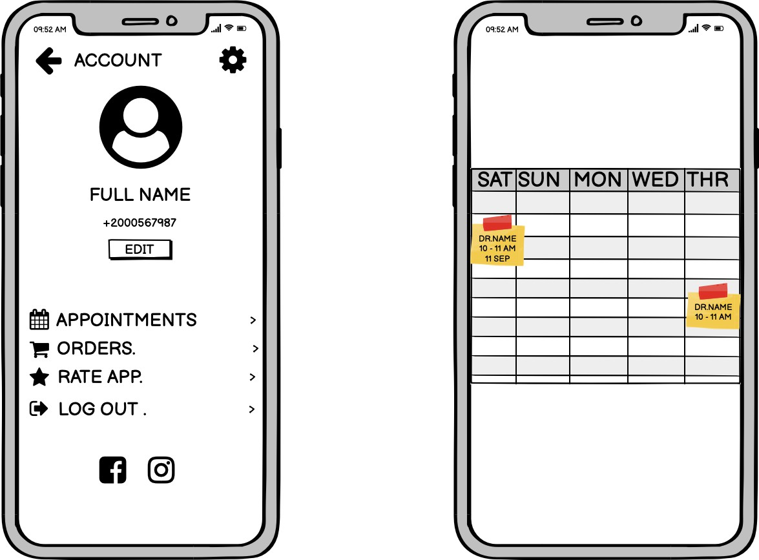

SUPPORT ACCOUNT APPOINTMENTS

MEDICINE CATEGORIES MEDICINES MEDICINE DETAILS

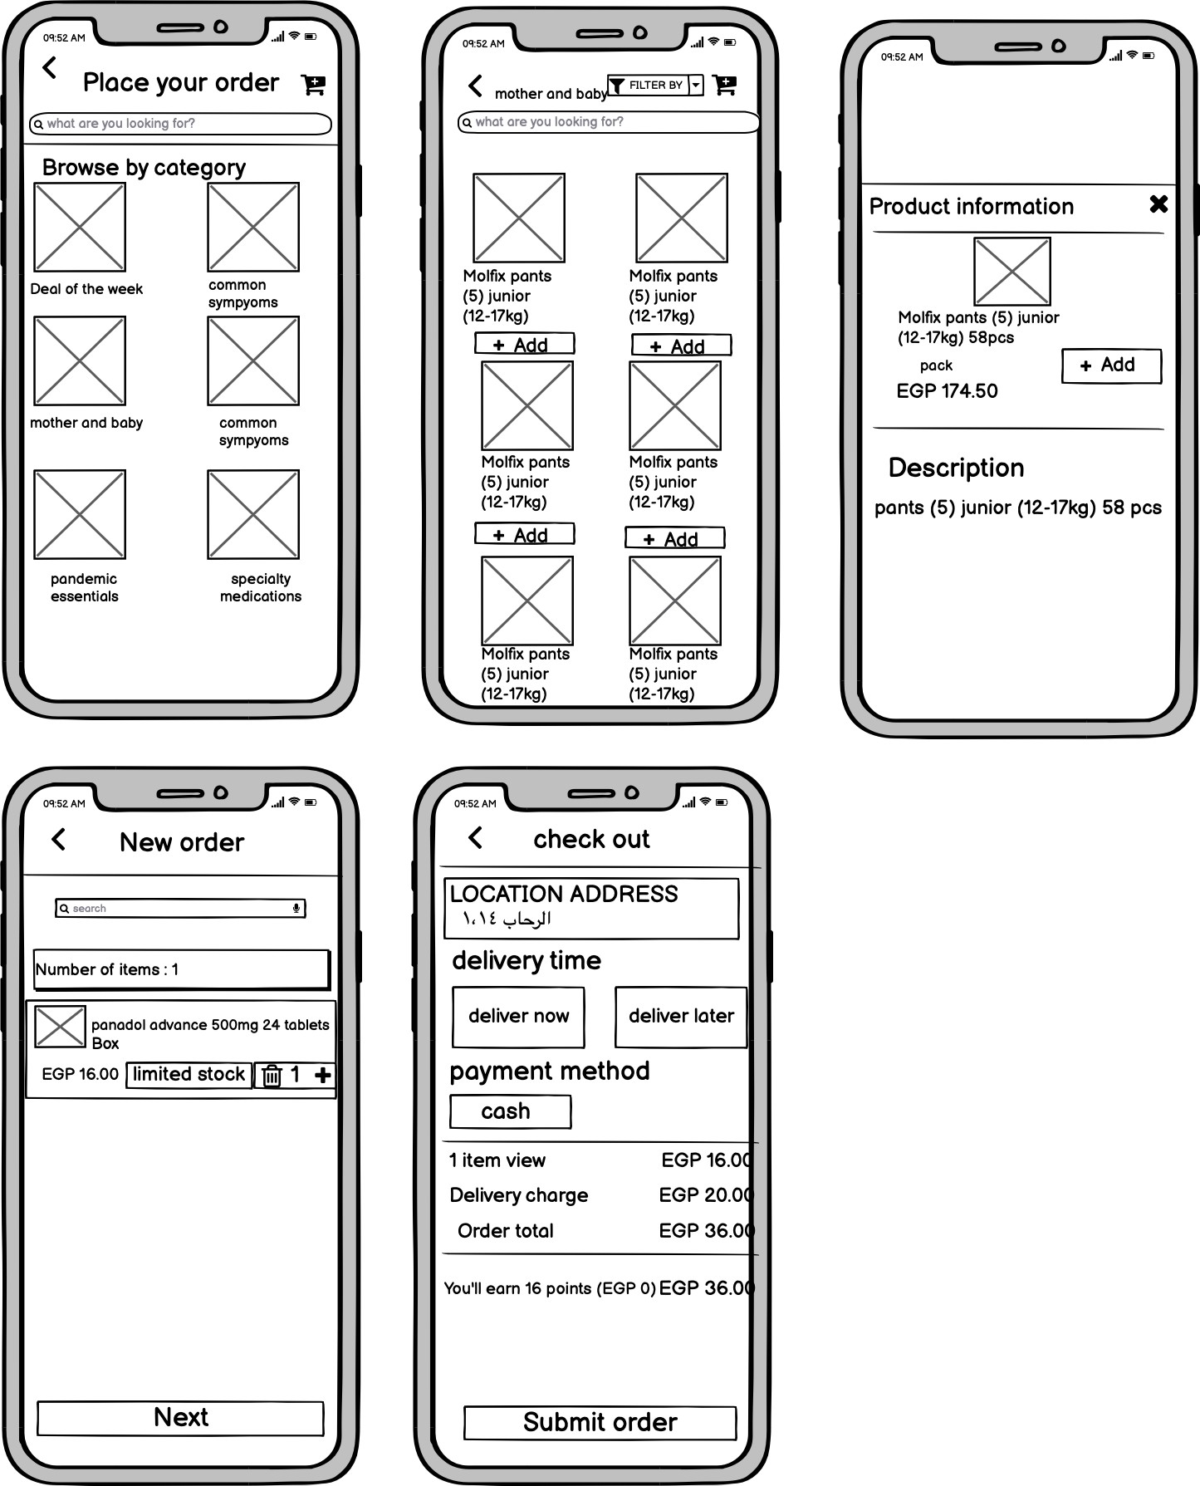

ORDER ORDER DETAILS

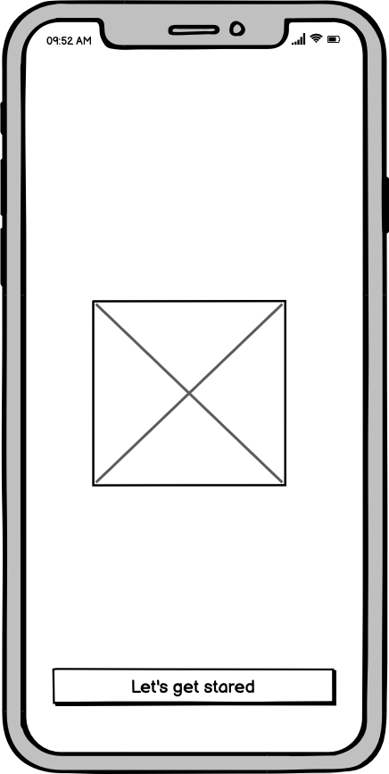SPLASH

## DOCTOR APP

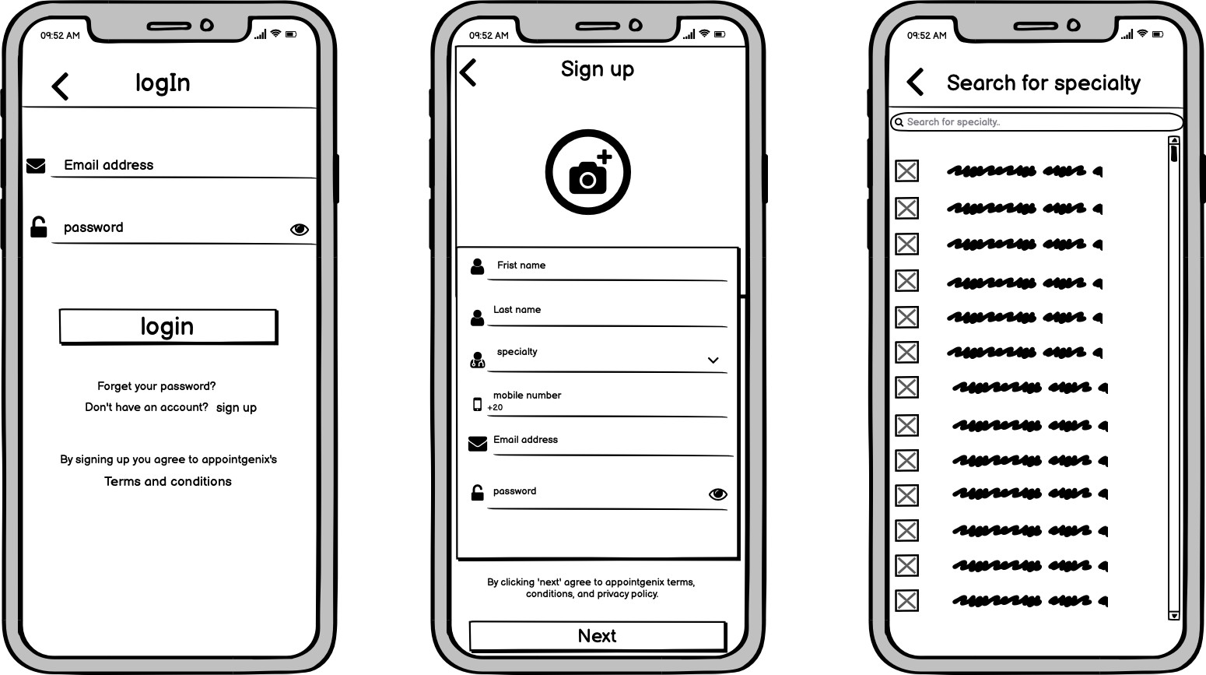

LOGIN SIGN UP DOCTOR SPECIALTY

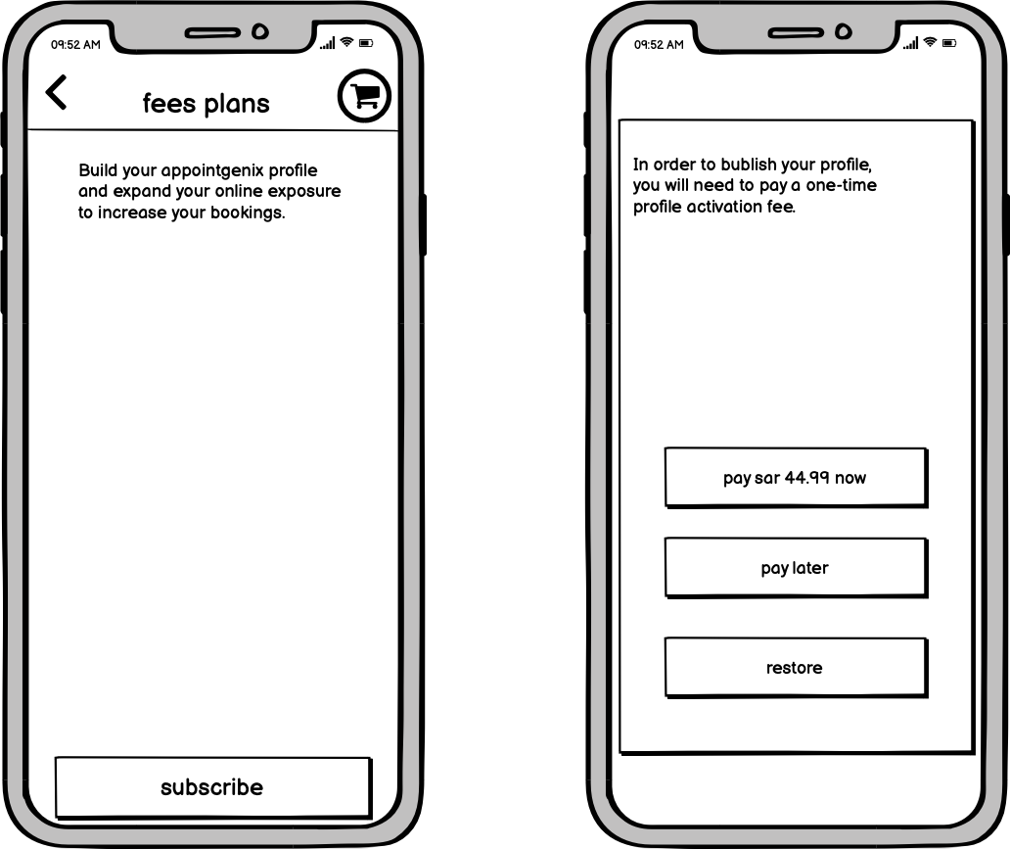

SUBSCRIBTION FEES

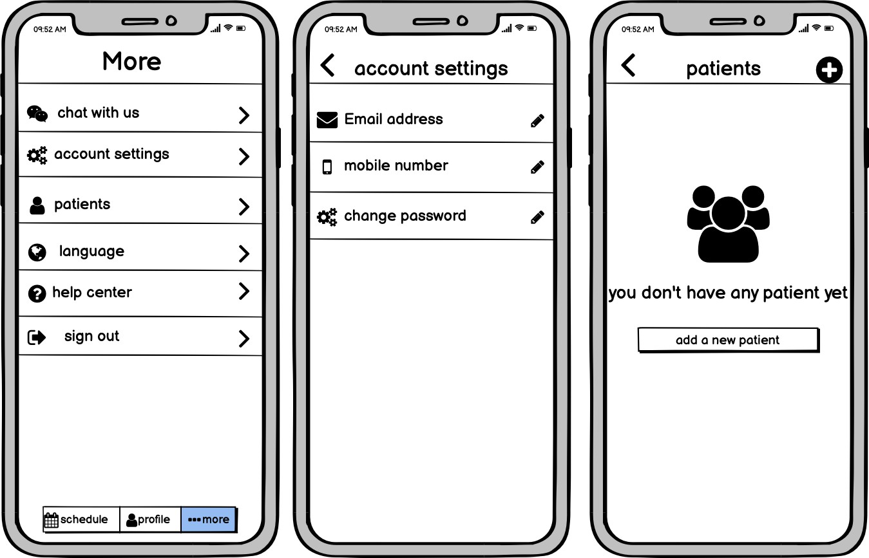

MORE PAGE ACCOUNT SITTING PATIENTS PAGE

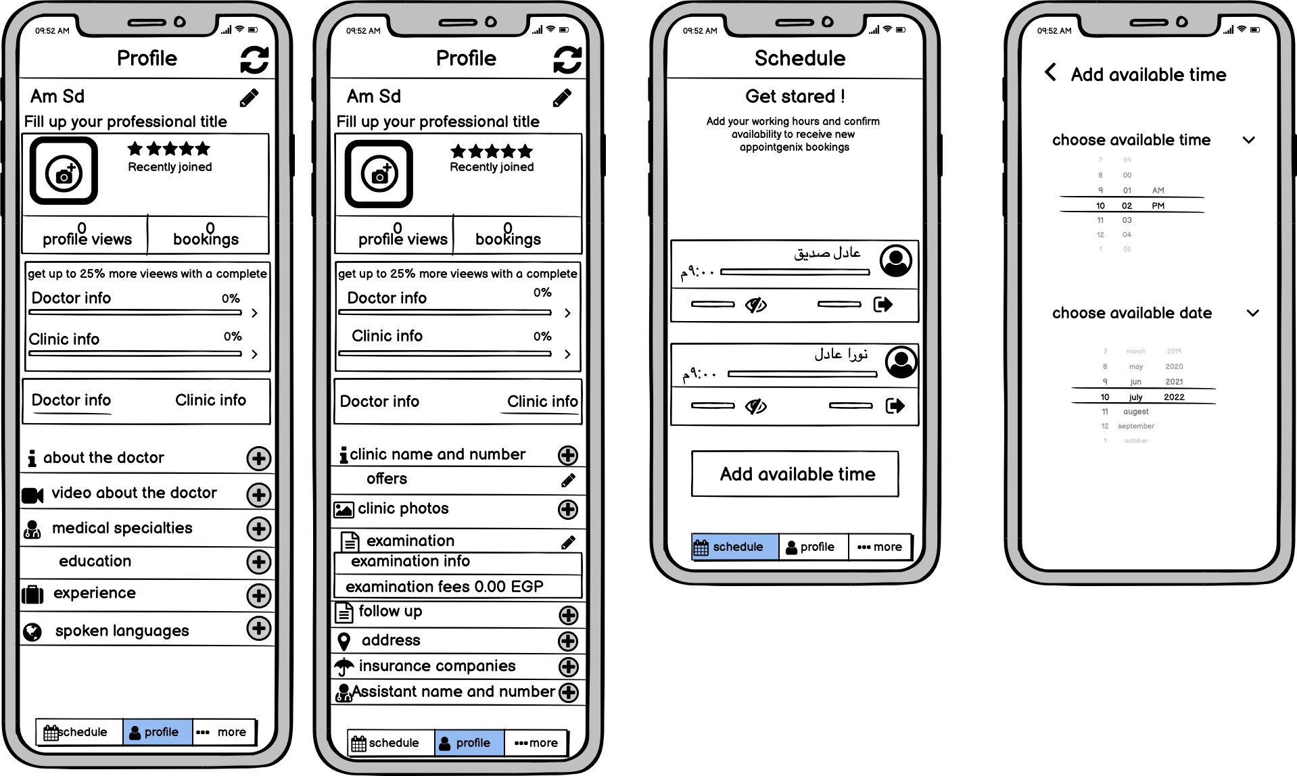

PROFILE INFORMATION SCHEDULE ( ADD AVAILABLE APPOINTMENT)

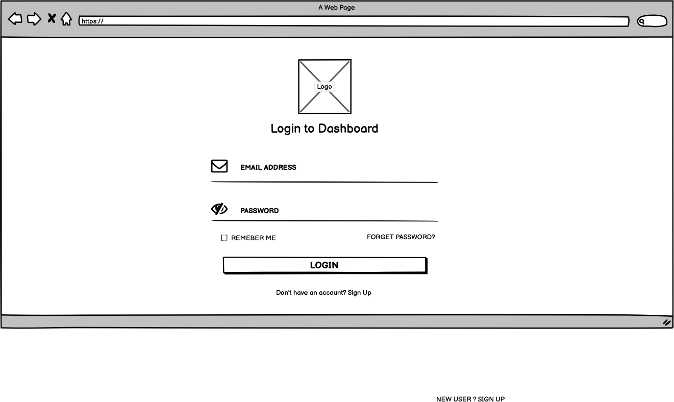

ADMIN LOGIN

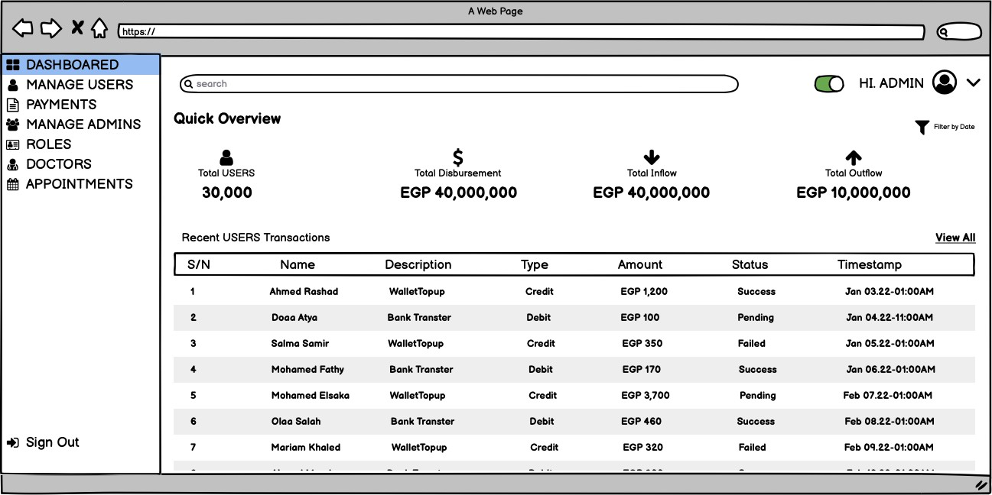

DASHBOARD

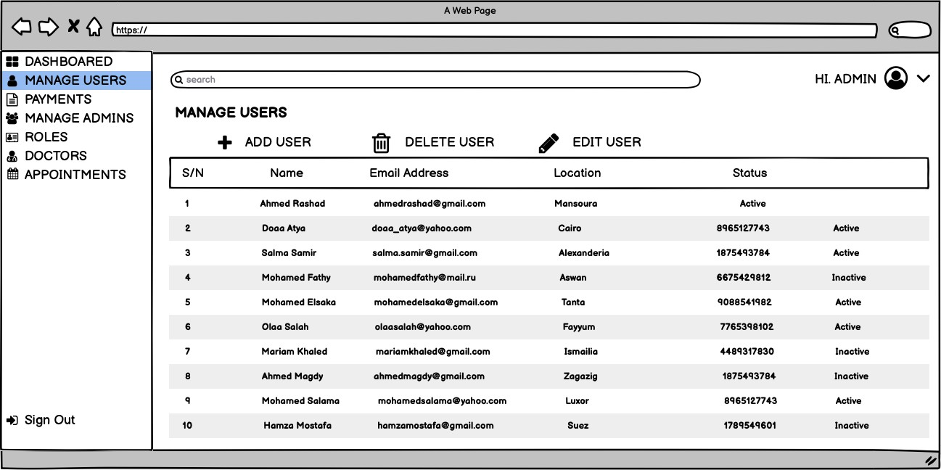

MANAGE USERS

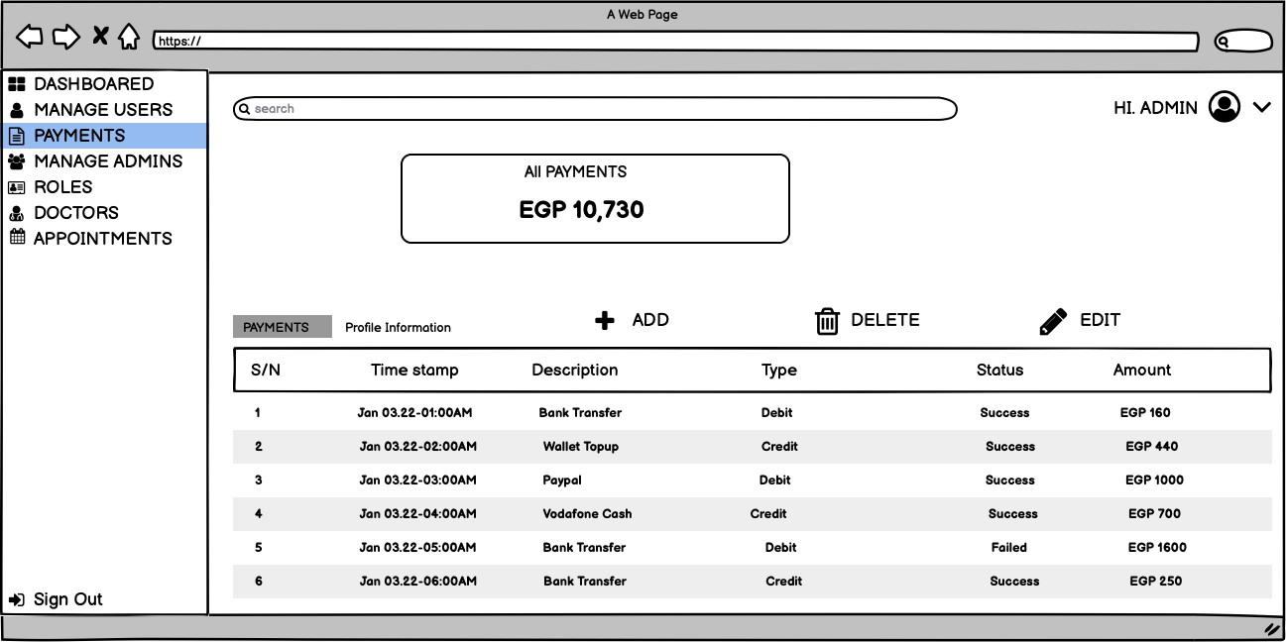

PAYMENTS

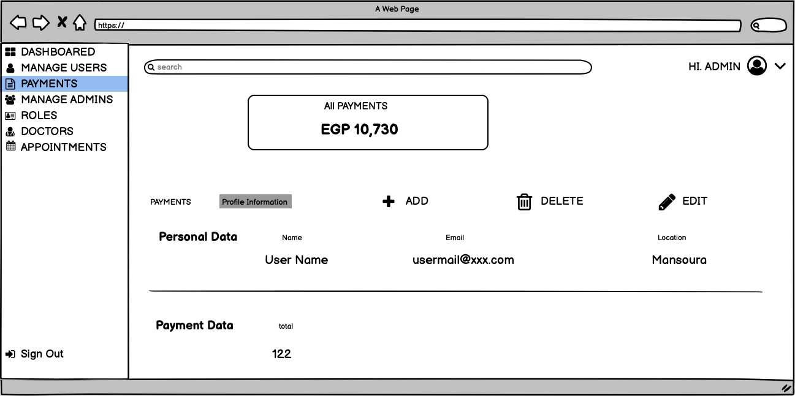

PAYMENTS DETAILS

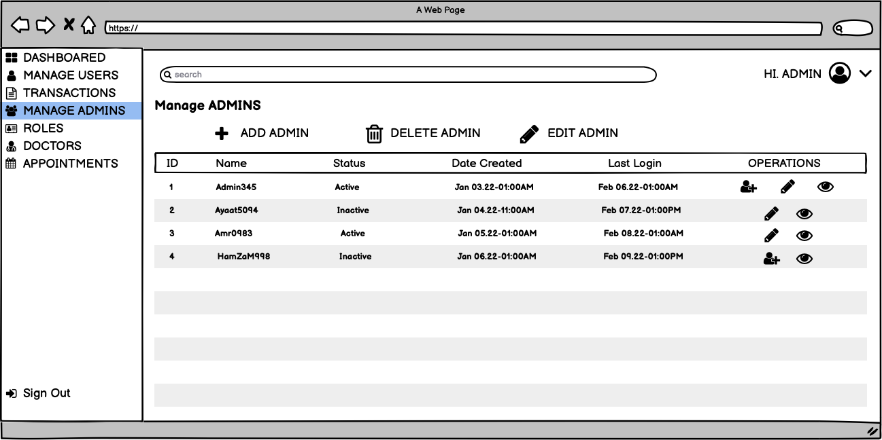

MANAGE ADMINS

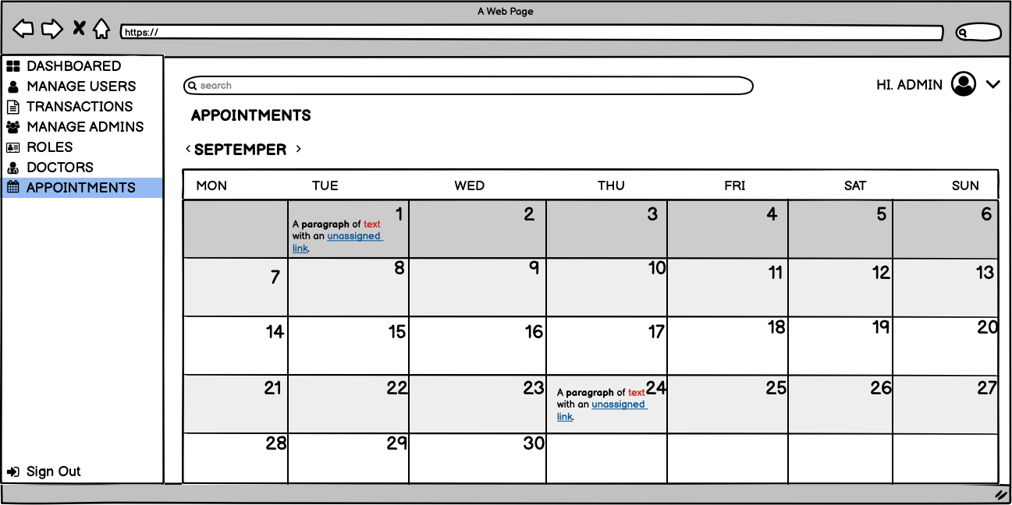

APPOINTMENS

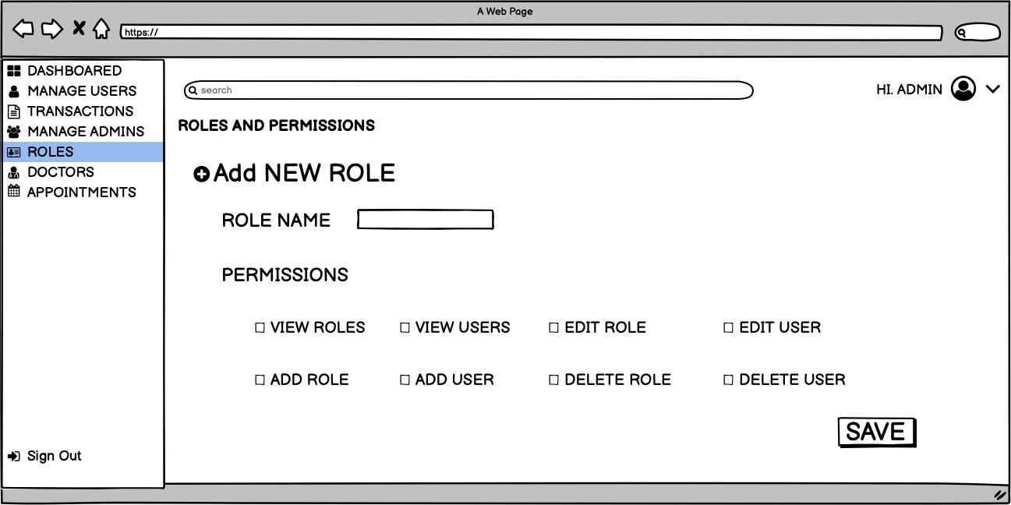

ROLES

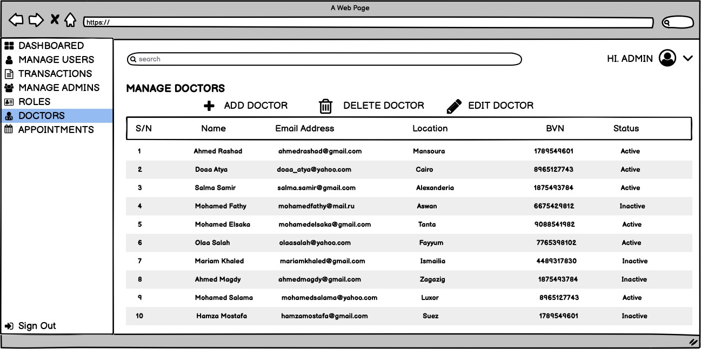

MANAGE DOCTORS