University of Tripoli
Faculty of Engineering
Computer Engineering Department

Fault Detection and Reliability Monitoring for a Newly Deployed
Weather Station Network in Libya

A project submitted in partial fulfillment of the requirements
for the bachelor’s degree in computer engineering

By:
Ayat Khalifa Elawej

Supervised by:
Dr. Ziad Elhajjaji
Dr. Dakhil Elgarwaly

2026

Fault Detection and Reliability Monitoring for a Newly Deployed Weather Station Network in Libya

By:
Ayat Khalifa Elawej

Approved by:
Dr. Ziad Elhajjaji
Dr. Dakhil Elgarwaly
Examiner: ______________________________
Examiner: ______________________________

Declaration
I hereby declare that this project report, “Fault Detection and Reliability Monitoring for a Newly Deployed Weather Station Network in Libya” submitted for the partial fulfillment of the requirements for the award of the Bachelor of Science degree in Computer Engineering from the Department of Computer Engineering at the University of Tripoli, is a bona fide work done by me under the supervision of Dr. Ziad Elhajjaji. It represents my own ideas in my own words, and where the ideas or words of others have been included, the original sources have been adequately cited and referenced.
I further declare that I have adhered to the principles of academic honesty and integrity, and have not misrepresented or fabricated any data, idea, fact, or source in this submission. I also declare that this work has not been previously submitted in support of another degree or qualification at this or any other university or institute of learning.

Ayat Khalifa Elawej
Date: ___/___/2026
Signature: ____________________

Abstract
This project develops a reproducible reliability-monitoring system for a 26-station personal weather-station network in Libya, using 166,017 hourly observations from 15 June 2025 to 30 June 2026 for development and a separately frozen July 2026 out-of-time test. The pipeline separates lifecycle states, extracts 2,398 full-outage events and 47 coordinated network windows, and extends availability monitoring with 803 partial-outage events covering 11,158 transmitting station-hours. A reproducible multi-label catalogue contains 4,799 fault-candidate episodes, including 1,121 evidence-supported faults, and supports hour-level fault detection with interpretable evidence. Histogram gradient boosting is the validation-selected operational detector; on 13,565 eligible July station-hours it achieved 0.714 precision, 0.813 recall, 0.761 F1, 0.936 accuracy, 0.977 AUROC, and 0.865 AUPRC without refitting. A transparent causal health score combines availability, completeness, fault burden, reference consistency, and stability into an auditable 0-100 measure. Frozen CatBoost residual policies forecast July health at 1, 3, 6, 12, and 24 hours, with MAE ranging from 1.378 to 6.619 and explicit comparison against persistence and deterministic roll-forward baselines. The resulting 80-field scorecard and read-only July replay dashboard integrate transmission state, health, forecasts, fault evidence, and reliability history. RGFN and mechanism reason codes are retained as development experiments rather than July deployment claims. Controlled hardware fault injection could not be performed because a station was not available for testing.

List of Abbreviations
Abbreviation | Full Meaning
API | Application Programming Interface
CSV | Comma-Separated Values
ECMWF | European Centre for Medium-Range Weather Forecasts
ERA5 | Fifth-generation ECMWF atmospheric reanalysis
F1 | Harmonic mean of precision and recall
GRU-D | Gated Recurrent Unit with Decay
RGFN | Reliability-Aware Gated Fusion Network (the custom model designed in this project)
UTC | Coordinated Universal Time

Contents
Declaration 2
Abstract 3
List of Abbreviations 4
List of Figures 8
List of Tables 10
Introduction 12
1.1 Motivation 12
1.2 Problem Statement 13
1.3 Objectives 13
1.4 Scope of the Project 14
1.5 Report Structure 14
Background and Theoretical Foundations 16
2.1 Technical Background 16
2.2 Tools and Technologies 17
2.3 Theoretical Concepts 17
Related Work 19
3.1 Previous Studies 19
3.2 Comparison with Existing Systems 20
3.3 Research Gap 21
Data Engineering and Reliability Foundations 22
4.1 System Overview and Requirements 22
4.1.1 Functional Requirements 24
4.1.2 Non-Functional Requirements 24
4.2 Data Sources and Hourly Dataset 24
4.3 Lifecycle States and Continuous Time Grid 25
4.4 Full, Partial, and Coordinated Outages 26
4.5 Feature Engineering and Fault Evidence 27
4.5.1 External and Spatial Context 27
4.5.2 Statistical Anomaly Features 28
4.5.3 Physical-Limit Features 31
4.6 Fault Taxonomy and Label Engineering 31
4.7 Transparent Station-Health Score 33
4.8 Data-Engineering Results and Discussion 36
4.8.1 Dataset Audit 36
4.8.2 Full and Partial Outage Results 37
4.8.3 Coordinated Network Events 41
4.8.4 Local Co-Occurrence Diagnostic 42
4.8.5 Statistical and Physical Evidence Results 43
4.8.6 Fault Label Results 45
4.8.7 External and Spatial Residual Results 47
4.8.8 Station-Health Score Results 50
Model Creation, Experiments, and Selection 55
5.1 Experimental Setup 55
5.2 Testing Procedure 55
5.3 Performance Metrics 55
5.4 Binary Fault Detection 57
5.4.1 Classical Baselines 57
5.4.2 Reliability-Aware Gated Fusion Network 57
5.4.3 Results and Final Binary-Detector Selection 57
5.5 Fault-Mechanism Reason Codes 61
5.6 Health-Forecasting Method 64
5.7 Health-Forecasting Results 65
5.8 Lag and Peer-Context Feasibility Test 72
5.9 Current Model Portfolio 72
Independent Testing and Validation 74
6.1 Evaluation Boundary 74
6.2 Frozen July Out-of-Time Evaluation 74
6.3 Controlled Hardware Fault Tests 77
6.4 Incident-Onset Forecasting Investigation 77
6.5 Validation Status Summary 80
Deployment, Dashboard, and MLOps 81
7.1 Operational Scorecard 81
7.2 Implementation and Reproducibility 81
7.3 Operational Scorecard Results 83
7.4 Dashboard 86
7.5 API and Roaya Integration 86
7.6 MLOps Controls 86
Integrated Discussion 87
8.1 Main Findings Across the Four Project Parts 87
8.2 What the RGFN Experiment Shows 87
8.3 Limitations 87
8.4 Operational Readiness 88
Conclusion and Future Work 89
9.1 Conclusion 89
9.2 Future Work 89
References 90
Appendices 92
Appendix A: Artifact Inventory 92

List of Figures
Figure 1.1. Geographic distribution of the 26-station Libyan network 12
Figure 1.2. Four-part project lifecycle used to organise the report and the implementation work 15
Figure 4.1. End-to-end reliability-monitoring architecture from observed station-hours to outage state, fault evidence, health, forecast, and operational scorecard 23
Figure 4.2. Exclusive lifecycle-state assignment for each observed station-hour 25
Figure 4.3. Full and partial outage construction on a continuous station-hour grid 27
Figure 4.4. Causal health-score composition from five bounded components 35
Figure 4.5. Weekly observed coverage by station across the frozen interval 36
Figure 4.6. Measurement missingness conditional on present station-hours 37
Figure 4.7. Full-outage availability by station 39
Figure 4.8. Daily mean fraction of stations offline 41
Figure 4.9. Repeated-zero wind evidence at ITRIPO33 43
Figure 4.10. Detector-fire rate by station and evidence group 44
Figure 4.11. Verified fault-evidence examples for stuck wind and impossible precipitation 45
Figure 4.12. Multi-label mechanism and component counts in the canonical 1,121-fault population 46
Figure 4.13. Trigger composition of the 177 spike-impossible episodes 47
Figure 4.14. Confirmed Layer 2 sustained-offset runs and their promotion status 49
Figure 4.15. Distribution of final causal station-health scores across all numeric station-hours 50
Figure 4.16. Distribution of the five health components after causal preprocessing 51
Figure 4.17. Correlation among final health components 52
Figure 4.18. Contrasting station-health trajectories 53
Figure 4.19. IDERNA7 health during a verified 814-hour outage and first recovery hour 54
Figure 5.1. Hour-level target composition across all 166,017 observed station-hours 58
Figure 5.2. Held-out retrospective test F1 for all predefined detector configurations 59
Figure 5.3. Validation-only operating-point selection followed by one held-out test evaluation 60
Figure 5.4. Residual health-forecasting pipeline 65
Figure 5.5. Primary forecast MAE against persistence and no-new-incident roll-forward at each horizon 67
Figure 5.6. Observed versus predicted health by forecast horizon 69
Figure 5.7. Regression and band-classification performance across 1-24 hours 71
Figure 5.8. Task-specific model portfolio showing the current selected models and the role of the custom architecture 73
Figure 6.1. Selected HGB evaluation summary: class distribution, confusion matrices, and threshold-independent ROC and precision-recall curves for the development held-out test and independent July test 75
Figure 6.2. Frozen July health-forecast MAE against persistence and no-new-incident roll-forward 76
Figure 7.1. Operational deployment and MLOps flow from source data to the dashboard and API 81

List of Tables
Table 2.1. Network and dataset summary 17
Table 4.1. Functional requirements 24
Table 4.2. Non-functional requirements 24
Table 4.3. Row-state taxonomy 25
Table 4.4. Sensor-group membership used for partial-outage classification 26
Table 4.5 Statistical anomaly detectors and the faults they target 29
Table 4.6 Fault mechanism labels 32
Table 4.7. Causal station-health components, weights, and evidence windows 33
Table 4.8. Progressive outage-duration multipliers used by the health score 35
Table 4.9 Status-class distribution from the June 2026 dataset audit 36
Table 4.10 Verified examples from the canonical dataset 37
Table 4.11 Outage-duration distribution from the June 2026 availability engine 38
Table 4.12 Outage-class distribution from the June 2026 availability engine 39
Table 4.13. Partial-outage event durations among transmitting hours 40
Table 4.14. Sensor-group availability conditional on station transmission 40
Table 4.15 Summary of coordinated network-outage windows 41
Table 4.16 Scope of the local co-occurrence diagnostic 42
Table 4.17 Statistical evidence funnel for the canonical label build 43
Table 4.18 Fault episodes by canonical mechanism and component labels. Counts are multi-label and are not mutually exclusive 46
Table 4.19 Confirmed Layer 2 sustained-offset runs and label resolution 48
Table 4.20. Effect of replacing the full-outage hard zero with progressive duration degradation 53
Table 5.1 Hour-level dataset composition and training use 58
Table 5.2 Hour-level binary fault-detection results. All operating points were selected on validation data 59
Table 5.3 RGFN configurations: validation selection and held-out retrospective test metrics 61
Table 5.4 Validation-only selection of the spaced mechanism reason-code configuration. Macro values are precision, recall, F1, and accuracy 62
Table 5.5 Retrospective event-level mechanism reason-code comparison under the predefined any-hour aggregation rule 63
Table 5.6 Held-out spaced event-level result by mechanism for the frozen validation-selected gradient-boosted any-hour configuration 63
Table 5.7. Primary transmitting-origin health forecasts and deterministic baselines 66
Table 5.8. Validation-selected transmitting-origin health-forecast configurations 68
Table 5.9. Health-band classification on transmitting origins 70
Table 5.10. Supplementary full-outage-origin health forecasts 72
Table 5.11. Direct classification of a health deterioration of at least five points 72
Table 6.1. Selected HGB development and frozen July evaluation. Counts, threshold-dependent metrics, and threshold-independent discrimination are reported together 74
Table 6.2. Frozen July transmitting-origin health forecasts and deterministic baselines 76
Table 6.3. Qualitative summary of incident-onset forecasting approaches investigated 78
Table 7.1. Implemented work areas, front doors, and primary artifacts used by this report 82
Table 7.2. Latest 26-station operational snapshot, sorted by health 83
Table 7.3. Latest operational scorecard distribution 85
Table 7.4. Causal persistent pressure-offset evidence in the latest scorecard 85
Chapter 1

Introduction
Personal weather stations can provide dense, low-cost weather observations in places where official observing networks are sparse. In Libya, a newly deployed network of 26 personal weather stations provides public weather observations for operational and humanitarian use cases. The network is valuable because it improves local situational awareness, but it is also vulnerable because the stations are commercial devices installed in real homes and rooftops rather than controlled research environments. Fault detection is therefore a necessary part of making the network reliable.
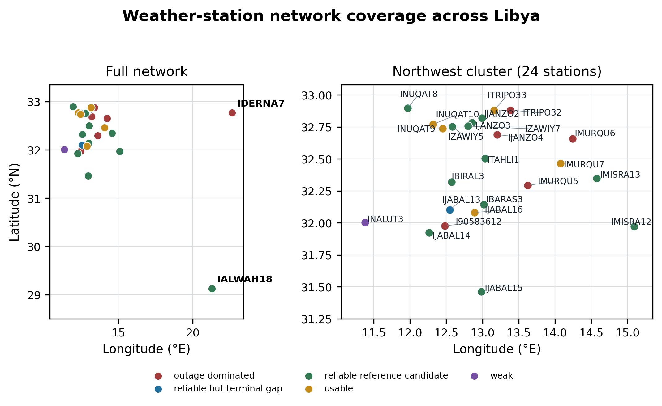
Figure 1.1. Geographic distribution of the 26-station Libyan network; the uneven spacing explains why spatial corroboration is available for most stations but unavailable for IALWAH18 and IDERNA7.
This project builds an auditable hour-level reliability-monitoring system for the 26 stations. It separates full transmission loss from partial sensor-group loss, records the evidence behind each fault label, evaluates binary fault detection, defines a causal station-health score, forecasts that score over five operational horizons, and joins the outputs into a station-level scorecard. A compact Streamlit dashboard replays the independent July period and exposes network state, station health, forecasts, and detector evidence without retraining or reading ground-truth episode identifiers.

1.1 Motivation
The problem was discovered during an earlier project by the same author. The Mozn post-processing system [7] is an open-source forecast-bias-correction system built on the same 26 stations. During its development, several stations showed problems that could not be explained by weather: persistent pressure offsets, long availability losses, repeated zero-wind readings, and impossible rainfall values. These observations motivate a separate reliability question: whether a station-hour should be trusted before it is used downstream.
The project is motivated by a practical reliability problem: a weather station that is offline is easy to detect, but a weather station that is online and reporting plausible-looking wrong values is much more dangerous. Downstream users may trust the data even when the station is affected by a stuck wind sensor, calibration drift, partial sensor dropout, or an upload-side anomaly.
The frozen record contains faults that simple range checks cannot catch. Verified examples include an 83-hour repeated-zero wind run at ITRIPO33, sustained pressure-offset runs found through external comparison, an 814-hour outage at IDERNA7, and impossible rainfall at IMURQU7. The analysis therefore combines temporal, contextual, reference, spatial, and missingness evidence rather than treating any individual rule as conclusive.
The network also supports public-good use cases such as forecasting, agriculture, and emergency response. In that context, reliability monitoring is not just a software feature; it is part of making the dataset safe to use. Figure 1.1 shows the network’s wide and uneven geographic coverage.

1.2 Problem Statement
The project addresses a newly deployed network of 26 personal weather stations across Libya, installed on homes and private buildings as part of a UNICEF-supported monitoring initiative. Because of where and how they are installed, the stations are exposed to power cuts, internet problems, weak communication, imperfect installation, and harsh environmental conditions. The data shows the consequences. Some stations go fully offline for long periods. Some stay online with whole sensor groups missing. Some sensors report spikes, repeated values, long zero-wind periods, strange wind-direction behavior, and unusual pressure changes. An offline station is easy to notice. A station that keeps reporting wrong values is not, and it silently poisons every downstream use of the data: monitoring, forecasting support, and early warning.
The problem is made harder by the absence of perfect fault ground truth. External weather models are useful but locally biased, so disagreement is evidence rather than proof. Nearby stations offer local context but can fail together, and two stations have no nearby neighbour. Missing data is itself part of the reliability signal. The project therefore uses the network’s own history together with imperfect external and spatial references to estimate whether a station-hour should be treated with caution and to retain the evidence behind that judgment.

1.3 Objectives
The objectives of the project are:
- Build a clean, reproducible hourly dataset covering all 26 stations.
- Detect full outages, identify coordinated network-wide windows, and quantify uptime, downtime, outage count, and duration.
- Detect partial outages in which a station still transmits while one or more physical sensor groups are absent.
- Detect suspicious sensor behaviour such as impossible spikes, stuck values, statistical anomalies, calibration offsets, and partial sensor failure.
- Compare station readings with external and nearby-station references while retaining uncertainty about reference error.
- Compare classical baselines with a custom Reliability-Aware Gated Fusion Network, then select the strongest validated model for current fault detection and diagnosis.
- Define an explainable causal 0-100 station-health score and forecast it at 1, 3, 6, 12, and 24 hours for transmitting stations.
- Integrate transmission, health, forecast, fault-evidence, and reliability-history fields into a parameterised 26-station operational scorecard.
- Complete a frozen July evaluation and a replay dashboard as the main independent test and deployment demonstration when direct live access is unavailable; document controlled station testing as an unresolved validation limitation.

1.4 Scope of the Project
The project scope is the 26-station Weather Underground personal weather-station network deployed across Libya. The frozen analysis interval is 15 June 2025 through 30 June 2026. Its canonical hourly record contains 166,017 observed station-hours and 41 columns; continuous-grid availability and health processing operates on an expanded 169,655-row grid, of which 1,454 rows are the materialised structural gaps described in Section 4.4. Delivered subsystems are dataset audit, lifecycle classification, full and partial outage classification, network-wide outage analysis, statistical, physical, external, and spatial evidence construction, multi-label episode labelling, retrospective binary detection and mechanism diagnosis, a causal station-health score, five-horizon health forecasting for transmitting stations, and the operational scorecard.
The report evaluates the detector, RGFN, and event-level reason codes retrospectively during development. The separately frozen July out-of-time test is intentionally limited to the validation-selected operational HGB detector and the selected health forecasts. Health-forecast configuration and shrinkage choices were made during development and then frozen before July. The completed dashboard is a read-only chronological July replay, not a live station integration. Controlled hardware disconnections are not claimed because a station was not available for testing.
The project does not attempt to replace national meteorological instrumentation or claim that personal weather stations are research-grade instruments. Instead, it focuses on making an existing low-cost network more trustworthy by identifying when its data should be treated with caution.

1.5 Report Structure
Chapter 2 explains the technical background, and Chapter 3 reviews related work. Chapter 4 presents data engineering and the reliability foundations. Chapter 5 presents model creation, experiments, and selection. Chapter 6 covers independent testing and validation. Chapter 7 describes deployment, the dashboard, and MLOps. Chapter 8 provides an integrated discussion, and Chapter 9 gives the conclusion and future work.
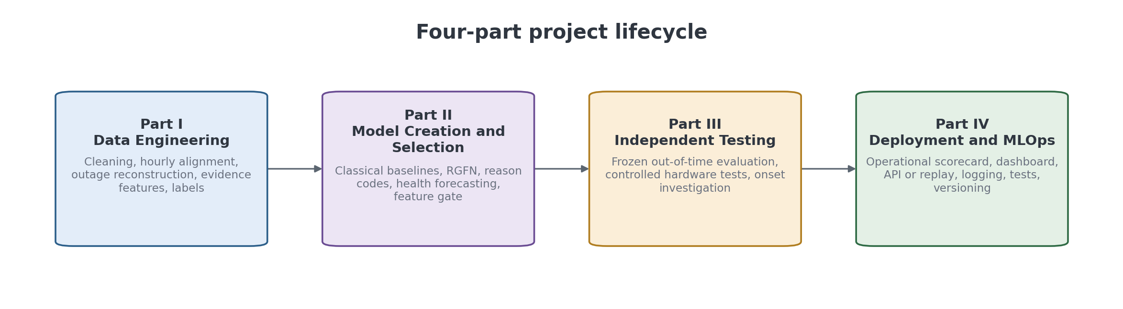
Figure 1.2. Four-part project lifecycle used to organise the report and the implementation work.

Chapter 2

Background and Theoretical Foundations
This chapter explains the technical ideas needed to understand the project. It introduces the station network, time-series processing, anomaly detection, machine-learning models, and reliability monitoring. Missing values are not treated only as a cleaning problem; they are also useful evidence about station condition.

2.1 Technical Background
The deployed devices are Sainlogic FT0360 Pro WiFi personal weather stations. Each station includes an outdoor sensor array and an indoor console that uploads observations to Weather Underground. The network is administered through a shared Weather Underground account, while station uploads use station-specific credentials. The account-level API key is used for data retrieval, not for uploads.
The stations are distributed across Libya. Twenty-four stations are located in the northwest region, including Tripoli, Misrata, Zawiya, Janzour, Jabal al Gharbi, and Nuqat al Khams. Two stations are geographically isolated in the southeast and east: IALWAH18 in Awjila and IDERNA7 in Derna. This distribution matters because neighbor-based quality control is strong in the dense northwest cluster but weak for isolated stations.
The dataset is hourly. Raw observations from Weather Underground are bucketed into hourly bins, where observations time-stamped HH:MM:SS are assigned to the next hour if the minute value is greater than 30. This convention is important when interpreting outage start times because a physical drop near the end of an hour can appear as a missing hourly bin in the following hour. Table 2.1 summarises the network and frozen dataset contract used throughout the analysis.
Common fault types in this network include complete outages, partial missingness, flatlined sensors, stuck wind sensors, calibration offsets, calibration drift, unstable sensors, and impossible rainfall values. Several of these faults are individually plausible at the single-value level but impossible when viewed across time or compared with references. For this reason, the project uses a hybrid detection design rather than a single range validator.
Table 2.1. Network and dataset summary.
Item | Value
Network size | 26 personal weather stations
Device model | Sainlogic FT0360 Pro WiFi
Deployment context | Roaya humanitarian weather-station initiative with UNICEF support
Upload platform | Weather Underground
Frozen data window | 15 June 2025 to 30 June 2026
Hourly rows | 166,017 station-hours
Full-station hourly span | 9,144 timestamps across the frozen window
Schema size | 41 columns; original names preserved
Geographic pattern | 24 northwest stations; IALWAH18 and IDERNA7 spatially isolated
Local time convention | UTC for analysis; Libya UTC+2

2.2 Tools and Technologies
The project is implemented as a Python-based data and machine-learning pipeline. It uses Parquet and CSV artifacts, Python source modules, automated tests, and static figures. Source acquisition is separated from the analysis workflow; the reproducible research artifacts begin with the canonical hourly station record.
External weather references come from Open-Meteo archive data derived from ECMWF products. The Mozn post-processing system introduced in Chapter 1 provides reusable utilities with attribution, including the station registry, the Open-Meteo data cache, a rate-limited Open-Meteo fetcher, and several feature-building utilities. The forecasting models and evaluation pipelines from that project are not copied, because forecast bias correction and fault detection are different problems.
The repository records a clean hour-level analysis path, canonical labels, generated evidence, automated tests, and a repository map so that the reported artifacts can be inspected and regenerated from the frozen data window.

2.3 Theoretical Concepts
Several concepts are central to the project methodology:
- Lifecycle labeling: each station-hour is assigned one of five row states: online complete, online partial missing, true outage candidate, warmup, or terminal padded absence.
- Run-length event extraction: consecutive outage-candidate hours are grouped into single events so that a 34-day blackout is treated as one outage event rather than hundreds of independent hours.
- Residual analysis: a station reading is compared with an external reference or neighbor median. A residual is evidence of disagreement, not proof of error by itself.
- Spatial comparison: neighboring stations provide a local consistency check, especially in dense station clusters.
- Missingness-aware modeling: absence itself carries information. Models such as GRU-D use missingness masks and learned decay to represent this [1]; the custom model in this project adopts the same principle in lighter form, feeding missingness masks and a time-since-last-observation signal into its temporal branch without the trainable decay of the original, since the mask and elapsed-time inputs already give the network the information it needs.
- Imbalanced evaluation: normal hours dominate the detection dataset, so accuracy is reported alongside precision, recall, and F1 rather than interpreted alone. The fault class forms 5.58% of all station-hours.
Chapter 3

Related Work
Fault detection in personal weather station networks overlaps with four areas of prior work: quality control for crowdsourced and citizen weather observations, fault taxonomies for deployed sensor networks, anomaly detection for imbalanced time series, and modelling under structured missingness. This chapter positions the project relative to those areas and explains the gap addressed by the Libya deployment.

3.1 Previous Studies
Crowdsourced and personal weather station networks are known to be noisy because installations vary in siting, exposure, maintenance, and sensor quality. Vos et al. studied the potential of urban rainfall monitoring using crowdsourced personal weather stations and showed that such networks can be useful but require careful quality control [3]. This project follows the same general motivation: low-cost dense observations are valuable only if unreliable measurements are detected and handled.
The reliability of privately owned stations has been examined directly. Bell, Cornford, and Bastin assessed citizen weather stations against professional references and found that station quality varies widely but that a substantial share of stations is usable once poor performers are identified [15]. That conclusion motivates the station-status classification used here, in which stations are graded as reference candidates, usable, weak, or outage dominated rather than accepted or rejected as a block.
Several established quality-control systems for such networks operate mainly on spatial agreement. Napoly, Grassmann, Meier, and Fenner developed CrowdQC, a statistically based procedure that flags suspect air-temperature values without requiring an official reference network [12], and Fenner and colleagues extended it as CrowdQC+ to address radiative errors and sensor response time [13]. Beele and colleagues combined quality control with correction for a citizen network in Leuven [16]. Baserud and colleagues describe TITAN, an operational system built from a sequence of tests, several of which rely on spatial consistency between nearby observations [14]. These systems are effective where stations are dense. The Libyan network is not dense: 24 of 26 stations sit in the northwest cluster, while IALWAH18 and IDERNA7 have no usable neighbours. Spatial agreement is therefore available as one evidence channel among several rather than as the primary test, and the evidence design in this project weights external reference residuals and station-specific history more heavily than neighbour comparison.
Fault taxonomies for deployed sensor networks provide the vocabulary used in Chapter 4. Ni and colleagues catalogue the fault types observed in real deployments, including spike, stuck-at, offset or bias, and noise faults, and model them from the features that expose them [10]. Sharma, Golubchik, and Govindan measure how often such faults actually occur in real-world sensor datasets and compare detection methods for them [11]. The four mechanisms adopted here map onto that vocabulary: spike_impossible corresponds to spike and out-of-bounds faults, stuck_flatline to stuck-at faults, calibration_offset to offset or bias faults, and statistical_anomaly to the residual category that is detectable only against a station's own history. Adopting an established taxonomy rather than inventing one keeps the labels comparable with prior sensor-network work.
For missing time-series data, Che et al. introduced GRU-D, a recurrent neural network architecture that explicitly incorporates missingness masks and learned decay mechanisms [1]. The original application was medical time series, but the same modeling issue appears in weather station data: missingness is not random noise, and long gaps should influence the model. This project does not adopt GRU-D directly. Instead, it borrows the missingness-mask idea inside a custom fusion architecture designed for this network (Section 5.4.2), so GRU-D serves here as related work and as a design reference.
For anomaly detection evaluation, Liu and Paparrizos note that common benchmark and metric choices can be misleading, especially with highly imbalanced datasets [2]. This is relevant because most station-hours are not faults. The project therefore reports precision, recall, F1, and accuracy together, while treating accuracy cautiously in the presence of class imbalance.

3.2 Comparison with Existing Systems
Simple range validators check whether a reading falls within broad physical limits, such as rejecting negative pressure or impossible temperatures. Such validators are necessary but insufficient. They cannot detect values that are plausible in isolation but impossible as a pattern, such as a wind sensor reporting zero for nine days while neighboring stations record normal wind, or a pressure sensor holding a fixed offset from its peers.
The spatial quality-control systems discussed above differ from this project in output as well as method. CrowdQC, CrowdQC+, and TITAN return a per-observation accept or reject decision, which suits gridding and assimilation, where the goal is a clean field. An operator maintaining physical hardware needs a different output: which station is degraded, since when, which sensor group is implicated, and whether the condition is worsening. This project therefore aggregates hour-level decisions into events, attaches mechanism and component evidence, and reduces the result to a station-level condition score and band, so the deliverable is a maintenance signal rather than a filtered dataset.
Weather Underground provides the upload and retrieval platform, but it is not designed as a full reliability-monitoring system for this project network. The outage investigation also shows that some missing-data patterns are likely related to upstream platform behavior rather than local station faults. A project-specific outage_class taxonomy is therefore required so that station-attributable faults can be separated from coordinated network-wide artifacts.
The Mozn post-processing system (Chapter 1) solves a different problem: forecast bias correction. It predicts what a station should read given ECMWF forecasts and recent station history. This project asks whether the station-hour should be trusted at all. The two systems can share selected data utilities, but their labels, evaluation criteria, and downstream outputs are different.

3.3 Research Gap
The gap addressed by this project is the absence of a reliability-monitoring pipeline tailored to a newly deployed, low-cost, geographically uneven weather station network in Libya. Existing quality-control ideas are useful, but this network has specific characteristics: strong missingness, station-specific behavior, two isolated stations with no useful neighbors, coordinated Weather Underground outage patterns, and limited ground truth for non-outage faults.
Three properties of this deployment fall outside the assumptions of the systems reviewed above. The network is sparse and geographically uneven, so spatial consistency testing is unavailable for two stations and weak for several more. Availability loss is itself a first-class failure mode, including partial loss in which the console continues to transmit while an outdoor sensor group is absent, which value-based quality control does not observe at all. Finally, coordinated platform-wide gaps must be separated from station-attributable faults, otherwise upstream behaviour is recorded as hardware failure. The pipeline described in Chapter 4 addresses these three properties directly.
The contribution is an auditable reliability-monitoring workflow for a geographically uneven Libyan station network. It combines full and partial availability events, interpretable statistical evidence, external and spatial context, reproducible multi-label episode labels, a custom missingness-aware fusion detector, a transparent causal health formula, residual health forecasting against strong deterministic baselines, and a parameterised operational scorecard. The contribution is therefore not a single model score; it is a traceable chain from observation quality to an operational station state.

Chapter 4

Data Engineering and Reliability Foundations
This chapter explains how the raw station observations were turned into reliable, auditable data products. It covers cleaning, time alignment, outage reconstruction, feature engineering, fault labels, and the transparent station-health score. The chapter ends with the main data-engineering results.

4.1 System Overview and Requirements
The delivered system begins with the canonical hourly record and station registry. Each station-hour receives one lifecycle state, while continuous-grid processing materialises truly absent hours so clock-time arithmetic remains correct. Availability processing distinguishes complete silence from sensor-group loss during continued transmission. Evidence construction and labelling lead to a station-hour fault score; causal evidence then feeds the health score and the five-horizon residual forecaster. The operational scorecard is the final data layer. It is not the visual dashboard itself and does not rely on ground-truth episode identifiers.
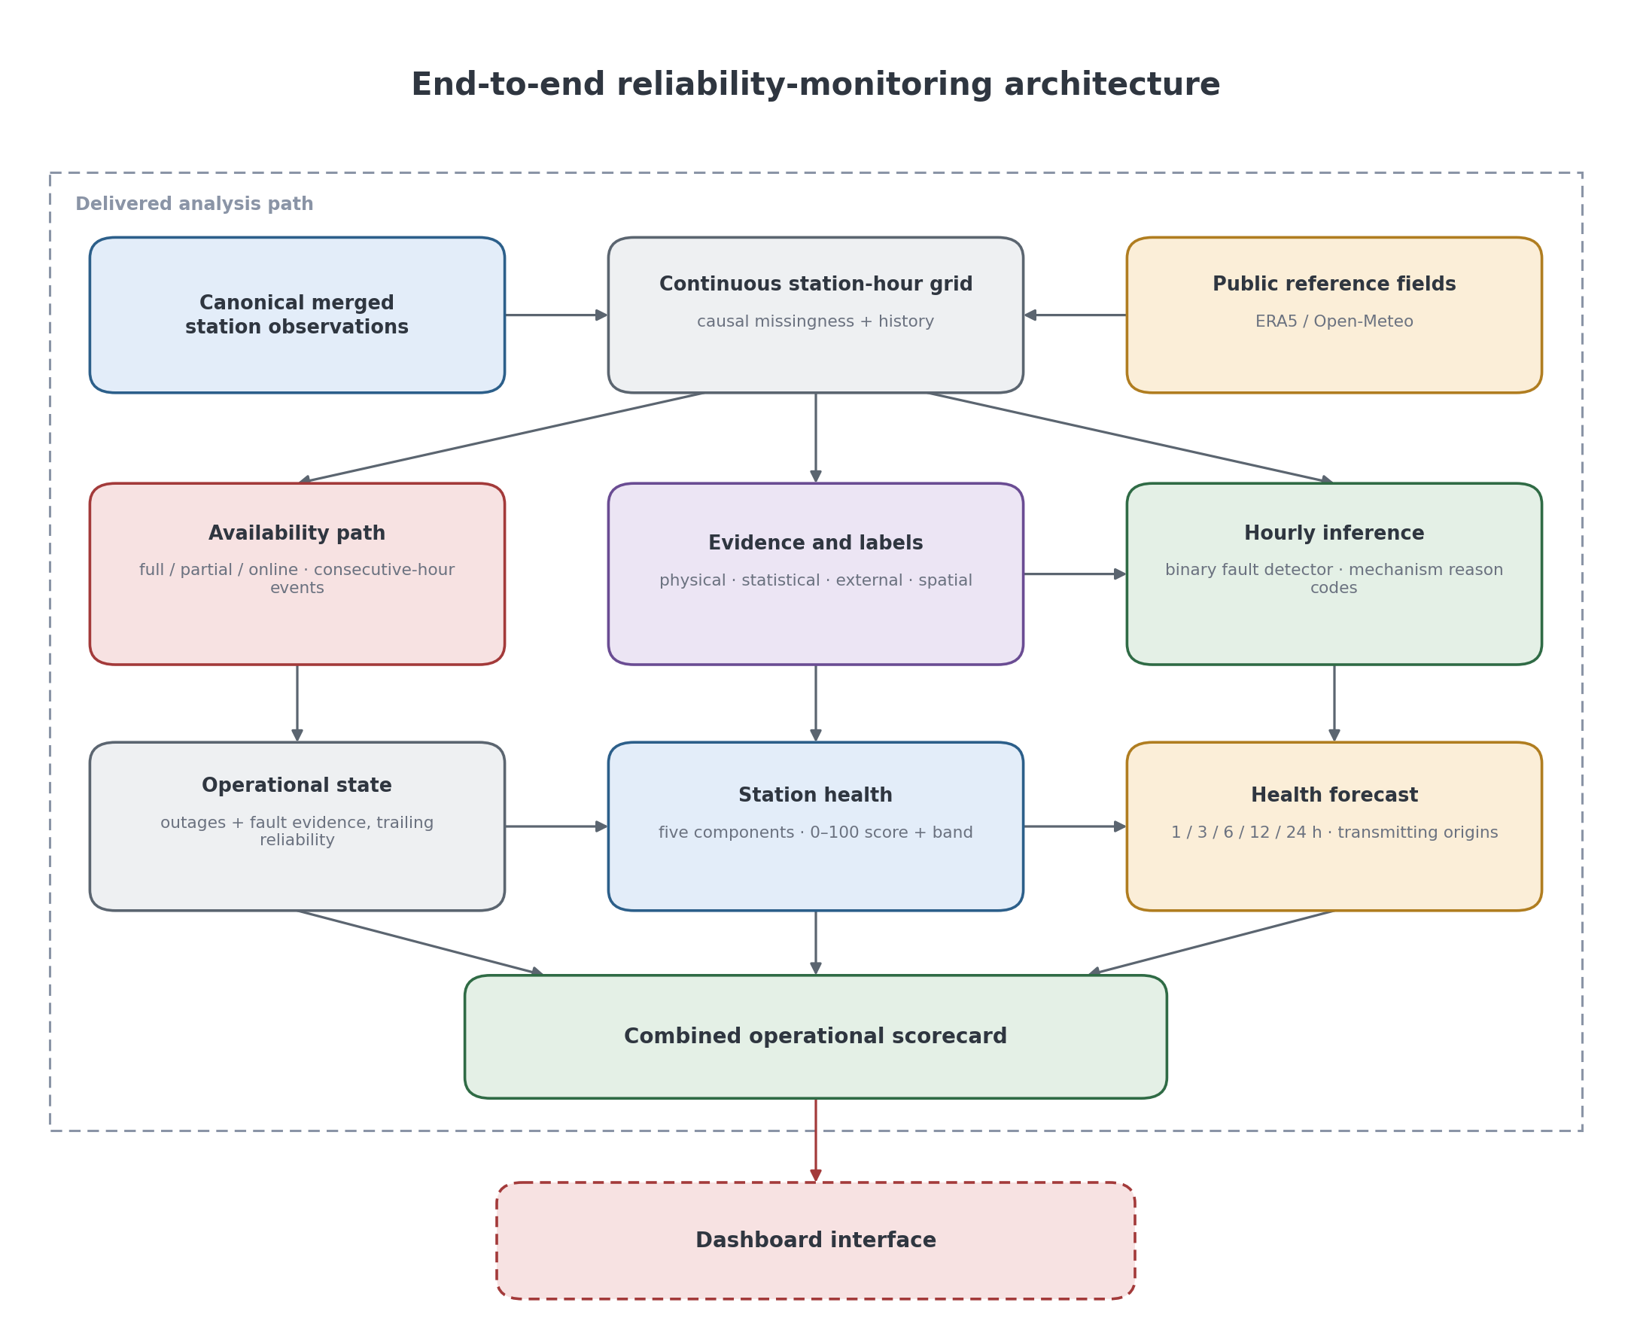
Figure 4.1. End-to-end reliability-monitoring architecture from observed station-hours to outage state, fault evidence, health, forecast, and operational scorecard; the diagram distinguishes completed analysis products from later dashboard presentation.
The system is hybrid because no individual source covers all fault types. Statistical checks are fast and interpretable; external residuals reveal divergence from a reference; spatial evidence supplies local context where neighbours exist; and the RGFN learns temporal and missingness patterns. These sources are retained as evidence rather than collapsed into an untraceable claim of ground truth. The evidence flow in Figure 4.1 explains where each source enters the system.
The requirements are divided into functional and non-functional requirements. Table 4.1 records functional behaviour, while Table 4.2 records reproducibility, causality, and auditability constraints.

4.1.1 Functional Requirements
Table 4.1. Functional requirements.
ID | Delivered requirement
F1 | Canonical hourly station record and station metadata
F2 | Lifecycle states, audit summaries, and missingness reporting
F3 | Station outage-event extraction and network-window classification
F4 | Statistical, physical, external-reference, and spatial evidence
F5 | Reproducible multi-label episode labels
F6 | Hour-level binary fault-detection dataset
F7 | Logistic, gradient-boosted, and custom RGFN comparisons
F8 | Evidence metadata for operational consumption
F9 | Documented risk and dashboard interface extensions

4.1.2 Non-Functional Requirements
Table 4.2. Non-functional requirements.
Requirement | Description
Reproducibility | Frozen data windows, deterministic artifacts, and tests support repeatable results.
Interpretability | Fault evidence retains detector, channel, mechanism, and component context.
Missingness awareness | Missingness is preserved and represented rather than silently imputed.
Station specificity | Baselines and context use station location and historical behaviour.
Geographic awareness | Neighbour evidence respects distance and identifies isolated stations.
Data safety | Credentials and source acquisition details remain separate from report artifacts.
Operational usefulness | Outputs are event- and station-hour-oriented rather than only point anomaly scores.

4.2 Data Sources and Hourly Dataset
The canonical hourly record preserves the original station-observation column names, including temp_avg_c, humidity_avg_pct, latitude, elevation, pressure_max_hpa, precip_total_mm, and precip_rate_mmh. This keeps the reliability analysis distinct from the companion Mozn forecast-bias-correction schema. Source acquisition and period staging are kept separate from the reproducible analysis path used in this report. Weather Underground supplies the source observation contract [5].
The analysis window ends at 30 June 2026, 23:00 UTC. Freezing this interval makes the audit, availability counts, labels, figures, and model comparisons reproducible from one defined record.

4.3 Lifecycle States and Continuous Time Grid
The row-state classifier assigns exactly one lifecycle label to each station-hour. This is the canonical filtering layer used by later processing. The outage engine treats only true_outage_candidate rows as real outage evidence, while warmup and terminal-padded rows are excluded from outage statistics. Figure 4.2 summarises the exclusive decision sequence. Table 4.3 defines the mutually exclusive lifecycle states that feed the decision flow.
Table 4.3. Row-state taxonomy.
row_state | Meaning
online_complete | Station is reporting and all required measurement variables are present.
online_partial_missing | Station is reporting but at least one required measurement variable is missing.
true_outage_candidate | Station has data_present = 0 and the absence is eligible for outage-event extraction.
terminal_padded_absence | End-of-window padding; excluded from outage statistics.
warmup | Commissioning-period row excluded from outage-event interpretation.

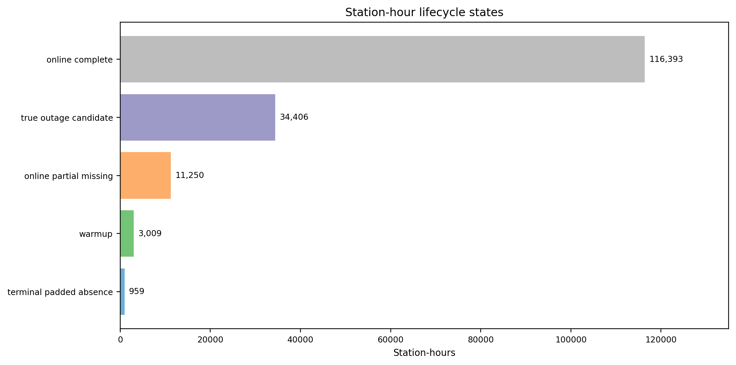
Figure 4.2. Exclusive lifecycle-state assignment for each observed station-hour; the flow prevents warm-up and terminal padding from being counted as operational outages.

4.4 Full, Partial, and Coordinated Outages
The availability engine distinguishes three mutually exclusive operational states. A full outage is an hour on a station’s continuous grid with no transmission. A partial outage is a transmitting hour in which every channel belonging to at least one defined sensor group is absent. All other transmitting hours are online. Consecutive full-outage hours are grouped using the established event engine: a gap greater than one clock hour or a station change starts a new event, and each frozen event receives a deterministic identifier. Consecutive partial hours are aggregated separately, carrying the union of absent sensor groups observed during the event.
Table 4.4. Sensor-group membership used for partial-outage classification; a group is absent only when all listed channels are missing in a transmitting hour.
Sensor group | Channels represented in the hourly record
Anemometer | Wind-speed mean, maximum, and gust channels
Barometer | Pressure mean, minimum, maximum, and pressure-trend channels
Light/UV | Solar-radiation and ultraviolet-index channels
Rain gauge | Precipitation total and precipitation-rate channels
Thermo-hygrometer | Temperature, humidity, dew-point, and heat-index channels
Wind vane | Wind-direction mean and directional evidence channels
Table 4.4 makes the hardware interpretation explicit and prevents a single missing variable from becoming a partial outage. The six groups correspond to the project taxonomy, while the group-level absence rule captures silent loss of a physical sensing subsystem.
After event extraction, coordinated network-wide windows are detected by searching for outage starts involving at least five distinct stations within plus or minus one hour. Consecutive candidates are merged into windows. Events are then classified using a three-way outage_class taxonomy: local, network_midnight, and network_other. This distinction prevents upstream platform events from being treated as station-attributable local failures during later model training. Figure 4.3 shows how hourly states become operational outage events.
Four source spans omit rows entirely rather than storing present-but-empty hours: I90583612, IMURQU6, ITRIPO32, and IDERNA7. Their boundary-to-boundary elapsed spans are 481, 379, 363, and 235 hours, while the number of truly absent hourly rows between the observed boundaries is 480, 378, 362, and 234, totalling 1,454. Materialising those hours as full outages is essential because a future horizon of H hours must mean H clock hours rather than H surviving rows.
$$F_{s,t}=1\{T_{s,t}=0\},P_{s,t}=1\left\{T_{s,t}=1∧∃g:\sum_{c∈g}{M_{s,c,t}}=|g|\right\}$$
T_(s,t) indicates that station s transmitted at hour t; M_(s,c,t) indicates a missing channel. F is the full-outage indicator. P is the partial-outage indicator and is evaluated only when transmission exists; a group g is absent when all of its channels are missing. Therefore F and P cannot both be one.
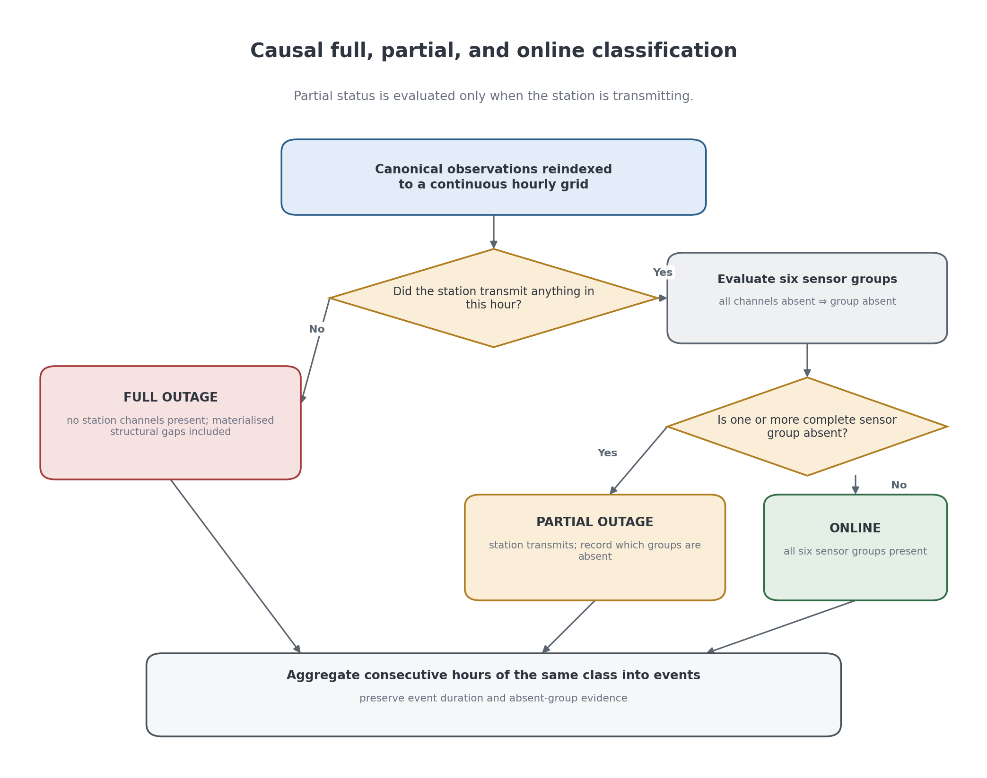
Figure 4.3. Full and partial outage construction on a continuous station-hour grid; materialised missing hours preserve clock-time duration while sensor-group absence reveals failures hidden by transmission uptime.

4.5 Feature Engineering and Fault Evidence

4.5.1 External and Spatial Context
The detection workflow uses complementary evidence sources: per-channel statistical screening, external residual analysis against Open-Meteo/ERA5, spatial residual analysis against nearby stations, and a supervised hour-level model. The RGFN consumes recent temporal values and rule evidence to produce a binary fault score; external and spatial evidence remain separately inspectable. The external reference is acquired through the Open-Meteo historical interface to ECMWF/ERA5 archives [6].
$$r_{ext}(s,c,t)=x_{s,c,t}-x_{ref}(s,c,t)$$
r_ext is the external residual between a station observation and its time- and location-matched Open-Meteo/ERA5 reference. It is evidence of disagreement, not an assumption that the reference is perfect.
$$z_{ext}(s,c,t)=\frac{r_{ext}(s,c,t)-b_{ext}(s,c,t)}{max({MAD}_{ext}(s,c,t),f_{ext,c})}$$
Pressure, dew point, and wind use a trailing 720-hour residual baseline with at least 240 observations; temperature and solar use the same hour of day over the trailing 30 days with at least 15 observations. The MAD floors are 0.8 hPa for pressure, 0.3 °C for temperature, 0.4 °C for dew point, 0.3 m/s for wind, and 10 W/m² for solar.
$$r_{sp}(s,c,t)=x_{s,c,t}-{median}_{j∈N_{s}(t)}x_{j,c,t}$$
N_s(t) is the set of configured nearby stations with comparable valid observations at hour t. The median limits the influence of a faulty neighbour; where N_s(t) is empty, spatial evidence is unavailable rather than adverse.
$$z_{sp}(s,c,t)=\frac{r_{sp}(s,c,t)-b_{sp}(s,c,t)}{max({MAD}_{sp}(s,c,t),0.5)}$$
Spatial pressure, temperature, and dew-point evidence uses a 720-hour trailing baseline with at least 240 observations and at least two present neighbours within 200 km. Insufficient neighbour support yields unavailable evidence and never lowers health or creates a fault by itself.
A critical design rule is that residuals are treated as reference signals, not ground truth. A station can disagree with ECMWF because the model is locally biased. A station can disagree with neighbors because the neighbors are faulty. Strong fault evidence comes from cross-patterns, such as one station disagreeing with both the external model and nearby stations while the rest of the network remains consistent.
Pressure residuals require special care. The FT0360 reports pressure as sea-level-corrected pressure, so pressure comparisons must use mean-sea-level reference pressure rather than surface pressure. Otherwise, the detector would create a false elevation-dependent offset and misinterpret it as a station fault.

4.5.2 Statistical Anomaly Features
The statistical anomaly layer operates per station and channel on the hourly record. It produces attributable detector and channel evidence, which is carried into the statistical gate and later into the hour-level feature set. Table 4.5 links each detector to the pattern it is designed to surface.
Three complementary detectors run on each channel. A robust z-score uses the median and median absolute deviation (MAD). A rolling-variance detector surfaces stuck or flatlined sensors. A one-dimensional Isolation Forest provides a distribution-free outlier score for unusual channel values. The detectors are summarised in Table 4.5. The Isolation Forest branch follows the distribution-isolation principle introduced by Liu et al. [8].
$$m_{s,c}=median(x_{s,c}),{MAD}_{s,c}=median|x_{s,c}-m_{s,c}|,z_{s,c,t}=\frac{x_{s,c,t}-m_{s,c}}{{MAD}_{s,c}}$$
x_(s,c,t) is channel c at station s and hour t. Baselines require at least 1,500 present channel-hours per station; otherwise the implementation uses the pooled eligible-station baseline. Zero or undefined MAD creates no flag. The implementation does not apply a Gaussian consistency factor.
$$τ_{z,c}=Q_{0.997}(|z_{c}|),D_{z,s,c,t}=1\{|z_{s,c,t}|≥τ_{z,c}\},τ_{IF,c}=Q_{0.997}(s_{c}^{IF})$$
Robust-z and Isolation Forest decisions use channel-specific 99.7th-percentile thresholds. The one-dimensional Isolation Forest score is the negative sample score, fitted with contamination 0.003 and seed 42. These are sensitive candidate detectors; the later contextual gate uses a separate fixed 3.5 threshold.
$$v_{s,c,t}={Var}_{ddof=1}(x_{s,c,t-23},…,x_{s,c,t}),D_{stuck}=1\{v_{s,c,t}<{10}^{-6}\}$$
The stuck rule requires a complete 24-hour past-only window and flags every hour in a qualifying window. For channels where zero is an ordinary physical state—precipitation rate, solar, UV, minimum wind speed, and minimum gust—the rolling mean magnitude must also exceed 10^(−9); cumulative precipitation is excluded.

Table 4.5 Statistical anomaly detectors and the faults they target.
Detector | Target evidence | Role
Robust z-score (median and MAD) | Large channel deviation | Flags values that deviate from the station/channel robust baseline.
Rolling variance | Stuck or flatlined sensor | Flags windows whose variance falls near zero.
Isolation Forest | One-dimensional channel outlier | Produces an isolation score from the observed channel distribution.

Before scoring, two channels are transformed so that the median and MAD remain meaningful. Wind direction is encoded as sine and cosine components, because the raw degree scale is circular and would otherwise treat 0 and 360 degrees as far apart when they are identical. Precipitation is passed through a logarithmic transform to handle its heavy, zero-inflated distribution. Nine derived channels that merely restate other readings are excluded from scoring to avoid double-counting, and missing readings are preserved as missing rather than imputed.
$$u=sin\left(\frac{πθ}{180}\right),v=cos\left(\frac{πθ}{180}\right),p^{'}=log(1+p)$$
θ is wind direction in degrees, so u and v preserve circular proximity across 0°/360°. p is non-negative precipitation; log1p compresses its heavy-tailed scale while retaining zero.
Detector flags are candidate evidence rather than automatic fault labels. The final statistical gate adds same-channel evidence, physical and stuck checks, a station hour-of-day and month context baseline, and ERA5 evidence where it is available. This keeps high but normal seasonal readings from being promoted solely because a generic detector fired.
$$q_{s,c,t}=\frac{x_{s,c,t}-m_{s,c,month,hour}^{ctx}}{max({MAD}_{s,c,month,hour}^{ctx},f_{c})},C=1\{|q_{s,c,t}|≥3.5\}$$
The contextual cohort uses the same station, transformed channel, calendar month, and hour of day, excludes the candidate hour plus physical/stuck rows, and requires at least 15 observations. f_c is a channel-specific MAD floor. Because this cohort uses available observations around the candidate, the label evidence is retrospective and is not an as-of-time deployment estimate.
$$A=C∧D_{z}∧D_{IF}∧E_{agree},B=C∧(D_{z}⊕D_{IF})∧E_{strong}∧I_{supported},D_{stat}=A∨B$$
Path A requires both statistical detectors and, where ERA5 is comparable, |z_ERA5|≥3 with the same direction as q; absence of ERA5 does not veto Path A. Path B requires exactly one statistical detector, a supported pressure/temperature/wind channel, and |z_ERA5|≥3, but not sign matching. Physical and stuck mechanisms are excluded from these paths and are labelled separately. For transformed wind direction, both sine and cosine channels must pass.
The flagged hours are consolidated so that they can be reviewed and labelled. Consecutive flagged hours for the same station and channel are grouped into events, each carrying its dominant detector, a measure of how many detectors agree, and its peak scores. Events on the same station that begin within a short onset window are merged into station-level episodes, which record the set of affected channels and sensor groups. These episodes are the unit at which ground-truth labels are assigned: each episode is joined back to its underlying readings and labelled by the value-based classifier of Section 4.6, which evaluates every channel independently and attaches every fault mechanism and component that is actually present. Labels therefore follow directly from the recorded values rather than from grouping episodes by similarity, so that the labelling is fully reproducible from the data.
Grouping channels by physical sensor helps interpret multi-label episodes. The FT0360 comprises an indoor console carrying the barometric pressure sensor and an outdoor array housing the thermo-hygrometer, anemometer, wind vane, rain gauge, and combined light/ultraviolet sensor [4]. Channels from a shared component can fail together, but the delivered taxonomy records the individual mechanisms and components present rather than assigning a broad summary class.

4.5.3 Physical-Limit Features
A physical-limit rule complements statistical screening by checking values and rate changes against documented hard bounds and gated suspect bounds. Its role is to surface clear measurement impossibilities while leaving plausible high values to the contextual statistical gate.
The rule distinguishes documented hard breaches from suspect evidence. Only hard physical breaches create the spike_impossible label in the canonical build. The current pressure-trend threshold of |Δpressure| > 20 hPa/h is itself a hard breach, so no separate pressure-trend suspect band survives in the implementation. Solar/UV suspect flags are retained as candidate evidence for contextual review but do not independently promote a spike label; no solar or UV hard spike survives in the canonical population.
$$I_{physical}(x_{t})=1\{x_{t}<L_{c}∨x_{t}>U_{c}∨|x_{t}|>U_{abs,c}\}$$
The comparisons are strict, so a value exactly on a bound is allowed. Hard valid ranges are temperature −60 to 60 °C, humidity 0-100%, wind speed 0-250 km/h, gust 0-300 km/h, direction 0-360°, pressure 870-1085 hPa, pressure trend |x|≤20 hPa/h, precipitation 0-1000, solar 0-1600 W/m², and UV 0-25. Surviving suspect-only upper ranges are wind speed 150, gust 180, precipitation 300, solar 1100, and UV 16; these are candidate evidence, not spike-impossible labels.
The rule recovers the IMURQU7 rainfall fault, including a cumulative precipitation value of 5,933.95 mm and a peak rate of 6,295.39 mm/h. It is deliberately simple and interpretable, and it complements rather than replaces the statistical gate.

4.6 Fault Taxonomy and Label Engineering
To train the binary detector, flagged episodes are labelled with the mechanisms and components they contain. The taxonomy describes faults on two independent multi-label axes, preserving multiple simultaneous causes without forcing an episode into a summary family. The hour-level model is evaluated on the binary fault target. Mechanism labels also support the separate retrospective event-level reason-code experiment in Section 5.5; component localisation remains exploratory metadata and is not claimed as a delivered reason-code result.
The mechanism axis has four labels, listed in Table 4.6. A reading is a spike when its value is physically impossible, a stuck fault when a sensor is confirmed flat while variation is expected, a statistical anomaly when the contextual evidence gate passes, and a calibration offset when Layer 2 resolves an eligible reference-supported episode. The component axis names the anemometer, barometer, light/UV, rain gauge, thermo-hygrometer, or wind vane. Table 4.6 defines the multi-label mechanism vocabulary used by training artifacts.
The taxonomy retains components and mechanisms with sufficient observed support for meaningful descriptive reporting. Calibration offset is retained as evidence even though only four resolved episodes exist. It is excluded from the event-level mechanism selection because the spaced validation partition contains only one positive complete event, below the predeclared five-event selection minimum.
Table 4.6 Fault mechanism labels.
Mechanism | Meaning
spike_impossible | A reading whose value is physically impossible or extremely unlikely for the region (a glitch or over-read).
stuck_flatline | A sensor reporting a constant, unchanging value while the quantity it measures should vary.
statistical_anomaly | A reading that is a genuine outlier against the station's own hour-of-day and seasonal history, while remaining physically possible.
calibration_offset | A sensor that is internally consistent but persistently biased away from an independent external reference.

Labels are assigned by a reproducible value-based classifier applied uniformly to episodes. A spike is assigned for a physical-limit breach; a stuck fault is assigned for confirmed flat behaviour; and a statistical anomaly passes one of two gates. Path A requires both statistical detectors on the same channel and hour, contextual outlier evidence, and ERA5 directional agreement where comparable. Path B requires one detector plus a strong absolute ERA5 residual, so it represents external discrepancy rather than same-direction corroboration. Episodes with no positive evidence are benign.
Wind direction is treated carefully. A direction frozen while meaningful wind-speed variation is present is evidence of a wind-vane problem, whereas unchanged direction during calm conditions is not automatically faulty. Unchanged direction accompanied by frozen wind speed supports an anemometer freeze. The canonical build derives these mechanism labels from hourly evidence and its documented raw-value fallback; separate five-minute audits may corroborate individual cases, but the label-builder path does not depend on a five-minute confirmation routine.
Sustained calibration offsets are examined by Layer 2 external-reference analysis and are spatially corroborated where neighbourhood evidence exists. Layer 2 promotes only an existing borderline-review episode that intersects a confirmed offset run; it does not create a fault label for every external residual run.
Episodes whose evidence is genuinely ambiguous, neither confidently faulty nor confidently benign, are held in a separate review state and excluded from model training and evaluation, so that uncertain cases neither inflate nor degrade reported performance. This keeps the trained model grounded in confidently labelled examples while preserving the ambiguous cases for later inspection.

4.7 Transparent Station-Health Score
The station-health score is a transparent 0-100 definition of current operational condition, not a learned label. This is deliberate: operators can inspect each component, reproduce the arithmetic, and distinguish a low score caused by availability from one caused by current sensor evidence. Every component is computed causally from observations at or before the scored hour.
$$B_{t}=30A_{t}+20C_{t}+25F_{t}+15R_{t}+10S_{t}$$
B_t is the unadjusted base health. A_t, C_t, F_t, R_t, and S_t are availability, sensor-completeness, fault-burden, reference-consistency, and stability components, each normalised to [0,1]. The coefficients sum to 100, so component contributions remain directly interpretable as health points.
Table 4.7. Causal station-health components, weights, and evidence windows; the decomposition makes every score auditable.
Component | Weight | Causal basis
Availability (A) | 30 | Fraction of trailing 168 hours transmitting
Sensor completeness (C) | 20 | Presence of six sensor groups among transmitting hours over trailing 168 hours, averaged
Fault burden (F) | 25 | Trailing seven-day causal detector evidence, exponentially weighted with a 24-hour half-life and capped before inversion
Reference consistency (R) | 15 | Current external residual plus prior-only persistent pressure-offset evidence
Stability (S) | 10 | Equal blend of adverse-event starts in trailing 30 days and time since the last adverse event, each capped
$$A_{t}=\frac{1}{168}\sum_{j=0}^{167}{T_{t-j}},C_{t}=\frac{1}{6}\sum_{g}{\frac{\sum_{j=0}^{167}{P_{g,t-j}}}{\sum_{j=0}^{167}{T_{t-j}}}}$$
T is one when the station transmits. P_g is one when sensor group g is present. Sensor completeness is therefore conditional on transmitting hours rather than treating a full outage as six independent missing sensors.
$$w_{j}=2^{-j/24},ρ_{t}=\frac{\sum_{j=0}^{167}{w_{j}}E_{t-j}}{\sum_{j=0}^{167}{w_{j}}},F_{t}=1-clip\left(\frac{ρ_{t}}{0.20} , 0 , 1\right)$$
E is causal hard-physical, stuck, or prior-only deviation evidence. The 24-hour half-life emphasises recent evidence, and the 0.20 cap maps a sufficiently persistent evidence burden to zero fault-health contribution.
$$R_{t}=1-max(u_{current,t},u_{persistent,t})$$
u_current is the largest normalised exact-hour external residual severity and u_persistent is prior-only pressure-offset severity relative to the fleet, requiring at least eight stations. When both reference modes are unavailable, the evidence is neutral and R_t=1 rather than a penalty.
$$S_{t}=0.5\left[1-clip\left(\frac{N_{adverse,30d}}{20} , 0 , 1\right)\right]+0.5clip\left(\frac{h_{since adverse}}{720} , 0 , 1\right)$$
N_adverse,30d counts starts of full outage, partial outage, or hard physical/stuck evidence in the trailing 30 days. h_since_adverse is hours since the last such event, capped at 720 hours. Contextual statistical candidates alone do not start a stability event.
Table 4.7 separates conceptually different operational questions. Availability measures whether a station sends data; completeness asks whether its physical sensor groups are present when it does; fault burden measures recent anomalous evidence; reference consistency asks whether current values agree with external and fleet context; and stability measures recurrence and recovery history. IALWAH18 and IDERNA7 have no configured spatial neighbour, so missing spatial evidence is neutral rather than a penalty.
Reviewed episode labels and completed calibration-offset intervals are deliberately excluded from the score. A reviewed episode may encode its eventual duration and resolution, and a completed offset interval is only known after it ends. Using either would create a retrospective score that cannot be reproduced live. The fault-burden and persistent-offset terms therefore use only causal rule and residual evidence available by hour t.
$$m_{full}(d)=e^{-d/24},m_{partial}(d)=e^{-d/72},H_{t}=Q_{t}m(d_{t})$$
d_t is the current uninterrupted outage duration in hours, measured only through t. Q_t is a causal cap on base health B_t: within one uninterrupted outage class it cannot exceed the preceding capped value, so an outage cannot improve health merely because a trailing window changes. The appropriate multiplier then scales every stored component contribution, preserving their exact sum to H_t. Both exponentials decrease monotonically and asymptotically approach zero, while the longer 72-hour constant gives partial outages a deliberately milder penalty than full loss of transmission.
Table 4.8. Progressive outage-duration multipliers used by the health score; the curves distinguish recent loss from prolonged loss without a discontinuous hard zero.
Current duration | Full-outage multiplier | Partial-outage multiplier
1 h | 0.959 | 0.986
6 h | 0.779 | 0.920
24 h | 0.368 | 0.717
168 h (7 d) | 0.0009 | 0.097
The progressive design replaced an initial hard-zero override. Under the former rule, a one-hour interruption and a multi-week interruption both scored zero. The monotonic multipliers in Table 4.8 create an immediate, duration-sensitive decline while preserving a visible recovery state when transmission resumes.
Health bands are defined before forecast evaluation as Healthy (80-100), Watch (60-79.999), Degraded (40-59.999), and Critical (0-39.999). The bands are operational summaries of the continuous score; the continuous value and its five components remain the primary explainable output. Figure 4.4 shows how the five causal components feed the score before banding.
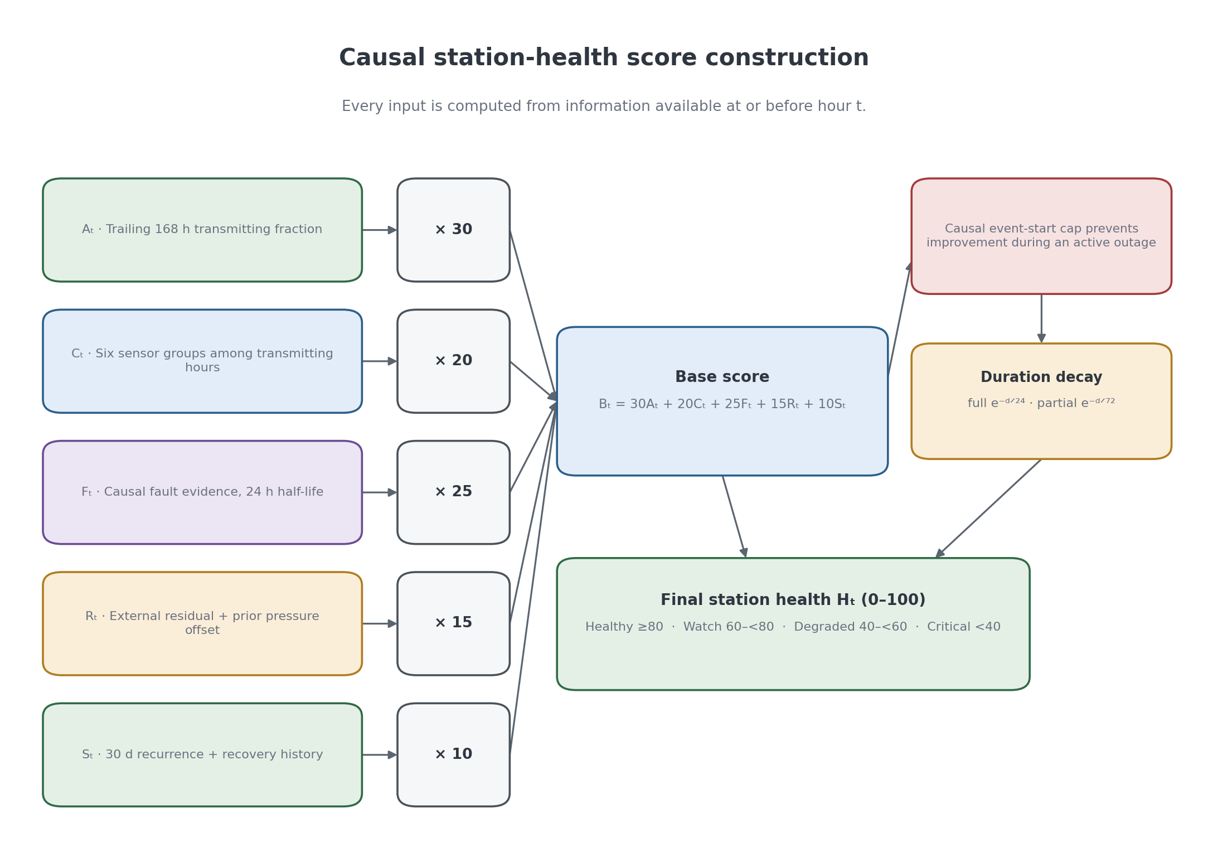
Figure 4.4. Causal health-score composition from five bounded components; the diagram shows how availability, completeness, evidence, reference agreement, and stability remain separately inspectable before their weighted sum.

4.8 Data-Engineering Results and Discussion

4.8.1 Dataset Audit
The dataset audit assigns a lifecycle row state to every station-hour and produces the network’s reliability profile. The status-class distribution shows a usable but uneven network: 13 stations qualify as reliable reference candidates, while six are outage dominated. Weekly coverage in Figure 4.5 makes the station-level imbalance visible. Table 4.9 quantifies the status classes underlying that reliability profile.

Table 4.9 Status-class distribution from the June 2026 dataset audit.
Status class | Stations | Interpretation
reliable_reference_candidate | 13 | High availability and completeness; eligible reference candidates.
usable | 5 | Usable stations with non-pristine reliability.
reliable_but_terminal_gap | 1 | Otherwise reliable station with terminal gap.
weak | 1 | Low availability and frequent flickers.
outage_dominated | 6 | Low present rate or frequent/long outages.

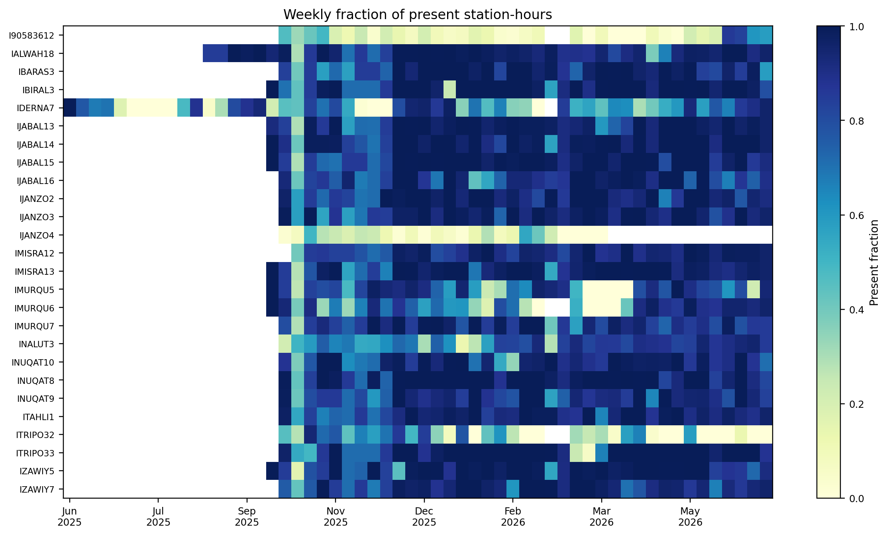
Figure 4.5. Weekly observed coverage by station across the frozen interval; persistent gaps identify stations whose availability dominates their reliability profile.
The missingness heatmap shows that some variables are absent together rather than independently. This supports retaining missingness masks and elapsed-time signals in the temporal model rather than treating all absences as ordinary numeric values. Figure 4.6 shows which variables disappear together.
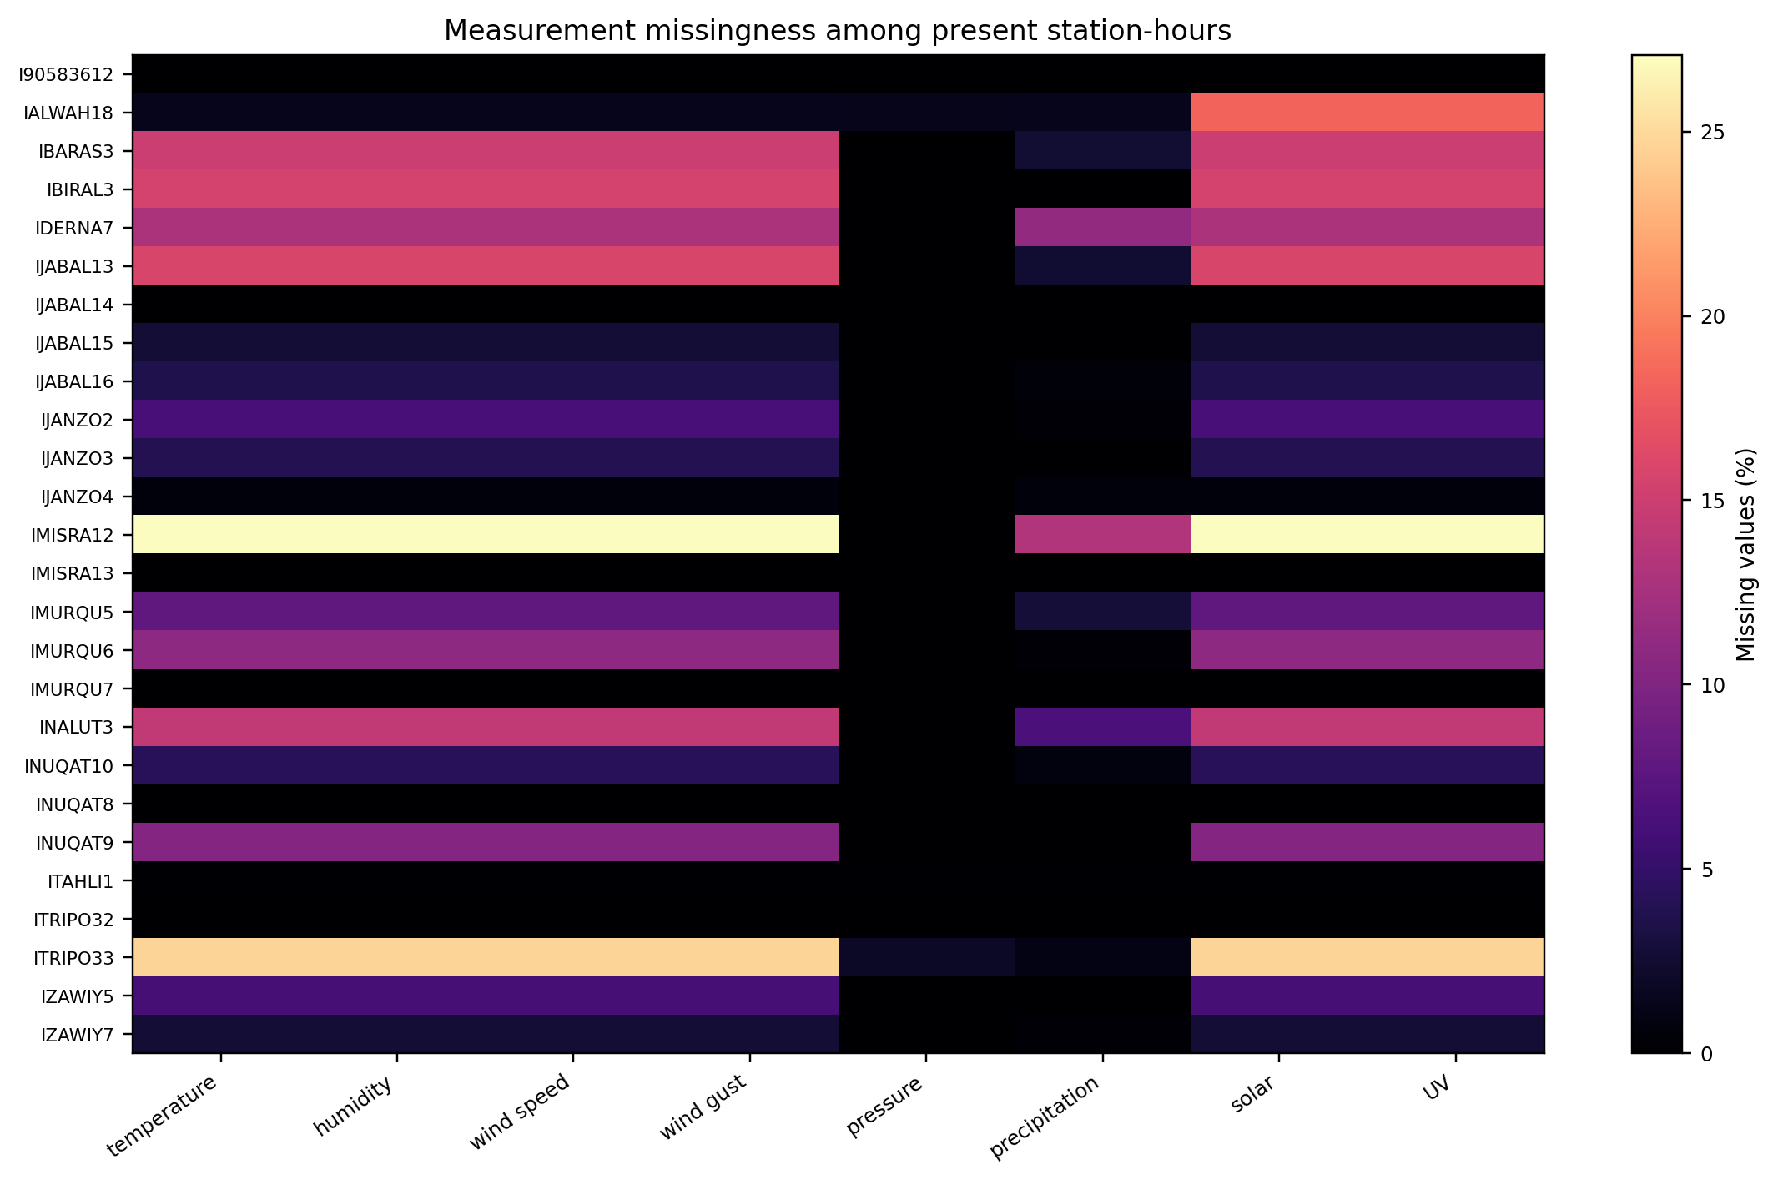
Figure 4.6. Measurement missingness conditional on present station-hours; co-missing channels motivate group-level partial-outage logic and explicit missingness inputs.
Table 4.10 Verified examples from the canonical dataset.
Station | Verified evidence | Observed fact
ITRIPO33 | Repeated-zero wind | Longest contiguous average-and-gust zero-wind run: 83 hours.
IBIRAL3 | Layer 2 pressure offset | −16.265 hPa run lasting 4,622 hours; level-channel statistical blind spot.
IJABAL13 | Layer 2 pressure offset | −81.780 hPa run lasting 2,037 hours; resolves four borderline episodes.
IDERNA7 | Very long local outage | 814-hour event from 8 July to 11 August 2025.
IMURQU7 | Impossible precipitation | Peak total 5,933.95 mm; peak rate 6,295.39 mm/h.

These examples demonstrate the validator gap. A range validator catches clear impossibilities, but it does not catch all values that are individually plausible and collectively inconsistent. The workflow therefore retains temporal, external-reference, spatial, and missingness evidence. Table 4.10 grounds the argument in verified station examples.

4.8.2 Full and Partial Outage Results
The frozen availability engine extracts 2,398 full-outage events from observed lifecycle rows, totalling 34,406 outage-candidate hours. Continuous operational classification additionally materialises 1,454 truly omitted hourly rows as full outages, giving 35,860 operational full-outage station-hours while intentionally preserving the frozen 2,398-event series and its 47 network-wide windows. This distinction keeps previously verified event statistics stable while making every station-hour available to downstream health and horizon arithmetic. Table 4.11 gives the frozen event-duration distribution. Figure 4.7 provides the corresponding station-level availability comparison.

Table 4.11 Outage-duration distribution from the June 2026 availability engine.
Duration class | Definition | Events
Short | 1–3 hours | 1,141
Medium | 4–24 hours | 1,024
Long | 25–168 hours | 211
Very long | >168 hours | 22

Most frozen full-outage events are short or medium, while long events dominate operational concern because they remove a station from the network for days or weeks. The median is 4 hours, the mean 14.35 hours, and the maximum 814 hours at IDERNA7 from 8 July to 11 August 2025. Figure 4.7 compares station availability, and Table 4.12 separates local full-outage events from the two coordinated-window classes.
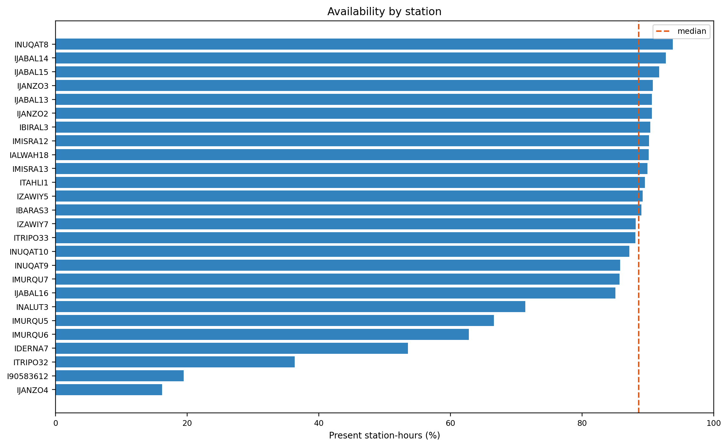

Figure 4.7. Full-outage availability by station; the uneven distribution shows why network averages cannot substitute for station-level monitoring.
Table 4.12 Outage-class distribution from the June 2026 availability engine.
outage_class | Definition | Events
local | Event outside a detected coordinated network window. | 1,968
network_midnight | Event in a coordinated window beginning at 22 or 23 UTC. | 267
network_other | Event in another coordinated network window. | 163
Table 4.13. Partial-outage event durations among transmitting hours; the dominance of 4-24-hour events shows that partial sensor loss is usually sustained rather than a one-hour omission.
Duration bucket | Events
1-3 h | 139
4-24 h | 630
25-168 h | 33
169 h or longer | 1
Total | 803
Across 130,652 transmitting station-hours, the group-level rule identifies 803 partial-outage events covering 11,158 hours. Their mean duration is 13.90 hours, median 14 hours, and maximum 465 hours. Table 4.13 shows that 630 events last between 4 and 24 hours, so the result is not driven by isolated missing values.
Table 4.14. Sensor-group availability conditional on station transmission; the contrast between the barometer and outdoor-array groups exposes failures hidden by ordinary uptime.
Sensor group | Availability
Anemometer | 92.40%
Barometer | 99.85%
Light/UV | 91.54%
Rain gauge | 98.27%
Thermo-hygrometer | 92.40%
Wind vane | 92.40%
The largest partial-availability burdens are IMISRA12 (1,508 hours), ITRIPO33 (1,473), IALWAH18 (1,220), IJABAL13 (923), and IBIRAL3 (910). In 7,662 partial hours, the anemometer, light/UV, thermo-hygrometer, and wind vane disappear together while barometric reporting continues; another 2,254 hours also lose the rain gauge. Because the FT0360 barometer is housed in the indoor console while these groups belong to the outdoor array, the pattern is consistent with loss of the outdoor-array-to-console link. It remains a testable hardware hypothesis rather than a confirmed diagnosis. Table 4.14 supplies the conditional sensor-group availability behind this hardware hypothesis.
The 11,158 operational partial-outage hours differ from the 11,250 lifecycle rows previously described as online_partial_missing. The lifecycle state counts missing required variables, whereas the operational partial-outage rule requires an entire physical sensor group to be absent during continued transmission. The narrower definition is why the two valid counts are not equal.

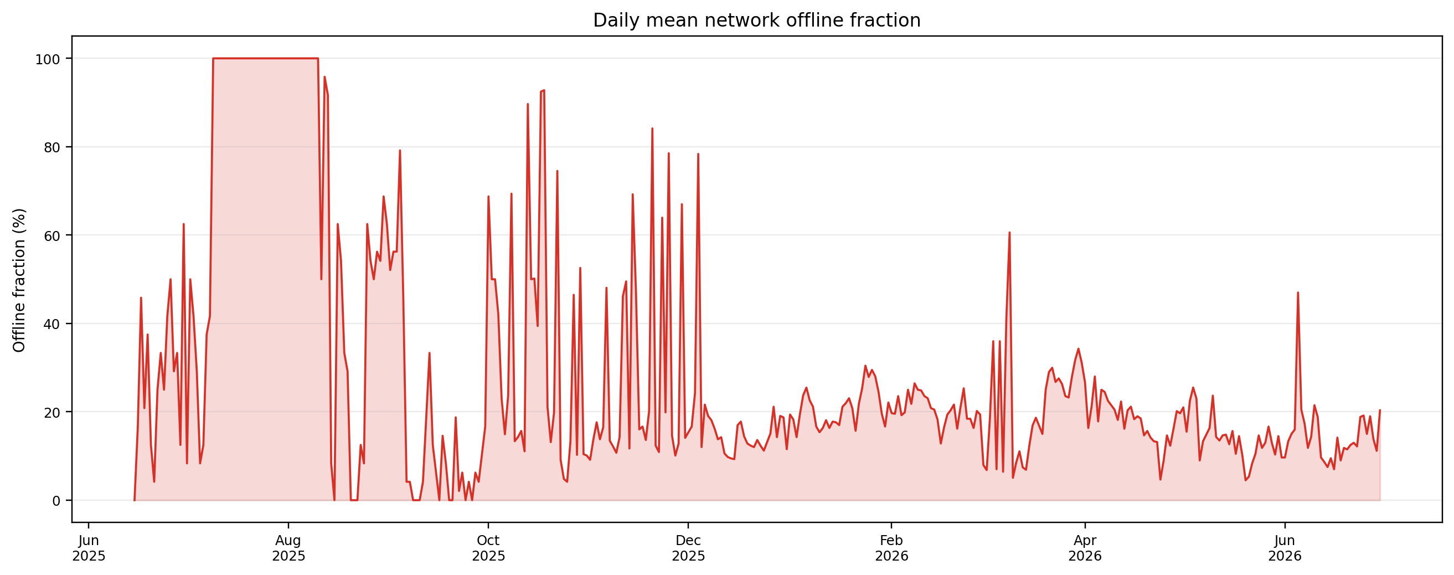

Figure 4.8. Daily mean fraction of stations offline; synchronized peaks motivate separate coordinated-window analysis rather than treating every event as local.

4.8.3 Coordinated Network Events
The network-wide detector found 47 coordinated windows: 22 classified as network_midnight and 25 as network_other. These windows contain 267 and 163 station events respectively. The classification separates shared platform-like patterns from local availability events; it does not establish a specific upstream cause. Figure 4.8 locates the coordinated peaks in the network timeline.
Table 4.15 Summary of coordinated network-outage windows.
Finding | Result
Detected network-wide windows | 47 total windows.
Midnight-classified windows | 22 windows beginning at 22–23 UTC.
Other network windows | 25 windows beginning at other hours.
Midnight station-events | 267 events.
Other-network station-events | 163 events.
Midnight duration pattern | Median event duration 24 hours; maximum 109 hours.
Other-window duration pattern | Median event duration 2.5 hours; maximum 190 hours.
Interpretation | Coordinated availability pattern; upstream cause not observed directly.

The spatial and temporal extent of several windows is inconsistent with a single station failure. The evidence supports treating them as coordinated availability patterns rather than using them to inflate local outage counts. The analysis does not identify the upstream mechanism directly.
Midnight-classified windows have a median event duration of 24 hours. Recovery timing varies by station, so a synchronized start does not imply synchronized restoration.
The current window inventory is reported in Table 4.15. It replaces earlier pre-June counts and does not rely on targeted minute-level claims from a superseded analysis window.

4.8.4 Local Co-Occurrence Diagnostic
Network-wide windows are excluded before pair comparison to prevent shared platform patterns from inflating apparent local dependence. The remaining pairwise comparison is a local-dependency diagnostic, not a detection target. Table 4.16 records the scope of this deliberately limited pairwise diagnostic.
Table 4.16 Scope of the local co-occurrence diagnostic.
Scope | Treatment | Interpretation
47 network-wide windows | Excluded before pair comparison | Prevents platform-wide patterns inflating local dependence.
Remaining station-hours | Observed/expected pair comparison | Local-dependency diagnostic only.
Model training | Does not use pair ratios as labels | Availability classification remains event-based.

The cleaned diagnostic may still surface nearby pairs for review, but the report does not treat a pairwise ratio as proof of shared infrastructure or as a model label. Figure 4.9 provides the retained repeated-zero example.
The availability investigation therefore distinguishes station-local events from coordinated network windows, while preserving uncertainty about the cause of coordinated patterns.
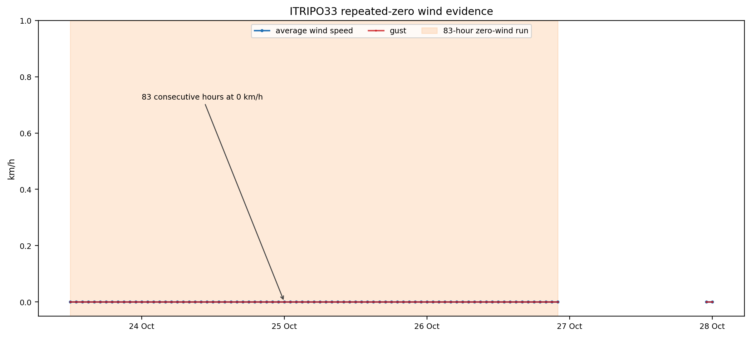
Figure 4.9. Repeated-zero wind evidence at ITRIPO33; sustained constancy under expected variation demonstrates a stuck-sensor pattern that range checks alone miss.

4.8.5 Statistical and Physical Evidence Results
The statistical layer was run over the full 166,017 station-hour record. Robust z-score and Isolation Forest evidence occurs together or separately on 5.99% of station-hours; both fire on 1.50%. When stuck and physical-limit evidence is included, at least one detector group fires on 10.10% of station-hours. These deliberately sensitive candidate flags are screened by the contextual gate before they become labels.
Table 4.17 Statistical evidence funnel for the canonical label build.
Stage | Count
Raw flagged evidence rows (hour, channel) | 17,789
Distinct episodes touched | 4,717
Rows passing the full statistical gate | 1,740
Episodes passing the gate | 706
Path A only / Path B only / both | 621 / 38 / 47

The detector funnel produces 17,789 raw evidence rows across 4,717 episodes. Of those rows, 1,740 pass the full statistical gate, yielding 706 statistical-anomaly episodes. Path A alone accounts for 621 episodes, Path B alone for 38, and both paths for 47. Path B uses strong absolute ERA5 discrepancy, not same-direction corroboration. Table 4.17 quantifies each stage of the statistical-evidence funnel.
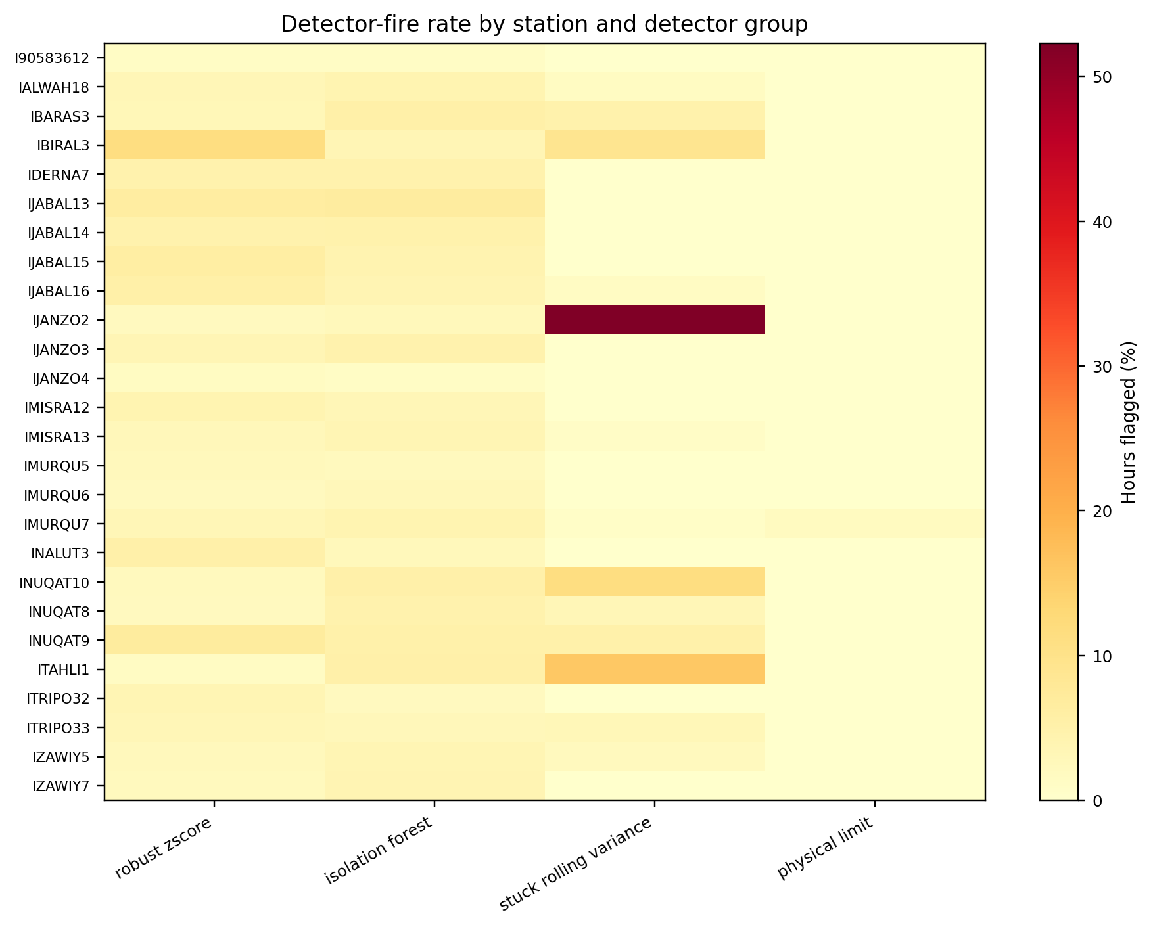
Figure 4.10. Detector-fire rate by station and evidence group; concentrated flags support station-specific review rather than a uniform fleet threshold.
Figure 4.10 shows that detector fires are concentrated in particular stations and evidence groups rather than spread uniformly. This concentration is consistent with the audit’s station-specific availability and sensor-quality differences.
The layer recovers verified examples from the audit. ITRIPO33 contains sustained repeated-zero wind behaviour, and IMURQU7 contains precipitation values beyond physical limits. Figure 4.11 displays both evidence patterns.
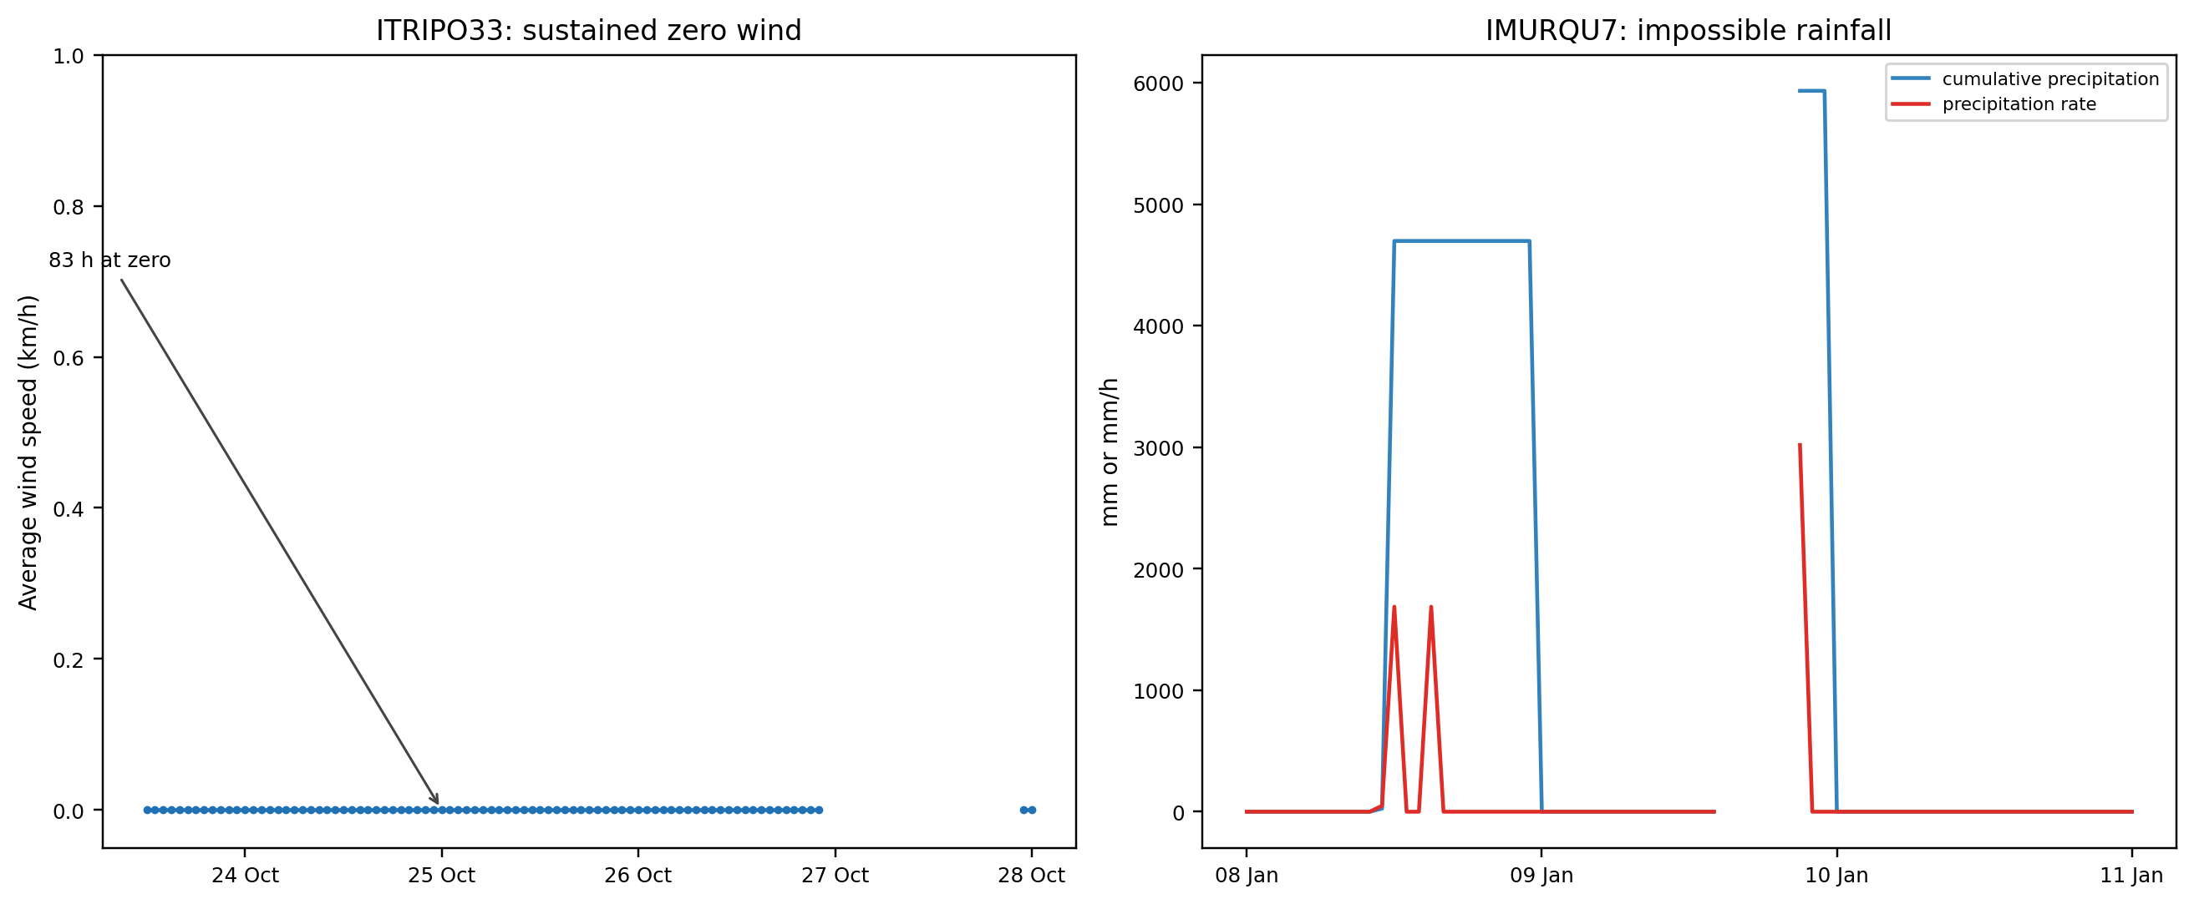
Figure 4.11. Verified fault-evidence examples for stuck wind and impossible precipitation; the paired cases show why temporal and physical rules are complementary.
The layer also has a precise structural blind spot. IBIRAL3’s sustained −16.27 hPa pressure offset is never flagged on the absolute pressure level: 46 candidate level rows were checked and none passed the gate. The only nine gate-passing hits are on the pressure-trend channel, the hour-to-hour rate of change, which cannot reveal a constant level bias. The two statistical-anomaly episodes inside the offset interval are incidental trend fluctuations, not detections of the fixed bias. Layer 2 external comparison resolves this fault.

4.8.6 Fault Label Results
The canonical value-based classifier produces 4,799 labelled episodes: 1,121 fault, 3,533 benign, and 145 borderline-review episodes. Borderline-review episodes are excluded from training and evaluation. The benign state records candidate episodes that did not clear the final fault evidence rule; it is not an estimate of the network’s ordinary-weather frequency.
Table 4.18 Fault episodes by canonical mechanism and component labels. Counts are multi-label and are not mutually exclusive.
Axis / label | Fault episodes
Mechanism: statistical_anomaly | 706
Mechanism: stuck_flatline | 302
Mechanism: spike_impossible | 177
Mechanism: calibration_offset | 4
Component: anemometer | 416
Component: barometer | 415
Component: light_uv | 184
Component: thermo_hygrometer | 134
Component: rain_gauge | 30
Component: wind_vane | 24

The taxonomy is multi-label, so mechanism and component counts are reported independently. Table 4.18 and Figure 4.12 use the canonical 1,121-fault population consumed by the hourly model, not the archived reconciliation inventory.
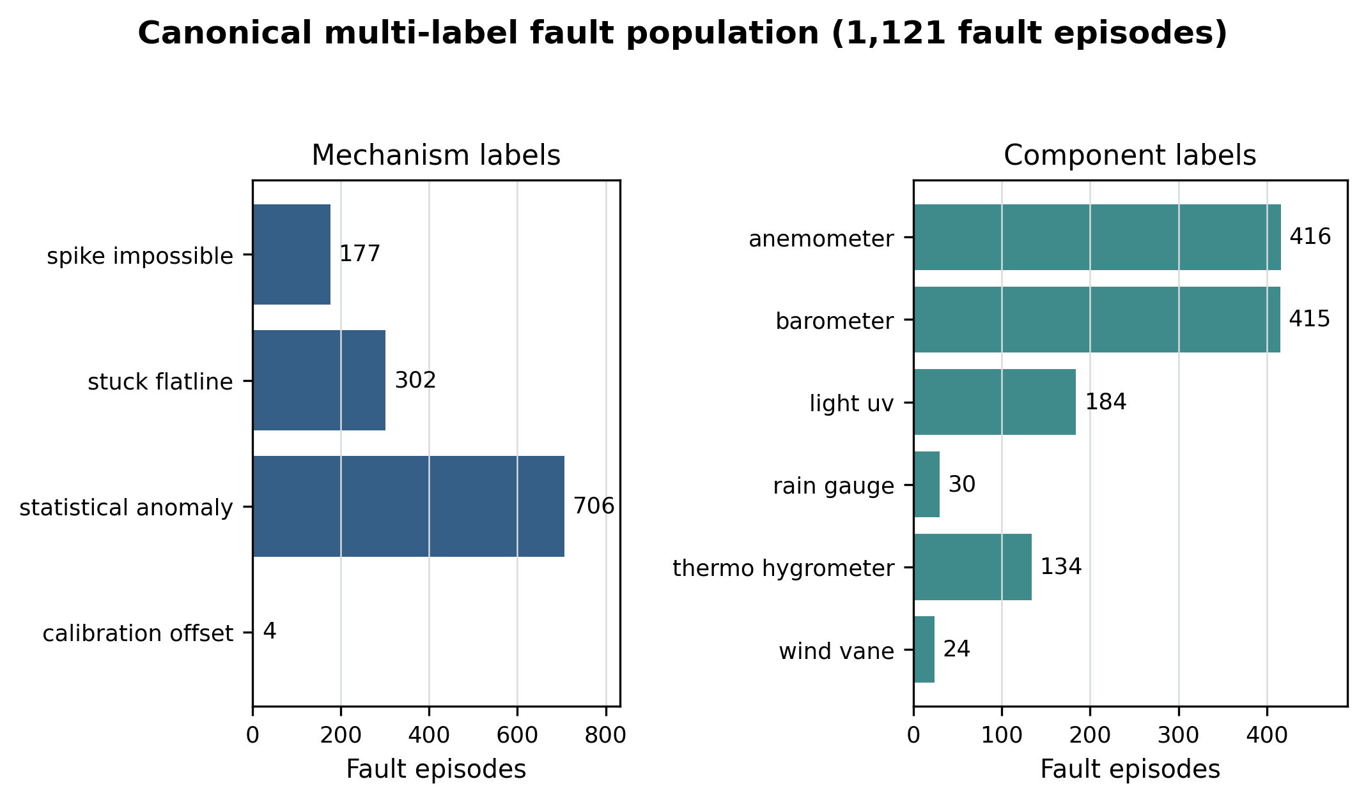
Figure 4.12. Multi-label mechanism and component counts in the canonical 1,121-fault population; independent axes preserve simultaneous causes without a synthetic multiple-fault class.
Statistical-anomaly episodes pass a two-path rule. The dominant Path A requires detector agreement on the same channel and hour, a contextual outlier, and ERA5 directional agreement where comparable. Path B accepts a single detector only with a strong absolute ERA5 residual; this is external discrepancy, not same-direction confirmation.
No solar or ultraviolet physical-limit spike is retained in the canonical label population. Of the 177 spike-impossible episodes, 147 arise from pressure-trend triggers and 30 from precipitation triggers. Figure 4.13 shows this composition. The IMURQU7 precipitation fault remains a verified physical-limit example. Figure 4.13 reports the verified trigger breakdown.
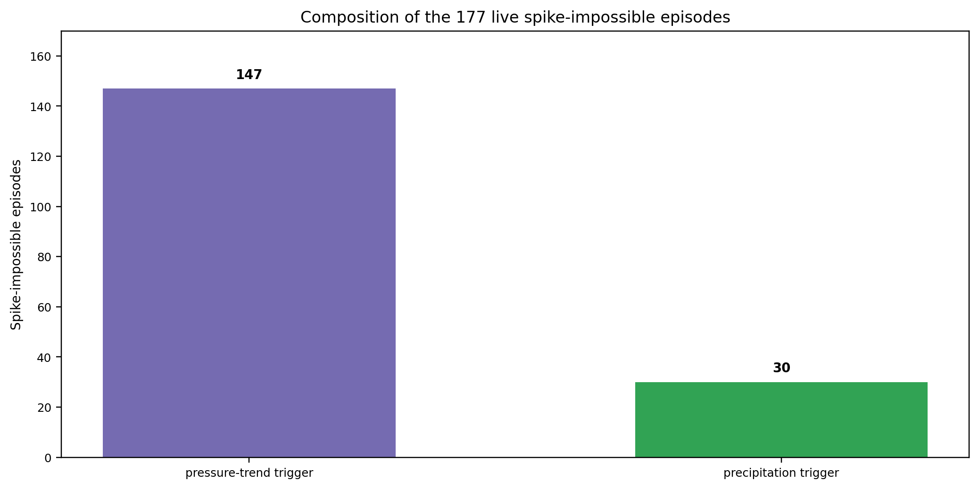
Figure 4.13. Trigger composition of the 177 spike-impossible episodes; the absence of solar/UV triggers corrects the earlier solar-over-read interpretation.
The stuck mechanism captures sensors reporting unchanging values where variation is expected. The clearest case is the ITRIPO33 anemometer. Wind-direction handling prevents a frozen direction during genuine calm from being mislabeled, while unchanged direction with corroborating frozen speed is retained as an anemometer-related fault. These canonical labels come from hourly detector evidence and the raw-value fallback; five-minute observations are useful for separate case review but are not required by the canonical label-builder path.
Calibration offsets are a distinct but sparse label mechanism: four episodes and 79 fault-hours. Layer 2 identifies more sustained residual runs than it labels; the promotion rule is explained in Section 4.8.7.

4.8.7 External and Spatial Residual Results
A sensor can be steadily wrong without ever spiking or freezing. The external-reference layer compares station readings with ERA5, while spatial context compares a station with nearby peers where such peers exist. A residual is treated as disagreement to be explained rather than automatic proof of sensor error.
Layer 2 evaluates sustained external-residual runs. It confirms 24 runs across 12 stations: 23 pressure runs and one dewpoint run. These runs are evidence records, not automatically minted label episodes. Table 4.19 lists the confirmed runs. Figure 4.14 shows run duration and promotion status.
The promotion rule resolves an existing borderline-review episode only when it intersects a confirmed run. IJABAL13’s −81.78 hPa pressure run spans 2,037 hours from 21 October 2025 to 14 January 2026 and intersects exactly four borderline episodes. Those four intersections explain all four calibration-offset labels; the other 23 confirmed runs remain evidence without a promoted episode.
External comparison is essential for stations that lack usable neighbour context. IALWAH18 and IDERNA7 have no spatial neighbour within the configured range. IBIRAL3 provides the complementary example: its stable pressure-level bias is structurally invisible to station-against-itself statistical screening.
Table 4.19 Confirmed Layer 2 sustained-offset runs and label resolution.
Station | Confirmed run values (hPa unless noted) | Canonical label resolution
IALWAH18 | −9.45, −9.76, −9.62 | 0 promoted episodes
IBIRAL3 | −16.27, −4.04 | 0 promoted episodes
IJABAL13 | +2.90 dewpoint; −81.78, −5.68 | −81.78 run resolves 4 episodes
IJABAL14 | −12.22, −11.25, −8.49 | 0 promoted episodes
IMISRA12 | −4.59 | 0 promoted episodes
IMISRA13 | −8.22, −8.02, −7.75 | 0 promoted episodes
IMURQU7 | +11.36 | 0 promoted episodes
INUQAT10 | −6.16, −7.77 | 0 promoted episodes
INUQAT9 | −4.58, −4.57 | 0 promoted episodes
ITRIPO33 | −14.06 | 0 promoted episodes
IZAWIY5 | −11.52, +8.23 | 0 promoted episodes
IZAWIY7 | −5.60 | 0 promoted episodes

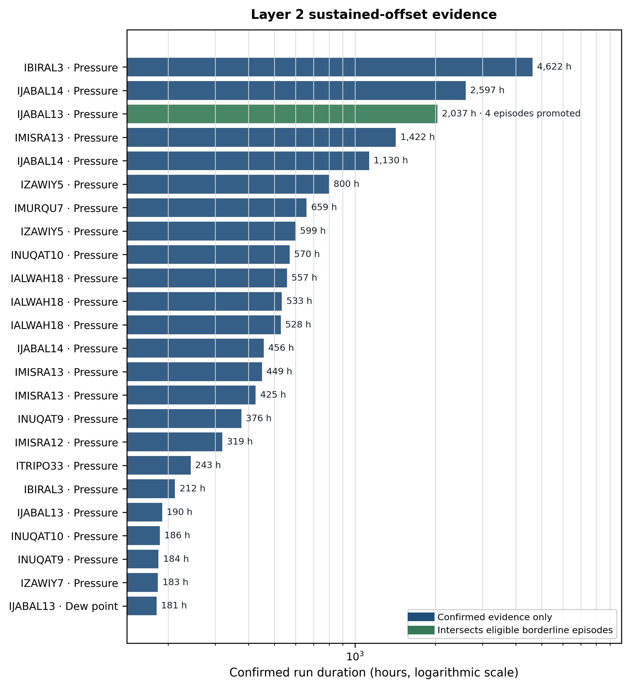
Figure 4.14. Confirmed Layer 2 sustained-offset runs and their promotion status; only the highlighted run intersects eligible borderline episodes, explaining why 24 runs produce four calibration-offset labels.
The offset evidence is heterogeneous: run values, channels, and durations differ by station. The report therefore treats external residuals as station-specific evidence rather than applying a fleet-wide pressure correction.
External and spatial context improve label review by preserving evidence about sustained disagreements while avoiding automatic promotion of every residual. Spatial evidence corroborates applicable runs; the two stations without neighbours remain external-reference cases. No separate solar, broad systemic, or stand-alone spatial anomaly result is claimed from the retired evidence inventory.

4.8.8 Station-Health Score Results
The continuous health artifact contains 169,655 station-hour rows. It has 165,313 numeric health scores: 127,659 ordinary scored rows plus 37,654 full-outage rows scored progressively under the revised design; 4,342 warm-up or otherwise insufficient-history rows remain explicitly unavailable. Figure 4.15 shows the final health distribution rather than silently treating insufficient history as zero.
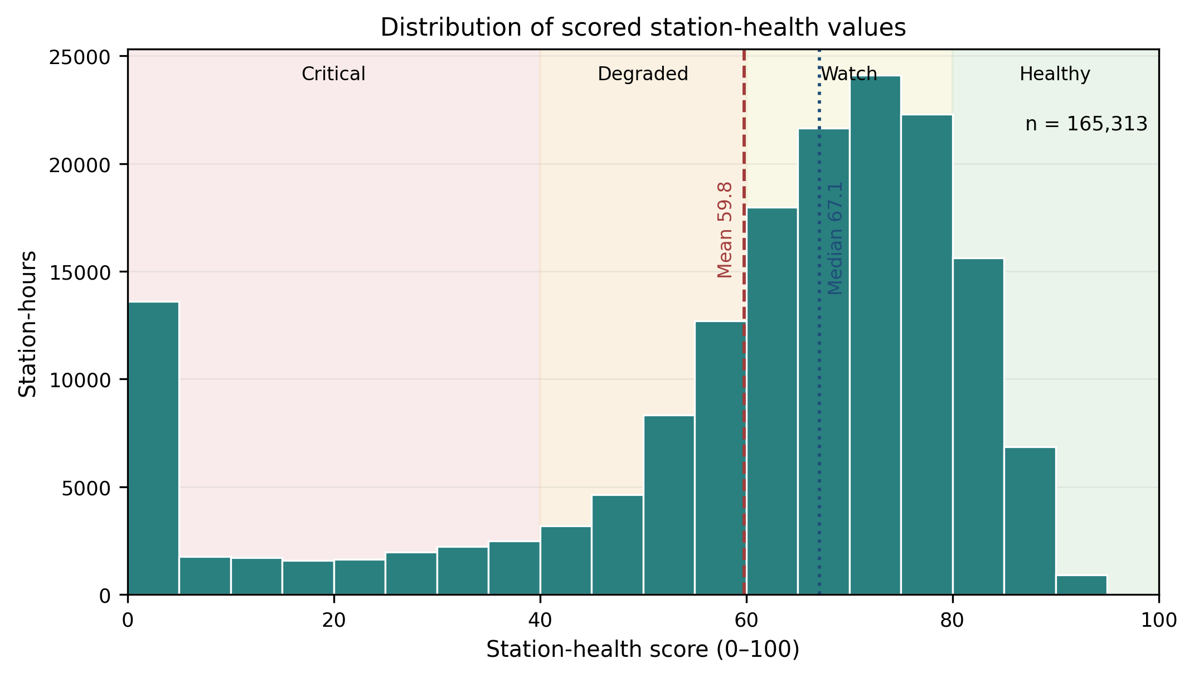
Figure 4.15. Distribution of final causal station-health scores across all numeric station-hours; the broad range shows that the score separates healthy operation, gradual degradation, and prolonged outages without a hard-zero spike.
The five components occupy different ranges, as Figure 4.16 shows. Availability and completeness are generally high but not saturated across every station, while fault burden, reference consistency, and stability provide separation among transmitting hours. Availability and sensor completeness have an all-row correlation of 0.802; part of that association is induced by their shared active-outage multiplier. Their base-component correlation is 0.484 and the final transmitting-only correlation is 0.314. Both are retained because one measures transmission and the other physical-sensor presence, but this partial redundancy is a stated limitation rather than hidden evidence of five independent signals. Figure 4.17 quantifies the corresponding component correlations.
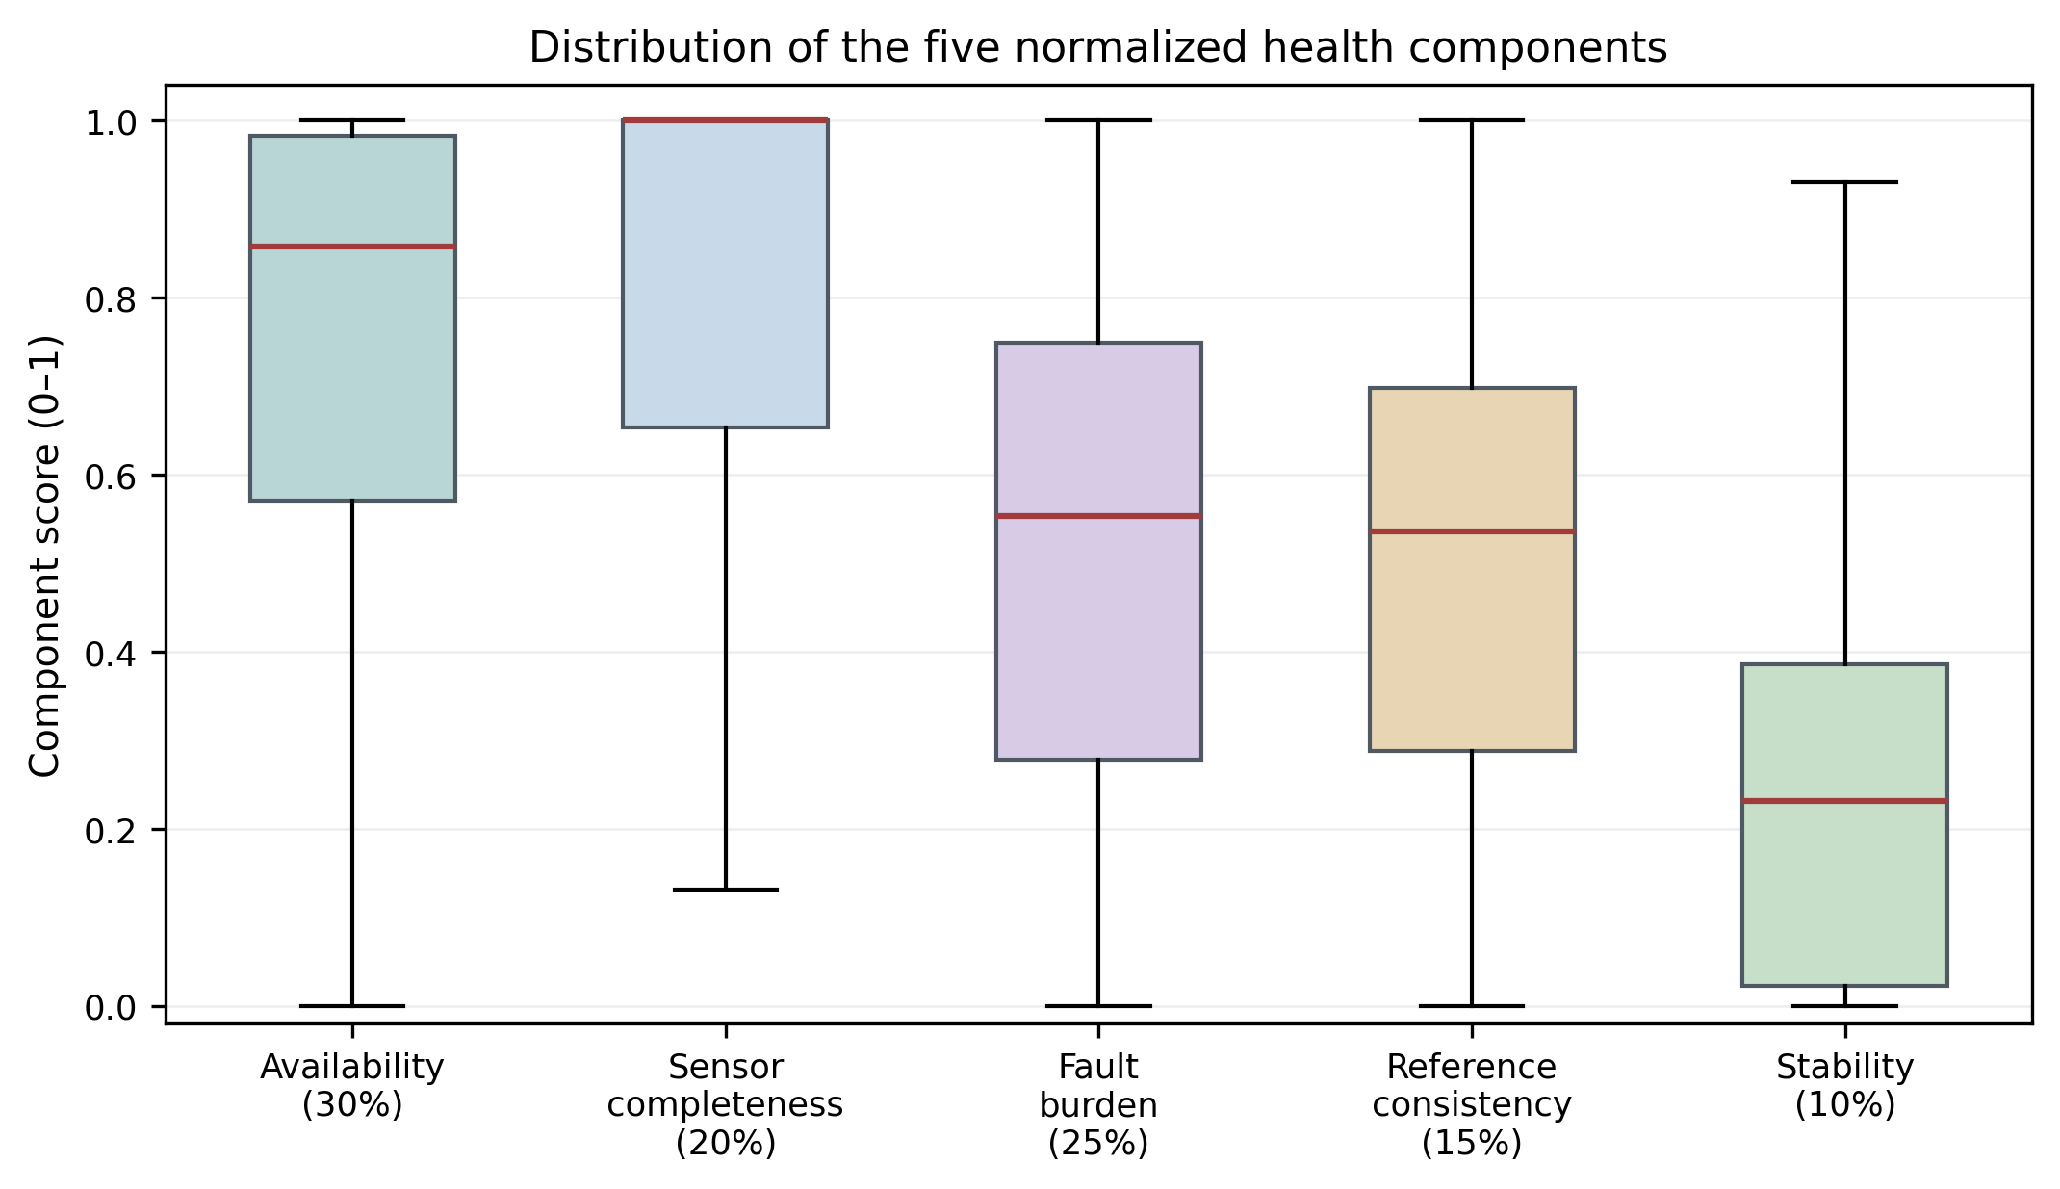
Figure 4.16. Distribution of the five health components after causal preprocessing; the panels reveal which components are concentrated near healthy values and which provide broader operational separation.
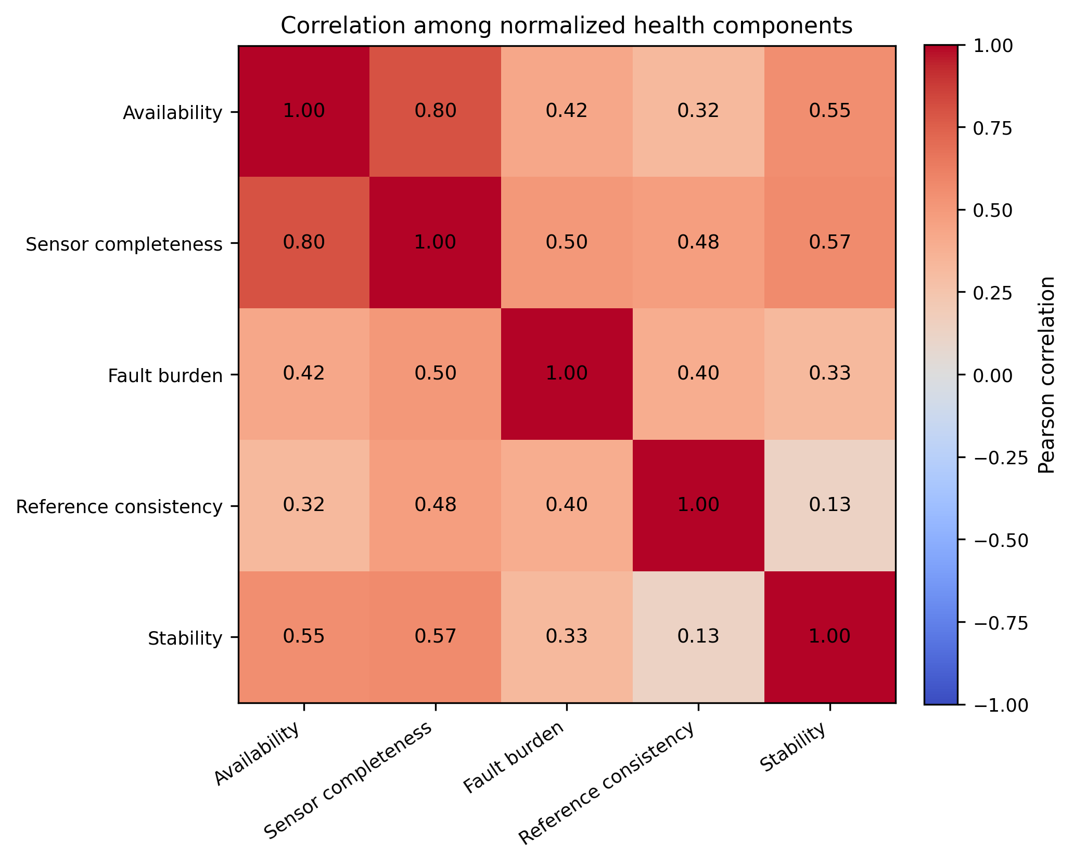
Figure 4.17. Correlation among final health components; the 0.802 availability-completeness association is partly structural, while lower transmitting-only correlation supports retaining both operational meanings.
Mean station health remains operationally coherent: INUQAT8 is highest at 75.26, while outage-dominated IJANZO4 is lowest at 19.43. Figure 4.18 contrasts station trajectories rather than reducing the fleet to one average.
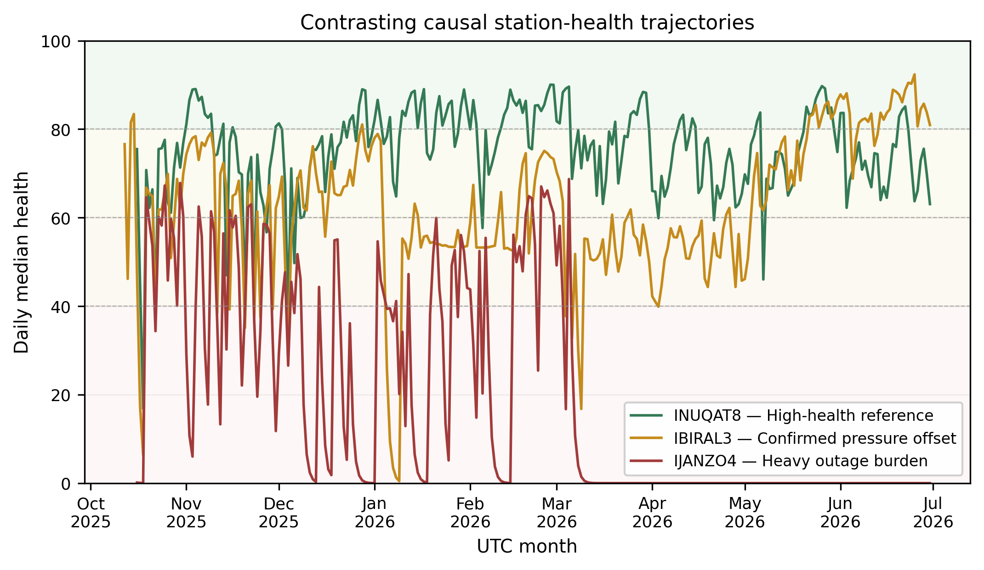
Figure 4.18. Contrasting station-health trajectories; the comparison shows how similar fleet-level averages can conceal sustained degradation, recovery, and recurring local evidence.
Table 4.20. Effect of replacing the full-outage hard zero with progressive duration degradation; the revised score removes a discontinuity and narrows the mean-median gap.
Statistic | Hard-zero design | Progressive design
Mean health | 54.88 | 59.81
Median health | 67.75 | 67.12
Exact-zero rows | 37,654 | 0
Mean-median gap | 12.87 | 7.31
Table 4.20 confirms that the revised formulation smooths the largest artificial discontinuity without inflating the median. The real IDERNA7 trajectory in Figure 4.19 supplies the more important operational check: health declines from 60.1 before its 814-hour outage to 57.7 after 1 hour, 46.8 after 6 hours, 22.1 after 24 hours, and 0.04 after 7 days. On the first recovered hour it returns to 65.2, in Watch rather than jumping directly to Healthy.
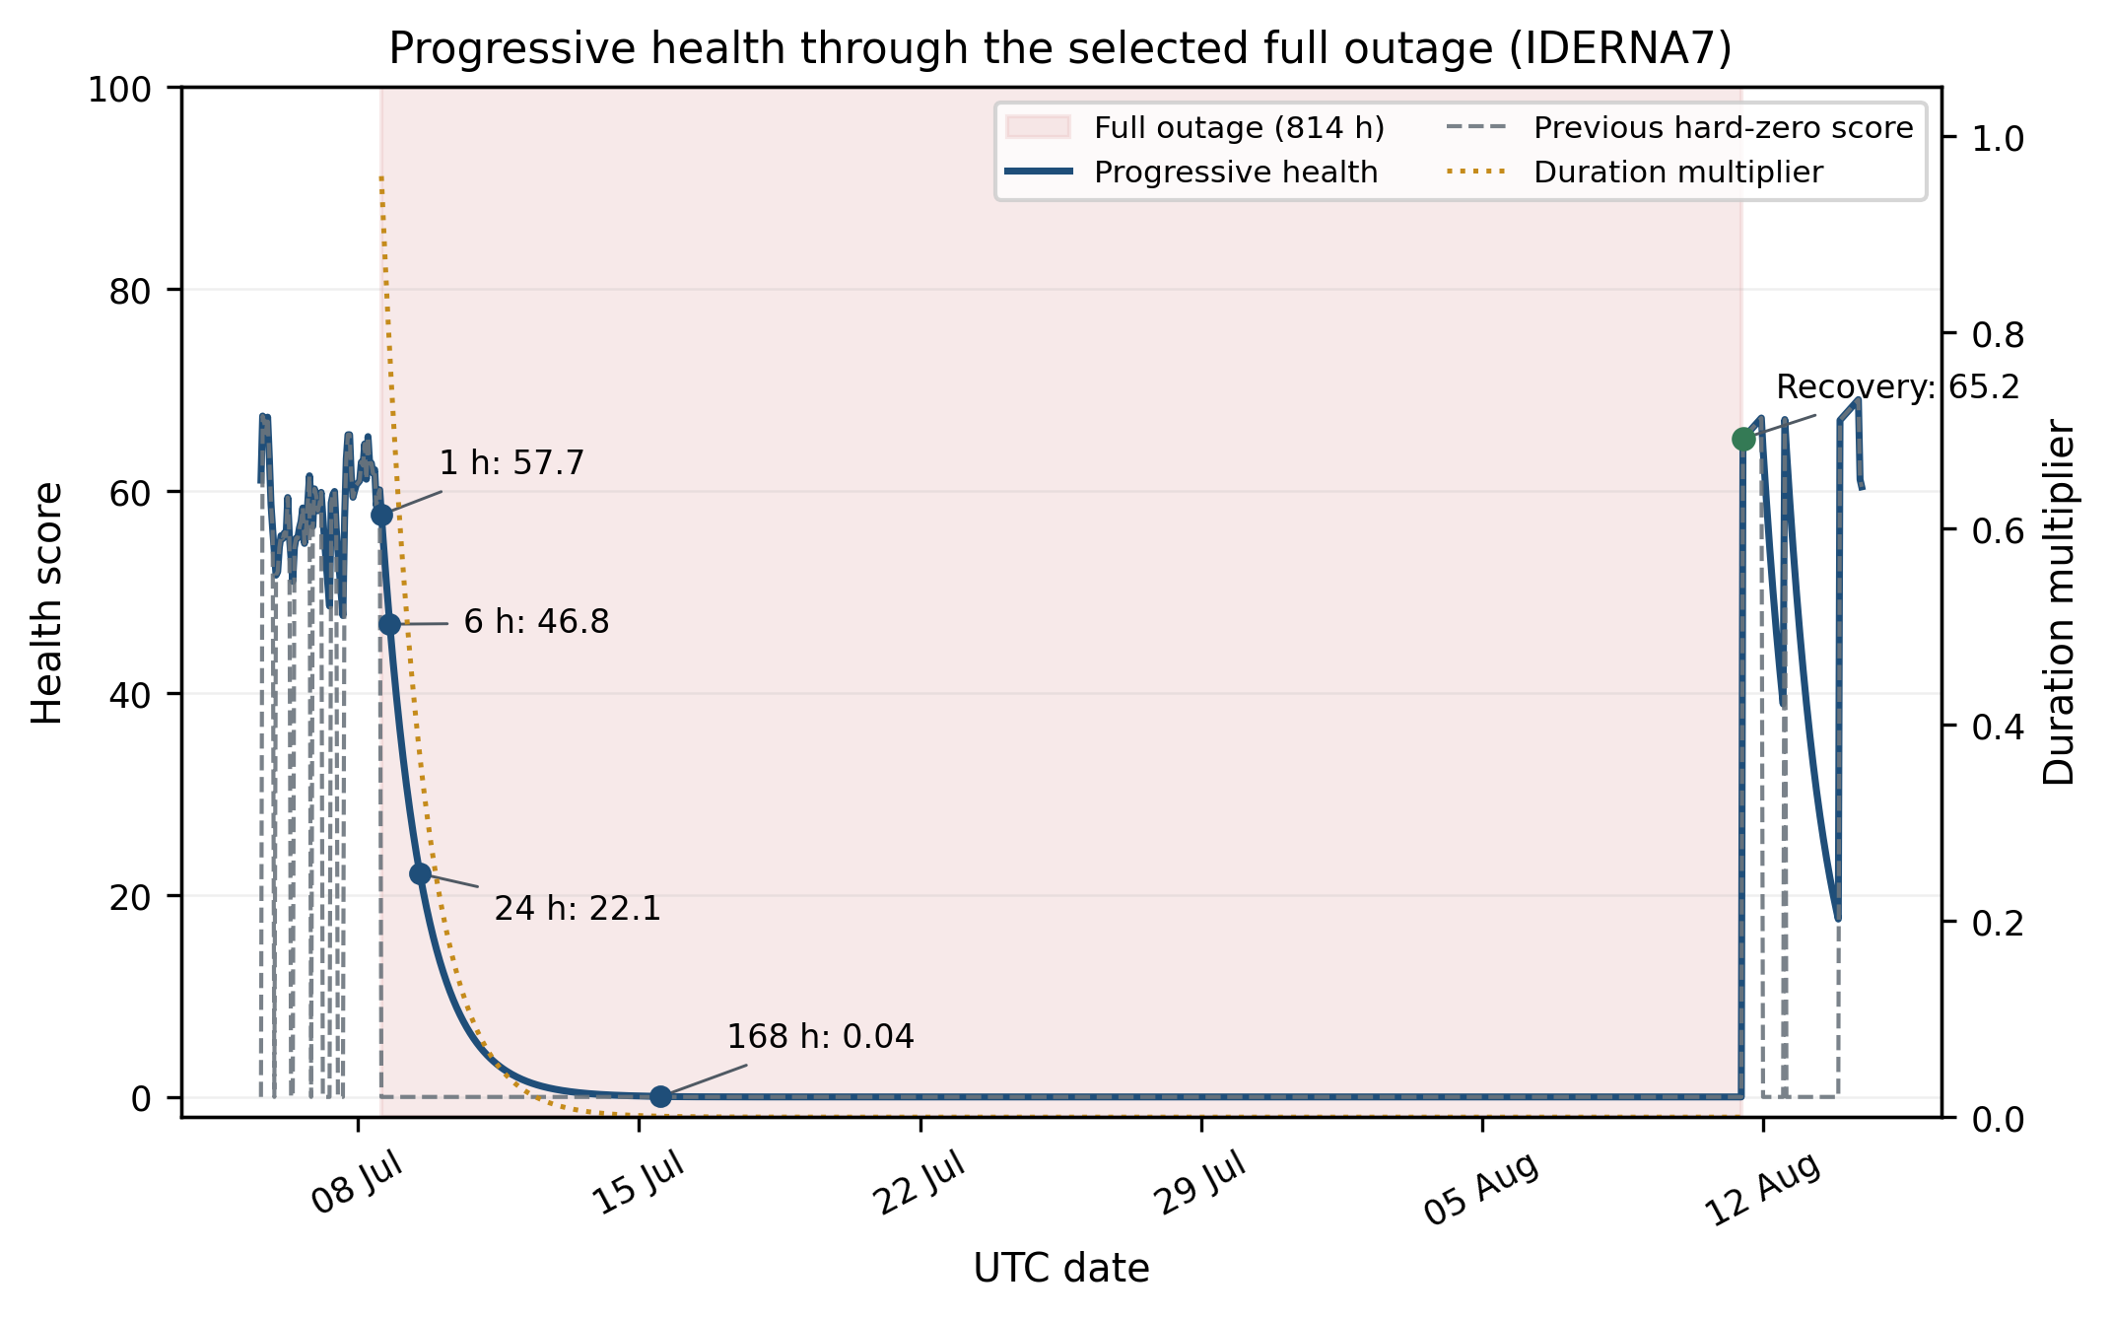
Figure 4.19. IDERNA7 health during a verified 814-hour outage and first recovery hour; the annotated trajectory verifies monotonic duration degradation and a graded, auditable recovery rather than an indistinguishable hard zero.
The health score is therefore an operational definition rather than a claim of clinical or meteorological ground truth. Its weights and exponential constants are declared design choices, not tuned outcomes. The score is useful because its causal components and duration effects are inspectable; an independent maintenance outcome dataset would be required to learn or validate an optimal utility weighting.
Chapter 5

Model Creation, Experiments, and Selection
This chapter separates the three learning tasks: current fault detection, fault-mechanism diagnosis, and future health forecasting. Each task is compared with suitable baselines, and the final model is selected from validation results rather than from the test set.

5.1 Experimental Setup
The experimental record covers 15 June 2025 through 30 June 2026. It contains 26 stations, 166,017 station-hours, and 41 columns. A fully covered station span contains 9,144 hourly timestamps across this frozen period. The network is geographically uneven: IALWAH18 and IDERNA7 have no nearby spatial neighbour.
The audit and availability results use the lifecycle table, audit summary, missingness table, frozen full-outage events, operational hourly availability classification, partial-outage events, and network-window table produced from the canonical record. Labelling uses the canonical episode catalogue, detection uses the frozen hour-level artifacts, and health, forecast, and scorecard results use their recorded reports, predictions, selection traces, and invariant files. All timestamps are UTC unless stated otherwise.
Network-wide outage analysis uses the 47 extracted windows and their station-event membership. It distinguishes midnight-classified windows from other coordinated windows without treating a network-wide pattern as a station-local failure.

5.2 Testing Procedure
Testing and evaluation use automated tests, deterministic artifact generation, and diagnostic investigation. The row-state classifier is checked for the five live lifecycle states. The outage engine is checked for deterministic grouping, event identifiers, durations, and class assignment.
Network-wide events are characterised from synchronized outage starts, station counts, timing, geographic spread, and recovery duration. The interpretation remains observational: the analysis identifies shared patterns without claiming direct access to the upstream upload platform.
Pairwise local co-occurrence is treated as a diagnostic after network-wide windows are excluded. It is not used as a fault label or a model target.

5.3 Performance Metrics
The foundation layers use present rate, lifecycle-state counts, per-variable missingness, full- and partial-outage counts, event durations, sensor-group availability, and coordinated-window count. The hour-level detector and retrospective reason-code experiment use accuracy, precision, recall, and F1. Health forecasting uses MAE as the primary validation criterion, with RMSE and R² retained for error-scale interpretation; band forecasts use accuracy, balanced accuracy, and macro F1, while transition-only accuracy isolates actual band changes.
For network-wide investigation, additional metrics include number of affected stations, window start hour, drop synchronization spread, per-station outage duration, recovery spread, pairwise geographic distance, concurrent offline fraction, and station-pair co-occurrence ratio.
The detector reports precision, recall, F1, and accuracy for the binary fault class. Accuracy is retained because it is a supervisor requirement, but it is interpreted with precision, recall, and F1 because only 5.58% of all station-hours are faults. The event-level mechanism experiment reports the same four metrics as macro averages, which weight evaluable mechanisms equally, and micro averages, which pool their label decisions. Operating weights, thresholds, and the event aggregation configuration are selected on validation data; all predefined test configurations are shown without test-set winner selection.
$$Precision=\frac{TP}{TP+FP},Recall=\frac{TP}{TP+FN},F_{1}=\frac{2PR}{P+R},Accuracy=\frac{TP+TN}{N}$$
TP, FP, TN, and FN denote true positives, false positives, true negatives, and false negatives. Precision measures alert correctness, recall measures detected-fault coverage, F1 is their harmonic mean, and accuracy measures all correct decisions; accuracy is never interpreted alone on imbalanced targets.
$$MAE=\frac{1}{n}\sum_{i}{|}y_{i}-{\overset{^}{y}}_{i}|,RMSE=\sqrt{\frac{1}{n}\sum_{i}{(}y_{i}-{\overset{^}{y}}_{i})^{2}}$$
For health forecasting, y_i and ŷ_i are observed and predicted future health. MAE is the primary model-selection loss because it matches the absolute-error objective and is less dominated by rare large errors; RMSE remains a useful sensitivity measure for those large misses.
$$R^{2}=1-\frac{\sum_{i}{(}y_{i}-{\overset{^}{y}}_{i})^{2}}{\sum_{i}{(}y_{i}-\overset{―}{y})^{2}}$$
R² compares squared forecast error with prediction by the test-set mean ȳ. Health-band accuracy is accompanied by balanced accuracy, the mean recall across bands, and macro F1, the unweighted mean of per-band F1. Transition-only accuracy is computed only where the observed future band differs from the current band.

5.4 Binary Fault Detection

5.4.1 Classical Baselines
Logistic regression provides a simple linear baseline. Histogram gradient boosting (HGB) provides a strong nonlinear baseline that can learn interactions between evidence features without requiring a deep sequence model.

5.4.2 Reliability-Aware Gated Fusion Network
RGFN is the first custom model developed in this project. Its temporal branch reads a seven-hour past-only sequence of engineered detector-derived features, including external and spatial residual scores, rolling statistical summaries, and fleet-relative measures. It also receives a missingness mask and time-since-last-observation signal. A separate evidence branch reads rule and detector indicators, while static station context represents properties such as elevation and geographic isolation. Raw station measurements are not directly present in this tensor.
A learned Evidence Gate combines the temporal representation with the rule-evidence representation before producing the binary fault probability. Its missingness representation is in the spirit of GRU-D [1], using mask and elapsed-time inputs without the trainable decay mechanism of the original GRU-D. The same architecture was also tested for fault-mechanism reason codes. These diagnosis experiments are evaluated retrospectively and do not define live event boundaries.
$$g_{t}=σ(W_{g}[h_{t};e_{t};c_{s}]+b_{g}),z_{t}=g_{t}z_{temporal}+(1-g_{t})z_{evidence},p_{t}=σ(z_{t})$$
h_t is the GRU temporal representation, e_t is the rule-evidence representation, c_s is static station context, σ is the logistic sigmoid, and g_t is the learned Evidence Gate. The fused logit z_t produces the station-hour fault probability p_t.

5.4.3 Results and Final Binary-Detector Selection
Fault detection is evaluated at the station-hour level. Each reported model uses a seven-hour past-only input window ending at the scored hour. The hour-level dataset has 130,218 training-eligible examples: 9,260 fault hours, 7,320 benign candidate hours, and 113,638 clean hours; 35,799 excluded hours do not receive a training label. Table 5.1 and Figure 5.1 make this composition explicit. Figure 5.1 visualises the target composition.
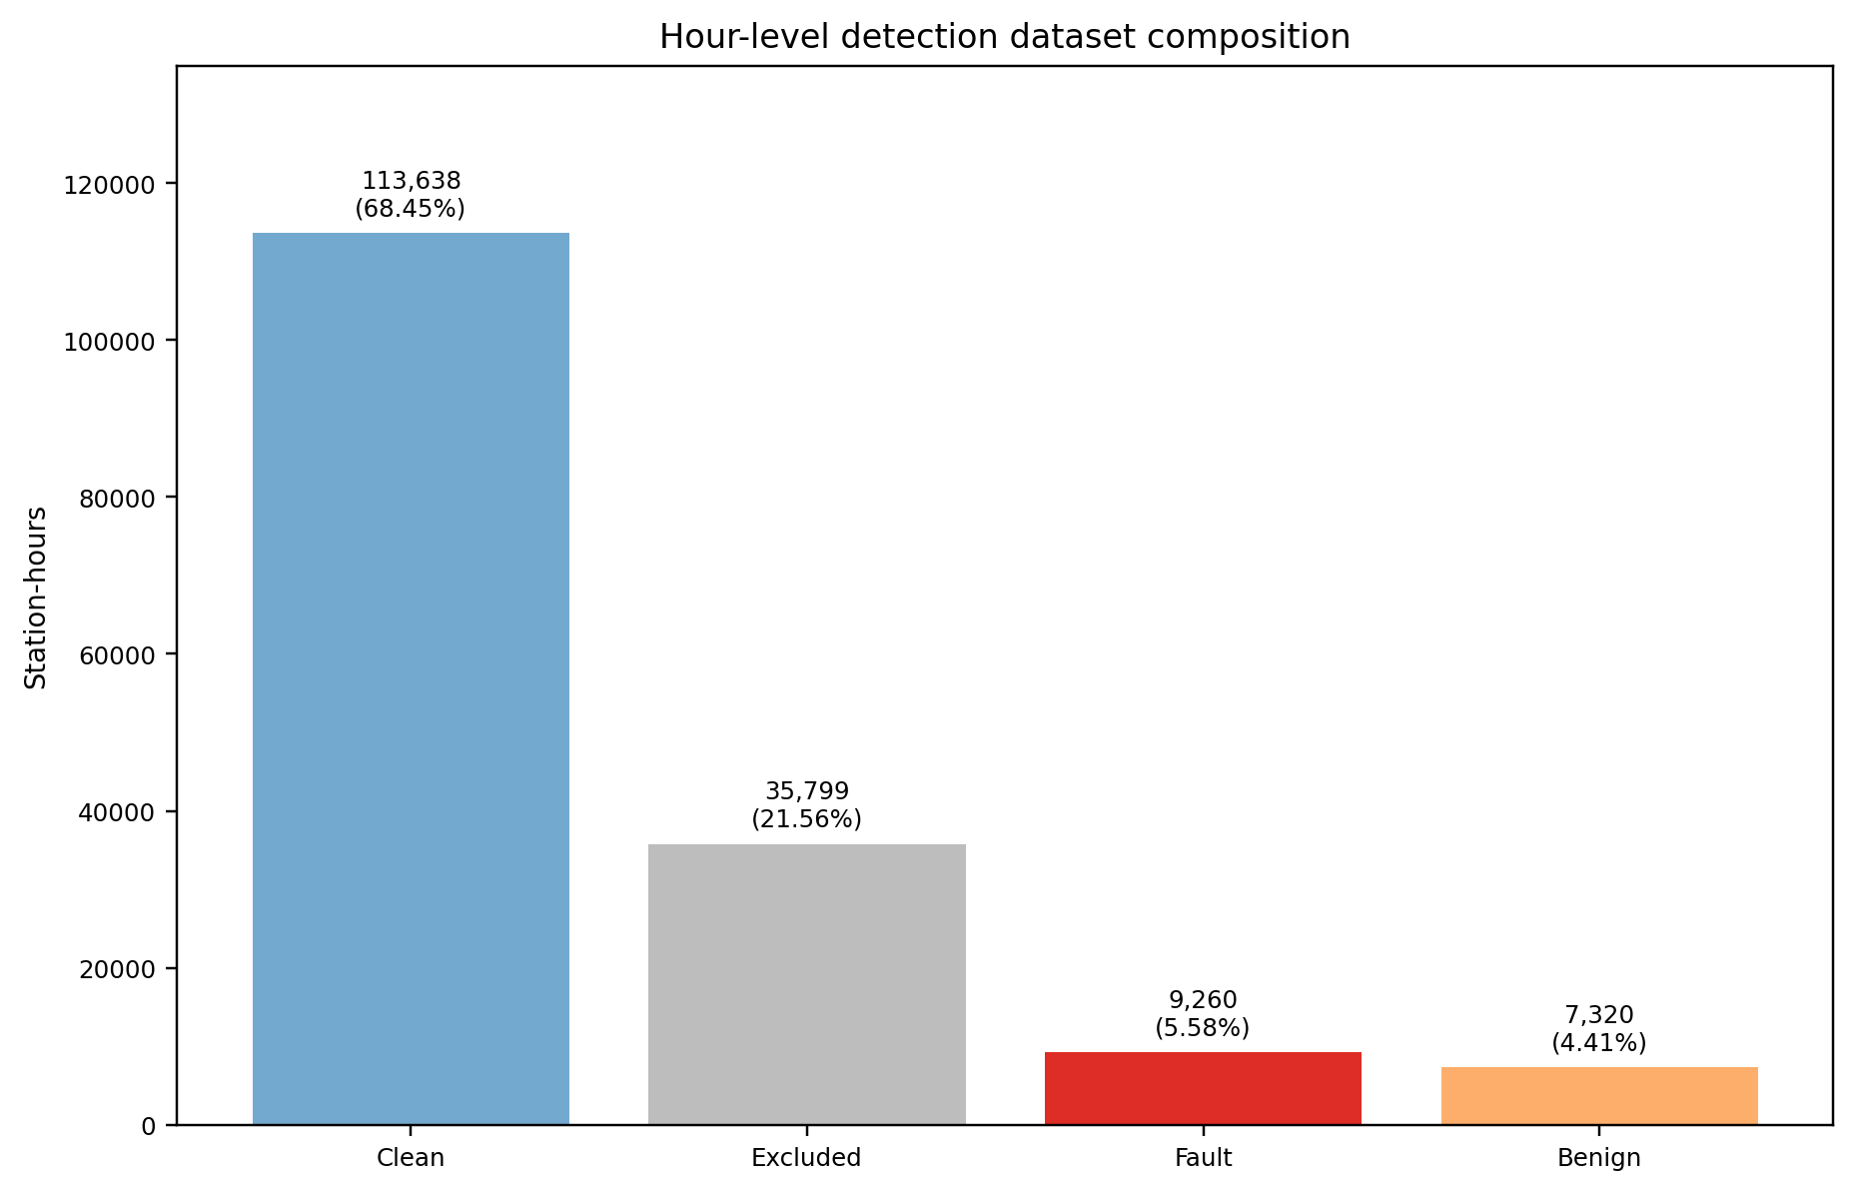
Figure 5.1. Hour-level target composition across all 166,017 observed station-hours; excluded hours remain outside training and the dominant clean class explains high raw accuracy.
Table 5.1 Hour-level dataset composition and training use.
Composition | Hours | % of total | Training use
Clean | 113,638 | 68.45% | fault_hour = 0
Excluded | 35,799 | 21.56% | No train/evaluation label
Fault | 9,260 | 5.58% | fault_hour = 1
Benign | 7,320 | 4.41% | fault_hour = 0
Training eligible | 130,218 | 78.44% | Included
Three model families are compared on the same binary task: logistic regression, histogram gradient boosting, and RGFN. Every model uses a seven-hour past-only window. Random and episode-grouped spaced partitions are reported, and model settings and decision thresholds are selected using validation data only.
The complete predefined comparison is reported so that the result does not depend on selecting a favourite test score. The episode-grouped spaced split is stricter because it keeps positive source episodes together, but it remains non-independent: 94.63% of its seven-hour test windows and 99.30% of its 49-hour test windows overlap a training window, and several underlying features use full historical context. The results are therefore retrospective development estimates rather than live deployment estimates.
Table 5.2 Hour-level binary fault-detection results. All operating points were selected on validation data.
Method | Split | Validation F1 | Test accuracy | Test precision | Test recall | Test F1
Logistic regression | Random | 0.834 | 0.976 | 0.833 | 0.825 | 0.829
Gradient boosted | Random | 0.900 | 0.986 | 0.899 | 0.906 | 0.902
RGFN Arm 2 | Random | 0.881 | 0.984 | 0.893 | 0.880 | 0.886
Logistic regression | Spaced | 0.856 | 0.981 | 0.856 | 0.877 | 0.867
Gradient boosted | Spaced | 0.887 | 0.984 | 0.890 | 0.881 | 0.886
RGFN Arm 2 | Spaced | 0.880 | 0.983 | 0.874 | 0.889 | 0.881

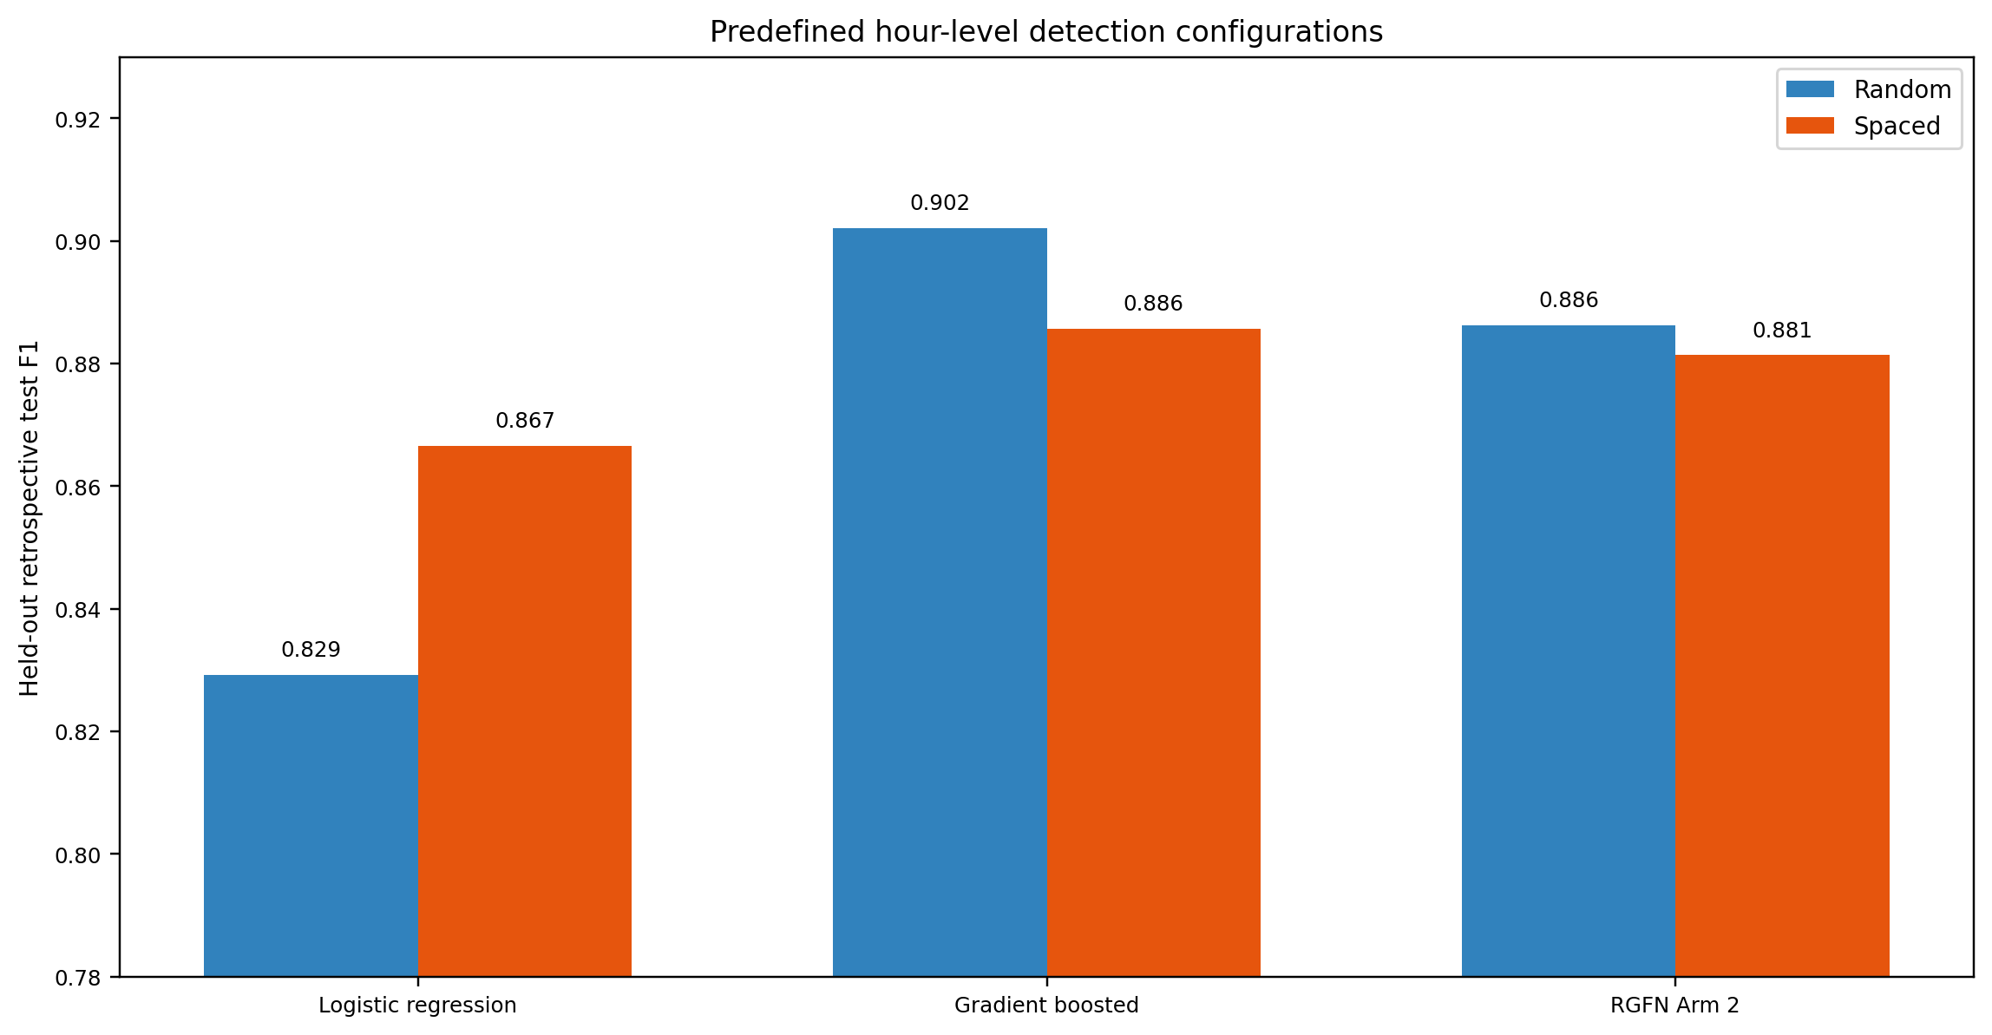
Figure 5.2. Held-out retrospective test F1 for all predefined detector configurations; the full table is reported without naming a test-selected winner.
The operating point trades false alarms against missed faults through class weighting and thresholding. Each split has its own validation-selected operating point: gradient boosting uses weight 2 and threshold 0.40 for the random split, and weight 4 and threshold 0.55 for the spaced split. These choices are recorded before the associated held-out test metrics are read. Figure 5.3 documents the validation-to-test boundary.
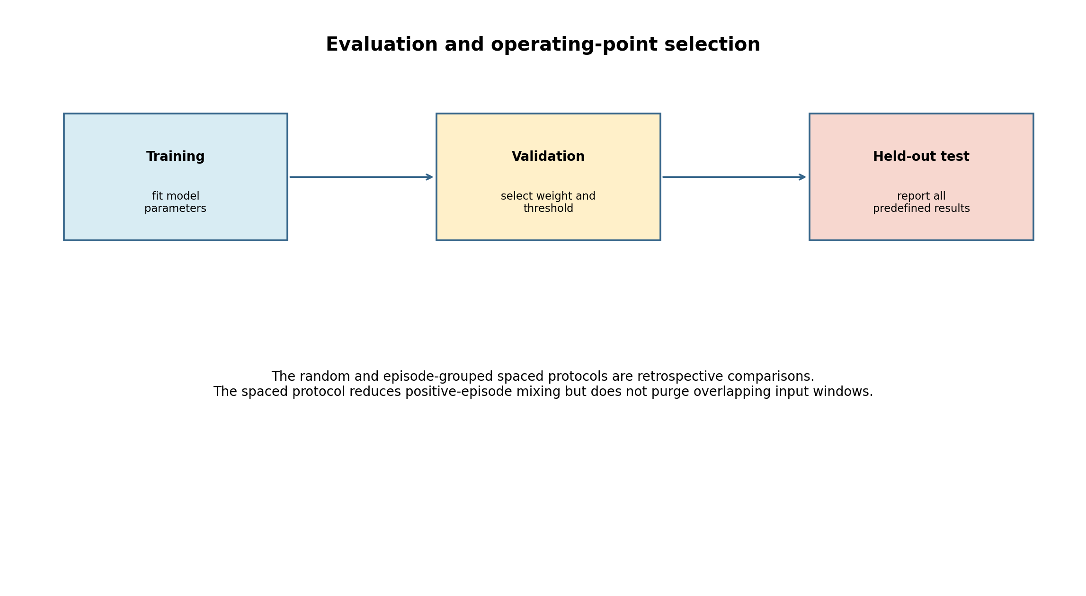
Figure 5.3. Validation-only operating-point selection followed by one held-out test evaluation; the boundary prevents test metrics from choosing weights or thresholds.
The reported configuration uses the per-hour presence mask with shape (N, window, 1). A reproducible per-feature mask experiment produced no measurable improvement, so it remains an explicit option rather than a parallel implementation. Both modes retain time-since-last-observation.
RGFN experiments examine three predefined arms: trailing-evidence features, architecture and optimisation tuning, and their combination. Arm 2 refers to the architecture/optimisation search; it is a configuration label rather than a claim of overall superiority.
The Arm 2 search varies the GRU hidden size, evidence encoder width, gate width, regularisation, learning rate, class weight, and decision threshold. Configuration selection uses validation metrics. The tuned architecture uses a 64-unit GRU, 32-unit evidence branch, 16-unit gate, and approximately twenty thousand parameters.
Table 5.3 reports the complete RGFN configuration set. The results show that architecture and feature choices change retrospective performance modestly; they do not justify a test-set-selected winner. The gradient-boosted and RGFN results are therefore presented side by side as complementary predefined comparisons.
Table 5.3 RGFN configurations: validation selection and held-out retrospective test metrics.
Split | RGFN configuration | Validation F1 | Test accuracy | Test precision | Test recall | Test F1
Random | Prior GRU | 0.884 | 0.985 | 0.909 | 0.874 | 0.891
Random | Arm 1: added features | 0.876 | 0.983 | 0.885 | 0.875 | 0.880
Random | Arm 2: tuned architecture | 0.881 | 0.984 | 0.893 | 0.880 | 0.886
Random | Arm 3: combined | 0.877 | 0.983 | 0.893 | 0.869 | 0.881
Spaced | Prior GRU | 0.878 | 0.984 | 0.896 | 0.872 | 0.884
Spaced | Arm 1: added features | 0.872 | 0.982 | 0.891 | 0.857 | 0.873
Spaced | Arm 2: tuned architecture | 0.880 | 0.983 | 0.874 | 0.889 | 0.881
Spaced | Arm 3: combined | 0.868 | 0.980 | 0.856 | 0.868 | 0.862

The taxonomy contains four fault mechanisms and six physical components. Binary fault detection remains the main station-hour task. Mechanism labels are evaluated separately as event-level reason codes. Component localisation is intentionally withheld from the delivered result because its independent support is too thin for a defensible claim.
HGB was selected as the operational binary detector from the predefined validation comparison and its practical deployment cost. Its held-out development result was then reported without using that test score to revise the choice. RGFN remains an important custom-model experiment because it tests whether gated temporal evidence fusion improves the same task; its competitive but lower development result showed that added architectural complexity did not improve this dataset.

5.5 Fault-Mechanism Reason Codes
The reason-code experiment is conditional: it receives only fault-hours and predicts the four mechanism labels. Logistic regression, gradient boosting, and the RGFN reuse the frozen binary split manifest and their existing training-only threshold selection. Predictions are aggregated across connected, ground-truth-labelled event groups by three predefined rules: any hour, majority, and mean probability. This is a diagnosis experiment, not a second binary detector and not a component-localisation claim.
Method and aggregation rule were selected from the 67 complete spaced validation event groups only. The support-qualified selection set contains spike-impossible, statistical-anomaly, and stuck-flatline; calibration offset has only one positive complete validation event and is excluded before selection. Gradient boosting with the any-hour rule ranks first on validation macro F1 (0.868), as shown in Table 5.4. No held-out test metric was available to this selection step.
Table 5.4 Validation-only selection of the spaced mechanism reason-code configuration. Macro values are precision, recall, F1, and accuracy.
Method | Aggregation | Macro precision | Macro recall | Macro F1 | Macro accuracy | Rank
Gradient boosted | Any hour | 0.780 | 1.000 | 0.868 | 0.881 | 1
Gradient boosted | Mean probability | 0.798 | 0.926 | 0.854 | 0.900 | 2
Gradient boosted | Majority | 0.786 | 0.889 | 0.831 | 0.896 | 3
Logistic regression | Majority | 0.801 | 0.852 | 0.824 | 0.920 | 4
Logistic regression | Mean probability | 0.795 | 0.852 | 0.821 | 0.915 | 5
Logistic regression | Any hour | 0.733 | 0.963 | 0.814 | 0.881 | 6
RGFN | Majority | 0.569 | 1.000 | 0.666 | 0.617 | 7
RGFN | Mean probability | 0.569 | 1.000 | 0.665 | 0.612 | 8
RGFN | Any hour | 0.544 | 1.000 | 0.649 | 0.592 | 9
Table 5.5 gives the held-out event-level comparison using the common any-hour aggregation rule. The random partition is retained only as a fragmentation sensitivity result: 318 of its 381 observed test event groups cross partitions. The spaced partition contains 70 complete held-out event groups and is the relevant retrospective comparison. Macro and micro cells list precision / recall / F1 / accuracy.
Table 5.5 Retrospective event-level mechanism reason-code comparison under the predefined any-hour aggregation rule.
Split | Method | Observed event groups | Macro P / R / F1 / Acc | Micro P / R / F1 / Acc
Random sensitivity | Logistic regression | 381 (63 complete; 318 fragmented) | 0.865 / 0.936 / 0.897 / 0.934 | 0.855 / 0.975 / 0.911 / 0.934
Random sensitivity | Gradient boosted | 381 (63 complete; 318 fragmented) | 0.931 / 0.981 / 0.954 / 0.966 | 0.917 / 0.993 / 0.953 / 0.966
Random sensitivity | RGFN | 381 (63 complete; 318 fragmented) | 0.924 / 0.925 / 0.924 / 0.961 | 0.932 / 0.958 / 0.945 / 0.961
Spaced held-out | Logistic regression | 70 (70 complete; 0 fragmented) | 0.728 / 1.000 / 0.826 / 0.886 | 0.753 / 1.000 / 0.859 / 0.886
Spaced held-out | Gradient boosted | 70 (70 complete; 0 fragmented) | 0.795 / 1.000 / 0.878 / 0.876 | 0.737 / 1.000 / 0.849 / 0.876
Spaced held-out | RGFN | 70 (70 complete; 0 fragmented) | 0.527 / 0.984 / 0.625 / 0.571 | 0.447 / 0.986 / 0.615 / 0.571
For the frozen validation-selected configuration, the spaced held-out macro precision, recall, F1, and accuracy are 0.795, 1.000, 0.878, and 0.876; micro values are 0.737, 1.000, 0.849, and 0.876. Gradient boosting is therefore the validation-selected configuration, not a test-selected winner. No configuration reaches 0.80 for all four macro measures on both validation and test: the selected any-hour rule intentionally favours recall, while its precision remains below 0.80.
Table 5.6 Held-out spaced event-level result by mechanism for the frozen validation-selected gradient-boosted any-hour configuration.
Mechanism | Test-event support | Precision | Recall | F1 | Accuracy | Interpretation
Spike-impossible | 8 | 0.727 | 1.000 | 0.842 | 0.957 | Small held-out support.
Statistical anomaly | 44 | 0.657 | 1.000 | 0.793 | 0.671 | Recall-oriented aggregation raises false positives.
Stuck-flatline | 21 | 1.000 | 1.000 | 1.000 | 1.000 | Rule recovery; see text.
Calibration offset | 0 | N/A | N/A | N/A | N/A | Excluded: one positive complete validation event (<5).
The perfect stuck-flatline row should not be interpreted as an independent diagnosis achievement. Its label derives from the deterministic rolling-variance stuck rule, and the corresponding rule-evidence flag is also a model input. Near-perfect recovery therefore measures recovery of that supplied rule evidence. Likewise, the any-hour aggregation produces macro recall of 1.000 because it asserts a mechanism when any constituent hour does so; the lower precision for statistical anomaly shows the cost of this permissive rule. Table 5.6 provides the label-level support and metrics needed to interpret the perfect stuck result correctly.
These results are retrospective diagnosis on ground-truth-connected events, whose source episode identifiers are unavailable in a live dashboard. A live system should display the binary fault score and detector evidence first, and mechanism reason codes require a separately validated source-identifier-free event segmentation and closure rule. Component localisation and live event diagnosis remain future work.
Gradient boosting is the validation-selected reason-code research configuration. RGFN is reported as a tested diagnostic architecture. Neither is promoted to autonomous live diagnosis because the available results remain retrospective development evidence.

5.6 Health-Forecasting Method
The forecast task estimates future station health at 1, 3, 6, 12, and 24 hours for stations transmitting at the forecast origin. A smooth score is strongly autocorrelated, so high level-prediction accuracy alone can be trivial. The experiment therefore compares learned forecasts with persistence, recent-trend extrapolation, and a no-new-incident roll-forward baseline that advances the score’s trailing windows while assuming no new adverse evidence arrives.
The roll-forward baseline is the strictest comparator because it already performs the score’s deterministic window arithmetic. The model predicts only the residual correction that remains. This reduces the need to relearn the score definition and allows validation to shrink an unreliable correction towards the baseline.
$$r(t,H)=H_{t+H}-B(t,H)$$
H_(t+H) is observed future health at horizon H and B(t,H) is the causal no-new-incident roll-forward baseline constructed from information at or before t.
$${\overset{^}{H}}_{t+H}=clip[B(t,H)+α_{H}\overset{^}{r}(t,H),0,100]$$
r̂(t,H) is the learned residual estimate. The shrinkage α_H is selected on chronological validation from {0, 0.1, 0.25, 0.5, 0.75, 1.0}; zero is included so validation may reject the learned correction entirely. The transmitting-origin configurations retain a non-zero correction at all horizons, while the supplementary active-full-outage regime selects zero at 1 and 3 hours.
Candidate models are a regularised linear regressor, histogram gradient boosting with absolute-error loss, and CatBoost with absolute-error loss and station identity treated categorically [9]. Candidate iteration counts and all other configurations are chosen on the chronological validation partition; automatic internal random early stopping is disabled. After the configuration and shrinkage are frozen, the final model is refitted on train plus validation and test is evaluated once.
Forecasts are scoped to transmitting origins because an already-silent station needs intervention rather than a generic continuation estimate, and recovery depends on unobserved maintenance response. Full-outage-origin forecasts are retained only as a supplementary diagnostic. The scope is fixed before interpreting results and propagates to the scorecard as an explicit forecast-not-applicable state during a current full outage. Figure 5.4 summarises the residual correction and validation-only policy selection.
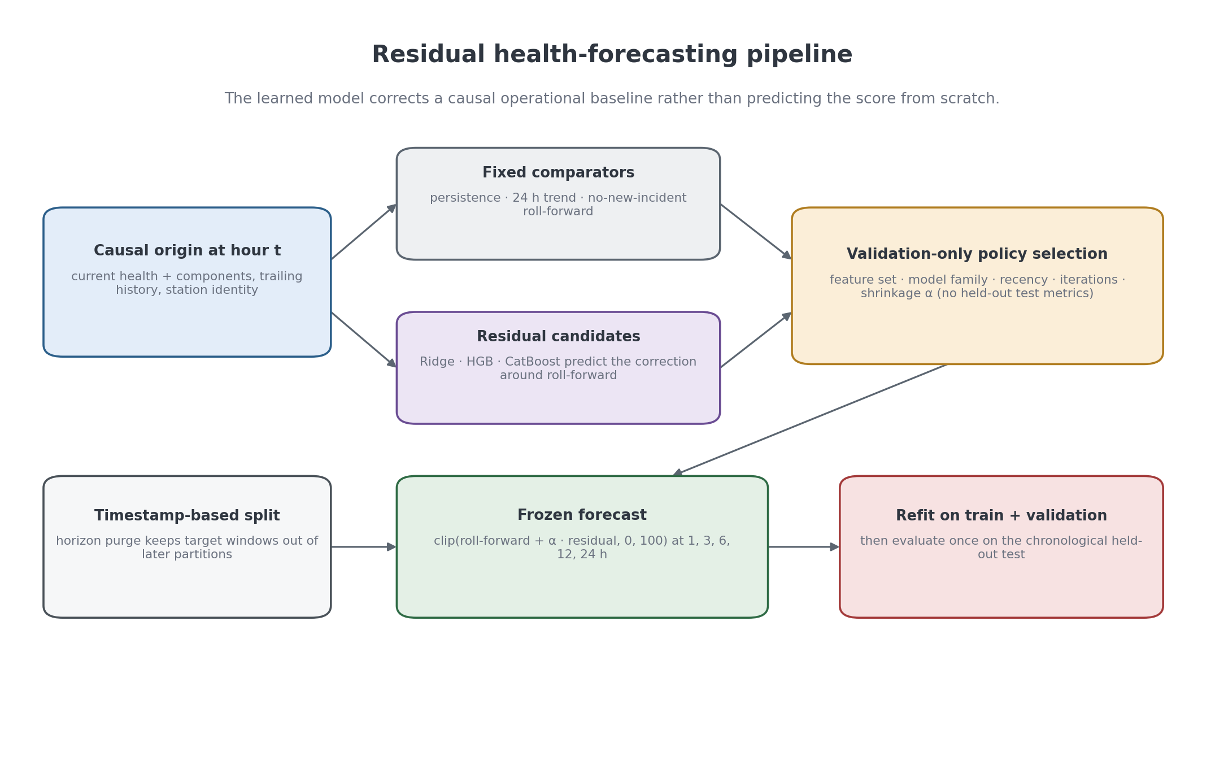
Figure 5.4. Residual health-forecasting pipeline; the learned model corrects a causal roll-forward baseline and validation-controlled shrinkage prevents an unsupported correction from dominating the bounded forecast.

5.7 Health-Forecasting Results
Health forecasting is evaluated at transmitting origins over 1, 3, 6, 12, and 24 hours. The selected configurations are frozen by chronological validation, with no test metric used to choose a horizon model. CatBoost is selected at all five primary horizons from the predefined linear, histogram-gradient-boosting, and CatBoost candidates; station identity is categorical and the residual correction is shrunk before being added to the deterministic roll-forward baseline.
Table 5.7. Primary transmitting-origin health forecasts and deterministic baselines; MAE improves over both persistence and roll-forward at every horizon, while error grows with forecast distance.
H | Test n | MAE | RMSE | R² | Persist. MAE | Roll-fwd MAE | Gain vs persist. | Gain vs roll-fwd
1 h | 28,968 | 1.270 | 2.314 | 0.971 | 1.383 | 1.311 | 8.14% | 3.10%
3 h | 28,990 | 2.533 | 3.952 | 0.916 | 2.767 | 2.796 | 8.46% | 9.41%
6 h | 28,962 | 3.835 | 6.018 | 0.807 | 4.111 | 4.353 | 6.71% | 11.89%
12 h | 28,936 | 4.613 | 6.753 | 0.767 | 5.758 | 6.570 | 19.89% | 29.79%
24 h | 28,871 | 6.070 | 8.689 | 0.640 | 6.539 | 8.406 | 7.16% | 27.78%
Table 5.7 shows that the learned correction adds the most relative value over roll-forward at 12 and 24 hours. The 1-hour MAE of 1.270 and R² of 0.971 reflect the score’s short-term continuity, while the 24-hour MAE of 6.070 and R² of 0.640 show genuine horizon degradation. At 6 hours the selected policy has the lower MAE, but persistence retains a slightly better RMSE and R² at that horizon (5.883 and 0.816, against 6.018 and 0.807); these two persistence values are not tabulated above because Table 5.7 reports baselines by MAE alone. The primary selection objective is MAE, so this secondary-metric trade-off is reported rather than hidden. Figure 5.5 presents the same baseline comparison visually across horizons.
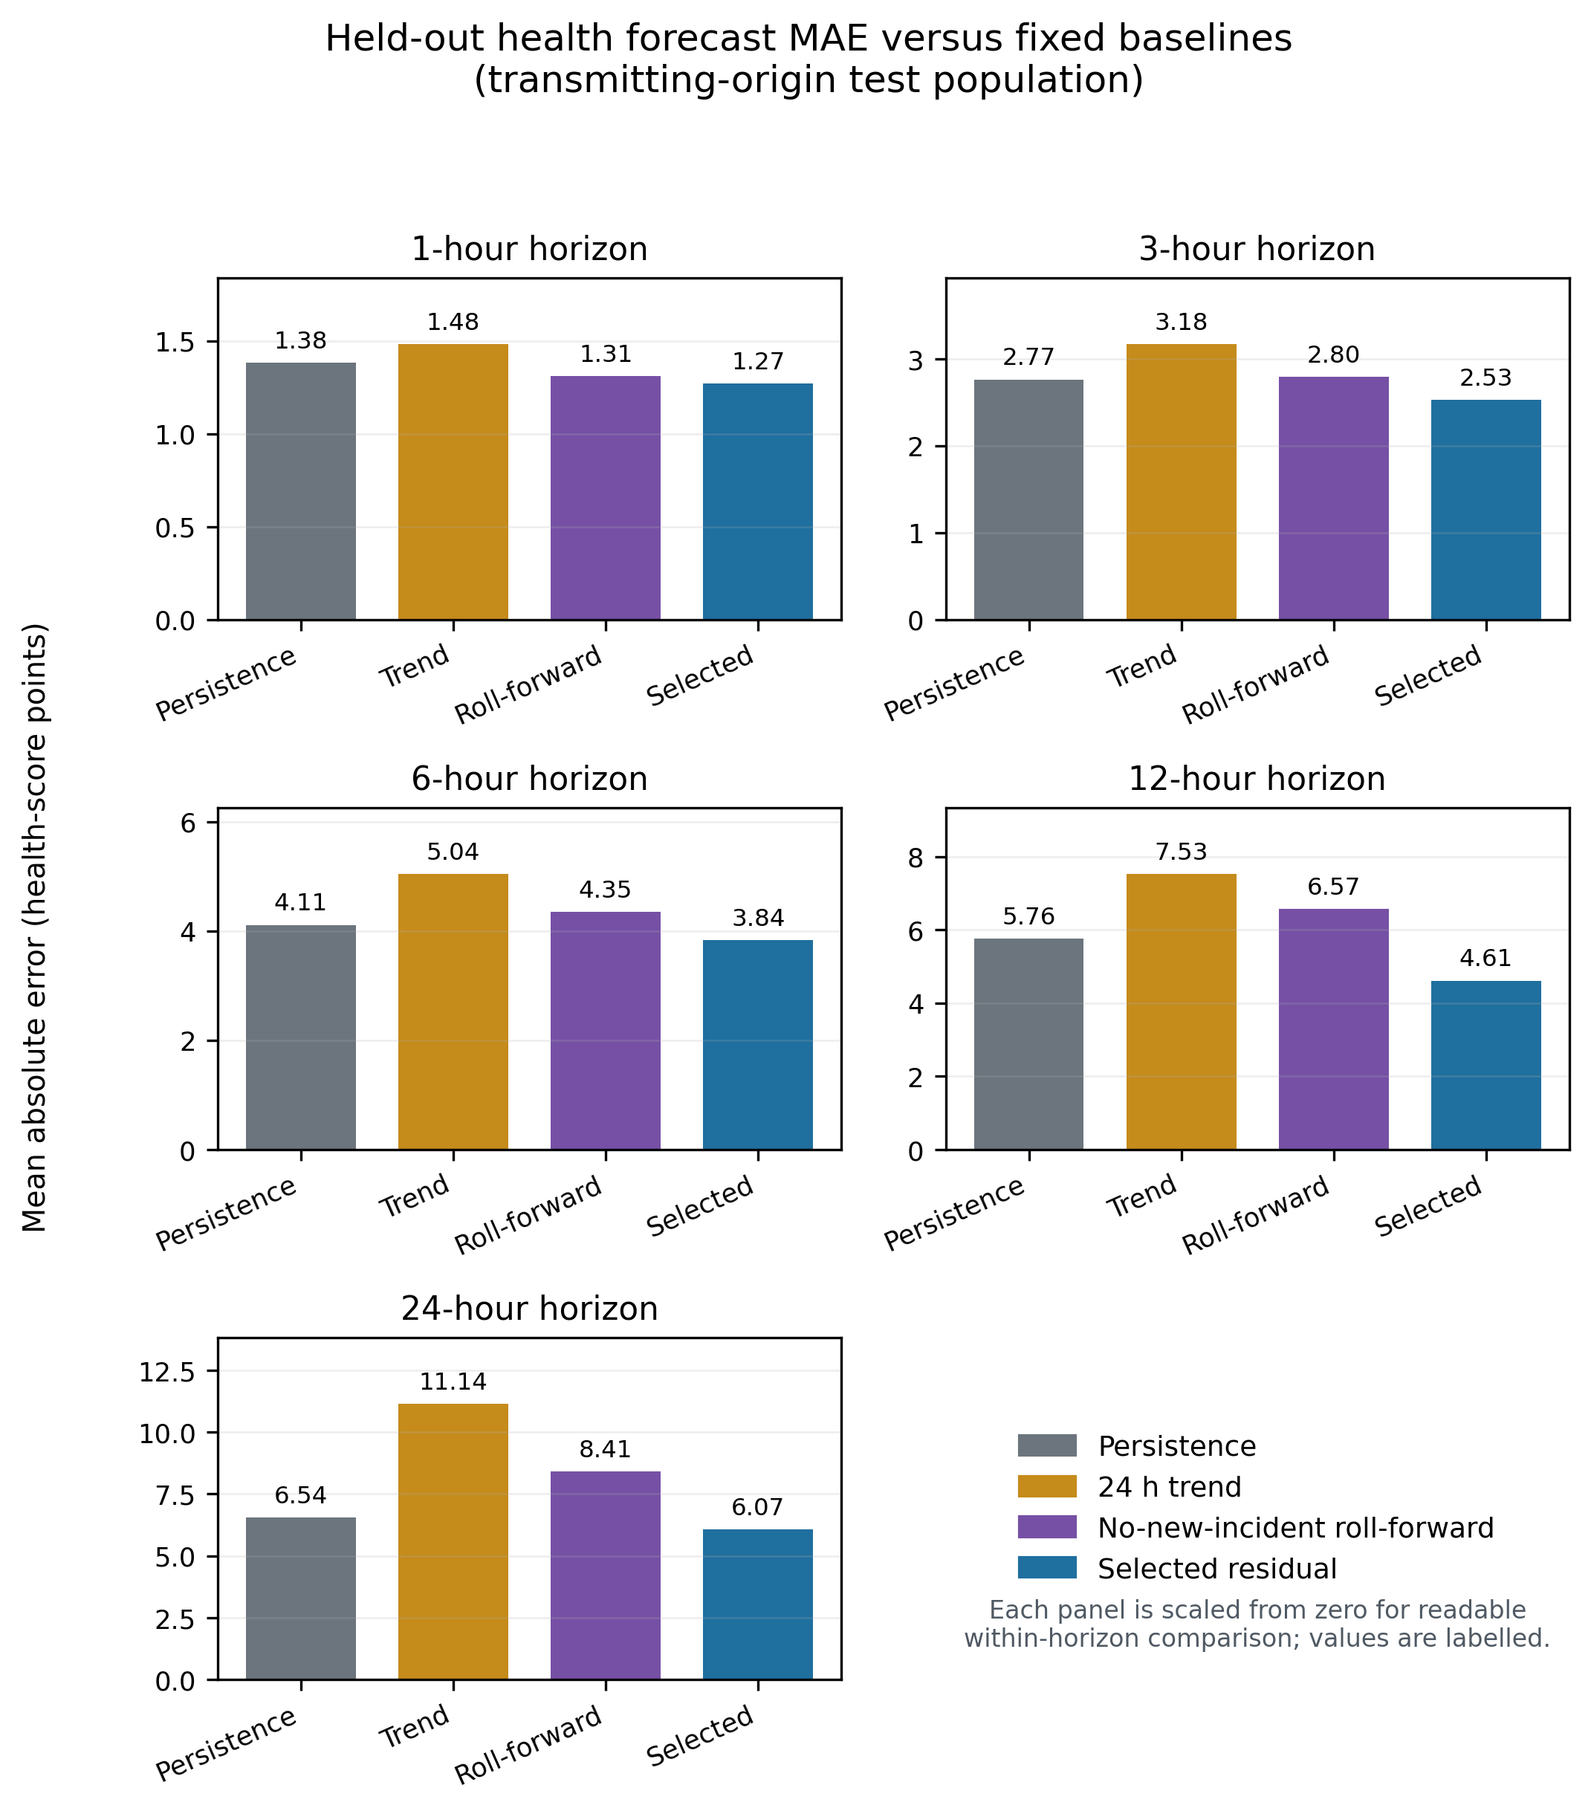
Figure 5.5. Primary forecast MAE against persistence and no-new-incident roll-forward at each horizon; the panels show where the learned residual adds value beyond smooth-signal continuation.
The selected transmitting configurations are CatBoost with core features and no recency restriction at 1 hour (300 iterations, α=0.75), core features with a 90-day training window at 3 hours (300, α=1), core features with a 30-day window at 6 hours (300, α=1), full engineered features with no recency restriction at 12 hours (300, α=1), and core features with no recency restriction at 24 hours (100, α=1). Candidate iteration counts are selected on chronological validation; automatic random early stopping is disabled. Table 5.8 records the frozen validation-selected policy for every horizon.
Table 5.8. Validation-selected transmitting-origin health-forecast configurations; iteration count, feature set, recency window, and shrinkage were frozen before held-out test evaluation.
H | Model | Features | Recency half-life | Iterations | α
1 h | CatBoost | Core | None | 300 | 0.75
3 h | CatBoost | Core | 90 d | 300 | 1.00
6 h | CatBoost | Core | 30 d | 300 | 1.00
12 h | CatBoost | Full engineered | None | 300 | 1.00
24 h | CatBoost | Core | None | 100 | 1.00
The regression design was corrected during development. An earlier squared-error level model produced averages between the near-zero still-down and roughly mid-sixties recovered modes for long outages. Aligning the objective with MAE, predicting a residual, separating transmitting from already-outage origins, and clipping physical bounds reduced overall-population 24-hour development MAE from 17.62 to 8.33 and raised R² from 0.31 to 0.60 over 34,892 test rows. This is a development comparison, not the primary transmitting-origin result and not an independent second test. Figure 5.6 shows the resulting level calibration at each horizon.
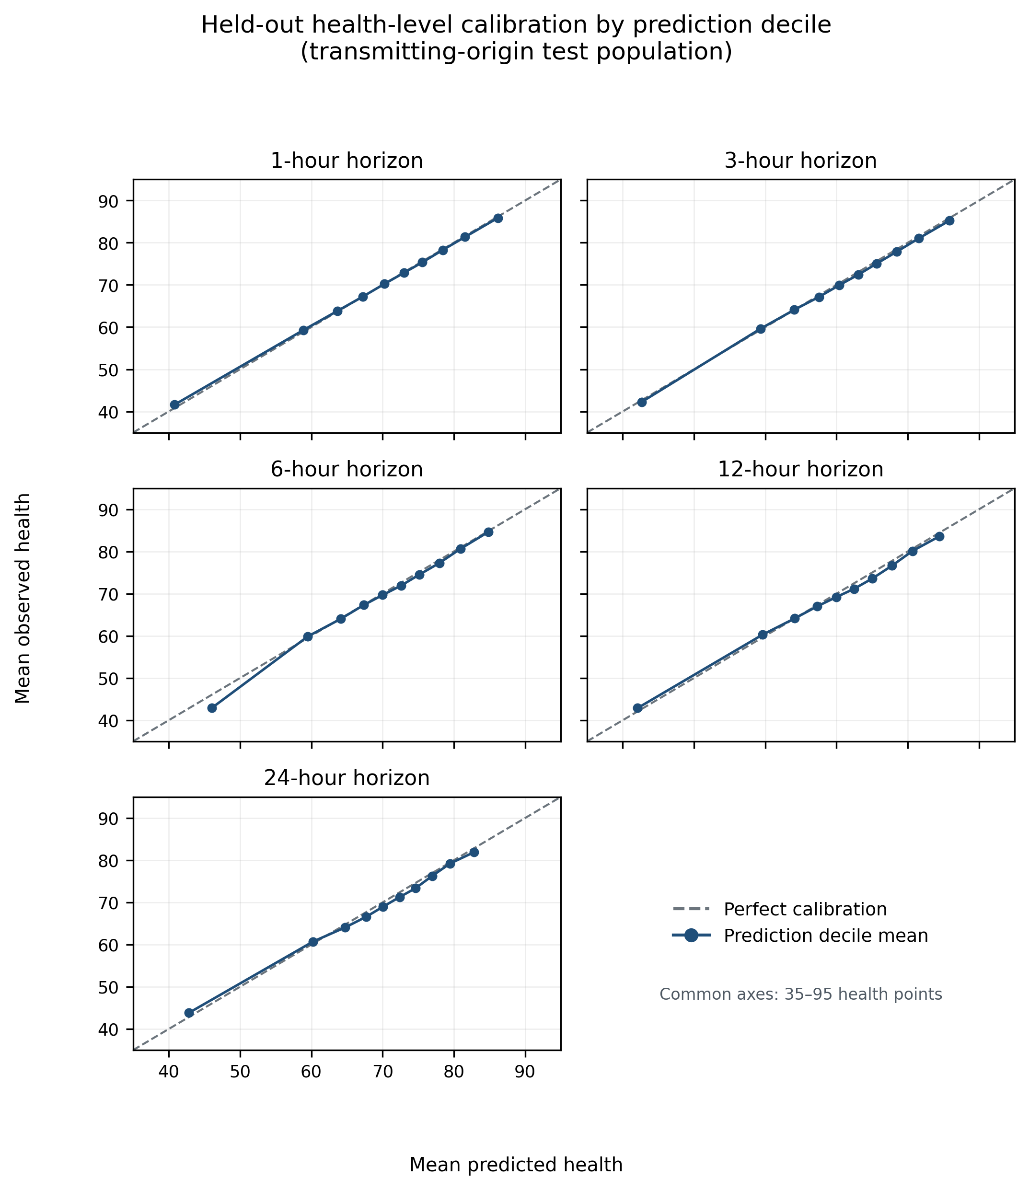
Figure 5.6. Observed versus predicted health by forecast horizon; calibration remains close to the identity line at short horizons and broadens at 12 and 24 hours, identifying where level uncertainty grows.
Table 5.9. Health-band classification on transmitting origins; balanced accuracy and macro F1 accompany accuracy because the four operational bands are imbalanced.
H | Accuracy | Balanced accuracy | Macro F1 | Current-band persistence | Transition-only accuracy
1 h | 93.62% | 94.09% | 93.57% | 93.04% | 21.74%
3 h | 88.11% | 86.55% | 87.18% | 86.39% | 28.97%
6 h | 83.42% | 79.13% | 81.14% | 79.83% | 34.18%
12 h | 78.42% | 72.88% | 75.19% | 72.50% | 36.34%
24 h | 71.48% | 59.05% | 63.40% | 69.71% | 28.28%
Table 5.9 shows that continuous-score accuracy does not translate uniformly into operational band transitions. The 1-hour band result is strong, but transition-only accuracy is only 21.74% because actual crossings are uncommon and difficult. At 24 hours the selected balanced accuracy of 59.05% falls below the balanced accuracy of current-band persistence, 60.32%, even though overall accuracy improves from the 69.71% persistence value in Table 5.9 to 71.48%. The 24-hour band result is therefore the weakest and must not be summarised by accuracy alone. Figure 5.7 places the regression and band degradation curves on one horizon axis.
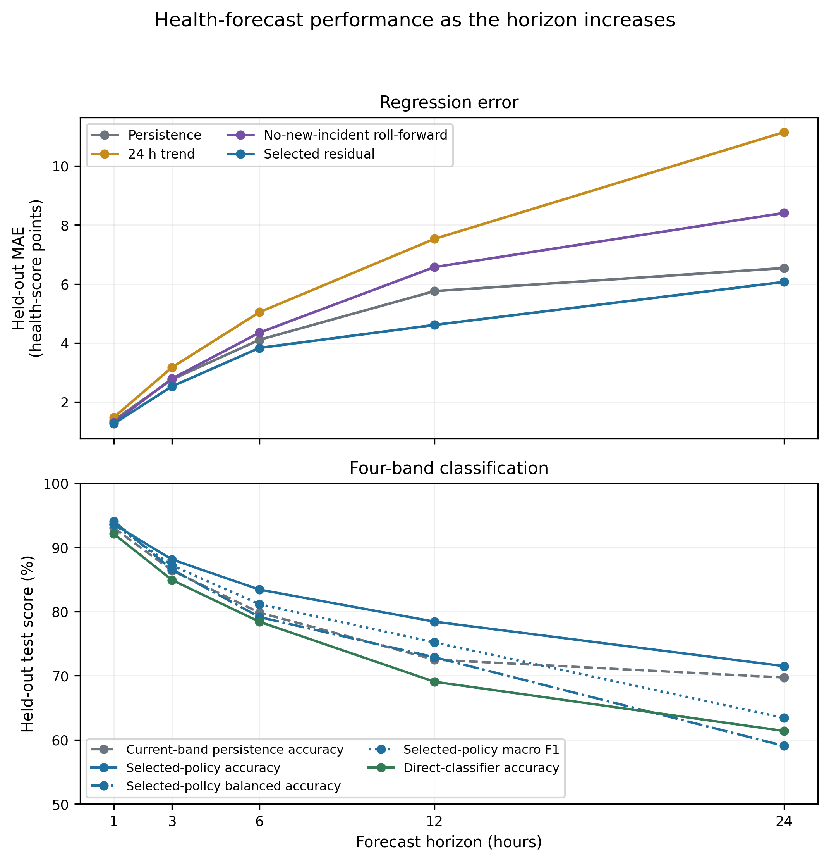
Figure 5.7. Regression and band-classification performance across 1-24 hours; the joint view makes horizon degradation and the weakness of long-horizon band transitions explicit.
Table 5.10. Supplementary full-outage-origin health forecasts; persistence is the stronger comparator, supporting the decision to mark live forecasts not applicable during a current full outage.
H | Test n | Selected MAE | Persistence MAE | Roll-forward MAE
1 h | 6,002 | 1.208 | 1.931 | 1.208
3 h | 5,980 | 3.773 | 4.555 | 3.773
6 h | 5,982 | 7.415 | 7.013 | 7.498
12 h | 5,982 | 10.504 | 9.628 | 14.056
24 h | 6,021 | 19.188 | 11.073 | 21.610
The learned full-outage correction improves on roll-forward at 6, 12, and 24 hours but loses to persistence at those horizons. Recovery timing depends on maintenance and connectivity response absent from the weather record, so Table 5.10 supports excluding active full outages from operational forecast claims.
Table 5.11. Direct classification of a health deterioration of at least five points; support and imbalance explain why these diagnostics do not replace the continuous-score and band forecasts.
H | Test n | Positive support | Accuracy | Bal. acc. | Precision | Recall | F1 | PR-AUC
1 h | 28,968 | 404 | 97.45% | 58.56% | 15.46% | 18.56% | 16.87% | 12.28%
3 h | 28,990 | 2,524 | 85.35% | 62.01% | 24.85% | 33.76% | 28.63% | 23.57%
6 h | 28,962 | 5,055 | 72.93% | 66.60% | 33.69% | 56.87% | 42.31% | 46.23%
12 h | 28,936 | 7,049 | 70.23% | 66.08% | 41.96% | 57.99% | 48.69% | 54.46%
24 h | 28,871 | 7,317 | 42.44% | 58.16% | 29.31% | 90.04% | 44.22% | 40.97%
Table 5.11 is a supporting diagnostic rather than a headline subsystem. The 1- and 3-hour targets are especially sparse, and every horizon is imbalanced enough that accuracy obscures weak positive-class precision and F1. The experiment does not reach the standard of the continuous-score forecast or the short-horizon band forecasts.

5.8 Lag and Peer-Context Feasibility Test
A later feasibility test added explicit health lags and nearby-station summaries to the existing CatBoost forecaster. The validation changes were small and inconsistent, and the added features did not improve the difficult deterioration and recovery periods. This result did not support building a generic GRU, LSTM, or temporal convolutional model from the same information.

5.9 Current Model Portfolio
HGB is selected for operational binary fault detection and CatBoost residual models are selected for health forecasting. Gradient boosting is retained as the reason-code research configuration but not as an autonomous deployed output. RGFN is the first custom architecture and is reported in full.
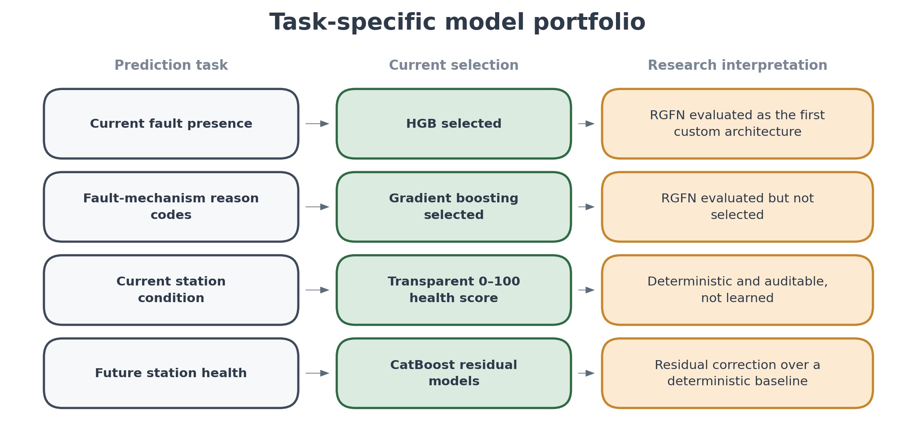
Figure 5.8. Task-specific model portfolio showing the current selected models and the role of the custom architecture.
Chapter 6

Independent Testing and Validation
This chapter separates retrospective model-development results from the independently frozen July 2026 out-of-time test and from controlled hardware validation that could not be performed because a station was unavailable.

6.1 Evaluation Boundary
Binary detection and mechanism diagnosis in Chapter 5 are retrospective development evaluations. Health forecasting there is also a development result. The July evaluation below strengthens the evidence by freezing statistics, models, thresholds, and forecast policies before scoring a later month. A read-only dashboard then replays those frozen July outputs. Controlled hardware injection remains unavailable and is stated as a validation limitation rather than an unfinished result.

6.2 Frozen July Out-of-Time Evaluation
The July protocol used the 25 stations available in the updated export and reconstructed every feature causally with the pre-July statistical basis. All model parameters, class weights, masks, scalers, decision thresholds, and health-forecast policies were frozen before July scoring. The final binary evaluation contains 13,565 eligible station-hours, including 1,701 fault hours and 11,864 not-fault hours. No model was trained, refitted, tuned, calibrated, or selected from a July metric.
The validation-selected operational HGB model uses class weight 2.0 and threshold 0.40. On the development held-out test it produced 1,258 true positives, 142 false positives, 131 false negatives, and 18,002 true negatives. On July it produced 1,383 true positives, 553 false positives, 318 false negatives, and 11,311 true negatives. Table 6.1 and Figure 6.1 report the selected model's class distribution, confusion matrices, operating-point metrics, AUROC, and AUPRC. No alternative model is compared on July because the purpose of the out-of-time test is to evaluate the system selected before July, not to reopen model selection.
Table 6.1. Selected HGB development and frozen July evaluation. Counts, threshold-dependent metrics, and threshold-independent discrimination are reported together.
Statistic | Development held-out test | Independent July test
Eligible station-hours | 19,533 | 13,565
Not-fault class | 18,144 (92.89%) | 11,864 (87.46%)
Fault class | 1,389 (7.11%) | 1,701 (12.54%)
True negatives | 18,002 | 11,311
False positives | 142 | 553
False negatives | 131 | 318
True positives | 1,258 | 1,383
Precision | 0.899 | 0.714
Recall | 0.906 | 0.813
F1 | 0.902 | 0.761
Accuracy | 0.986 | 0.936
AUROC | 0.997 | 0.977
AUPRC | 0.971 | 0.865
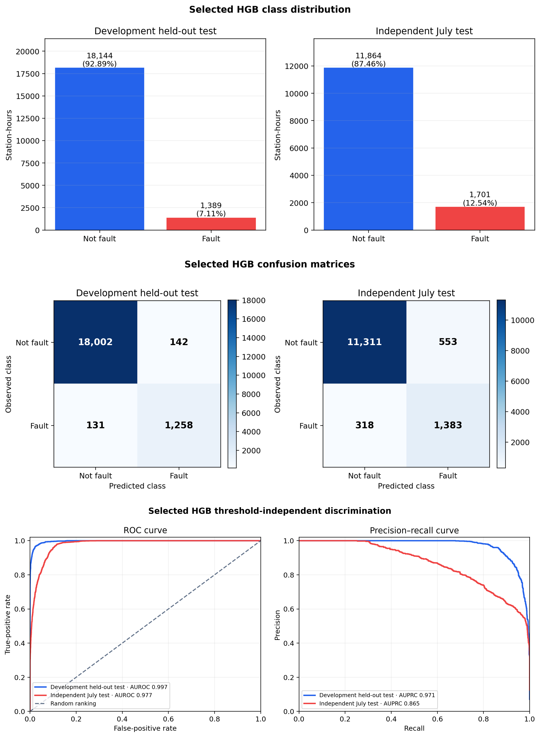
Figure 6.1. Selected HGB evaluation summary: class distribution, confusion matrices, and threshold-independent ROC and precision-recall curves for the development held-out test and independent July test.
The July fault prevalence is higher than in the development test, and false positives increase from 142 to 553. Of the 553 July false-positive hours, 384 carry temperature or humidity detector evidence. This concentration indicates a thermal distribution shift relative to the shorter development record: unusual but spatially coherent weather can resemble the statistical evidence used for sensor-fault detection. It does not prove that heat caused every false alert. The July AUROC of 0.977 and AUPRC of 0.865 show that ranking quality remains strong; the larger precision loss at the frozen 0.40 threshold identifies operating-point robustness under seasonal shift as the main future improvement.
Health forecasting was evaluated only at transmitting July origins whose forecast targets also remained inside July. Table 6.2 shows the frozen selected policy and its deterministic comparators. The selected policy improved MAE over persistence at 1, 3, 12, and 24 hours and over roll-forward at all five horizons. At 6 hours, persistence was slightly better (4.445 versus 4.496 MAE), an exception retained explicitly. Forecast error increases with horizon, while health-band accuracy declines from 93.96% at 1 hour to 72.26% at 24 hours.
Table 6.2. Frozen July transmitting-origin health forecasts and deterministic baselines.
H | n | MAE | RMSE | R² | Band acc. | Persist. MAE | Roll-fwd MAE
1 h | 13,799 | 1.378 | 2.391 | 0.973 | 93.96% | 1.483 | 1.447
3 h | 13,781 | 2.914 | 4.314 | 0.912 | 87.59% | 2.999 | 3.136
6 h | 13,719 | 4.496 | 6.767 | 0.792 | 81.53% | 4.445 | 4.879
12 h | 13,603 | 5.112 | 7.399 | 0.763 | 77.16% | 6.017 | 7.005
24 h | 13,378 | 6.619 | 9.598 | 0.631 | 72.26% | 7.230 | 9.160
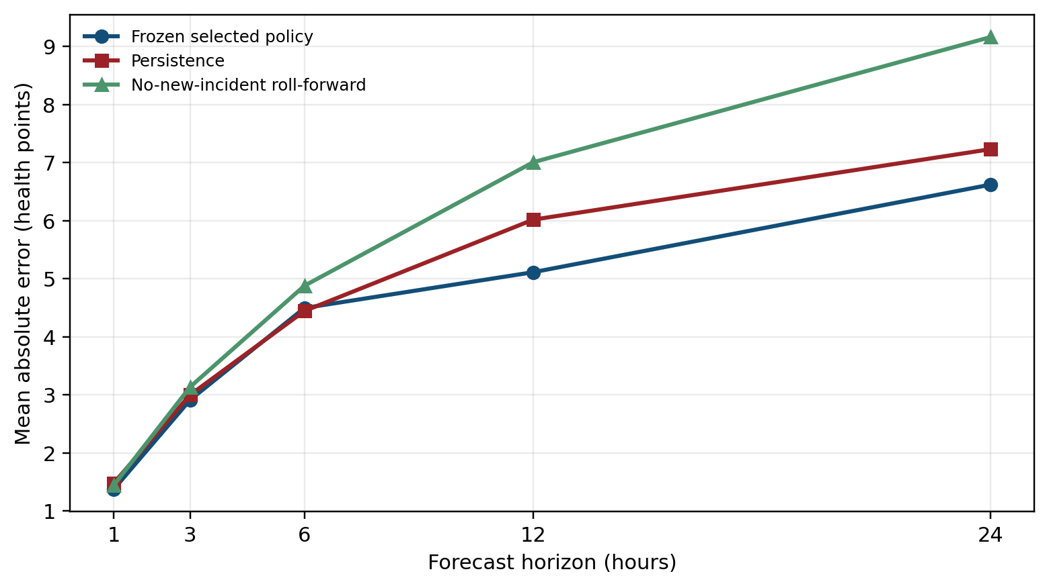
Figure 6.2. Frozen July health-forecast MAE against persistence and no-new-incident roll-forward; the 6-hour persistence exception is visible rather than suppressed.
Taken together, July independently tests the two selected operational learning outputs. HGB retains strong recall and accuracy with lower precision than its retrospective development result. Health forecasts transfer well at short horizons and remain informative at 24 hours, with one transparent 6-hour persistence exception. Unselected development experiments are not part of the July deployment claim.

6.3 Controlled Hardware Fault Tests
Controlled physical fault-injection tests were planned to supply known fault start times and affected components, but they could not be performed because a station was not available for testing. The intended measurements were binary-detector response, detection delay, reason-code agreement, health-score response, and recovery behaviour. The independent frozen July test was added as an out-of-time substitute, but it does not provide known injected fault causes and therefore does not remove this limitation.

6.4 Incident-Onset Forecasting Investigation
Discrete incident-onset forecasting was investigated as a future extension to the monitoring system. The task is more specific than identifying present station condition: for each station and forecast time, it asks whether a new fault or outage incident will begin in the following 6, 12, or 24 hours, using only information available at or before that time. It therefore requires evidence of a precursor to an incident, rather than evidence that a station is already faulty, already offline, or continuing through an existing event.
The investigation considered several causal feature sets, model families, and operating-point rules. The qualitative findings are summarised in Table 6.3. None currently provides sufficient independent evidence to support a discrete incident-onset alert; the investigation instead establishes the data and telemetry requirements for a reliable future implementation.
Table 6.3. Qualitative summary of incident-onset forecasting approaches investigated.
Approach | Outcome for future development
Gradient boosting with a restricted 33-feature causal set | Did not surpass the persistence baseline.
Gradient boosting with the full verified 1,014-feature causal set | Expanding the feature scope did not remove the limiting constraint.
Temporal convolutional sequence model with gated evidence fusion | Not advanced to held-out evaluation under the corrected onset formulation.
Escalation from sub-threshold detector warnings | Produced modest precursor enrichment, but insufficient evidence for an individual incident-onset alert.
Five-minute packet-presence features for outage onset | Revealed a meaningful precursor signal, but it was insufficient as a standalone basis for prediction.
Five-minute sensor-variation features for fault onset | Did not transfer reliably beyond development data.
Trailing incident-history and recurrence features | The most promising direction for fault onset, but still constrained by limited independent incident support.
Alternative operating-point selection rules | Did not materially alter the overall conclusion.

The principal limitation is the number of independent incidents, rather than the absence of model capacity or feature availability. The full record contains 923 physical fault starts. Of these, 784 are observable under the onset definition, which requires the preceding station-hour to be clean and scoreable; 291 also meet the sustained-duration criterion of at least three continuous fault-hours. The outage inventory contains 2,398 starts, of which 2,315 are observable. The 671 qualifying outage incidents are observable, sustained, non-network-associated station outages: they meet the six-hour minimum duration requirement and exclude starts associated with known network-wide interruptions.
These incident counts are materially different from the 9,260 labelled fault-hours available to the detection system. Multiple hours within one prolonged incident are correlated observations of the same event and do not provide independent examples of a precursor pattern. After chronological partitioning, the held-out data contain only 39–40 independent qualifying fault onsets, depending on horizon, and 47–53 qualifying outage onsets. This is approximately 40 and 50 independent held-out events respectively. Such support is adequate for an exploratory investigation, but insufficient for a robust comparison among complex onset-prediction models or for a dependable operational alert threshold.
The investigation used controls intended to make this conclusion methodologically meaningful. Labels were constructed on continuous hourly grids, with the four structural data gaps materialised explicitly so that a six-, twelve-, or twenty-four-hour horizon corresponds to real clock time. Partitions were chronological by timestamp, ensuring that all stations at the same hour remain in the same partition. A horizon-specific purge was applied at each partition boundary so that no training or validation row could receive a label determined by an incident in a later partition. Every candidate feature was checked for causality by recomputing it after withholding all subsequent observations; this was verified across thousands of feature-row comparisons without a detected failure. Operating points were selected using validation data only, held-out data were evaluated once per predefined configuration, and persistence and base-rate baselines accompanied each model assessment.
An important correction was also made to the target definition. An earlier formulation could score a station-hour positively while it was already inside an active fault, meaning that a positive outcome could be satisfied by continuation of an existing incident rather than the onset of a new one. That formulation measures persistence or continuation, not incident onset. The corrected formulation scores only clean, at-risk station-hours and defines the outcome as the start of a new qualifying incident within the specified horizon. This distinction is essential for an operational forecast: an alert about a fault that has already begun is not a forecast of its onset.
A stronger future solution requires both a larger incident inventory and telemetry closer to the failure mechanisms. A longer observation period and/or a larger station network would increase the number of distinct onset events available for learning and independent evaluation. More importantly, the current dataset contains weather observations but not the device-level signals that commonly precede communication, power, hardware, or ingestion failures. The minimum useful additional telemetry should include boot identifier, device uptime, reset reason, input or battery voltage, signal quality, upload retry count, packet sequence number, and server-side arrival timestamp. Firmware and configuration identifiers, reconnection information, and maintenance records would further improve attribution. Together, these fields would help distinguish power loss, communication failure, device reset, sensor failure, and ingestion failure—distinctions that cannot reliably be inferred from weather observations alone.
With sufficient independent incidents and device telemetry, the appropriate next direction is a discrete-time recurrent-event hazard formulation that treats incident onset and incident continuation separately. Evaluation should then be performed at the level of alert episodes rather than correlated individual station-hours, allowing the system to issue a single operationally meaningful warning for a developing incident.

6.5 Validation Status Summary
The July campaign is complete for the validation-selected HGB binary detector and transmitting-origin health forecasting. These are independent out-of-time results because all learned artifacts and operating points were frozen before July. The dashboard replays these saved outputs without fitting or inference. Other model comparisons remain development evidence, while controlled hardware tests remain unavailable as an independent source of known fault start times and affected components.
Chapter 7

Deployment, Dashboard, and MLOps
This chapter explains how the data products and selected models are packaged for operational use. It covers the scorecard, reproducible front doors, the implemented July replay dashboard, API integration boundaries, automated tests, logging, and model versioning.
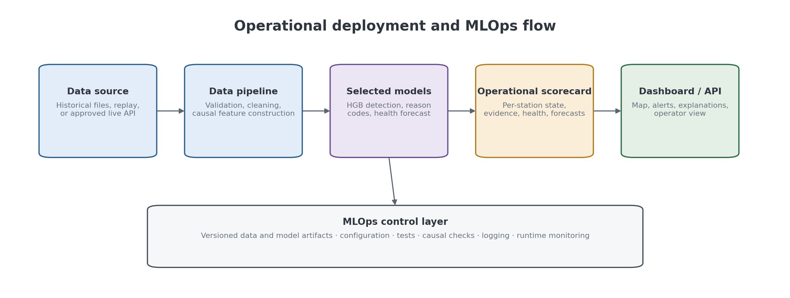
Figure 7.1. Operational deployment and MLOps flow from source data to the dashboard and API.

7.1 Operational Scorecard
The operational scorecard is a parameterised per-station snapshot, not a trained model. At a chosen reference hour it joins transmission state, current outage duration and absent sensor groups, health components and band, five-horizon forecasts, causal fault evidence, trailing reliability history, and offset evidence into 80 fields for every station. Sorting by ascending health places the stations needing attention first.
Two exclusions preserve causal deployability. First, retrospective event reason codes are not emitted as live diagnoses because their development aggregation uses source episode identifiers unavailable to an operational interface; the scorecard exposes causal detector evidence instead. Second, retrospectively completed Layer 2 calibration intervals are not treated as current confirmations; the scorecard reports causal persistent pressure-offset evidence derived only from observations through the reference hour. Stations in a current full outage receive forecast-not-applicable rather than a misleading numerical forecast.

7.2 Implementation and Reproducibility
The implementation follows the data foundation, availability classification, statistical and physical evidence, labelling, external and spatial context, hour-level binary detector, retrospective mechanism experiment, station-health score, residual health forecaster, and operational scorecard described above. Each front door records its artifacts and invariants; report tables and figures read those frozen outputs rather than recomputing undocumented values. Table 7.1 maps each implemented work area to its front door and report artifact.

Table 7.1. Implemented work areas, front doors, and primary artifacts used by this report.
Work area | Front door | Primary artifact(s)
Canonical data | merge_station_data.py | station_hourly_merged.csv
Public reference data | fetch_reference_data.py | external reference cache
Availability and evidence | rebuild_detection_features.py | availability, statistical, external, and spatial features
Canonical labels | build_labels.py | episode_labels.csv and label evidence
Hour-level dataset | build_hourly_dataset.py | hourly_labels.csv and masked tensors
Detector and reason codes | train_hourly_detection.py | models, metrics, and localisation output
Predefined detector comparison | tune_hourly_detection.py | validation-selected configuration tables
Health, forecast, scorecard | build_station_health.py | health scores, forecasts, and operational scorecard
Report assets | generate_report_assets.py | reproducible methodology and result figures
July replay dashboard | run_dashboard.py | read-only network, station-health, forecast, and detector-evidence replay

The codebase contains automated tests for dataset contracts, lifecycle states, full and partial availability, structural-gap materialisation, detectors, labelling, hourly dataset construction, detection models, causal health scoring, forecast splits and selection traces, delete-the-future invariants, and the scorecard join. The report tables and figures use the frozen June 2026 artifacts listed in Appendix A.

7.3 Operational Scorecard Results
The completed operational scorecard is the dashboard's structured data layer. At the latest frozen June reference hour, 30 June 2026 21:00 UTC, it contains all 26 stations and 80 fields per station with no unexplained nulls or join inconsistencies. The reference hour is parameterised, every derived field uses data at or before that hour, and the output is sorted by ascending health. The July replay dashboard uses separate saved July operational tables so that it can advance hour by hour without rewriting this frozen June snapshot.
Table 7.2. Latest 26-station operational snapshot, sorted by health; the report shows the main operator-facing fields while the machine-readable artifact retains all 80 columns.
Station | Transmission / current run | Health / band | Causal mechanism evidence | Forecast health: 1 / 6 / 24 h
IJANZO4 | full outage; 2807 h | 0.0 / Critical | None | N/A / N/A / N/A
ITRIPO32 | full outage; 280 h | 0.0 / Critical | None | N/A / N/A / N/A
IALWAH18 | partial outage; 120 h; light_uv absent | 12.0 / Critical | None | 11.8 / 22.8 / 17.9
IMURQU7 | full outage; 2 h | 56.8 / Degraded | None | N/A / N/A / N/A
IMURQU5 | transmitting | 58.3 / Degraded | statistical_anomaly | 55.9 / 51.0 / 53.4
IZAWIY5 | transmitting | 59.7 / Degraded | None | 60.2 / 60.7 / 63.0
ITRIPO33 | partial outage; 5 h; anemometer|light_uv|rain_gauge|thermo_hygrometer|wind_vane absent | 60.7 / Watch | None | 59.9 / 56.2 / 58.7
INUQAT8 | transmitting | 64.3 / Watch | None | 64.4 / 64.3 / 67.5
IJABAL16 | transmitting | 65.1 / Watch | None | 65.4 / 64.4 / 64.4
IZAWIY7 | transmitting | 65.4 / Watch | None | 65.9 / 66.5 / 70.0
I90583612 | full outage; 2 h | 65.5 / Watch | None | N/A / N/A / N/A
IBARAS3 | transmitting | 65.9 / Watch | None | 66.3 / 66.0 / 67.9
ITAHLI1 | transmitting | 69.6 / Watch | statistical_anomaly | 67.1 / 65.6 / 67.9
INUQAT10 | transmitting | 72.9 / Watch | statistical_anomaly | 69.8 / 63.2 / 63.8
IJABAL15 | transmitting | 73.7 / Watch | None | 73.9 / 73.6 / 73.0
IDERNA7 | transmitting | 76.1 / Watch | None | 76.2 / 74.2 / 73.3
IJANZO2 | transmitting | 77.4 / Watch | None | 77.3 / 75.8 / 75.7
IMISRA12 | transmitting | 78.9 / Watch | None | 79.1 / 78.6 / 78.8
INUQAT9 | transmitting | 79.0 / Watch | None | 79.1 / 77.5 / 74.1
INALUT3 | transmitting | 79.4 / Watch | None | 79.5 / 77.8 / 74.0
IJANZO3 | transmitting | 79.6 / Watch | None | 79.3 / 77.9 / 77.7
IBIRAL3 | transmitting | 82.2 / Healthy | None | 82.4 / 81.9 / 79.1
IJABAL13 | transmitting | 83.0 / Healthy | None | 83.1 / 81.5 / 80.5
IMURQU6 | transmitting | 83.6 / Healthy | None | 83.3 / 81.0 / 77.4
IMISRA13 | transmitting | 86.0 / Healthy | None | 85.9 / 83.7 / 81.3
IJABAL14 | transmitting | 91.1 / Healthy | None | 91.1 / 89.0 / 87.2
Table 7.2 keeps the fleet view readable while preserving the full scorecard in the accompanying CSV. Forecast cells are explicitly N/A for active full outages, not missing by accident; partial-outage stations remain forecast eligible because they are transmitting.
Table 7.3. Latest operational scorecard distribution; explicit forecast eligibility prevents active full outages from receiving misleading future-health values.
Snapshot measure | Count
Stations | 26
Transmitting | 20
Partial outage | 2
Full outage | 4
Healthy / Watch / Degraded / Critical | 5 / 15 / 3 / 3
Forecast eligible / not applicable | 22 / 4
Join inconsistencies | 0
Unexplained nulls | 0
The snapshot identifies four current full outages—IJANZO4 at 2,807 hours, ITRIPO32 at 280 hours, IMURQU7 at 2 hours, and I90583612 at 2 hours—and two partial outages: IALWAH18 lacks light/UV for 120 hours and ITRIPO33 lacks anemometer, light/UV, rain-gauge, thermo-hygrometer, and wind-vane groups for 5 hours. Current causal fault evidence appears for IMURQU5, ITAHLI1, and INUQAT10 as statistical-anomaly evidence; these are provisional operational signals, not ground-truth-segmented trained reason codes. Table 7.3 summarises the fleet-wide status and forecast eligibility counts.
Table 7.4. Causal persistent pressure-offset evidence in the latest scorecard; these estimates are available at the reference hour and are not retrospectively confirmed Layer 2 intervals.
Station | Channel | Estimated offset
ITRIPO33 | Pressure | +1.330 hPa
IMISRA13 | Pressure | −7.565 hPa
IJABAL14 | Pressure | −8.390 hPa
Table 7.4 illustrates the product-level causality rule: the scorecard can expose current persistent offset evidence, but it does not call those intervals confirmed calibration offsets. Retrospective Layer 2 confirmation and mechanism aggregation remain evaluation artifacts. The replay dashboard follows the same distinction and exposes causal detector evidence rather than presenting retrospective labels as live truth.

7.4 Dashboard
The implemented Streamlit dashboard is a read-only operational replay over July 2026 because direct live station access is unavailable. A visible simulated UTC clock can advance automatically or move to a selected hour. The Network tab reports four mutually exclusive fleet counts and a sortable 26-station table. The Station tab shows current status, health history, five weighted components, six sensor-group states, and 1, 3, 6, 12, and 24-hour forecasts. Transmitting stations use the frozen selected health models; active full outages show a clearly labelled continued-outage projection that assumes no recovery and is not presented as a learned forecast.
The Evidence tab segments events only from consecutive HGB-predicted positive hours, breaking on the first non-fault hour or time gap. It never reads episode_labels.csv, reviewed truth, or source episode identifiers. For a selected predicted event it reports detector, channel, score, frozen threshold, and margin, together with compact ERA5 and neighbour-availability statements. The dashboard loads saved artifacts only, loads no model, performs no training or inference, and writes nothing under data/.

7.5 API and Roaya Integration
Direct live integration depends on external API access administered by Roaya and is unavailable for this evaluation. The deployment path therefore uses a deterministic July replay feed. A later live API test should measure schema validity, missing and repeated records, processing delay, and dashboard refresh time.

7.6 MLOps Controls
The operational pipeline should record the data window, configuration, feature version, model artifact, threshold, prediction time, and software version used for every run. Automated tests should protect data contracts, causal feature generation, model loading, scorecard joins, and dashboard-facing outputs. Logs should distinguish data-source failures from model failures.
Chapter 8

Integrated Discussion

8.1 Main Findings Across the Four Project Parts
The main contribution is the complete reliability workflow rather than one model score. The data-engineering stage reconstructs the station timeline and creates auditable evidence. The model-selection stage compares classical and custom models for three different tasks. The validation stage defines the boundary between retrospective development and independent testing. The deployment stage turns the outputs into an operational station record.

8.2 What the RGFN Experiment Shows
RGFN is reported in full. It is a serious custom architecture and it achieved competitive results. However, HGB performed better for binary detection and reason codes. The correct conclusion is not that RGFN was wasted work: the result shows that a well-tuned tree ensemble was better suited to the current engineered evidence and dataset size. RGFN was not extended to health forecasting because the lag and peer-context feasibility test of Section 5.8 showed that the available information did not support sequence models on that task.

8.3 Limitations
The cause of network-midnight patterns cannot be observed directly from outside the upload platform. The evidence supports classifying them as coordinated network windows, but it does not identify a specific upstream mechanism.
There is no perfect independent ground truth for online-but-wrong sensor readings. Fault labels are rule- and evidence-supported judgments, and their support differs by mechanism. Calibration offsets are especially sparse: four resolved labelled episodes arise from 24 confirmed Layer 2 runs.
Development detector comparisons remain retrospective because input-window overlap and historical feature construction prevent a prospective interpretation. The frozen July test addresses that boundary for the validation-selected operational HGB detector without reopening model selection. Health forecasting also has a completed frozen July test; its selected model is slightly worse than persistence at 6 hours, and full-outage recovery still depends on unobserved maintenance response. RGFN and reason-code figures remain development results, and the scorecard marks forecasts not applicable during current full outages.
The health score is a transparent design formula rather than a learned utility function. Its weights and duration constants are auditable but not validated against maintenance outcomes. Availability and sensor completeness correlate at 0.802 across final rows, partly because both share an outage-duration multiplier, so the components are not statistically independent. Spatial evidence is unavailable for IALWAH18 and IDERNA7 and is treated as neutral. The outdoor-array link interpretation of coordinated partial sensor loss remains a testable hypothesis pending controlled disconnection.

8.4 Operational Readiness
The project provides a reproducible offline monitoring pipeline, a complete operational scorecard, a compact July replay dashboard, and independently frozen July evaluation for the selected HGB detector and health forecasting. The remaining deployment boundary is direct live-feed integration, while controlled station tests remain unavailable.
Chapter 9

Conclusion and Future Work

9.1 Conclusion
This project establishes an auditable reliability-monitoring system for a newly deployed 26-station weather network in Libya. From 166,017 development station-hours, it separates lifecycle states, preserves 2,398 full-outage events and 47 coordinated windows, identifies 803 partial-outage events, and documents a canonical 4,799-episode fault catalogue. HGB is the validation-selected operational detector and achieved 0.761 F1, 0.936 accuracy, 0.977 AUROC, and 0.865 AUPRC on the frozen July test. Frozen CatBoost residual policies forecast July transmitting-station health with MAE from 1.378 at 1 hour to 6.619 at 24 hours. RGFN and mechanism reason codes remain fully documented development experiments rather than July deployment claims. Together with the causal five-component health score, 80-field scorecard, and read-only July replay dashboard, these outputs turn heterogeneous observations into traceable availability, fault, health, forecast, station-state, and operator-facing evidence.
Measured against the objectives of Section 1.3, the dataset, outage, partial-outage, suspicious-behaviour, external-reference, model-comparison, health-score, forecasting, scorecard, July evaluation, and replay-dashboard objectives are met. Direct live integration is outside the available access boundary, and controlled physical fault injection could not be completed.
Three findings deserve emphasis. First, development comparison shows that a well-tuned tree ensemble is better suited than the purpose-built RGFN to the current engineered evidence and dataset size. Second, the selected HGB detector retained strong ranking, recall, and accuracy under July temporal shift, but precision declined; thermal detector evidence appears in 384 of 553 false-positive hours, identifying distribution-shift robustness as the main detector improvement target. Third, frozen health policies remained useful across five July horizons, although persistence was slightly better at 6 hours. The missing controlled hardware test limits independent known-cause validation and is reported explicitly.

9.2 Future Work
Priority extensions are controlled FT0360 disconnection tests if station access becomes available, direct live-feed integration, production-safe closed-event mechanism assignment, component localisation with adequate independent support, and the incident-onset work specified in Section 6.4. Longer observation and maintenance records would permit empirical calibration of health weights and better adaptation to rare deterioration, recovery, and seasonal regimes.
The immediate submission work is final deployment verification and documentation. Longer-term work should add maintenance logs, device telemetry, and additional annual cycles so that incident onset, fault causes, and seasonal extremes can be evaluated more directly.

References
[1] Z. Che, S. Purushotham, K. Cho, D. Sontag, and Y. Liu, "Recurrent Neural Networks for Multivariate Time Series with Missing Values," Scientific Reports, vol. 8, Article 6085, 2018.
[2] Q. Liu and J. Paparrizos, "The Elephant in the Room: Towards a Reliable Time-Series Anomaly Detection Benchmark," in Advances in Neural Information Processing Systems, 2024.
[3] L. W. Vos, H. Leijnse, A. Overeem, and R. Uijlenhoet, "The Potential of Urban Rainfall Monitoring with Crowdsourced Personal Weather Stations in Amsterdam," Hydrology and Earth System Sciences, vol. 23, no. 2, pp. 765-777, 2019.
[4] Sainlogic, FT0360 Pro WiFi Weather Station User Manual. Sections 4, 5, 11, and 12.
[5] Weather Underground / IBM, Personal Weather Station History API documentation, /v2/pws/history/all endpoint.
[6] Open-Meteo, Historical Weather API and ECMWF/ERA5 archive access documentation.
[7] A. K. Elawej, Mozn Post-Processing System: open-source forecast bias-correction for the Libyan station network, 2026. Available: https://github.com/Ayatelawej/mozn-postprocessing-system
[8] F. T. Liu, K. M. Ting, and Z.-H. Zhou, ‘Isolation Forest,’ in 2008 Eighth IEEE International Conference on Data Mining, 2008, pp. 413-422.
[9] L. Prokhorenkova, G. Gusev, A. Vorobev, A. Dorogush, and A. Gulin, "CatBoost: Unbiased Boosting with Categorical Features," in Advances in Neural Information Processing Systems 31, 2018.
[10] K. Ni, N. Ramanathan, M. N. H. Chehade, L. Balzano, S. Nair, S. Zahedi, E. Kohler, G. Pottie, M. Hansen, and M. Srivastava, "Sensor Network Data Fault Types," ACM Transactions on Sensor Networks, vol. 5, no. 3, 2009, doi: 10.1145/1525856.1525863.
[11] A. B. Sharma, L. Golubchik, and R. Govindan, "Sensor Faults: Detection Methods and Prevalence in Real-World Datasets," ACM Transactions on Sensor Networks, vol. 6, no. 3, 2010, doi: 10.1145/1754414.1754419.
[12] A. Napoly, T. Grassmann, F. Meier, and D. Fenner, "Development and Application of a Statistically-Based Quality Control for Crowdsourced Air Temperature Data," Frontiers in Earth Science, vol. 6, Article 118, 2018, doi: 10.3389/feart.2018.00118.
[13] D. Fenner, B. Bechtel, M. Demuzere, J. Kittner, and F. Meier, "CrowdQC+ - A Quality-Control for Crowdsourced Air-Temperature Observations Enabling World-Wide Urban Climate Applications," Frontiers in Environmental Science, vol. 9, Article 720747, 2021, doi: 10.3389/fenvs.2021.720747.
[14] L. Båserud, C. Lussana, T. N. Nipen, I. A. Seierstad, L. Oram, and T. Aspelien, "TITAN Automatic Spatial Quality Control of Meteorological In-Situ Observations," Advances in Science and Research, vol. 17, pp. 153-163, 2020, doi: 10.5194/asr-17-153-2020.
[15] S. Bell, D. Cornford, and L. Bastin, "How Good Are Citizen Weather Stations? Addressing a Biased Opinion," Weather, vol. 70, no. 3, pp. 75-84, 2015, doi: 10.1002/wea.2316.
[16] E. Beele, M. Reyniers, R. Aerts, and B. Somers, "Quality Control and Correction Method for Air Temperature Data from a Citizen Science Weather Station Network in Leuven, Belgium," Earth System Science Data, vol. 14, no. 10, pp. 4681-4717, 2022, doi: 10.5194/essd-14-4681-2022.

Appendices

Appendix A: Artifact Inventory
This appendix lists the canonical artifacts supporting the report. Historical reconciliation inventories and retired model outputs are omitted because they are not part of the delivered training or operational population.
- data/merged/station_hourly_merged.csv — canonical 166,017-row station-hour record.
- data/processed/hourly_row_states.parquet — lifecycle state for every station-hour.
- data/processed/data_audit_summary.csv — station audit and status-class rollup.
- data/processed/missingness_by_variable.csv — variable-level missingness summary.
- data/processed/availability_events.parquet — frozen 2,398-event full-outage series used for historical event statistics.
- data/processed/network_outage_windows.csv — 47 coordinated full-outage windows.
- data/labels/episode_labels.csv — canonical 4,799-episode label catalogue used by the hour-level system.
- data/labels/calibration_offset_layer2.csv — confirmed sustained-offset evidence and promotion resolution.
- data/hourly_detection/hourly_labels.csv — station-hour binary labels and display states.
- data/hourly_detection/hourly_rgfn_tuning_metrics.json — recorded RGFN configuration metrics.
- data/hourly_detection/reason_code_mechanism_selection.csv and reason_code_selected_mechanism_test_metrics.csv — validation-only mechanism configuration selection and its frozen held-out event-level evaluation.
- data/processed/hourly_availability_classification.parquet and partial_outage_events.parquet — operational full/partial/online states and 803 partial events.
- scripts/build_labels.py — reproducible live episode-label build.
- scripts/build_hourly_dataset.py — hour-level labels and past-only tensor build.
- scripts/train_hourly_detection.py — baseline and RGFN training front door.
- scripts/tune_hourly_detection.py — predefined RGFN tuning experiments.
- data/processed/station_health_scores.parquet and station_health_summary.csv — causal component scores, total health, and station summaries.
- data/processed/station_operational_scorecard.csv — latest parameterised 26-station, 80-field operational snapshot.
- src/availability/health_score.py, health_forecast.py, and operational_scorecard.py — causal health, forecasting, and scorecard implementations.
- REPO_MAP.md — pipeline, module, data, and runbook map.
- tests/ — automated behavioral checks for the delivered pipeline.
data/eval/july_2026_scoring/july_binary_metrics.csv — frozen July operational-detector metrics and confusion counts.
data/eval/july_2026_health_forecast/july_health_forecast_metrics.csv — frozen July health forecasts and deterministic baselines.
- data/eval/health_forecast/ — frozen health-forecast metrics, predictions, configuration selection trace, baselines, calibration, and causal invariants.

