University of Tripoli
Faculty of Engineering
Computer Engineering Department

Fault Detection and Reliability Monitoring for a Newly Deployed Weather Station Network in
Libya

A project submitted in partial fulfillment of the requirements
for the bachelor’s degree in computer engineering

By:
Ayat Khalifa Elawej

Supervised by:
Dr. Ziad Elhajjaji
Dr. [Co-Supervisor Name]

2026

Fault Detection and Reliability Monitoring for a Newly Deployed Weather Station Network in Libya

By:
Ayat Khalifa Elawej

Approved by:
Dr. Ziad Elhajjaji
Dr. [Co-Supervisor Name]
Dr. [Examiner Name]
Dr. [Committee Member]

Declaration
I hereby declare that this project report, "Fault Detection and Reliability Monitoring for a Newly Deployed Weather Station Network in Libya” submitted for the partial fulfillment of the requirements for the award of the Bachelor of Science degree in Computer Engineering from the Department of Computer Engineering at the University of Tripoli, is a bona fide work done by me under the supervision of Dr. Ziad Elhajjaji. It represents my own ideas in my own words, and where the ideas or words of others have been included, the original sources have been adequately cited and referenced.
I further declare that I have adhered to the principles of academic honesty and integrity, and have not misrepresented or fabricated any data, idea, fact, or source in this submission. I also declare that this work has not been previously submitted in support of another degree or qualification at this or any other university or institute of learning.

Ayat Khalifa Elawej
Date: ___/___/2026
Signature: ____________________

Abstract
Draft note: this abstract describes the work completed through Phase 2 and should be revised after the final detector, risk model, validation campaign, and dashboard are complete.
This project develops a fault detection and reliability monitoring system for a newly deployed network of 26 personal weather stations across Libya. The stations are Sainlogic FT0360 Pro WiFi units that upload observations to Weather Underground, and the network supports public weather data use cases such as forecasting, agricultural planning, and emergency response. Because the stations are mounted on private homes and rooftops, the data is exposed to power interruptions, weak connectivity, sensor faults, siting problems, and backend upload anomalies. The central problem is not only whether a station is online, but whether each station-hour should be trusted.
The work completed so far covers data acquisition, dataset assembly, lifecycle labeling, reliability auditing, outage event extraction, and network-wide outage investigation. A frozen hourly dataset from June 15, 2025 through March 31, 2026 was assembled, containing 111,417 station-hours and 41 columns. Phase 1 assigned every station-hour to a row_state category and produced the canonical row-state table, station registry, audit summary, missingness analysis, and diagnostic figures. Phase 2 converted outage candidate hours into 1,670 outage events totaling 25,336 absent hours, produced station reliability summaries, and identified 31 coordinated network-wide windows.
The current findings show that the network contains several distinct failure modes: local station outages, specific nearby station co-failures, synchronized network-wide events, stuck wind sensors, pressure calibration faults, unstable pressure sensors, and physically impossible rainfall readings. A major empirical finding is a set of midnight-clustered Weather Underground outage events: 22 of the 31 network-wide windows begin at 22-23 UTC, shortly after Libya local midnight, with a subset showing sub-minute drop synchronization across geographically separated stations. These results motivate the remaining planned system: a hybrid detector combining statistical anomaly detection, external residuals, spatial residuals, and a missingness-aware GRU-D layer, followed by risk prediction and a dashboard.

Acknowledgement
[To be written at the end.]
Suggested acknowledgement points to fill later: supervisor guidance from Dr. Ziad Elhajjaji; any co-supervisor or committee support; Roaya and UNICEF context for the weather station network if appropriate; access to the Weather Underground account; and any support received during station setup, device testing, or data collection.

List of Abbreviations
Abbreviation | Full Meaning
API | Application Programming Interface
AWS | Automatic Weather Station
CSV | Comma-Separated Values
ECMWF | European Centre for Medium-Range Weather Forecasts
ERA5 | Fifth-generation ECMWF atmospheric reanalysis
F1 | Harmonic mean of precision and recall
GRU | Gated Recurrent Unit
GRU-D | Gated Recurrent Unit with Decay
ML | Machine Learning
MSL | Mean Sea Level
PWS | Personal Weather Station
QC | Quality Control
UTC | Coordinated Universal Time
WU | Weather Underground

Contents
Abstract iii
Acknowledgement iv
List of Abbreviations v
Contents vi
List of Figures vii
List of Tables viii
1 Introduction x
1.1 Motivation x
1.2 Problem Statement x
1.3 Objectives x
1.4 Scope of the Project x
1.5 Report Structure x
2 Background x
2.1 Technical Background x
2.2 Tools and Technologies x
2.3 Theoretical Concepts x
3 Related Work x
3.1 Previous Studies x
3.2 Comparison with Existing Systems x
3.3 Research Gap x
4 Methodology x
4.1 System Overview x
4.2 Requirements x
4.3 System Design x
4.4 Implementation x
5 Results and Evaluation x
5.1 Experimental Setup x
5.2 Testing Procedure x
5.3 Performance Metrics x
5.4 Results and Discussion x
6 Conclusion and Future Work x
References x
Appendices x
Note: page numbers are placeholders. Update the table of contents in Microsoft Word after inserting final figures and pagination.

List of Figures
Figure 1.1 Map of the 26-station network across Libya [placeholder] x
Figure 4.1 Proposed hybrid fault detection architecture [placeholder] x
Figure 4.2 Row-state classification flow [placeholder] x
Figure 4.3 Outage event construction from hourly row states [placeholder] x
Figure 5.1 Station coverage timeline from Phase 1 audit [insert station_coverage_timeline.png] x
Figure 5.2 Station-variable missingness heatmap from Phase 1 audit [insert missingness_heatmap.png] x
Figure 5.3 Per-station uptime bar chart from Phase 2 [insert station_uptime_bar.png] x
Figure 5.4 Network offline fraction timeline from Phase 2 [insert network_offline_fraction_timeline.png] x
Figure 5.5 Example stuck-wind fault panel [placeholder] x

List of Tables
Table 2.1 Network and dataset summary x
Table 4.1 Functional requirements x
Table 4.2 Non-functional requirements x
Table 4.3 Row-state taxonomy x
Table 4.4 Completed Phase 1 and Phase 2 deliverables x
Table 5.1 Status class distribution from Phase 1 x
Table 5.2 Concrete fault examples found in the data x
Table 5.3 Outage duration distribution from Phase 2 x
Table 5.4 Outage class distribution from Phase 2 x
Table 5.5 Summary of network-wide outage investigation x
Table 5.6 Local co-occurrence ratios after excluding network-wide hours x

Chapter 1
Introduction
Personal weather stations can provide dense, low-cost weather observations in places where official observing networks are sparse. In Libya, a newly deployed network of 26 personal weather stations provides public weather observations for operational and humanitarian use cases. The network is valuable because it improves local situational awareness, but it is also vulnerable because the stations are commercial devices installed in real homes and rooftops rather than controlled research environments. Fault detection is therefore a necessary part of making the network reliable.
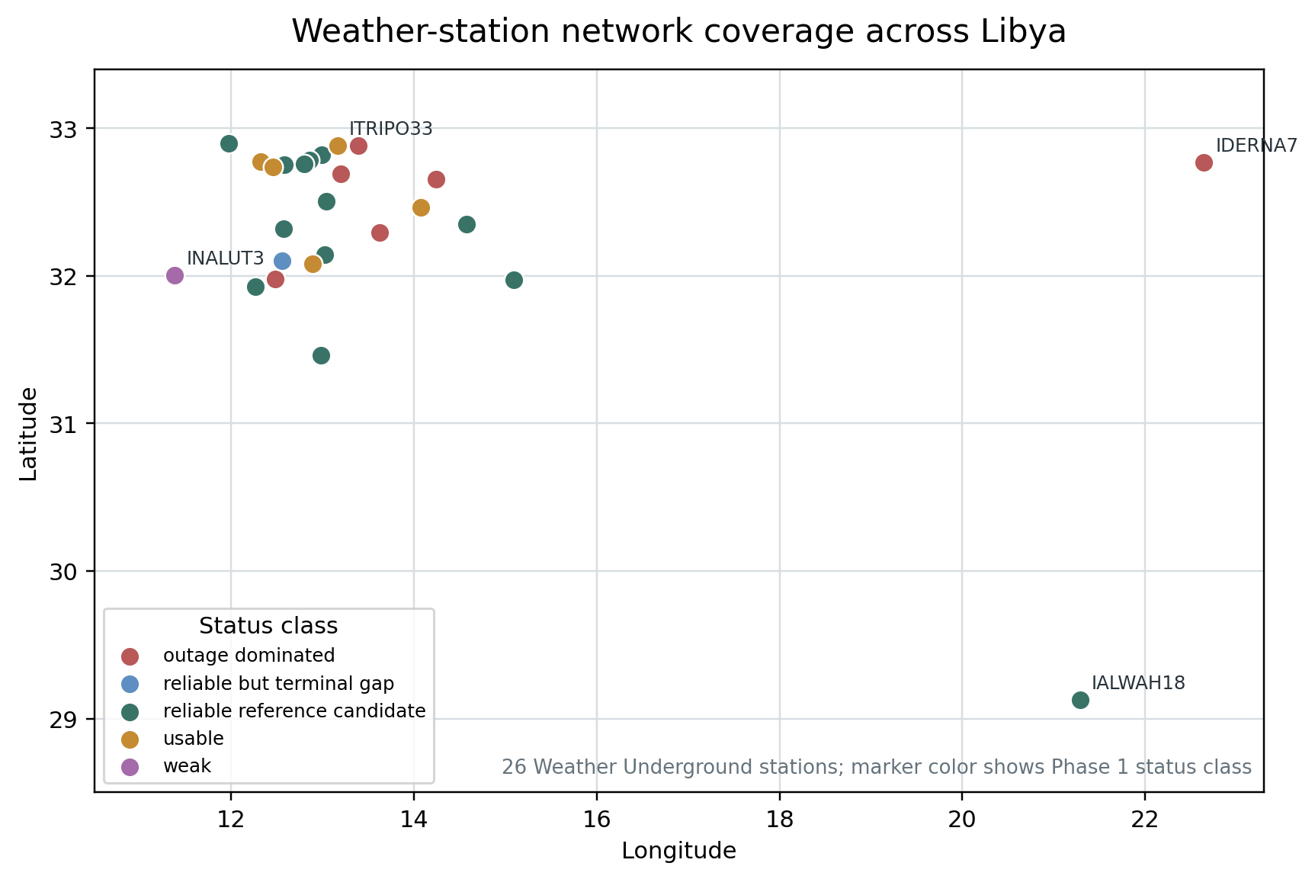

Figure 1.1. Map of the 26-station network across Libya.
1.1 Motivation
The project is motivated by a practical reliability problem: a weather station that is offline is easy to detect, but a weather station that is online and reporting plausible-looking wrong values is much more dangerous. Downstream users may trust the data even when the station is affected by a stuck wind sensor, calibration drift, partial sensor dropout, or an upload-side anomaly.
The completed audit already shows why basic validation is not enough. Examples found in the frozen dataset include a station reporting zero wind continuously for 220 hours, pressure readings with persistent station-specific offsets, unstable pressure residuals reaching extreme values, and rainfall values that are physically impossible. These faults are not always caught by simple range checks because individual values may still fall inside broad physical limits. The system being developed must therefore reason over time, across variables, against external references, and against neighboring stations.
The network also supports public-good use cases such as forecasting, agriculture, and emergency response. In that context, reliability monitoring is not just a software feature; it is part of making the dataset safe to use.
1.2 Problem Statement
The problem addressed by this project is to determine whether each station-hour in a personal weather station network is trustworthy, to identify and characterize station outages and suspicious readings, and to provide operational explanations for detected faults. The difficulty is that the deployed network has no complete ground-truth label set for all faulty hours. Some labels can be created automatically from upload absence, but many sensor faults are only visible through patterns such as flatlines, abnormal residuals, disagreement with peers, or block-aligned missingness.
A second difficulty is that not every disagreement indicates a station fault. External weather models such as ECMWF are useful references, but they are not ground truth. Nearby stations are also useful references, but they can fail together during shared infrastructure problems. The detector must therefore combine several imperfect signals rather than relying on any one source alone.
1.3 Objectives
The objectives of the project are:
- Assemble and freeze a reproducible hourly dataset for the 26-station network.
- Classify every station-hour into a documented lifecycle row_state so that downstream processing uses consistent definitions.
- Extract true station outage events from hourly absence runs and separate local outages from coordinated network-wide events.
- Characterize reliability, missingness, station uptime, and concrete fault examples in the deployed network.
- Design a hybrid fault detector that combines statistical anomaly detection, external residuals, spatial residuals, and missingness-aware deep learning.
- Build a validation strategy based on strong outage labels, controlled FT0360 device-test labels, and manually reviewed suspicious windows.
- Produce risk predictions and a dashboard that make the detector useful for network operators.
The first four objectives have been implemented through Phase 1 and Phase 2. The remaining objectives are included in the methodology and future-work plan, but their final results are not reported as completed work in this draft.
1.4 Scope of the Project
The project scope is the 26-station Weather Underground personal weather station network deployed across Libya. The report uses a frozen dataset covering June 15, 2025 through March 31, 2026. The hourly dataset contains 111,417 station-hours and 41 columns. The current completed work covers dataset acquisition, audit, row-state classification, outage event extraction, network-wide outage detection, and reliability investigation.
The final system scope is broader than the completed work so far. It includes a hybrid fault detector, a risk prediction layer for 6-hour, 12-hour, and 24-hour horizons, controlled validation on a home Sainlogic FT0360 unit, and a Streamlit dashboard. These later stages are described as planned design elements and future work in this draft. They should be updated after implementation and evaluation.
The project does not attempt to replace national meteorological instrumentation or claim that personal weather stations are research-grade instruments. Instead, it focuses on making an existing low-cost network more trustworthy by identifying when its data should be treated with caution.
1.5 Report Structure
Chapter 2 introduces the technical background, tools, and theoretical concepts used in the project. Chapter 3 discusses related work in personal weather station quality control, time-series anomaly detection, and missingness-aware modeling. Chapter 4 presents the methodology, including the completed Phase 1 and Phase 2 pipelines and the planned hybrid detector. Chapter 5 reports the completed audit and outage-engine results. Chapter 6 summarizes the current conclusions, limitations, and future work required to complete the full system.

Chapter 2
Background
This chapter provides the background needed to understand the network, the data sources, and the modeling choices. The project combines weather station engineering, time-series data processing, anomaly detection, and reliability monitoring. The most important point is that missingness and faults are not simply data-cleaning problems in this project; they are part of the signal that the system must detect.
2.1 Technical Background
The deployed devices are Sainlogic FT0360 Pro WiFi personal weather stations. Each station includes an outdoor sensor array and an indoor console that uploads observations to Weather Underground. The network is administered through a shared Weather Underground account, while station uploads use station-specific credentials. The account-level API key is used for data retrieval, not for uploads.
The stations are distributed across Libya. Twenty-four stations are located in the northwest region, including Tripoli, Misrata, Zawiya, Janzour, Jabal al Gharbi, and Nuqat al Khams. Two stations are geographically isolated in the southeast and east: IALWAH18 in Awjila and IDERNA7 in Derna. This distribution matters because neighbor-based quality control is strong in the dense northwest cluster but weak for isolated stations.
The dataset is hourly. Raw observations from Weather Underground are bucketed into hourly bins, where observations time-stamped HH:MM:SS are assigned to the next hour if the minute value is greater than 30. This convention is important when interpreting outage start times because a physical drop near the end of an hour can appear as a missing hourly bin in the following hour.
Common fault types in this network include complete outages, partial missingness, flatlined sensors, stuck wind sensors, calibration offsets, calibration drift, unstable sensors, and impossible rainfall values. Several of these faults are individually plausible at the single-value level but impossible when viewed across time or compared with references. For this reason, the project uses a hybrid detection design rather than a single range validator.
Table 2.1. Network and dataset summary.
Item | Value
Network size | 26 personal weather stations
Device model | Sainlogic FT0360 Pro WiFi
Deployment context | Roaya humanitarian weather station initiative with UNICEF support
Upload platform | Weather Underground
Frozen data window | June 15, 2025 through March 31, 2026
Hourly rows | 111,417 station-hours
Full-station hourly span | 6,840 hours per fully active station
Schema size | 41 columns, original column names preserved
Main geographic pattern | 24 stations in northwest Libya, 2 isolated stations in southeast/east Libya
Elevation range | 2 m to 815 m
Local time convention | Libya is UTC+2 year-round, no daylight saving time

2.2 Tools and Technologies
The project is implemented as a Python-based data and machine-learning pipeline. Completed stages use Parquet and CSV artifacts, Python source modules, automated tests, and static figures. The raw data was retrieved from the Weather Underground history endpoint using a custom downloader built for this project. The downloader handles Weather Underground response quirks, rate limits, retries, and merging into a unified hourly dataset.
External weather references are planned through Open-Meteo archive data derived from ECMWF products. A companion post-processing project at Mozn AI provides reusable utilities with attribution, including the station registry, Open-Meteo parquet cache, a rate-limited Open-Meteo fetcher, and several feature-building utilities. The forecasting models and evaluation pipelines from that companion project are not copied because forecast bias correction and fault detection are different problems.
The repository uses Git tags to freeze completed project phases. Phase 1 is tagged as v0.1-phase1-complete, and Phase 2 is tagged as v0.2-phase2-complete. Automated tests are used to protect the row-state classifier and outage engine from silent changes.
2.3 Theoretical Concepts
Several concepts are central to the project methodology:
- Lifecycle labeling: each station-hour is assigned a row_state that distinguishes online complete rows, partial missing rows, true outage candidates, warmup periods, terminal padding, and pre-installation bookkeeping rows.
- Run-length event extraction: consecutive outage-candidate hours are grouped into single events so that a 34-day blackout is treated as one outage event rather than hundreds of independent hours.
- Residual analysis: a station reading is compared with an external reference or neighbor median. A residual is evidence of disagreement, not proof of error by itself.
- Spatial comparison: neighboring stations provide a local consistency check, especially in dense station clusters.
- Missingness-aware modeling: GRU-D uses missingness masks and learned decay to model time series where absence itself contains information [1].
- Imbalanced evaluation: normal hours dominate anomaly datasets, so accuracy can be misleading. The project therefore plans to report F1, precision, and recall rather than raw accuracy for fault detection [2].

Chapter 3
Related Work
Fault detection in personal weather station networks overlaps with three areas of prior work: quality control for crowdsourced weather observations, anomaly detection for time series, and modeling with missing data. This chapter positions the project relative to those areas and explains the gap addressed by the Libya deployment.
3.1 Previous Studies
Crowdsourced and personal weather station networks are known to be noisy because installations vary in siting, exposure, maintenance, and sensor quality. Vos et al. studied the potential of urban rainfall monitoring using crowdsourced personal weather stations and showed that such networks can be useful but require careful quality control [3]. This project follows the same general motivation: low-cost dense observations are valuable only if unreliable measurements are detected and handled.
For missing time-series data, Che et al. introduced GRU-D, a recurrent neural network architecture that explicitly incorporates missingness masks and learned decay mechanisms [1]. The original application was medical time series, but the same modeling issue appears in weather station data: missingness is not random noise, and long gaps should influence the model. This project adapts that idea to weather station monitoring and extends it with station-specific baseline embeddings.
For anomaly detection evaluation, Liu and Paparrizos argue that common benchmark and metric choices can be misleading, especially when datasets are highly imbalanced [2]. This is directly relevant because most station-hours are normal. A detector that predicts all hours as normal can achieve high accuracy while detecting no faults. The project therefore separates strong labels and reviewed labels and uses F1-based metrics for final evaluation.
3.2 Comparison with Existing Systems
Simple range validators check whether a reading falls within broad physical limits, such as rejecting negative pressure or impossible temperatures. Such validators are necessary but insufficient. They cannot detect values that are plausible in isolation but impossible as a pattern, such as a wind sensor reporting zero for nine days while neighboring stations record normal wind, or a pressure sensor holding a fixed offset from its peers.
Weather Underground provides the upload and retrieval platform, but it is not designed as a full reliability-monitoring system for this project network. The completed Phase 2 investigation also shows that some missing-data patterns are likely related to upstream platform behavior rather than local station faults. A project-specific outage_class taxonomy is therefore required so that station-attributable faults can be separated from coordinated network-wide artifacts.
The companion Mozn AI post-processing system solves a different problem: forecast bias correction. It predicts what a station should read given ECMWF forecasts and recent station history. This EC499 project asks whether the station-hour should be trusted at all. The two systems can share selected data utilities, but their labels, evaluation criteria, and downstream outputs are different.
3.3 Research Gap
The gap addressed by this project is the absence of a reliability-monitoring pipeline tailored to a newly deployed, low-cost, geographically uneven weather station network in Libya. Existing quality-control ideas are useful, but this network has specific characteristics: strong missingness, station-specific behavior, two isolated stations with no useful neighbors, coordinated Weather Underground outage patterns, and limited ground truth for non-outage faults.
The proposed contribution is therefore not a completely new neural architecture. Instead, it is an end-to-end hybrid system that combines interpretable statistical checks, external model residuals, neighbor disagreement, missingness-aware sequence modeling, event construction, reason codes, risk prediction, and dashboarding for this specific deployed network.

Chapter 4
Methodology
The methodology is organized around a staged pipeline. The completed stages build a trustworthy data foundation: data acquisition, row-state classification, dataset audit, outage event extraction, network-wide outage classification, and reliability summaries. Later stages build on this foundation to detect online sensor faults, predict risk, validate against controlled device tests, and expose the results through a dashboard.
4.1 System Overview
The designed system begins with Weather Underground history data and a station registry. The data is converted into a unified hourly dataset, then each station-hour is labeled by lifecycle state. Outage candidate hours are grouped into events, and events are classified as local, network_midnight, or network_other. After these completed stages, the planned detector computes four parallel signal sources: per-channel statistical anomaly scores, external residuals, spatial residuals, and GRU-D sequence anomaly scores. A fusion layer then produces a hybrid health score, reason codes, and a fault cause likelihood distribution. A separate risk model predicts future outage or suspicious-event probability over 6-hour, 12-hour, and 24-hour horizons.
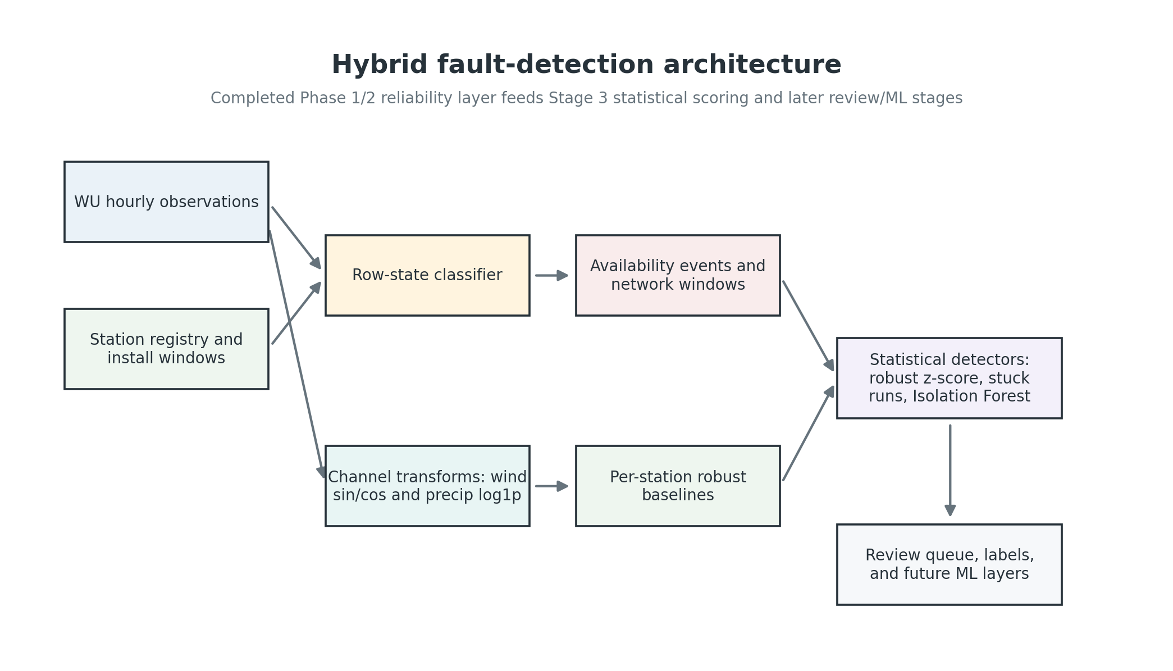

Figure 4.1. Proposed hybrid fault detection architecture.
The system is intentionally hybrid because no single signal source covers all fault types. Statistical checks are fast and interpretable. External residuals reveal divergence from physical model references. Spatial residuals reveal local disagreement with nearby stations. GRU-D models temporal patterns and missingness. The fusion layer combines these signals so that the final detector is more robust than any single component.
4.2 Requirements
The requirements are divided into functional and non-functional requirements. Some requirements are already satisfied by Phase 1 and Phase 2, while others belong to later stages.
4.2.1 Functional Requirements
Table 4.1. Functional requirements.
ID | Requirement | Status
F1 | Weather Underground hourly ingestion | Completed
F2 | Station registry and coverage metadata | Completed
F3 | Lifecycle row_state classification | Completed
F4 | Audit summaries and missingness reports | Completed
F5 | Outage event extraction from true outage hours | Completed
F6 | Network-wide window and outage_class assignment | Completed
F7 | Statistical anomaly flags for sensor channels | Planned
F8 | External residuals against Open-Meteo/ECMWF | Planned
F9 | Spatial residuals against nearby stations | Planned
F10 | GRU-D sequence model, fusion, and reason codes | Planned
F11 | 6h/12h/24h risk prediction | Planned
F12 | Operator dashboard and station drilldown | Planned

4.2.2 Non-Functional Requirements
Table 4.2. Non-functional requirements.
Requirement | Description
Reproducibility | Frozen data windows, deterministic event IDs, phase tags, and tests should allow the same outputs to be regenerated.
Interpretability | Detected faults should include reason codes and supporting evidence, not only black-box scores.
Missingness awareness | The system must preserve and model missing data rather than cleaning it away.
Station specificity | Thresholds and baselines should account for each station location, elevation, and historical behavior.
Geographic awareness | Neighbor comparisons should respect distance limits and identify isolated stations explicitly.
Data safety | API keys and private upload credentials must not be exposed in public artifacts.
Operational usefulness | Outputs should be event-based and dashboard-ready rather than only point-wise anomaly scores.

4.3 System Design
The system design follows the data lifecycle from raw hourly observations to operational fault events.
4.3.1 Data Acquisition and Hourly Dataset
A custom Weather Underground downloader was developed to retrieve history data from the /v2/pws/history/all endpoint. The downloader handles rate limits, retries, Weather Underground response format quirks, and merging into a single hourly dataset. The original project column names were preserved, such as temp_avg_c, humidity_avg_pct, latitude, elevation, pressure_max_hpa, precip_total_mm, and precip_rate_mmh. This preserves separation between the EC499 dataset and the companion Mozn post-processing schema.
The dataset was frozen at March 31, 2026, 23:00 UTC for the current project cycle. Although the live network continues to collect observations, freezing the data ensures that the audit, outage counts, and validation work are reproducible.
4.3.2 Row-State Classifier
The row-state classifier assigns exactly one lifecycle label to each station-hour. This is the canonical filtering layer used by all later stages. For example, Phase 2 only treats true_outage_candidate rows as real outage evidence, while pre-installation rows and terminal padding rows are excluded from outage statistics.
Table 4.3. Row-state taxonomy.
row_state | Meaning
online_complete | Station is reporting and all measurement variables are present.
online_partial_missing | Station is reporting but at least one measurement variable is missing.
true_outage_candidate | Station is offline with data_present = 0, and the absence is a real outage candidate rather than installation or padding artifact.
terminal_padded_absence | Station is offline at dataset freeze; rows extend to March 31, 2026 23:00 UTC as dataset-shape padding and are excluded from outage statistics.
warmup | First seven days after install_date. Flagged because stations can log inconsistently during commissioning.
pre_install_padded_absence | Pre-installation bookkeeping row with no real measurement. Excluded downstream.
pre_install_padded_present | Pre-installation row where data appears present and is treated as invalid bookkeeping.
pre_install_invalid_unknown | Pre-installation row with ambiguous or invalid status. Excluded downstream.

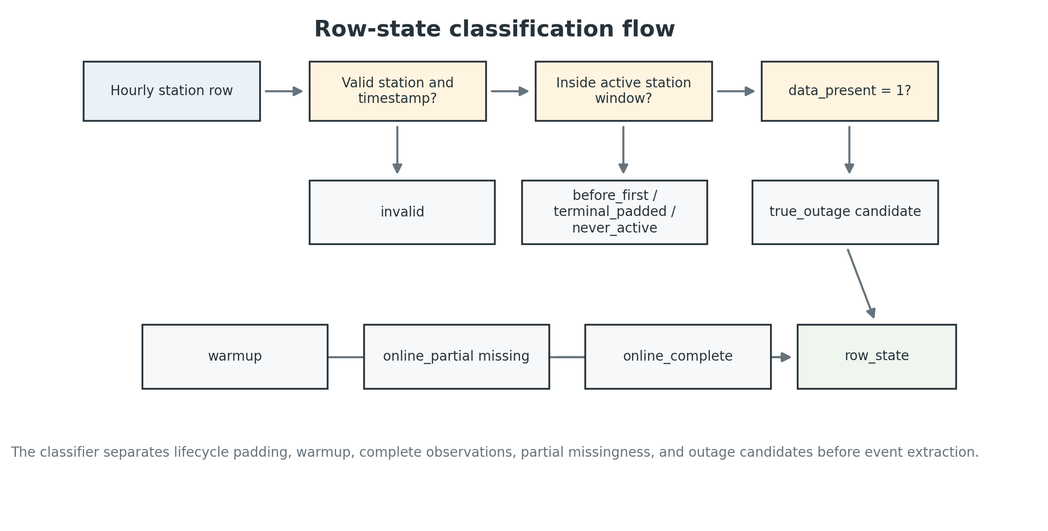

Figure 4.2. Row-state classification flow.
4.3.3 Outage Event Engine
The outage engine converts hourly outage labels into events. It filters hourly_row_states to true_outage_candidate rows, sorts by station and time, and groups consecutive hours into a single event. A gap greater than one hour starts a new event, and a station change always starts a new event. Each event receives a deterministic event_id in the form STATION__YYYYMMDDTHH__NNNNh, along with station_id, start_utc, end_utc, and duration_hours.
After event extraction, coordinated network-wide windows are detected by searching for outage starts involving at least five distinct stations within plus or minus one hour. Consecutive candidates are merged into windows. Events are then classified using a three-way outage_class taxonomy: local, network_midnight, and network_other. This distinction prevents upstream platform events from being treated as station-attributable local failures during later model training.
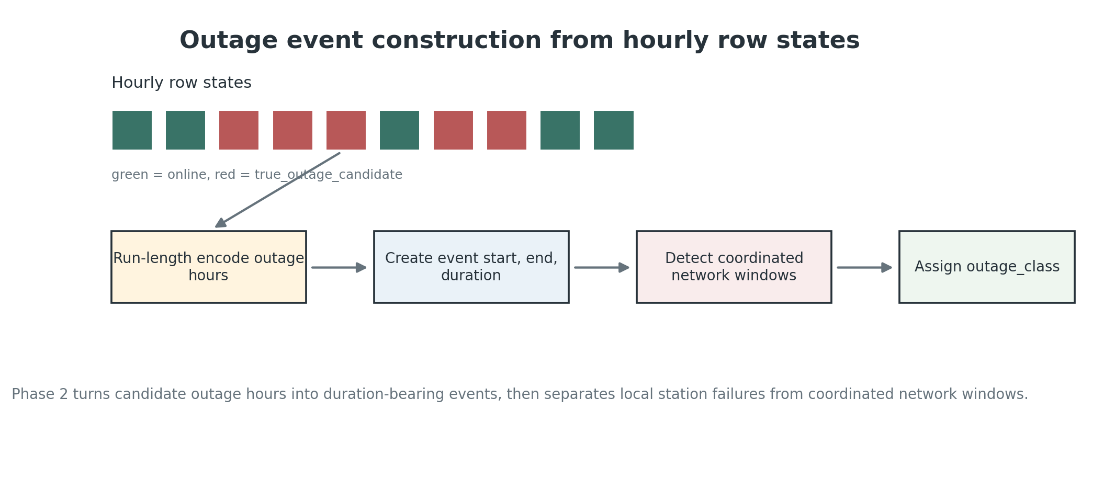

Figure 4.3. Outage event construction from hourly row states.
4.3.4 Planned Hybrid Detection Layers
The remaining detector design uses four signal sources. The first is per-channel statistical anomaly detection, which learns station-specific thresholds and uses lightweight models such as Isolation Forest where appropriate. The second is external residual analysis, where station readings are compared against Open-Meteo/ECMWF references for temperature, humidity, pressure, and wind speed. The third is spatial residual analysis, where each station is compared with nearby peers within a 200 km cap. The fourth is a GRU-D sequence model with missingness masks, learned decay, and per-station baseline embeddings [1].
A critical design rule is that residuals are treated as reference signals, not ground truth. A station can disagree with ECMWF because the model is locally biased. A station can disagree with neighbors because the neighbors are faulty. Strong fault evidence comes from cross-patterns, such as one station disagreeing with both the external model and nearby stations while the rest of the network remains consistent.
Pressure residuals require special care. The FT0360 reports pressure as sea-level-corrected pressure, so pressure comparisons must use mean-sea-level reference pressure rather than surface pressure. Otherwise, the detector would create a false elevation-dependent offset and misinterpret it as a station fault.
4.4 Implementation
The implementation completed so far consists of the data acquisition and audit foundation, followed by the outage event engine and network-wide outage investigation.
Table 4.4. Completed Phase 1 and Phase 2 deliverables.
Phase | Artifact | Purpose
Phase 1 | data/merged/station_registry.csv | Station metadata and coverage summary.
Phase 1 | data/processed/hourly_row_states.parquet | Canonical row_state label for every station-hour.
Phase 1 | data/processed/data_audit_summary.csv | Per-station audit rollup.
Phase 1 | data/processed/missingness_by_variable.csv | Per-station, per-variable missingness.
Phase 1 | outputs/figures/station_coverage_timeline.png | Coverage timeline figure.
Phase 1 | outputs/figures/missingness_heatmap.png | Missingness heatmap figure.
Phase 1 | src/features/row_state.py and related audit modules | Row-state classification and audit source code.
Phase 1 | tests/test_phase1_data_audit.py | Phase 1 automated tests.
Phase 2 | data/processed/availability_events.parquet | 1,670 extracted outage events.
Phase 2 | data/processed/network_outage_windows.csv | 31 detected network-wide windows.
Phase 2 | data/processed/station_reliability_summary.csv | Per-station reliability summary.
Phase 2 | outputs/figures/station_uptime_bar.png | Per-station uptime figure.
Phase 2 | outputs/figures/network_offline_fraction_timeline.png | Network offline fraction timeline.
Phase 2 | docs/phase2_outage_engine.md | Phase 2 documentation.
Phase 2 | tests/test_phase2_availability.py | Phase 2 automated tests.

At the current checkpoint, Phase 1 and Phase 2 are closed and tagged in Git as v0.1-phase1-complete and v0.2-phase2-complete. Across both completed phases, 21 automated tests are reported as passing. Later stages will extend the implementation with anomaly flags, residual features, reviewed labels, the hybrid detector, risk prediction, final validation, and dashboarding.

Chapter 5
Results and Evaluation
This chapter reports results only for work completed so far: Phase 1 dataset audit and Phase 2 outage engine plus network-wide investigation. Final detector performance, GRU-D results, risk prediction, controlled FT0360 validation, and dashboard evaluation are not yet available and are therefore not reported as completed results.
5.1 Experimental Setup
The experimental setup is the frozen Libya personal weather station dataset from June 15, 2025 through March 31, 2026. The dataset contains 26 stations, 111,417 station-hours, and 41 columns. A fully active station contributes 6,840 hourly bins across the frozen window. The station network is geographically uneven: most stations are in the northwest, while IALWAH18 and IDERNA7 are isolated from the dense cluster.
The primary data source is Weather Underground history data retrieved through the project downloader. Station metadata comes from the station registry. Phase 1 and Phase 2 results use the row_state table, availability events table, station reliability summary, missingness table, and diagnostic figures produced by the repository pipeline. Libya is treated as UTC+2 year-round, with no daylight saving time.
For network-wide outage investigation, the project also used targeted minute-level pulls for the 31 detected windows. These pulls were used to estimate drop synchronization and to distinguish tightly synchronized upstream events from looser coincidence clusters.
5.2 Testing Procedure
Testing and evaluation in the completed phases used a combination of automated tests, deterministic artifact generation, and diagnostic investigation. The row-state classifier was tested to ensure that pre-installation rows, warmup rows, terminal padding, online rows, partial missing rows, and outage candidates are classified consistently. The outage engine was tested to ensure that consecutive outage candidate hours are grouped correctly and that event IDs and durations are deterministic.
The network-wide outage detector was evaluated by inspecting synchronized outage starts, station counts, event timing, geographic spread, recovery duration, and alternative explanations. For the midnight phenomenon, minute-level data was pulled for detected windows to compare raw drop timestamps across stations. Geographic checks were used to rule out local infrastructure explanations for events spanning hundreds of kilometers.
Local co-occurrence analysis was performed by comparing observed simultaneous outage hours for station pairs against the expected co-occurrence under independence. This analysis was run both before and after excluding station-hours belonging to network-wide events. The cleaned result better represents local station-level dependence.
5.3 Performance Metrics
The completed phases use reliability and event characterization metrics rather than final model performance metrics. The main Phase 1 metrics are present_rate, row_state counts, status_class distribution, and per-variable missingness. The main Phase 2 metrics are outage event count, total absent hours, duration class distribution, station-level uptime, outage_class distribution, and network-wide window counts.
For network-wide investigation, additional metrics include number of affected stations, window start hour, drop synchronization spread, per-station outage duration, recovery spread, pairwise geographic distance, concurrent offline fraction, and station-pair co-occurrence ratio.
The final fault detector will use F1 as its headline metric for outage detection because accuracy is misleading on imbalanced anomaly detection datasets [2]. Reviewed-event precision and recall will be reported separately and not collapsed with strong outage labels. These final metrics are planned for later stages and should be added after model training and validation.
5.4 Results and Discussion
5.4.1 Phase 1 Dataset Audit
Phase 1 assigned a lifecycle row_state to every station-hour and produced the first reliability profile of the network. The status_class distribution shows that the network is usable but uneven: half of the stations are strong reference candidates, while several stations are outage dominated.
Table 5.1. Status class distribution from Phase 1.
Status class | Stations | Interpretation
reliable_reference_candidate | 13 | High uptime and complete enough to serve as neighbor references.
usable | 5 | Good stations, but not pristine.
reliable_but_terminal_gap | 1 | Reliable except for a multi-day silence at the dataset end.
weak | 1 | Low uptime and frequent flickers; INALUT3 is the main example.
outage_dominated | 6 | Low present_rate, frequent or long blackouts; includes IDERNA7, IJANZO4, IMURQU6, and ITRIPO32.

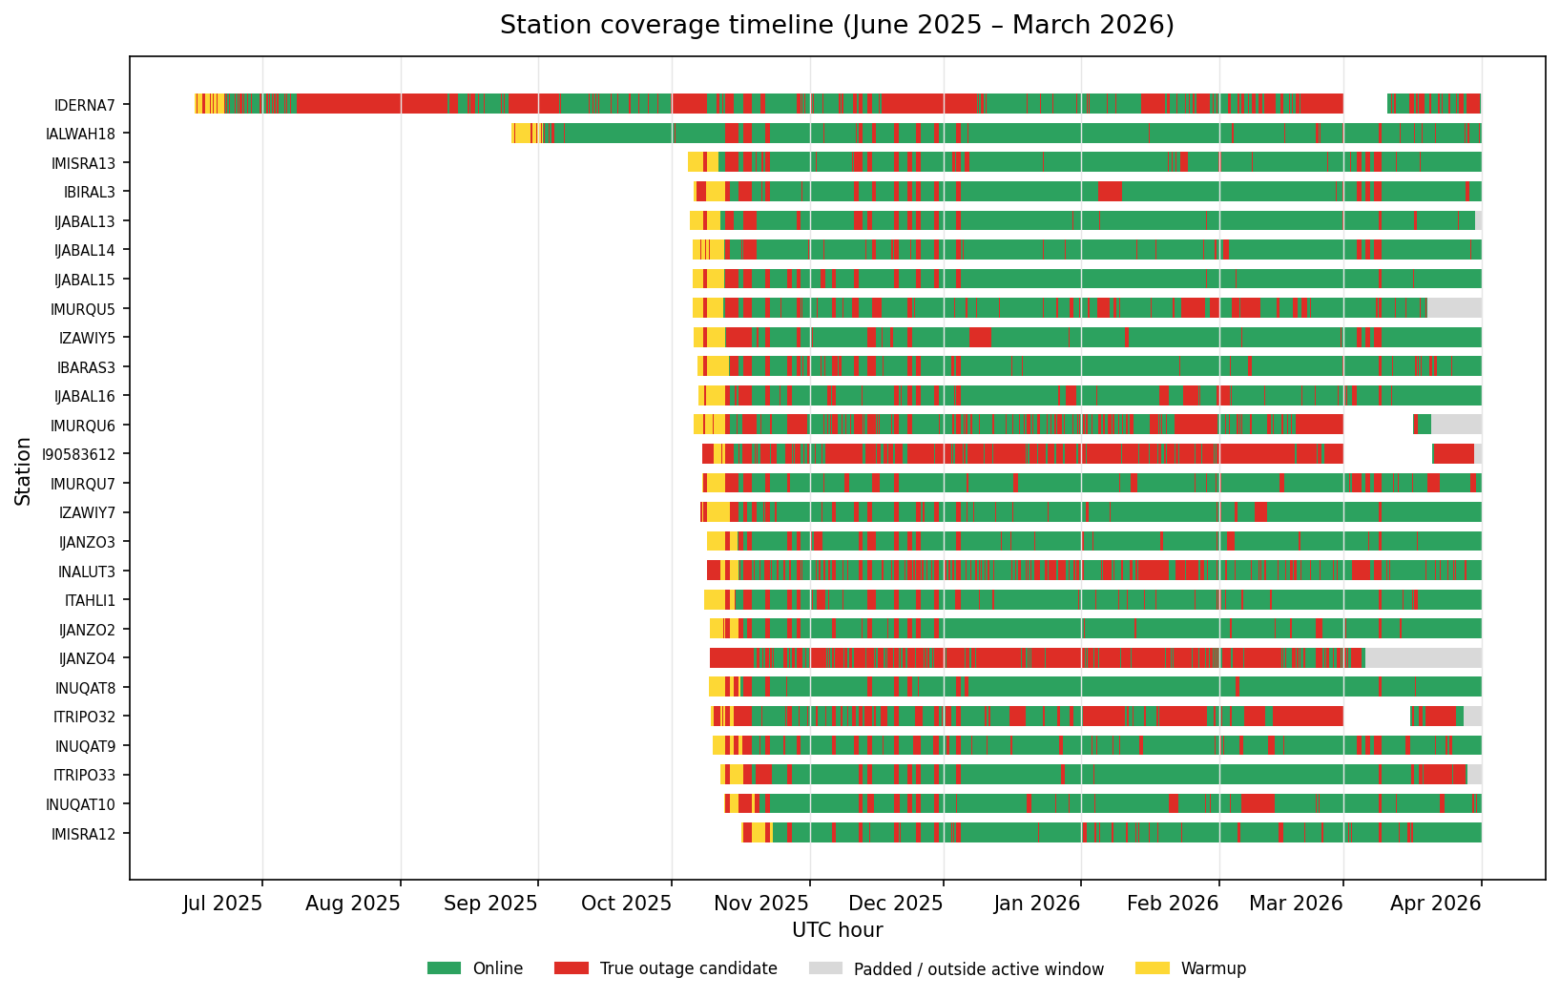

Figure 5.1. Station coverage timeline from Phase 1 audit.
The missingness heatmap shows that missing variables often occur in blocks rather than independently. Examples include IDERNA7 with 18% missingness on every measurement variable simultaneously, IMISRA12 with 35% missingness on every measurement variable simultaneously, IJABAL13 with 19% missingness across most variables, and INALUT3 and IBARAS3 with 13% block missingness. This finding supports the choice of missingness-aware modeling in later stages.
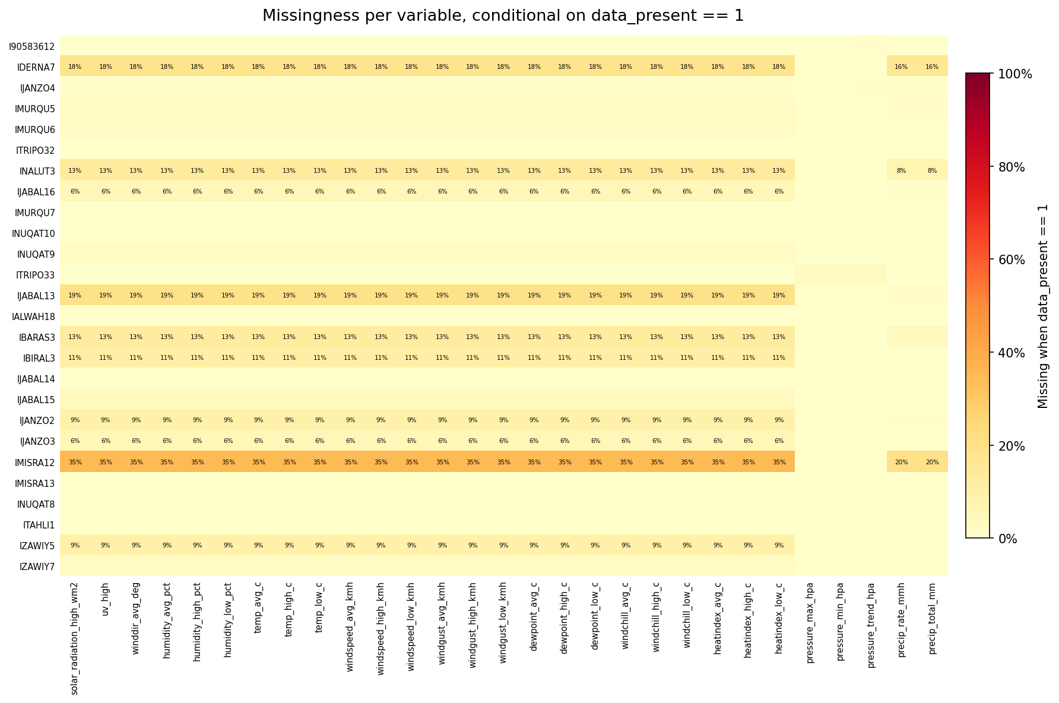

Figure 5.2. Station-variable missingness heatmap from Phase 1 audit.
Table 5.2. Concrete fault examples found in the data.
Station | Fault family | Evidence
ITRIPO33 | Stuck wind sensor | Wind sensor reported 0 km/h continuously for 220 hours while neighboring stations recorded normal wind.
IJANZO2 | Repeated stuck wind events | Five separate stuck-wind events totaling 526 hours.
IBIRAL3 | Pressure calibration offset | Persistent pressure bias of about -16 hPa with near-zero noise, consistent with fixed-offset calibration error.
IJABAL13 | Unstable pressure sensor | Mean pressure offset about -38 hPa with standard deviation about 40 hPa, consistent with degrading sensor behavior.
IDERNA7 | Very long outage | Single 814-hour blackout from July 8 through August 11, 2025.
IMURQU7 | Stuck or faulty rain counter | Forty absurd rain rows clustered around four dates, including repeated values such as 4697.98 mm across consecutive hours.
Unspecified rain extremes | Physically impossible rainfall | Rain-rate values above 5,933 mm/hr, far beyond plausible physical limits.

These examples demonstrate the validator gap. A range validator catches impossible single values, but it does not catch all values that are individually plausible and collectively impossible. The project therefore requires temporal, residual, spatial, and missingness-aware signals.
5.4.2 Phase 2 Outage Event Results
Phase 2 converted outage candidate hours into events. The resulting event table contains 1,670 outage events totaling 25,336 absent hours across the frozen window.
Table 5.3. Outage duration distribution from Phase 2.
Duration class | Definition | Events
Short | 1-3 hours | 744
Medium | 4-24 hours | 737
Long | 25-168 hours | 173
Very long | >168 hours | 16

The distribution shows that most outages are short or medium, but long events dominate operational concern because they remove a station from the network for days or weeks. Selected per-station event counts confirm the audit findings: INALUT3 has 204 events, IDERNA7 has 192 events including the 814-hour blackout, IMURQU6 has 121 events, and IBIRAL3 has only 22 events, making it one of the cleanest stations in the network.
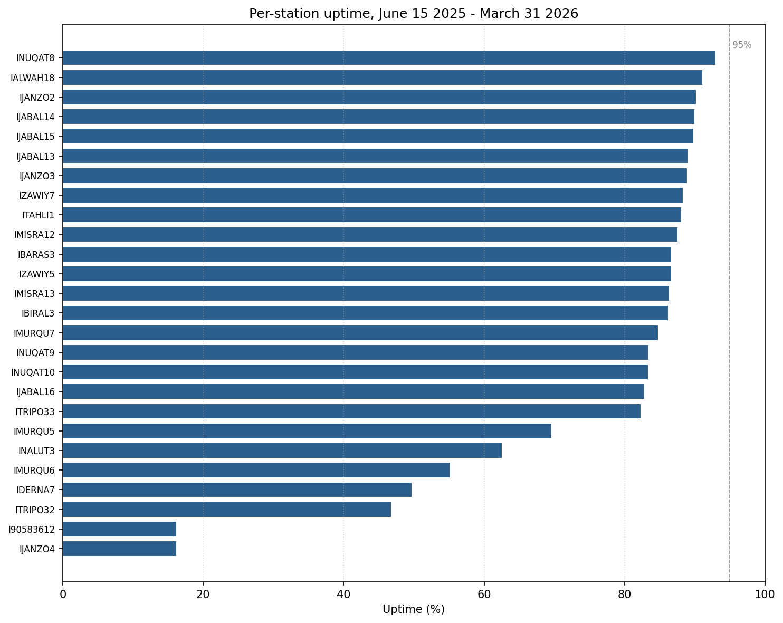

Figure 5.3. Per-station uptime bar chart from Phase 2.
Table 5.4. Outage class distribution from Phase 2.
outage_class | Definition | Events
local | Event not part of a detected coordinated network outage. | 1,353
network_midnight | Event in a network-wide window beginning at 22 or 23 UTC. | 267
network_other | Event in a network-wide window beginning at any other hour. | 50

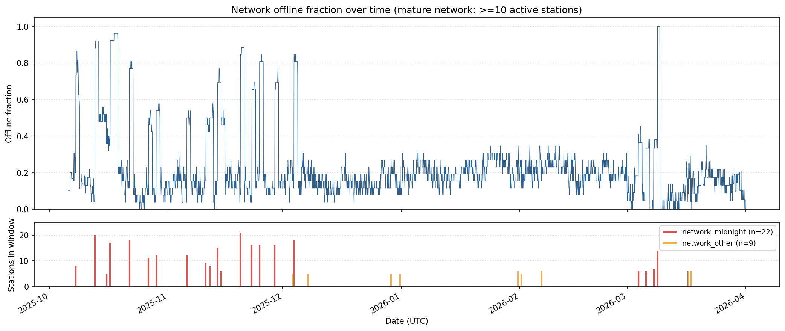

Figure 5.4. Network offline fraction timeline from Phase 2.
5.4.3 Network-Wide Outage Investigation
The network-wide detector found 31 coordinated windows. Twenty-two of these windows cluster at 22-23 UTC, which is shortly after Libya local midnight because Libya is UTC+2. The remaining nine windows occur at other hours.
Table 5.5. Summary of network-wide outage investigation.
Finding | Result
Detected network-wide windows | 31 total windows.
Midnight-clustered windows | 22 windows beginning at 22-23 UTC.
Non-midnight windows | 9 windows beginning at other hours.
Midnight station-events | 267 events.
Network_other station-events | 50 events.
Tight minute-level synchronization | 9 midnight windows show sub-minute drop synchronization with spreads of 23 to 59 seconds.
March 8, 2026 case | 14-station minute-level sample dropped within 55 seconds across stations spanning about 950 km; the longer hourly view shows all 21 active stations offline.
Midnight duration pattern | Median per-station duration in midnight windows is 24 hours, with a range of 2 to 116 hours.
Non-midnight duration pattern | Median per-station duration in non-midnight windows is 2 hours, with a range of 1 to 5 hours.
90-day silence | No detected midnight phenomenon from December 4, 2025 through March 2, 2026, despite 158 of 178 midnight bins having at least 20 stations online.

The March 8, 2026 case is especially important. The affected stations spanned roughly 950 km, from the Tunisian-border side of the network to Awjila in the eastern desert. A synchronized drop across that distance is not consistent with a single Libyan power-grid event, a single local ISP outage, or local weather. The strongest interpretation is that the drops were caused by an upstream process in the Weather Underground/IBM ingestion pipeline, likely related to day-boundary processing. The exact mechanism cannot be confirmed from outside the platform.
The investigation also corrected an early simplified interpretation. The midnight events are not merely one-hour rollover blips. The drops can be sub-minute synchronized, but recoveries are staggered over hours to days. The median per-station duration in midnight windows is 24 hours.
A concurrent offline analysis of the mature network period, defined as at least 10 active stations from October 5, 2025 onward, found 169 hours with at least 80% of active stations offline and 15 hours with 100% of active stations offline. These high-blackout hours are not concentrated only at midnight because extended events contribute many non-midnight blackout hours after a synchronized start.
5.4.4 Local Co-Occurrence After Removing Network-Wide Events
The station-pair co-occurrence analysis shows why network-wide events must be separated before studying local station dependence. With network-wide hours included, all distance buckets appear elevated. After excluding 8,167 station-hours belonging to network-wide events, distant station pairs collapse to ratios close to 1.0, meaning their outages are mostly independent.
Table 5.6. Local co-occurrence ratios after excluding network-wide hours.
Distance bucket | Median observed/expected ratio | Pairs
0-25 km | 1.12 | 15
25-50 km | 0.96 | 34
50-100 km | 1.08 | 93
100-200 km | 0.99 | 105
200-500 km | 1.01 | 30
>500 km | 1.04 | 48

Specific nearby pairs remain elevated after cleanup, which suggests local infrastructure clustering rather than general distance effects. The strongest example is IJANZO2 and IJANZO3, about 13 km apart in the Janzour area, with a 5.58x co-occurrence ratio. Other elevated pairs include INUQAT9 and IZAWIY5 at 3.0x, IZAWIY5 and IZAWIY7 at 2.89x, IBIRAL3 and IJABAL13 at 2.13x, and INUQAT10 and INUQAT9 at 1.66x.
The completed investigation therefore identifies three empirically distinct outage modes: synchronized network-wide events, local infrastructure clustering for specific nearby pairs, and mostly independent station-level outages after removing network-wide artifacts.
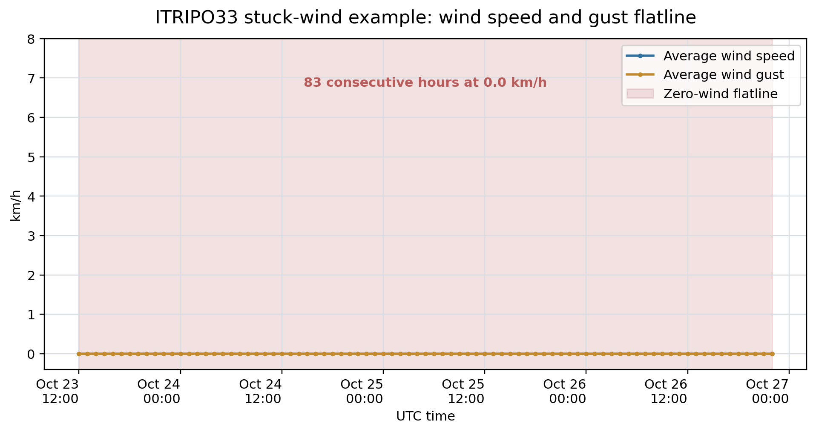

Figure 5.5. Example stuck-wind fault panel.

Chapter 6
Conclusion and Future Work
This chapter summarizes the project status through the completed audit and outage-engine phases. The full hybrid detector has not yet been evaluated, so the conclusion is an interim conclusion about the foundation that has been built and the empirical reliability findings already discovered.
6.1 Conclusion
The work completed so far establishes a solid data and reliability foundation for the fault detection system. A nine-and-a-half-month hourly dataset for 26 weather stations was assembled, and every station-hour was assigned a lifecycle row_state. This created a stable definition of online, missing, outage, warmup, terminal padding, and pre-installation data for all later stages.
The Phase 1 audit showed that the network contains both reliable reference candidates and stations with significant reliability problems. It also showed block-aligned missingness, confirming that many station problems affect groups of variables together rather than independent single sensors. Several concrete faults were identified, including stuck wind sensors, pressure calibration problems, unstable pressure readings, long outages, and impossible rainfall values.
The Phase 2 outage engine extracted 1,670 outage events and separated local station failures from coordinated network-wide windows. The investigation of 31 network-wide windows revealed a distinctive midnight-clustered phenomenon, with several windows showing sub-minute drop synchronization across stations spread over large geographic distances. This finding is important because those events should not be treated as local station-attributable failures during model training.
Overall, the completed work demonstrates that the dataset contains enough real fault structure to justify the planned hybrid detector. It also shows that reliability monitoring must be event-based, missingness-aware, and careful about distinguishing station faults from platform-level artifacts.
6.2 Limitations
The main limitation of this draft is that it reports only the completed foundation stages. The statistical anomaly layer, external residual layer, spatial residual layer, GRU-D model, fusion layer, risk model, FT0360 controlled validation, and dashboard have not yet produced final results in this report.
A second limitation is that the exact upstream cause of the Weather Underground midnight phenomenon cannot be directly observed from outside the Weather Underground/IBM platform. The analysis can rule out several local explanations for geographically spread, tightly synchronized events, but it cannot identify the internal platform mechanism with certainty.
A third limitation is the lack of complete ground truth for online-but-wrong sensor faults. Outage labels are strong because upload absence is observable, but faults such as calibration drift, wind exposure problems, and rain gauge faults require controlled experiments or manual review. This is why the later validation strategy separates strong outage labels, controlled FT0360 device labels, and reviewed labels.
A fourth limitation is geographic unevenness. The northwest cluster supports spatial comparison, but IALWAH18 and IDERNA7 are too isolated for reliable neighbor-based quality control. For those stations, the system must rely more heavily on external residuals and station-specific temporal behavior.
6.3 Future Work
The planned future work is organized into the remaining project stages:
- Stage 3: implement per-channel statistical anomaly detection, including station-specific thresholds, flatline checks, stuck-wind detection, spike and step detection, and candidate fault windows for review.
- Stage 4: compute external residuals against Open-Meteo/ECMWF references and spatial residuals against nearby stations, using a 200 km neighbor cap and correct mean-sea-level pressure convention.
- Stage 5: freeze the validation protocol, define the final fault taxonomy, and label 200-400 reviewed suspicious events with confidence flags.
- Stage 6: build the hybrid detector, including GRU-D, signal fusion, event builder, reason codes, and fault cause likelihood distribution.
- Stage 7: train a risk prediction model for 6-hour, 12-hour, and 24-hour horizons, with calibration and lead-time analysis.
- Stage 8: complete final validation using real outages, controlled FT0360 fault injection scenarios, and reviewed events, reported separately.
- Stage 9: build the Streamlit dashboard with network overview, station drilldown, recent events, and risk visualization.
After these stages are complete, the abstract, conclusion, references, list of figures, list of tables, and final performance sections should be revised to reflect the final validated system rather than the interim Phase 1 and Phase 2 checkpoint.

References
[1] Z. Che, S. Purushotham, K. Cho, D. Sontag, and Y. Liu, "Recurrent Neural Networks for Multivariate Time Series with Missing Values," Scientific Reports, vol. 8, Article 6085, 2018.
[2] Q. Liu and J. Paparrizos, "The Elephant in the Room: Towards a Reliable Time-Series Anomaly Detection Benchmark," in Advances in Neural Information Processing Systems, 2024.
[3] L. W. Vos, H. Leijnse, A. Overeem, and R. Uijlenhoet, "The Potential of Urban Rainfall Monitoring with Crowdsourced Personal Weather Stations in Amsterdam," Hydrology and Earth System Sciences, vol. 23, no. 2, pp. 765-777, 2019.
[4] Sainlogic, FT0360 Pro WiFi Weather Station User Manual. Sections 4, 5, 11, and 12.
[5] Weather Underground / IBM, Personal Weather Station History API documentation, /v2/pws/history/all endpoint. [Verify final access date and URL before submission.]
[6] Open-Meteo, Historical Weather API and ECMWF/ERA5 archive access documentation. [Verify final access date and URL before submission.]
[7] Mozn AI Post-Processing System, companion forecasting bias-correction project and reusable data utilities, 2026.

Appendices
Appendix A: Completed Artifact Inventory
This appendix lists the main completed artifacts that should be included or referenced when finalizing the report.
- data/merged/station_registry.csv
- data/processed/hourly_row_states.parquet
- data/processed/data_audit_summary.csv
- data/processed/missingness_by_variable.csv
- data/processed/availability_events.parquet
- data/processed/network_outage_windows.csv
- data/processed/station_reliability_summary.csv
- outputs/figures/station_coverage_timeline.png
- outputs/figures/missingness_heatmap.png
- outputs/figures/station_uptime_bar.png
- outputs/figures/network_offline_fraction_timeline.png
- docs/phase1_data_audit.md
- docs/phase2_outage_engine.md
Appendix B: Figure and Screenshot Placeholder Checklist
Insert the following visuals before final submission:
- Map of station locations across Libya.
- Hybrid detector architecture diagram.
- Row-state classifier flow diagram.
- Outage event construction flow diagram.
- Station coverage timeline from Phase 1.
- Missingness heatmap from Phase 1.
- Station uptime bar chart from Phase 2.
- Network offline fraction timeline from Phase 2.
- At least one fault case study panel, preferably ITRIPO33 stuck wind or IJABAL13 unstable pressure.
Appendix C: Planned Validation Notes
The final validation section should be updated after the controlled FT0360 campaign and reviewed-label sprint. Strong outage labels, controlled device labels, and reviewed labels should be reported in separate rows. Do not collapse them into a single accuracy number.

