University of Tripoli
Faculty of Engineering
Computer Engineering Department

Fault Detection and Reliability Monitoring for a Newly Deployed
Weather Station Network in Libya

A project submitted in partial fulfillment of the requirements
for the bachelor’s degree in computer engineering

By:
Ayat Khalifa Elawej

Supervised by:
Dr. Ziad Elhajjaji
Dr. Dakhil Elgarwaly

2026

Fault Detection and Reliability Monitoring for a Newly Deployed Weather Station Network in Libya

By:
Ayat Khalifa Elawej

Approved by:
Dr. Ziad Elhajjaji
Dr. Dakhil Elgarwaly
Examiner: ______________________________
Examiner: ______________________________

Declaration
I hereby declare that this project report, “Fault Detection and Reliability Monitoring for a Newly Deployed Weather Station Network in Libya” submitted for the partial fulfillment of the requirements for the award of the Bachelor of Science degree in Computer Engineering from the Department of Computer Engineering at the University of Tripoli, is a bona fide work done by me under the supervision of Dr. Ziad Elhajjaji. It represents my own ideas in my own words, and where the ideas or words of others have been included, the original sources have been adequately cited and referenced.
I further declare that I have adhered to the principles of academic honesty and integrity, and have not misrepresented or fabricated any data, idea, fact, or source in this submission. I also declare that this work has not been previously submitted in support of another degree or qualification at this or any other university or institute of learning.

Ayat Khalifa Elawej
Date: ___/___/2026
Signature: ____________________

Abstract
This project develops a working reliability monitoring system for a network of 26 personal weather stations spread across Libya. It uses hourly data (aggregated from a 5-minute interval dataset) that spans from June 2025 to June 2026 and was further tested on an unseen month (July 2026). The dataset contains sensor readings for 29 different meteorological variables including temperature, humidity, pressure, rainfall, and wind measurements. This system was created to detect sensor faults and classify full and partial outages occurring in these different stations using only sensor readings, external references and engineered features. This showed the ability of the system at detecting faults and labeling them with likely mechanism reason codes without direct access to station hardware or maintenance records. The system also calculates an overall health score for every single station at each observed hour, while also giving a future prediction for the station’s health in the next 1, 3, 6, 12 and 24 hours. The project was engineered from scratch, covering dataset preparation, data cleaning and labelling, feature engineering, model training and validation, and dashboard development. It also includes two custom models created specifically for this system: RGFN (Reliability-Aware Gated Fusion Network), a custom deep-learning model evidence-fusion model, and EF-HGB (Evidence-Fused Histogram Gradient Boosting), a custom classical machine-learning model based on HGB. RGFN performed competitively, while EF-HGB achieved the strongest validation results beating out every other architecture and was selected as the final fault detector for the system. The final system is deployed on an admin facing dashboard that lets operators see the full scorecard of each station to support monitoring, inspection, and maintenance-planning decisions.

List of Abbreviations
Abbreviation | Full Meaning
API | Application Programming Interface
PWS | Personal Weather Station
CSV | Comma-Separated Values
ECMWF | European Centre for Medium-Range Weather Forecasts
ERA5 | Fifth-generation ECMWF atmospheric reanalysis
F1 | Harmonic mean of precision and recall
GRU | Gated Recurrent Unit
GRU-D | Gated Recurrent Unit with Decay
HGB | Histogram Gradient Boosting
RGFN | Reliability-Aware Gated Fusion Network (the custom model designed in this project)
EF-HGB | Evidence-Fused Histogram Gradient Boosting
UTC | Coordinated Universal Time

Contents
Declaration 2
Abstract 3
List of Abbreviations 4
List of Figures 7
List of Tables 8
Introduction 10
1.1 Motivation and Problem Statement 11
1.2 Objectives 12
Background and Theoretical Foundations 13
2.1 Technical Background 13
2.2 Tools and Technologies 14
2.3 Theoretical Concepts 14
Related Work 16
3.1 Previous Studies 16
3.2 Comparison with Existing Systems 18
3.3 Research Gap 19
Data Engineering and Reliability Foundations 20
4.1 System Overview and Requirements 20
4.1.1 Functional Requirements 21
4.1.2 Non-Functional Requirements 22
4.2 Data Sources and Hourly Dataset 22
4.3 Lifecycle States and Continuous Time Grid 23
4.4 Full, Partial, and Coordinated Outages 24
4.5 Feature Engineering and Fault Evidence 25
4.5.1 External and Spatial Context 25
4.5.2 Statistical Anomaly Features 26
4.5.3 Physical-Limit Features 28
4.6 Fault Taxonomy and Label Engineering 29
4.7 Transparent Station-Health Score 30
4.8 Data-Engineering Results and Discussion 34
4.8.1 Dataset Audit 34
4.8.2 Full and Partial Outage Results 37
4.8.3 Coordinated Network Events 40
4.8.4 Local Co-Occurrence Diagnostic 41
4.8.5 Statistical and Physical Evidence Results 42
4.8.6 Fault Label Results 44
4.8.7 External and Spatial Residual Results 46
4.8.8 Station-Health Score Results 48
Model Creation, Experiments, and Selection 54
5.1 Experimental Setup 54
5.2 Testing Procedure 54
5.3 Performance Metrics 55
5.4 Binary Fault Detection 56
5.4.1 Classical Baselines 56
5.4.2 Reliability-Aware Gated Fusion Network 56
5.4.3 Results and Final Binary-Detector Selection 56
5.5 Fault-Mechanism Reason Codes 61
5.6 Health-Forecasting Method 63
5.7 Health-Forecasting Results 64
5.8 Longer-Horizon Health Experiments 70
5.9 Current Model Portfolio 71
Later-Month Testing and Validation 72
6.1 Evaluation Boundary 72
6.2 Frozen July Later-Month Evaluation 72
6.3 Controlled Hardware Fault Tests 76
6.4 Validation Status Summary 76
Operational Scorecard and Dashboard 77
7.1 Operational Scorecard 77
7.2 Implementation and Reproducibility 77
7.3 Operational Scorecard Results 78
7.4 Dashboard 81
7.5 API and Roaya Integration 81
7.6 Reproducibility Controls 82
Integrated Discussion 83
8.1 Main Findings Across the Four Project Parts 83
8.2 What the Custom-Model and Window Experiments Show 83
8.3 Limitations 83
8.4 Operational Readiness 84
Conclusion and Future Work 85
9.1 Conclusion 85
9.2 Future Work 85
9.3 Incident-Onset Forecasting as Future Work 86
References 89
Appendices 91
Appendix A: Artifact Inventory 91

List of Figures
Figure 1.1. Geographic distribution of the 26-station Libyan network. 10
Figure 4.1. End-to-end system: the label-building and detection path is separate from the causal health and forecasting path. Hardware telemetry is not an input. 21
Figure 4.2. Counts of the five exclusive lifecycle states in the 166,017-row frozen dataset. 23
Figure 4.3. Full and partial outage construction on a continuous station-hour grid 25
Figure 4.4. Causal health-score composition from five bounded components 34
Figure 4.5. Weekly observed coverage by station across the frozen interval 35
Figure 4.6. Measurement missingness conditional on present station-hours 36
Figure 4.7. Full-outage availability by station 38
Figure 4.8. Daily mean fraction of stations offline 40
Figure 4.9. Repeated-zero wind evidence at ITRIPO33 42
Figure 4.10. Detector-fire rate by station and evidence group 43
Figure 4.11. Verified fault-evidence examples for stuck wind and impossible precipitation 44
Figure 4.12. Multi-label mechanism and component counts in the canonical 1,121-fault population 45
Figure 4.13. Trigger composition of the 177 spike-impossible episodes 46
Figure 4.14. Twelve longest sustained-offset evidence runs. The highlighted IJABAL13 run intersects the four episodes promoted to calibration_offset. 48
Figure 4.15. Distribution of final causal station-health scores across all numeric station-hours 49
Figure 4.16. Distribution of the five health components after causal preprocessing 50
Figure 4.17. Correlation among final health components 51
Figure 4.18. Contrasting station-health trajectories 52
Figure 4.19. IDERNA7 during an 814-hour outage: gradual decline while silent and a visible jump on recovery. The projection does not predict when recovery will occur. 53
Figure 5.1. Hour-level target composition across all 166,017 observed station-hours 57
Figure 5.2. Development test F1 for the final one-hour comparison. EF-HGB is selected using the validation maximin rule, not the plotted test values. 58
Figure 5.3. EF-HGB's three feature views and validation-selected probability fusion. The final operational configuration assigns zero weight to the context-only branch. 59
Figure 5.4. Input-window comparison: validation and development-test F1. The complete values are in Table 5.3. 60
Figure 5.5. Health forecasting: chronological selection, final fitting and a bounded correction to the roll-forward baseline. No new model is fitted during dashboard replay. 64
Figure 5.6. Primary forecast MAE against persistence and no-new-incident roll-forward at each horizon 66
Figure 5.7. Mean observed health against mean predicted health within prediction deciles. Near-diagonal averages show calibration of groups, not the error or uncertainty of individual station-hour forecasts. 67
Figure 5.8. Regression and band-classification performance across 1-24 hours 69
Figure 5.9. Final subsystem roles: calculated availability and health, selected EF-HGB detection, selected CatBoost forecasting and separate development experiments. 71
Figure 6.1. Confusion matrices for the final EF-HGB at threshold 0.30. Class counts and proportions are given in Table 6.1. 73
Figure 6.2. Final EF-HGB ROC and precision–recall curves. Average precision is the AUPRC summary used here. 74
Figure 6.3. Frozen July health-forecast MAE against persistence and roll-forward. The 6-hour persistence advantage is retained. 75
Figure 6.4. Health-band accuracy across the five horizons in development and July. These values describe bands, not exact-score accuracy. 75
Figure 7.1. Implemented read-only dashboard flow. Model inference happens before replay 77

List of Tables
Table 2.1. Network and dataset summary. 14
Table 4.1. Functional requirements. 21
Table 4.2. Non-functional requirements. 22
Table 4.3. Row-state taxonomy. 23
Table 4.4. Sensor-group membership used for partial-outage classification 24
Table 4.5. Statistical anomaly detectors and the faults they target. 27
Table 4.6. Fault mechanism labels. 30
Table 4.7. Causal station-health components, weights, and evidence windows 31
Table 4.8. Progressive outage-duration multipliers used by the health score 33
Table 4.9. Status-class distribution from the June 2026 dataset audit. 34
Table 4.10. Verified examples from the canonical dataset. 36
Table 4.11. Outage-duration distribution from the June 2026 availability engine. 37
Table 4.12. Outage-class distribution from the June 2026 availability engine. 38
Table 4.13. Partial-outage event durations among transmitting hours 38
Table 4.14. Sensor-group availability conditional on station transmission 39
Table 4.15. Summary of coordinated network-outage windows. 40
Table 4.16. Scope of the local co-occurrence diagnostic. 41
Table 4.17. Statistical evidence funnel for the canonical label build. 42
Table 4.18. Fault episodes by canonical mechanism and component labels. Counts are multi-label and are not mutually exclusive. 44
Table 4.19. Sustained-offset evidence runs and their canonical label resolution. Pressure values are in hPa 47
Table 4.20. Effect of replacing the full-outage hard zero with progressive duration degradation 52
Table 5.1. Hour-level dataset composition and training use. 57
Table 5.2. Final one-hour model comparison. Metrics are percentages 58
Table 5.3. HGB input-window comparison. Each row uses its own validation-selected operating point 60
Table 5.4. Validation-only selection of the spaced mechanism reason-code configuration. Macro values are precision, recall, F1, and accuracy. 61
Table 5.5. Retrospective event-level mechanism reason-code comparison under the predefined any-hour aggregation rule. 62
Table 5.6. Held-out spaced event-level result by mechanism for the frozen validation-selected gradient-boosted any-hour configuration. 62
Table 5.7. Primary transmitting-origin health forecasts and deterministic baselines 64
Table 5.8. Validation-selected transmitting-origin health-forecast configurations 66
Table 5.9. Health-band classification on transmitting origins 68
Table 5.10. Supplementary full-outage-origin experiments. These are distinct from the dashboard's deterministic continued-outage projection. 69
Table 5.11. Direct classification of a health deterioration of at least five points 70
Table 5.12. Supplementary 2–7-day health-band accuracy on the development test. The deployed 1–24-hour models are unchanged. 70
Table 6.1. Final selected EF-HGB: development test and July later-month test. Operating-point metrics are percentages 72
Table 6.2. Frozen July transmitting-origin health forecasts and deterministic baselines. 74
Table 7.1. Main entry scripts and their roles. Paths are relative to the repository root 78
Table 7.2. Frozen June 26-station operational snapshot, sorted by health. These are selected fields from the historical 80-column scorecard. 78
Table 7.3. Status distribution in the frozen June scorecard. Forecast eligibility refers to learned forecasts, not the later dashboard's scenario projections. 80
Table 7.4. Causal persistent pressure-offset evidence in the latest scorecard 81
Table 9.1. Qualitative outcomes of the incident-onset investigation 86

Chapter 1

Introduction
Personal weather stations can provide low cost and efficient weather observations in places where official sources and observational networks are sparse. In Libya, this is one of the main challenges we currently face, and a growing newly deployed network of personal weather stations was installed all throughout the country to help solve that issue, aiding in providing public weather observations for operational use (26 of these weather stations were present at the time of creating this project but now the system has grown to over 70 weather stations spread across the nation) [18]. This network of PWSs is valuable not only for real time weather observation but it has aided in the creation of a weather forecast post-processing system [7] which was utilized in a national early warning system [17],[19] that helps protect citizens from natural disasters that could occur at any moment. Therefore, it’s necessary to make sure that these stations are recording and displaying correct readings and their reliability must be monitored. Despite their usefulness, they are still PWSs mounted to people’s homes meaning they are prone to all kinds of faults since they are not in a controlled research environment overseen by professionals. Fault detection is therefore essential in making sure that this network remains reliable for all its use cases.

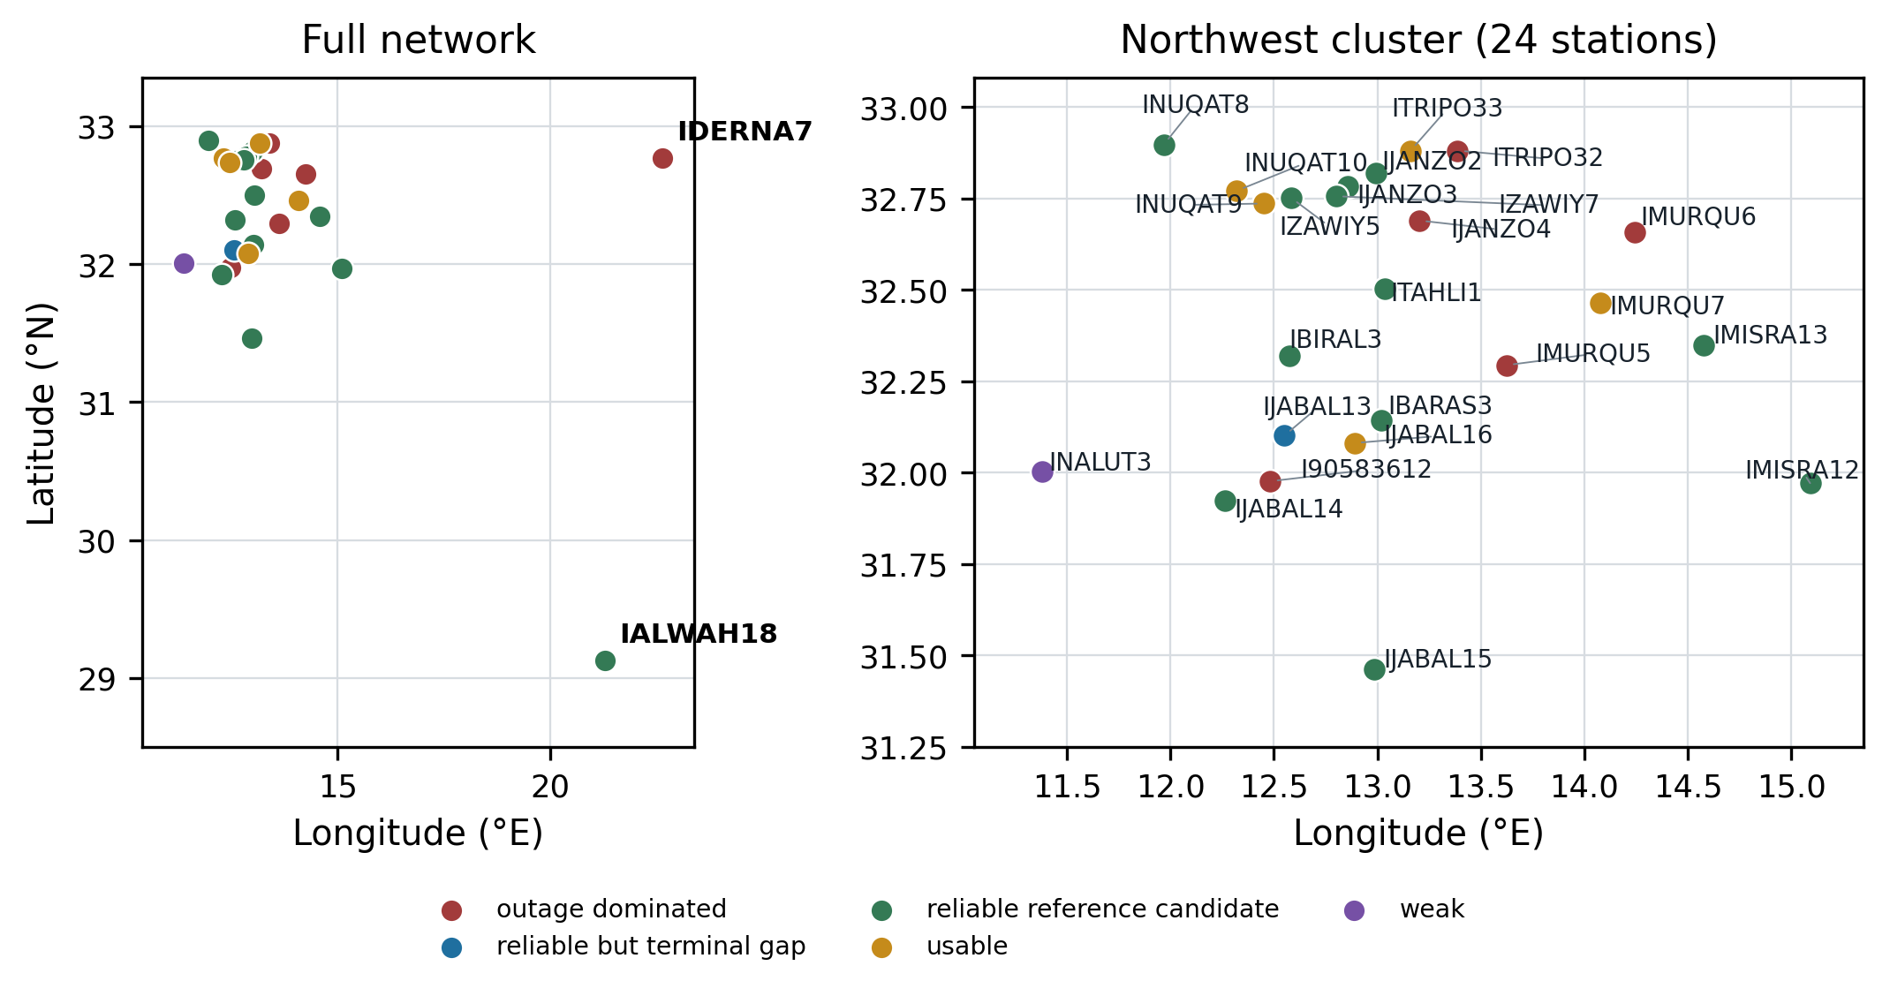
Figure 1.1. Geographic distribution of the 26-station Libyan network.

This project builds an hour-level reliability monitoring system for 26 of these stations. It can reliably detect when a likely fault has occurred, whether it’s a sensor fault, a full outage, partial outage or network wide outage, records the likely mechanism reason for fault occurrence, gives a station health score and forecasts future station health (spanning from 1 hour to 24 hours). Then these results are joined into a per station scorecard. This scorecard is deployed onto a dashboard that lets an administrator monitor each station’s health, see which station is facing a fault and needs immediate attention and what the likely reason is behind this fault occurrence. It can also let them keep an eye on what station has a likely dip in its health score in the next 24 hours so they can make sure to prioritize monitoring, inspection, or maintenance planning.

1.1 Motivation and Problem Statement
The motivation behind working on this project came from problems I discovered during my earlier work on the Mozn forecast post-processing system [7]. While working with this same dataset, I found that sometimes station behavior deviated from expectations and could not be explained by normal weather conditions. This included random spikes, long periods of repeated unchanging outputs, persistent bias, impossible values and even occasional outages. This led me to believe that these observations were not merely weather anomalies but could be sensor faults that may negatively affect the results of my post-processing system and the reliability of the live deployed website [19].
A station that completely stops transmitting (blacks out) can be easily noticed. What’s more dangerous is an online station that continues to transmit incorrect but believable values and measurements. These readings could be trusted because there’s no sign or proof that the sensor is faulty. This negatively affects the weather monitoring, the forecasting and early warning applications. It could also affect the dataset that includes these values and any weather-related research that depends on the observations being correct.
Unfortunately, hardware/maintenance data for these stations and their sensors or a built-in fault detection system do not exist, so we must find another way to determine whether the observations can be trusted. This idea proves to be difficult, but several available observations and reference sources can be reliably used to label the likelihood of fault occurrence but they each have their own limitations. For instance, station observations can be used. They may give unusual measurements, but we can’t say for sure if they are truly faults or just weather anomalies. We must be able to separate the two very well. External references including ERA5/Open-Meteo data are also an option. They provide good references but can differ due to local conditions. We can also rely on spatial comparisons, but stations may fail together or a specific station might not have enough neighbors to help determine if its observations are truly false.
Therefore, this project combines all of these into a multi-layer evidence system. Instead of treating one detector as the final answer, we look at all of them. These layers include physical limits, statistical anomalies, external weather references, nearby station comparisons, missing data patterns and changes over time. The goal is to identify which station hours should be treated with caution, with enough evidence to understand why they were flagged, when there is no real hardware evidence to point us in the right direction.

1.2 Objectives
The objectives of the project are:
- Prepare and validate a clean hourly analysis dataset for the selected 26 stations using observations from the published Mozn dataset [18].
- Detect full outages, distinguish between local and network-wide outages.
- Detect partial outages in which a station still transmits while one or more physical sensor groups are absent.
- Detect suspicious sensor behaviour such as impossible spikes, stuck values, statistical anomalies and calibration offsets.
- Compare station readings with external and nearby-station references.
- Label fault-candidate episodes using the multi-layer evidence system.
- Train various models to detect the fault occurrence and predict mechanism reason codes using a 70/15/15 split.
- Use various partition methods including random and spaced splits to assure correct model selection.
- Compare classical baselines with a custom model, then select the strongest validated model.
- Define a 0-100 station-health score and forecast it at horizons ranging from 1 to 24 hours.
- Integrate transmission, health, health forecast and fault-evidence fields into an operational scorecard.
- Complete a test on an unseen month (July 2026) alongside the preexisting testing mechanisms.
- Create a dashboard as the main deployment demonstration (direct live access is unavailable so a replay dashboard will be created).

Chapter 2

Background and Theoretical Foundations
This chapter explains all the technical ideas needed to understand this project fully. It introduces the network of personal weather stations, time-series processing, anomaly detection, machine learning models and what reliability monitoring is. It also mentions how in this project missing values are not just a cleaning problem, they can be utilized as important information about a station’s condition.

2.1 Technical Background
The devices deployed in this network are Sainlogic FT0360 Pro Wi-Fi PWSs. Each station has an array of outdoor sensors that measure numerous variables including temperature, humidity, rainfall, windspeed and pressure. The indoor console receives these measurements/observations and uploads them via Wi-Fi to the Weather Underground servers [4], [5]. This provides a low cost and practical way of collecting weather information from all around the country, especially in places where official observations are limited.
The project dataset contains observations from 26 different stations distributed throughout Libya, most of the stations are in a dense cluster near the western side of the country, while two of the stations are geographically isolated from the rest. This means that these two station cannot rely on nearby station comparisons for fault detection while the others can. Instead, they must rely more heavily on their own recent behavior and external weather references.
The main public dataset contains 5-minute interval observations in UTC [18], while the reliability monitoring system that was built uses an aggregated version with hour long intervals. The hourly table contained one row for each station and hour, with fields such as hourly averages, minimums and maximums for the present meteorological observations. This design decision was made to limit the amount of noise that goes into the system and choose an interval that is long enough to still support a stable system while also having the same temporal resolution as external reference data (hourly), to ensure correct alignment in the external reference layer. The project treats the combination of station_id and hour_utc as the unique identifier for each station-hour. Table 2.1 summarizes the network and dataset used throughout the project.
The availability analysis in this project helps distinguish between when a full outage occurs (a station fully blacks out and stops transmitting) and when a partial outage occurs (only one or more of the sensors, but not all of them, stop transmitting). Also, the sensor faults the system tries to catch are spikes, stuck or flatlined values, statistical anomalies and persistent calibration offsets. It was kept in mind that some suspicious observations can still appear physically possible when viewed individually, especially during periods of unusual weather, which is why the project relies on several sources. These sources as stated previously are physical limits, changes over time, external weather references and nearby station comparisons.

Table 2.1. Network and dataset summary.
Item | Value
Network size | 26 personal weather stations
Device model | Sainlogic FT0360 Pro WiFi
Deployment context | Roaya weather-station initiative with UNICEF support
Upload platform | Weather Underground
Frozen data window | 15 June 2025 to 30 June 2026
Hourly rows | 166,017 station-hours
Full-station hourly span | 9,144 timestamps across the frozen window
Schema size | 41 columns in the canonical hourly dataset
Geographic pattern | 24 western stations, 2 eastern spatially isolated stations
Local time convention | UTC for analysis; Libya UTC+2

2.2 Tools and Technologies
This project is a Python-based data and machine learning pipeline. It uses parquet files (for quicker data loading and manipulation) and CSV artifacts. External weather references come from the Open-Meteo archive derived from ECMWF. The Mozn post-processing system introduced earlier in chapter 1 provided some reusable utilities with attribution, including the station registry and Open-Meteo data cache, fetcher and a few feature building utilities.
As for the Python libraries, the project mainly used Pandas and NumPy for processing and manipulating the weather data, while scikit-learn was used for a lot of the statistical and machine-learning methods used for fault detection. PyTorch was used for the neural-network-based models developed in the project, including the custom RGFN architecture. Matplotlib was used to generate plots and figures for exploratory data analysis, evaluation and result presentation. CatBoost was used for the station-health forecasting models and Streamlit was used to build the dashboard. Git and GitHub were also used for version control and to maintain the project repository throughout development.

2.3 Theoretical Concepts
Several concepts are central to the project methodology:
- Lifecycle labeling: each station-hour is assigned one of five row states: online complete, online partial missing, true outage candidate, warmup, or terminal padded absence.
- Run-length event extraction: consecutive outage-candidate hours are grouped into single events so that a 34-day blackout is treated as one outage event rather than hundreds of independent hours.
- Residual analysis: a station reading is compared with an external reference or neighbor median. A residual is evidence of disagreement, not proof of error by itself.
- Spatial comparison: neighboring stations provide a local consistency check, especially in dense station clusters.
- Missingness-aware modeling: absence itself carries information. Models such as GRU-D use missingness masks and learned decay to represent this [1]; The project represents missingness using explicit masks and time-since-last-observation features. The final RGFN uses a sensor encoder, a separate rule-evidence encoder, and a learned gate that combines the two sources.
- Evidence fusion: the final EF-HGB detector combines a full-feature HGB model with models focused on contextual and rule evidence. Their influence is selected using validation data rather than the final test set.
- Imbalanced evaluation: normal hours dominate the detection dataset, so accuracy is reported alongside precision, recall, F1, AUROC, AUPRC, class distribution, and confusion matrices rather than being interpreted alone. The fault class forms 5.58% of all station-hours.

Chapter 3

Related Work
Fault detection in personal weather stations overlaps with several areas of previous work. These include quality control for crowdsourced weather observations, fault types in real-world sensor networks, anomaly detection for imbalanced time-series data, handling missing values, availability monitoring, and forecasting future system health.
This chapter discusses the work related to these areas and explains how this project is different. One of the main differences is that no internal hardware information, maintenance records, or confirmed fault logs are available for the stations. The system must therefore estimate whether a station is faulty using its sensor readings, missing-data patterns, previous behavior, external weather references, and comparisons with nearby stations.

3.1 Previous Studies
Crowd-sourced and personal weather station networks are known to contain unreliable observations because their installation conditions can vary. Stations may differ in their location, exposure, maintenance, sensor quality, and distance from surrounding buildings or other objects.
de Vos et al. studied the potential of using crowdsourced personal weather stations for urban rainfall monitoring. Their work showed that these networks can provide useful observations, but careful quality control is needed before the data can be trusted [3]. This project follows the same general idea: low-cost and widely distributed observations are only useful when unreliable measurements can be identified and handled correctly.
The reliability of privately owned weather stations has also been studied directly. Bell, Cornford, and Bastin compared citizen weather stations with professional references and found that the quality of individual stations can vary considerably [15]. Their findings support the need to assess stations individually instead of accepting or rejecting the entire network. This is important for the Libyan network because each station may have different environmental conditions, reporting behavior, and sensor reliability.
Several quality-control systems for crowdsourced weather networks depend mainly on spatial agreement. Napoly, Grassmann, Meier, and Fenner developed CrowdQC, a statistical method for identifying suspicious air-temperature observations without requiring a professional reference network [12]. Fenner and colleagues later extended this approach through CrowdQC+ to address problems such as radiative errors and sensor response time [13]. Beele and colleagues combined quality control with correction methods for a citizen weather-station network in Leuven [16]. Båserud and colleagues developed TITAN, an operational quality-control system that applies several checks, including tests based on agreement between nearby observations [14].
These approaches work best when stations are located close enough to support useful comparisons. However, the Libyan network is geographically uneven. Most of its stations are concentrated in the west, while two of the stations don’t have any usable neighbors. Spatial agreement is therefore used as one source of supporting evidence in this project, but it cannot be the only source. When spatial evidence is unavailable, the system must still be able to use the station’s own observations, its previous behavior, and external weather references.
Fault categories found in real sensor networks provide the vocabulary used in this project. Ni and colleagues described common sensor-fault types such as spikes, stuck-at values, offsets or biases, and noisy readings [10]. Sharma, Golubchik, and Govindan studied the frequency of sensor faults in real datasets and compared methods for detecting them [11].
The fault mechanisms used in this project follow this established vocabulary. spike_impossible represents sudden spikes and physically impossible values. stuck_flatline represents sensors that remain fixed or unchanged for an unreasonable period. calibration_offset represents a sustained difference or bias between a station and its references. statistical_anomaly represents suspicious behavior that requires statistical, external, spatial, or historical evidence to identify. Using these existing fault categories makes the labels easier to compare with previous sensor-network research.
A major difficulty in this project is that the true hardware condition of each station is unknown. There are no internal diagnostic readings, technician reports, maintenance records, or confirmed hardware-fault logs. A suspicious value cannot automatically be treated as proof of a damaged sensor because it may represent real local weather. For this reason, the labels and reason codes produced by the system represent evidence-supported likely faults rather than confirmed hardware diagnoses.
Missing data are also important in weather-station monitoring. Che et al. introduced GRU-D, a recurrent neural-network architecture that treats missingness as useful information by using missing-value masks and learned decay mechanisms [1]. Although GRU-D was developed for medical time-series data, the general idea is relevant here because missing observations may indicate communication problems, partial sensor failure, or a full outage.
Isolation Forest, introduced by Liu, Ting, and Zhou, is an unsupervised anomaly-detection method that identifies unusual observations by measuring how easily they can be isolated from the rest of the data [8]. This is useful when confirmed fault labels are limited. Isolation Forest is used as one source of statistical anomaly evidence in this project, but its output is not treated as final proof of a fault. It is combined with other available evidence.
Tree-based boosting methods are also relevant to this project because they can model nonlinear relationships between many engineered features and can work well with tabular data. CatBoost was introduced by Prokhorenkova and colleagues as a gradient-boosting method that can handle complex relationships and categorical information [9]. CatBoost is used in the health-forecasting part of this project, while Histogram Gradient Boosting is used in the fault-detection experiments.
Liu and Paparrizos explain that anomaly-detection benchmarks and evaluation choices can sometimes produce misleading conclusions, especially when the dataset is imbalanced [2]. This is directly relevant because most station-hours in this project are not faulty. Accuracy alone could therefore appear high even if the detector missed many faults. The project reports precision, recall, F1, accuracy, AUROC, AUPRC, class distributions, and confusion matrices so that performance can be examined from several directions. AUPRC is particularly useful because it focuses on performance for the less common positive fault class.

3.2 Comparison with Existing Systems
Simple range checks determine whether a measurement falls within known physical limits. For example, they may reject impossible pressure or temperature values. These checks are necessary, but they are not enough to detect every fault.
Some faulty values are believable when viewed individually. A wind sensor may report zero for several days, or a pressure sensor may remain consistently different from external and nearby references. Each individual value may still fall within a possible physical range. The fault only becomes visible when the observation is examined over time or compared with other evidence.
The spatial quality-control systems discussed previously mainly decide whether individual observations should be accepted, rejected, or corrected. This is useful when the objective is to produce a cleaner weather dataset. However, an operator responsible for the physical stations needs additional information. The operator needs to know which station requires attention, whether the entire station or only part of it is unavailable, how long the condition has continued, which sensor group is involved, and what evidence caused the warning.
This project therefore produces more than an accepted or rejected measurement. It groups station-hour conditions into events, records the available fault evidence, assigns likely mechanism reason codes where supported, calculates an overall station-health score, and forecasts that score over several horizons. The results are then joined into an operational scorecard and displayed through an administrative dashboard. These outputs support monitoring, inspection, and maintenance planning.
Weather Underground provides the platform through which station observations are uploaded and accessed, but it does not provide the complete reliability-monitoring workflow needed for this network. A station may stop transmitting completely, continue transmitting while one sensor group is absent, or disappear at the same time as several other stations.
The availability system therefore separates transmitting hours, partial outages, and full outages. It also identifies periods in which outages from multiple stations overlap. These coordinated periods may suggest a shared communication, platform, power, or network problem.
The Mozn post-processing system discussed in Chapter 1 solves a different problem [7]. It improves weather forecasts by correcting forecast bias using station observations and previous behavior. This project instead asks whether the station observations themselves can be trusted. Unreliable station data can affect weather monitoring, forecast correction, early-warning applications, and any later research that uses the dataset. Although the two systems use data from the same network, they have different labels, models, evaluation methods, and outputs.

3.3 Research Gap
The main gap addressed by this project is the absence of a complete reliability-monitoring system designed for a geographically uneven, low-cost weather-station network where hardware information and confirmed maintenance records are unavailable.
Existing quality-control methods provide useful ways to detect suspicious observations, but this network presents several additional problems. Spatial comparison is unavailable for isolated stations and may be weaker where stations are far apart. Missing data may indicate a full outage, a partial sensor failure, or a communication problem. Several stations may also stop reporting at the same time, meaning that an outage should not automatically be blamed on one station’s hardware.
The lack of hardware information makes fault identification more difficult. The system cannot directly inspect a sensor, read internal diagnostic codes, or confirm that a component was repaired. It must instead build its decision from the evidence that is available: sensor observations, physical limits, missing-data patterns, changes over time, station-specific behaviour, ERA5/Open-Meteo references, and comparisons with nearby stations. Combining these sources makes the result more defensible than relying on one rule alone.
Another gap is the difference between detecting bad data and supporting station operation. A quality-control system may identify an unreliable observation, but an administrator also needs a summary of the station’s current condition and whether it is becoming worse. This project addresses that need by combining fault detection, outage analysis, likely mechanism reason codes, a transparent health score, future health forecasts, and an operational dashboard.
The contribution is therefore a complete reliability-monitoring workflow for the Libyan personal weather-station network. It includes full and partial outage detection, interpretable statistical and rule evidence, external and spatial comparisons, evidence-supported episode labels, comparisons between classical and custom models, the validation-selected EF-HGB detector, the custom RGFN model, a health score, health forecasting, an operational scorecard, and a dashboard.
The contribution is not based on one model score alone. It is the complete and traceable process that begins with station observations and ends with an operational station state. Most importantly, it shows what can be achieved using sensor readings and external evidence when direct hardware and maintenance information are not available.

Chapter 4

Data Engineering and Reliability Foundations
This chapter explains how the supplied hourly observations become the data products used by the monitoring system. It covers data checks, missing hours, full and partial outages, fault evidence, labels and the station-health score. The main idea is to make useful reliability decisions from observations and reference data when hardware telemetry and maintenance records are unavailable.

4.1 System Overview and Requirements
The system starts with the frozen hourly dataset and station registry. It first checks each station's reporting state and inserts truly absent clock hours where needed. Separate paths then describe availability, build evidence-supported fault labels, and calculate current station health. EF-HGB uses engineered features to detect current fault-hours. The health forecaster uses current and past health evidence to predict future health. Their outputs are joined into a station snapshot for the dashboard. The health calculation does not consume reviewed episode labels or the final binary detector's predictions.
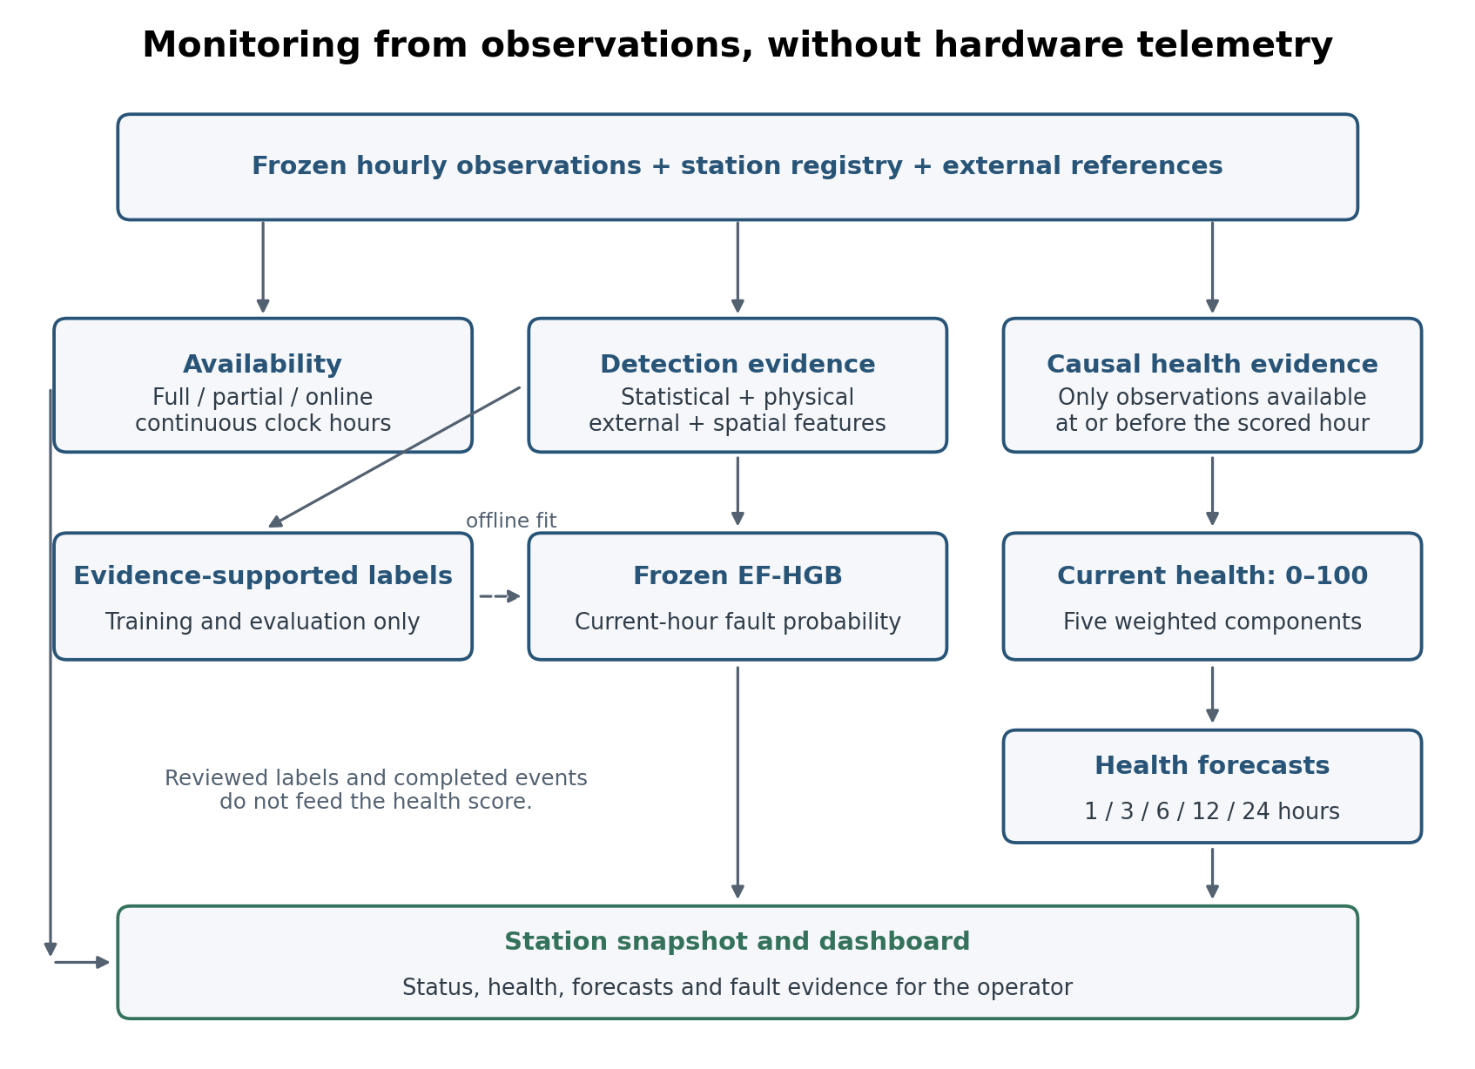
Figure 4.1. End-to-end system: the label-building and detection path is separate from the causal health and forecasting path. Hardware telemetry is not an input.
No single source can explain every suspicious reading. Physical rules catch impossible measurements. Statistical rules find unusual values or repeated flat readings. External references and nearby stations help distinguish local sensor behaviour from wider weather changes. These sources provide evidence, not proof of a hardware cause. The custom EF-HGB detector combines complementary views of this evidence; RGFN is retained as a development comparison.
The requirements are divided into functional and non-functional requirements. Table 4.1 records functional behaviour, while Table 4.2 records reproducibility, causality, and auditability constraints.

4.1.1 Functional Requirements
Table 4.1. Functional requirements.
ID | Delivered requirement
F1 | Canonical hourly station record and station metadata
F2 | Lifecycle states, audit summaries, and missingness reporting
F3 | Station outage-event extraction and network-window classification
F4 | Statistical, physical, external-reference, and spatial evidence
F5 | Reproducible multi-label episode labels
F6 | Hour-level binary fault-detection dataset
F7 | Compare HGB, RGFN and custom EF-HGB; select using validation
F8 | Evidence metadata for operational consumption
F9 | Causal health, five-horizon forecasting, scorecard and dashboard demonstration

4.1.2 Non-Functional Requirements
Table 4.2. Non-functional requirements.
Requirement | Description
Reproducibility | Frozen data windows, deterministic artifacts, and tests support repeatable results.
Interpretability | Fault evidence retains detector, channel, mechanism, and component context.
Missingness awareness | Missingness is preserved and represented rather than silently imputed.
Station specificity | Baselines and context use station location and historical behaviour.
Geographic awareness | Neighbour evidence respects distance and identifies isolated stations.
Data safety | Credentials and source acquisition details remain separate from report artifacts.
Operational usefulness | Outputs are event- and station-hour-oriented rather than only point anomaly scores.

4.2 Data Sources and Hourly Dataset
The analysis begins with the frozen hourly dataset supplied from the published Mozn dataset [18], rather than with station upload credentials or acquisition software. The canonical file contains 166,017 station-hour rows and 41 columns for 26 stations. Its 29 measurement columns include related summaries of temperature, humidity, pressure, rainfall, wind and other reported quantities. The station registry supplies identity, location and static context. Dataset acquisition and the provider's raw-data preparation are outside the delivered analysis code.
The development interval is 15 June 2025 through 30 June 2026. There are 9,144 possible UTC clock hours in that interval, but not every station has an observation at every hour. Missing measurements remain missing: replacing them with zero would confuse absence with real values such as zero rainfall. The later July evaluation is reported separately in Chapter 6.

4.3 Lifecycle States and Continuous Time Grid
A missing row can mean several different things. A station may not yet have completed its startup period, it may be silent during its active life, or its export may contain padding after its last genuine observation. The row-state classifier distinguishes these cases before outage counts are built. Each supplied station-hour receives exactly one state in Table 4.3. A continuous hourly grid is then used where elapsed time matters, so the next available row is not automatically treated as the next hour.
Table 4.3. Row-state taxonomy.
row_state | Meaning
online_complete | Station is reporting and all required measurement variables are present.
online_partial_missing | Station is reporting but at least one required measurement variable is missing.
true_outage_candidate | Station has data_present = 0 and the absence is eligible for outage-event extraction.
terminal_padded_absence | End-of-window padding; excluded from outage statistics.
warmup | Commissioning-period row excluded from outage-event interpretation.

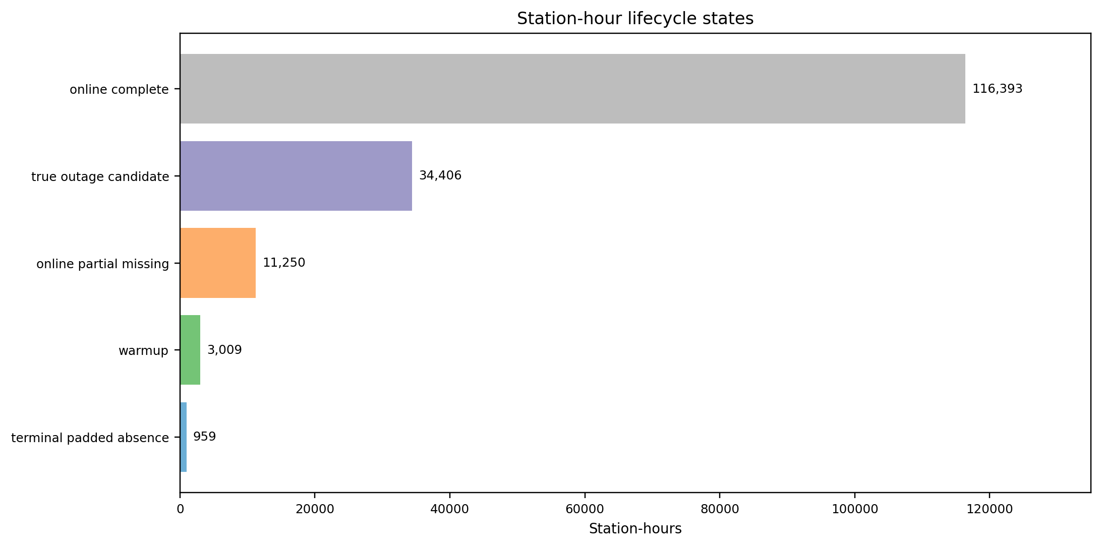
Figure 4.2. Counts of the five exclusive lifecycle states in the 166,017-row frozen dataset.

4.4 Full, Partial, and Coordinated Outages
A full outage means that the station is not transmitting usable measurements in an expected operational hour. A partial outage means that the station still transmits, but every channel belonging to at least one physical sensor group is missing. An individual missing variable does not necessarily imply that the whole sensor group has stopped reporting. Table 4.4 lists the groups used in the code.
Table 4.4. Sensor-group membership used for partial-outage classification; a group is absent only when all listed channels are missing in a transmitting hour.
Physical sensor group | Measurement channels used for presence
Anemometer | Mean, high and low wind speed and wind gust
Barometer | Maximum/minimum pressure and pressure trend
Light/UV | High solar radiation and high UV
Rain gauge | Precipitation rate and cumulative total
Thermo-hygrometer | Mean, high and low temperature and humidity
Wind vane | Mean wind direction
For each transmitting hour, the implementation checks the channels assigned to each group. At least one present channel is enough to mark that group as present. Consecutive hours with the same outage classification are grouped into events. Their durations use clock hours, and the affected groups remain recorded for inspection. The group definitions are implemented in src/availability/build_availability_events.py.
Coordinated network windows are detected when at least five stations begin outages within the configured one-hour tolerance. Events outside these windows are local; coordinated windows starting at 22 or 23 UTC receive the network_midnight label, and the remaining windows receive network_other. These names describe timing and shared behaviour. They do not establish whether the cause was electricity, communications, the upload service or another shared dependency.
Four structural gaps contain 480, 378, 362 and 234 omitted hours, giving 1,454 missing station-hour rows in total. The elapsed times between the surrounding observations are one hour larger: 481, 379, 363 and 235 hours. Materialising these missing positions preserves real elapsed time for outages, health history and forecast targets without changing the frozen source file.
$$F_{s,t}=1\{T_{s,t}=0\},P_{s,t}=1\left\{T_{s,t}=1∧∃g:\sum_{c∈g}{M_{s,c,t}}=|g|\right\}$$
T_(s,t) indicates that station s transmitted at hour t; M_(s,c,t) indicates a missing channel. F is the full-outage indicator. P is the partial-outage indicator and is evaluated only when transmission exists; a group g is absent when all of its channels are missing. Therefore F and P cannot both be one.

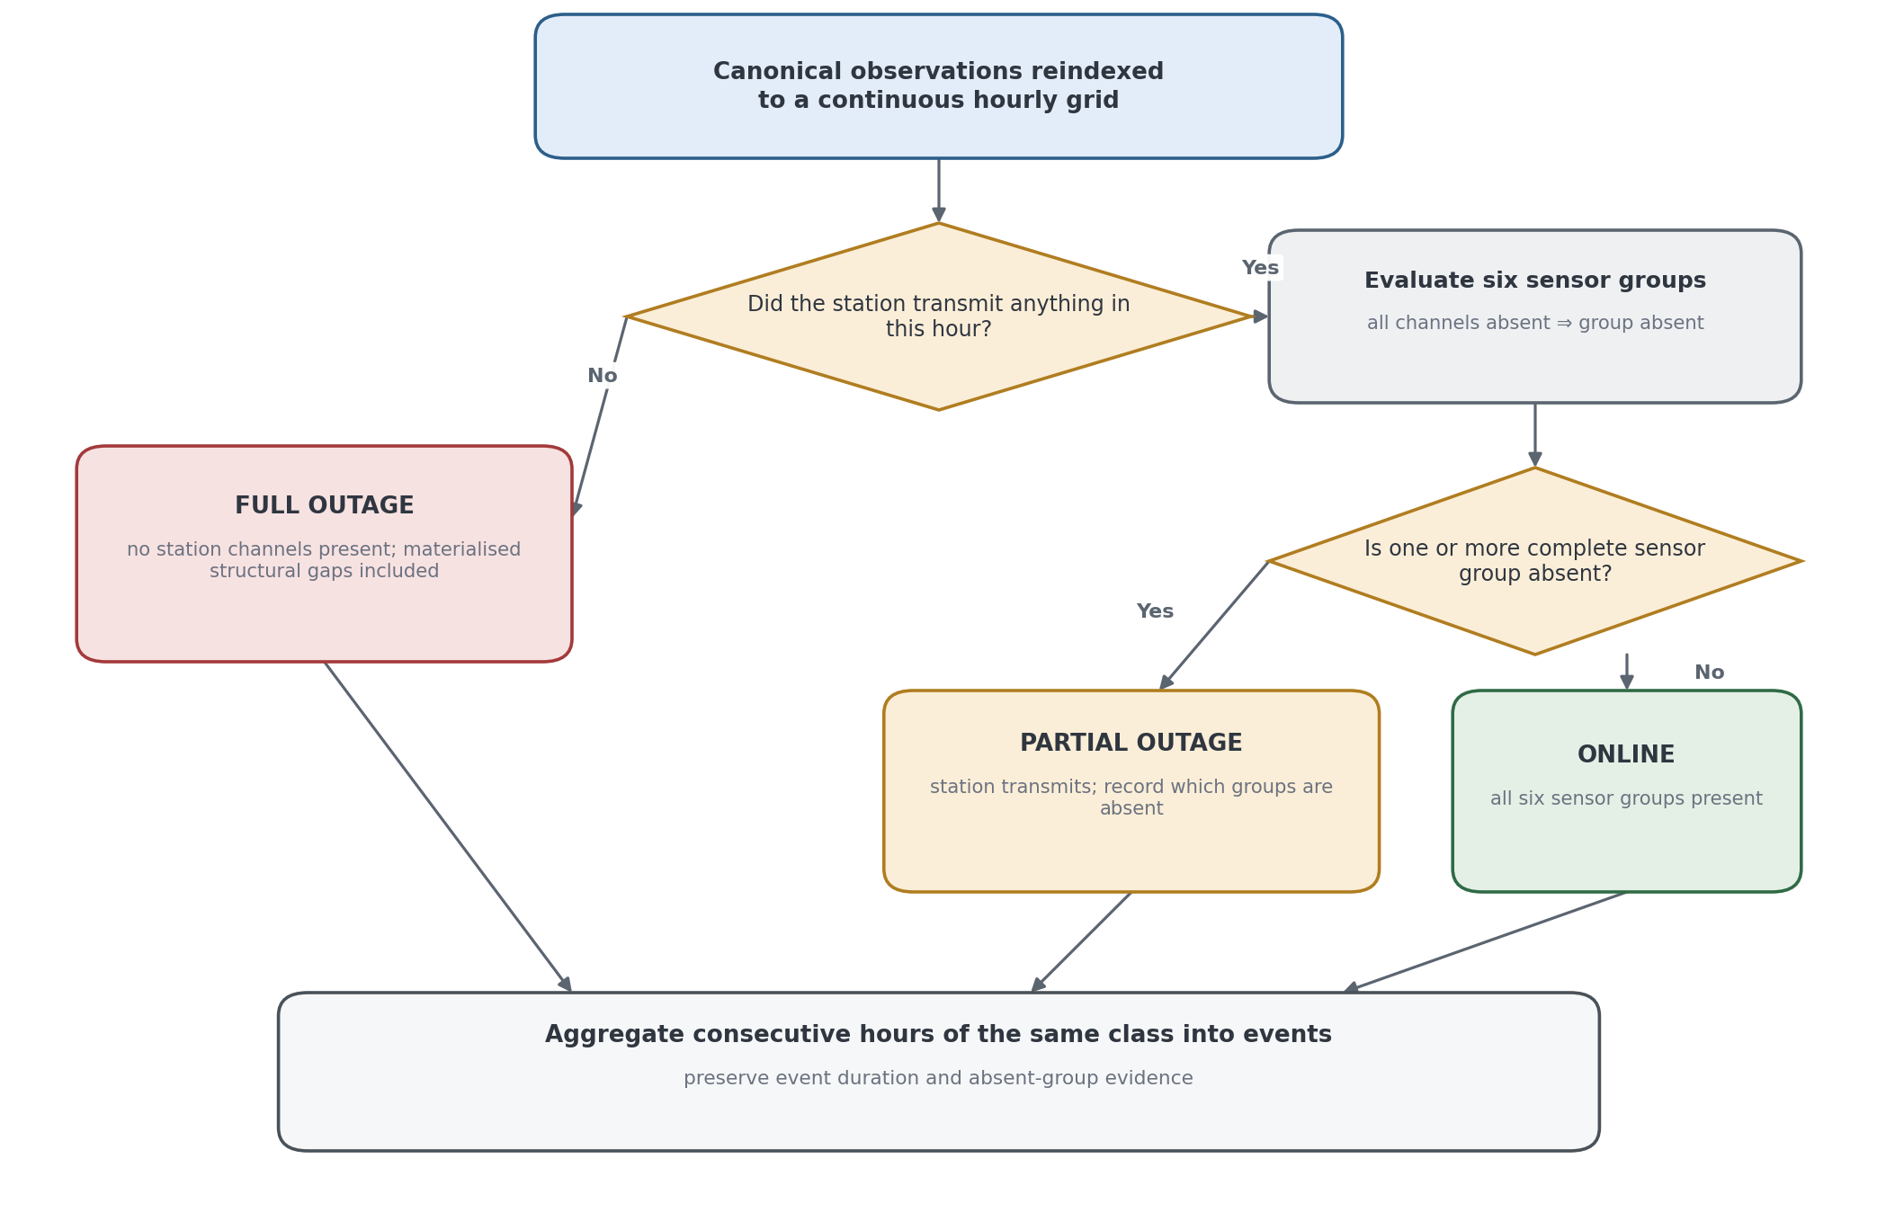
Figure 4.3. Full and partial outage construction on a continuous station-hour grid; materialised missing hours preserve clock-time duration while sensor-group absence reveals failures hidden by transmission uptime.

4.5 Feature Engineering and Fault Evidence

4.5.1 External and Spatial Context
The feature pipeline measures both a station's own behaviour and its disagreement with other sources. An external residual is the station reading minus the corresponding reference value. A spatial residual compares a station with the median of available neighbouring readings. The final detector receives these engineered summaries, not a raw sequence of all 29 measurement columns. The calculations are implemented in src/rules/external_residuals.py and src/rules/spatial_residuals.py.
$$r_{ext}(s,c,t)=x_{s,c,t}-x_{ref}(s,c,t)$$
r_ext is the external residual between a station observation and its time- and location-matched Open-Meteo/ERA5 reference. It is evidence of disagreement, not an assumption that the reference is perfect.
$$z_{ext}(s,c,t)=\frac{r_{ext}(s,c,t)-b_{ext}(s,c,t)}{max({MAD}_{ext}(s,c,t),f_{ext,c})}$$
External residual baselines use a trailing 720-hour window with at least 240 valid observations. Temperature and solar comparisons also use matching hour-of-day history over 30 days, with at least 15 observations. Small MAD floors prevent division by a near-zero spread: 0.8 for pressure, 0.3 for temperature, 0.4 for dewpoint, 0.3 for wind and 10 for solar. These scales belong to the reference-comparison calculation; a large residual is not automatically a fault label.
$$r_{sp}(s,c,t)=x_{s,c,t}-{median}_{j∈N_{s}(t)}x_{j,c,t}$$
N_s(t) is the set of configured nearby stations with comparable valid observations at hour t. The median limits the influence of a faulty neighbour; where N_s(t) is empty, spatial evidence is unavailable rather than adverse.
$$z_{sp}(s,c,t)=\frac{r_{sp}(s,c,t)-b_{sp}(s,c,t)}{max({MAD}_{sp}(s,c,t),0.5)}$$
Spatial pressure, temperature, and dew-point evidence uses a 720-hour trailing baseline with at least 240 observations and at least two present neighbours within 200 km. Insufficient neighbour support yields unavailable evidence and never lowers health or creates a fault by itself.
Reference disagreement needs interpretation. A nearby station can share the same fault, and gridded weather can differ from a real rooftop site. Missing reference or neighbour evidence is reported as unavailable rather than treated as evidence that the station is wrong. IALWAH18 and IDERNA7 have no neighbour within the configured graph and are not penalised for that absence.
Pressure comparisons use the mean-sea-level pressure reference. A persistent difference can reflect a sensor offset, pressure reduction settings or local representativeness. Without station configuration and maintenance records, the system records sustained disagreement rather than claiming a confirmed physical cause.

4.5.2 Statistical Anomaly Features
Three statistical detectors provide different kinds of candidate evidence: robust z-score for unusual levels, rolling variance for flat readings, and one-dimensional Isolation Forest for values that are unusual in the fitted channel distribution. Isolation Forest follows the isolation-based approach in [8]. Their flags are inputs to the evidence process, not the final fault decision.
Three complementary detectors run on each channel. A robust z-score uses the median and median absolute deviation (MAD). A rolling-variance detector surfaces stuck or flatlined sensors. A one-dimensional Isolation Forest provides a distribution-free outlier score for unusual channel values. The detectors are summarised in Table 4.5. The Isolation Forest branch follows the distribution-isolation principle introduced by Liu et al. [8].
$$m_{s,c}=median(x_{s,c}),{MAD}_{s,c}=median|x_{s,c}-m_{s,c}|,z_{s,c,t}=\frac{x_{s,c,t}-m_{s,c}}{{MAD}_{s,c}}$$
x_(s,c,t) is channel c at station s and hour t. Baselines require at least 1,500 present channel-hours per station; otherwise the implementation uses the pooled eligible-station baseline. Zero or undefined MAD creates no flag. The implementation does not apply a Gaussian consistency factor.
$$τ_{z,c}=Q_{0.997}(|z_{c}|),D_{z,s,c,t}=1\{|z_{s,c,t}|≥τ_{z,c}\},τ_{IF,c}=Q_{0.997}(s_{c}^{IF})$$
Robust-z and Isolation Forest decisions use channel-specific 99.7th-percentile thresholds. The one-dimensional Isolation Forest score is the negative sample score, fitted with contamination 0.003 and seed 42. These are sensitive candidate detectors; the later contextual gate uses a separate fixed 3.5 threshold.
$$v_{s,c,t}={Var}_{ddof=1}(x_{s,c,t-23},…,x_{s,c,t}),D_{stuck}=1\{v_{s,c,t}<{10}^{-6}\}$$
The stuck detector requires a complete trailing 24-hour window. A nearly constant window supplies flatline evidence. For channels where zero is normal, including rainfall rate, solar and UV, an all-zero window is not enough to call the sensor stuck. Cumulative precipitation is excluded from this variance rule. The final value-based label checks add sensor-specific context, including the relationship between wind direction and wind speed.

Table 4.5. Statistical anomaly detectors and the faults they target.
Detector | Target evidence | Role
Robust z-score (median and MAD) | Large channel deviation | Flags values that deviate from the station/channel robust baseline.
Rolling variance | Stuck or flatlined sensor | Flags windows whose variance falls near zero.
Isolation Forest | One-dimensional channel outlier | Produces an isolation score from the observed channel distribution.

Wind direction is converted into sine and cosine features so that 0 and 360 degrees remain close. Precipitation uses a logarithmic transform because most values are small or zero, with a few very large values. Redundant derived channels are excluded from statistical scoring, and missing values remain missing. These transformations make the comparisons meaningful without pretending that missing data were observed.
$$u=sin\left(\frac{πθ}{180}\right),v=cos\left(\frac{πθ}{180}\right),p^{'}=log(1+p)$$
θ is wind direction in degrees, so u and v preserve circular proximity across 0°/360°. p is non-negative precipitation; log1p compresses its heavy-tailed scale while retaining zero.
A statistical flag only nominates an hour for review by the evidence rules. The final gate checks the same channel and hour, a station-specific month and hour-of-day comparison, and external evidence where available. This is intended to avoid labelling ordinary seasonal or daily variation as a sensor fault simply because a generic detector fired.
$$q_{s,c,t}=\frac{x_{s,c,t}-m_{s,c,month,hour}^{ctx}}{max({MAD}_{s,c,month,hour}^{ctx},f_{c})},C=1\{|q_{s,c,t}|≥3.5\}$$
The contextual comparison uses the same station, transformed channel, calendar month and hour of day. It excludes the candidate hour and physical/stuck rows and requires at least 15 observations. This comparison can use observations later than the candidate hour within the available record. It is therefore retrospective label evidence, not a prospective live feature. A causal score, in contrast, uses only values available by its reference hour.
$$A=C∧D_{z}∧D_{IF}∧E_{agree},B=C∧(D_{z}⊕D_{IF})∧E_{strong}∧I_{supported},D_{stat}=A∨B$$
Path A requires both statistical detectors and, where ERA5 is comparable, |z_ERA5|≥3 with the same direction as q; absence of ERA5 does not veto Path A. Path B requires exactly one statistical detector, a supported pressure/temperature/wind channel, and |z_ERA5|≥3, but not sign matching. Physical and stuck mechanisms are excluded from these paths and are labelled separately. For transformed wind direction, both sine and cosine channels must pass.
Consecutive flagged hours are first grouped by station and channel. Channel events with nearby start times are then combined into station-level candidate episodes. The label builder checks the values and evidence for each channel and records every supported mechanism and component. These are evidence-supported reference labels, not independently verified hardware ground truth. Grouping makes review manageable; it does not by itself establish that every hour inside an episode is faulty.
Grouping channels by physical sensor helps interpret multi-label episodes. The FT0360 comprises an indoor console carrying the barometric pressure sensor and an outdoor array housing the thermo-hygrometer, anemometer, wind vane, rain gauge, and combined light/ultraviolet sensor [4]. Channels from a shared component can fail together, but the delivered taxonomy records the individual mechanisms and components present rather than assigning a broad summary class.

4.5.3 Physical-Limit Features
Physical-limit rules flag values outside declared bounds and selected excessive changes. Hard breaches can support an impossible-value label. Suspect-only breaches remain evidence for contextual assessment. This distinction prevents every unusually high but physically possible reading from being treated as a definite fault.
The rule distinguishes documented hard breaches from suspect evidence. Only hard physical breaches create the spike_impossible label in the canonical build. The current pressure-trend threshold of |Δpressure| > 20 hPa/h is itself a hard breach, so no separate pressure-trend suspect band survives in the implementation. Solar/UV suspect flags are retained as candidate evidence for contextual review but do not independently promote a spike label; no solar or UV hard spike survives in the canonical population.
$$I_{physical}(x_{t})=1\{x_{t}<L_{c}∨x_{t}>U_{c}∨|x_{t}|>U_{abs,c}\}$$
The comparisons are strict, so a value exactly on a bound is allowed. Hard valid ranges are temperature −60 to 60 °C, humidity 0-100%, wind speed 0-250 km/h, gust 0-300 km/h, direction 0-360°, pressure 870-1085 hPa, pressure trend |x|≤20 hPa/h, precipitation 0-1000, solar 0-1600 W/m², and UV 0-25. Surviving suspect-only upper ranges are wind speed 150, gust 180, precipitation 300, solar 1100, and UV 16; these are candidate evidence, not spike-impossible labels.
The rule recovers the IMURQU7 rainfall fault, including a cumulative precipitation value of 5,933.95 mm and a peak rate of 6,295.39 mm/h. It is deliberately simple and interpretable, and it complements rather than replaces the statistical gate.

4.6 Fault Taxonomy and Label Engineering
Labels have two separate axes: mechanism and component. An episode can have more than one of each. The binary detector learns whether an eligible station-hour is labelled faulty. A separate development experiment predicts likely mechanism reason codes for fault-hours and aggregates them over labelled event groups. Component names describe the evidence location; they are not a separately validated deployed component classifier.
The four mechanisms are spike_impossible, stuck_flatline, statistical_anomaly and calibration_offset. They describe impossible values, flat readings under expected variation, context-supported anomalies and sustained reference-supported offsets. The six component labels name the anemometer, barometer, light/UV sensor, rain gauge, thermo-hygrometer and wind vane. Table 4.6 defines the mechanism terms.
The taxonomy retains components and mechanisms with sufficient observed support for meaningful descriptive reporting. Calibration offset is retained as evidence even though only four resolved episodes exist. It is excluded from the event-level mechanism selection because the spaced validation partition contains only one positive complete event, below the predeclared five-event selection minimum.
Table 4.6. Fault mechanism labels.
Mechanism | Meaning
spike_impossible | A hard physical-bound or declared hard rate-change breach.
stuck_flatline | A sensor reporting a constant, unchanging value while the quantity it measures should vary.
statistical_anomaly | A statistically unusual reading that passes the contextual and available reference-evidence gate.
calibration_offset | An eligible episode promoted after overlap with a sustained reference-supported offset run.

Labels are assigned by a reproducible value-based classifier applied uniformly to episodes. A spike is assigned for a physical-limit breach; a stuck fault is assigned for confirmed flat behaviour; and a statistical anomaly passes one of two gates. Path A requires both statistical detectors on the same channel and hour, contextual outlier evidence, and ERA5 directional agreement where comparable. Path B requires one detector plus a strong absolute ERA5 residual, so it represents external discrepancy rather than same-direction corroboration. Episodes with no positive evidence are benign.
Wind direction is treated carefully. A direction frozen while meaningful wind-speed variation is present is evidence of a wind-vane problem, whereas unchanged direction during calm conditions is not automatically faulty. Unchanged direction accompanied by frozen wind speed supports an anemometer freeze. The canonical build derives these mechanism labels from hourly evidence and its documented raw-value fallback; separate five-minute audits may corroborate individual cases, but the label-builder path does not depend on a five-minute confirmation routine.
Sustained-offset corroboration examines long external-reference disagreements, with spatial evidence where available. Its promotion rule only resolves an existing borderline-review episode that overlaps a qualifying offset run. It does not label every hour of every offset run. This explains why the evidence inventory is larger than the set of calibration-offset labels.
Ambiguous episodes remain in borderline_review rather than being forced into fault or benign. Their affected hours are excluded from supervised training and evaluation under the hourly labelling rules. They are retained for later evidence-led review. Reported detection performance therefore applies to the eligible labelled population, not to every ambiguous hour in the network; exclusion does not make those cases solved.

4.7 Transparent Station-Health Score
Current health is calculated, not predicted by a trained model. It is a 0–100 operational score made from five visible components. A low value can therefore be traced to missing transmission, missing sensor groups, recent fault evidence, reference disagreement or unstable operation. Each input uses data at or before the scored hour. This time-order property is called causality here; it is not a claim to know the physical cause of a fault.
$$B_{t}=30A_{t}+20C_{t}+25F_{t}+15R_{t}+10S_{t}$$
B_t is the unadjusted base health. A_t, C_t, F_t, R_t, and S_t are availability, sensor-completeness, fault-burden, reference-consistency, and stability components, each normalised to [0,1]. The coefficients sum to 100, so component contributions remain directly interpretable as health points.
Table 4.7. Causal station-health components, weights, and evidence windows; the decomposition makes every score auditable.
Component | Weight | Causal basis
Availability (A) | 30 | Fraction of trailing 168 hours transmitting
Sensor completeness (C) | 20 | Presence of six sensor groups among transmitting hours over trailing 168 hours, averaged
Fault burden (F) | 25 | Trailing seven-day causal detector evidence, exponentially weighted with a 24-hour half-life and capped before inversion
Reference consistency (R) | 15 | Current external residual evidence and prior-only persistent pressure-offset evidence
Stability (S) | 10 | Equal blend of adverse-event starts in trailing 30 days and time since the last adverse event, each capped
$$A_{t}=\frac{1}{168}\sum_{j=0}^{167}{T_{t-j}},C_{t}=\frac{1}{6}\sum_{g}{\frac{\sum_{j=0}^{167}{P_{g,t-j}}}{\sum_{j=0}^{167}{T_{t-j}}}}$$
T is one when the station transmits. P_g is one when sensor group g is present. Sensor completeness is therefore conditional on transmitting hours rather than treating a full outage as six independent missing sensors.
$$w_{j}=2^{-j/24},ρ_{t}=\frac{\sum_{j=0}^{167}{w_{j}}E_{t-j}}{\sum_{j=0}^{167}{w_{j}}},F_{t}=1-clip\left(\frac{ρ_{t}}{0.20} , 0 , 1\right)$$
E is causal hard-physical, stuck, or prior-only deviation evidence. The 24-hour half-life emphasises recent evidence, and the 0.20 cap maps a sufficiently persistent evidence burden to zero fault-health contribution.
$$R_{t}=1-max(u_{current,t},u_{persistent,t})$$
u_current is the largest normalised exact-hour external residual severity and u_persistent is prior-only pressure-offset severity relative to the fleet, requiring at least eight stations. When both reference modes are unavailable, the evidence is neutral and R_t=1 rather than a penalty.
$$S_{t}=0.5\left[1-clip\left(\frac{N_{adverse,30d}}{20} , 0 , 1\right)\right]+0.5clip\left(\frac{h_{since adverse}}{720} , 0 , 1\right)$$
N_adverse,30d counts starts of full outage, partial outage, or hard physical/stuck evidence in the trailing 30 days. h_since_adverse is hours since the last such event, capped at 720 hours. Contextual statistical candidates alone do not start a stability event.
The five components answer different questions. Availability asks whether data arrive. Completeness asks which physical sensor groups report when the station transmits. Fault burden describes recent adverse evidence. Reference consistency measures disagreement with available references. Stability describes repeated adverse events and time since the last one. Missing spatial neighbours are not a health penalty.
The score does not use reviewed episode labels, a completed future event duration, or completed sustained-offset intervals. Those records can include information only known later. It instead calculates its own causal fault and offset evidence from the history available at the hour being scored. This is why changing the selected binary detector does not automatically change the health target.
$$m_{full}(d)=e^{-d/24},m_{partial}(d)=e^{-d/72},H_{t}=Q_{t}m(d_{t})$$
The outage duration d is the uninterrupted run length known so far, not its eventual length. During a continuing outage class, a running cap prevents the base health from increasing simply because older evidence leaves a trailing window. The full-outage multiplier is exp(−d/24); the partial-outage multiplier is exp(−d/72). All five contributions receive the same scale factor, so their sum still equals total health. The longer partial-outage time constant gives partial loss a milder penalty.
Table 4.8. Progressive outage-duration multipliers used by the health score; the curves distinguish recent loss from prolonged loss without a discontinuous hard zero.
Current duration | Full-outage multiplier | Partial-outage multiplier
1 h | 0.959 | 0.986
6 h | 0.779 | 0.920
24 h | 0.368 | 0.717
168 h (7 d) | 0.0009 | 0.097
The original hard-zero rule made a one-hour interruption look the same as a multi-week interruption. The progressive rule removes that artificial onset jump and lets duration affect health. It does not make every change smooth: health may still rise sharply when a station resumes transmission. The 24-hour and 72-hour constants are declared engineering choices, not fitted against forecast performance or maintenance outcomes.
Listing 4.1. The active-outage duration multipliers.
Source: src/availability/health_score.py, lines 236–237.
full_multiplier = np.exp(-full_hours / FULL_OUTAGE_DECAY_HOURS)
partial_multiplier = np.exp(-partial_hours / PARTIAL_OUTAGE_DECAY_HOURS)
The full and partial constants are 24 and 72 hours. The rest of the function applies the correct multiplier to the current state; the score builder also enforces the within-outage cap and preserves the weighted component sum.
Health bands are defined before forecast evaluation as Healthy (80-100), Watch (60-79.999), Degraded (40-59.999), and Critical (0-39.999). The bands are operational summaries of the continuous score; the continuous value and its five components remain the primary explainable output. Figure 4.4 shows how the five causal components feed the score before banding.
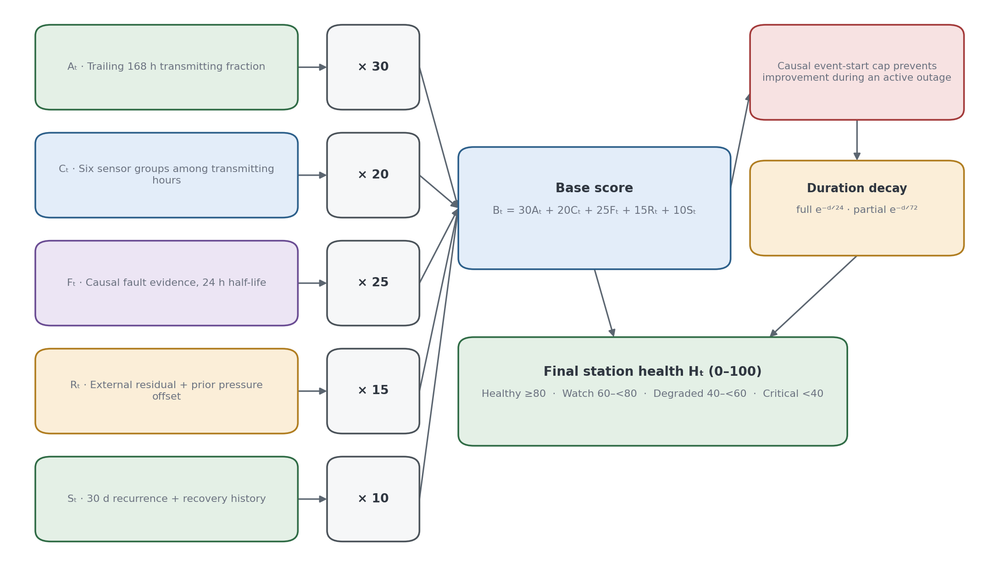
Figure 4.4. Causal health-score composition from five bounded components; the diagram shows how availability, completeness, evidence, reference agreement, and stability remain separately inspectable before their weighted sum.

4.8 Data-Engineering Results and Discussion

4.8.1 Dataset Audit
The dataset audit assigns a lifecycle row state to every station-hour and produces the network’s reliability profile. The status-class distribution shows a usable but uneven network: 13 stations qualify as reliable reference candidates, while six are outage dominated. Weekly coverage in Figure 4.5 makes the station-level imbalance visible. Table 4.9 quantifies the status classes underlying that reliability profile.

Table 4.9. Status-class distribution from the June 2026 dataset audit.
Status class | Stations | Interpretation
reliable_reference_candidate | 13 | High availability and completeness; eligible reference candidates.
usable | 5 | Usable stations with non-pristine reliability.
reliable_but_terminal_gap | 1 | Otherwise reliable station with terminal gap.
weak | 1 | Low availability and frequent flickers.
outage_dominated | 6 | Low present rate or frequent/long outages.

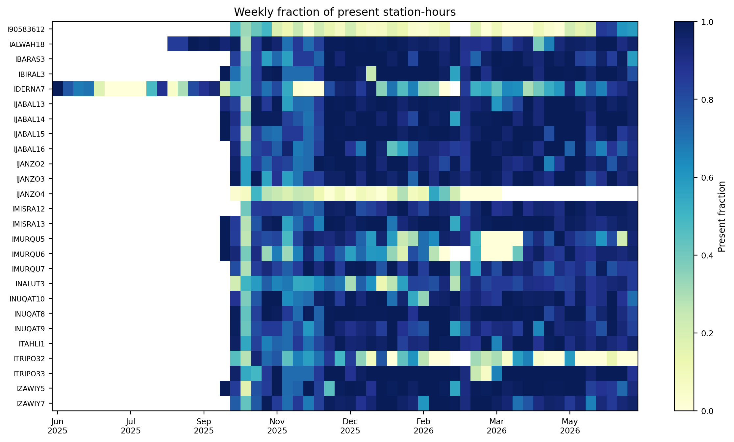
Figure 4.5. Weekly observed coverage by station across the frozen interval; persistent gaps identify stations whose availability dominates their reliability profile.
The missingness heatmap shows groups of variables disappearing together. The system therefore retains missingness indicators and elapsed time as information, rather than replacing missing observations with ordinary numeric readings. This is useful for the final current-hour detector as well as the earlier sequence-model experiments.
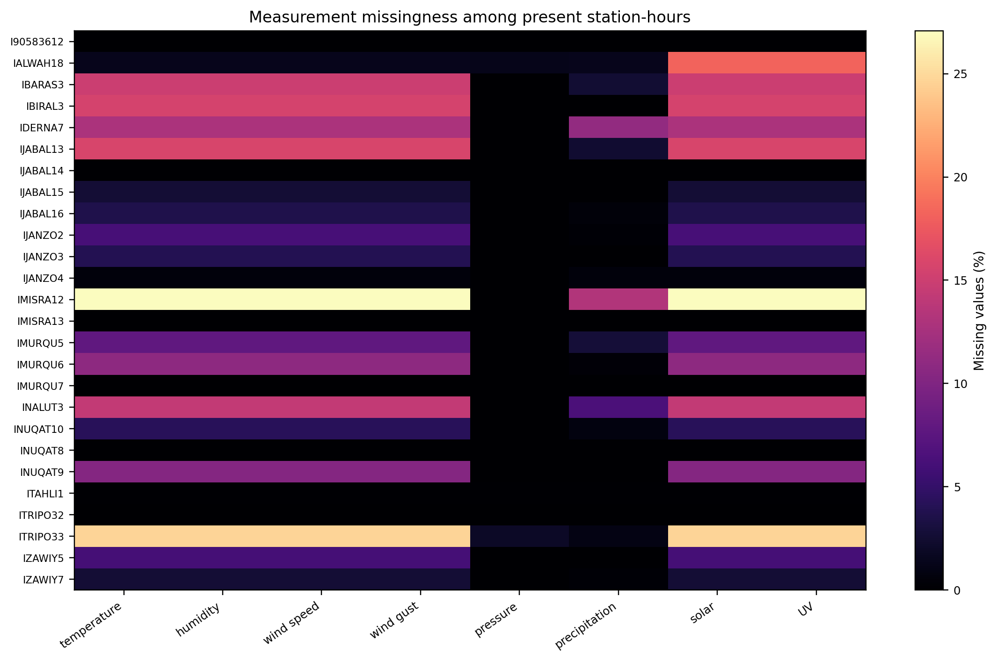
Figure 4.6. Measurement missingness conditional on present station-hours; co-missing channels motivate group-level partial-outage logic and explicit missingness inputs.
Table 4.10. Verified examples from the canonical dataset.
Station | Verified evidence | Observed fact
ITRIPO33 | Repeated-zero wind | Longest contiguous average-and-gust zero-wind run: 83 hours.
IBIRAL3 | Reference-supported pressure offset | −16.265 hPa run lasting 4,622 hours; level-channel statistical blind spot.
IJABAL13 | Reference-supported pressure offset | −81.780 hPa run lasting 2,037 hours; resolves four borderline episodes.
IDERNA7 | Very long local outage | 814-hour event from 8 July to 11 August 2025.
IMURQU7 | Impossible precipitation | Peak total 5,933.95 mm; peak rate 6,295.39 mm/h.

These examples demonstrate the validator gap. A range validator catches clear impossibilities, but it does not catch all values that are individually plausible and collectively inconsistent. The workflow therefore retains temporal, external-reference, spatial, and missingness evidence. Table 4.10 grounds the argument in verified station examples.

4.8.2 Full and Partial Outage Results
The frozen availability engine extracts 2,398 full-outage events from observed lifecycle rows, totalling 34,406 outage-candidate hours. Continuous operational classification additionally materialises 1,454 truly omitted hourly rows as full outages, giving 35,860 operational full-outage station-hours while intentionally preserving the frozen 2,398-event series and its 47 network-wide windows. This distinction keeps previously verified event statistics stable while making every station-hour available to downstream health and horizon arithmetic. Table 4.11 gives the frozen event-duration distribution. Figure 4.7 provides the corresponding station-level availability comparison.

Table 4.11. Outage-duration distribution from the June 2026 availability engine.
Duration class | Definition | Events
Short | 1–3 hours | 1,141
Medium | 4–24 hours | 1,024
Long | 25–168 hours | 211
Very long | >168 hours | 22

Most frozen full-outage events are short or medium, while long events dominate operational concern because they remove a station from the network for days or weeks. The median is 4 hours, the mean 14.35 hours, and the maximum 814 hours at IDERNA7 from 8 July to 11 August 2025. Figure 4.7 compares station availability, and Table 4.12 separates local full-outage events from the two coordinated-window classes.
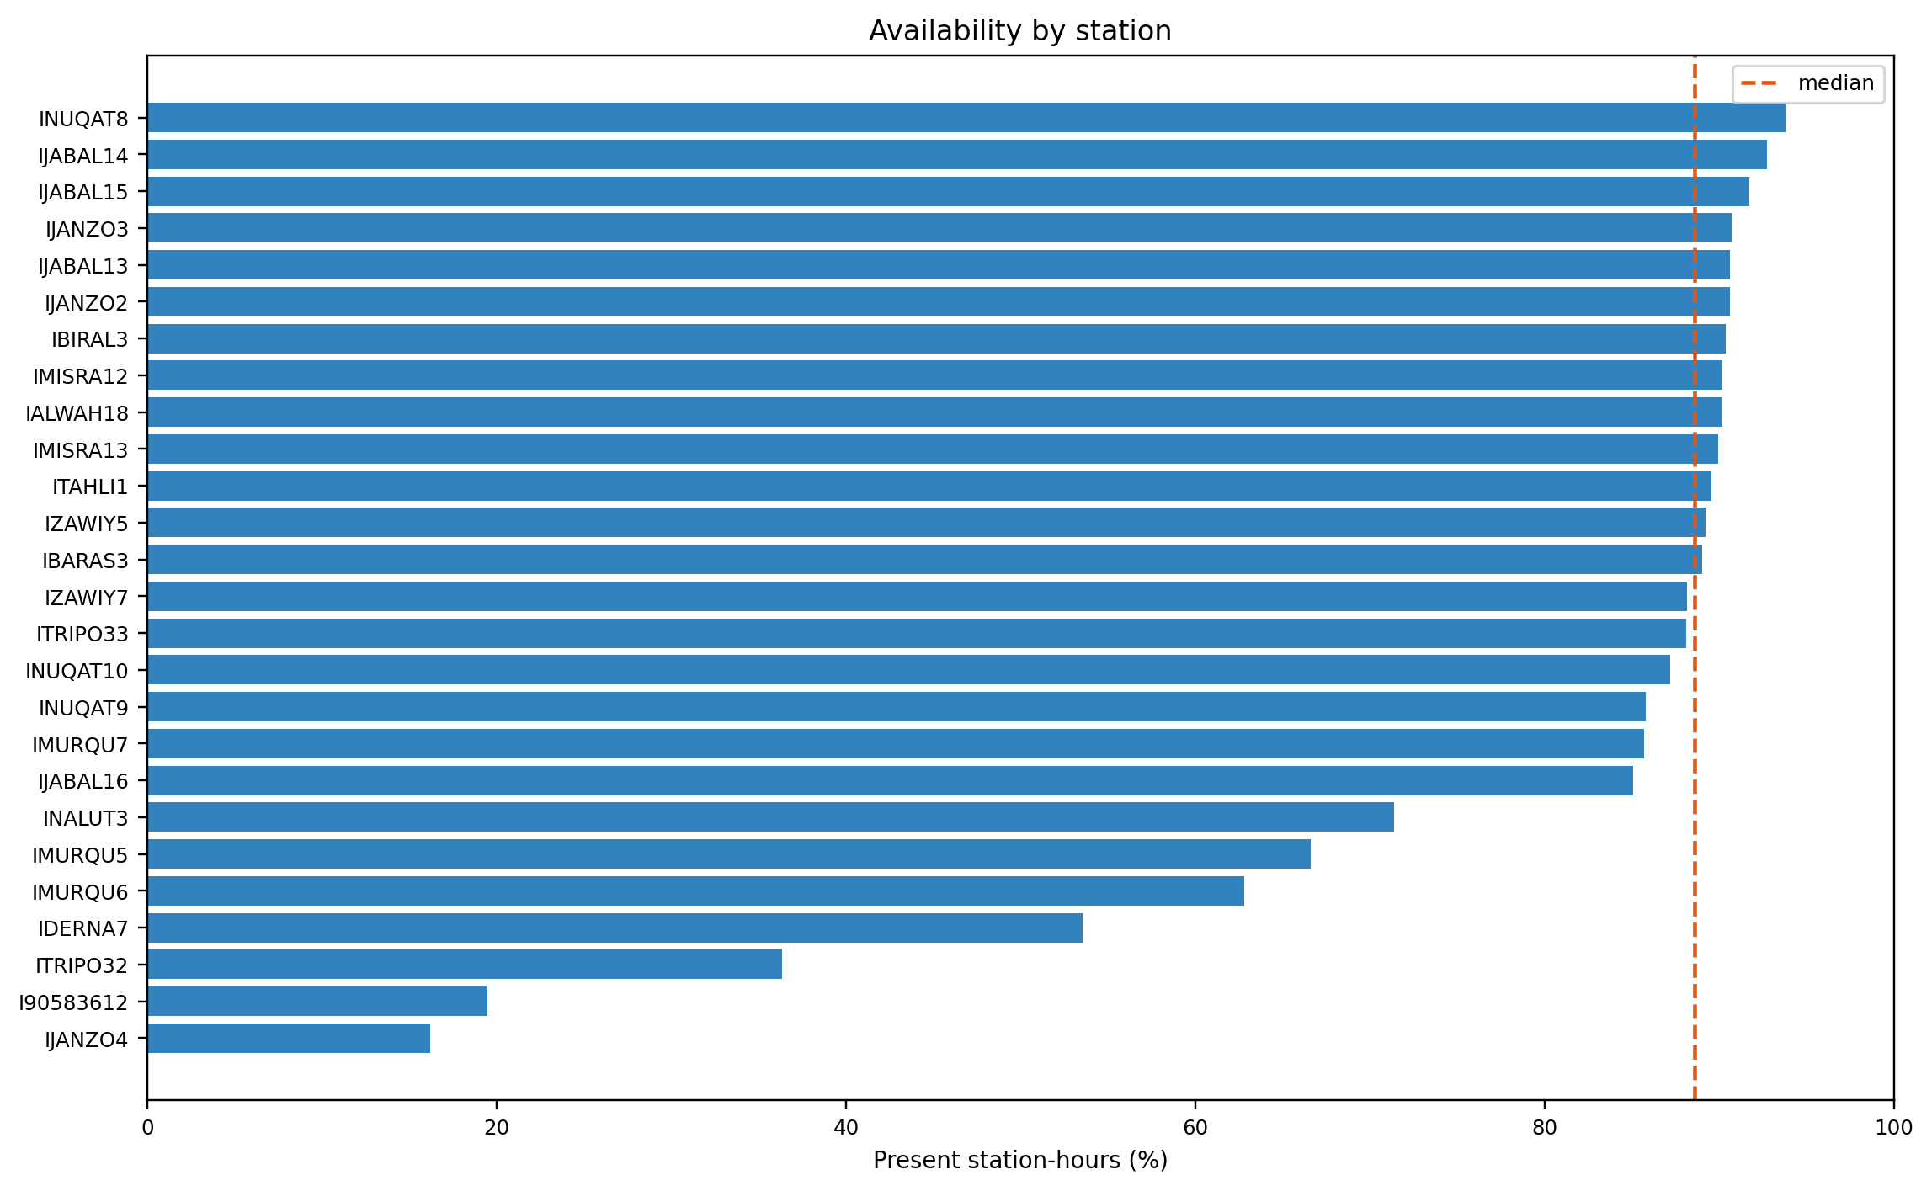
Figure 4.7. Full-outage availability by station; the uneven distribution shows why network averages cannot substitute for station-level monitoring.
Table 4.12. Outage-class distribution from the June 2026 availability engine.
outage_class | Definition | Events
local | Event outside a detected coordinated network window. | 1,968
network_midnight | Event in a coordinated window beginning at 22 or 23 UTC. | 267
network_other | Event in another coordinated network window. | 163
Table 4.13. Partial-outage event durations among transmitting hours; the dominance of 4-24-hour events shows that partial sensor loss is usually sustained rather than a one-hour omission.
Duration bucket | Events
1-3 h | 139
4-24 h | 630
25-168 h | 33
169 h or longer | 1
Total | 803
Across 130,652 transmitting station-hours, the group-level rule identifies 803 partial-outage events covering 11,158 hours. Their mean duration is 13.90 hours, median 14 hours, and maximum 465 hours. Table 4.13 shows that 630 events last between 4 and 24 hours, so the result is not driven by isolated missing values.
Table 4.14. Sensor-group availability conditional on station transmission; the contrast between the barometer and outdoor-array groups exposes failures hidden by ordinary uptime.
Sensor group | Availability
Anemometer | 92.40%
Barometer | 99.85%
Light/UV | 91.54%
Rain gauge | 98.27%
Thermo-hygrometer | 92.40%
Wind vane | 92.40%
The largest partial-availability burdens are IMISRA12 (1,508 hours), ITRIPO33 (1,473), IALWAH18 (1,220), IJABAL13 (923), and IBIRAL3 (910). In 7,662 partial hours, the anemometer, light/UV, thermo-hygrometer, and wind vane disappear together while barometric reporting continues; another 2,254 hours also lose the rain gauge. Because the FT0360 barometer is housed in the indoor console while these groups belong to the outdoor array, the pattern is consistent with loss of the outdoor-array-to-console link. It remains a testable hardware hypothesis rather than a confirmed diagnosis. Table 4.14 supplies the conditional sensor-group availability behind this hardware hypothesis.
The 11,158 operational partial-outage hours differ from the 11,250 lifecycle rows previously described as online_partial_missing. The lifecycle state counts missing required variables, whereas the operational partial-outage rule requires an entire physical sensor group to be absent during continued transmission. The narrower definition is why the two valid counts are not equal.
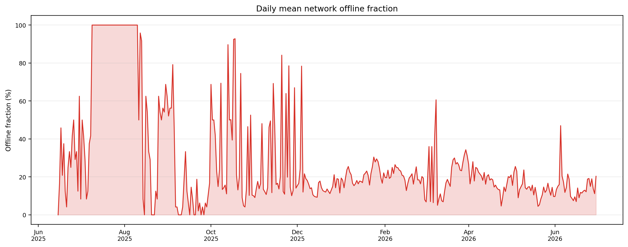

Figure 4.8. Daily mean fraction of stations offline; synchronized peaks motivate separate coordinated-window analysis rather than treating every event as local.

4.8.3 Coordinated Network Events
The network-wide detector found 47 coordinated windows: 22 classified as network_midnight and 25 as network_other. These windows contain 267 and 163 station events respectively. The classification separates shared platform-like patterns from local availability events; it does not establish a specific upstream cause. Figure 4.8 locates the coordinated peaks in the network timeline.
Table 4.15. Summary of coordinated network-outage windows.
Finding | Result
Detected network-wide windows | 47 total windows.
Midnight-classified windows | 22 windows beginning at 22–23 UTC.
Other network windows | 25 windows beginning at other hours.
Midnight station-events | 267 events.
Other-network station-events | 163 events.
Midnight duration pattern | Median event duration 24 hours; maximum 109 hours.
Other-window duration pattern | Median event duration 2.5 hours; maximum 190 hours.
Interpretation | Coordinated availability pattern; upstream cause not observed directly.
The spatial and temporal extent of several windows is inconsistent with a single station failure. The evidence supports treating them as coordinated availability patterns rather than using them to inflate local outage counts. The analysis does not identify the upstream mechanism directly.
Midnight-classified windows have a median event duration of 24 hours. Recovery timing varies by station, so a synchronized start does not imply synchronized restoration.
The current window inventory is reported in Table 4.15. It replaces earlier pre-June counts and does not rely on targeted minute-level claims from a superseded analysis window.

4.8.4 Local Co-Occurrence Diagnostic
Network-wide windows are excluded before pair comparison to prevent shared platform patterns from inflating apparent local dependence. The remaining pairwise comparison is a local-dependency diagnostic, not a detection target. Table 4.16 records the scope of this deliberately limited pairwise diagnostic.
Table 4.16. Scope of the local co-occurrence diagnostic.
Scope | Treatment | Interpretation
47 network-wide windows | Excluded before pair comparison | Prevents platform-wide patterns inflating local dependence.
Remaining station-hours | Observed/expected pair comparison | Local-dependency diagnostic only.
Model training | Does not use pair ratios as labels | Availability classification remains event-based.

The cleaned diagnostic may still surface nearby pairs for review, but the report does not treat a pairwise ratio as proof of shared infrastructure or as a model label. Figure 4.9 provides the retained repeated-zero example.
The availability investigation therefore distinguishes station-local events from coordinated network windows, while preserving uncertainty about the cause of coordinated patterns.
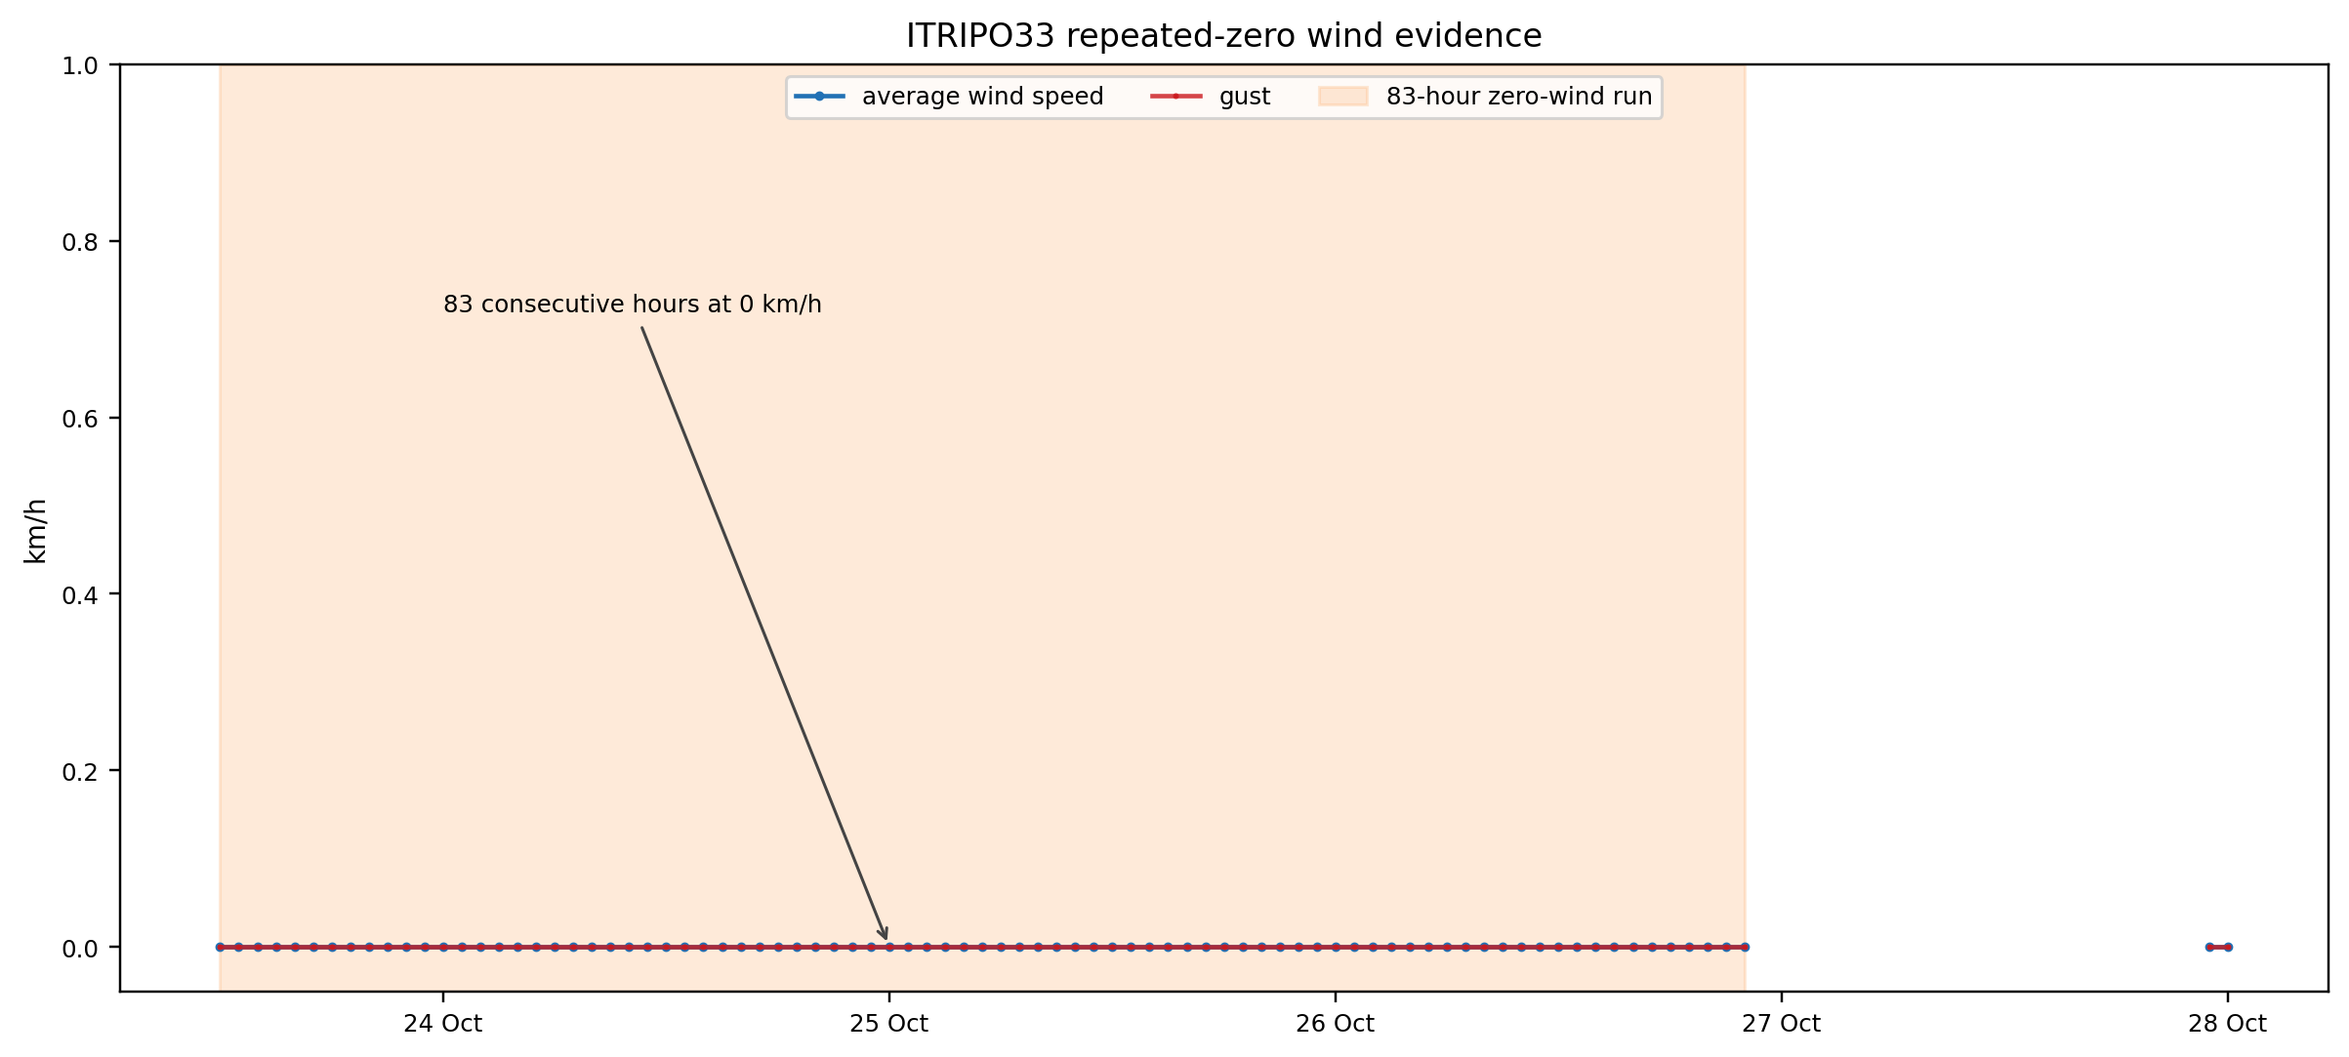
Figure 4.9. Repeated-zero wind evidence at ITRIPO33; sustained constancy under expected variation demonstrates a stuck-sensor pattern that range checks alone miss.

4.8.5 Statistical and Physical Evidence Results
The statistical layer was run over the full 166,017 station-hour record. Robust z-score and Isolation Forest evidence occurs together or separately on 5.99% of station-hours; both fire on 1.50%. When stuck and physical-limit evidence is included, at least one detector group fires on 10.10% of station-hours. These deliberately sensitive candidate flags are screened by the contextual gate before they become labels.
Table 4.17. Statistical evidence funnel for the canonical label build.
Stage | Count
Raw flagged evidence rows (hour, channel) | 17,789
Distinct episodes touched | 4,717
Rows passing the full statistical gate | 1,740
Episodes passing the gate | 706
Path A only / Path B only / both | 621 / 38 / 47

The detector funnel produces 17,789 raw evidence rows across 4,717 episodes. Of those rows, 1,740 pass the full statistical gate, yielding 706 statistical-anomaly episodes. Path A alone accounts for 621 episodes, Path B alone for 38, and both paths for 47. Path B uses strong absolute ERA5 discrepancy, not same-direction corroboration. Table 4.17 quantifies each stage of the statistical-evidence funnel.

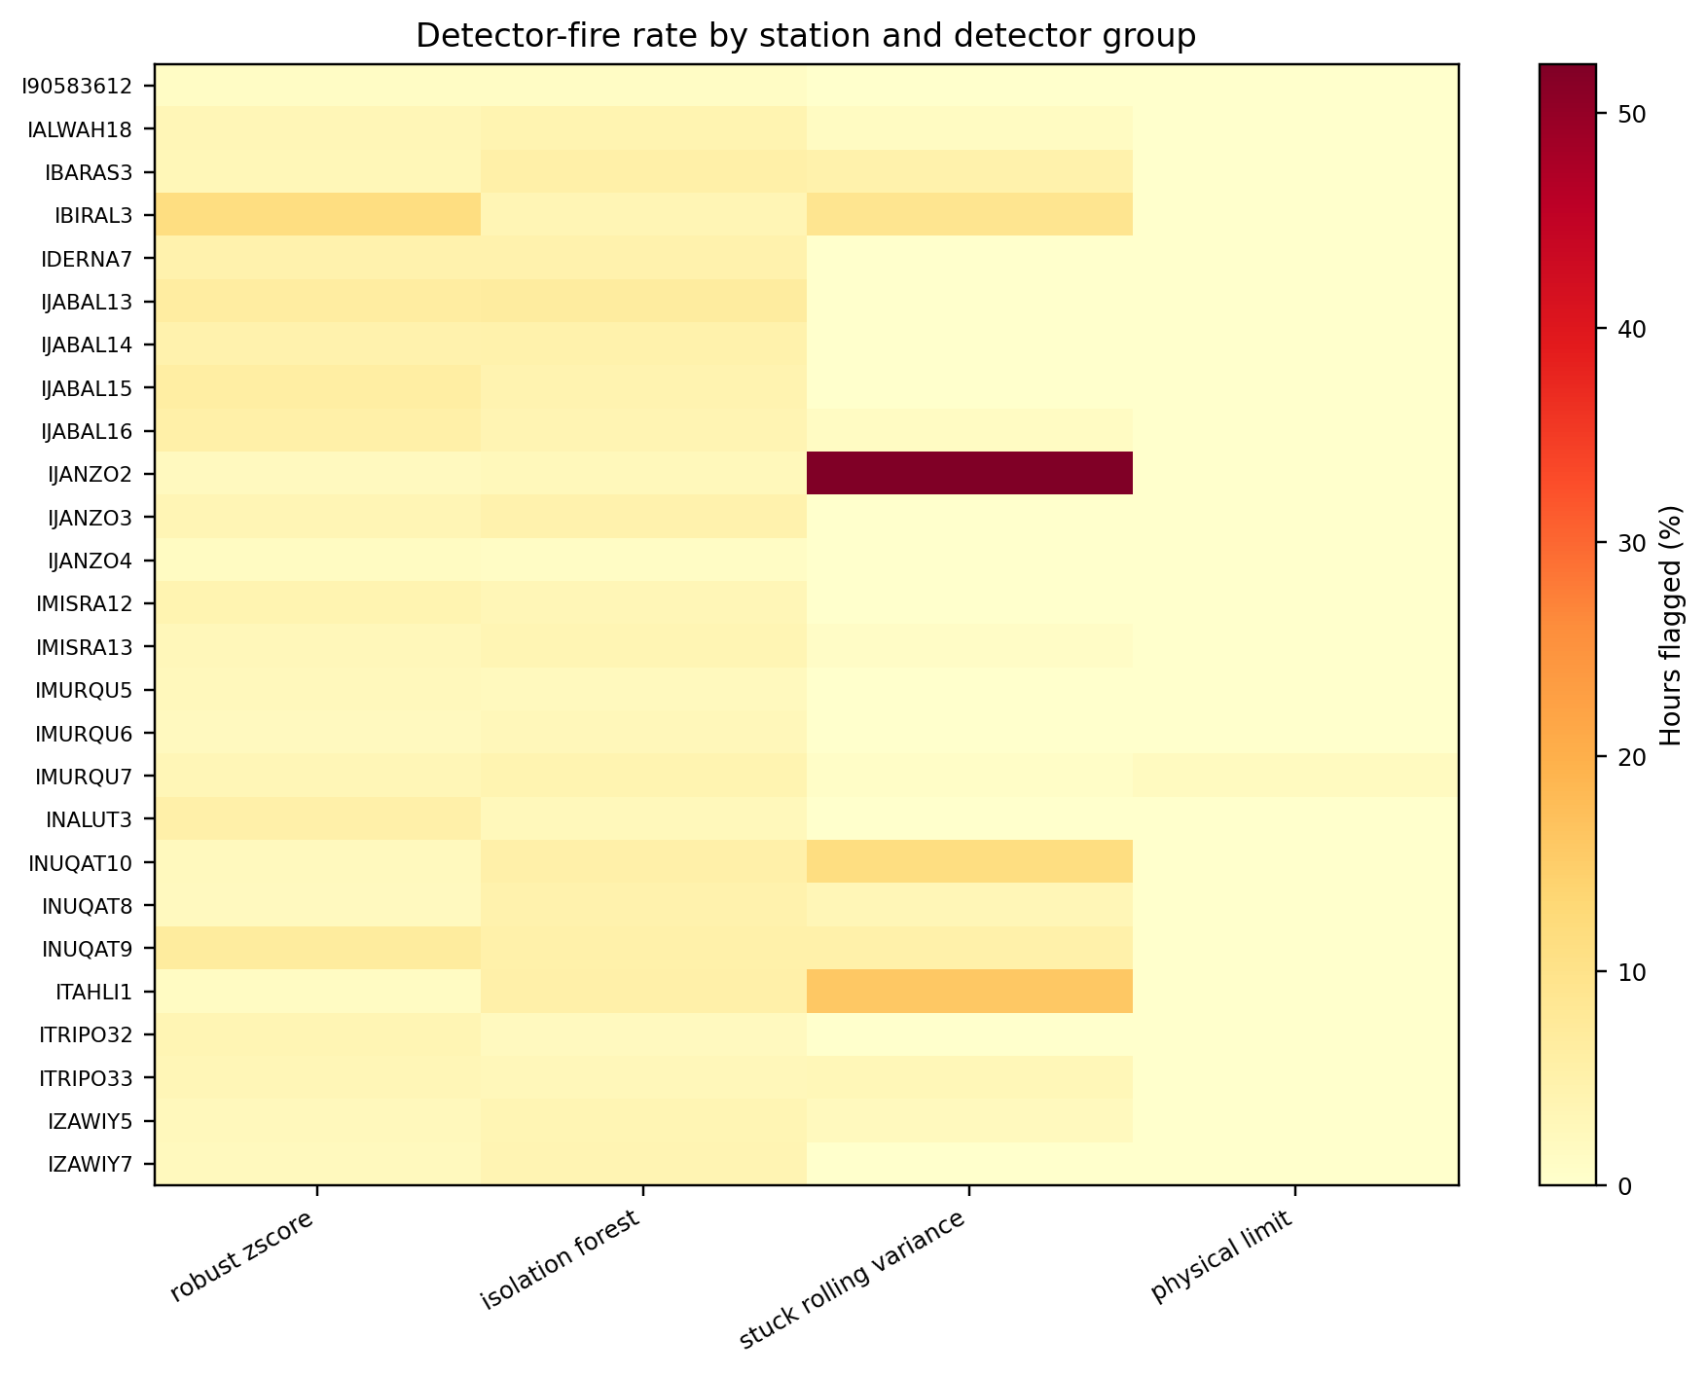
Figure 4.10. Detector-fire rate by station and evidence group; concentrated flags support station-specific review rather than a uniform fleet threshold.
Figure 4.10 shows that detector fires are concentrated in particular stations and evidence groups rather than spread uniformly. This concentration is consistent with the audit’s station-specific availability and sensor-quality differences.
The layer recovers verified examples from the audit. ITRIPO33 contains sustained repeated-zero wind behaviour, and IMURQU7 contains precipitation values beyond physical limits. Figure 4.11 displays both evidence patterns.
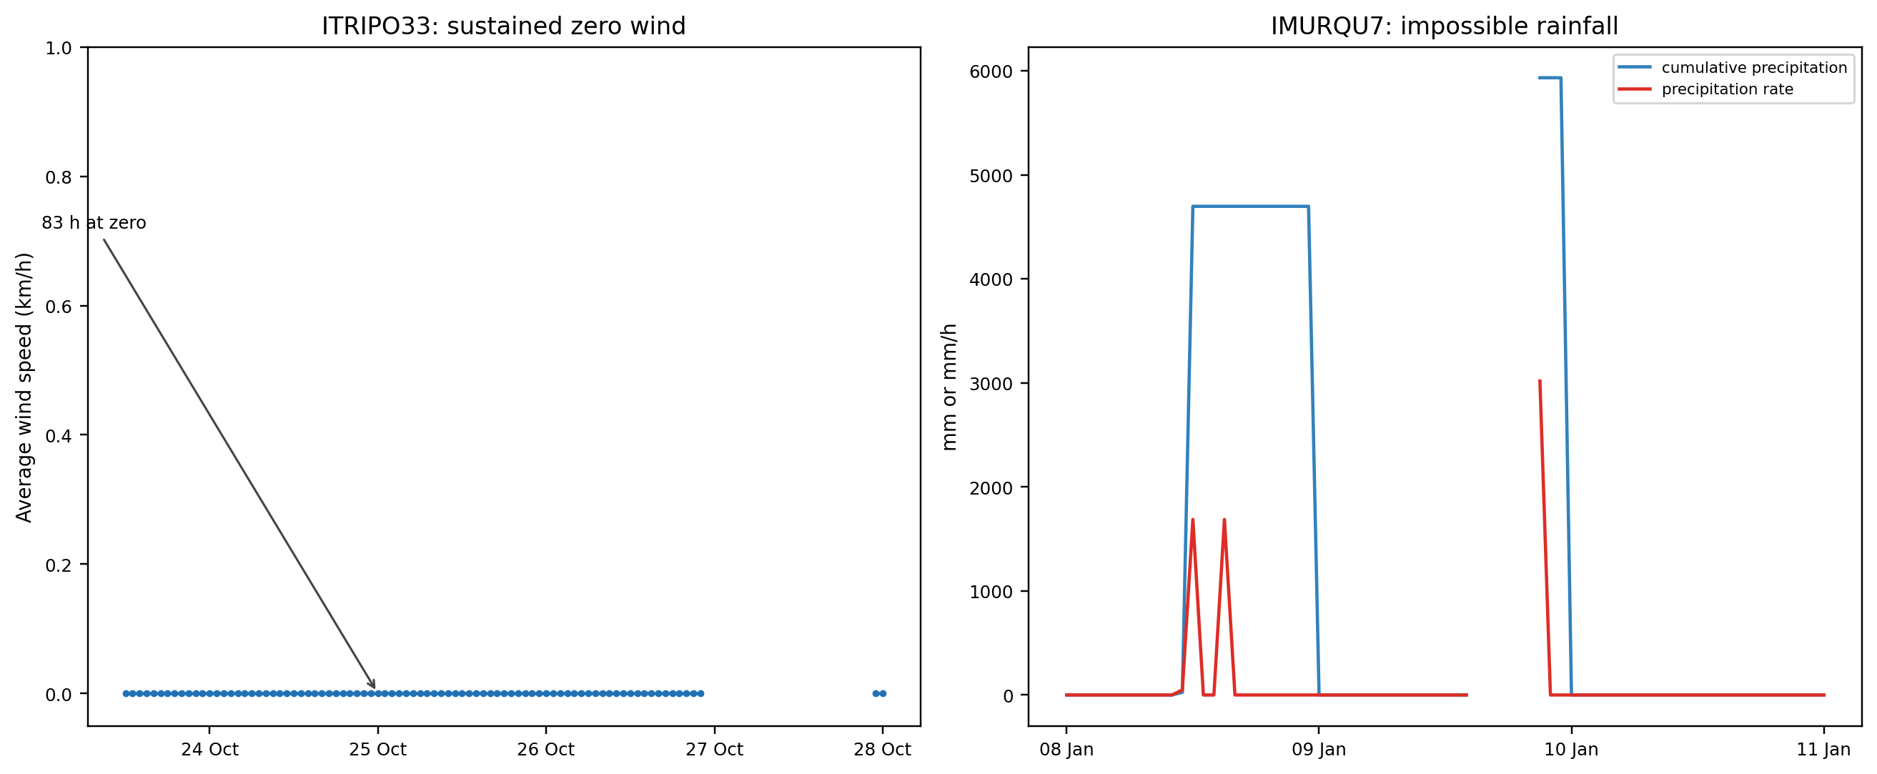
Figure 4.11. Verified fault-evidence examples for stuck wind and impossible precipitation; the paired cases show why temporal and physical rules are complementary.
IBIRAL3 illustrates a weakness of station-against-itself screening. A stable pressure bias can become normal in that station's own historical distribution. In the retained audit, none of 46 candidate absolute-pressure rows passed the statistical gate; nine passing rows involved pressure trend instead. External comparison reveals the sustained level disagreement. That evidence does not mean a calibration-offset label was created for the whole run.

4.8.6 Fault Label Results
The canonical value-based classifier produces 4,799 labelled episodes: 1,121 fault, 3,533 benign, and 145 borderline-review episodes. Borderline-review episodes are excluded from training and evaluation. The benign state records candidate episodes that did not clear the final fault evidence rule; it is not an estimate of the network’s ordinary-weather frequency.
Table 4.18. Fault episodes by canonical mechanism and component labels. Counts are multi-label and are not mutually exclusive.
Axis / label | Fault episodes
Mechanism: statistical_anomaly | 706
Mechanism: stuck_flatline | 302
Mechanism: spike_impossible | 177
Mechanism: calibration_offset | 4
Component: anemometer | 416
Component: barometer | 415
Component: light_uv | 184
Component: thermo_hygrometer | 134
Component: rain_gauge | 30
Component: wind_vane | 24

The taxonomy is multi-label, so mechanism and component counts are reported independently. Table 4.18 and Figure 4.12 use the canonical 1,121-fault population consumed by the hourly model, not the archived reconciliation inventory.
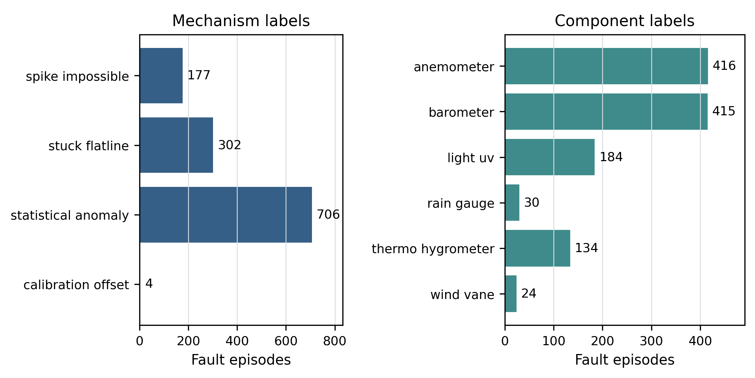
Figure 4.12. Multi-label mechanism and component counts in the canonical 1,121-fault population; independent axes preserve simultaneous causes without a synthetic multiple-fault class.
Statistical-anomaly episodes pass a two-path rule. The dominant Path A requires detector agreement on the same channel and hour, a contextual outlier, and ERA5 directional agreement where comparable. Path B accepts a single detector only with a strong absolute ERA5 residual; this is external discrepancy, not same-direction confirmation.
No solar or ultraviolet physical-limit spike is retained in the canonical label population. Of the 177 spike-impossible episodes, 147 arise from pressure-trend triggers and 30 from precipitation triggers. Figure 4.13 shows this composition. The IMURQU7 precipitation fault remains a verified physical-limit example. Figure 4.13 reports the verified trigger breakdown.
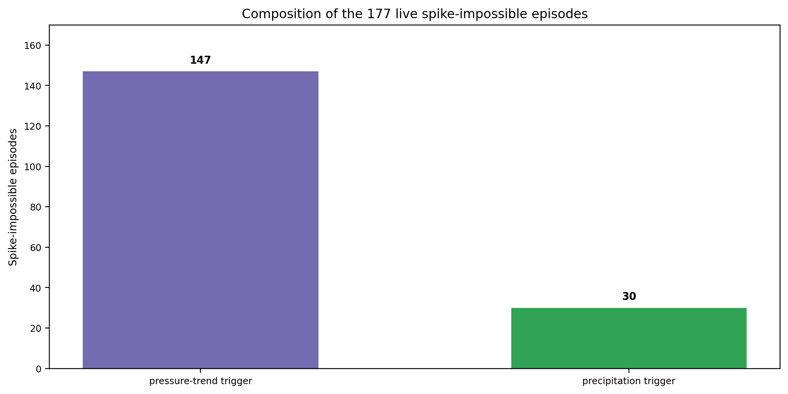
Figure 4.13. Trigger composition of the 177 spike-impossible episodes; the absence of solar/UV triggers corrects the earlier solar-over-read interpretation.
The stuck mechanism captures sensors reporting unchanging values where variation is expected. The clearest case is the ITRIPO33 anemometer. Wind-direction handling prevents a frozen direction during genuine calm from being mislabeled, while unchanged direction with corroborating frozen speed is retained as an anemometer-related fault. These canonical labels come from hourly detector evidence and the raw-value fallback; five-minute observations are useful for separate case review but are not required by the canonical label-builder path.
Calibration offset is retained but sparsely labelled: four promoted episodes and 79 fault-hours. Sustained-offset corroboration records more residual runs than it promotes. Section 4.8.7 explains this distinction.

4.8.7 External and Spatial Residual Results
A sensor can be steadily wrong without ever spiking or freezing. The external-reference layer compares station readings with ERA5, while spatial context compares a station with nearby peers where such peers exist. A residual is treated as disagreement to be explained rather than automatic proof of sensor error.
Sustained-offset corroboration records 24 qualifying runs across 12 stations: 23 pressure runs and one dewpoint run. In the artifact, the verdict confirmed means that the defined evidence criteria passed. It does not mean that a technician confirmed the hardware cause. Table 4.19 lists the run values, and Figure 4.14 shows the twelve longest runs.
Only one qualifying run overlaps episodes eligible for promotion. IJABAL13's −81.78 hPa pressure run lasts 2,037 hours from 21 October 2025 to 14 January 2026 and intersects four borderline episodes. These intersections produce all four calibration-offset episode labels. The other runs remain recorded evidence without a promoted label.
External comparison is essential for stations that lack usable neighbour context. IALWAH18 and IDERNA7 have no spatial neighbour within the configured range. IBIRAL3 provides the complementary example: its stable pressure-level bias is structurally invisible to station-against-itself statistical screening.
Table 4.19. Sustained-offset evidence runs and their canonical label resolution. Pressure values are in hPa; the dewpoint value is in °C.
Station | Confirmed run values (hPa unless noted) | Canonical label resolution
IALWAH18 | −9.45, −9.76, −9.62 | 0 promoted episodes
IBIRAL3 | −16.27, −4.04 | 0 promoted episodes
IJABAL13 | +2.90 dewpoint; −81.78, −5.68 | −81.78 run resolves 4 episodes
IJABAL14 | −12.22, −11.25, −8.49 | 0 promoted episodes
IMISRA12 | −4.59 | 0 promoted episodes
IMISRA13 | −8.22, −8.02, −7.75 | 0 promoted episodes
IMURQU7 | +11.36 | 0 promoted episodes
INUQAT10 | −6.16, −7.77 | 0 promoted episodes
INUQAT9 | −4.58, −4.57 | 0 promoted episodes
ITRIPO33 | −14.06 | 0 promoted episodes
IZAWIY5 | −11.52, +8.23 | 0 promoted episodes
IZAWIY7 | −5.60 | 0 promoted episodes

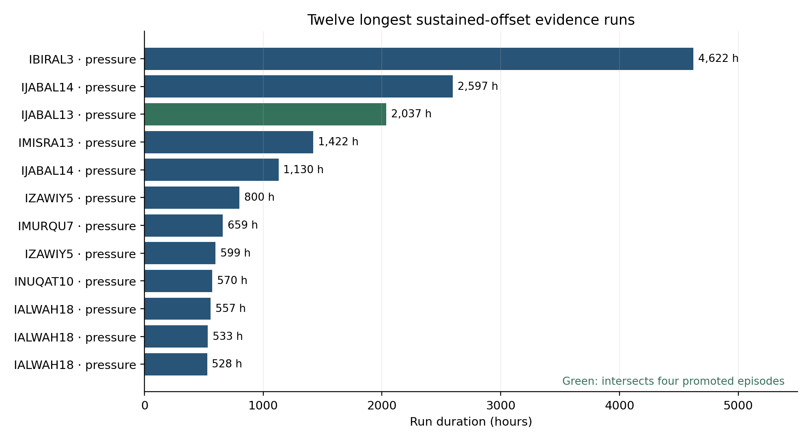
Figure 4.14. Twelve longest sustained-offset evidence runs. The highlighted IJABAL13 run intersects the four episodes promoted to calibration_offset.
The offset evidence is heterogeneous: run values, channels, and durations differ by station. The report therefore treats external residuals as station-specific evidence rather than applying a fleet-wide pressure correction.
External and spatial context improve label review by preserving evidence about sustained disagreements while avoiding automatic promotion of every residual. Spatial evidence corroborates applicable runs; the two stations without neighbours remain external-reference cases. No separate solar, broad systemic, or stand-alone spatial anomaly result is claimed from the retired evidence inventory.

4.8.8 Station-Health Score Results
The health artifact contains 169,655 continuous-grid station-hour rows. Of these, 165,313 have numeric scores, including 37,654 full-outage rows evaluated with progressive degradation. The remaining 4,342 startup or insufficient-history rows are explicitly unavailable. This health-grid population is different from the frozen observed-row outage inventory; their totals should not be substituted for one another.
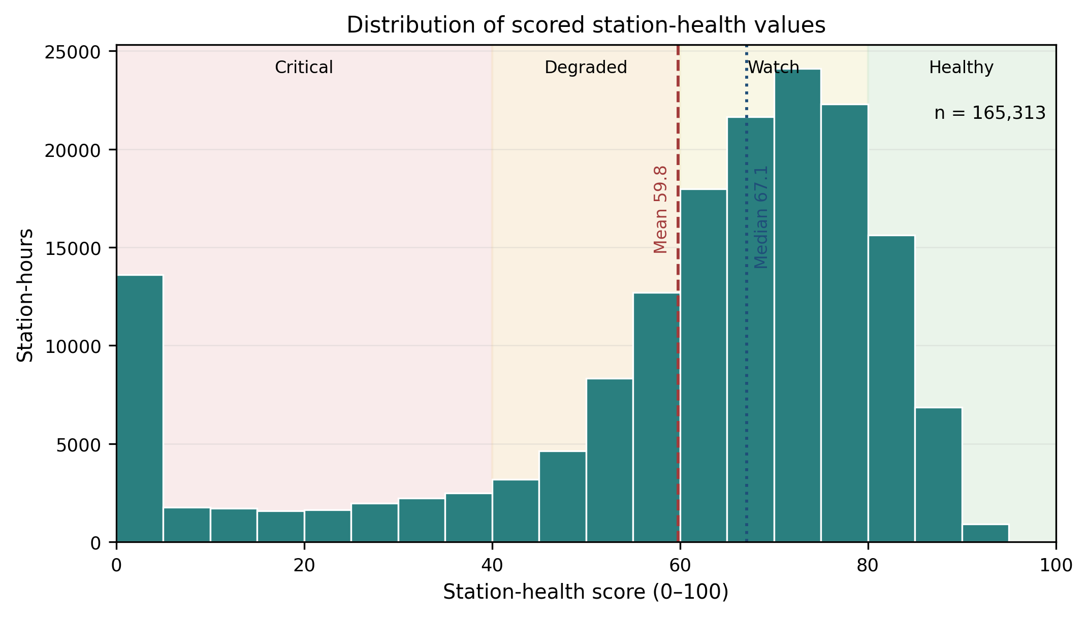
Figure 4.15. Distribution of final causal station-health scores across all numeric station-hours; the broad range shows that the score separates healthy operation, gradual degradation, and prolonged outages without a hard-zero spike.
The five components occupy different ranges, as Figure 4.16 shows. Availability and completeness are generally high but not saturated across every station, while fault burden, reference consistency, and stability provide separation among transmitting hours. Availability and sensor completeness have an all-row correlation of 0.802; part of that association is induced by their shared active-outage multiplier. Their base-component correlation is 0.484 and the final transmitting-only correlation is 0.314. Both are retained because one measures transmission and the other physical-sensor presence, but this partial redundancy is a stated limitation rather than hidden evidence of five independent signals. Figure 4.17 quantifies the corresponding component correlations.
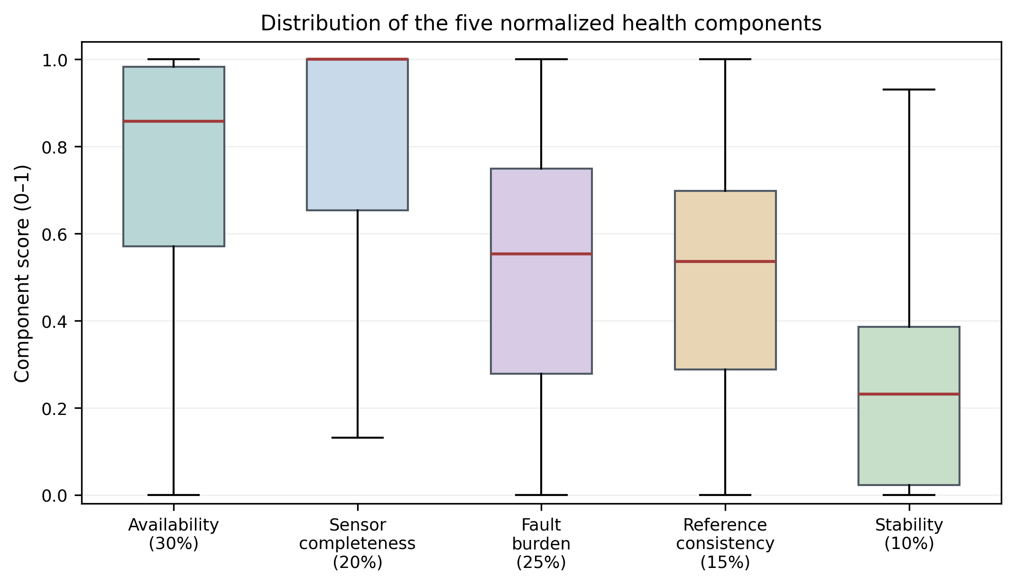
Figure 4.16. Distribution of the five health components after causal preprocessing; the panels reveal which components are concentrated near healthy values and which provide broader operational separation.
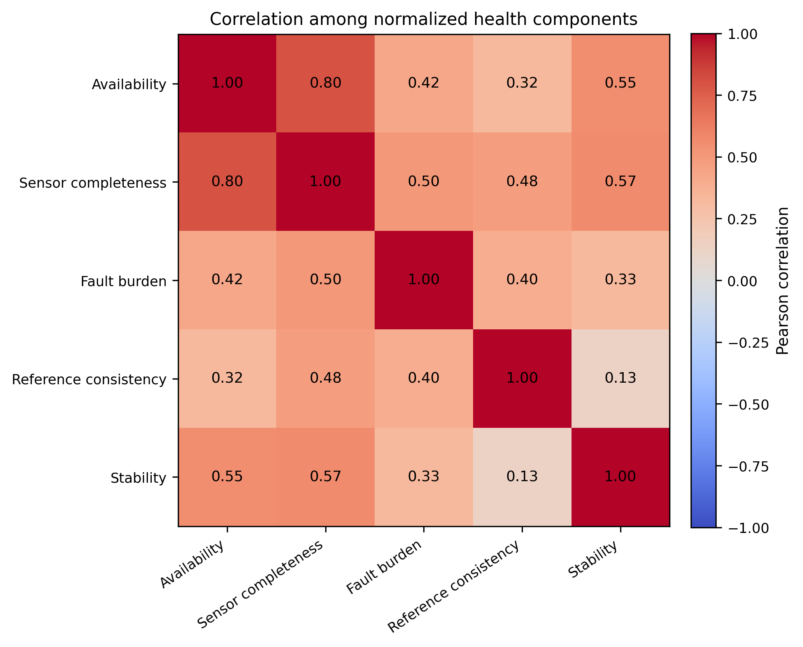
Figure 4.17. Correlation among final health components; the 0.802 availability-completeness association is partly structural, while lower transmitting-only correlation supports retaining both operational meanings.
Mean station health remains operationally coherent: INUQAT8 is highest at 75.26, while outage-dominated IJANZO4 is lowest at 19.43. Figure 4.18 contrasts station trajectories rather than reducing the fleet to one average.
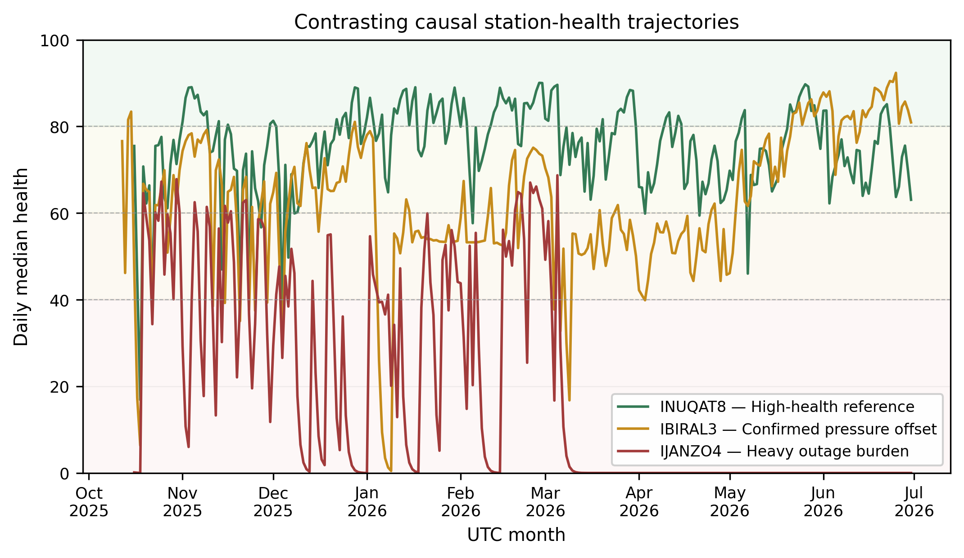
Figure 4.18. Contrasting station-health trajectories; the comparison shows how similar fleet-level averages can conceal sustained degradation, recovery, and recurring local evidence.

Table 4.20. Effect of replacing the full-outage hard zero with progressive duration degradation; the revised score removes a discontinuity and narrows the mean-median gap.
Statistic | Hard-zero design | Progressive design
Mean health | 54.88 | 59.81
Median health | 67.75 | 67.12
Exact-zero rows | 37,654 | 0
Mean-median gap | 12.87 | 7.31
The progressive score has no exact-zero rows, although very long outages approach zero and are displayed as 0.0. The distribution change alone is not proof that forecasting became easier. The IDERNA7 example gives a direct check of the duration rule: health falls from 60.1 before its 814-hour outage to 57.7 after one hour, 46.8 after six hours, 22.1 after 24 hours and 0.04 after seven days. On the first recovered hour it rises to 65.2, showing that recovery can still create a large change.
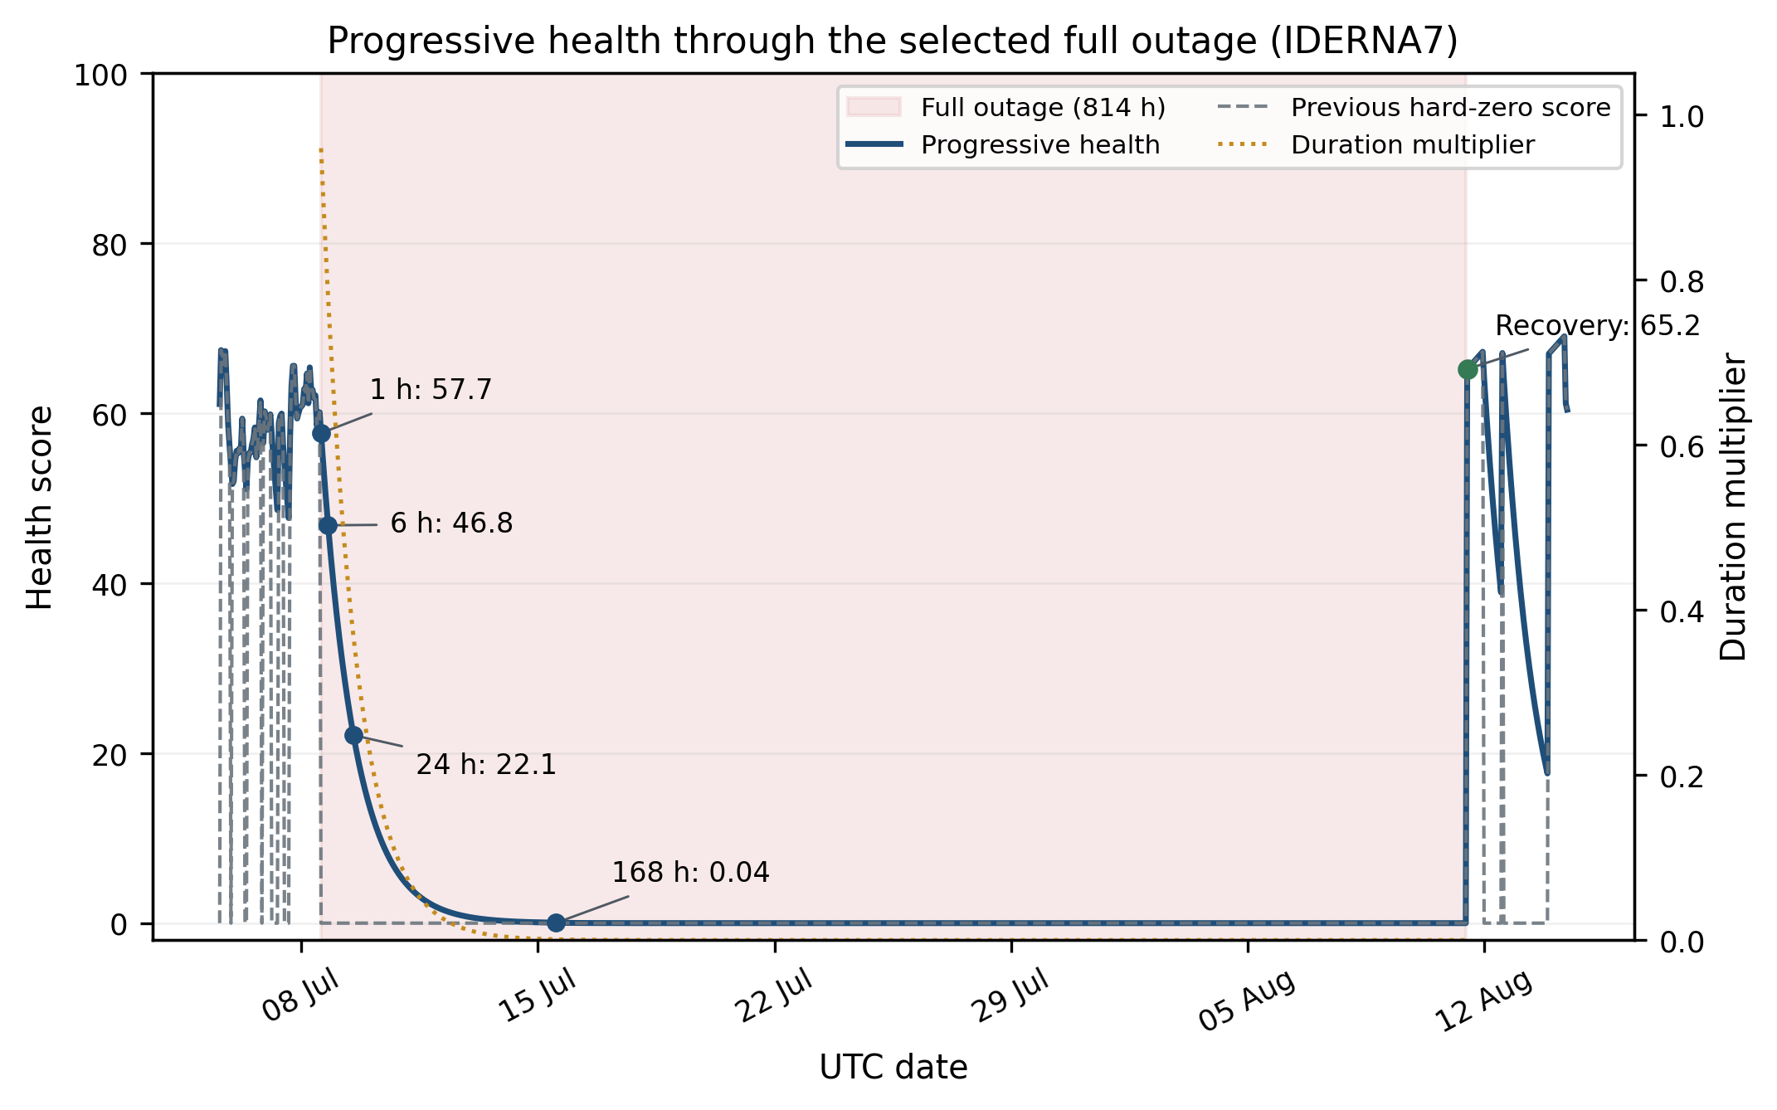
Figure 4.19. IDERNA7 during an 814-hour outage: gradual decline while silent and a visible jump on recovery. The projection does not predict when recovery will occur.
The score is an explainable operational definition, not a measured probability of hardware failure. Its weights and duration constants are fixed design choices. Maintenance records would be needed to test whether a given score or band reliably corresponds to an inspection need, repair cost or service outcome.
Chapter 5

Model Creation, Experiments, and Selection
This chapter separates current fault detection, retrospective mechanism reason codes and future health forecasting. It explains the final one-hour detector and both custom models, the input-window experiment, the validation selection rules and the frozen results. Each task is evaluated against the target it actually predicts.

5.1 Experimental Setup
The experimental record covers 15 June 2025 through 30 June 2026. It contains 26 stations, 166,017 station-hours, and 41 columns. A fully covered station span contains 9,144 hourly timestamps across this frozen period. The network is geographically uneven: IALWAH18 and IDERNA7 have no nearby spatial neighbour.
The audit and availability results use the lifecycle table, audit summary, missingness table, frozen full-outage events, operational hourly availability classification, partial-outage events, and network-window table produced from the canonical record. Labelling uses the canonical episode catalogue, detection uses the frozen hour-level artifacts, and health, forecast, and scorecard results use their recorded reports, predictions, selection traces, and invariant files. All timestamps are UTC unless stated otherwise.
Network-wide outage analysis uses the 47 extracted windows and their station-event membership. It distinguishes midnight-classified windows from other coordinated windows without treating a network-wide pattern as a station-local failure.

5.2 Testing Procedure
Automated tests check software behaviour: dataset keys, lifecycle states, consecutive-hour event grouping, full and partial outages, model inputs and output joins. They help detect implementation errors. Predictive performance is evaluated separately on validation and test partitions; a passing software test does not prove that a model predicts real faults correctly.
Binary detection uses two 70/15/15 development partitions. The random partition uses a fixed seed and class stratification. The spaced partition groups connected positive source episodes before assignment and allocates clean and benign hours within month and display-state strata. This reduces positive-episode fragmentation, but it is not a chronological train-before-test split or a last-days-of-each-month holdout.
Health forecasting uses timestamp-based chronological partitions instead. All stations at the same clock hour receive the same partition. For horizon H, an H-hour purge removes origins immediately before each boundary so that a target cannot fall in a later partition. These splits are built separately for each horizon. Repeated development experiments remain development evidence; the report does not describe the whole project as a single untouched test run.

5.3 Performance Metrics
For binary detection, precision measures how often an alert is correct, recall measures how much of the labelled fault population is detected, F1 balances precision and recall, and accuracy counts all correct decisions. AUROC measures ranking across thresholds. AUPRC is reported using average precision, which summarises the precision–recall curve and is particularly useful when faults are rare. These metrics are interpreted together.
For health forecasting, MAE is the average absolute error in health points. RMSE gives more weight to large errors. R² compares squared error with a constant mean prediction. Health-band accuracy is the fraction of future Healthy, Watch, Degraded or Critical bands predicted correctly; it is not exact numerical-score accuracy. Persistence means keeping the current score or band unchanged.
Faults are 5.58% of all 166,017 source station-hours, but 7.11% of the 130,218 training-eligible rows. The latter is the relevant development model class proportion. Mechanism results use per-label, macro and micro metrics and a different event population. Four-band health accuracy is accompanied by balanced accuracy and macro F1 where useful because the bands are not equally common; 25% random guessing is not the appropriate operational baseline.
$$Precision=\frac{TP}{TP+FP},Recall=\frac{TP}{TP+FN},F_{1}=\frac{2PR}{P+R},Accuracy=\frac{TP+TN}{N}$$
TP, FP, TN, and FN denote true positives, false positives, true negatives, and false negatives. Precision measures alert correctness, recall measures detected-fault coverage, F1 is their harmonic mean, and accuracy measures all correct decisions; accuracy is never interpreted alone on imbalanced targets.
$$MAE=\frac{1}{n}\sum_{i}{|}y_{i}-{\overset{^}{y}}_{i}|,RMSE=\sqrt{\frac{1}{n}\sum_{i}{(}y_{i}-{\overset{^}{y}}_{i})^{2}}$$
For health forecasting, y_i and ŷ_i are observed and predicted future health. MAE is the primary model-selection loss because it matches the absolute-error objective and is less dominated by rare large errors; RMSE remains a useful sensitivity measure for those large misses.
$$R^{2}=1-\frac{\sum_{i}{(}y_{i}-{\overset{^}{y}}_{i})^{2}}{\sum_{i}{(}y_{i}-\overset{―}{y})^{2}}$$
R² compares squared forecast error with prediction by the test-set mean ȳ. Health-band accuracy is accompanied by balanced accuracy, the mean recall across bands, and macro F1, the unweighted mean of per-band F1. Transition-only accuracy is computed only where the observed future band differs from the current band.

5.4 Binary Fault Detection

5.4.1 Classical Baselines
Logistic regression was an early linear comparator. HGB is the stronger nonlinear baseline: it learns a sequence of decision trees over tabular features and can model interactions between fault evidence. Its selected current-hour input has 67 columns: 24 continuous engineered features, one presence-mask value, one elapsed-time value, 38 rule-evidence values and three static-context values. Trees do not require feature standardisation; learned preprocessing for neural models is fitted on training data only.

5.4.2 Reliability-Aware Gated Fusion Network
RGFN, the Reliability-Aware Gated Fusion Network, was developed to combine sensor-context features with explicit rule evidence. Earlier experiments used a GRU sensor encoder over multiple hours. The final one-hour comparison replaces that sequence encoder with a small feed-forward MLP because its input has one time step. It retains a separate evidence encoder, static context and a learned gate. It would therefore be inaccurate to describe the final one-hour model as a temporal GRU model.
The sensor encoder compresses continuous features, missingness and elapsed time into a representation. The evidence encoder separately represents rule indicators. The gate learns how much to trust the two branch logits for each example. The original missing-data design was informed by GRU-D [1], but RGFN does not implement GRU-D's learned decay mechanism. Unlike EF-HGB's fixed validation-selected weights, RGFN's gate varies with the example.
In the implementation, alpha is the learned gate value between zero and one. It weights the sensor-branch and rule-branch logits, and a sigmoid converts their combination into a fault probability. Some variable names retain the word temporal from the original GRU version; for the final one-hour MLP they refer to the sensor branch, not a multi-hour sequence.
Listing 5.1. RGFN's learned gate and final probability.
Source: src/model/hourly_rgfn.py, lines 231–233.
alpha = torch.sigmoid(self.gate(fusion).squeeze(-1))
final_fault_logit = alpha * temporal_logit + (1.0 - alpha) * rule_logit
probability = torch.sigmoid(final_fault_logit)
Unlike the fixed EF-HGB mixture, this gate is learned during neural-network training and can vary from one input example to another.

5.4.3 Results and Final Binary-Detector Selection
The final binary experiment contains 130,218 eligible station-hours: 9,260 fault, 7,320 benign-candidate and 113,638 clean hours. The remaining 35,799 source hours are excluded under the hourly label rules. Table 5.1 and Figure 5.1 distinguish the supervised population from the complete source dataset.
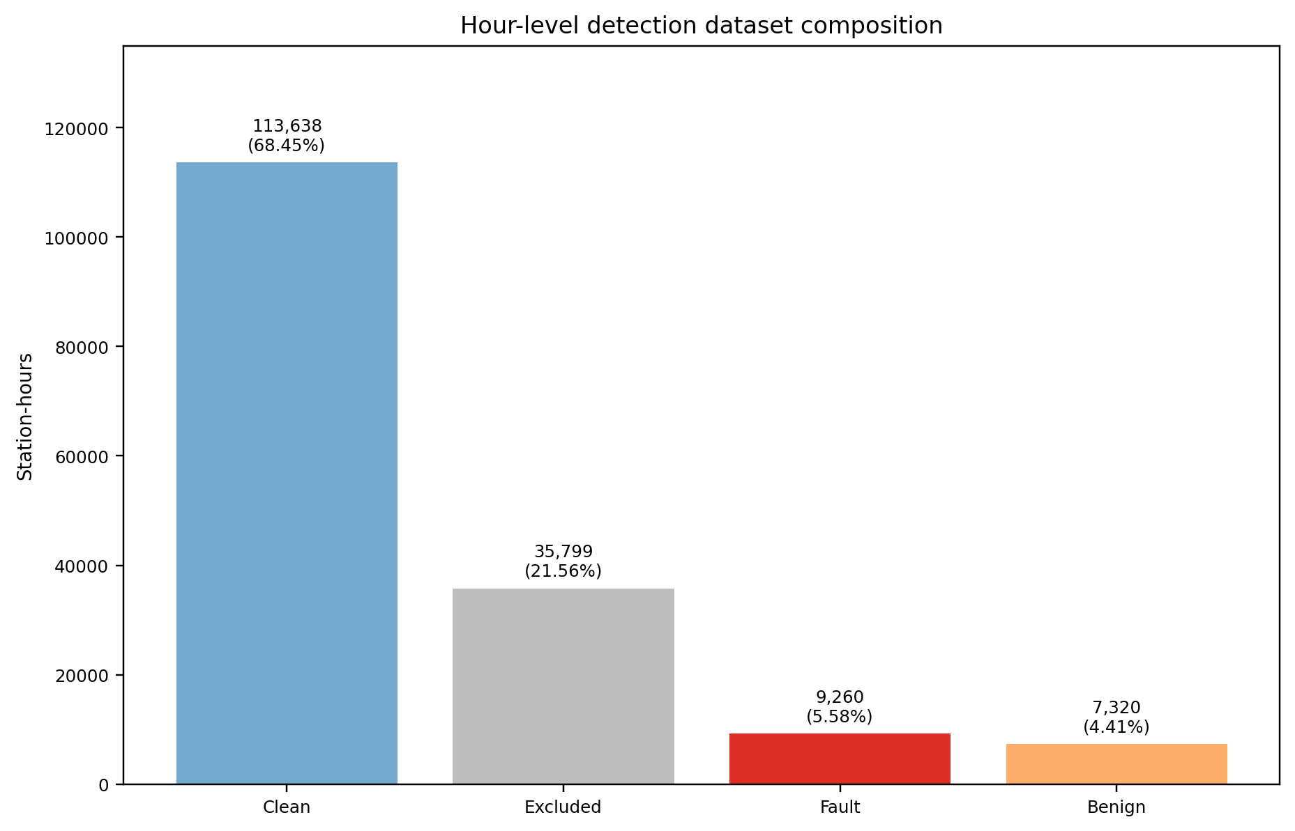
Figure 5.1. Hour-level target composition across all 166,017 observed station-hours; excluded hours remain outside training and the dominant clean class explains high raw accuracy.
Table 5.1. Hour-level dataset composition and training use.
Composition | Hours | % of total | Training use
Clean | 113,638 | 68.45% | fault_hour = 0
Excluded | 35,799 | 21.56% | No train/evaluation label
Fault | 9,260 | 5.58% | fault_hour = 1
Benign | 7,320 | 4.41% | fault_hour = 0
Training eligible | 130,218 | 78.44% | Included
The final same-input comparison evaluates one-hour HGB, one-hour RGFN and EF-HGB using the same eligible rows and split manifest. The selection objective is to maximise the minimum of validation precision, recall and F1, with recorded tie-breaking rules. It is not simply maximum F1. The RGFN values summarise five seeded runs; HGB and EF-HGB are the corresponding fixed tree-model runs.
The one-hour input removes overlap caused by explicitly stacking several adjacent hourly rows. It does not remove historical information from the features, correlation within events, or the retrospective nature of some development feature statistics and labels. Random and spaced results are therefore offline development estimates. They should not be described as prospective real-time validation.
Table 5.2. Final one-hour model comparison. Metrics are percentages; configurations are selected from validation, not test. RGFN entries are five-seed summaries.
Model | Split | Val. F1 | Test acc. | Test P | Test R | Test F1
EF-HGB | random | 92.44 | 98.86 | 91.47 | 92.58 | 92.02
HGB | random | 92.29 | 98.85 | 91.39 | 92.51 | 91.95
RGFN | random | 89.70 | 98.51 | 89.74 | 89.39 | 89.54
EF-HGB | spaced | 90.91 | 98.76 | 91.40 | 91.40 | 91.40
HGB | spaced | 91.20 | 98.58 | 90.30 | 89.98 | 90.14
RGFN | spaced | 88.52 | 98.54 | 89.09 | 91.16 | 90.04
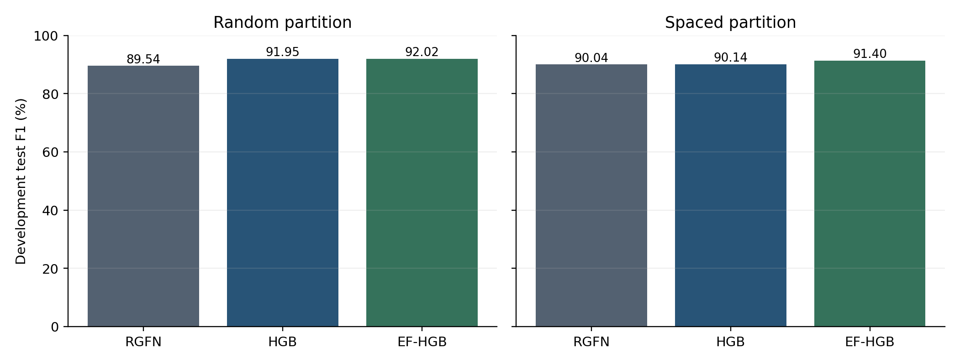
Figure 5.2. Development test F1 for the final one-hour comparison. EF-HGB is selected using the validation maximin rule, not the plotted test values.
EF-HGB, Evidence-Fused Histogram Gradient Boosting, is the second custom model. It fits three HGB views on the same training rows: all 67 inputs, 29 context inputs, and 41 rule-view inputs. The rule view includes the three static-context columns, so the views are not disjoint. A validation search combines their probabilities using non-negative weights that sum to one and selects the decision threshold. This is weighted fusion, not a learned per-example neural gate or a claim of a new boosting algorithm.
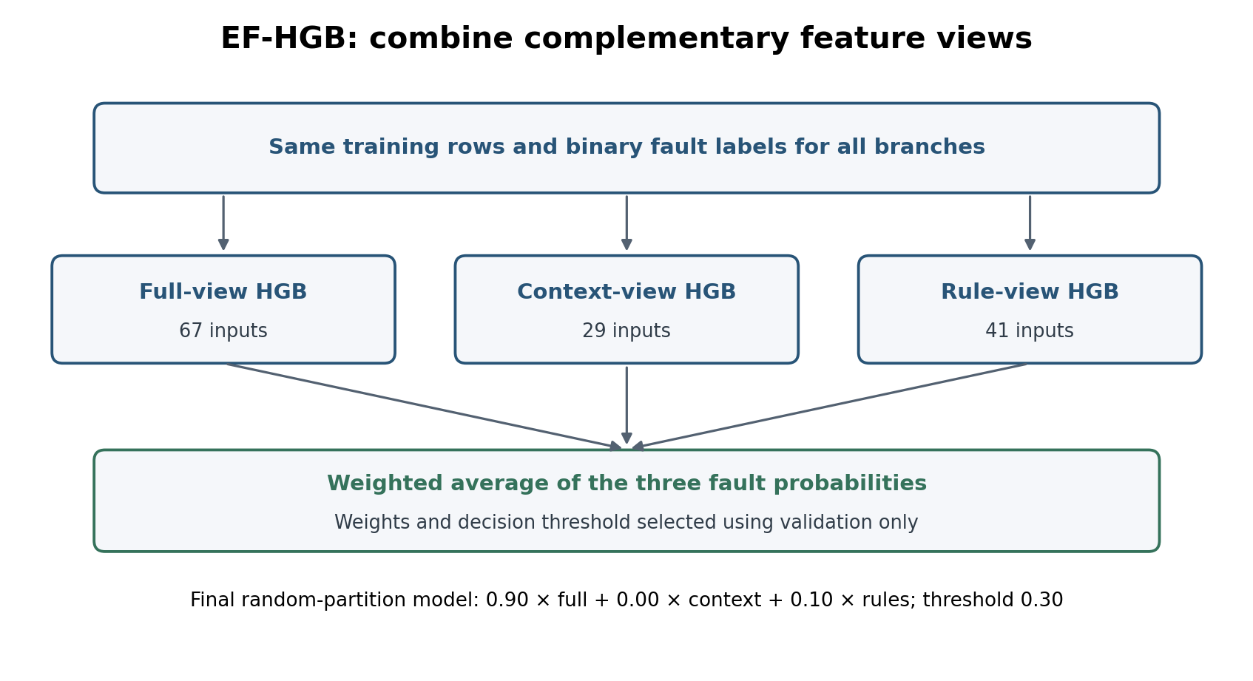
Figure 5.3. EF-HGB's three feature views and validation-selected probability fusion. The final operational configuration assigns zero weight to the context-only branch.
For the random partition, fusion weights are 0.90 full, 0.00 context and 0.10 rules, with threshold 0.30. The underlying HGB uses positive class weight 1.0. For the spaced comparison, weights are 0.00 full, 0.20 context and 0.80 rules, with threshold 0.80 and HGB class weight 13.0. The dashboard uses the selected random-partition EF-HGB bundle. The spaced model is an additional development comparison, not a second dashboard detector.
Listing 5.2. The actual EF-HGB probability combination.
Source: src/model/hourly_baseline.py, lines 87–92.
probability = (
float(self.full_weight) * full
+ float(self.context_weight) * context
+ float(self.rule_weight) * rules
)
return np.column_stack([1.0 - probability, probability])
The three branch probabilities are combined with the frozen weights. The saved decision threshold is then applied to the fault probability. A zero weight means that a branch does not affect this configuration's prediction.
The input-window study tested 1, 3, 5, 7, 12 and 24 hours using the same HGB machinery and partition assignments. It increased the flattened input from 67 to 665 columns. The one-hour input had the strongest validation result in both partitions. Table 5.3 reports every tested window rather than hiding the unsuccessful longer alternatives.
This result suggests that repeated historical rows added more redundancy or noise than useful information for current-fault classification in this dataset. It does not prove that faults have no temporal pattern or that deep learning is unsuitable in general. The current-hour engineered features already contain historical summaries, and the experiment changes both context length and input dimension.
EF-HGB's random-partition development test F1 is 92.02%, compared with 91.95% for the one-hour HGB and 89.54% for the one-hour RGFN. The fusion improvement over the already strong one-hour HGB is small. In the spaced validation comparison, HGB actually has slightly higher F1 than EF-HGB, but EF-HGB has the higher minimum of precision, recall and F1 and is selected under the declared objective. No claim of a statistically significant improvement is made.
Table 5.3. HGB input-window comparison. Each row uses its own validation-selected operating point; percentages are fault-class F1.
h | Inputs | Random val. F1 | Random test F1 | Spaced val. F1 | Spaced test F1
1 | 67 | 92.29% | 91.95% | 91.20% | 90.14%
3 | 119 | 91.30% | 91.12% | 90.35% | 89.89%
5 | 171 | 90.87% | 91.03% | 89.30% | 89.07%
7 | 223 | 89.97% | 90.21% | 88.70% | 88.57%
12 | 353 | 89.13% | 88.97% | 88.53% | 88.37%
24 | 665 | 87.76% | 87.58% | 86.76% | 86.48%
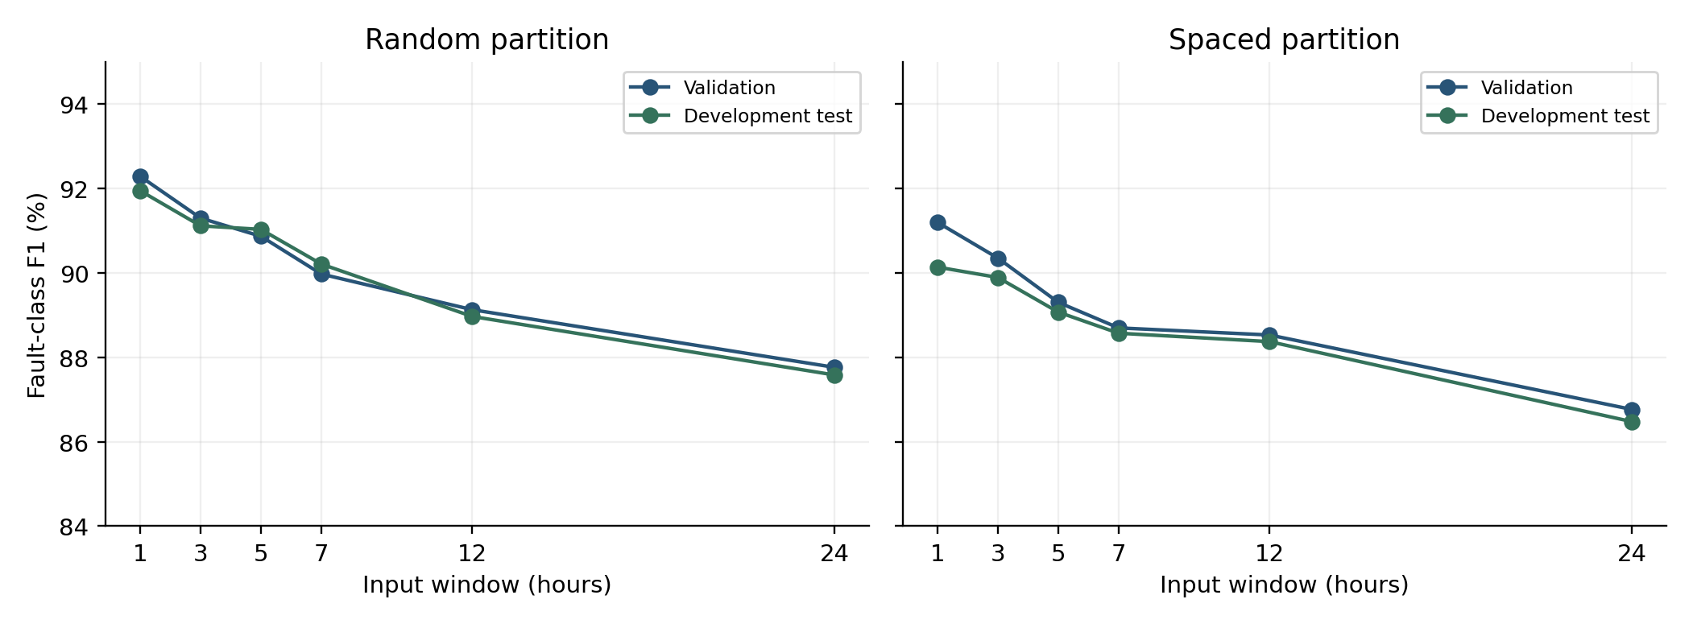
Figure 5.4. Input-window comparison: validation and development-test F1. The complete values are in Table 5.3.
Current-fault detection and mechanism classification remain separate tasks. The final one-hour detector does not automatically replace the older reason-code models or their input tensors. The reason-code evidence below retains its own saved configuration and retrospective event population.
The final operational detector is the random-partition EF-HGB configuration selected on development validation. Its one-hour feature order, mask mode, model file and threshold are frozen before the associated July evaluation. RGFN remains a custom-model development result, not a July deployment claim.

5.5 Fault-Mechanism Reason Codes
The reason-code experiment receives labelled fault-hours and predicts mechanism labels. It is therefore conditional on a fault population, unlike end-to-end detection among all eligible hours. The saved models reuse the corresponding binary split assignments. Their hourly outputs are aggregated over connected labelled event groups using any-hour, majority or mean-probability rules. These event boundaries use source labels and are retrospective.
Method and aggregation rule were selected from the 67 complete spaced validation event groups only. The support-qualified selection set contains spike-impossible, statistical-anomaly, and stuck-flatline; calibration offset has only one positive complete validation event and is excluded before selection. Gradient boosting with the any-hour rule ranks first on validation macro F1 (0.868), as shown in Table 5.4. No held-out test metric was available to this selection step.
Table 5.4. Validation-only selection of the spaced mechanism reason-code configuration. Macro values are precision, recall, F1, and accuracy.
Method | Aggregation | Macro precision | Macro recall | Macro F1 | Macro accuracy | Rank
Gradient boosted | Any hour | 0.780 | 1.000 | 0.868 | 0.881 | 1
Gradient boosted | Mean probability | 0.798 | 0.926 | 0.854 | 0.900 | 2
Gradient boosted | Majority | 0.786 | 0.889 | 0.831 | 0.896 | 3
Logistic regression | Majority | 0.801 | 0.852 | 0.824 | 0.920 | 4
Logistic regression | Mean probability | 0.795 | 0.852 | 0.821 | 0.915 | 5
Logistic regression | Any hour | 0.733 | 0.963 | 0.814 | 0.881 | 6
RGFN | Majority | 0.569 | 1.000 | 0.666 | 0.617 | 7
RGFN | Mean probability | 0.569 | 1.000 | 0.665 | 0.612 | 8
RGFN | Any hour | 0.544 | 1.000 | 0.649 | 0.592 | 9
Table 5.5 gives the held-out event-level comparison using the common any-hour aggregation rule. The random partition is retained only as a fragmentation sensitivity result: 318 of its 381 observed test event groups cross partitions. The spaced partition contains 70 complete held-out event groups and is the relevant retrospective comparison. Macro and micro cells list precision / recall / F1 / accuracy.
Table 5.5. Retrospective event-level mechanism reason-code comparison under the predefined any-hour aggregation rule.
Split | Method | Observed event groups | Macro P / R / F1 / Acc | Micro P / R / F1 / Acc
Random sensitivity | Logistic regression | 381 (63 complete; 318 fragmented) | 0.865 / 0.936 / 0.897 / 0.934 | 0.855 / 0.975 / 0.911 / 0.934
Random sensitivity | Gradient boosted | 381 (63 complete; 318 fragmented) | 0.931 / 0.981 / 0.954 / 0.966 | 0.917 / 0.993 / 0.953 / 0.966
Random sensitivity | RGFN | 381 (63 complete; 318 fragmented) | 0.924 / 0.925 / 0.924 / 0.961 | 0.932 / 0.958 / 0.945 / 0.961
Spaced held-out | Logistic regression | 70 (70 complete; 0 fragmented) | 0.728 / 1.000 / 0.826 / 0.886 | 0.753 / 1.000 / 0.859 / 0.886
Spaced held-out | Gradient boosted | 70 (70 complete; 0 fragmented) | 0.795 / 1.000 / 0.878 / 0.876 | 0.737 / 1.000 / 0.849 / 0.876
Spaced held-out | RGFN | 70 (70 complete; 0 fragmented) | 0.527 / 0.984 / 0.625 / 0.571 | 0.447 / 0.986 / 0.615 / 0.571
For the frozen validation-selected configuration, the spaced held-out macro precision, recall, F1, and accuracy are 0.795, 1.000, 0.878, and 0.876; micro values are 0.737, 1.000, 0.849, and 0.876. Gradient boosting is therefore the validation-selected configuration, not a test-selected winner. No configuration reaches 0.80 for all four macro measures on both validation and test: the selected any-hour rule intentionally favours recall, while its precision remains below 0.80.
Table 5.6. Held-out spaced event-level result by mechanism for the frozen validation-selected gradient-boosted any-hour configuration.
Mechanism | Test-event support | Precision | Recall | F1 | Accuracy | Interpretation
Spike-impossible | 8 | 0.727 | 1.000 | 0.842 | 0.957 | Small held-out support.
Statistical anomaly | 44 | 0.657 | 1.000 | 0.793 | 0.671 | Recall-oriented aggregation raises false positives.
Stuck-flatline | 21 | 1.000 | 1.000 | 1.000 | 1.000 | Rule recovery; see text.
Calibration offset | 0 | N/A | N/A | N/A | N/A | Excluded: one positive complete validation event (<5).
The perfect stuck-flatline row should not be interpreted as an independent diagnosis achievement. Its label derives from the deterministic rolling-variance stuck rule, and the corresponding rule-evidence flag is also a model input. Near-perfect recovery therefore measures recovery of that supplied rule evidence. Likewise, the any-hour aggregation produces macro recall of 1.000 because it asserts a mechanism when any constituent hour does so; the lower precision for statistical anomaly shows the cost of this permissive rule. Table 5.6 provides the label-level support and metrics needed to interpret the perfect stuck result correctly.
These figures do not measure end-to-end diagnosis of automatically detected incidents. A deployed interface has no ground-truth episode IDs, and binary misses and false alarms would also affect its reason-code performance. The current dashboard therefore displays predicted fault runs and detector evidence rather than claiming the event-level reason-code accuracy as a live result. No July reason-code performance is presented in this report.
Gradient boosting is the validation-selected reason-code research configuration. RGFN remains a tested alternative. Mechanism confidence is not proof of the hardware cause, and component names derived from detector evidence are not model-predicted component diagnoses.

5.6 Health-Forecasting Method
The primary health task predicts the score at exactly t+H for H = 1, 3, 6, 12 and 24 hours. Origins must be transmitting, including partial outages, but a future target may be in an outage. There is one model per horizon, not one shared multi-output model. Its inputs include current health and components, slopes over 6–72 hours, sensor presence, recent detector evidence, outage history, station age and network context. The core set has 53 numeric features plus station identity; the full engineered set has 181 numeric features plus station identity.
Three simple comparisons show whether learning adds useful information. Persistence keeps today's score. A recent-trend baseline extends the trailing 24-hour trend. The no-new-incident roll-forward advances the score's existing history under a stated continuation scenario. The learned model predicts a correction to this last baseline. It is not predicting every future sensor reading and then calculating health from those readings.
$$r(t,H)=H_{t+H}-B(t,H)$$
H_(t+H) is observed future health at horizon H and B(t,H) is the causal no-new-incident roll-forward baseline constructed from information at or before t.
$${\overset{^}{H}}_{t+H}=clip[B(t,H)+α_{H}\overset{^}{r}(t,H),0,100]$$
The forecast adds alpha times the predicted residual to the baseline, then clips the result to 0–100. Alpha is selected on chronological validation from 0, 0.1, 0.25, 0.5, 0.75 and 1. A value of zero would reject the learned correction. All five primary transmitting-origin policies retain a non-zero correction.
Candidates are a regularised linear model, HGB and CatBoost [9]. Forecast selection minimises validation MAE. Model family, feature set, iteration count, recency weighting and alpha are selected before the corresponding test evaluation. Recency is an exponential training weight: a 30-day half-life gives a row 30 days older half as much weight, rather than removing all rows older than 30 days. The selected model is then refitted on train plus validation. Earlier test results influenced the broader development redesign, so these are post-hoc model-improvement results, not a single-shot untouched development test.
Learned forecasts are intended for stations transmitting at the origin. The dashboard still displays current health during a full outage and can show a continued-outage projection. That projection assumes that the outage continues; it does not predict when the station will recover. Supplementary full-outage-origin experiments are reported separately and do not justify a learned recovery claim.
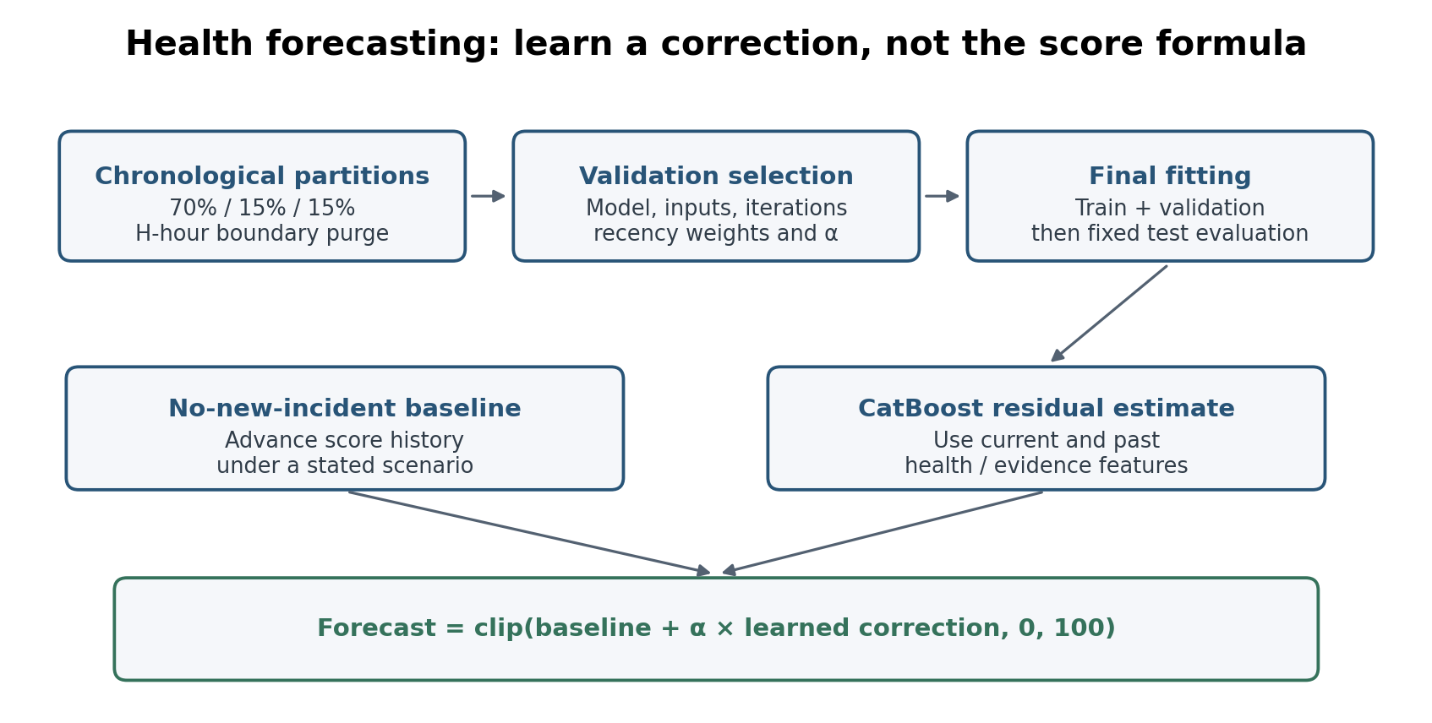
Figure 5.5. Health forecasting: chronological selection, final fitting and a bounded correction to the roll-forward baseline. No new model is fitted during dashboard replay.

5.7 Health-Forecasting Results
Health forecasting is evaluated at transmitting origins over 1, 3, 6, 12, and 24 hours. The selected configurations are frozen by chronological validation, with no test metric used to choose a horizon model. CatBoost is selected at all five primary horizons from the predefined linear, histogram-gradient-boosting, and CatBoost candidates; station identity is categorical and the residual correction is shrunk before being added to the deterministic roll-forward baseline.
Table 5.7. Primary transmitting-origin health forecasts and deterministic baselines; MAE improves over both persistence and roll-forward at every horizon, while error grows with forecast distance.
H | Test n | MAE | RMSE | R² | Persist. MAE | Roll-fwd MAE | Gain vs persist. | Gain vs roll-fwd
1 h | 28,968 | 1.270 | 2.314 | 0.971 | 1.383 | 1.311 | 8.14% | 3.10%
3 h | 28,990 | 2.533 | 3.952 | 0.916 | 2.767 | 2.796 | 8.46% | 9.41%
6 h | 28,962 | 3.835 | 6.018 | 0.807 | 4.111 | 4.353 | 6.71% | 11.89%
12 h | 28,936 | 4.613 | 6.753 | 0.767 | 5.758 | 6.570 | 19.89% | 29.79%
24 h | 28,871 | 6.070 | 8.689 | 0.640 | 6.539 | 8.406 | 7.16% | 27.78%
Table 5.7 shows that the learned correction adds the most relative value over roll-forward at 12 and 24 hours. The 1-hour MAE of 1.270 and R² of 0.971 reflect the score’s short-term continuity, while the 24-hour MAE of 6.070 and R² of 0.640 show genuine horizon degradation. At 6 hours the selected policy has the lower MAE, but persistence retains a slightly better RMSE and R² at that horizon (5.883 and 0.816, against 6.018 and 0.807); these two persistence values are not tabulated above because Table 5.7 reports baselines by MAE alone. The primary selection objective is MAE, so this secondary-metric trade-off is reported rather than hidden. Figure 5.6 presents the same baseline comparison visually across horizons.
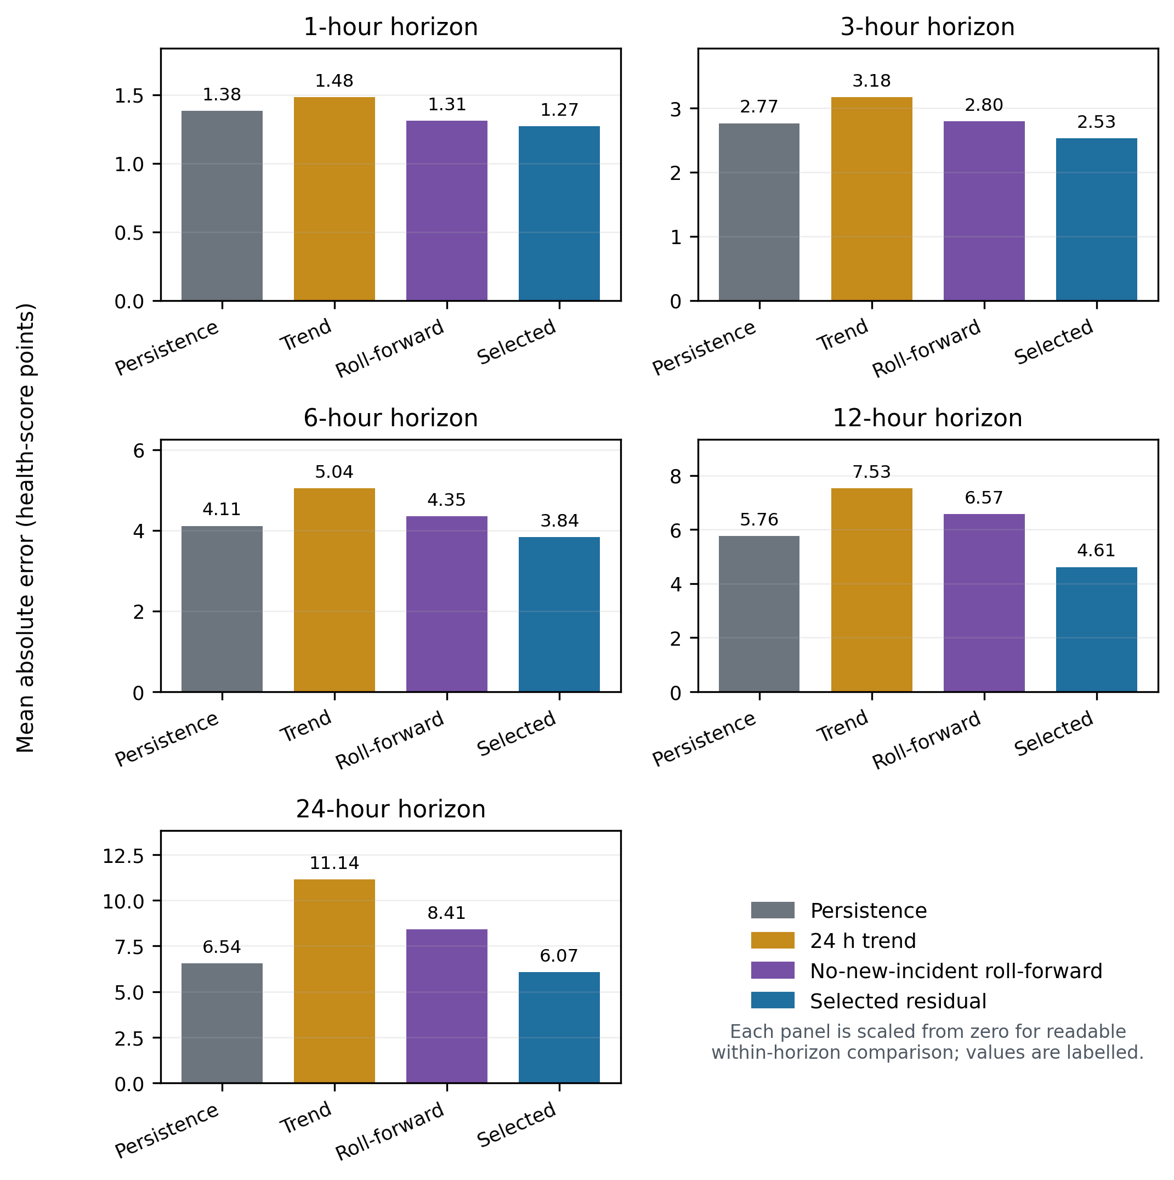
Figure 5.6. Primary forecast MAE against persistence and no-new-incident roll-forward at each horizon; the panels show where the learned residual adds value beyond smooth-signal continuation.
CatBoost is selected at all five primary horizons. The 1-hour model uses 300 iterations, core features, no recency weighting and alpha 0.75. The 3-hour and 6-hour models use core features, 300 iterations, alpha 1 and recency half-lives of 90 and 30 days respectively. The 12-hour model uses all 181 numeric features, 300 iterations and no recency weighting. The 24-hour model uses core features, 100 iterations and no recency weighting. Table 5.8 records these choices.
Table 5.8. Validation-selected transmitting-origin health-forecast configurations; iteration count, feature set, recency half-life and shrinkage are fixed for the corresponding test evaluation.
H | Model | Features | Recency half-life | Iterations | α
1 h | CatBoost | Core | None | 300 | 0.75
3 h | CatBoost | Core | 90 d | 300 | 1.00
6 h | CatBoost | Core | 30 d | 300 | 1.00
12 h | CatBoost | Full engineered | None | 300 | 1.00
24 h | CatBoost | Core | None | 100 | 1.00
The forecast was improved during development by changing the target to a correction around the roll-forward baseline, using an absolute-error objective and separating transmitting origins from current full outages. These changes avoid interpreting a compromise between outage continuation and recovery as a reliable recovery prediction. The final 1–24-hour policies and their saved test results are retained unchanged here.
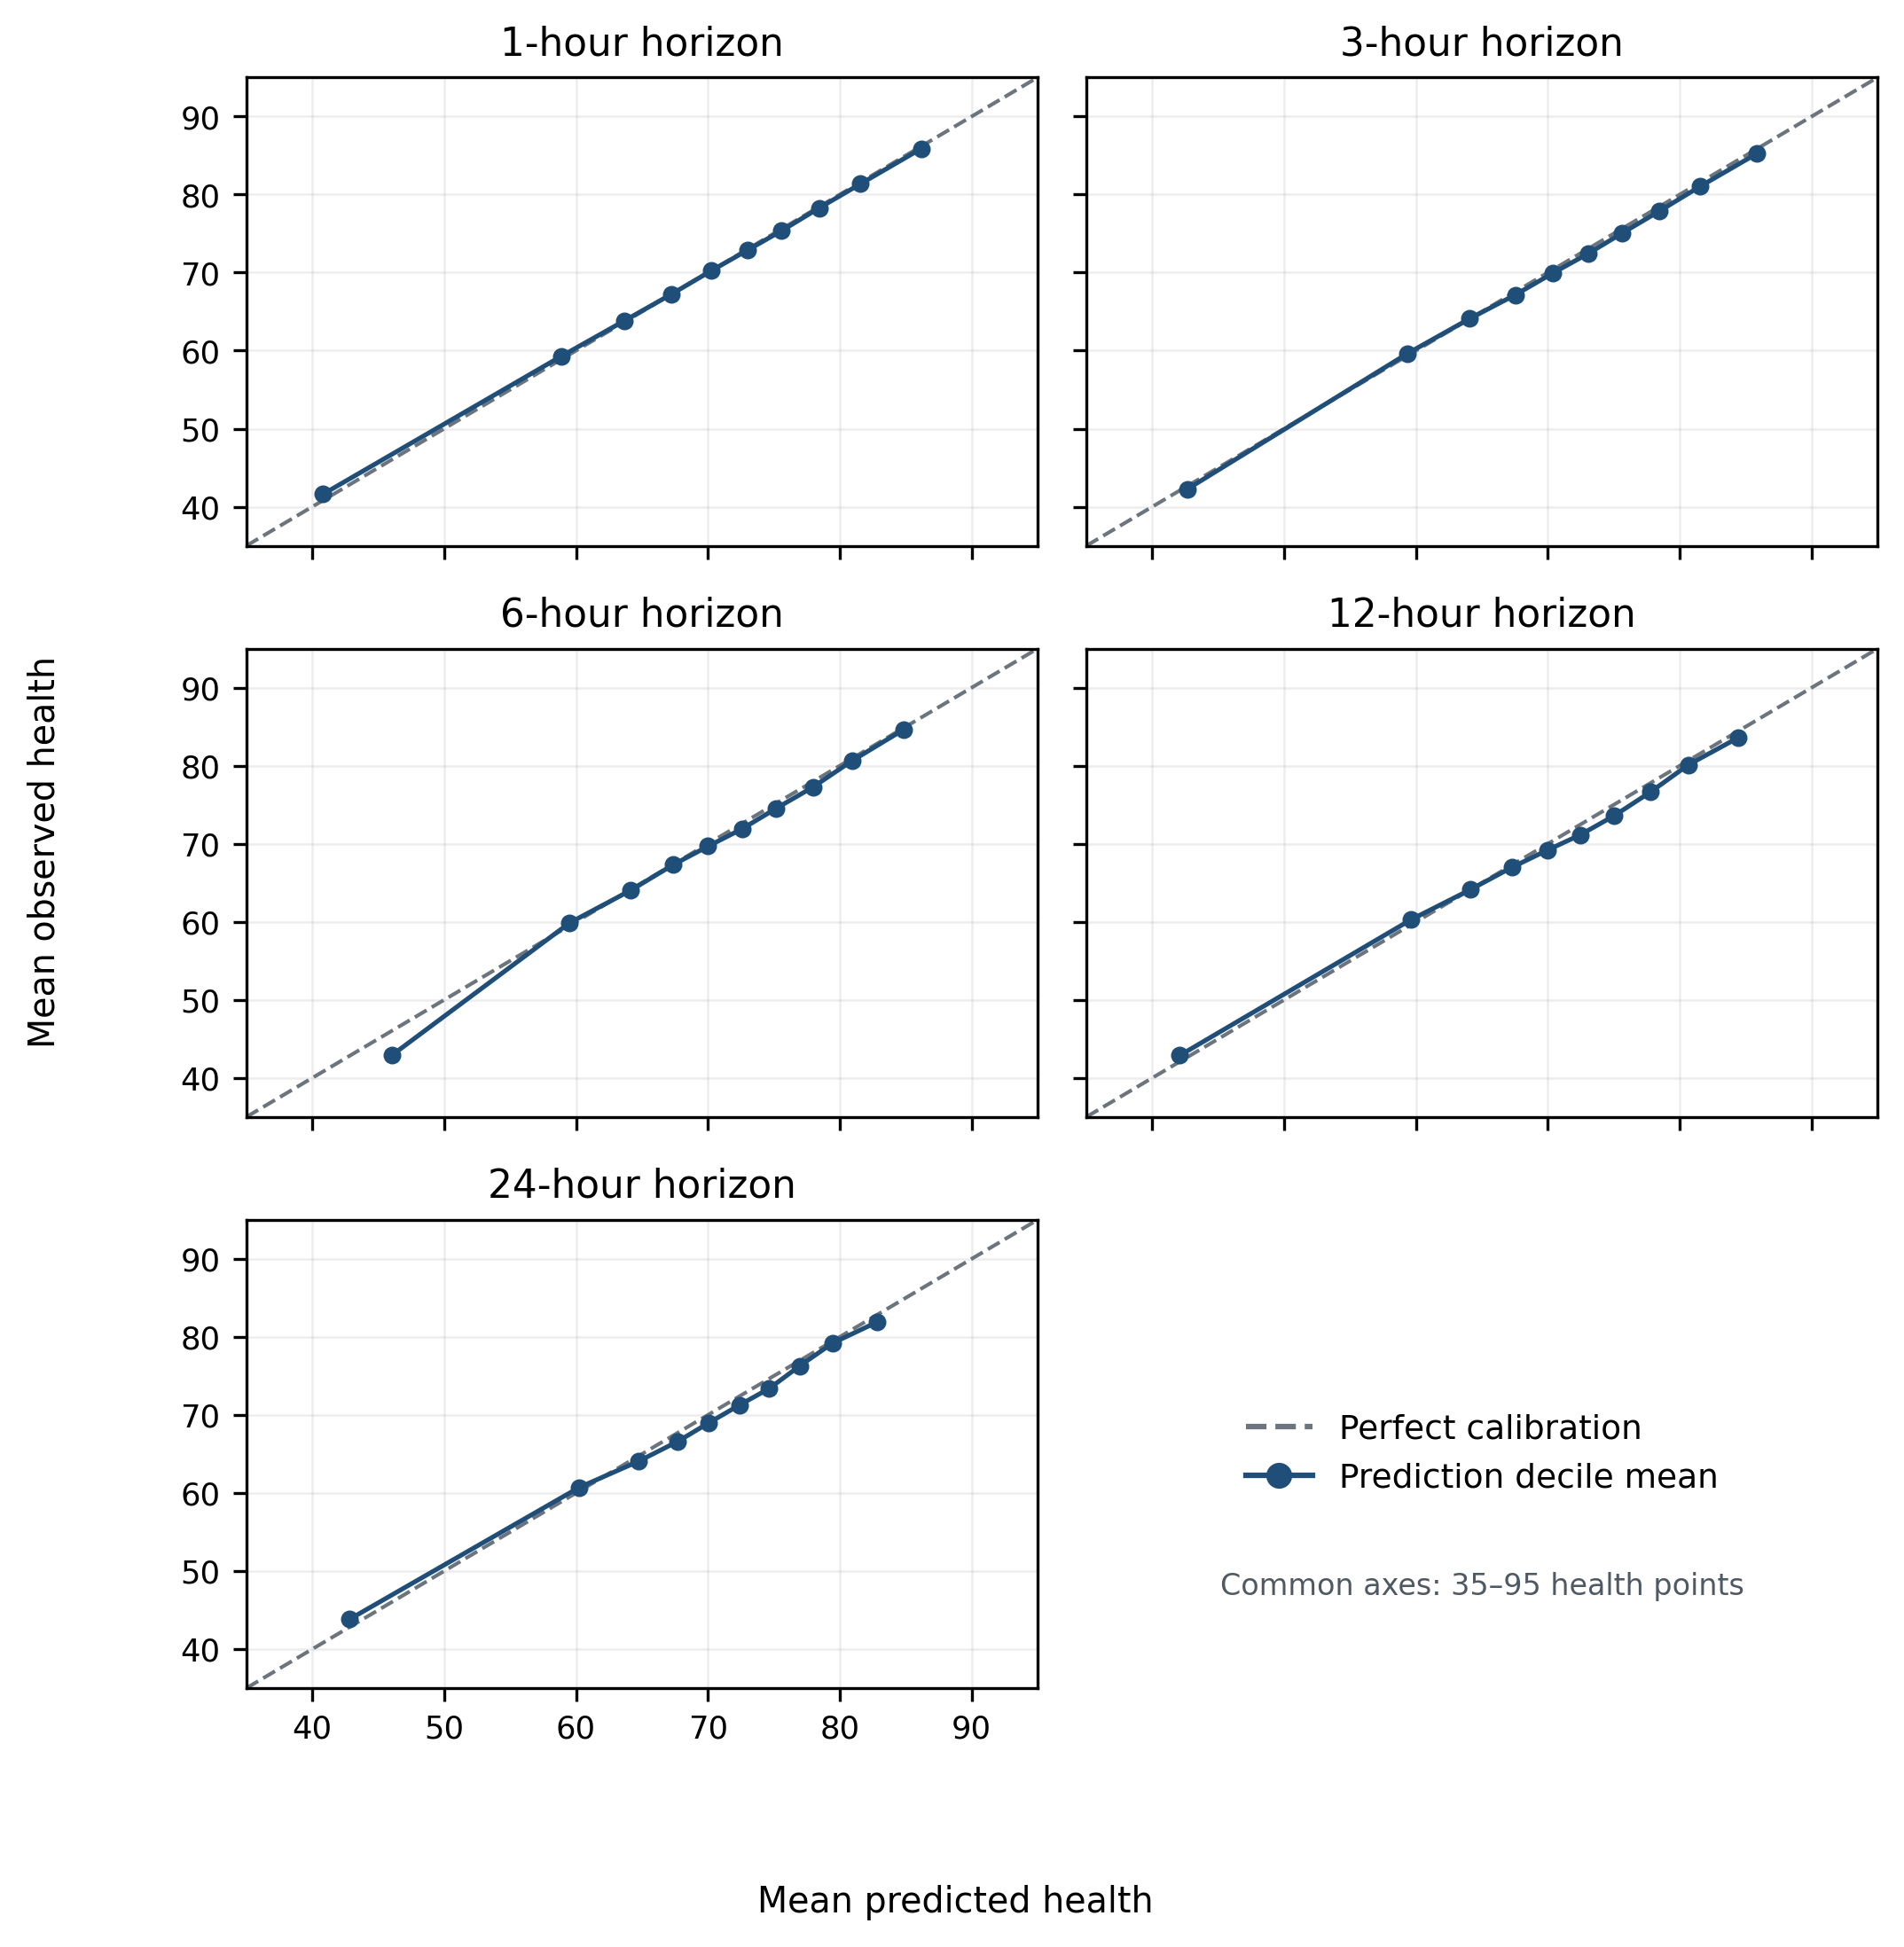
Figure 5.7. Mean observed health against mean predicted health within prediction deciles. Near-diagonal averages show calibration of groups, not the error or uncertainty of individual station-hour forecasts.
Table 5.9. Health-band classification on transmitting origins; balanced accuracy and macro F1 accompany accuracy because the four operational bands are imbalanced.
H | Accuracy | Balanced accuracy | Macro F1 | Current-band persistence | Transition-only accuracy
1 h | 93.62% | 94.09% | 93.57% | 93.04% | 21.74%
3 h | 88.11% | 86.55% | 87.18% | 86.39% | 28.97%
6 h | 83.42% | 79.13% | 81.14% | 79.83% | 34.18%
12 h | 78.42% | 72.88% | 75.19% | 72.50% | 36.34%
24 h | 71.48% | 59.05% | 63.40% | 69.71% | 28.28%
Accuracy falls as the horizon grows, but that pattern alone does not prove the model is useful or explain the cause of every error. The baseline comparison is important. At 24 hours, band accuracy improves over persistence from 69.71% to 71.48%, while balanced accuracy is lower: 59.05% against 60.32%. Transition-only accuracy is also limited. These results support short-horizon monitoring and cautious longer-horizon use, not reliable prediction of every new fault or maintenance event.
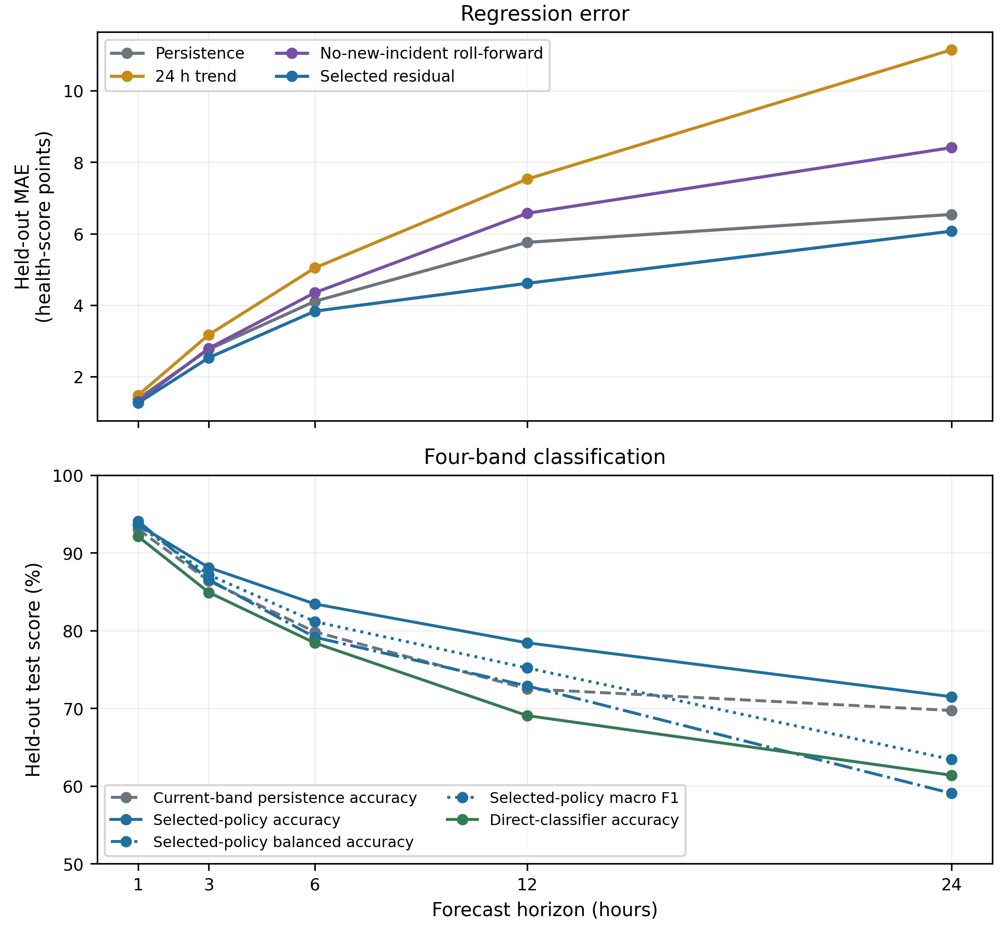
Figure 5.8. Regression and band-classification performance across 1-24 hours; the joint view makes horizon degradation and the weakness of long-horizon band transitions explicit.
Table 5.10. Supplementary full-outage-origin experiments. These are distinct from the dashboard's deterministic continued-outage projection.
H | Test n | Selected MAE | Persistence MAE | Roll-forward MAE
1 h | 6,002 | 1.208 | 1.931 | 1.208
3 h | 5,980 | 3.773 | 4.555 | 3.773
6 h | 5,982 | 7.415 | 7.013 | 7.498
12 h | 5,982 | 10.504 | 9.628 | 14.056
24 h | 6,021 | 19.188 | 11.073 | 21.610
At 6, 12 and 24 hours, the supplementary outage-origin policy loses to persistence on MAE. Recovery timing is not directly observed through maintenance or communications telemetry. The current dashboard therefore labels its silent-station values as continued-outage projections, while keeping the actual current-health score visible.
Table 5.11. Direct classification of a health deterioration of at least five points; support and imbalance explain why these diagnostics do not replace the continuous-score and band forecasts.
H | Test n | Positive support | Accuracy | Bal. acc. | Precision | Recall | F1 | PR-AUC
1 h | 28,968 | 404 | 97.45% | 58.56% | 15.46% | 18.56% | 16.87% | 12.28%
3 h | 28,990 | 2,524 | 85.35% | 62.01% | 24.85% | 33.76% | 28.63% | 23.57%
6 h | 28,962 | 5,055 | 72.93% | 66.60% | 33.69% | 56.87% | 42.31% | 46.23%
12 h | 28,936 | 7,049 | 70.23% | 66.08% | 41.96% | 57.99% | 48.69% | 54.46%
24 h | 28,871 | 7,317 | 42.44% | 58.16% | 29.31% | 90.04% | 44.22% | 40.97%
Table 5.11 is a supporting diagnostic rather than a headline subsystem. The 1- and 3-hour targets are especially sparse, and every horizon is imbalanced enough that accuracy obscures weak positive-class precision and F1. The experiment does not reach the standard of the continuous-score forecast or the short-horizon band forecasts.

5.8 Longer-Horizon Health Experiments
A separate extension tested 48, 72, 96, 120, 144 and 168 hours. It compared the existing feature families with added long-history summaries and target-calendar features. Each horizon used chronological validation selection and an appropriate boundary purge. The deployed 1–24-hour policies were not replaced. Table 5.12 gives both saved accuracy series, including the small improvement at 72 hours and the absence of improvement at the other horizons. Accuracy is not strictly monotonic across these long horizons, and 59.20% at seven days is an observed result, not a proven forecasting ceiling.
Table 5.12. Supplementary 2–7-day health-band accuracy on the development test. The deployed 1–24-hour models are unchanged.
Forecast horizon | Current features | Extended selection
2 days (48 h) | 62.16% | 62.16%
3 days (72 h) | 59.69% | 59.98%
4 days (96 h) | 59.28% | 59.28%
5 days (120 h) | 59.43% | 59.43%
6 days (144 h) | 57.28% | 57.28%
7 days (168 h) | 59.20% | 59.20%
The 72-hour extended model improves accuracy by only 0.29 percentage points. The series dips at six days and rises at seven days; changes in horizon-specific support and selection also affect the comparison. No measured model establishes the best possible accuracy from these observations.

5.9 Current Model Portfolio
EF-HGB is the operational binary detector. Five separate CatBoost residual policies forecast health at transmitting origins. Current health and availability are calculated by fixed rules. The reason-code models and RGFN remain documented development experiments. Figure 5.9 separates these roles so that a strong result on one task is not attributed to another.
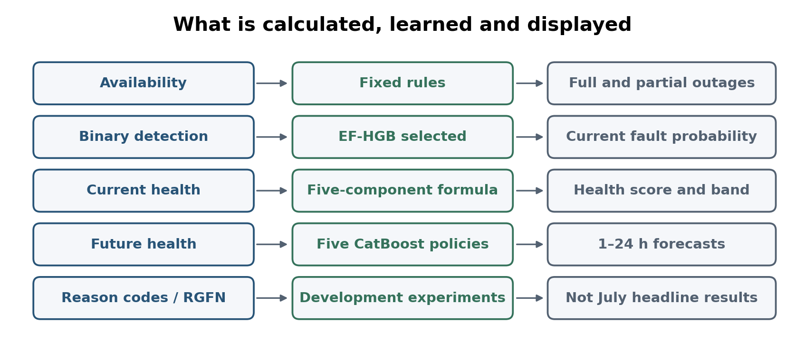
Figure 5.9. Final subsystem roles: calculated availability and health, selected EF-HGB detection, selected CatBoost forecasting and separate development experiments.
Chapter 6

Later-Month Testing and Validation
This chapter reports July results for the final selected EF-HGB detector and the frozen health forecaster. It also explains what these tests can and cannot establish without access to a station for controlled hardware testing.

6.1 Evaluation Boundary
Development detection uses random and episode-grouped partitions, while health forecasting uses chronological timestamp partitions. July is a later-month evaluation with no July rows used to fit the selected model parameters. However, July had already been inspected in earlier project iterations and its label package was corrected before the final scoring. The final run records development-validation-only selection, but July is not presented as a never-inspected single-shot holdout for the entire research process.

6.2 Frozen July Later-Month Evaluation
July uses the 25 stations in the staged later export; retired IJANZO4 contributes no new July observations. Its binary evaluation contains 13,565 eligible station-hours: 1,701 labelled fault and 11,864 not fault. The feature rebuild uses frozen pre-July rule statistics and external evidence, and final keys and labels match the frozen July evaluation ledger. The development feature matrix was historically stitched from different fitted bases; a pre-July sensitivity check found small prediction changes under the uniform frozen rebuild. This check supports using the frozen basis for July but does not make historical feature semantics identical or establish real-time reference availability.
The final EF-HGB model uses a one-hour, 67-column input and threshold 0.30. Its development confusion counts are 1,286 true positives, 120 false positives, 103 false negatives and 18,024 true negatives. July has 1,361 true positives, 472 false positives, 340 false negatives and 11,392 true negatives. Table 6.1 reports class proportions and metrics; Figures 6.1 and 6.2 show confusion matrices and ranking curves. July comparisons with unselected RGFN or reason-code models are not presented.
Table 6.1. Final selected EF-HGB: development test and July later-month test. Operating-point metrics are percentages; AUROC and average precision are on a 0–1 scale.
Statistic | Development test | July later-month test
Eligible station-hours | 19,533 | 13,565
Not-fault class | 18,144 (92.89%) | 11,864 (87.46%)
Fault class | 1,389 (7.11%) | 1,701 (12.54%)
True negatives | 18,024 | 11,392
False positives | 120 | 472
False negatives | 103 | 340
True positives | 1,286 | 1,361
Precision | 91.47% | 74.25%
Recall | 92.58% | 80.01%
F1 | 92.02% | 77.02%
Accuracy | 98.86% | 94.01%
AUROC | 0.998 | 0.982
AUPRC (average precision) | 0.981 | 0.886
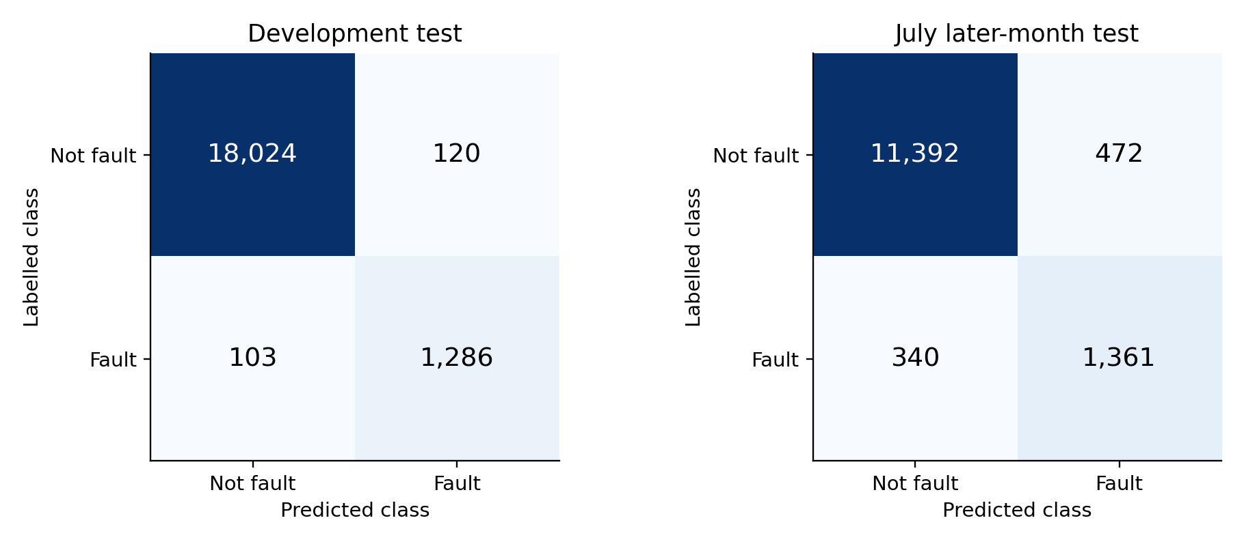
Figure 6.1. Confusion matrices for the final EF-HGB at threshold 0.30. Class counts and proportions are given in Table 6.1.
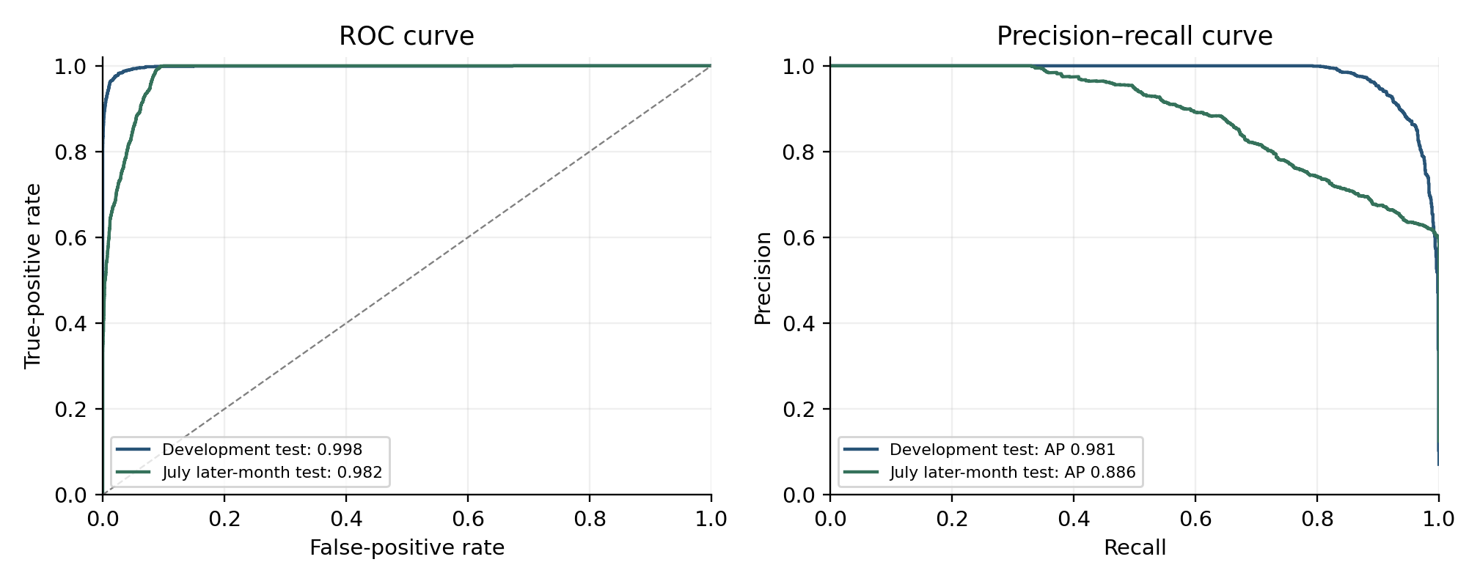
Figure 6.2. Final EF-HGB ROC and precision–recall curves. Average precision is the AUPRC summary used here.
July precision and F1 remain lower than development values. This indicates that the later-month conditions and labelled population are harder for the fixed detector. The previous detector's thermal false-positive audit counted 384 temperature/humidity-flagged hours among 553 false positives; those counts do not describe the final EF-HGB's 472 false positives and are not reused as its explanation. Temperature-related distribution shift is a hypothesis requiring a fresh error audit, not a confirmed extreme-heat cause. Compared with the previously reported detector, EF-HGB improves July precision, F1 and accuracy but has slightly lower recall.
Health forecasting was evaluated only at transmitting July origins whose forecast targets also remained inside July. Table 6.2 shows the frozen selected policy and its deterministic comparators. The selected policy improved MAE over persistence at 1, 3, 12, and 24 hours and over roll-forward at all five horizons. At 6 hours, persistence was slightly better (4.445 versus 4.496 MAE), an exception retained explicitly. Forecast error increases with horizon, while health-band accuracy declines from 93.96% at 1 hour to 72.26% at 24 hours.
Table 6.2. Frozen July transmitting-origin health forecasts and deterministic baselines.
H | n | MAE | RMSE | R² | Band acc. | Persist. MAE | Roll-fwd MAE
1 h | 13,799 | 1.378 | 2.391 | 0.973 | 93.96% | 1.483 | 1.447
3 h | 13,781 | 2.914 | 4.314 | 0.912 | 87.59% | 2.999 | 3.136
6 h | 13,719 | 4.496 | 6.767 | 0.792 | 81.53% | 4.445 | 4.879
12 h | 13,603 | 5.112 | 7.399 | 0.763 | 77.16% | 6.017 | 7.005
24 h | 13,378 | 6.619 | 9.598 | 0.631 | 72.26% | 7.230 | 9.160
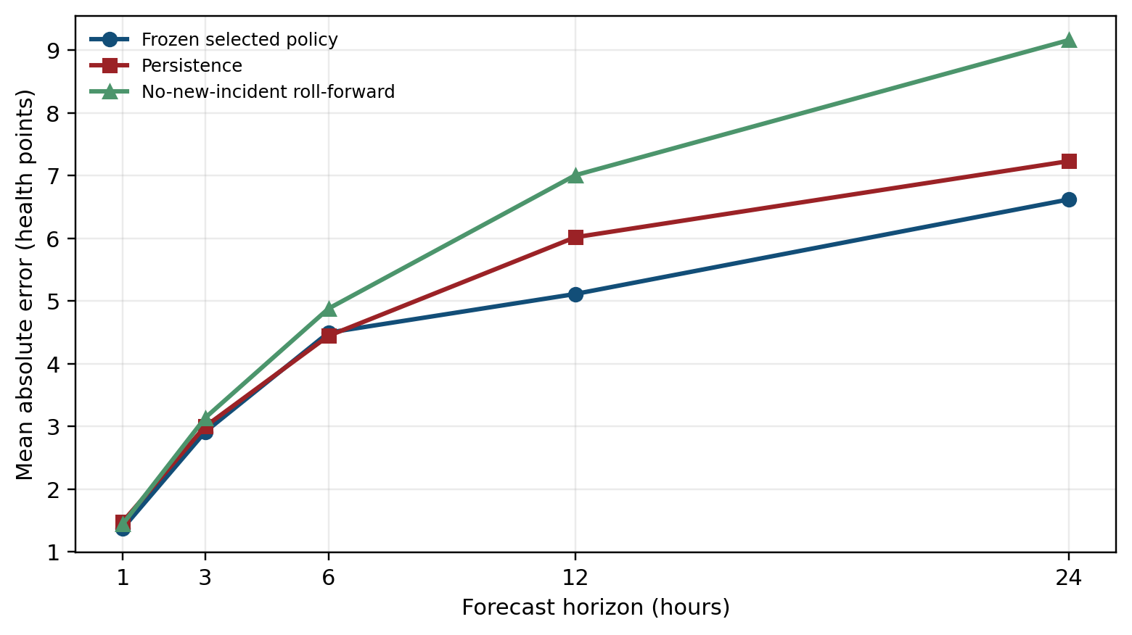
Figure 6.3. Frozen July health-forecast MAE against persistence and roll-forward. The 6-hour persistence advantage is retained.
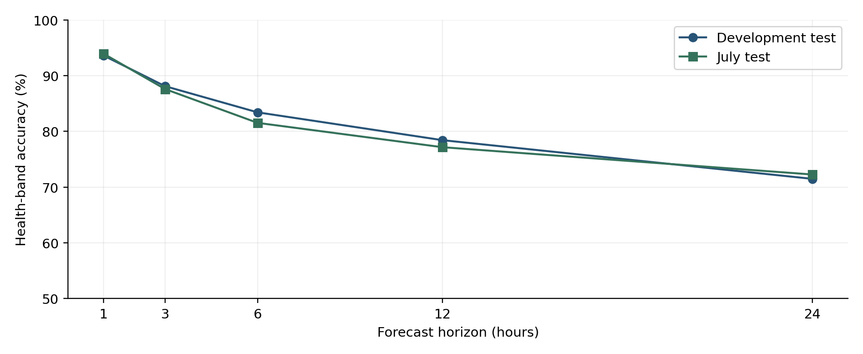
Figure 6.4. Health-band accuracy across the five horizons in development and July. These values describe bands, not exact-score accuracy.
July tests the transfer of the selected binary detector and the existing health policies to a later month. It does not directly establish true hardware causes, maintenance benefit, live latency or new-station generalisation. The health policies improve MAE over roll-forward at every horizon and over persistence at four of five horizons. Longer forecast horizons remain less accurate, without proving that further useful predictors are impossible.

6.3 Controlled Hardware Fault Tests
Controlled physical fault-injection tests were planned but could not be performed because a station was unavailable. Such tests could provide known fault start times, affected components, detection delays and recovery behaviour. The July evaluation was added to test later-month transfer. It is useful evidence, but it is not a replacement for known-cause hardware validation.

6.4 Validation Status Summary
The final saved July evaluation covers EF-HGB binary detection and transmitting-origin health forecasting. The scoring runs use frozen models and operating points without refitting on July. The dashboard reads those outputs. Mechanism experiments remain retrospective development evidence, and hardware causes remain unverified. A fresh, prospectively specified future period would provide stronger confirmation after the full development process.
Chapter 7

Operational Scorecard and Dashboard
This chapter explains how the analysis is made usable by an operator. A station-level scorecard assembles the outputs, and a compact dashboard displays recent status, health, forecasts and supporting evidence. Direct live access was unavailable, so the implemented demonstration replays saved July outputs with a visible clock.
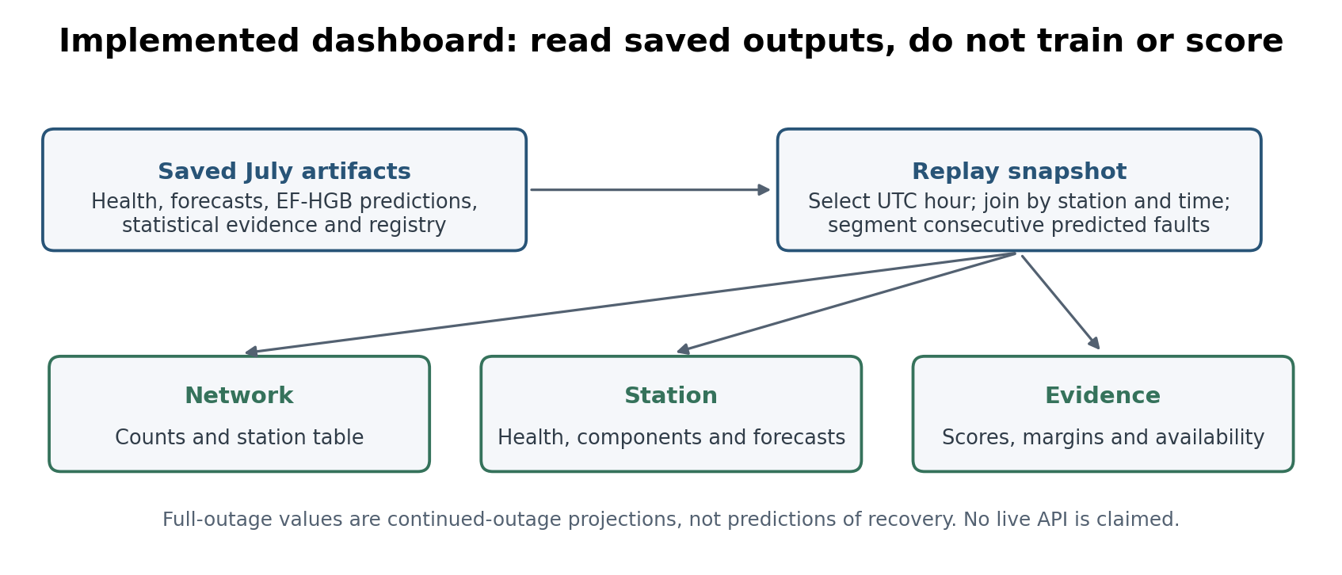
Figure 7.1. Implemented read-only dashboard flow. Model inference happens before replay; the interface joins saved outputs and calculates scenario projections.

7.1 Operational Scorecard
The operational scorecard is a table, not a model. At a chosen hour it joins station identity, transmission status, outage duration, missing sensor groups, health components, forecasts, fault evidence and recent reliability history. The frozen June snapshot contains 80 fields for each of the 26 registered stations. The dashboard uses a smaller July view suited to its display rather than requiring all 80 columns on screen.
The scorecard and dashboard do not use ground-truth episode IDs to define operational fault events. Current offset evidence is also kept separate from completed retrospective offset runs. The original June scorecard records learned forecasts as not applicable during full outages. The later dashboard adds clearly labelled continued-outage projections, while preserving the distinction from learned forecasts at transmitting origins.

7.2 Implementation and Reproducibility
Each entry script starts one part of the workflow; the implementation lives in the corresponding source modules. Table 7.1 connects those scripts to their inputs and outputs. This report uses the frozen artifacts rather than regenerating labels or fitting new models during writing. The published dataset is an input to the submitted analysis; provider acquisition and merge software are not required as part of this repository.

Table 7.1. Main entry scripts and their roles. Paths are relative to the repository root; Appendix A identifies the frozen result artifacts.
Entry script | Role / main output
scripts/build_reliability_foundations.py | Reads the frozen hourly dataset; builds registry/audit, lifecycle and availability products.
scripts/rebuild_detection_features.py | Builds statistical, physical, external and spatial feature artifacts; isolated output support.
scripts/build_labels.py | Creates evidence-supported episode labels and corroboration records.
scripts/build_hourly_dataset.py | Builds hour labels, feature tensors and metadata.
scripts/train_hourly_detection.py | Selects and evaluates detector/reason-code workflows; evidence-fusion mode builds EF-HGB.
scripts/build_station_health.py | Builds causal health; forecast and scorecard modes share the same implementation.
scripts/run_dashboard.py | Reads saved July artifacts and displays the operational replay.

Automated tests cover data contracts, row states, full and partial outages, missing clock hours, evidence rules, labels, detector inputs, health arithmetic, forecast boundaries and dashboard joins. Delete-the-future checks compare calculations before and after later observations are removed. Passing those checks supports the tested time-order properties, but does not prove that an external reference was available with zero delay in real operation.

7.3 Operational Scorecard Results
The frozen June scorecard contains 26 stations and 80 fields at 30 June 2026 21:00 UTC. Its recorded checks report no unexplained nulls or join inconsistencies. The hour is a parameter, not a fixed code date. Table 7.2 is a historical example of the scorecard data layer; it is not a new July prediction run or a dashboard screenshot.
Table 7.2. Frozen June 26-station operational snapshot, sorted by health. These are selected fields from the historical 80-column scorecard.
Station | Transmission / current run | Health / band | Causal mechanism evidence | Forecast health: 1 / 6 / 24 h
IJANZO4 | full outage; 2807 h | 0.0 / Critical | None | N/A / N/A / N/A
ITRIPO32 | full outage; 280 h | 0.0 / Critical | None | N/A / N/A / N/A
IALWAH18 | partial outage; 120 h; light_uv absent | 12.0 / Critical | None | 11.8 / 22.8 / 17.9
IMURQU7 | full outage; 2 h | 56.8 / Degraded | None | N/A / N/A / N/A
IMURQU5 | transmitting | 58.3 / Degraded | statistical_anomaly | 55.9 / 51.0 / 53.4
IZAWIY5 | transmitting | 59.7 / Degraded | None | 60.2 / 60.7 / 63.0
ITRIPO33 | partial outage; 5 h; five outdoor groups absent | 60.7 / Watch | None | 59.9 / 56.2 / 58.7
INUQAT8 | transmitting | 64.3 / Watch | None | 64.4 / 64.3 / 67.5
IJABAL16 | transmitting | 65.1 / Watch | None | 65.4 / 64.4 / 64.4
IZAWIY7 | transmitting | 65.4 / Watch | None | 65.9 / 66.5 / 70.0
I90583612 | full outage; 2 h | 65.5 / Watch | None | N/A / N/A / N/A
IBARAS3 | transmitting | 65.9 / Watch | None | 66.3 / 66.0 / 67.9
ITAHLI1 | transmitting | 69.6 / Watch | statistical_anomaly | 67.1 / 65.6 / 67.9
INUQAT10 | transmitting | 72.9 / Watch | statistical_anomaly | 69.8 / 63.2 / 63.8
IJABAL15 | transmitting | 73.7 / Watch | None | 73.9 / 73.6 / 73.0
IDERNA7 | transmitting | 76.1 / Watch | None | 76.2 / 74.2 / 73.3
IJANZO2 | transmitting | 77.4 / Watch | None | 77.3 / 75.8 / 75.7
IMISRA12 | transmitting | 78.9 / Watch | None | 79.1 / 78.6 / 78.8
INUQAT9 | transmitting | 79.0 / Watch | None | 79.1 / 77.5 / 74.1
INALUT3 | transmitting | 79.4 / Watch | None | 79.5 / 77.8 / 74.0
IJANZO3 | transmitting | 79.6 / Watch | None | 79.3 / 77.9 / 77.7
IBIRAL3 | transmitting | 82.2 / Healthy | None | 82.4 / 81.9 / 79.1
IJABAL13 | transmitting | 83.0 / Healthy | None | 83.1 / 81.5 / 80.5
IMURQU6 | transmitting | 83.6 / Healthy | None | 83.3 / 81.0 / 77.4
IMISRA13 | transmitting | 86.0 / Healthy | None | 85.9 / 83.7 / 81.3
IJABAL14 | transmitting | 91.1 / Healthy | None | 91.1 / 89.0 / 87.2
The historical June snapshot intentionally shows N/A for learned forecasts at active full outages. Partial-outage stations are still transmitting and remain in forecast scope. During July replay, the dashboard can additionally display the deterministic continued-outage projection for a silent station. That display change does not alter the old snapshot or its learned-forecast evaluation.
Table 7.3. Status distribution in the frozen June scorecard. Forecast eligibility refers to learned forecasts, not the later dashboard's scenario projections.
Snapshot measure | Count
Stations | 26
Transmitting | 20
Partial outage | 2
Full outage | 4
Healthy / Watch / Degraded / Critical | 5 / 15 / 3 / 3
Forecast eligible / not applicable | 22 / 4
Join inconsistencies | 0
Unexplained nulls | 0
The snapshot identifies four current full outages—IJANZO4 at 2,807 hours, ITRIPO32 at 280 hours, IMURQU7 at 2 hours, and I90583612 at 2 hours—and two partial outages: IALWAH18 lacks light/UV for 120 hours and ITRIPO33 lacks anemometer, light/UV, rain-gauge, thermo-hygrometer, and wind-vane groups for 5 hours. Current causal fault evidence appears for IMURQU5, ITAHLI1, and INUQAT10 as statistical-anomaly evidence; these are provisional operational signals, not ground-truth-segmented trained reason codes. Table 7.3 summarises the fleet-wide status and forecast eligibility counts.
Table 7.4. Causal persistent pressure-offset evidence in the latest scorecard; these estimates are available at the reference hour and are not retrospectively confirmed sustained-offset corroboration intervals.
Station | Channel | Estimated offset
ITRIPO33 | Pressure | +1.330 hPa
IMISRA13 | Pressure | −7.565 hPa
IJABAL14 | Pressure | −8.390 hPa
These pressure values are estimates available at the snapshot hour. They should not be called technician-confirmed calibration offsets. Completed sustained-offset runs and retrospective mechanism assignments remain separate evidence products. This distinction is important when an operator decides whether to inspect a station.

7.4 Dashboard
The Streamlit dashboard displays a visible simulated July UTC clock, with play/pause and station selection. The Network tab has four mutually exclusive categories and a sortable 26-station table. Full outages take precedence, followed by fault alerts, then healthy online stations; the remaining cases need attention. Partial outages remain explicitly marked in the station row. The Station tab shows current health, recent health history, five weighted components, six sensor-group states and forecasts at 1, 3, 6, 12 and 24 hours. It has no map or model-performance panels.
The Evidence tab builds events from consecutive EF-HGB-positive hours, breaking at a non-fault hour or time gap. The function segment_predicted_fault_events() in src/dashboard/replay.py applies the reference-hour cutoff before grouping. It reads only station ID, hour, saved probability and prediction from the detection ledger, not episode_labels.csv or truth fields. Evidence tables show detector, channel, score, threshold and margin, with short statements about external and neighbour availability. The interface loads no learned model, retrains nothing and does not write to data/. Continued-outage projections are calculated by fixed arithmetic from the available history.

7.5 API and Roaya Integration
A live source connector remains future work. The current demonstration does not send alerts, change station settings, replace consumer measurements or connect to a maintenance system. An operator inspects the evidence and decides what action is appropriate. A later live integration should test arrival delay, missing and duplicate records, schema changes and reference-data availability at the actual decision time.

7.6 Reproducibility Controls
Saved manifests identify model files, feature order, mask mode, thresholds, configuration and evaluation inputs. Checksums can verify that these artifacts have not changed. Software tests protect the main transformations and joins. A future continuously running service would also need runtime monitoring, source-failure logs and controlled model-version rollout; those service features are not claimed as implemented here.
Chapter 8

Integrated Discussion

8.1 Main Findings Across the Four Project Parts
The main contribution is an end-to-end monitoring workflow built without direct station hardware telemetry or maintenance logs. It makes missing transmission and partial sensor loss visible, combines several forms of fault evidence, learns current-fault detection, defines an explainable health score and forecasts that score. The dashboard brings these outputs together so that an operator can prioritise inspection rather than watch every reading manually.

8.2 What the Custom-Model and Window Experiments Show
The GRU-based development work and RGFN tested whether learned sequence and evidence fusion would help. The later HGB window study favoured a single engineered hour over longer stacked inputs. The one-hour RGFN therefore used an MLP sensor encoder while keeping its learned evidence gate. EF-HGB then tested a simpler classical fusion of context and rule views. It achieved the selected validation operating point, although its gain over one-hour HGB is small on the random development test. These findings favour the simpler tabular design for this dataset; they do not prove that history is useless or that neural models cannot work.

8.3 Limitations
The cause of network-midnight patterns cannot be observed directly from outside the upload platform. The evidence supports classifying them as coordinated network windows, but it does not identify a specific upstream mechanism.
The labels are evidence-supported, not independently confirmed hardware truth. Some of the same rules help create labels and appear in model inputs, so high detection and mechanism scores partly measure recovery of those rules. Borderline cases are excluded rather than solved. Calibration-offset labels are particularly sparse, with four promoted episodes despite 24 qualifying evidence runs. These limits matter when interpreting apparent precision or perfect per-mechanism results.
Development random and spaced partitions do not establish prospective independence. Historical feature construction, correlated station-hours and repeated development decisions remain limitations even after the explicit input window is reduced to one hour. July supplies later-month evidence but was inspected during earlier iterations, so it is not described as untouched throughout the project. Health forecasting has its own chronological purges and causal arithmetic checks, but archived weather-reference availability does not automatically establish live-time availability. A future prospective period and independent fault adjudication would strengthen both claims.
Current health is a designed index rather than a measured failure probability. Its component weights and outage-decay constants have not been validated against maintenance outcomes. Some components are correlated, and sudden recovery can still change the score sharply. Health-band transitions and long-horizon forecasts remain difficult; the seven-day accuracy is not proof of an information-theoretic limit. Spatial evidence is unavailable for two stations. The outdoor-array link explanation remains a hardware hypothesis, not a demonstrated fault cause.

8.4 Operational Readiness
The delivered system is a reproducible offline pipeline with a working read-only dashboard, a station scorecard, frozen EF-HGB detection outputs and health forecasts. It supports monitoring and inspection planning from observations alone. Direct live operation, autonomous maintenance decisions and independently confirmed hardware diagnosis require additional access and validation.
Chapter 9

Conclusion and Future Work

9.1 Conclusion
This project develops a reliability-monitoring system for 26 personal weather stations in Libya using observations and external references without direct hardware telemetry or maintenance records. The frozen development data contain 166,017 station-hours. The analysis preserves 2,398 full-outage events and 47 coordinated windows, identifies 803 partial-outage events and records 4,799 candidate episodes with evidence-supported labels. The final selected EF-HGB achieves 94.01% accuracy, 74.25% precision, 80.01% recall and 77.02% F1 on July, with AUROC 0.982 and average precision 0.886. These are later-month detection results, not proof of physical fault causes.
The five-component health score explains current operational condition, while separate CatBoost policies forecast health at 1, 3, 6, 12 and 24 hours for transmitting stations. July band accuracy is 93.96% at one hour and 72.26% at 24 hours; July MAE ranges from 1.378 to 6.619 health points. The scorecard and dashboard expose these outputs alongside transmission and fault evidence. The objectives on dataset analysis, outage classification, labelling, model comparison, health, forecasting, later-month evaluation and dashboard demonstration are addressed, with the stated boundaries on uncertain labels and reason-code validation.
Both custom models contribute to the development account. RGFN explores learned neural evidence fusion; EF-HGB uses classical boosting across complementary feature views and becomes the selected detector. The window experiment supports the final compact input but not a general rejection of temporal modelling. Forecasting adds information beyond simple continuation at several horizons, while baseline exceptions and limited transition performance remain visible. Controlled hardware fault injection could not be completed because a station was unavailable.

9.2 Future Work
The first priorities are independent fault adjudication, controlled disconnection tests if station access becomes available, and a live-feed trial with measured reference and observation delays. More annual cycles and maintenance records would support stronger tests of seasonal transfer, score usefulness and recovery. Borderline labels should be reviewed from evidence rather than changed to improve model metrics. Larger component-level support and source-ID-free evaluation are needed before promoting mechanism or component outputs to autonomous diagnosis.
Further forecast work should compare any new feature or model with the same persistence and roll-forward baselines and select it on validation. Device uptime, voltage, signal quality, packet sequence numbers, upload retries and repair logs could add information missing from weather observations. Future incident-onset work is described below; it is not claimed as a delivered alerting capability.

9.3 Incident-Onset Forecasting as Future Work
Discrete incident-onset forecasting was investigated as a future extension to the monitoring system. The task is more specific than identifying present station condition: for each station and forecast time, it asks whether a new fault or outage incident will begin in the following 6, 12, or 24 hours, using only information available at or before that time. It therefore requires evidence of a precursor to an incident, rather than evidence that a station is already faulty, already offline, or continuing through an existing event.
The investigation considered several feature sets and model approaches. Table 9.1 records the qualitative outcomes. None was adopted as an operational incident-onset alert. The aim of the future work is to establish whether genuine warning signs can be learned with enough independent incident examples and closer-to-device telemetry.
Table 9.1. Qualitative outcomes of the incident-onset investigation; no onset F1 values are presented.
Approach | Outcome for future development
Gradient boosting with a restricted 33-feature causal set | Did not surpass the persistence baseline.
Gradient boosting with the full verified 1,014-feature causal set | Expanding the feature scope did not remove the limiting constraint.
Temporal convolutional sequence model with gated evidence fusion | Not advanced to held-out evaluation under the corrected onset formulation.
Escalation from sub-threshold detector warnings | Produced modest precursor enrichment, but insufficient evidence for an individual incident-onset alert.
Five-minute packet-presence features for outage onset | Revealed a meaningful precursor signal, but it was insufficient as a standalone basis for prediction.
Five-minute sensor-variation features for fault onset | Did not transfer reliably beyond development data.
Trailing incident-history and recurrence features | The most promising direction for fault onset, but still constrained by limited independent incident support.
Alternative operating-point selection rules | Did not materially alter the overall conclusion.

The limiting evidence is the number of distinct incidents, not simply the number of hourly rows. The record contains 923 physical fault starts; 784 have a preceding clean, scoreable hour, and 291 also last at least three continuous fault-hours. Of 2,398 outage starts, 2,315 are observable. The 671 qualifying outage incidents are observable, sustained, non-network-associated station outages, using a six-hour minimum duration. These counts describe this investigation's target definitions, not a new label catalogue.
These incident counts are materially different from the 9,260 labelled fault-hours available to the detection system. Multiple hours within one prolonged incident are correlated observations of the same event and do not provide independent examples of a precursor pattern. After chronological partitioning, the held-out data contain only 39–40 independent qualifying fault onsets, depending on horizon, and 47–53 qualifying outage onsets. This is approximately 40 and 50 independent held-out events respectively. Such support is adequate for an exploratory investigation, but insufficient for a robust comparison among complex onset-prediction models or for a dependable operational alert threshold.
The investigation used continuous hourly grids, timestamp-based chronological splits and horizon-specific boundary purges. Features were checked by deleting future observations and recomputing at the same origin. Threshold selection used validation rather than test, with persistence and base-rate comparisons. These controls prevent continuation or later-partition targets from being mistaken for useful onset forecasting, but do not turn a small incident inventory into independent hardware truth.
An important correction was also made to the target definition. An earlier formulation could score a station-hour positively while it was already inside an active fault, meaning that a positive outcome could be satisfied by continuation of an existing incident rather than the onset of a new one. That formulation measures persistence or continuation, not incident onset. The corrected formulation scores only clean, at-risk station-hours and defines the outcome as the start of a new qualifying incident within the specified horizon. This distinction is essential for an operational forecast: an alert about a fault that has already begun is not a forecast of its onset.
A stronger future solution requires both a larger incident inventory and telemetry closer to the failure mechanisms. A longer observation period and/or a larger station network would increase the number of distinct onset events available for learning and independent evaluation. More importantly, the current dataset contains weather observations but not the device-level signals that commonly precede communication, power, hardware, or ingestion failures. The minimum useful additional telemetry should include boot identifier, device uptime, reset reason, input or battery voltage, signal quality, upload retry count, packet sequence number, and server-side arrival timestamp. Firmware and configuration identifiers, reconnection information, and maintenance records would further improve attribution. Together, these fields would help distinguish power loss, communication failure, device reset, sensor failure, and ingestion failure—distinctions that cannot reliably be inferred from weather observations alone.
With more incidents, a future model could estimate new-incident risk and be evaluated on complete alert episodes, keeping onset separate from continuation. This is not an implemented subsystem.

References
[1] Z. Che, S. Purushotham, K. Cho, D. Sontag, and Y. Liu, "Recurrent Neural Networks for Multivariate Time Series with Missing Values," Scientific Reports, vol. 8, Article 6085, 2018.
[2] Q. Liu and J. Paparrizos, "The Elephant in the Room: Towards a Reliable Time-Series Anomaly Detection Benchmark," in Advances in Neural Information Processing Systems, 2024.
[3] L. W. Vos, H. Leijnse, A. Overeem, and R. Uijlenhoet, "The Potential of Urban Rainfall Monitoring with Crowdsourced Personal Weather Stations in Amsterdam," Hydrology and Earth System Sciences, vol. 23, no. 2, pp. 765-777, 2019.
[4] Sainlogic, FT0360 Pro WiFi Weather Station User Manual. Sections 4, 5, 11, and 12.
[5] Weather Underground / IBM, Personal Weather Station History API documentation, /v2/pws/history/all endpoint.
[6] Open-Meteo, Historical Weather API and ECMWF/ERA5 archive access documentation.
[7] A. K. Elawej, Mozn Post-Processing System: open-source forecast bias-correction for the Libyan station network, 2026. Available: https://github.com/Ayatelawej/mozn-postprocessing-system
[8] F. T. Liu, K. M. Ting, and Z.-H. Zhou, ‘Isolation Forest,’ in 2008 Eighth IEEE International Conference on Data Mining, 2008, pp. 413-422.
[9] L. Prokhorenkova, G. Gusev, A. Vorobev, A. Dorogush, and A. Gulin, "CatBoost: Unbiased Boosting with Categorical Features," in Advances in Neural Information Processing Systems 31, 2018.
[10] K. Ni, N. Ramanathan, M. N. H. Chehade, L. Balzano, S. Nair, S. Zahedi, E. Kohler, G. Pottie, M. Hansen, and M. Srivastava, "Sensor Network Data Fault Types," ACM Transactions on Sensor Networks, vol. 5, no. 3, 2009, doi: 10.1145/1525856.1525863.
[11] A. B. Sharma, L. Golubchik, and R. Govindan, "Sensor Faults: Detection Methods and Prevalence in Real-World Datasets," ACM Transactions on Sensor Networks, vol. 6, no. 3, 2010, doi: 10.1145/1754414.1754419.
[12] A. Napoly, T. Grassmann, F. Meier, and D. Fenner, "Development and Application of a Statistically-Based Quality Control for Crowdsourced Air Temperature Data," Frontiers in Earth Science, vol. 6, Article 118, 2018, doi: 10.3389/feart.2018.00118.
[13] D. Fenner, B. Bechtel, M. Demuzere, J. Kittner, and F. Meier, "CrowdQC+ - A Quality-Control for Crowdsourced Air-Temperature Observations Enabling World-Wide Urban Climate Applications," Frontiers in Environmental Science, vol. 9, Article 720747, 2021, doi: 10.3389/fenvs.2021.720747.
[14] L. Båserud, C. Lussana, T. N. Nipen, I. A. Seierstad, L. Oram, and T. Aspelien, "TITAN Automatic Spatial Quality Control of Meteorological In-Situ Observations," Advances in Science and Research, vol. 17, pp. 153-163, 2020, doi: 10.5194/asr-17-153-2020.
[15] S. Bell, D. Cornford, and L. Bastin, "How Good Are Citizen Weather Stations? Addressing a Biased Opinion," Weather, vol. 70, no. 3, pp. 75-84, 2015, doi: 10.1002/wea.2316.
[16] E. Beele, M. Reyniers, R. Aerts, and B. Somers, "Quality Control and Correction Method for Air Temperature Data from a Citizen Science Weather Station Network in Leuven, Belgium," Earth System Science Data, vol. 14, no. 10, pp. 4681-4717, 2022, doi: 10.5194/essd-14-4681-2022.
[17] Mozn-Roaya, “Mozn AI,” GitHub repository, 2026. [Online]. Available: https://github.com/Mozn-Roaya/mozn-ai.
[18] A. Elawej, “Mozn Weather Dataset: Libya Station-Time Weather Observations,” Zenodo, Aug. 5, 2026, doi: 10.5281/zenodo.21811533.
[19] Mozn, “Mozn Early Warning System.” [Online]. Available: https://mozn.or.ly.

Appendices

Appendix A: Artifact Inventory
These artifacts identify the frozen analysis and final results used in Chapters 4–9. Paths are relative to the repository root. Report-building helpers and personal study notes are not part of the submitted runtime pipeline.
- data/merged/station_hourly_merged.csv — canonical 166,017-row station-hour record.
- data/processed/hourly_row_states.parquet — lifecycle state for every station-hour.
- data/processed/data_audit_summary.csv — station audit and status-class rollup.
- data/processed/missingness_by_variable.csv — variable-level missingness summary.
- data/processed/availability_events.parquet — frozen 2,398-event full-outage series used for historical event statistics.
- data/processed/network_outage_windows.csv — 47 coordinated full-outage windows.
- data/labels/episode_labels.csv — canonical 4,799-episode label catalogue used by the hour-level system.
- data/labels/calibration_offset_corroboration.csv — sustained-offset evidence, corroboration verdicts and label-promotion links.
- data/hourly_detection/hourly_labels.csv — station-hour binary labels and display states.
- data/hourly_detection/one_hour_final/ — final one-hour tensor, HGB and RGFN comparison, EF-HGB selection grid, metrics and saved detector bundles.
- data/hourly_detection/reason_code_mechanism_selection.csv and reason_code_selected_mechanism_test_metrics.csv — validation-only mechanism configuration selection and its frozen held-out event-level evaluation.
- data/processed/hourly_availability_classification.parquet and partial_outage_events.parquet — operational full/partial/online states and 803 partial events.
- scripts/build_labels.py — entry point for evidence-supported episode labels; not a live ground-truth service.
- scripts/build_hourly_dataset.py — hour-level labels and past-only tensor build.
- scripts/train_hourly_detection.py — common entry point for baseline, calibration, RGFN, evidence-fusion, reason-code and frozen one-hour July workflows.
- data/report/hgb_history_window_comparison.csv and one_hour_detection_model_comparison.csv — retained input-window and final detector comparisons.
- data/processed/station_health_scores.parquet and station_health_summary.csv — causal component scores, total health, and station summaries.
- data/processed/station_operational_scorecard.csv — latest parameterised 26-station, 80-field operational snapshot.
- src/availability/health_score.py, health_forecast.py, and operational_scorecard.py — causal health, forecasting, and scorecard implementations.
- REPO_MAP.md — pipeline, module, data, and runbook map.
- tests/ — automated behavioral checks for the delivered pipeline.
data/eval/one_hour_candidate/july_ef_hgb_binary_metrics.csv and july_ef_hgb_scoring_manifest.json — final July EF-HGB metrics and frozen-input checksums.
data/eval/july_2026_health_forecast/july_health_forecast_metrics.csv — frozen July health forecasts and deterministic baselines.
- data/eval/health_forecast/ and data/eval/health_forecast_long_horizon/ — primary and supplementary forecast predictions, metrics, baselines, model-selection traces and invariants.
data/report/health_forecast_2_to_7_day_accuracy.csv — saved supplementary long-horizon accuracy comparison.
src/dashboard/replay.py and scripts/run_dashboard.py — saved-output loading, predicted-run segmentation, snapshot joins and the Streamlit interface.
Frozen final detector: data/hourly_detection/one_hour_final/models/evidence_fusion/selected_ef_hgb_random_01h.joblib; SHA-256 262182f1431b2c2c5b1cd2bc4e3cf6724cbc3579c4a30176417492138bf13305.

