Traffic Analysis
Based on the dataset, we defined the following parameters used in the project.
The num of classes is 5 = 4 + 1 ( person_on_bike + human + motorcycle +helmet + background)
POOL_SIZE 7
STEPS_PER_EPOCH 15
Training link: https://colab.research.google.com/drive/1js0Urmo8iJdUMyD-GKEuN1p3dFPp8qo3
The task is to detect and segment people riding bikes from images using Mask R-CNN, a powerful model for instance segmentation. The dataset is annotated in COCO format, which is a common format used for object detection and segmentation tasks.

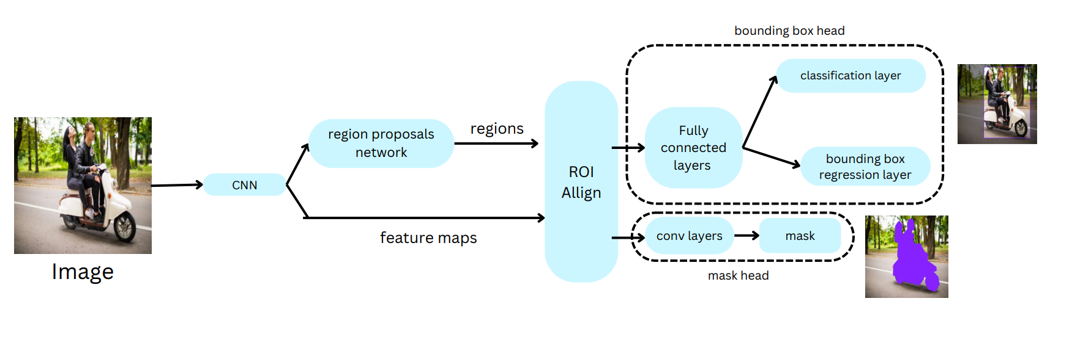
Mask R-CNN pipeline processes an image of a person riding a bike, where the annotation (class label) is person_on_bike. The goal is to understand how this image is transformed at each stage of the pipeline to detect the object and predict the segmentation mask.
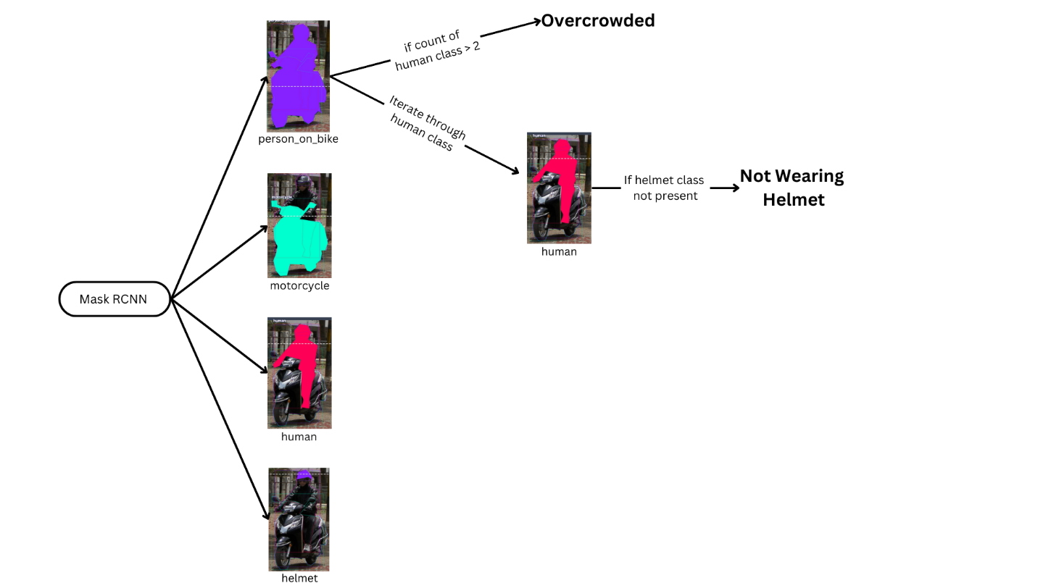After Mask RCNN generates all the masks, we check inside the person_on_bike class to see if the number of human classes is greater than 2 which implies the motorcycle is overcrowded. We iterate through all the human class to check for helmet and if it is not present helmet violation is detected.

1. Input Image
- Input: The input is an image containing a person riding a bike.
- Annotation: The class label for this object is person_on_bike.
- Size: 612 x 612 pixel size.

2. Backbone (Feature Extraction)
- Convolutional Layers:
  - The input image is passed through a deep CNN
  - Early layers capture basic features like edges and textures (e.g., contours of the bike frame, helmet, etc.).
  - Deeper layers extract more abstract features, recognizing patterns like the overall shape of the bike or person.
- Feature Maps: As the image passes through the convolutional layers, the spatial resolution decreases, but the depth (number of channels) increases. For example:
  - Early feature maps might have a resolution of
  - 512×512 with 64 channels.
  - Later feature maps might reduce to 32×32 with 2048 channels, representing higher-level object features (bike wheels, human body structure).
- Feature Pyramid Network (FPN):
  - FPN constructs a multi-scale feature pyramid, enabling the network to detect objects of varied sizes. This is especially useful for detecting both large objects like the person and bike and smaller parts like wheels or helmets.

3. Region Proposal Network (RPN)
- Anchor Generation:
  - The RPN generates a set of predefined bounding boxes (anchors) of various sizes and aspect ratios, covering the entire image.
  - For example, anchors are generated around parts of the image where it suspects the presence of an object, like the region covering the bike's frame or the person’s torso.
- Proposal Generation:
  - The RPN processes the feature maps and generates candidate proposals (regions) that might contain objects, filtering out non-relevant regions.
  - It scores each proposal with an "objectness" score (whether the region contains an object like the bike or person).
  - `These proposals are passed to the next stage.
  - 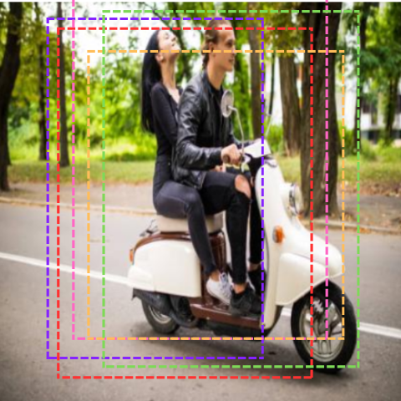
  - ROIs before refinement

4. RoI Align
- Region of Interest (RoI) Align:
  - The candidate proposals from the RPN are transformed into fixed-size feature maps (14×14).
  - For each region, RoI Align ensures precise alignment by eliminating quantization errors, making sure the feature maps for regions like the person’s body and bike are accurately cropped.
  - 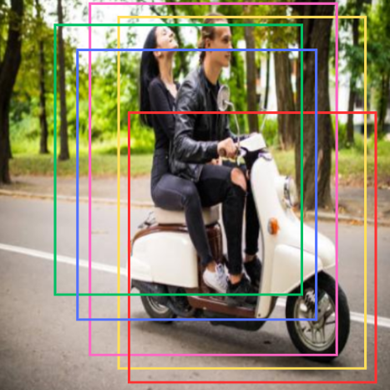
  - Boundary boxes after refinement

5. Bounding Box Head
- Classification and Bounding Box Regression:
  - The cropped feature maps from RoI Align are passed through fully connected layers to classify the object and refine the bounding box.
  - In this case, the network classifies the region as person_on_bike.
  - Simultaneously, the network refines the bounding box to precisely enclose the person and bike together.
- In the above image there are multiple bounding boxes detected for the same object, so we per class non-maximum suppression (nms) is performed so it groups highly overlapped boxes for the same class and selects the most confidence prediction only. This avoids duplicates for the same object.

6. Mask Head
- Convolutional Layers for Mask Prediction:
  - The Mask Head takes the same RoI features (for the person_on_bike) and uses a Fully Convolutional Network (FCN) to predict a binary mask.
  - This mask corresponds to the shape of the object (person riding the bike), predicting which pixels belong to the person and which belong to the bike.
- Mask Output: The output is a segmentation mask with the same resolution as the RoI, 14x14, indicating which pixels in the region belong to the person_on_bike object.

7. Post-Processing
- Non-Maximum Suppression (NMS):
  - NMS is applied to eliminate redundant overlapping boxes and keep only the best bounding box for the person_on_bike class.
- Segmentation Mask Refinement:
  - The mask predicted for the RoI is resized back to the size of the predicted bounding box. The result is a mask showing the silhouette of the person and bike within the bounding box.
  - 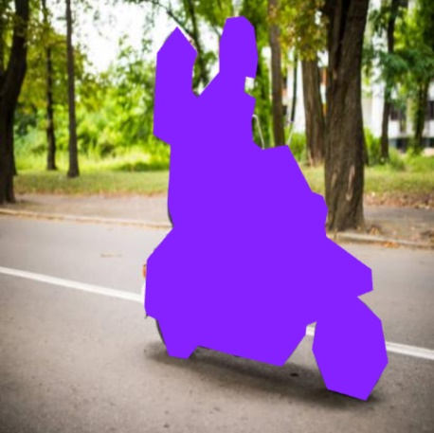
The pipeline efficiently detects both the person and the bike as a single entity, accurately predicting a bounding box and segmentation mask tailored to the "person on a bike" class.
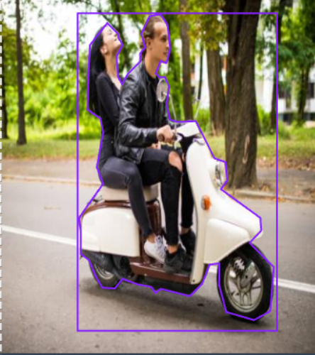

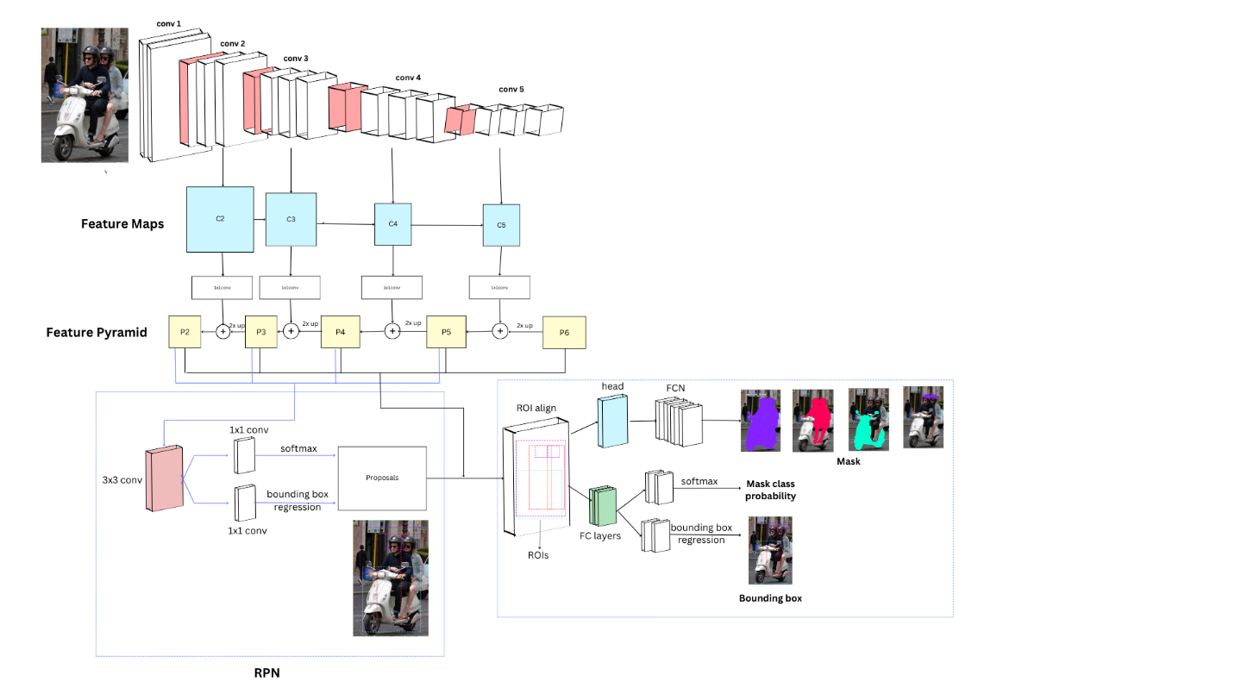

https://www.researchgate.net/figure/The-structure-of-a-feature-pyramid-network-The-bottom-up-pathway-is-a-deep-convolutional_fig2_335238163
https://www.google.com/url?sa=i&url=https%3A%2F%2Fwww.mdpi.com%2F2072-4292%2F11%2F3%2F339&psig=AOvVaw2zpSBsosZtzBfqJRyxlw7J&ust=1729767979070000&source=images&cd=vfe&opi=89978449&ved=0CBQQjRxqFwoTCKjtiYOupIkDFQAAAAAdAAAAABAJ
https://www.researchgate.net/figure/The-structure-of-a-feature-pyramid-network-The-bottom-up-pathway-is-a-deep-convolutional_fig2_335238163
https://www.researchgate.net/figure/sualizations-of-convolutional-feature-maps-The-feature-maps-are-extracted-from-different_fig2_351927650
https://www.google.com/url?sa=i&url=https%3A%2F%2Fmedium.com%2F%40t.mostafid%2Foverview-of-vgg16-xception-mobilenet-and-resnet50-neural-networks-c678e0c0ee85&psig=AOvVaw1aZB615DGQPXwJwghAdNx7&ust=1729766994110000&source=images&cd=vfe&opi=89978449&ved=0CBQQjRxqFwoTCMDjiauqpIkDFQAAAAAdAAAAABAE
https://www.researchgate.net/publication/346075907_Deep_learning-based_instance_segmentation_of_cracks_from_shield_tunnel_lining_images#full-text

https://www.google.com/url?sa=i&url=https%3A%2F%2Fwww.researchgate.net%2Ffigure%2FArchitecture-details-of-Customized-Mask-RCNN-with-Region-Proposal-Network-RPN-Feature_fig3_361349925&psig=AOvVaw3N_yr026v_3gR2etqOD57W&ust=1729761095177000&source=images&cd=vfe&opi=89978449&ved=0CBQQjRxqFwoTCLCa8a6UpIkDFQAAAAAdAAAAABAJ
https://blog.roboflow.com/mask-rcnn/
https://aws.amazon.com/blogs/machine-learning/distributed-mask-rcnn-training-with-amazon-sagemakercv/
https://medium.com/@saptarshimt/feature-pyramid-network-object-detection-tensorflow-from-scratch-430e8ad50b85

