**Architecture** :

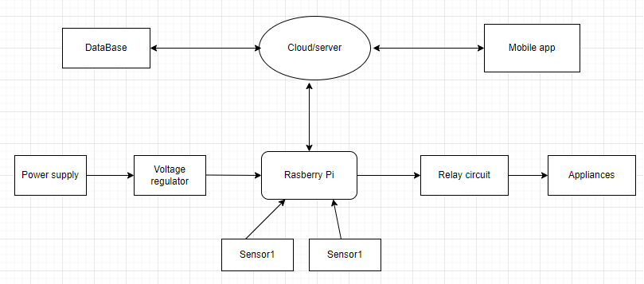

**APIs and Methods**

/api/indicators

GET : Returns an array of all measurements of the sensors sent to the server

**Data Model :**

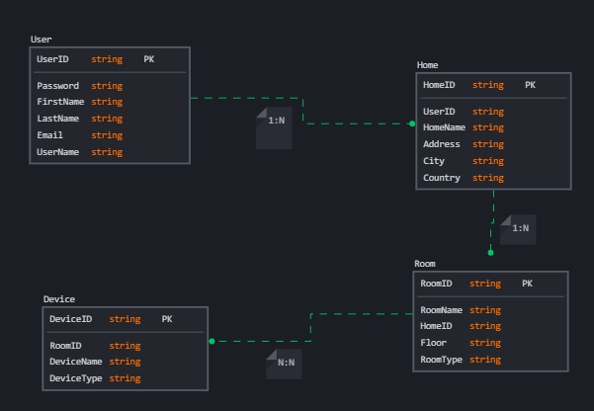

**User Stories**

* As a user, I want to real-time energy consumption statistics for my smart devices
* As a user, I need to receive a notification when a door in unlocked
* As a user, I need to add new rooms to my home and assign devices to each room

**Mockups**

