Astana IT University

Diploma Project Proposal Report

Project Title: Development of an Intelligent Chatbot for Student Information Support Based on Language Models
Developer: Baurzhanova Ayauzhan
Project Supervisor: Sadirmekova Zhanna
GitHub Repository: https://github.com/Ayauzhan-Baurzhanova/Diploma-Chatbot-with-Mascot.git

Astana 2026

Contents
1. Project Proposal: Introduction, Problem Statement, and Scope 3
2. Evidence of Relevance & User Research 5
3. Literature Review 7
4. Existing System Comparison 9
5. Technology Comparison & Justification 11
6. Requirements Specification 12
7. System Architecture, Database Schema, and Diagrams 14
8. UX / Prototype Specification 20
9. Verification and Evaluation Plan 22
10. Project Management, Repository Organization, and Risk Analysis 23
11. Supervisor Feedback & Action Log 25
References 27
APPENDIX 29

1. Project Proposal: Introduction, Problem Statement, and Scope
1.1 Problem Statement
Undergraduate students at Astana IT University (AITU) currently spend an excessive amount of time (5 to 20 minutes per inquiry) searching for academic regulations, FX/retake rules, GPA/scholarship formulas, and course policies scattered across unstructured PDF documents (such as the AITU Academic Policy and course syllabuses) across various Moodle sections. Existing search utilities within Moodle and the university website rely on basic keyword matching without semantic or contextual understanding. Consequently, students face bureaucratic friction and frequently resort to asking peers in informal Telegram chats—risking misinformation—while university administrative staff and academic advisors face a high volume of repetitive, trivial inquiries.
1.2 Target Users
- Primary Target Users: Current undergraduate students at Astana IT University (1st, 2nd, and 3rd-year students across all faculties).
- Secondary Beneficiaries: University administrative staff, academic advisors, and course instructors (via reduced workload).
1.3 Aim and Objectives
Aim: To develop RemoodleChat, a student-centric, gamified intelligent mobile application featuring the unofficial, student-designed mascot Remoodle-chan, powered by a Retrieval-Augmented Generation (RAG) architecture and a local relational state database to rapidly deliver source-verified information regarding university regulations while inspiring student engagement and hobbyist creativity.
Core Objectives & Expected Outcomes:
- Objective 1 (Multi-Source Knowledge Base Aggregation): Parse, clean, chunk, and vectorize the university's institutional PDF knowledge base (AITU Academic Policy, syllabuses, bureaucratic templates) with section-level metadata.
  - Expected Outcome: A structured ChromaDB vector database containing normalized text chunks paired with exact source document titles, page numbers, and URLs.
- Objective 2 (Grounded RAG & Deterministic Calculation Backend): Integrate a Large Language Model via the OpenRouter API (DeepSeek V3/3.2) orchestrated by FastAPI and LangChain, incorporating semantic similarity thresholding, deterministic academic grade/GPA calculation functions, and dynamic persona prompt injection.
  - Expected Outcome: An asynchronous REST API backend capable of answering academic queries and calculating hypothetical grade scenarios with >85% factual extraction accuracy, <8-second latency, and strict source citations.
- Objective 3 (Gamified Unity Client & Relational Store Economy): Design and implement an interactive Android mobile client in Unity (C#) featuring the mascot, an assignment/grade tracker, a virtual store for unlocking different mascot sprites (outfits), and dynamic personality/speech adaptation based on user profile (name, gender, year, faculty) and equipped outfits (with an optional toggle in settings).
  - Expected Outcome: A deployed mobile client backed by a local SQLite relational database that persists chat history, user profile attributes, logged assignments, point balances (P), inventory, and mascot state transitions.
- Objective 4 (Empirical Verification & Evaluation): Execute rigorous accuracy, latency, and hallucination-abstention testing against a 70-question benchmark dataset derived from the AITU Academic Policy.
  - Expected Outcome: Empirical validation demonstrating >85% accuracy, >=95% out-of-scope abstention reliability, and <8 seconds average response time compared to a non-RAG baseline.
1.4 Project Scope
The project encompasses a full-stack client-server architecture combined with client-side relational persistence:
- In Scope:
  - Automated ETL pipeline for AITU PDF documents (Academic Policy, syllabuses) and vector indexing in ChromaDB.
  - FastAPI + LangChain middleware supporting semantic retrieval, citation packaging, deterministic grade calculations, and dynamic system prompt modulation (adapting tone to user gender and equipped mascot outfit persona).
  - Unity (C#) Android mobile application featuring Onboarding/Profiling, Chat UI with hideable mascot panel, Chat History, Assignment/Grade Point Logger (1:1 grade-to-point conversion), Virtual Store for purchasing/equipping Remoodle-chan outfits, and Settings (including a toggle to disable outfit-based personality shifts).
  - Local relational database (SQLite) for managing structured user state, inventory, and chat logs.
- Out of Scope:
  - Direct API integration with AITU's official Moodle LMS (as AITU Moodle lacks an open student-facing API; assignment grades are logged manually by the student within the app).
  - Voice-to-text audio synthesis (interaction is strictly natural language text and visual sprite/animator state transitions).

2. Evidence of Relevance & User Research
To validate the problem statement and establish empirical system requirements, a structured qualitative and quantitative interview study was conducted with 6 current AITU undergraduate students across 6 core questions.
2.1 Summary of Verified Findings from Student Interviews
- Search Friction & Time Loss (Q1): 4 out of 6 respondents reported spending between 5 and 20 minutes (specifically 15–20 min, 5–10 min, 10–20 min, and 10–15 min) searching for rules on Moodle or the university website. The primary frustrations identified are downloading large PDF files, manual scrolling, information scattered across folders, and keyword search failures. One respondent admitted giving up on Moodle entirely to ask course chats.
- High-Demand Use Cases (Q2): Students explicitly requested:
  - Hypothetical grade, scholarship, and retake/FX calculations (e.g., "if I get 80 on endterm, and my midterm is 60, how many points I should get on my finals to keep the scholarship?" — Respondents 1, 4, 6).
  - Deadlines, exam schedules, and syllabus weightings (Respondents 1, 3).
  - Navigating bureaucratic procedures, such as writing absence justifications (Respondent 6), campus navigation, and instructor schedules (Respondents 2, 3, 5).
- Strict Latency Threshold (Q3): 5 out of 6 respondents demanded a response time between 2 and 10 seconds (specifically 2–5s, "a few seconds", 5–10s, and <8s). Respondents warned that if latency exceeds 8–10 seconds, they will close the app and message classmates on Telegram instead.
- Zero Tolerance for Unverified Hallucinations (Q4): Respondents stated that inaccurate academic policy advice is critical and would cause them to immediately distrust and abandon the bot (Respondents 1, 2, 5, 6). Respondent 1 explicitly requested "direct links to the relevant sections of official regulations or the syllabus so the information can be verified".
- Gamification, Mascot Culture & UI Unobtrusiveness (Q5 & Q6): Respondents agreed that a mascot (Remoodle-chan) and achievement/reward mechanics make the app more appealing than a sterile text interface (Respondents 1, 2, 3, 4, 5, 6), provided that the gamification is non-intrusive and does not obstruct quick access to answers (Respondents 1, 3, 5, 6).
2.2 Distinguishing Verified Findings from Design Hypotheses
- Verified Requirements: Sub-8-second latency, mandatory source citations/hyperlinks, deterministic grade calculation, and a collapsible/non-intrusive UI are directly mandated by user interviews.
- Design Hypothesis (Standalone Unity App vs. Telegram Bot): While Respondent 3 noted the convenience of Telegram, a standalone Unity mobile app was intentionally selected for engaging UI and gamified features. To satisfy the non-intrusiveness requirement identified in Q5, the UI includes a dedicated "Enlarge/Collapse" toggle in the chat window (hiding the mascot when a student only wants text) and a Settings toggle to disable outfit-induced personality changes.

3. Literature Review
The literature review synthesizes 12 meaningfully utilized sources, comprising 10 peer-reviewed scientific publications (focused on 2024–2026 advancements alongside foundational RAG works) and 2 core technical architecture references.
3.1 Critical Synthesis of Existing Approaches
- Hallucination Mitigation: Standard LLMs rely on parametric memory, leading to severe fabrications when answering institution-specific queries (Lewis et al., 2020; Ong et al., 2026). While advanced verification pipelines such as CoVe-RAG+ (Joseph, 2025) use multi-stage Chain-of-Verification loops and SeaRAG (Yuan et al., 2026) probes token-level hidden states to reduce hallucinations, both introduce heavy multi-pass inference latency. Similarly, RAGMail (Sanyal et al., 2026) uses iterative Factualness Evaluation via Weighting LLMs (FEWL) over $n$ refinement loops, which still left a 42.2% hallucination rate prior to threshold tuning while increasing compute overhead. Because our user research enforces a strict <8s latency ceiling, multi-loop LLM self-verification is unsuitable for real-time student chat. Instead, RemoodleChat adopts RAGMail's SLA-aware retrieval conditioning combined with CoVe-RAG+'s Explainability Layer concept (deterministic metadata source linking and strict cosine-similarity thresholding) to guarantee fast, verifiable answers.
- Multiply Sources: University rules span multiple document types (Academic Policy PDFs, syllabuses, schedules). MultiRAG (Wu et al., 2025) demonstrates that normalizing heterogeneous sources with explicit metadata and authority weighting prevents conflicting outputs. We adapt this principle during our offline ETL phase by tagging every ChromaDB chunk with document authority, publication year, and section metadata.
- AskNarelle (Ong et al., 2026) and Shihab (2026) prove that RAG-based university assistants (using chunk sizes of 1000–1500 tokens and top-k retrieval) significantly reduce repetitive staff inquiries and provide 24/7 support. However, Ong et al. (2026) found that "reserved followers" avoid educational bots due to perceived trust issues and unengaging interfaces, recommending transparent reliability and stronger human-centered engagement.
- Gamified AI-Enabled Digital Learning Environments (GAI-DLEs): EduAssist (Rafique et al., 2026) and the systematic review by Niyazova et al. (2026) establish that gamification (points, avatars, customization) grounded in Self-Determination Theory (Ryan & Deci, 2020) fulfills psychological needs for autonomy, competence, and relatedness. Crucially, Niyazova et al. (2026) warn that gamification fails if it becomes intrusive or detached from student goals. RemoodleChat directly operationalizes this finding by tying virtual store points (P) to real academic assignment grades and providing a toggleable anime mascot interface.
3.2 Structured Analysis Table of Scientific Publications
# | Author(s) & Year | System / Focus | Methodology & Stack | Key Findings | Limitations Addressed by RemoodleChat
1 | Ong et al. (2026) | AskNarelle: Context-specific LLM course assistant | GPT-4o, Azure AI Search (chunk=1500, overlap=150, top_k=10), RAGAS evaluation | Alleviates instructor burden for trivial queries; identifies "Early Adopters" vs. "Reserved Followers". | Lacks gamification and inline source links; relies on expensive enterprise Azure stack.
2 | Rafique et al. (2026) | EduAssist: Gamified personalized learning platform | Next.js, NestJS, MongoDB, LangChain, Azure OpenAI, XP/Badges | 85% usability rating and 70% positive motivation impact ($M=3.9/5.0$) via XP rewards. | Focuses on subject quizzes rather than institutional regulation retrieval or character mascots.
3 | Niyazova et al. (2026) | Systematic Review of Gamified AI Environments (GAI-DLEs) | PRISMA 2020 review of Scopus empirical studies; Self-Determination Theory | Avatars and points boost autonomy and emotional engagement only when aligned with user utility. | Theoretical synthesis; requires practical implementation with non-intrusive UI controls.
4 | Sanyal et al. (2026) | RAGMail: Cloud-based RAG framework for hallucination reduction | FastAPI, ChromaDB, LangChain, Llama, FEWL iterative scoring | Reduces hallucinations by 17.9% and improves factualness by 44.86% via SLA-aware RAG. | Multi-loop FEWL refinement adds latency; we adopt its FastAPI+ChromaDB stack with single-pass thresholding.
5 | Yuan et al. (2026) | SeaRAG: Statement-Entity Adaptive Ranking in RAG | Statement-entity extraction and adaptive ranking for RAG grounding | Mitigates entity-level fabrications in complex factual synthesis tasks. | Requires white-box model probing unavailable in third-party APIs; we enforce entity grounding via structured metadata prompts.
6 | Shihab (2026) | AI-Enabled Higher Education Management | Conversational and analytical AI models for university administration | Provides 24/7 enrolment/deadline support, reducing administrative staff burnout. | High-level administrative framework lacking concrete RAG architecture or mobile client spec.
7 | Joseph (2025) | CoVe-RAG+: Self-Verification + RAG in Engineering | LangChain, FAISS, BM25, Mistral 7B, iterative Chain-of-Verification + Explainability Layer | Achieves 28% precision improvement and transparent source traceability via Explainability Layer. | Iterative re-retrieval loops increase latency; we adopt its Explainability Layer (strict citations) without multi-loop delay.
8 | Wu et al. (2025) | MultiRAG: Multi-source RAG Hallucination Mitigation | JSON-LD data normalization, Multi-source Line Graphs, authority confidence scoring | Resolves conflicting multi-source claims by weighting official sources over informal ones. | Graph construction at query time is slow; we apply metadata normalization and authority tagging during offline ETL.
9 | Es et al. (2024) | RAGAS: Automated Evaluation of RAG Pipelines | Reference-free & ground-truth metrics (Faithfulness, Answer Relevance, Context Precision) | Standardizes quantitative evaluation of RAG retrieval and generation phases independently. | Adopted directly in our Phase 4 verification methodology to validate the >85% accuracy metric.
10 | Ryan & Deci (2020) | Self-Determination Theory (SDT) in Education | Psychological framework of Autonomy, Competence, and Relatedness | Extrinsic rewards must be optional and informative so they do not thwart learner autonomy. | Directly informs our optional persona toggle and collapsible mascot UI.

4. Existing System Comparison
To justify the development of RemoodleChat, the proposed system is evaluated against 4 relevant existing systems across 8 consistent engineering and operational criteria:
- Standard ChatGPT (OpenAI Web/Mobile): General-purpose parametric LLM frequently used by students.
- AITU Website & Moodle Search: The current baseline keyword search used by AITU students.
- Standard Rule-Based FAQ Bot (e.g., Telegram Menu Bot): Rigid decision-tree bots commonly deployed by university clubs/deans' offices.
- AskNarelle / MoodleBot (Academic RAG Prototypes, Ong et al., 2026): State-of-the-art university RAG web chatbots from recent literature.
Table 4.1: Comparative Analysis of Existing Systems
Comparison Criteria | RemoodleChat (Proposed) | Standard ChatGPT (Web/App) | AITU Website / Moodle Search | Standard Rule-Based FAQ Bot | AskNarelle (Ong et al., 2026)
1. Knowledge of AITU Local Rules & Syllabuses | Complete (Vectorized AITU PDFs & syllabuses) | Low / Speculative (No access to private Moodle PDFs) | Fragmented (Requires manual PDF downloads) | Limited (Hardcoded static Q&A pairs only) | Course-Specific (Single course scope only)
2. Hallucination Prevention | High (Strict RAG grounding + abstention threshold) | Low (Prone to inventing academic rules) | N/A (Returns raw files without synthesis) | High (Deterministic, but fails on unseen queries) | High (RAG-grounded with query classification)
3. Inline Source Traceability | Yes (Clickable source document link/icon) | No (Cannot cite unindexed internal files) | Partial (Links to whole file, not specific rule) | Manual (Only if hardcoded by admin) | No (Synthesizes answer without section links)
4. Contextual & Semantic Understanding | High (Dense vector embeddings + DeepSeek LLM) | High (Advanced LLM reasoning) | Low (Exact keyword matching only) | Low (Button/keyword triggers only) | High (GPT-4o + Azure AI Search)
5. Hypothetical Grade & GPA Calculation | Yes (Deterministic tool-calling + AITU formulas) | Unreliable (Unaware of AITU regmid/regend weights) | No (Static documents only) | No (Unless custom-scripted per formula) | No (Escalates non-trivial queries to instructor email)
6. Gamification & Student Culture UI | High (Anime mascot, outfit store, dynamic persona) | Low (Sterile text-only interface) | None (Standard web portal) | Low (Plain text and inline buttons) | Low (Standard web chat interface)
7. Average Information Retrieval Time | < 8 seconds (Automated RAG synthesis) | ~3–5 seconds (Fast, but factually unverified) | 10–20 minutes (Manual downloading & reading) | < 2 seconds (If question exists in menu tree) | ~4–8 seconds (Cloud RAG pipeline)
8. Personalization (Chatbot’s Persona) | High (Adapts speech to gender & equipped outfit) | Manual (Requires custom instructions per chat) | None | None | N/A

5. Technology Comparison & Justification
To ensure that every architectural decision is justified by functional and non-functional requirements, 5 core technical subsystems were evaluated against 3 reasonable alternatives each.
Table 5.1: Multi-Alternative Technology Comparison
Subsystem | Selected Technology | Alternatives Considered | Technical Justification & Alignment with Requirements
1. Mobile Frontend & Animation Engine | Unity Engine (C#) | • Flutter (Dart)  • React Native (TS)  • Native Android SDK (Kotlin) | Fulfills FR-5, FR-6 & NFR-3. Unity's native Animator state machine and Sprite/Live2D rendering pipeline effortlessly manage layered outfit swaps (hair, uniform, accessories) and emotional state transitions (Emotion ID). Standard UI frameworks (Flutter, React Native, Android SDK) lack native 2D rigging/state-machine controllers, requiring heavy third-party bridges.
2. Backend API Framework & RAG Orchestration | FastAPI (Python) + LangChain | • Django REST Framework (Python)  • Flask (Python)  • Node.js (Express + LangChain.js) | Fulfills FR-1, FR-2 & NFR-2. FastAPI provides native async/await ASGI concurrency and automatic Pydantic JSON validation, keeping overhead minimal to meet the <8s latency NFR. Django carries excessive monolithic ORM overhead, Flask lacks native async performance at scale, and Node.js has weaker native ecosystem support for Python-first PDF parsing and ML libraries.
3. Vector Database (RAG Storage) | ChromaDB | • Pinecone (Managed Cloud)  • FAISS (Meta Library)  • Qdrant | Fulfills FR-1, FR-3 & NFR-1. ChromaDB is an open-source, AI-native vector store that supports rich metadata filtering (document section, page, authority score) and persistent disk storage without paid cloud subscriptions (avoiding Pinecone's cost constraints). Unlike raw FAISS indexes, ChromaDB provides built-in CRUD operations and metadata querying out of the box.
4. Client-Side Relational Database (Store & Profile) | SQLite (sqlite-net-pcl in Unity) | • Unity PlayerPrefs  • PostgreSQL (Remote Server)  • Firebase Firestore | Fulfills FR-4, FR-5 & FR-6. The virtual economy requires relational integrity across Users, Assignments, StoreItems, UserInventory, and ChatHistory. PlayerPrefs is an unindexed key-value store unsuitable for relational logs; remote PostgreSQL/Firebase adds unnecessary network latency and hosting costs for local single-player progression data.
5. LLM Inference Provider | OpenRouter API (DeepSeek V3 / 3.2) | • Official OpenAI API (GPT-4o)  • Official DeepSeek API  • Local LLM via Ollama (Llama-3 8B) | Fulfills FR-2, FR-6 & NFR-2. OpenRouter provides a unified OpenAI-compatible endpoint with hot-swappable model routing and high throughput. It avoids the hardware bottlenecks and slow token generation of local Ollama models on student laptops, bypasses recent tariff increases and rate bottlenecks on the direct DeepSeek API, and is significantly more cost-effective than GPT-4o while excelling at roleplay persona adherence and math.

6. Requirements Specification
All requirements are unified between the proposal and presentation, prioritized using the MoSCoW method (Must, Should, Could), and paired with verifiable acceptance criteria.
6.1 Functional Requirements (FR)
ID | Requirement Title | Description | Priority | Verifiable Acceptance Criteria
FR-1 | Multi-Source RAG Processing & Conflict Resolution | The backend must parse natural language queries, retrieve top-$k$ relevant chunks from ChromaDB across AITU PDFs (Academic Policy, syllabuses), and prioritize higher-authority documents when rules conflict. | Must | Given a query covered in the uploaded AITU PDFs, the retriever returns top-$k$ ($k=5$) chunks with cosine similarity $≥0.72$, prioritizing official Academic Policy over syllabus drafts in 100% of test cases.
FR-2 | Deterministic Academic Scenario Calculation | The system must accurately calculate hypothetical academic scenarios (e.g., required Final Exam score to retain scholarship or avoid FX given RegMid and RegEnd scores) using AITU's official grading formula. | Must | When given any valid combination of RegMid/RegEnd scores (0–100), the backend invokes the deterministic grade calculator function and returns the exact required Final score with 0% arithmetic error.
FR-3 | Inline Source Traceability | Every factual response generated by the bot must include a clickable reference link that would open the source document. | Must | 100% of non-fallback bot responses in the Chat UI include a clickable reference link matching the metadata of the retrieved ChromaDB chunk.
FR-4 | User Onboarding & Gender/Profile Personalization | The client must capture user onboarding data (Name, Gender: Boy/Girl, Study Year: 1st/2nd/3rd, and Faculty) in SQLite and inject these attributes into the prompt so Remoodle-chan personalizes her forms of address and academic context. | Must | Completing the Onboarding screen persists the profile in SQLite (Users table) and includes gender, year, and faculty in the JSON request payload, altering the bot's greeting and pronouns accordingly.
FR-5 | Assignment Grade Logger & Store Economy | Users must be able to manually log completed assignments and earned grades (converted 1:1 into in-app POINTS / P) and spend P in the Store to unlock and equip sprite modifications (hairstyles, outfits). | Must | Logging an assignment with grade $X∈\left[0,100\right]$ increments the user's SQLite point balance by $+X$ P. Purchasing an item deducts its cost, sets status to OWNED, and allows toggling to CHOSEN.
FR-6 | Dynamic Mascot Emotion & Outfit-Driven Persona (with Settings Toggle) | The backend must return an emotion_id in every JSON response to trigger Unity Animator transitions. Additionally, equipping specific outfits in the Store must dynamically shift Remoodle-chan's speaking personality, with a toggle in Settings to disable persona shifts while keeping visual outfits. | Should | 1) Valid emotion_id triggers the matching Unity sprite/animation within $<100\text{ ms}$.  2) Changing equipped_outfit_id updates the active persona prompt unless persona_toggle == false in Settings.
FR-7 | Persistent Chat History Management | Users must be able to create new chat sessions and review previous conversation threads stored locally on the device. | Should | Pressing the Chat History icon displays a scrollable list of past sessions loaded from SQLite (grouped by session_id in the ChatMessages table).
6.2 Non-Functional Requirements (NFR)
ID | Requirement Title | Description | Priority | Verifiable Acceptance Criteria
NFR-1 | Hallucination Abstention & Grounding | The system must strictly anchor answers to retrieved context and explicitly refuse to fabricate answers when queried about information absent from the knowledge base. | Must | 1) Achieves $>85\%$ factual accuracy on the 50-question in-scope AITU benchmark.  2) On an out-of-scope test set (20 unindexed questions), the system abstains and triggers the System Warning UI state in $≥95\%$ of cases (when max chunk similarity $<0.72$).
NFR-2 | Low End-to-End Response Latency | End-to-end query processing (embedding + ChromaDB search + OpenRouter LLM inference + JSON serialization) must remain fast enough to prevent user abandonment. | Must | Average end-to-end response time is $<8.0\text{ seconds}$ (and 95th percentile $<10.0\text{ seconds}$) measured across 50 sequential benchmark queries over standard Wi-Fi/4G.
NFR-3 | Unobtrusive Gamified UI | The mascot interface and gamification mechanics must remain optional and non-intrusive so they never obstruct rapid information retrieval. | Must | Pressing the "Enlarge" icon on the chat panel collapses the mascot viewport in $<200\text{ ms}$, expanding the text chat to full screen.
NFR-4 | Configuration Security & Secret Isolation | API keys (OpenRouter) and server credentials must never be hardcoded in the Unity client binary or committed to Git. | Must | Zero secrets exist in the Git commit history (.env excluded via .gitignore); Unity communicates solely with the FastAPI middleware, which loads keys from server environment variables.

7. System Architecture, Database Schema, and Diagrams
7.1 Architectural Overview
RemoodleChat operates on a 3-tier Hybrid Client-Server RAG Architecture:
- Presentation & Local Persistence Tier (Unity Mobile Client + Local SQLite): Built in C# for Android. Renders the anime-inspired UI, manages the Animator state machine for Remoodle-chan (layered sprites for hair, outfit, and facial emotion), and executes local CRUD operations against an embedded SQLite database for user profiling, manual assignment grade logging, virtual store inventory, and chat history.
- Application & RAG Middleware Tier (FastAPI + LangChain Server): Exposes asynchronous REST endpoints (POST /api/v1/chat, POST /api/v1/calculate-grade, GET /api/v1/health). The middleware:
  - Embeds incoming student queries using a dense embedding model.
  - Queries ChromaDB for top-$k$ relevant chunks filtered by student faculty/year metadata.
  - Evaluates the cosine similarity score against the abstention threshold ($τ=0.72$). If below $τ$, it immediately returns the deterministic fallback warning payload (emotion_id: "confused_apologetic", is_fallback: true) without wasting LLM tokens.
  - If above $τ$, it dynamically constructs the system prompt by combining: (a) retrieved AITU document chunks + metadata, (b) deterministic grade calculation output (if triggered), (c) student profile attributes (name, gender for boy/girl speech styling, year, faculty), and (d) the active outfit persona instruction (if persona_enabled == true in user settings).
- Data & External AI Tier (ChromaDB + OpenRouter API): ChromaDB persists the vectorized institutional PDF corpus locally on the server volume. OpenRouter routes the augmented prompt to DeepSeek V3/3.2, enforcing structured JSON output containing { "answer_text", "citations": [...], "emotion_id" }.
7.2 Local Relational Database Schema (SQLite)
To support the Onboarding profile, Chat History, Assignment Point logger, and Mascot Store, the local SQLite database implements five relational tables:
- Users: user_id (PK), name (TEXT), gender (TEXT: 'BOY'|'GIRL'), study_year (INT: 1|2|3), faculty (TEXT), points_balance (INT, default 0), equipped_hair_id (FK), equipped_style_id (FK), persona_shift_enabled (BOOLEAN, default 1).
- Assignments: assignment_id (PK), user_id (FK), course_name (TEXT), assignment_title (TEXT), grade_score (INT 0..100), points_awarded (INT), logged_at (DATETIME).
- StoreItems: item_id (PK), item_name (TEXT) (e.g., Default Hair, Ponytail with Ribbon, Default Style, School Uniform), category (TEXT: 'HAIR'|'STYLE'), price_points (INT), sprite_asset_key (TEXT), persona_prompt_modifier (TEXT).
- UserInventory: inventory_id (PK), user_id (FK), item_id (FK), purchased_at (DATETIME).
- ChatMessages: message_id (PK), session_id (TEXT), sender (TEXT: 'USER'|'BOT'), message_text (TEXT), citation_json (TEXT), emotion_id (TEXT), timestamp (DATETIME).
7.3 Architectural Diagrams Specification
- System Context Diagram (C4 Level 1):
  - Central System: RemoodleChat System (Black Box).
  - External Actors: AITU Student (submits queries, logs assignment grades, customizes Remoodle-chan); System Administrator / Developer (uploads updated AITU PDF regulations/syllabuses to the ingestion pipeline).
  - External Systems: OpenRouter LLM API (DeepSeek V3/3.2) (receives augmented RAG + persona prompts over HTTPS and returns structured JSON responses).
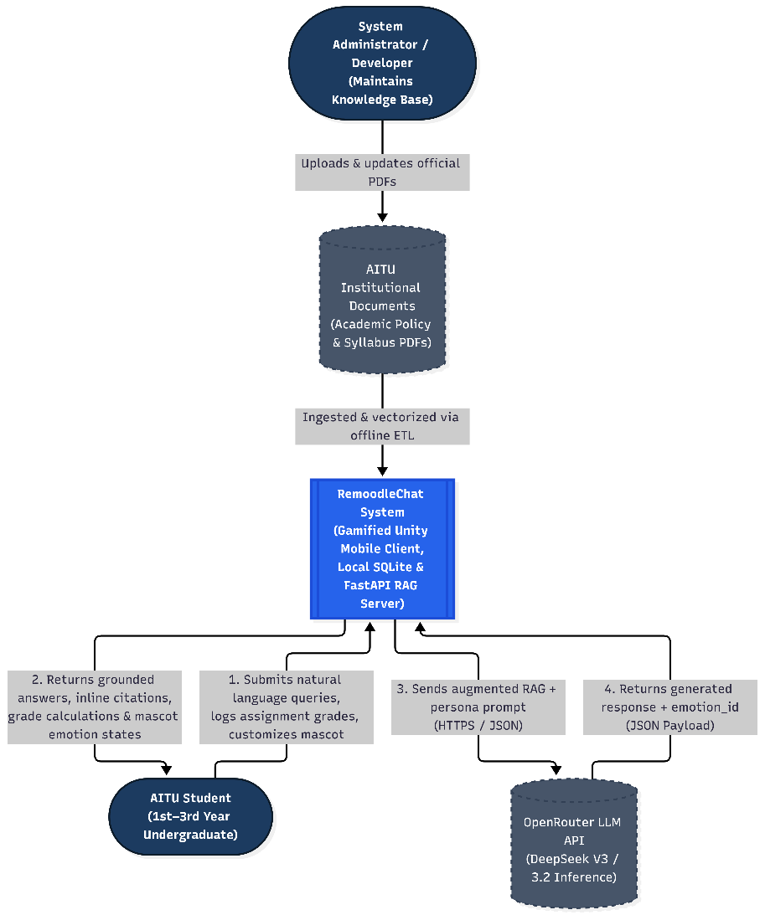
Figure 1 System context diagram
- UML Use Case Diagram:
  - Actor 1: AITU Student connected to Use Cases:
    - Complete Onboarding & Set Profile (Name, Boy/Girl, Year, Faculty)
    - Ask Academic Policy / Syllabus Question (<<include>> View Inline Source Citations; <<extend>> Receive Fallback Warning when Data Absent)
    - Calculate Hypothetical Grade / Scholarship Scenario
    - Log Assignment Grade to Earn Points (P)
    - Purchase & Equip Mascot Outfits in Store (<<extend>> Shift Remoodle-chan Persona)
    - Toggle Mascot Panel Visibility & Persona Settings
    - Review Past Chat History
  - Actor 2: Administrator connected to Use Case:
    - Ingest & Vectorize Institutional PDF Documents.
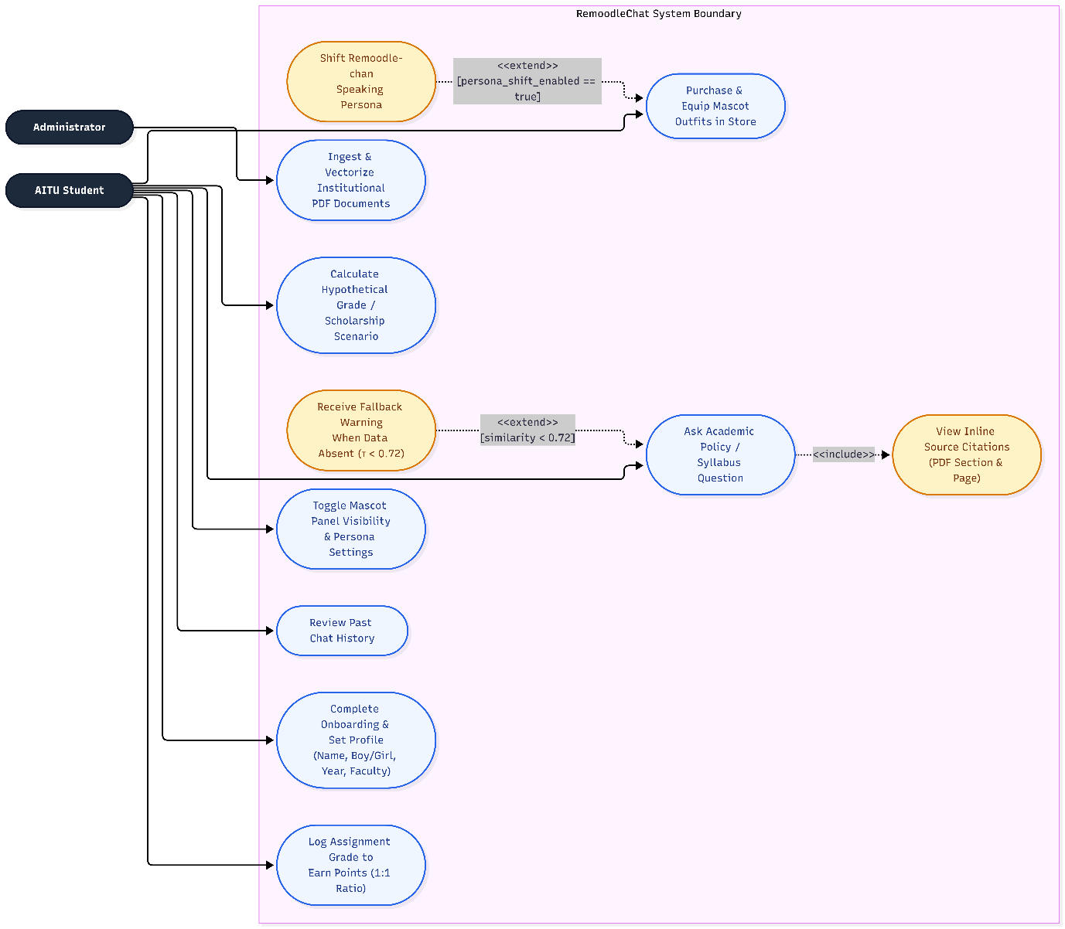
Figure 2 UML Case diagram
- Component Diagram (C4 Level 3 Draft):
  - Unity Mobile Client Container: Onboarding & Profile Controller, Chat UI & Collapsible Viewport Controller, Mascot Animator & Outfit Sprite Manager, Store & Assignment Logger Controller, Local SQLite Data Access Layer, and NetworkManager (UnityWebRequest).
  - FastAPI Backend Container: REST API Router, LangChain RAG Orchestrator, Persona & Gender Prompt Builder, Deterministic Grade Calculator Tool, PDF ETL & Chunking Pipeline, and Embedding Service.
  - Data Stores & External APIs: Local SQLite DB (Client-side), ChromaDB Vector Store (Server-side), and OpenRouter API (External HTTPS).
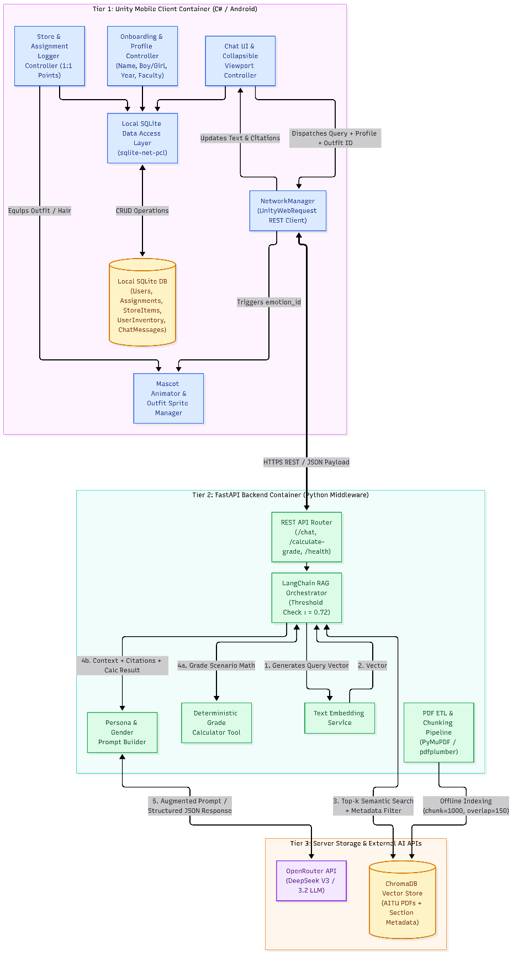
Figure 3 Component diagram

8. UX / Prototype Specification
The Figma and Unity UI mockups embody a vibrant, student-crafted aesthetic combining AITU's official palette (White, Blue, Charcoal) with anime/internet-culture visual novel elements centered around Remoodle-chan:
Screen 1: Splash & Onboarding Personalization
  - Splash View: Displays the AITU logo, the chibi Remoodle-chan mascot surrounded by books, and the "Start chatting" CTA button.
  - Onboarding View: Remoodle-chan greets the user in an informal, friendly student tone. The user inputs their Name, selects Boy / Girl (used by Remoodle-chan to personalize her speech patterns and honorifics/slang for the student), selects 1st / 2nd / 3rd year, and enters their Faculty.
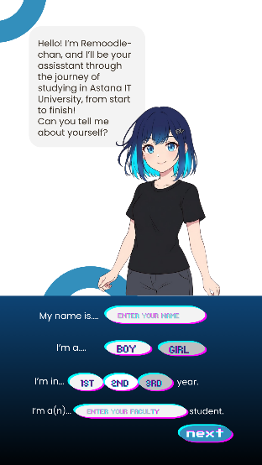
Screen 2: Primary Chat Interface & Collapsible Mascot Panel
  - Displays the upper viewport featuring Remoodle-chan in her active outfit and emotional sprite state, flanked by quick-access icons for Chat History (top-left), New Chat, Points Balance (P 245), Store/Wardrobe (Hanger Icon), Profile, and Settings (Gear Icon) (where outfit-based personality shifts can be toggled on/off).
  - The lower panel renders the conversational UI with natural language queries, bot answers, and a clickable source document icon next to each response.
  - Includes an Enlarge/Collapse icon at the top-right of the chat panel, allowing students to hide the mascot sprite and side panels whenever they want a distraction-free, text-only experience (directly satisfying NFR-3).
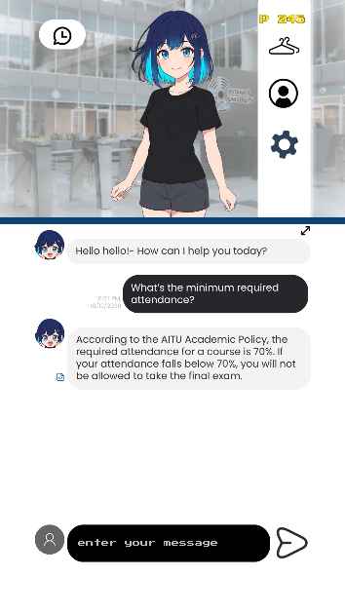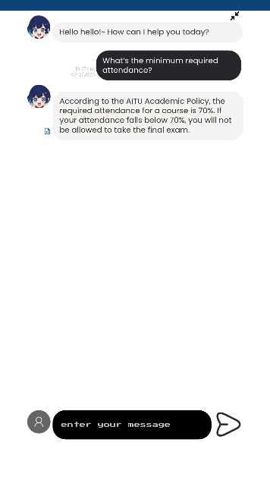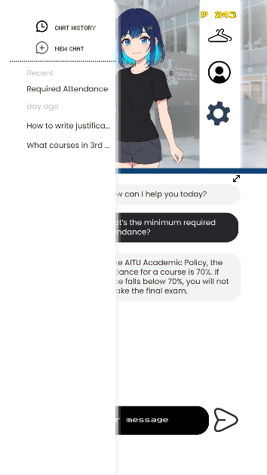
Screen 3: Gamified Virtual "Store" & Assignment Point System
  - Displays the student's current currency (P 245), earned at a 1:1 ratio by manually logging completed course assignments and grades inside the app.
  - Allows cycling through and purchasing Hair modifications and Style/Outfit modifications.
  - Equipping an outfit updates Remoodle-chan's visual sprite across the app, triggers an interactive thank-you reaction ("Yay! Thank you for buying this!"), and dynamically shifts her conversational personality to match the outfit's trope (unless disabled in Settings).
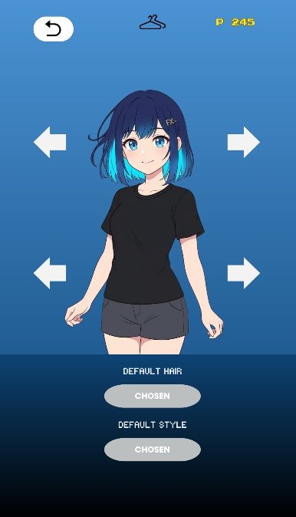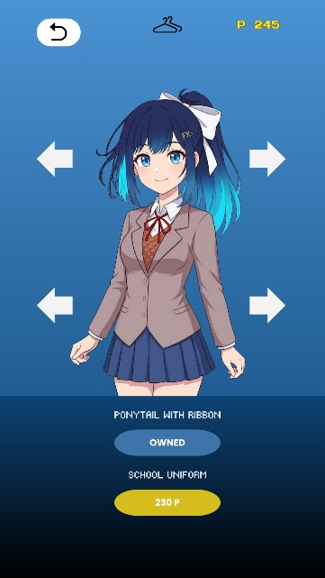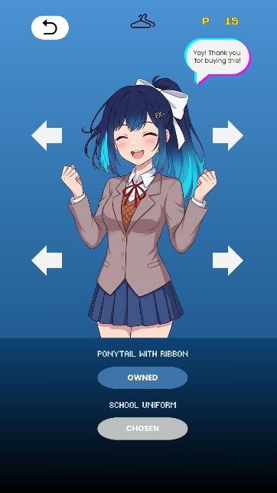

9. Verification and Evaluation Plan
To demonstrate that the project aim and NFRs are achieved, a structured 3-part evaluation protocol will be executed during Phase 4:
9.1 Benchmark Dataset & Evaluation Conditions
- Test Corpus: Official AITU Academic Policy PDF, 3 departmental syllabuses, and scholarship regulations.
- Query Dataset ($N=70$ total queries):
  - 50 In-Scope Complex Queries: Multi-clause questions covering attendance thresholds, FX/F retake rules, GPA calculation scenarios, academic integrity, and syllabus weightings, paired with expert-verified ground-truth answers and exact page/section citations.
  - 20 Out-of-Scope Adversarial/Unindexed Queries: Questions regarding unindexed topics or fabricated rules to test hallucination abstention.
- Baseline Solution for Comparison: Standard non-RAG LLM (ChatGPT-4o / DeepSeek V3 without RAG context) prompted with the same 70 questions.
9.2 Outcome Metrics & Target Thresholds
Following the RAGAS evaluation framework (Es et al., 2024; Ong et al., 2026) and system profiling:
- Factual Extraction Accuracy & Faithfulness: Must exceed $>85\%$ on the 50 in-scope questions.
- Hallucination Abstention Rate: Must achieve $≥95\%$ correct fallback activation on the 20 out-of-scope queries.
- Citation Precision: 100% of answered in-scope queries must link to the correct source document.
- End-to-End Response Latency: Mean latency $<8.0\text{ seconds}$ across 50 queries measured from Unity UnityWebRequest dispatch to UI text rendering.

10. Project Management, Repository Organization, and Risk Analysis
10.1 Development Methodology, Git & YouTrack Traceability
As a solo diploma project, Baurzhanova Ayauzhan is the sole software engineer responsible for data engineering, backend RAG development, Unity frontend/mascot integration, SQLite database design, and QA testing.
Repository & Branching Workflow: Hosted on GitHub (https://github.com/Ayauzhan-Baurzhanova/Diploma-Chatbot-with-Mascot.git). main is maintained as the reviewed baseline; all features are developed in task-linked branches and merged via Pull Requests, and tagged at milestones.
- Repository Directory Structure:
  - /client-unity/ — Unity C# project, UI scenes, Animator controllers, Sprite assets, and SQLite models.
  - /server-fastapi/ — FastAPI endpoints, LangChain RAG pipeline, deterministic grade calculator, and ChromaDB client.
  - /data-pipeline/ — Python PDF parsers, chunking scripts, and sample AITU documents.
  - /docs/ — Project proposal, literature review, requirements, and editable diagram sources (.drawio / .puml).
  - /tests/ — 70-question benchmark dataset, RAGAS evaluation scripts, and unit tests.
10.2 Project Milestones & YouTrack Task Breakdown
Phase & Timeline | YouTrack Tasks | Key Deliverables & Acceptance Criteria
Phase 0: Analysis & Pre-Defense 1 (Completed — By Oct 24) | DIP-1-3, DIP-5-17 | Problem formulation, 6 student interviews, 12-source literature review, architecture diagrams, Figma/UI prototype mockups, Git tag prob-period-1.
Phase 1: Infrastructure & Data Pipeline (Weeks 1–2) | DIP-18: PDF Parser & Cleaner | Python script parses AITU Academic Policy & syllabuses into metadata-tagged chunks (chunk_size=1000, overlap=150) and populates persistent ChromaDB.
Phase 2: Backend RAG, Calculator & Persona API (Weeks 3–4) | DIP-20: Grade Calculator Tool  DIP-19: OpenRouter & Persona Prompting  DIP-4: Setup FastAPI backend and OpenRouter  connection | Working REST API returning grounded answers, citations, emotion_id, and gender/outfit-adapted speech in $<8\text{s}$.
Phase 3: Unity Client, SQLite & Store System (Weeks 5–10) | DIP-21: SQLite Schema & Onboarding  DIP-22: Chat UI & Collapsible Mascot  DIP-23: Assignment Logger & Store | Functional Unity Android build with persistent profile, assignment point logging (1:1), outfit purchasing/equipping, Animator state machine, and settings toggle.
Phase 4: Testing, Optimization & Deployment (Weeks 11–14) | DIP-24: Benchmark Evaluation  DIP-25: Caching & APK Build | Execution of 70-query test suite achieving $>85\%$ accuracy and $<8\text{s}$ latency; final Android APK compilation and UAT with students.
10.3 Risk Management & Mitigation Matrix
Risk ID | Risk Description | Likelihood | Impact | Concrete Mitigation Strategy
R-1 | API Latency Exceeds 8-Second Threshold due to external OpenRouter/DeepSeek network congestion. | Medium | High | Implement asynchronous streaming/requests in FastAPI, semantic caching (Redis/SQLite cache) for frequent queries, and automatic fallback to a faster model tier on OpenRouter if response exceeds 5s.
R-2 | PDF Parsing Corruption on Complex Tables (e.g., grading scales or prerequisite tables in syllabuses). | High | High | Utilize layout-aware PDF parsers (PyMuPDF / pdfplumber) and convert complex grading tables into structured Markdown/JSON-LD blocks prior to vectorization (following Wu et al., 2025).
R-3 | LLM Arithmetic Errors in Grade Calculations when students ask complex scholarship/FX scenarios. | Medium | High | Bypass LLM token prediction for math by routing grade queries to a deterministic Python calculation function (calculate_required_final()) and injecting the exact numerical result into the LLM response.
R-4 | Persona Prompt Overriding Factual Grounding (playful outfit persona causing the bot to improvise rules). | Medium | Medium | Decouple factual extraction from persona styling via structured JSON prompting: force the LLM to extract the verbatim rule and citation first, then apply the gender/outfit stylistic tone only to the conversational wrapper.
R-5 | API Quota / Cost Exhaustion during testing and evaluation phases. | Low | Medium | Enforce token length caps (max_tokens=400), strict .env key protection, and local response caching during Unity UI debugging.

11. Supervisor Feedback & Action Log
Regular consultations were conducted with the project supervisor, Sadirmekova Zhanna, to review the project scope, empirical justification, and system architecture prior to Pre-Defense 1. Table 11.1 records the substantive feedback received and the engineering decisions implemented to address each comment.
Table 11.1: Supervisor Review & Revision Traceability Log
Checkpoint Date | Deliverable Reviewed | Supervisor Feedback / Comment | Engineering Decision & Action Taken
Checkpoint 1 (Late September  2026) | Initial Topic & Problem Formulation | Supervisor validated and approved the topic and proposed project idea. Gave permission to follow through with the idea. Gave recommendation to conduct an interview to determine requirements and relevancy of the project. | Conducted a 6-question interview study with 6 AITU students to empirically quantify search time (10–20 min) and user pain points.
Checkpoint 2 (Mid-October 2026) | First version of Presentation  and Documentation | Presentation’s design and prose did not meet standards. Did not include Github and Youtrack links. Objectives, expected outcomes and requirements weren’t clearly defined. Lacked a comprehensive literature review to derive the requirements. Lacked mock-up UI. The initial proposal draft allowed a 15-second response time, which contradicts student expectations. | Made a severe change to presentation design and have included additional slides to meet presentation criteria. Designed UI screens. Tightened NFR-2 latency from 15s down to $<8\text{ seconds}$; refined FR-3 and a similarity abstention threshold ($τ=0.72$).
Checkpoint 3 (Mid-October 2026) | Second version of Presentation  and Documentation  (UI prototype, Literature Review, Tech comparison table) | Supervisor noted the improvements, and gave permission to continue the work. The order of slides required a slight change. Lacked Risk management table. 4 of 12 chosen sources needed to be changed to a more meaningful alternative. Needed a local database choice for user profiles. | Added a local SQLite relational database to store user profiles, manual assignment grade logs, and store inventory; added a collapsible chat viewport button (Enlarge) and a Settings toggle to disable outfit persona shifts.

References
- Rafique, R., et al. (2026). EduAssist: Enhancing Academic Skills and Engagement Through Personalization and Gamification. Pakistan Journal of Engineering and Technology (Pak. J. Eng. Technol.), Vol. 9, No. 1.
- Ong, C. A., Gopi, S. K. P., & Lee, B. S. F. (2026). Exploring Student Perceptions Towards AskNarelle: A Context-Specific LLM-Powered Educational Assistant. In Proceedings of the ACM Symposium on Applied Computing (SAC '26), Thessaloniki, Greece.
- Shihab, S. M. (2026). AI-Enabled Higher Education Management. International Journal of Emerging Engineering and Technology Research (IJEETR).
- Niyazova, G. Z., et al. (2026). The effects of gamified AI-supported digital learning environments on personalized learning and student engagement. Frontiers in Education.
- Wu, W., et al. (2025). MultiRAG: A Knowledge-guided Framework for Mitigating Hallucination in Multi-source RAG. arXiv preprint.
- Sanyal, P., et al. (2026). RAGMail: A cloud-based retrieval-augmented framework for reducing hallucinations in LLM text generation. Scientific Reports (Nature).
- Yuan, X., et al. (2026). SeaRAG: Reducing Hallucination in Retrieval-Augmented Generation via Statement-Entity Adaptive Ranking. In Proceedings of the ACM Web Conference (WWW '26).
- Joseph, A. (2025). Reducing Hallucinations in Large Language Models Through Integrated Self-Verification and Retrieval-Augmented Generation (CoVe-RAG+). In Proceedings of the ASME 2025 International Design Engineering Technical Conferences and Computers and Information in Engineering Conference (IDETC/CIE2025).
- Es, S., James, J., Espinosa-Anke, L., & Schockaert, S. (2024). RAGAS: Automated Evaluation of Retrieval Augmented Generation. In Proceedings of the 18th Conference of the European Chapter of the Association for Computational Linguistics (EACL): System Demonstrations.
- Ryan, R. M., & Deci, E. L. (2020). Intrinsic and extrinsic motivation from a self-determination theory perspective: Definitions, theory, practices, and future directions. Contemporary Educational Psychology, 61, 101860.
- Chroma Technologies (2026). ChromaDB Technical Architecture: HNSW Vector Indexing, Metadata Filtering, and Persistent Local Storage. https://docs.trychroma.com.
- Unity Technologies (2026). Unity Mecanim Animation System: Animator Controllers, State Machines, and 2D Sprite Swap Pipelines. https://docs.unity3d.com.

APPENDIX
Appendix 1: Interview questions
1. The "Moodle" Problem: How much time does it usually take you to find specific rules (like FX policies, GPA calculations, or syllabus details) on Moodle or the official website? What is the most frustrating part of that process?
2. The Solution: If you had an AITU-specific AI chatbot, what exact features or information would you use it for the most? (e.g., asking about academic rules, finding syllabus deadlines, navigating campus, etc.)
3. Speed & Accuracy: How fast should the bot reply for you to actually use it instead of asking a human?
4. How would you react if the bot gave you incorrect information (hallucinated)?
5. The Interface: Would an interactive, gamified interface with a mascot (Remoodle-chan) make the app more engaging to use compared to a standard, boring text chat (like standard ChatGPT)?
6. The Final Verdict: Be honest — if you already have Moodle, why would you choose to open a separate chatbot app to look up university information?
Appendix 2: Interview responses (6 respondents in total)
1-respondent:
1. Usually 15–20 minutes; the most annoying part is having to download and manually scroll through long PDF files, plus the fact that information is scattered across different Moodle sections and doesn't show up in the standard search.
2. I would mostly use it to calculate and understand grades (FX rules, GPA, assessment weighting), quickly check deadlines and exam dates against the academic calendar, and look up specific syllabus requirements.
3. The bot needs to respond within 2–5 seconds. If a response takes longer than 10 seconds, it’s easier for me to just ask classmates on Telegram or message my academic advisor.
4. I would react very negatively, as errors regarding academic matters are critical. To build trust, the bot should always provide direct links to the relevant sections of official regulations or the syllabus so the information can be verified.
5. Yes, that would be cool, but the accuracy of the information is what matters most; I’m not really concerned about the overall design.
6. Moodle requires too many extra steps—opening the browser, logging in, finding the right folder, and reading through an entire document. A bot would save time by providing a precise answer in a couple of seconds based on a natural language query.
2-respondent:
1. It usually takes 5 to 10 minutes of active searching. The most annoying part is having to download large documents and hoping the information I need is actually in there.
2. For quick answers regarding navigation and academic regulations.
3. A few seconds; if it takes longer, I’d rather just ask my classmates in the group chat.
4. Trust in the bot would drop. Answers need to be accurate and easy to verify.
5. Yes, achievements for certain actions or a fun mascot would make the bot more appealing.
6. Instead of manually searching through the Moodle menu, I’d rather ask the bot and get a quick answer.
3-respondent:
1. Not long—just a few seconds.
2. Mainly for deadlines. But if I were a first-year student, I’d use it for navigation, too.
3. If it’s a frequently asked question, the bot would likely answer quickly. But for other questions, it would be great to have a staff member respond—the sooner, the better. In that case, I’d recommend it in most situations.
4. I’d double-check the information on the university website.
5. Possibly, provided it wasn’t too intrusive (i.e., didn’t keep popping up on the screen).
6. Since all my chats are on Telegram, it would be more convenient to check information via the chatbot than to visit the website separately.
4-respondent:
1. Around 10-20 minutes.
2. I would’ve used it to calculate my regmid, regend and final grades.
3. It should respond in 1 or 2 minutes.
4. I would’ve asked again, if it’s true.
5. Yes.
6. Because I’d be lazy to search for everything myself.
5-respondent:
1. I dunno, I usually just ask my groupmates or people in course chat.
2. I would’ve loved to use it for navigation if I was a first year student again, and also I’d appreciate schedules of professors and instructors as it is hard to find them when we need to meet face-to-face.
3. Around 5-10 seconds would be good, it should answer around as fast as chatgpt for me start using it daily.
4. I would’ve gone and double check it in docs, but if I didn’t know that info was wrong and went with it – I’d be disappointed and stopped using the bot. Education related stuff should always be correct, I think.
5. Yes, but personally I don’t really care about it. If the app doesn’t require to engage with gamification elements, I will likely not pay attention to it, but some people might find it fun. 6. Because searching everything myself is hard and boring. I prefer just asking people.
6-respondent:
1. Around 10-15 minutes, but sometimes I don’t even find the right info I’m looking for and have to ask other students.
2. I would’ve used it to calculate my hypothetical grades, like asking “if I get 80 on endterm, and my midterm is 60, how many points I should get on my finals to keep the scholarship?”. Also, I would’ve used to navigate bureaucratic nonsense, like how to write justifications for being absent, or something like that.
3. It shouldn’t take longer than 8 seconds, or I will get impatient and close the app.
4. I would’ve stopped using it.
5. Yes, I would love a good gamification system, if it’s not too intrusive and obnoxious.
6. Because I find quick “ask and get answer” type apps better than endless searching and reading through moodle documents.

Appendix 3. YouTrack Agile Board Screenshot
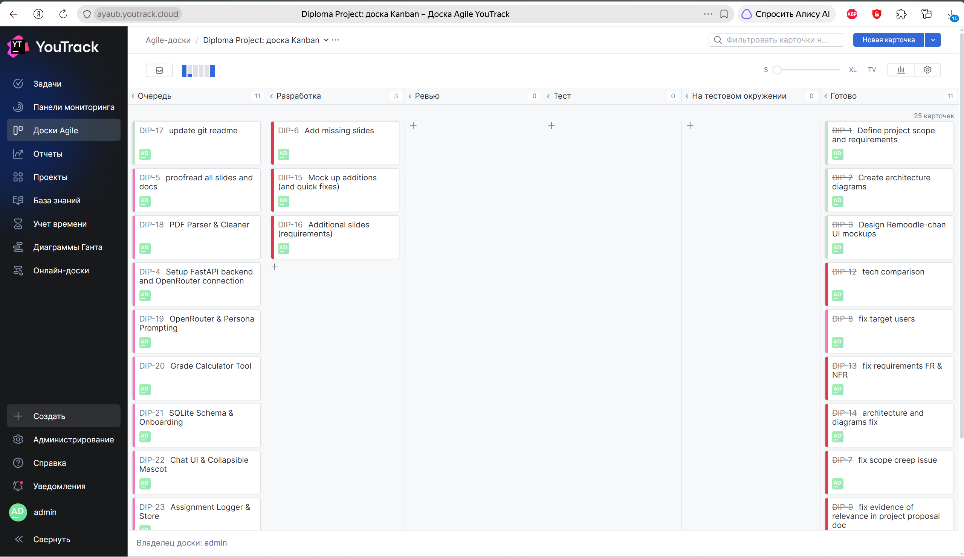
Appendix 4. Github Screenshot
