Erik Ayavaca-Tirado

5/1/19

Compilers

User Manual for Compiler

To use this compiler:

1. Locate the “ayavacacompiler.jar” file in the “Product” folder
2. Locate the Mini-pascal (.pas) file you would like to compile, in the case of this compiler, we would use a text file
3. Put both files in the same directory
4. Use the command line to navigate to files
5. Run the following command: java -jar ayavacacompiler.jar input.txt Where input.txt is the name of your pascal file you would like to compile

Example of using compiler:

program foo;

begin

end

.

Is an example of the simplest pascal program:

Below is an image detailing how to use the jar

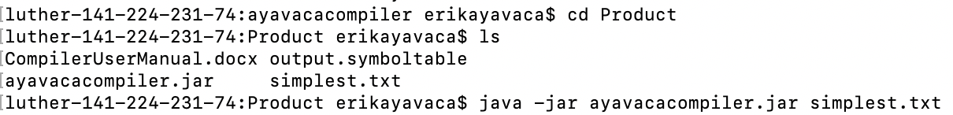

Using the instructions above we get the following output in the command line:

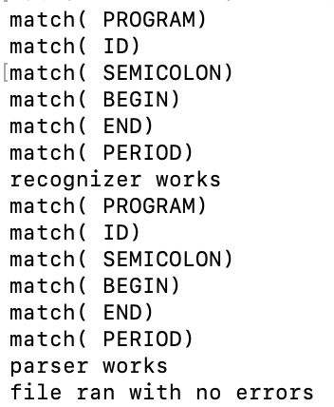

Now if we were to parse the following program:

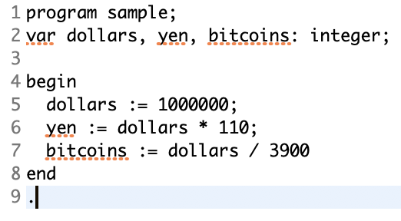

The parser will output the following tree:

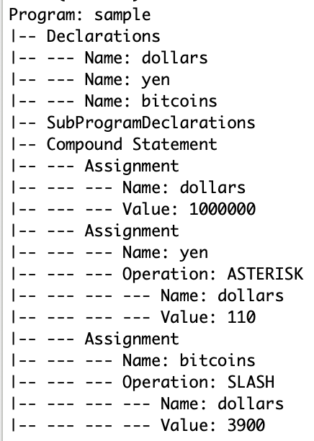

Limitations of this compiler:

* Can only recognize valid pascal programs.
* Can parse pascal program to return nodes.
* Semantic analyzer is not working properly.
* Code generation not working properly.