Erik Ayavaca-Tirado

12/16/18

CSC 450

SDD- Software Design Document

Scanner Project

**Overview:**

In this project I am going to create a scanner for our Pascal language as described in the grammar given in class. The scanner will be created using the JFlex tool. This is just the beginning part for the compiler, which will be made in CSC 451. In order to find out the different reserve words and symbols, I went through that grammar and complied the list below.

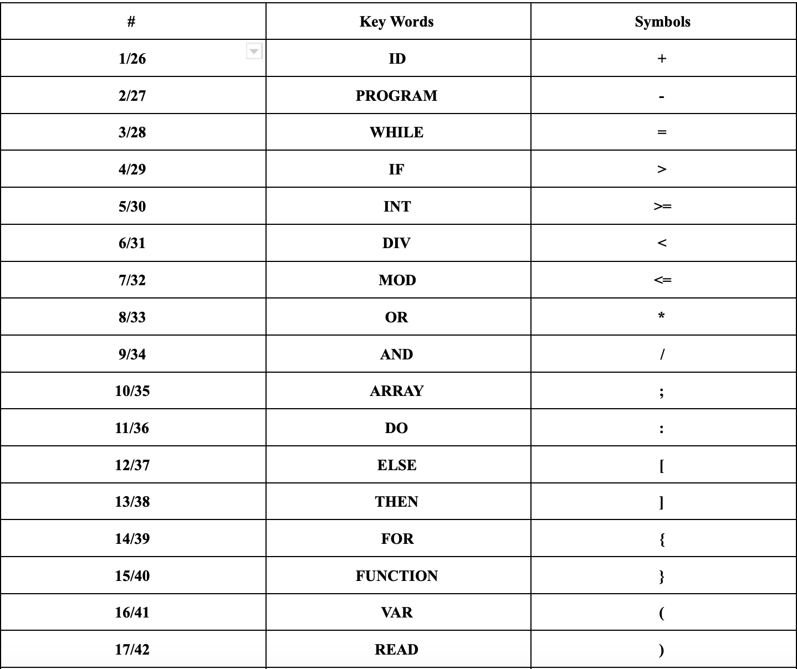

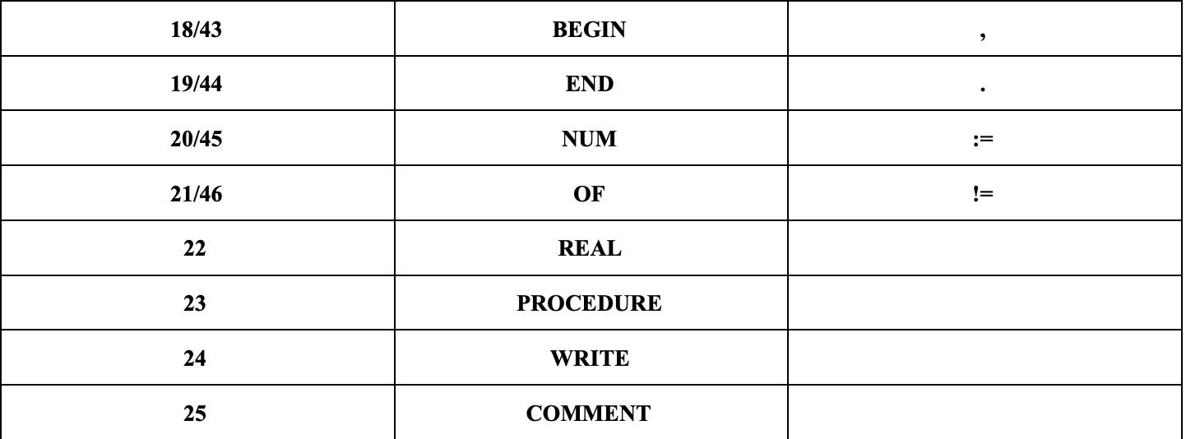

So based on this list I created a state diagram, which is below:

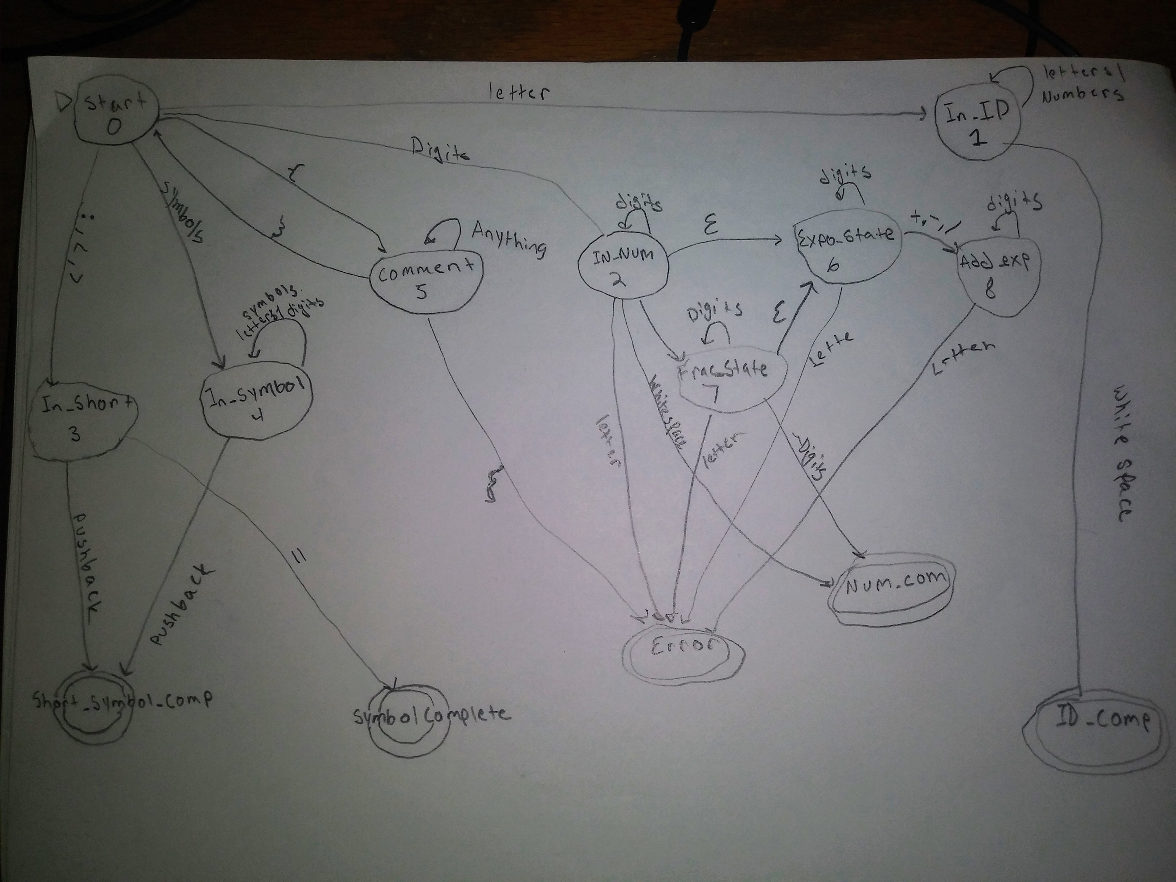  
Note: better image will be used

So, based on this image I will creating a scanner will the help of the jflex tool.

**Design:**

The scanner will be created using the jflex tool. There are 3 other specific classes in addition to the jfelex file. The TokenType java file contains the list of keywords as well as the symbols found in the grammar obtained in class. The Token java file creates the token used in the scanner file. The lookUpTable java file contains the list of all of the lexemes followed by their representing token type.