Erik Ayavaca-Tirado

10/22/18

CSC 450

Python project

Overview:

In this project the use of the python programming language will be used to simulate a simulation of Airport take off time. This program will keep track of information that is needed for airstrip scheduling such as request identifier, request submission time, time slot requested, length of time requested, actual start time, actual end time. This information will be read in by a file. A queue detailing the airplanes waiting before they can take off. A print out the status of

the queue as time moves along will be the output produced.

Design:

There is python class named flightSimulations.py that contains 4 different functions. Below is a list of the 4 functions and what each function does.

1. read_file: reads in a file
2. printQueue: prints the queue at each time interval
3. simulate_airport: simulates an actual airport, so adding/removing planes based on request time. Priority queue is implemented here.
4. takeOffPrint: prints out the list of flight that have departed the runway.

Example:

If the user were to input the following content of a cvs file.

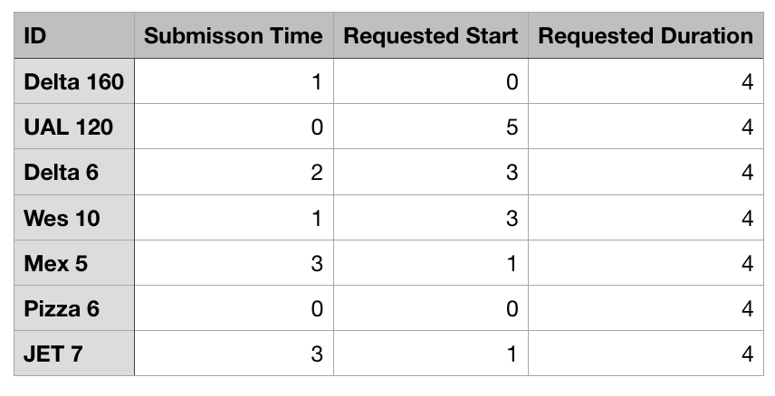

Figure 1: content of a cvs input file

The expected output will look like the following images below:

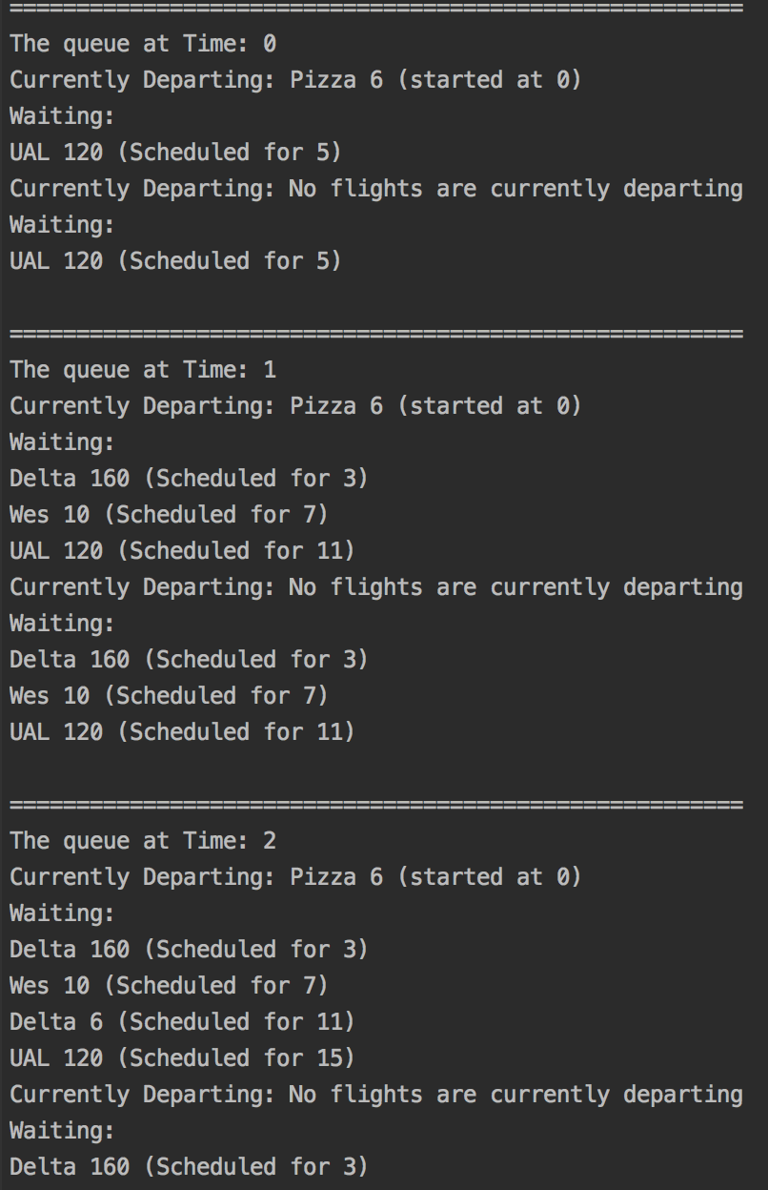

Figure 2: Output of queue at different time intervals

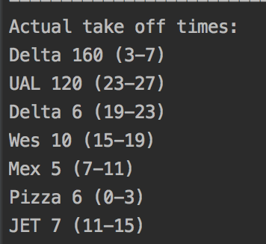

Figure 3: Ending output with final take off times for all airplanes from file.