**CHAPTER 1**

**INTRODUCTION**

**\*\*\*\*\*\*\*\*\*\*\*\*\*\*\*\*\*\*\*\*\*\*\*\*\*\*\*\*\*\*\*\*\*\*\*\*\*\*\*\*\*\*\*\*\*\*\*\*\*\*\*\*\*\*\*\***

**1.1** **PURPOSE**

To develop an android application for the necessary documents requires. By the help of application we won’t need to worry about carrying and thus losing our documents. We could also save our time and money to obtain a new document.

**1.1.1** **Scope For Extension**

We need to create an extra portal for police stations which would help in identifying a lost/ stolen vehicle. A complain could be lodged immediately by the mobile application.

**1.1.2** **Future Scope**

This is helpful for people as well as RTO and Police stations investigating a lost vehicle. The road worthiness certificates are easy to check as it would be readily available**.**

**1.2** **DOCUMENT CONVENTIONS**

The document follows MLA format. Bold-faced text has been used to emphasize section and sub-section headings. Highlighting is to point out words in the glossary an italicized text is used to label and recognize diagrams.

**1.3** **INTENDED AUDIENCE AND READING SUGGESTIONS**

This document is to be read by the development team, the project managers, marketing staff, testers and documentation writers. The SRS has been organized approximately in order of increasing specificity. The developers and project managers need to become intimately familiar with the SRS.

Page 1

**Others involved need to review the document as such:**

* **Overall Description –** Marketing staff have to become accustomed to the variousproduct features in order to effectively advertise the product.
* **System features –** Testers need an understanding of the system features to developmeaningful test cases and give useful feedback to the developers.

**1.4** **SCOPE**

We need to create an extra portal for police stations which would help in identifying a lost/ stolen vehicle. A complain could be lodged immediately by the mobile application. This is helpful for people as well as RTO and Police stations investigating a lost vehicle. The road worthiness certificates are easy to check as it would be readily available**.**

**1.5** **REFERENCES**

* Android System Programming –Roger Ye
* ANDROID: [www.W3school.com](http://www.w3school.com)
* ANDROID: [www.Javatpoint.com](http://www.javatpoint.com)
* Udemy Android Course
* Wikipedia: [www.wikipedia.com](http://www.wikipedia.com)

Page 2

**CHAPTER 2**

**OVERALL DESCRIPTION**

**\*\*\*\*\*\*\*\*\*\*\*\*\*\*\*\*\*\*\*\*\*\*\*\*\*\*\*\*\*\*\*\*\*\*\*\*\*\*\*\*\*\*\*\*\*\*\*\*\*\*\*\*\*\*\*\*\*\*\*\*\*\*\*\*\*\*\*\*\*\***

**2.1** **PRODUCT PERSPECTIVE**

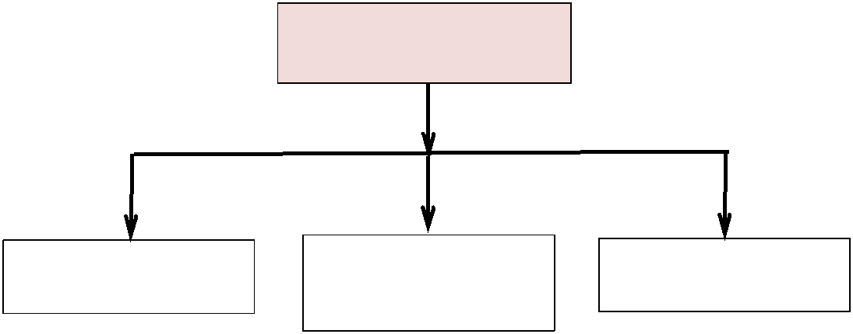

**TRAFFIC POLICE**

|  |  |  |  |  |  |
| --- | --- | --- | --- | --- | --- |
|  |  | **Checks Vehicle** |  |  |  |
| **Checks License** |  |  | **Generates Fine** |  |
|  |  | **Info** |  |  |  |
|  |  |  |  |  |  |

**2.2** **PRODUCT FUNCTIONS**

**2.2.1** **Traffic Module**

This module mainly focuses on providing the information only to the traffic police officers it consists of checks license checks vehicle information check insurance and also generate fines.

**2.2.2** **Check License**

The Check License module takes a License number. As an input and returns the respective License information like Name, Photo, address, DOB, issued date, License status and Validity of the license. In case if the record doesn't exist it shows a respective message that record not found.

Page 3

**2.2.3 Check Vehicle**

The Check Vehicle module takes a Vehicle Registration number as an input and returns the Respective Owner details like Name and Address. It also includes the Vehicle issued date and valid date of vehicle.

**2.2.4 Generate Fine**

The Generate Fine module mainly focuses on generating fines for the offences committed. It provides for selecting a variety of offences from a set of given offences for which the fine amount is auto-generated. The user (R.T.O officer) needs to enter other information related to Officer like Officer Id and Other important Vehicle information. This overall process requires internet for data transfer between the client and the server and the data is stored on server.

**2.3** **USER CLASSES AND CHARACTERISTICS**

**2.3.1 Traffic Police**

Traffic police interface is used to check vehicle license, insurance, vehicle documents/papers and generate fine.

**2.3.2** **Vehicle Owner**

The vehicle owner interface is used to store vehicle documents and add beneficiaries to drive a vehicle.

**2.3.3 Beneficiary**

They get the benefit of driving the vehicle they may or do not possess but has been added from the vehicle owner.

**2.4** **OPERATING ENVIRONMENT**

**Android Operating System**

Android is a comprehensive open source platform designed for mobile devices. It is championed by Google and owned by Open Handset Alliance. The goal of the alliance is to accelerate innovation in mobile computing and offer consumers a richer, less expensive, and better mobile experience. Android is the vehicle to do so. Android is a Linux-based operating system mainly used for running mobile devices such as smart phones and tablet computers. Its usability

Page 4

is not limited to mobile devices. Because of its open and customizable features, it is used in a wide range of electronics devices, like laptops, smart TV, cameras, headphones, wristwatches, game consoles, car CD and DVD players, home automations and many more [Marko Gargenta]. Android OS is hardware independent and runs on devices from different vendors, unlike other proprietary operating systems such as iOS (Apple Inc. products), Blackberry OS (Blackberry), S40 OS (Nokia), Windows OS (Windows Phone) etc., which are licensed and controlled by certain companies. As of May 2013, Android dominates the smartphone market accounting 74.4% of worldwide smartphone sales [Gartner].

Android is a full-fledged operating system and a complete software stack for mobile devices. Android APIs are a rich set of system services wrapped in an intuitive class files which provides easy access to several features like location, web, telephony, Wi-Fi, media, camera , and so on. All the tools, frameworks and software necessary to develop a mobile application are available for free.

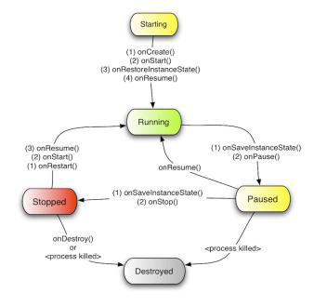

Page 5

**2.5** **DESIGN AND IMPLEMENTATION CONSTRAINTS**

The mobile application is constrained by the data provided by the website and the verification at the block level. If the data provided by the site is not accurate and the block officials don’t pay attention or do fraud then the system will have problem showing the stats.

The Internet connection is also a constraint for the application. Since the application fetches data from the database over the Internet, it is crucial that there is an Internet connection for the application to function. The mobile application will be constrained by the capacity of the database. The database may be forced to queue incoming requests and therefore increase the time it takes to fetch data.

**2.6** **USER DOCUMENTATION**

The application’s user interface has been specifically designed with their customers in mind, giving them convenience while they travel. It makes sure at every point, that the customer spends most of the time using the device rather than figuring out how to use it.

The home screen offers a menu with a list of functions that the device performs. The user can select one of the options on the menu, and is taken to the respective screen. Every screen displays the menu on the bottom. The user can click on any one of the options and is taken to the screen of their choice.

The device offers easy scroll options to navigate the screens efficiently. To scroll down any screen, simply touch the scroll bar on the screen, and roll down. If the user does not know how to use any functionality or has any queries, the help option can be used. The help screen contains a text field to enter search terms. A list of search results pertaining to the query is displayed.

**2.7** **ASSUMPTIONS AND DEPENDENCIES**

One assumption about the product is that the data on the database is accurate and the chances of fraud being done at block level are minimal. The user will have enough space in his/her phone to store the data fetched from the

Page 6

database as the application will store the data in memory so that in case of zero updation or slow network it can show the last successfully retrieved data.

Page 7

**CHAPTER 3**

**EXTERNAL INTERFACE REQUIREMENTS**

**\*\*\*\*\*\*\*\*\*\*\*\*\*\*\*\*\*\*\*\*\*\*\*\*\*\*\*\*\*\*\*\*\*\*\*\*\*\*\*\*\*\*\*\*\*\*\*\*\*\*\*\*\*\*\*\*\*\*\*\***

|  |  |  |  |  |
| --- | --- | --- | --- | --- |
| **3.1** | **USER INTERFACE** | |  |  |
| **3.2** | **HARDWARE INTERFACE** | |  |  |
|  |  | An android phone or tablet |  |  |
| **3.3** | **SOFTWARE INTERFACE** | |  |  |
|  | ✓ | **OS** | **-** | Windows XP or above |
|  | ✓ | **TOOLS** | **-** | Eclipse, NetBeans IDE 8.0.1 |
|  | ✓ | **PLATFORM** | **-** | Android SDK Framework |
|  | ✓ | **IDE** | **-** | Eclipse, NetBeans |
|  | ✓ | **ANDROID EMULATOR** | **-** | SDK Version 2.2 or higher |
|  | ✓ | **TECHNOLOGIES USED** | **-** | Java |
|  | ✓ | **DATABASE** | **-** | Google Firebase |

**3.4** **COMMUNICATIONS INTERFACES**

Firebase provides a real-time database and backend as a service. The service provides application developers an API that allows application data to be synchronized across clients and stored on Firebase's cloud. The company provides client libraries that enable integration with Android, iOS, JavaScript, Java, Objective-C, Swift and Node.js applications. The database is also accessible through a REST API and bindings for several JavaScript frameworks such as AngularJS, React, Ember.js and Backbone.js. The REST API uses the Server-Sent Events protocol, which is an API for creating HTTP connections for receiving push notifications from a server. Developers using the real-time database can secure their data by using the company's server-side-enforced security rules. Cloud Firestore which is Firebase's next generation of the Real-time Database was released for beta use.

Page 8

**CHAPTER 4**

**SYSTEM FEATURES**

**\*\*\*\*\*\*\*\*\*\*\*\*\*\*\*\*\*\*\*\*\*\*\*\*\*\*\*\*\*\*\*\*\*\*\*\*\*\*\*\*\*\*\*\*\*\*\*\*\*\*\*\*\*\*\*\***

**4.1 SYSTEM FEATURE 1**

* **Traffic Police Login:-** Traffic police will login with his/her ID and password.
* **View Vehicle and Driver Location :-** Admin can view vehicle and driverlocation.
* **Registration :-** Admin will register the driver by entering driver details.
* **User Login :-** User can login with user ID and password.
* **Service Entry :-** A servicing Entry form is used to maintain the servicing data foreach vehicle in per month.
* **Beneficiary :-** Beneficiary can check his/her authority of driving vehicle.

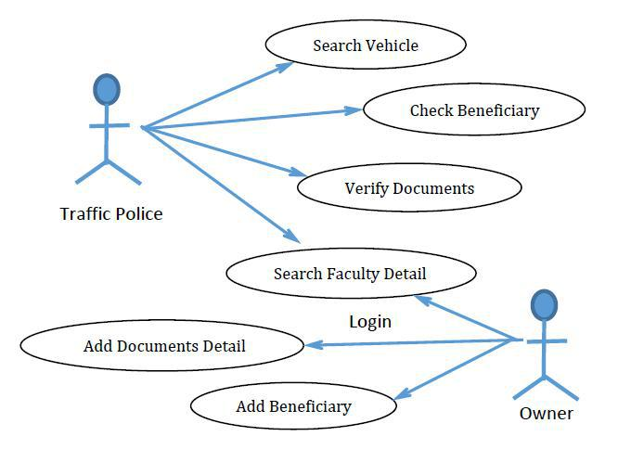

**Figure 4.1.a:** Use Case Diagram

Page 9

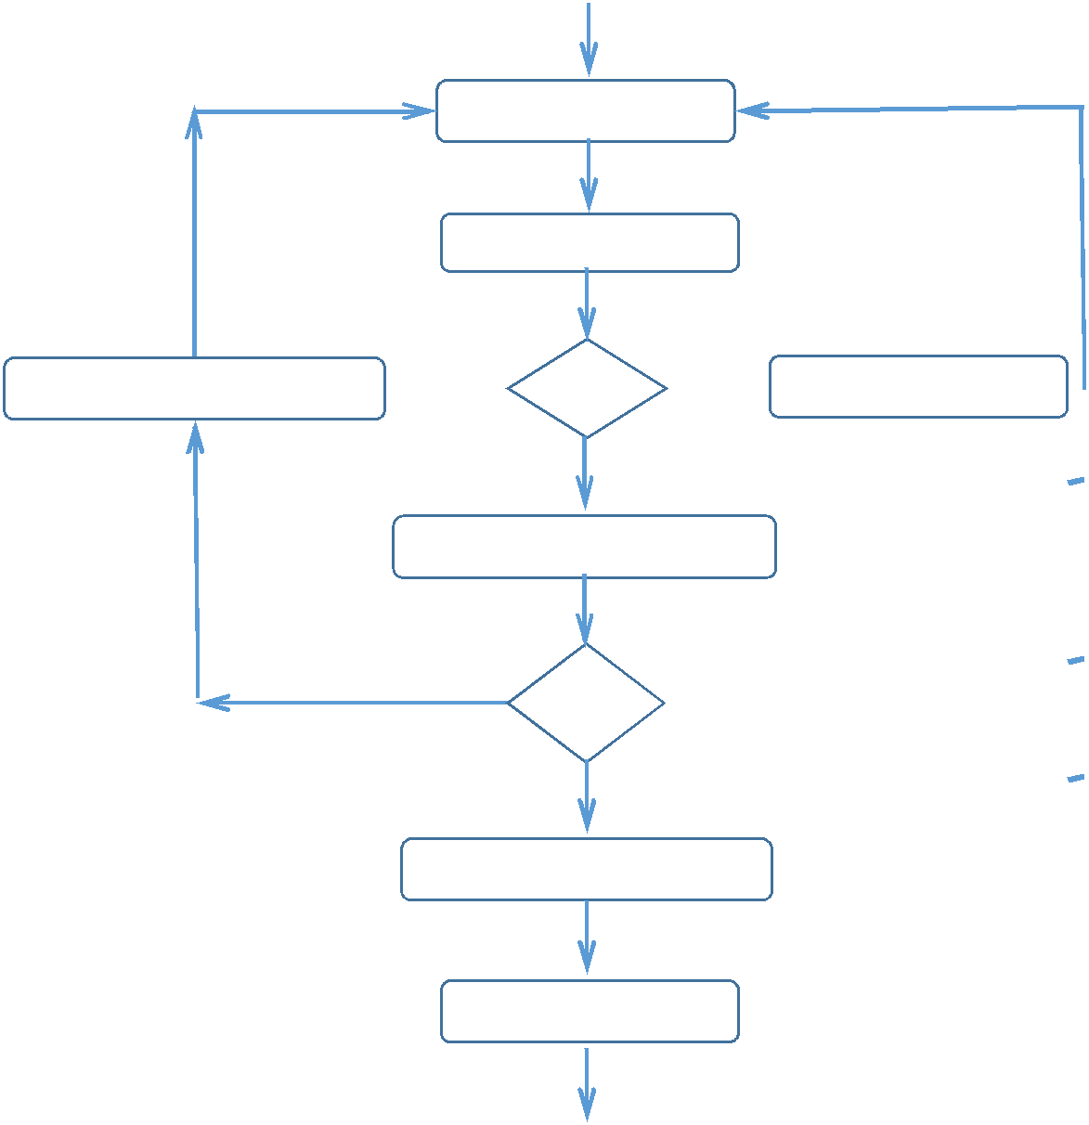

Enter User ID

Enter Password

Invalid

Fill The Manadatory Field  ID Pass Not Valid

Valid

Verification Mandatory Field

Invalid

Valid

Add/ Remove Beneficiary

Add Document



**Figure 4.1.b**: Activity Diagram (Owner)

Page 10

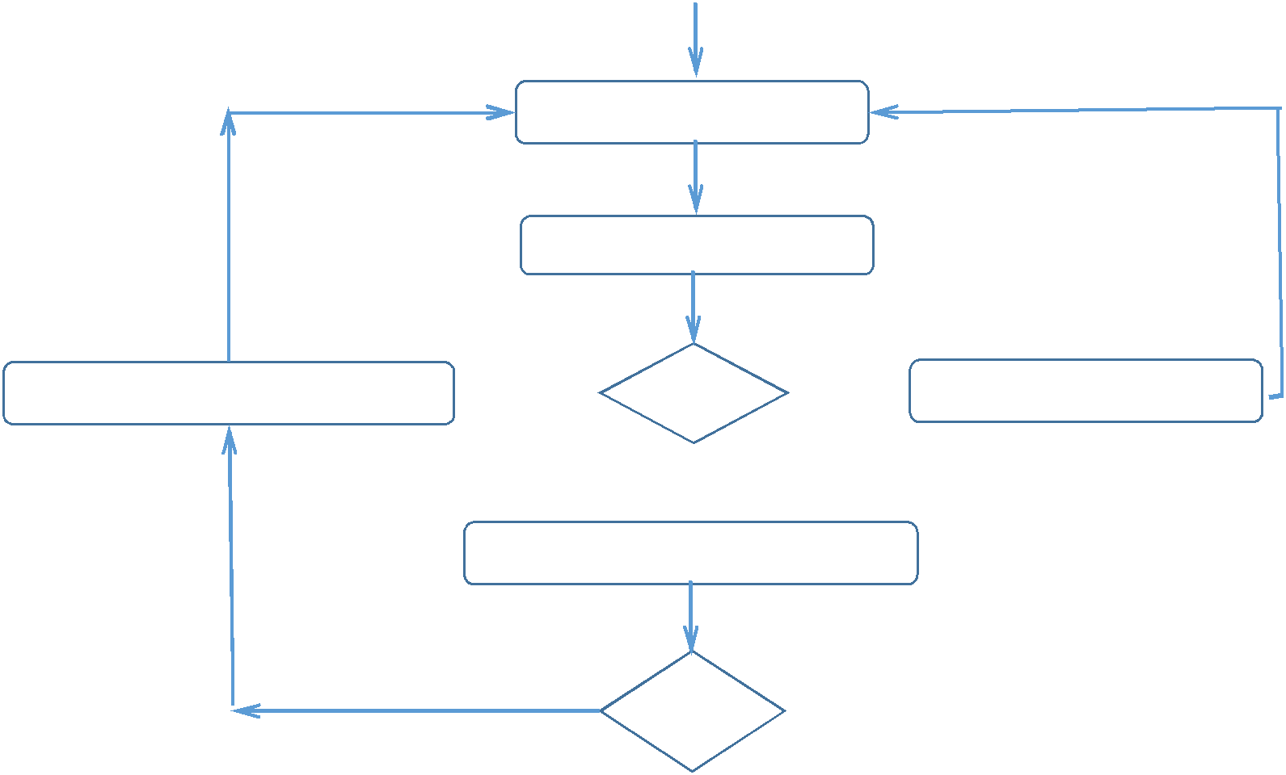

Enter User ID

Enter Password

Invalid

Fill The Manadatory Field  ID Pass Not Valid

 Valid

Verification Mandatory Field

Invalid

 Valid

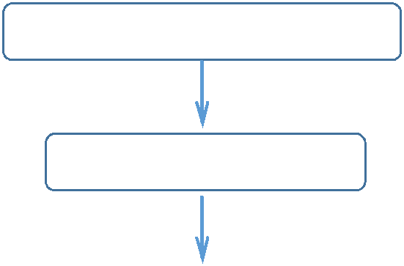

Search Vehicle

Check Document



**Figure 4.1.c**: Activity Diagram (Traffic Police)

Page 11

**4.2 SYSTEM FEATURE 2**

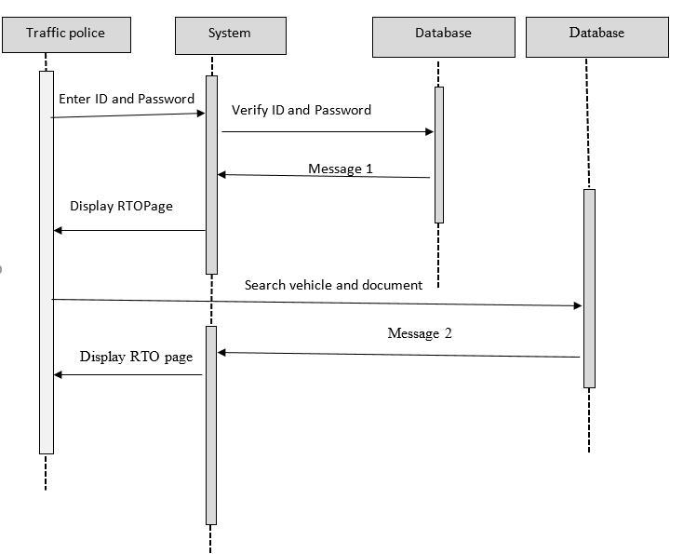

**Figure 4.2.a**: Sequence Diagram (Traffic Police)

Page 12

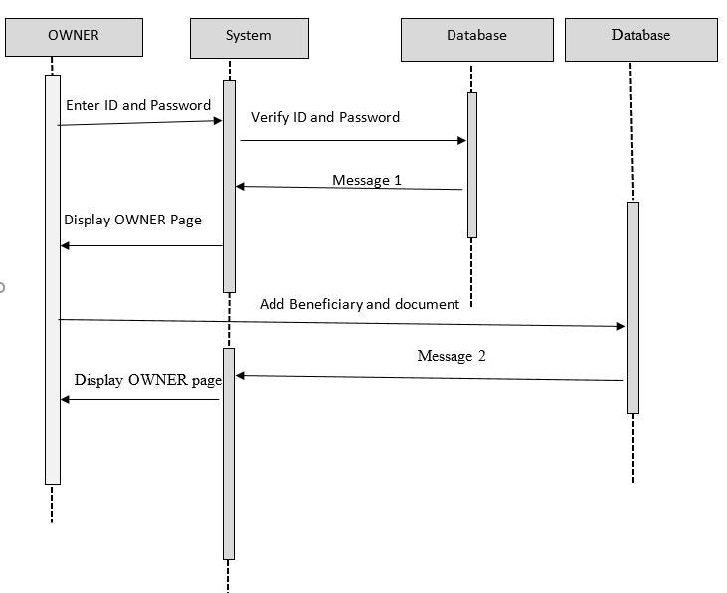

**Figure 4.2.b**: Sequence Diagram (Owner)

Page 13

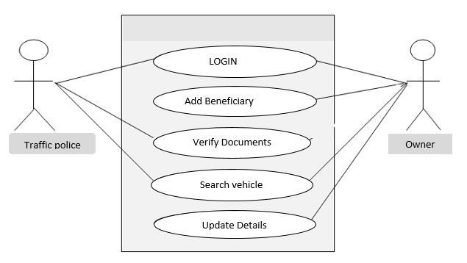

**Figure 4.2.c**: Use Case Model Survey

**CHAPTER 6**

**OTHER REQUIREMENTS**

**\*\*\*\*\*\*\*\*\*\*\*\*\*\*\*\*\*\*\*\*\*\*\*\*\*\*\*\*\*\*\*\*\*\*\*\*\*\*\*\*\*\*\*\*\*\*\*\*\*\*\*\*\*\*\*\*\*\***

**6.1** **APPENDIX A: GLOSSARY**

**A** **H**

Abbreviations- Hardware

Acronyms HTML

Administrator HTTP

Analysis HTTPS

**R**

RAD

References

Reports

**C**

Client on Internet Client on Intranet Communication Constraints Constructions

**D**

Database

DB

Definition

Development

Drawbacks

Introduction

**E**

Elaboration

ER Diagram

Existing System

**I**

Interface

Introduction

**J**

JavaScript

**M**

Methodology

**O**

Operating System

Our Plan

OverOverview

Overall

**P**

Product

Proposed system

Purpose

**S**

Scope

Sequence

Software

**T**

Transition

Technology

**U**

Use-case

UML

**W**

Waterfall

**I**

Page 16

**6.2** **APPENDIX B: ANALYSIS MODEL**

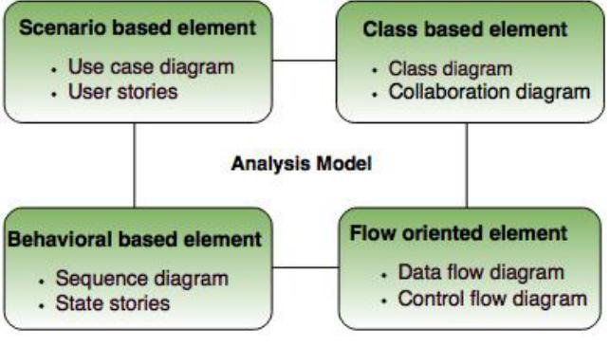

**Figure 6.2.a**: Elements of Analysis Model

Page 17



**Figure 6.2.b**: Use case diagram

Page 18

**SPECIAL THANKS**

**\*\*\*\*\*\*\*\*\*\*\*\*\*\*\*\*\*\*\*\*\*\*\*\*\*\*\*\*\*\*\*\*\*\*\*\*\*\*\*\*\*\*\*\*\*\*\*\*\*\*\*\*\*\*\*\*\*\***

**DEPARTMENT OF COMPUTER ENGINEERING AND APPLICATIONS**

We convey a special thanks to our department and our college and also convey a special thanks to all these software’s and websites, they have been helping a lot in completing the project.

Page 19

Page 14

**CHAPTER 5**

**NON FUNCTIONAL REQUIREMENTS**

**\*\*\*\*\*\*\*\*\*\*\*\*\*\*\*\*\*\*\*\*\*\*\*\*\*\*\*\*\*\*\*\*\*\*\*\*\*\*\*\*\*\*\*\*\*\*\*\*\*\*\*\*\*\*\*\*\*\***

**5.1** **PERFORMANCE REQUIREMENT**

The system is interactive and the delays involved are less. So in every action-response of the system, there are no immediate delays.

**5.2** **SECURITY REQUIREMENT**

Access permissions for the system information may only be changed by the system’s data administrator or the person who is responsible for the documents.

**5.3** **SAFETY REQUIREMENT**

If there is extensive damage to a wide portion of the database due to catastrophic failure, such as a disk crash, the recovery method restores a past copy of the database that was backed up to archival storage (typically tape) and reconstructs a more current state by reapplying or redoing the operations of committed transactions from the backed up log, up to the time of failure.

**5.4** **SOFTWARE QUALITY ATTRIBUTES**

**5.4.1** **Availability**

The documents of any particular or specified vehicle gets open on the window as you entire its required information.

**5.4.2** **Correctness**

The only documents open on the window whose information are to be entered. Problems like overlapping will not create any issue.

Page 15

**5.4.3** **Maintainability**

The administrators and vehicle-in-chargers should maintain correct schedules of vehicles.

**5.4.4** **Usability**

The vehicle information should satisfy a maximum number of customers needs.

Page 16