A
Minor Project Report On
“Workspace Room Booking App”
Submitted To

C.B PATEL COMPUTER COLLEGE AND J. N. M. PATEL SCIENCE COLLEGE
Affiliated To
VEER NARMAD SOUTH GUJARAT UNIVERSITY,
SURAT
As A Partial Fulfillment for the Degree of

BACHELOR OF COMPUTER APPLICATION (BCA)

ACADEMIC YEAR: 2025-26

GUIDED BY: Ms. Mamta

SUBMITED BY:
5814 – Patrawala Hashnain

INDEX

Sr No. | Topic
1. | Introduction
2. | Tools/Technologies Used
3. | Objective
4. | System Flow Chart
5. | Database Design
6. | Screenshots
7. | References

1.

Introduction
In the present era, modern life in cities has become increasingly fast-paced and demanding. People are often in search of organized, efficient, and peaceful environments where they can focus on their professional activities without unnecessary distractions. Workspaces have therefore become more than just a physical place to sit; they represent a balanced environment where individuals and teams can collaborate, innovate, and grow together.

With the growth of shared working culture and the concept of flexible office spaces, there has arisen a strong need for simple and reliable systems to manage room bookings. Whether for a quick meeting, a brainstorming session, or a quiet corner to work, people require an easy way to reserve rooms without conflict and confusion. Just like amusement parks provide joy and recreation for families, a well-managed workspace provides comfort, focus, and productivity for professionals.

Today’s technology allows us to bring this comfort into the palm of our hands. A workspace booking application not only ensures efficient usage of rooms but also creates a peaceful environment where users can concentrate on their goals instead of worrying about availability. It provides the ease of viewing, filtering, and reserving rooms with just a few clicks, while ensuring fair and conflict-free scheduling.

In the modern times of digital transformation, such applications have become an essential part of urban professional life. They bring order, efficiency, and convenience, making workspaces truly functional and enjoyable for both individuals and organizations.

Tools/Environment used

Front End | : | Android XML Layouts (UI)
Database | : | SQLite (in-built database)
Programming Language | : | Kotlin
E-R Diagram / DFD | : | E Draw Max
Additional Technologies | : | RecyclerView, DialogFragment, Material Design , git

Objective of Project
▪ Project Definition:
A mobile application designed to manage and streamline workspace room bookings. The system allows users to sign up, log in, view available rooms, and book them for meetings or personal use. It also provides an admin interface to manage the workspace details, rooms, and bookings. The aim is to ensure efficient utilization of workspace facilities, reduce booking conflicts, and create a simple yet reliable environment for users and administrators.

▪ Features:
- Users can sign up, log in, and manage their profiles.
- Users can search and filter rooms by type, size, or location.
- Room detail page with images, features (computer/projector), and description.
- Book Now option to select date, time, and purpose of booking.
- Users can view all their bookings with live status (future, completed, cancelled).
- Cancel booking option available to users.
- Automatic status updates for past bookings (future → completed).
▪ Admin panel features:
- Admin can log in with predefined credentials.
- Manage Workspace (update banner and name).
- Manage Rooms – Add, edit, delete room details and upload images.
- View bookings per room with details of users and timings.
- Search and filter rooms/bookings for quick access.

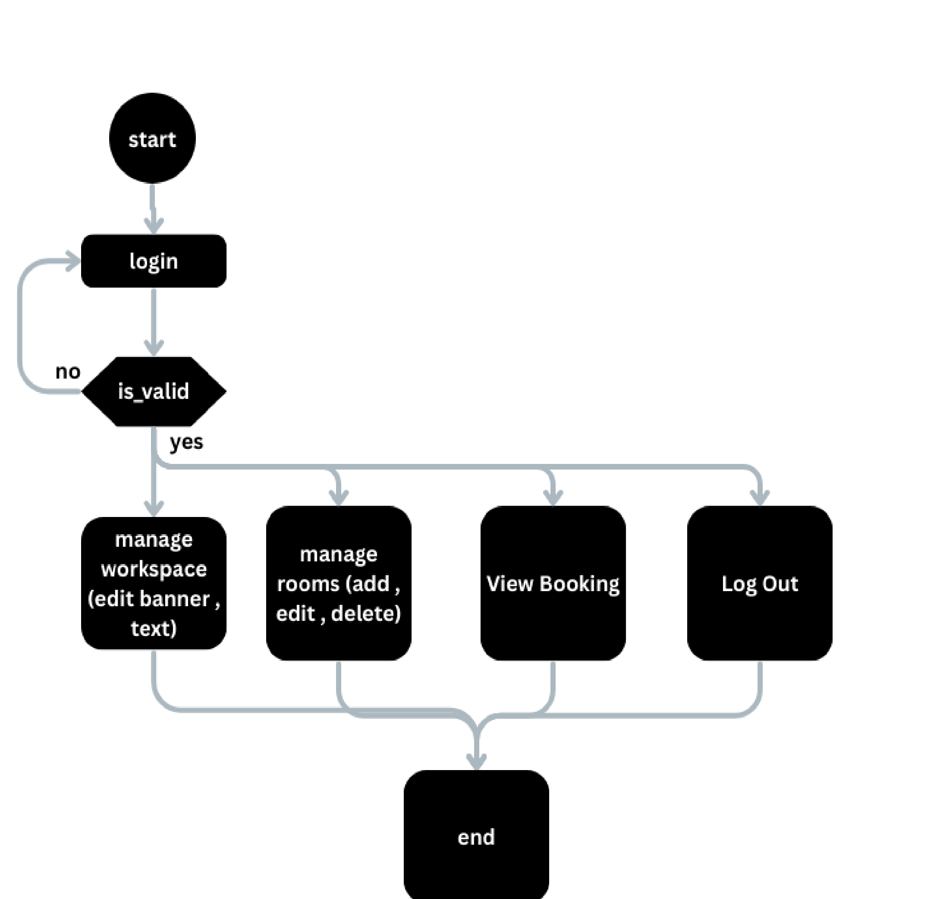
System Flow Chart Admin:

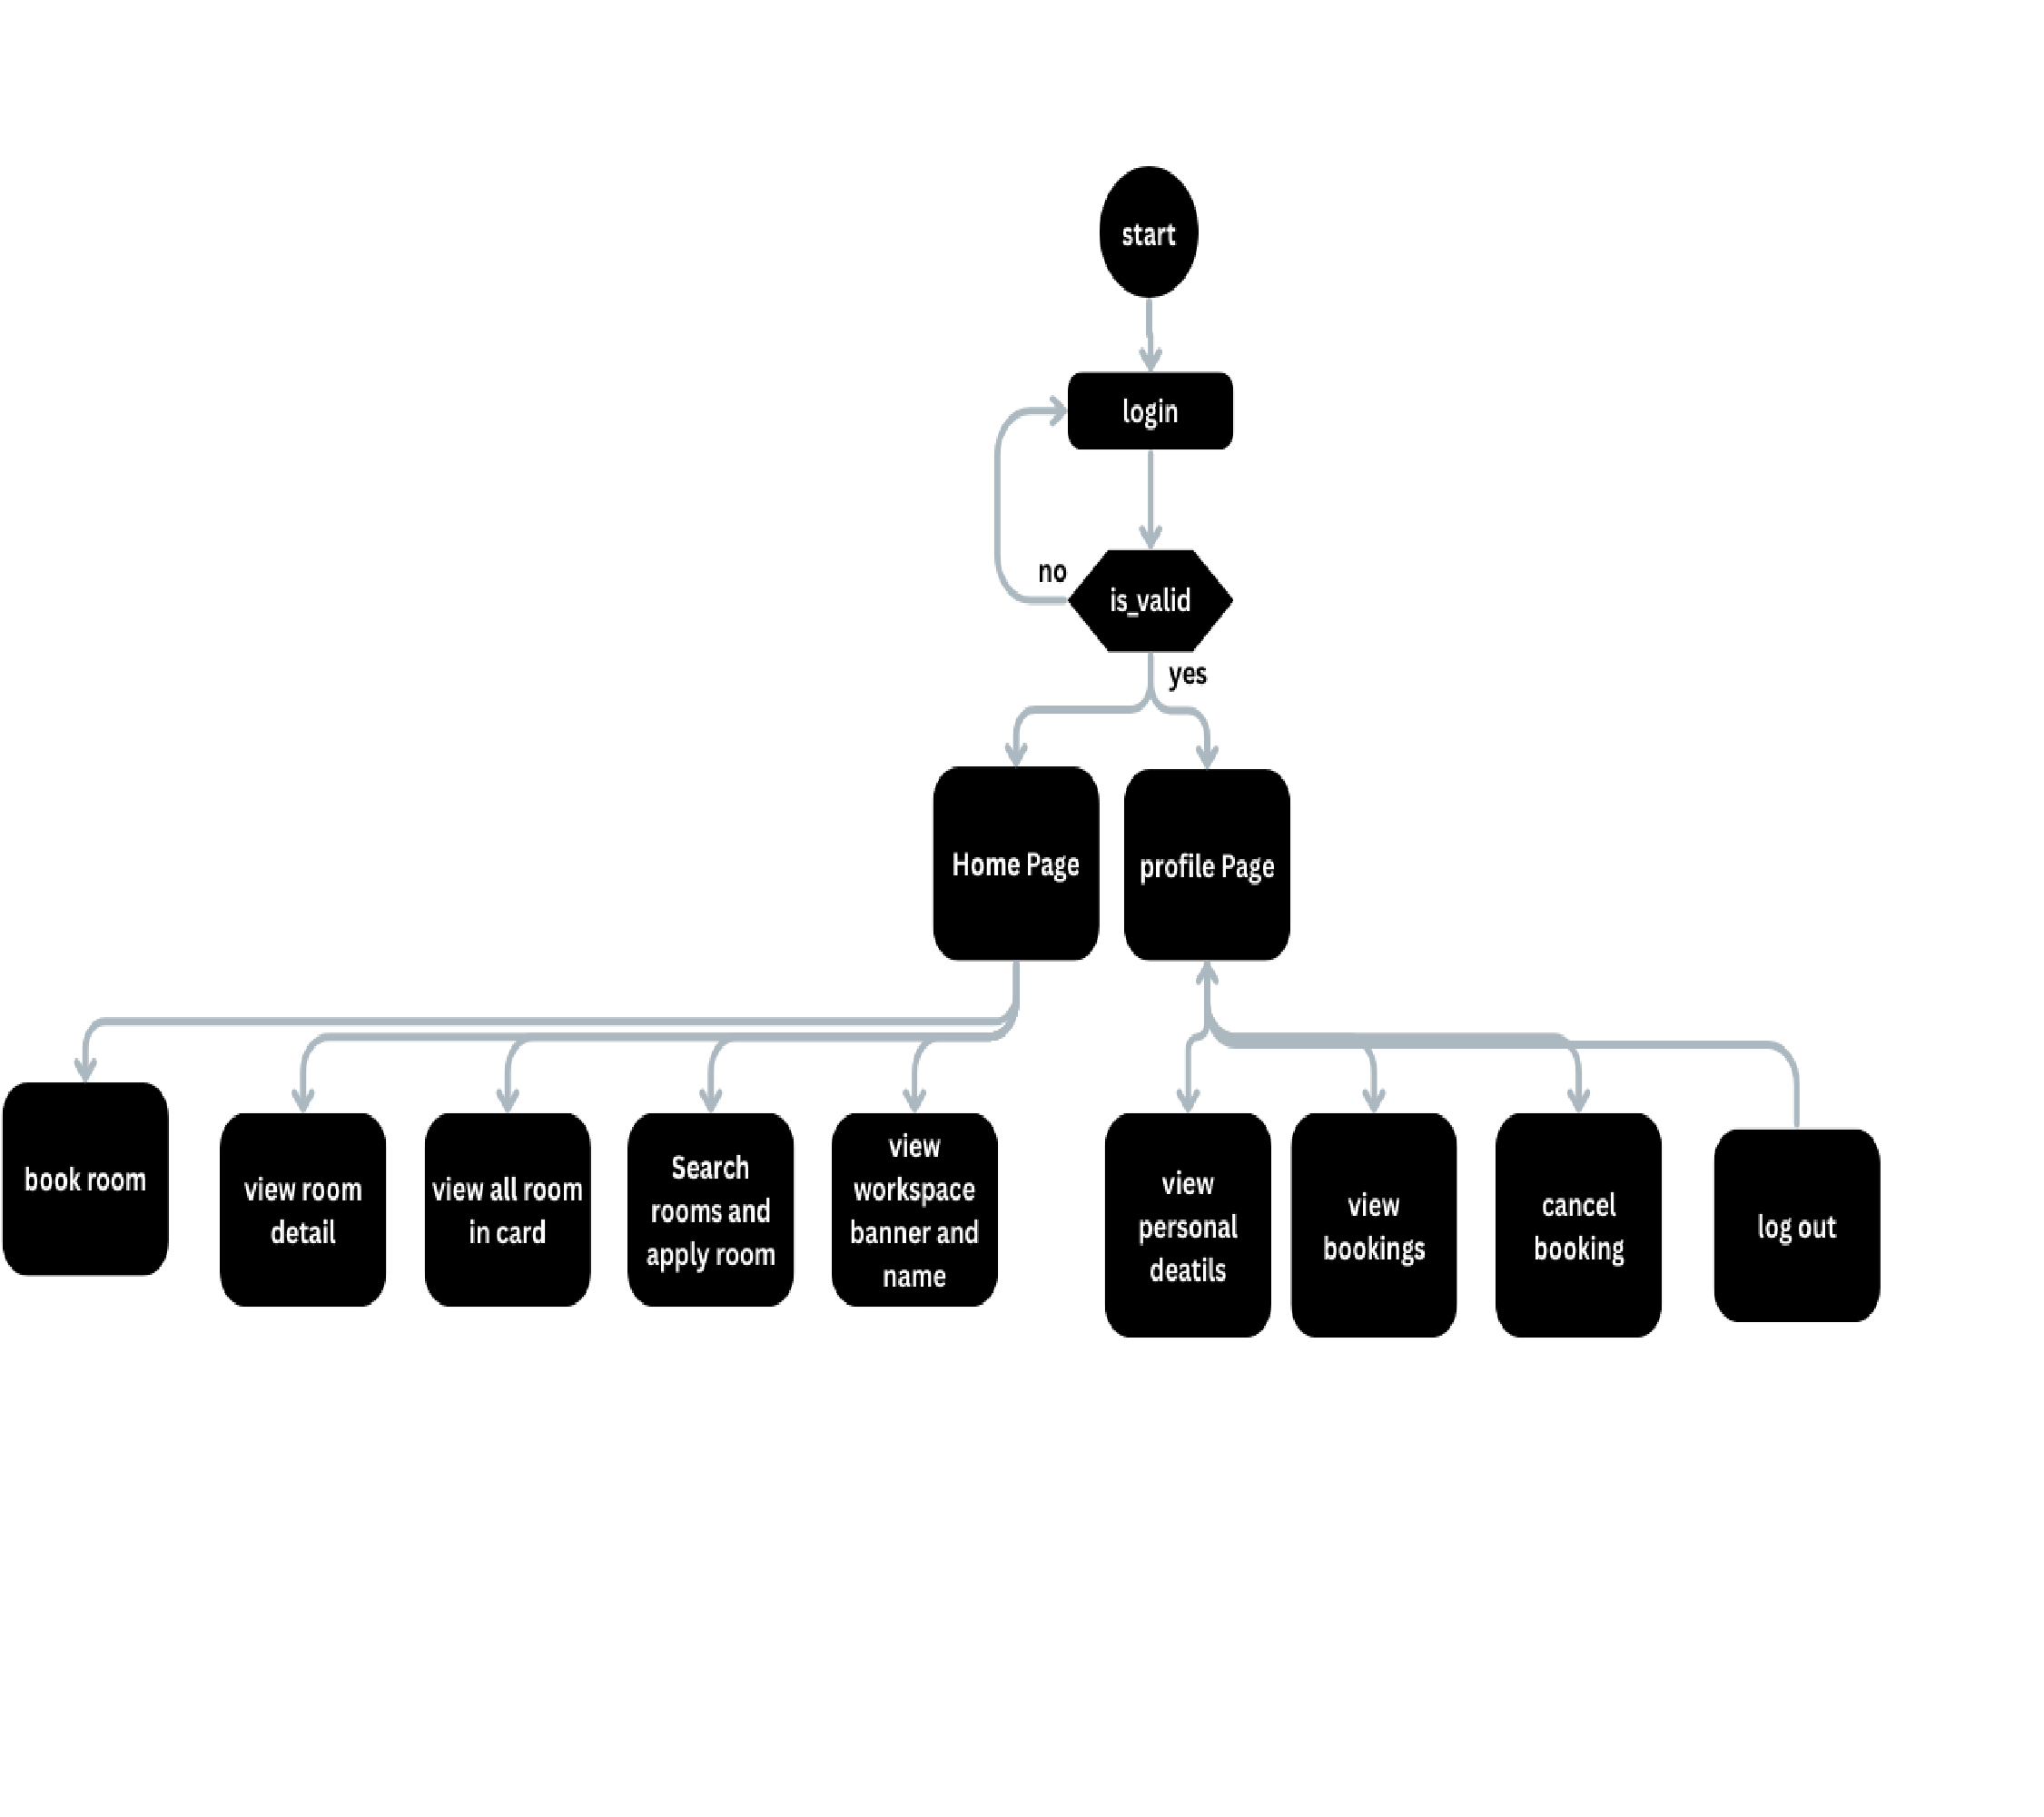
System Flow Chart User:

5. Database Design

- Users_tbl
User Id – Primary Key
Field Name | Data Type | Size | Constraint | Description
UserId | Int | 2,0 | Primary Key | Contains unique ID of User
Name | nvarchar(250) | 50 | Not Null | Full name of the user
Email | nvarchar(250) | 50 | Unique, Not Null | Unique email address
Phone | nvarchar(20) | 20 | Not Null | Contact number of user
Password | nvarchar(250) | 50 | Not Null | Password of user
Role | nvarchar(20) | 20 | Not Null | User role (admin / user)
Created_at | datetime | — | Not Null | Registration date & time

- Workspaces_tbl
Workspace Id – Primary Key
Field Name | Data Type | Size | Constraint | Description
WorkspaceId | Int | 2,0 | Primary Key | Unique ID of Workspace
Name | nvarchar(250) | 50 | Not Null | Workspace name
Banner_url | nvarchar(500) | 100 | Null | URL of banner image
Created_at | datetime | — | Not Null | Creation date & time

- RoomImages_tbl
Image Id – Primary Key
Field Name | Data Type | Size | Constraint | Description
ImageId | Int | 2,0 | Primary Key | Unique ID of Room Image
RoomId | Int | 2,0 | Foreign Key | FK → Rooms.RoomId
ImageUrl | nvarchar(500) | 100 | Not Null | URL / Path of room image
Created_at | datetime | — | Not Null | Date & time image was added

- Rooms_tbl
Room Id – Primary Key
Field Name | Data Type | Size | Constraint | Description
RoomId | Int | 2,0 | Primary  Key | Unique ID of Room
Name | nvarchar(250) | 50 | Not Null | Room name
WorkspaceId | Int | 2,0 | Foreign Key | FK → WorkspaceId
Room_type | nvarchar(50) | 20 | Not Null | Type (meeting / normal / chill)
Location | nvarchar(250) | 100 | Not Null | Full location of room
Size | int | — | Not Null | Capacity of the room
Has_computer | bit | 1 | Not Null | Whether room has computer
Has_projector | bit | 1 | Not Null | Whether room has projector
Description | nvarchar(500) | 100 | Null | Optional description
Created_at | datetime | — | Not Null | Room creation date & time

- Bookings_tbl
Booking Id – Primary Key
Field  Name | Data Type | Size | Constraint | Description
BookingId | Int | 2,0 | Primary  Key | Unique ID of Booking
UserId | Int | 2,0 | Foreign Key | FK → Users.UserId
RoomId | Int | 2,0 | Foreign Key | FK → Rooms.RoomId
Date | date | — | Not Null | Booking date
Start_time | time | — | Not Null | Start time of booking
Field  Name | Data Type | Size | Constraint | Description
End_time | time | — | Not Null | End time of booking
Purpose | nvarchar(500) | 100 | Null | Purpose / reason of booking
Status | nvarchar(20) | 20 | Not Null | Status (future / completed / cancelled)
Created_at | datetime | — | Not Null | Booking creation time

Screenshots
Sign Up page
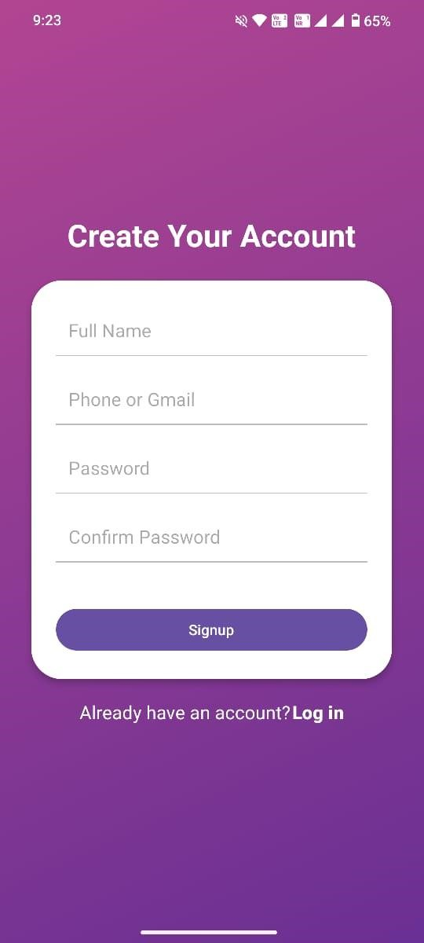
Login page

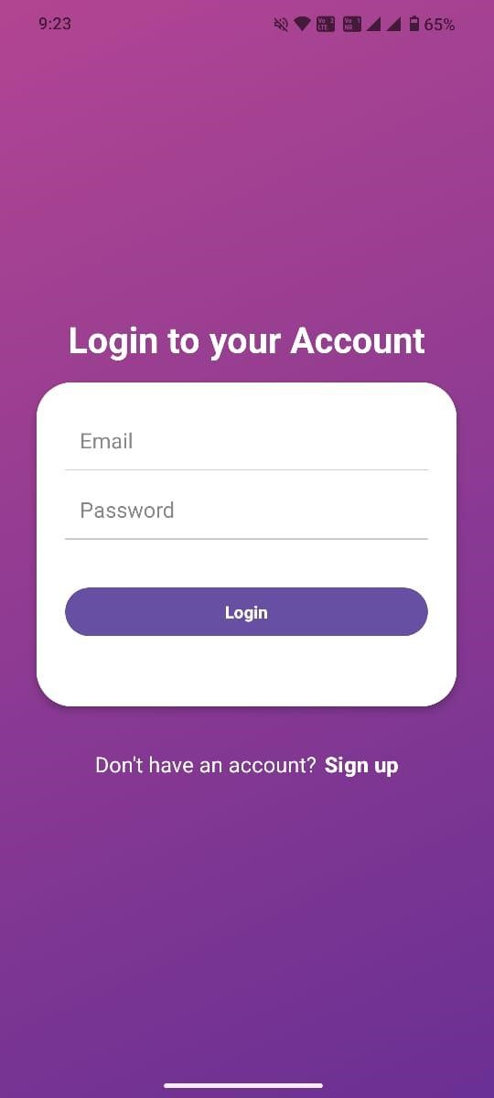
Home page

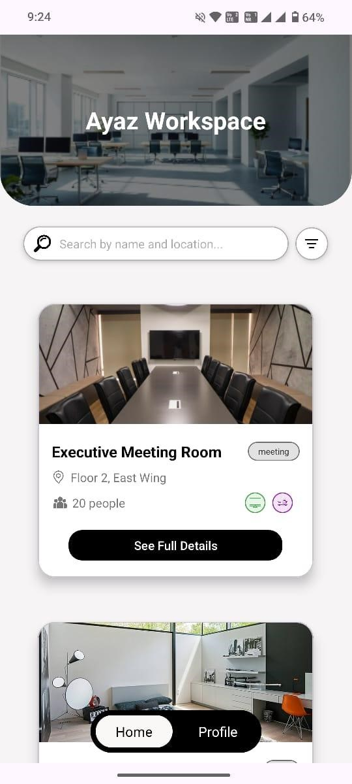
Profile page

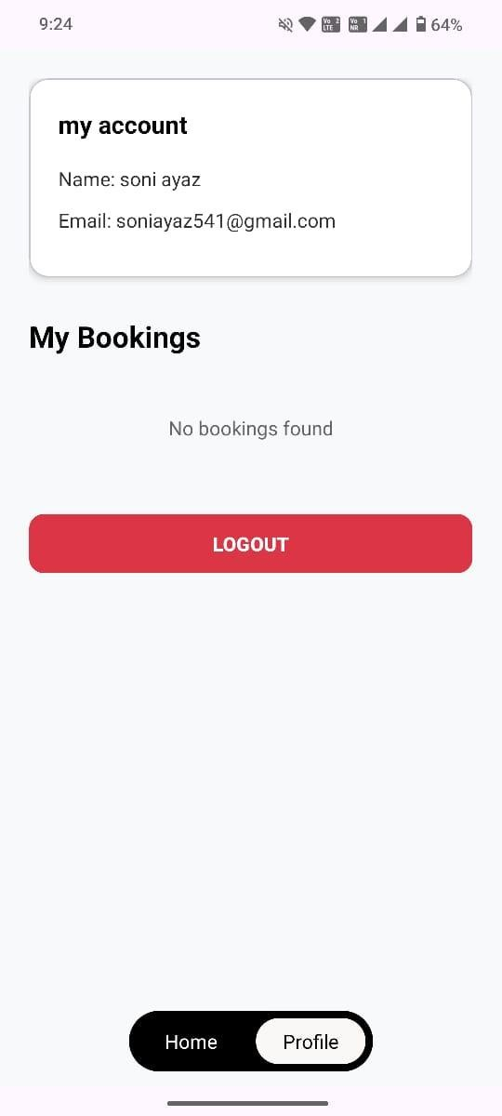

Filter room

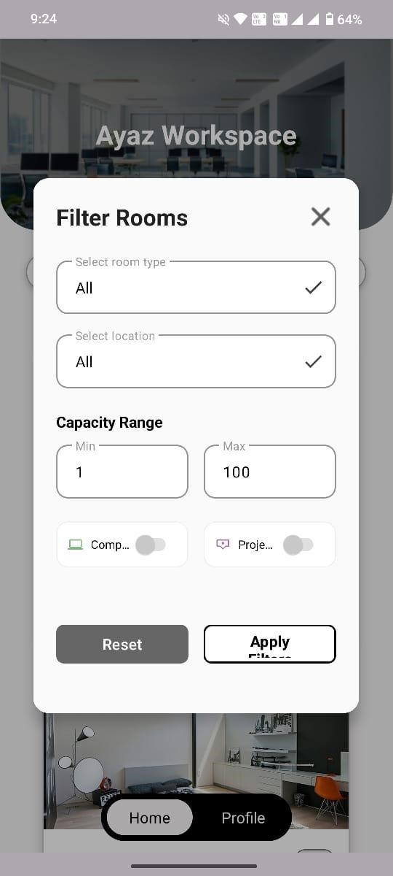
Room Detail

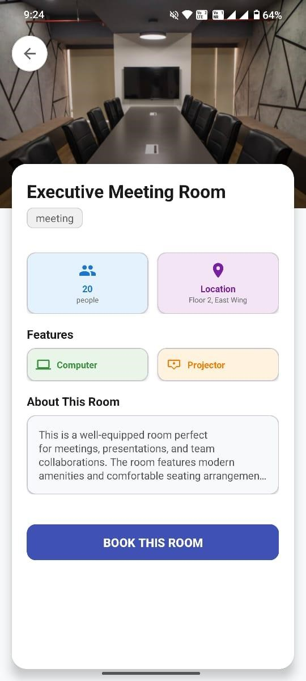

Booking Page

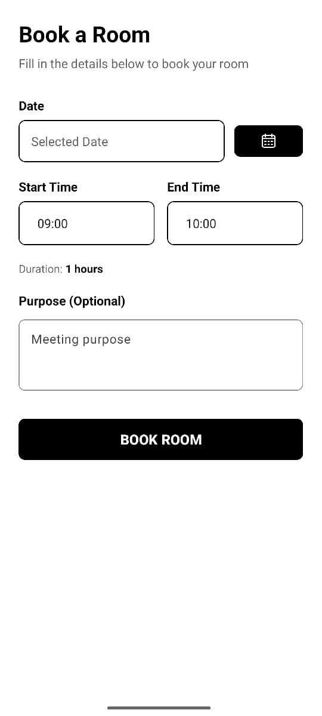

Cancel Booking

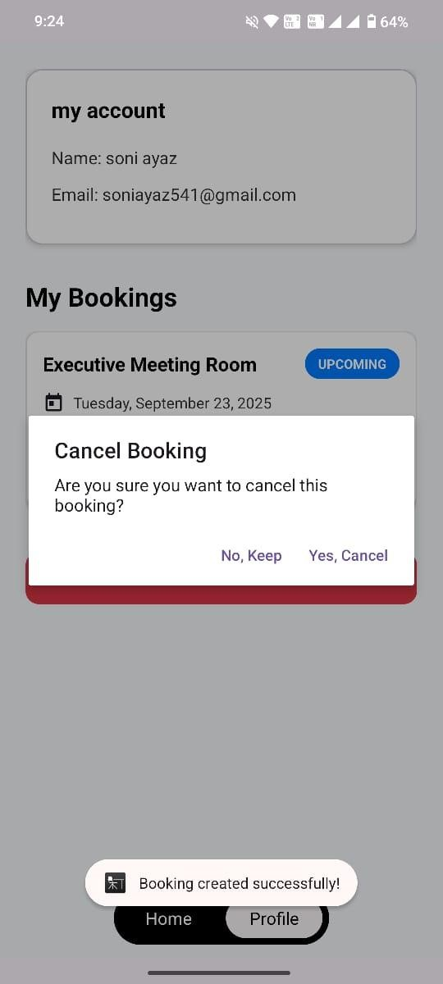

Admin Page

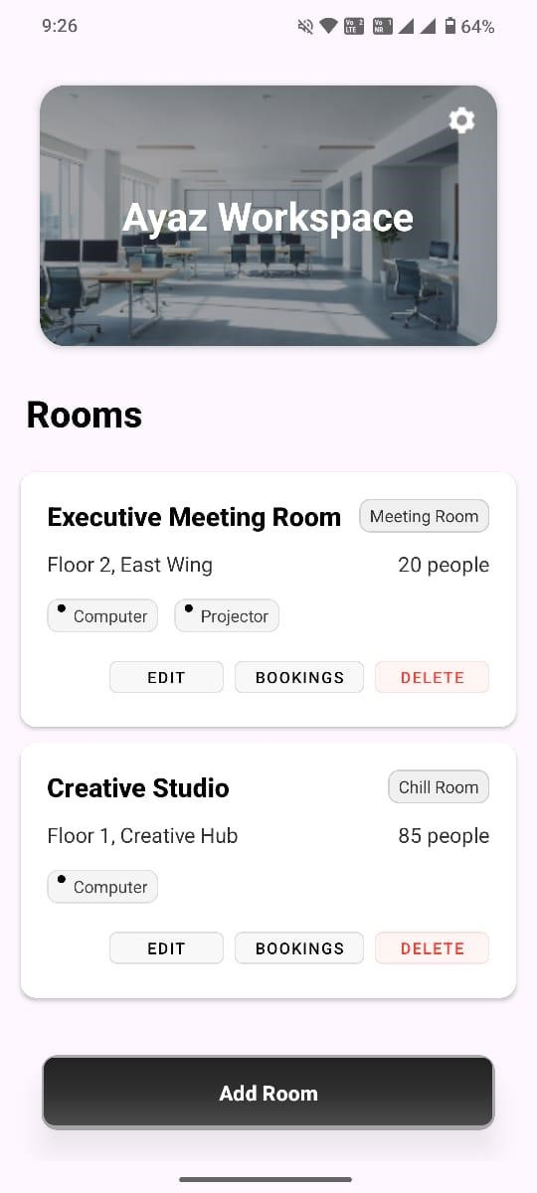

Add room dialog

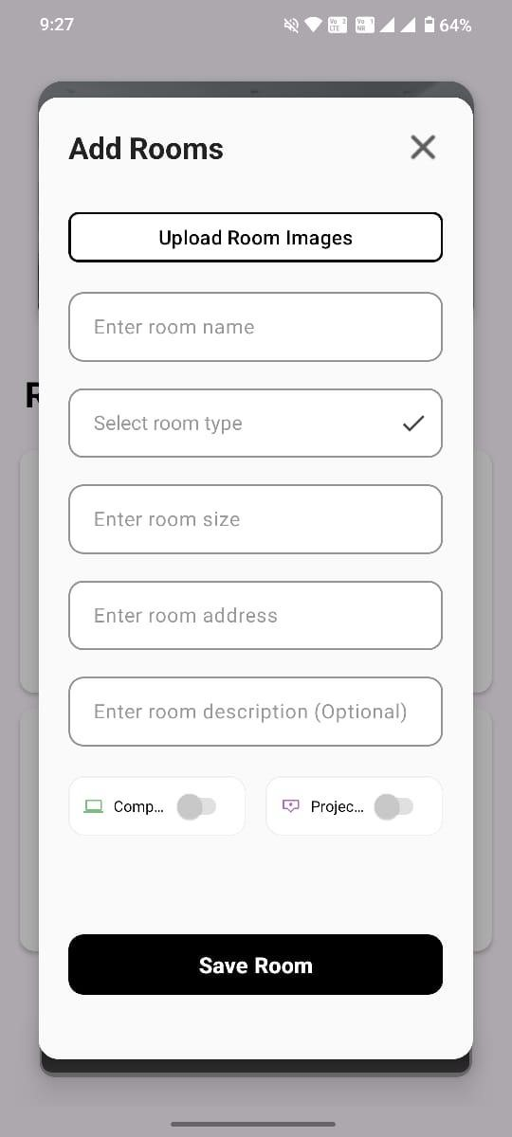
Edit room Dialog

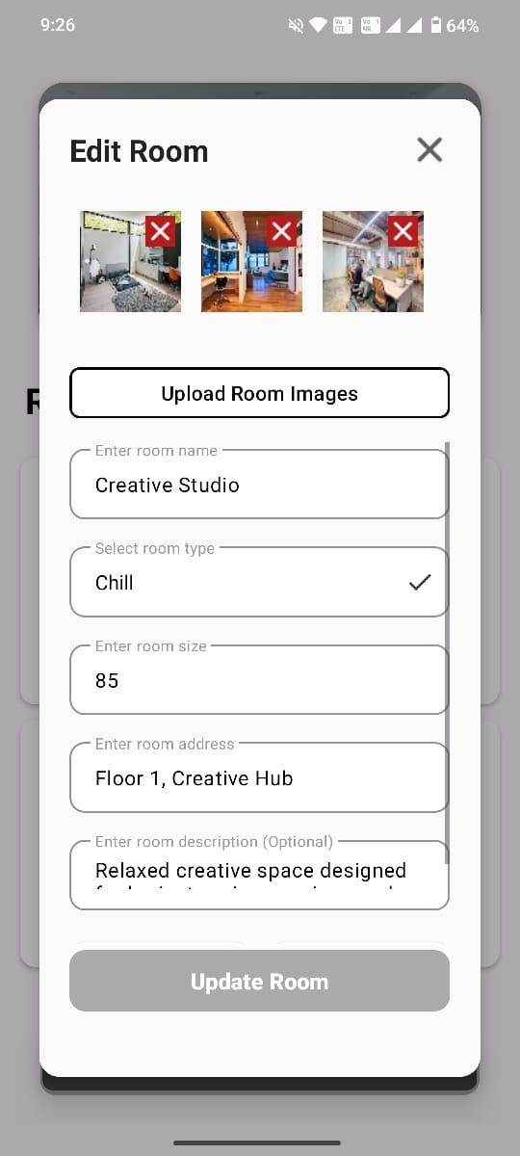

Certificate

