Code Review & Architecture Q&A

1. What steps would you take to secure a web application?
Security has to be layered end to end rather than bolted on at one point:
- Transport & headers: enforce HTTPS/TLS everywhere, HSTS, and security headers (CSP, X-Content-Type-Options, X-Frame-Options) to close common browser-side attack vectors.
- Authentication & authorization: strong password policies (or delegate to an identity provider), MFA where possible, short-lived JWT access tokens with rotating refresh tokens, and role/claim-based authorization enforced server-side on every endpoint — never trust a client-side check alone.
- Input handling: validate and sanitize all input at the boundary (FluentValidation or similar), use parameterized queries/ORM (EF Core) to eliminate SQL injection, and encode output to prevent XSS.
- CSRF & session hygiene: use anti-forgery tokens for cookie-based flows, store tokens in httpOnly/secure cookies where applicable, and invalidate sessions/refresh tokens on logout.
- Secrets management: never commit secrets to source control — use environment variables, user-secrets locally, or a managed vault (Azure Key Vault) in production; fail startup loudly if a required secret is missing.
- Rate limiting & abuse prevention: throttle authentication and other sensitive endpoints to blunt brute-force and credential-stuffing attempts.
- Dependency hygiene: run vulnerability scans (dotnet list package --vulnerable, npm audit) regularly and patch promptly — most real-world breaches exploit known, unpatched CVEs.
- Least privilege: scope database accounts, cloud IAM roles, and service-to-service credentials to only what each component actually needs.
- Observability: centralized logging and alerting so suspicious activity (repeated failed logins, unusual traffic) is caught quickly, plus periodic security review or penetration testing for anything handling sensitive data.

2. How would you improve the performance of a slow React application?
I would never optimize blind — the first step is always profiling (React DevTools Profiler, Chrome Performance tab, Lighthouse) to find where time is actually going, since the fix for a slow network request is completely different from the fix for an expensive re-render. From there, common levers:
- Re-render control: wrap expensive components in React.memo, and stabilize props/callbacks with useMemo/useCallback so children do not re-render on every parent update. Split large contexts so a change to one slice of state does not re-render every consumer.
- Code-splitting: lazy-load routes and heavy components with React.lazy + Suspense so the initial bundle only ships what the first screen needs.
- List rendering: virtualize long lists (react-window / react-virtualized) instead of rendering thousands of DOM nodes at once.
- Network efficiency: cache and deduplicate server requests with a data-fetching library (React Query/SWR) instead of re-fetching on every mount, and debounce/throttle handlers tied to frequent events (search-as-you-type, scroll, resize).
- Bundle size: analyze the production bundle (source-map-explorer) to find and remove oversized or duplicate dependencies, and confirm the app is actually running a production build.
- Assets: lazy-load and serve appropriately sized/modern-format images; they are frequently the single biggest contributor to a slow first paint.
Each of these should be verified with a before/after profile — performance work without measurement tends to optimize the wrong thing.

3. Explain the difference between SQL and NoSQL databases and when you would use each.
SQL (relational) databases — PostgreSQL, SQL Server, MySQL — store data in tables with a fixed schema and enforce relationships via foreign keys. They provide ACID transactions and strong consistency, and are built for complex queries and joins across related entities. I use a relational database (SQL Server + EF Core, as in this project) when the data is genuinely relational — users, roles, and their owned records.
NoSQL databases cover several different models — document (MongoDB), key-value (Redis), column-family (Cassandra), and graph (Neo4j) — and trade some consistency guarantees for flexibility and horizontal scale. They do not require a fixed schema up front, which suits data whose shape evolves or varies per record, and they are built to scale out across many nodes for very high read/write throughput.
I would reach for NoSQL when the access pattern, not the relationships, drives the design: high-velocity writes (telemetry, logs, IoT events), caching layers needing sub-millisecond key lookups, content with a flexible or evolving shape (a CMS with varying document structures), or graph-shaped data like social connections. The practical decision usually comes down to: do I need joins and transactional consistency across related records (SQL), or do I need to scale horizontally and store loosely structured, high-volume data (NoSQL)? Many real systems use both — a relational store for core business data and a NoSQL store for caching or logging alongside it.

4. How would you deploy a full-stack application to Azure?
For a project shaped like this one (ASP.NET Core API + React frontend + SQL Server), I would typically:
- Provision resources: Azure App Service (or Azure Container Apps for a containerized setup) for the API, Azure Static Web Apps for the built React bundle, and Azure SQL Database for data. .NET Aspire projects specifically integrate with the Azure Developer CLI (azd), which can provision and deploy the whole solution from the AppHost definition with minimal extra configuration.
- Build artifacts: dotnet publish for the API, npm run build for the frontend, producing the deployable output for each.
- Configuration & secrets: move connection strings and the JWT signing key out of appsettings.json into App Service Application Settings or Azure Key Vault — never deploy with secrets baked into the published files.
- Database: run EF Core migrations against the Azure SQL instance (dotnet ef database update pointed at the Azure connection string, or a migration bundle run as part of the pipeline) before or during the first deploy.
- CI/CD: a GitHub Actions or Azure DevOps pipeline that builds both projects, runs tests, and deploys on push to main — avoiding manual, inconsistent deploys.
- Networking & security: configure CORS on the API to allow only the real frontend origin, attach a custom domain with a managed TLS certificate, and put the API behind Azure Front Door or an App Service access restriction if it should not be publicly open.
- Observability: enable Application Insights on the API for request tracing, exception logging, and performance metrics post-deploy.
That sequence — provision, configure secrets properly, migrate the database, automate the deploy, then wire up monitoring — covers the practical gaps between "it runs locally" and "it runs safely in production."

Screenshots

First UI
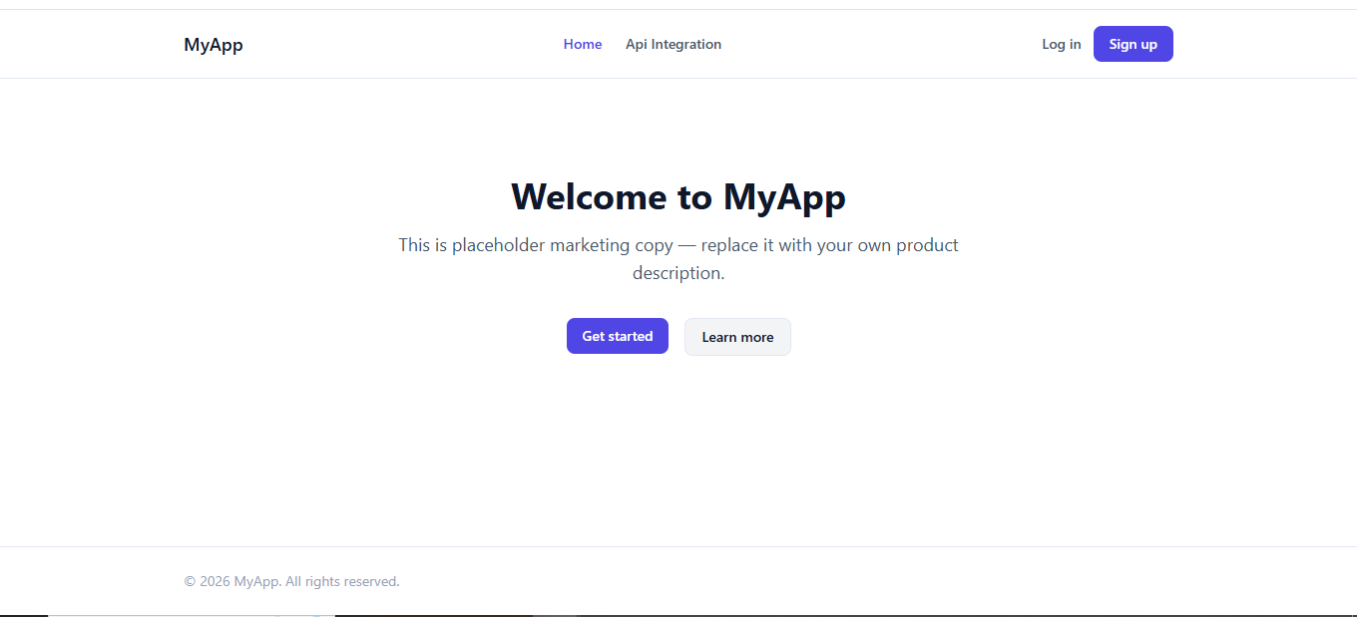

API Integrations

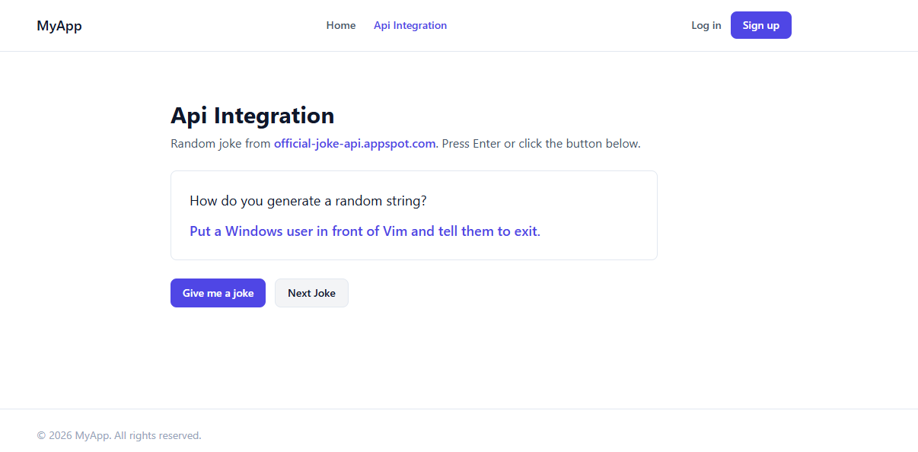

Task List

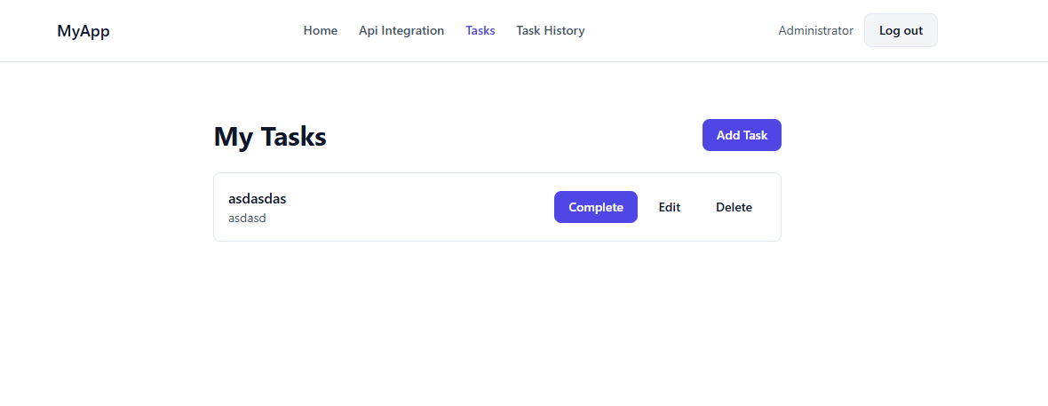

Task History

