JobFit AI
Project Documentation
Version 1.0 (Draft) – Prepared with Claude Code for Ivant
24 October 2026
Table of Contents

Introduction and Document Control
Item | Detail
Document | Documentation set - index and reading guide
Version | 1.0 draft
Date | 24 October 2026
Status | Draft for review
Author | Prepared with Claude Code for Ivant
Project owner | Ivant
Product version described | 0.1.0
Audience | Clients, end users, project owner, developers, testers
Purpose: This folder is the complete documentation set for JobFit AI. This page explains what is in each file and who should read it.

1. What is JobFit AI?
JobFit AI is a job-hunting app. The long-term idea is simple: you paste a job description, and the app helps you create a resume and cover letter that fit that job, using only the real facts you have stored about yourself.
Today (24 October 2026), the app helps you build and keep your Master Profile. This is one safe place that holds your personal details, work experience, projects, education and skills. You can type everything in yourself, or import it from an existing PDF or DOCX resume and review it before it is saved.
Core rule of the product: the AI never invents skills or experience. It may only rephrase, reorder and highlight real data. Anything the app cannot find stays blank, and in the planned job-matching feature, missing skills go to a "gaps" list.

2. Where the project stands today
Every feature in this documentation carries one of three status labels.
Label | Meaning
Available now | Built and accepted as complete (Phase 1).
Built, awaiting verification | Built (Phase 2) and covered by automated tests where noted, but not yet formally accepted. The manual acceptance checklist is in 10-testing-and-quality.md.
Planned | Not built. Described only so readers know the direction. Phases 3 to 7 are all in this group.

Phase | Scope | Status
1 | Foundation: database, API skeleton, app shell, login | Available now
2 | Master Profile: profile screens, resume import, profile photo | Built, awaiting verification
3 to 7 | AI job matching and document generation, export and editor, tracker and analytics, automation, release polish | Planned (nothing built)
Details are in 09-roadmap-and-status.md.

3. Table of contents
# | File | One-line description | Who should read it
01 | 01-product-overview.md | Vision, problem, users, scope, assumptions and success criteria | Everyone, especially clients
02 | 02-requirements-specification.md | Business, functional and non-functional requirements, user stories, traceability | Clients, analysts, testers
03 | 03-user-guide.md | Step-by-step guide for using the app, FAQ and troubleshooting | End users, support staff
04 | 04-system-analysis-and-design.md | Actors, use cases, diagrams, business rules, error handling | Analysts, developers, testers
05 | 05-architecture.md | Architecture, technology, components, AI provider layer, design decisions | Developers, technical stakeholders
06 | 06-data-model.md | Tables, relationships, access rules, storage buckets, sample data | Developers, database staff
07 | 07-security-and-privacy.md | Security model, privacy and data handling, risks | Clients, security reviewers, developers
08 | 08-api-reference.md | Every backend endpoint and the direct Supabase access | Developers
09 | 09-roadmap-and-status.md | Phase roadmap, limitations, risks, next steps, decisions log | Clients, project owner
10 | 10-testing-and-quality.md | Test strategy, results, how to run tests, acceptance checklist | Testers, clients (acceptance)
11 | 11-glossary.md | Plain-language explanation of terms | Everyone
12 | 12-installation-and-operations.md | Setup on Windows, configuration, running, Android, troubleshooting | Technical staff
- | CHANGELOG.md | What changed, by version | Everyone

4. How to read this documentation
Pick the path that matches your role. You do not need to read everything.
If you are... | Start with | Then read
A client or sponsor | 01 | 09, 07 (sections 1 to 3), 02
An end user | 03 | 11 if a word is unclear
An acceptance tester | 10 (section 5) | 03, 02
A business or system analyst | 02 | 04, 06
A developer | 05 | 08, 06, 12
A security reviewer | 07 | 05, 06
Two audiences, kept apart. Files 01, 03 and 09 are written in plain language. Files 04, 05, 06, 07 (later sections), 08 and 12 are technical. File 02 has both: the business requirements and user stories are plain, the non-functional requirements are technical.

5. Conventions used in all files
- Product name: JobFit AI. Main data area: Master Profile.
- IDs: BRQ- business requirement, FR- functional requirement, NFR- non-functional requirement, US- user story, UC- use case, BR- business rule (file 04), UAT- acceptance test (file 10), ERR- error case (file 04).
- Priorities: Must, Should, Could.
- Honesty rule: If the code does not clearly confirm a behaviour, the text says to be confirmed instead of guessing.
- No secrets: These documents never contain keys, passwords or the contents of any .env file. Only variable names are shown, with placeholder values.
- Screenshots: Not included yet. The checklist of screenshots to add is at the end of 03-user-guide.md.
- Dates: Written as day, month name, year (for example 24 October 2026).

6. Source of truth
This documentation was written by reading the actual code, database migrations and tests in the repository on 24 October 2026. If the code and a document disagree, the code is correct and the document should be corrected. Please report the difference to the project owner.

01 – Product Overview
Item | Detail
Document | Product overview
Version | 1.0 draft
Date | 24 October 2026
Status | Draft for review
Audience | Clients, sponsors, end users, project team
Purpose: To explain what JobFit AI is for, who it helps, what it does today, and what it will not do. This file is written in plain language.

1. Vision
Applying for jobs is slow because every employer wants a slightly different resume and cover letter. JobFit AI aims to make this faster and calmer: you keep one trusted record of your real background, and the app helps you present it well for each job, without ever making things up.

2. Problem statement
Problem | Effect on the job seeker
Resumes must be rewritten for each job | Hours of repeated work, copy-and-paste mistakes
Details are scattered across old files | Hard to remember what was said where
Online tools that "write for you" may add skills you do not have | Risk of false claims in an application
Applications are hard to track | Missed follow-ups
JobFit AI's answer is a Master Profile (one source of truth), with an AI that is only allowed to work with the facts in it.

3. Target users
User group | Description | Main need
Active job seekers | People applying to several jobs | Keep details in one place, reuse them
Career changers and graduates | People with limited experience or mixed backgrounds | Present real strengths honestly
Mobile-first users | People who prefer a phone | A simple app that works on a phone screen
The primary user and owner of the project is a single developer (Ivant) building the app as a portfolio project. No customer list, user numbers or market figures exist, and none are claimed here.

4. Value proposition
- One place for your facts. Personal details, jobs, projects, education and skills in a single profile.
- Honest by design. The AI never invents skills or experience.
- Fast start. Import an existing PDF or DOCX resume, then review and correct it before anything is saved.
- You stay in control. Nothing is saved from an import until you press "Save to profile". Duplicates are detected for you.
- Private. Your uploaded resume file is not stored, and your profile data is only visible to you (see 07-security-and-privacy.md).

5. The core rule
The AI never invents skills or experience. It may rephrase, reorder and highlight real data only. Anything it cannot find stays blank. In the planned matching feature, skills that a job asks for but you do not have go to a "gaps" list instead of being added to your resume.
How this rule is enforced today in resume import:
- The AI is told to copy only what is written in the resume and to use "not found" otherwise.
- After the AI answers, the server checks emails, phone numbers, web links, dates, years, skills and technologies against the resume text. Values it cannot find in the text are removed.
- Imported skills are added without a level. The app never guesses your level.
- You review every item and can edit or untick it before saving.
Honest limit: free-text fields such as job titles, company names, bullet points and the summary are copied by the AI and are not word-for-word verified by the server. This is why the review step exists. See 07-security-and-privacy.md, section 4.

6. Key features and status
Feature | Description | Status
Sign up and log in | Email and password through Supabase | Available now
Home dashboard: system checks | Shows whether login, profile record and backend are working | Available now
Home dashboard: profile completeness and recent activity | Progress ring (8 checks) and last 5 logged actions | Built, awaiting verification
Personal info | Name, headline, phone, location, links, summary | Built, awaiting verification
Experience, Projects, Education | Add, edit, delete entries | Built, awaiting verification
Skills with levels | Search the shared skills bank, set level 1 to 5 and years | Built, awaiting verification
Custom skills | Add a skill that is not in the bank | Built, awaiting verification
Resume import | Upload PDF or DOCX, choose an AI model, review, save | Built, awaiting verification
Profile photo | Choose or take a photo, adjust, save, remove | Built, awaiting verification
Themes | 35 colour themes, light and dark | Available now
Job description parsing and skill matching | Paste a job post, match against your profile, list gaps | Planned (Phase 3)
Tailored resume and cover letter generation | Using only real profile data | Planned (Phase 3)
DOCX/PDF export and editor | Download and edit generated documents | Planned (Phase 4)
Application tracker, activity logs, analytics | Follow each application from saved to offer | Planned (Phase 5)
Automation | Share-to-app, follow-up reminders, weekly report | Planned (Phase 6)
Release polish | Testing, Android/iOS builds, screenshots | Planned (Phase 7)
The Jobs and Tracker tabs exist in the app but only show a "Coming soon" message.

7. Scope

7.1 In scope (version 0.1.0)
Area | Included
Accounts | Sign up, log in, log out
Master Profile | Personal info, experience, projects, education, skills (with custom skills)
Resume import | PDF and DOCX, up to 5 MB, choice of AI model, review before saving
Profile photo | Private storage, in-app crop
Appearance | 35 themes
Platforms | Web browser; Android through Capacitor

7.2 Out of scope (version 0.1.0)
Area | Reason
Job description parsing, matching, resume and cover letter generation | Planned for Phase 3
DOCX/PDF export and document editor | Planned for Phase 4
Application tracker and analytics | Planned for Phase 5
Reminders, share-to-app, weekly report | Planned for Phase 6
iOS app | No iOS project exists yet; release work is Phase 7
Reading scanned (image-only) resumes | No text recognition (OCR) is built
Old Word files (.doc) | Not supported; save as .docx or PDF
Password reset, account deletion, profile export screens | Not found in the app; to be confirmed whether planned

8. Assumptions
ID | Assumption
A-1 | Users have an email address and an internet connection.
A-2 | The project owner runs the Supabase project and applies the database migrations in order (0001, then 0002).
A-3 | At least one AI provider key (Groq, Google Gemini or OpenAI) is configured on the server for resume import to work.
A-4 | Free-tier AI plans are enough for development and testing.
A-5 | Users upload text-based PDF or DOCX resumes.
A-6 | Whether new accounts must confirm their email depends on the Supabase project settings.

9. Constraints
ID | Constraint
C-1 | Technology is fixed: Ionic and Vue front end, FastAPI back end, Supabase for database, login and storage.
C-2 | AI cost must stay low: resume import uses free-tier providers, which have rate limits and may change model names.
C-3 | Secrets (service key, AI keys) must live only on the server.
C-4 | The AI must never invent skills or experience.
C-5 | A single developer builds and maintains the project.
C-6 | Resume file limits: 5 MB, 30 pages read, 30,000 characters sent to the AI.

10. Success criteria
These are qualitative. No numeric targets have been agreed, so none are stated.
ID | Criterion | How it is judged
S-1 | A new user can create an account and reach the Home screen without help. | Acceptance checklist UAT-01 to UAT-03 (10)
S-2 | A user can build a complete Master Profile by hand. | UAT-04 to UAT-10
S-3 | A user can import a text-based resume, review it and save it, and nothing is saved without confirmation. | UAT-11 to UAT-18
S-4 | Imported data contains no skills, dates or contact details that are not in the resume. | UAT-16 and the automated anti-invention tests
S-5 | One user can never see another user's profile data or photo. | Access-rule review (06); live check to be confirmed
S-6 | Errors are shown in friendly words, never as raw technical text. | UAT-23 and troubleshooting table in 03
S-7 | The project owner can explain, run and extend the system using this documentation. | Review of files 05, 06, 08 and 12

11. Related documents
- Requirements in detail: 02-requirements-specification.md
- How to use the app: 03-user-guide.md
- Roadmap: 09-roadmap-and-status.md

02 – Requirements Specification
Item | Detail
Document | Requirements specification
Version | 1.0 draft
Date | 24 October 2026
Status | Draft for review
Audience | Clients, business and system analysts, testers
Purpose: To list what JobFit AI must do (business, functional and non-functional requirements), to describe the implemented features as user stories with acceptance criteria, and to trace each requirement to a feature, a status and a test.
Status labels: Available now (Phase 1 complete), Built, awaiting verification (Phase 2), Planned (Phases 3 to 7, not built). See README.md.

1. Business requirements
ID | Business requirement | Priority | Status
BRQ-01 | Each user has one trusted Master Profile that holds their real background. | Must | Built, awaiting verification
BRQ-02 | Users can save typing time by importing an existing resume. | Must | Built, awaiting verification
BRQ-03 | The AI never invents skills or experience; missing items stay blank (and go to a "gaps" list in the planned matching feature). | Must | Built, awaiting verification (import); Planned (gaps list)
BRQ-04 | A user's data is private to that user. | Must | Built, awaiting verification
BRQ-05 | Running costs stay low (free-tier AI providers for resume import). | Should | Built, awaiting verification
BRQ-06 | The app works in a web browser and on Android phones. | Should | Available now (web); Built, awaiting verification (Android)
BRQ-07 | Users can paste a job description and receive a tailored resume and cover letter. | Must (product goal) | Planned (Phase 3)
BRQ-08 | Users can track every application and see analytics. | Should | Planned (Phase 5)
BRQ-09 | All messages are friendly and understandable to non-technical users. | Should | Built, awaiting verification

2. Functional requirements
Priority: Must, Should, Could. "Tested by" lists automated test files (see 10-testing-and-quality.md) and manual acceptance tests (UAT).

2.1 Accounts and access (AUTH)
ID | Requirement | Priority | Status | Tested by
FR-AUTH-01 | A visitor can sign up with email, password (at least 6 characters, checked in the app) and an optional full name. | Must | Available now | UAT-01
FR-AUTH-02 | A user can log in with email and password. Wrong details show a friendly message. | Must | Available now | UAT-02, UAT-03; dashboard.spec.ts (friendly errors)
FR-AUTH-03 | A profile record is created automatically when an account is created (database trigger). | Must | Available now | UAT-01
FR-AUTH-04 | A user can log out. Logging out clears the profile, photo and any import draft held in memory. | Must | Built, awaiting verification | avatarStore.spec.ts (reset); UAT-26
FR-AUTH-05 | Signed-out visitors are sent to the login screen; signed-in users who open the login screen are sent to Home. | Must | Available now | UAT-02
FR-AUTH-06 | The backend rejects requests without a valid login token (HTTP 401). | Must | Available now | test_api.py, test_skills.py, test_resume_import.py, test_ai_models.py

2.2 Home dashboard (DSH)
ID | Requirement | Priority | Status | Tested by
FR-DSH-01 | Home greets the user by time of day and first name. | Should | Built, awaiting verification | UAT-25
FR-DSH-02 | Home shows profile completeness as a percentage, built from 8 equal checks (see 04, section 6). | Must | Built, awaiting verification | dashboard.spec.ts, profileLogic.spec.ts; UAT-25
FR-DSH-03 | Home shows the next suggested step and a Start/Continue button until the profile is complete. | Should | Built, awaiting verification | UAT-25
FR-DSH-04 | Home lists the 5 most recent logged activities with an icon and a relative time. | Should | Built, awaiting verification | dashboard.spec.ts (activityKind)
FR-DSH-05 | Home shows system status for login, profile record and backend, with a Retry button. | Should | Available now | UAT-23
FR-DSH-06 | Pulling down on Home and Profile refreshes the data. | Could | Built, awaiting verification | UAT-25
FR-DSH-07 | Quick actions: "Paste a job description" (opens the Jobs tab, which says "Coming soon"), "Edit profile", and "Import from resume" (shown only while the profile is incomplete). | Should | Built, awaiting verification | UAT-27

2.3 Personal info (PROF)
ID | Requirement | Priority | Status | Tested by
FR-PROF-01 | A user can save full name (required, up to 100 characters), headline (120), phone (30), location (100) and summary (1,000). | Must | Built, awaiting verification | profileLogic.spec.ts; UAT-04
FR-PROF-02 | A user can save GitHub, LinkedIn and website links (up to 200 characters). A missing https:// is added automatically. | Should | Built, awaiting verification | profileLogic.spec.ts; UAT-04
FR-PROF-03 | Invalid phone numbers and web addresses show a friendly message before saving. | Must | Built, awaiting verification | profileLogic.spec.ts
FR-PROF-04 | The Profile screen shows name, headline, location, counts of jobs/projects/skills, completeness and a row per section with a tick when done. | Should | Built, awaiting verification | UAT-25

2.4 Experience, projects, education (EXP, PRJ, EDU, CRUD)
ID | Requirement | Priority | Status | Tested by
FR-EXP-01 | A user can add, edit and delete work experience: role and company (required, up to 100 each), location, start month, end month or "I currently work here", up to 12 bullet points of up to 300 characters. | Must | Built, awaiting verification | profileLogic.spec.ts; UAT-05
FR-EXP-02 | Experience is listed newest first; current jobs come first. | Should | Built, awaiting verification | profileLogic.spec.ts (sorting)
FR-PRJ-01 | A user can add, edit and delete projects: name (required, up to 100), description (600), up to 20 technologies (30 characters each), link. | Must | Built, awaiting verification | profileLogic.spec.ts; UAT-06
FR-PRJ-02 | Projects are listed newest first. | Should | Built, awaiting verification | profileLogic.spec.ts (sorting)
FR-EDU-01 | A user can add, edit and delete education: school (required, up to 120), degree, honors, start and end year (4 digits, 1950 up to 8 years ahead, end not before start). | Must | Built, awaiting verification | profileLogic.spec.ts; UAT-07
FR-EDU-02 | Education is listed with the latest finishing year first; no end year (still studying) comes first. | Should | Built, awaiting verification | profileLogic.spec.ts (sorting)
FR-CRUD-01 | Deleting any entry asks for confirmation. Saving or deleting shows a short message and updates the Home progress. | Must | Built, awaiting verification | UAT-05 to UAT-10, UAT-25

2.5 Skills (SKL)
ID | Requirement | Priority | Status | Tested by
FR-SKL-01 | A user can search the shared skills bank by name, canonical name or alias. Skills the user already has are hidden from the results. | Must | Built, awaiting verification | profileLogic.spec.ts (skills); UAT-08
FR-SKL-02 | A user adds a skill with a level from 1 to 5 (Beginner, Basic, Intermediate, Advanced, Expert) and optional years of experience (0 to 60, one decimal). | Must | Built, awaiting verification | profileLogic.spec.ts; UAT-08
FR-SKL-03 | A user can change the level or years of a skill, and remove a skill (swipe left, with confirmation). | Must | Built, awaiting verification | UAT-10
FR-SKL-04 | If a skill is not in the bank, the user can add it as a custom skill (2 to 60 characters; letters, digits, spaces and . + # - / & _ only). The server never creates a duplicate. | Must | Built, awaiting verification | test_skills.py; UAT-09
FR-SKL-05 | Skills without a level (from resume import) show a "Set level" tag. | Should | Built, awaiting verification | importLogic.spec.ts; UAT-17
FR-SKL-06 | The skills bank starts with 25 seeded skills (database migration 0001). | Should | Available now | UAT-08

2.6 Resume import (IMP)
ID | Requirement | Priority | Status | Tested by
FR-IMP-01 | The user can choose one PDF or DOCX file up to 5 MB. Wrong type, empty or too-large files are refused in the app before upload; old .doc files get a specific message. | Must | Built, awaiting verification | resumeImport.spec.ts; UAT-20
FR-IMP-02 | The user can choose which AI model reads the resume from a list supplied by the server. Models whose provider has no key are shown as "not set up" and cannot be chosen. The last choice is remembered on the device. | Must | Built, awaiting verification | aiModels.spec.ts, test_ai_models.py; UAT-11
FR-IMP-03 | The server reads the file in memory only (PDF: first 30 pages; DOCX: paragraphs, tables and page header) and sends at most 30,000 characters of text to the AI. | Must | Built, awaiting verification | test_resume_import.py
FR-IMP-04 | The server removes anything the AI returned that cannot be found in the resume text (anti-invention guard). | Must | Built, awaiting verification | test_resume_import.py (hallucination tests); UAT-16
FR-IMP-05 | The result is a draft shown for review. Nothing is saved until the user presses "Save to profile". | Must | Built, awaiting verification | test_resume_import.py (nothing is saved); UAT-13
FR-IMP-06 | Items missing a required detail (role and company; school; project name) are flagged and start unticked. | Should | Built, awaiting verification | importLogic.spec.ts
FR-IMP-07 | Items that match something already in the profile, or another ticked item in the same import, are flagged and not saved. | Must | Built, awaiting verification | importLogic.spec.ts; UAT-14
FR-IMP-08 | Personal info is merged safely: empty profile fields are filled; where both differ, the user chooses "Keep current" (default) or "Use imported". Email is not imported. | Must | Built, awaiting verification | importLogic.spec.ts; UAT-15
FR-IMP-09 | Skills are matched to the bank (name, canonical name, alias, any letter case). Skills the user already has are skipped. Skills not in the bank are added only if the user ticks them. All are added without a level. | Must | Built, awaiting verification | importLogic.spec.ts; UAT-17
FR-IMP-10 | If some writes fail, the others still save, the message states how many worked, and trying again does not save the same item twice. | Should | Built, awaiting verification | resumeImport.spec.ts (executePlan)
FR-IMP-11 | The draft lives only in memory. It is wiped after a successful save, after Discard, and at log out. Discarding an edited draft asks for confirmation. | Must | Built, awaiting verification | UAT-18, UAT-26
FR-IMP-12 | The user can cancel while the resume is being read. | Should | Built, awaiting verification | UAT-11
FR-IMP-13 | Every failure shows a short friendly message and, where it makes sense, a "Try again" button. | Must | Built, awaiting verification | resumeImport.spec.ts; UAT-19, UAT-20
FR-IMP-14 | The uploaded file and its text are never stored or logged. The activity log keeps only the provider, model, counts and file type. | Must | Built, awaiting verification | test_resume_import.py (log and storage tests)

2.7 Profile photo (AVA)
ID | Requirement | Priority | Status | Tested by
FR-AVA-01 | The user can choose a photo from the gallery or take one with the camera (JPEG, PNG or WebP, up to 10 MB). | Should | Built, awaiting verification | imageCrop.spec.ts; UAT-21
FR-AVA-02 | The user can move and zoom the photo in a round window; the saved result is a 512 by 512 pixel JPEG. | Should | Built, awaiting verification | imageCrop.spec.ts; UAT-21
FR-AVA-03 | The photo is stored in a private bucket, in the user's own folder, and shown through a short-lived link (1 hour) that is renewed automatically. | Must | Built, awaiting verification | avatarLogic.spec.ts, avatarStore.spec.ts
FR-AVA-04 | The user can remove the photo (with confirmation); initials are shown instead. | Should | Built, awaiting verification | avatarStore.spec.ts; UAT-22
FR-AVA-05 | If the database update (migration 0002) has not been applied, the app keeps working and says "Photo upload is not set up yet - run the database update." | Should | Built, awaiting verification | avatarLogic.spec.ts, avatarStore.spec.ts

2.8 Appearance (THM)
ID | Requirement | Priority | Status | Tested by
FR-THM-01 | The user can choose from 35 colour themes (filter: Light, Dark, All) on the Login and Home screens. | Should | Available now | theme.spec.ts; UAT-24
FR-THM-02 | The choice is saved on the device. With no saved choice, the app follows the device's light or dark setting. | Should | Available now | theme.spec.ts; UAT-24
FR-THM-03 | Animations are reduced when the device asks for reduced motion. | Should | Built, awaiting verification | motion.spec.ts

2.9 Backend services (API)
ID | Requirement | Priority | Status | Tested by
FR-API-01 | GET /api/v1/health is public and reports status, environment, and whether Supabase and AI are configured. | Must | Available now | test_api.py, test_ai_models.py
FR-API-02 | GET /api/v1/me returns the user id, email and profile row for a valid token. | Must | Available now | test_api.py
FR-API-03 | POST /api/v1/skills/custom creates or returns a skill in the shared bank. | Must | Built, awaiting verification | test_skills.py
FR-API-04 | GET /api/v1/ai/models lists selectable models and availability, never keys. | Must | Built, awaiting verification | test_ai_models.py
FR-API-05 | POST /api/v1/profile/import-resume returns a draft profile and saves nothing. | Must | Built, awaiting verification | test_resume_import.py, test_ai_providers.py
FR-API-06 | Meaningful backend actions are written to the activity log (auth.me_checked, skill.created, resume.parsed). | Should | Built, awaiting verification | test_resume_import.py, test_skills.py

2.10 Planned functional requirements (not built)
ID | Requirement | Priority | Status
FR-AI-01 | Parse a pasted job description into structured data. | Must | Planned (Phase 3)
FR-AI-02 | Match the job against the Master Profile and list matched skills and gaps. | Must | Planned (Phase 3)
FR-AI-03 | Generate a tailored, ATS-friendly resume and cover letter from real profile data only. | Must | Planned (Phase 3)
FR-AI-04 | Validate generated documents so nothing invented is included. | Must | Planned (Phase 3)
FR-DOC-01 | Export documents as DOCX and PDF using templates. | Must | Planned (Phase 4)
FR-DOC-02 | Edit generated documents in an editor screen; store files in private storage. | Should | Planned (Phase 4)
FR-TRK-01 | Track applications through statuses (saved, applied, interview, offer, rejected, ghosted). | Must | Planned (Phase 5)
FR-TRK-02 | Activity logs and an analytics dashboard. | Should | Planned (Phase 5)
FR-AUT-01 | Share-to-app and follow-up reminders. | Could | Planned (Phase 6)
FR-AUT-02 | Weekly report. | Could | Planned (Phase 6)
FR-REL-01 | Release testing, Android and iOS builds, README with screenshots. | Should | Planned (Phase 7)

3. Non-functional requirements
ID | Category | Requirement | Evidence / status
NFR-SEC-01 | Security | Login uses Supabase Auth. The API verifies the token signature (asymmetric keys, or the legacy shared secret), expiry and subject. | backend/app/core/auth.py; test_api.py
NFR-SEC-02 | Security | Every user-owned table has Row Level Security so users see only their own rows. | Migration 0001
NFR-SEC-03 | Security | The Supabase service (secret) key and AI keys exist only in the server environment, never in the app or documents. | Code review; 07
NFR-SEC-04 | Security | Storage buckets are private. Photos are shown through signed links. | Migrations 0001, 0002
NFR-SEC-05 | Security | Uploaded files are checked for size, extension and real content type (PDF signature; DOCX structure). | resume_text.py; test_resume_import.py
NFR-SEC-06 | Security | Resume text is placed inside data tags in the AI prompt, and the AI is told to ignore instructions inside the resume (prompt-injection defence). | resume_parser.py; test_resume_import.py
NFR-SEC-07 | Security | Only model names on a server-side allow-list can be sent to an AI provider. | ai_providers.py; test_ai_providers.py
NFR-PRI-01 | Privacy | The resume file is not stored and resume text is not logged. | test_resume_import.py
NFR-PRI-02 | Privacy | Users are told before upload that resume text is sent to the chosen AI provider and that free plans of some providers may use submitted content to improve their products. | ImportModelPicker.vue
NFR-USE-01 | Usability | Every screen that loads data has a loading state, an empty state and a friendly error. | Frontend rules; UAT-23
NFR-USE-02 | Usability | Raw technical errors are never shown to users. | errors.ts; dashboard.spec.ts
NFR-USE-03 | Usability | Mobile-first layout, designed and checked at 375 pixels wide. | Frontend rules; UAT-28
NFR-ACC-01 | Accessibility | Buttons have text or labels for screen readers; errors are announced; tap targets are at least about 44 pixels; reduced-motion is respected. | Code review. No formal audit yet: to be confirmed
NFR-PERF-01 | Performance | A single AI provider request times out after 60 seconds; at most one retry is made when the answer is not valid JSON. | ai_providers.py
NFR-PERF-02 | Performance | Response-time and load targets. | To be defined (no targets agreed)
NFR-COMP-01 | Compatibility | Modern web browsers (development with Vite); Android through Capacitor. | Android project present; device testing to be confirmed
NFR-COMP-02 | Compatibility | iOS support. | Planned (Phase 7); no iOS project yet
NFR-MNT-01 | Maintainability | Business logic in plain functions with unit tests; routers thin; settings only through one settings module; model lists in environment variables. | Code structure; 05
NFR-MNT-02 | Maintainability | Database changes are numbered migration files that are safe to re-run. | supabase/migrations/
NFR-REL-01 | Reliability | A failing activity-log write never breaks a request; one failing save in an import does not stop the others. | supabase_client.py; importSave.ts

4. User stories and acceptance criteria
Format: As a (role), I want (goal), so that (benefit). Acceptance criteria use Given / When / Then.

US-01 Sign up and log in (FR-AUTH-01 to FR-AUTH-05)
As a job seeker, I want to create an account and log in, so that my profile is saved privately.
- Given I am on the login screen, when I choose "Sign up", enter an email, a password of at least 6 characters and press "Create account", then I see "Account created. Check your email to confirm, then log in." and I am switched to the log-in form.
- Given I have an account, when I enter the correct email and password and press "Log in", then I arrive on the Home screen.
- Given I enter a wrong password, then I see "That email or password does not look right." and I stay on the login screen.
- Given I am not logged in, when I open any app address, then I am sent to the login screen.

US-02 Personal info (FR-PROF-01 to FR-PROF-03)
As a job seeker, I want to save my basic details, so that they appear at the top of future resumes.
- Given I open Profile, Personal info, when I enter a full name and press Save, then I see "Profile saved." and the Profile screen shows my name.
- Given I leave the full name empty, then Save is refused with "Please enter your full name."
- Given I type "github.com/me" in GitHub, then it is saved as "https://github.com/me".
- Given I type letters in the phone field, then I see "Please enter a valid phone number, like +1 555 123 4567."

US-03 Experience (FR-EXP-01, FR-EXP-02)
As a job seeker, I want to list my jobs, so that employers can see my history.
- Given I tap "Add", when I enter a role, company and start month and switch on "I currently work here", then the job is saved and listed first.
- Given I leave the end month empty and "I currently work here" is off, then I am asked to add an end month.
- Given I swipe an entry left and confirm, then it is deleted and the Home progress updates.

US-04 Projects (FR-PRJ-01, FR-PRJ-02)
As a job seeker, I want to list projects I built, so that my skills are shown in action.
- Given I add a project name, a description and technologies separated by commas, then the project is saved with each technology as a tag, without duplicates.
- Given I enter an invalid web address in Link, then I see a friendly message and nothing is saved.

US-05 Education (FR-EDU-01, FR-EDU-02)
As a job seeker, I want to list my education, so that my background is clear.
- Given I enter a school, then the entry can be saved even without a degree or years.
- Given the end year is before the start year, then I see "The end year cannot be before the start year."

US-06 Skills and levels (FR-SKL-01 to FR-SKL-03, FR-SKL-05)
As a job seeker, I want to add the skills I really have with a level, so that matching can be honest later.
- Given I tap "Add skill" and search "python", then matching skills from the bank are listed; skills I already have are not.
- Given I pick a skill, then I must choose a level from 1 to 5 before saving; years are optional.
- Given a skill has no level, then it shows "Set level" and tapping it lets me set one.

US-07 Custom skills (FR-SKL-04)
As a job seeker, I want to add a skill that is not in the list, so that my profile is complete.
- Given I search for a skill that is not in the bank, then I see Add "<my text>" as a new skill.
- Given the name has 2 to 60 characters with allowed characters only, when I save, then the skill is created once in the shared bank and added to my skills.
- Given another person already added the same skill, then the existing skill is used and no duplicate is created.
- Given the server cannot create the skill, then I see a message saying so and that I can pick a skill from the list.

US-08 Resume import with AI model choice (FR-IMP-01 to FR-IMP-14)
As a job seeker, I want to import my existing resume and review the result, so that I do not retype everything and nothing wrong is saved.
- Given I open "Import from resume", then I see an "AI model" list and the note that my resume text is sent to the chosen provider and that my file is not stored.
- Given no provider is set up on the server, then I see "No AI provider is set up on the server yet. Please try again later." and cannot upload.
- Given I choose a PDF or DOCX up to 5 MB, then I see "Reading your resume..." with a Cancel button.
- Given the file is readable, then I see "Review what we found" with Personal info, Experience, Education, Projects and Skills sections.
- Given something could not be found, then it is left empty with the note "Not found - add it yourself".
- Given an item is already in my profile, then it is marked "Already in your profile" and cannot be saved again.
- Given I press "Save to profile", then only ticked, valid, non-duplicate items are saved and I see a summary such as "Added 2 experiences, 1 education, 8 skills."
- Given I press Discard after editing, then I am asked to confirm and nothing is saved.
- Given the file is a scanned image, then I see a message explaining that scanned resumes cannot be read yet.

US-09 Profile photo (FR-AVA-01 to FR-AVA-05)
As a job seeker, I want a profile photo, so that my profile feels personal.
- Given I tap my avatar on the Profile screen, then I can choose from the gallery, take a photo, or (if I have one) remove it.
- Given I pick a JPEG, PNG or WebP photo up to 10 MB, then I can drag and zoom it in a round window and press "Save photo".
- Given I pick another file type, then I see "Please choose a JPEG, PNG or WebP photo."
- Given the database update has not been applied, then I see "Photo upload is not set up yet - run the database update."

US-10 Themes (FR-THM-01 to FR-THM-03)
As a user, I want to change the colours, so that the app is comfortable for me.
- Given I tap the palette icon, then I see themes grouped as Light, Dark or All, and the one I tap is applied at once.
- Given I close and reopen the app, then my theme is still applied.

US-11 Dashboard completeness (FR-DSH-02 to FR-DSH-05)
As a job seeker, I want to see how complete my profile is, so that I know what to do next.
- Given my profile is empty, then Home shows 0 of 8 steps and "Next: Add your full name".
- Given I add a work experience, then the ring and count update after I return to Home.
- Given all 8 checks pass, then Home shows "Your profile is complete. Nice work."

5. Requirements traceability
Requirement | Feature | Status | Where tested
BRQ-01 | Master Profile screens | Built, awaiting verification | UAT-04 to UAT-10
BRQ-02 | Resume import | Built, awaiting verification | test_resume_import.py, importLogic.spec.ts, UAT-11 to UAT-20
BRQ-03 | Anti-invention guard; skills without level | Built, awaiting verification | test_resume_import.py, UAT-16
BRQ-04 | RLS, private buckets | Built, awaiting verification | Migration review; UAT-29
BRQ-05 | Free-tier providers | Built, awaiting verification | test_ai_providers.py (no real calls)
BRQ-06 | Web and Android | Available now / awaiting verification | UAT-28
BRQ-07, BRQ-08 | Matching, generation, tracker | Planned | -
BRQ-09 | Friendly messages | Built, awaiting verification | resumeImport.spec.ts, dashboard.spec.ts, UAT-23
FR-AUTH-01 to 05 | Login screen, router guard, database trigger | Available now | UAT-01 to UAT-03
FR-AUTH-06 | Token check in API | Available now | test_api.py
FR-DSH-01 to 07 | Home screen | Available now / awaiting verification | dashboard.spec.ts, profileLogic.spec.ts, UAT-23, UAT-25
FR-PROF-01 to 04 | Personal info and Profile screens | Built, awaiting verification | profileLogic.spec.ts, UAT-04
FR-EXP, FR-PRJ, FR-EDU, FR-CRUD | Section screens | Built, awaiting verification | profileLogic.spec.ts, UAT-05 to UAT-07
FR-SKL-01 to 06 | Skills screen, /skills/custom | Built, awaiting verification | profileLogic.spec.ts, test_skills.py, UAT-08 to UAT-10
FR-IMP-01 to 14 | Import screen, /profile/import-resume, /ai/models | Built, awaiting verification | test_resume_import.py, test_ai_providers.py, test_ai_models.py, importLogic.spec.ts, resumeImport.spec.ts, aiModels.spec.ts, UAT-11 to UAT-20
FR-AVA-01 to 05 | Profile photo | Built, awaiting verification | imageCrop.spec.ts, avatarLogic.spec.ts, avatarStore.spec.ts, UAT-21, UAT-22
FR-THM-01 to 03 | Theme picker | Available now / awaiting verification | theme.spec.ts, motion.spec.ts, UAT-24
FR-API-01 to 06 | Backend endpoints | Available now / awaiting verification | Backend test files
FR-AI, FR-DOC, FR-TRK, FR-AUT, FR-REL | Phases 3 to 7 | Planned | -
Note: no automated test drives the screens themselves (there are no component or end-to-end tests yet). Screen behaviour is covered by the manual acceptance checklist in 10-testing-and-quality.md.

03 – User Guide
Item | Detail
Document | User guide
Version | 1.0 draft
Date | 24 October 2026
Status | Draft for review (describes app version 0.1.0)
Audience | End users and support staff (no technical knowledge needed)
Purpose: To show you, step by step, how to use JobFit AI today. Each important step ends with a line that says how to check that it worked.
Please note. JobFit AI is still being built. This guide covers what exists now: your account, your Master Profile, importing a resume, your profile photo and the colour themes. The Jobs and Tracker tabs only say "Coming soon". Creating tailored resumes and cover letters is planned, not available yet.
Our promise. The AI never invents skills or experience. When something is not found in your resume, it stays empty so that you can fill it in with the truth.

1. Before you start
You need:
- An email address and a password (at least 6 characters).
- The app, opened in a web browser or on an Android phone, as provided by the project owner.
- An internet connection.
- For resume import: a PDF or Word (.docx) resume that contains real text (not a photo or scan), smaller than 5 MB.

2. Create an account and log in

2.1 Create an account
- Open the app. You will see the login screen.
- Tap Sign up (the switch at the top of the card).
- Type your Full name (optional), your Email and a Password of at least 6 characters. The eye icon shows or hides the password.
- Tap Create account.
How to check it worked: You see the message "Account created. Check your email to confirm, then log in." and the form switches back to Log in.
Depending on how the project owner set up the service, you may need to click a link in a confirmation email before you can log in. If you do not see an email, check your spam folder.

2.2 Log in
- On the Log in tab, type your email and password.
- Tap Log in.
How to check it worked: You arrive on the Home screen and see a greeting such as "Good morning, Ada".
If a field is wrong, a short message appears under it (for example "That does not look like an email address.").

2.3 Log out
- On the Home screen, tap the log-out icon (arrow leaving a door) at the top right.
How to check it worked: You are taken back to the login screen. Your profile, photo and any resume draft are cleared from the screen's memory.

3. The Home screen
Home is your starting point. From top to bottom it shows:
Part | What it tells you
Greeting | "Good morning / afternoon / evening" and your first name
Profile completeness | A ring with a percentage, "x of 8 steps done", and the next thing to add
Quick actions | "Paste a job description" (coming soon), "Edit profile", and "Import from resume" (shown only until your profile is complete)
Recent activity | Your last 5 logged actions, such as "Resume parsed"
System status | Three checks: Supabase login, Profile in database, FastAPI backend. Each should be OK. Tap Retry to check again.
The top bar has the theme (palette) icon, your photo (tap it to open your profile) and the log-out icon. Pull the page down to refresh it.
How to check it worked: The System status text says "Everything is working."
At the bottom you will find four tabs: Home, Profile, Jobs (coming soon) and Tracker (coming soon).

4. Build your Master Profile
Open the Profile tab. You will see your photo, name, a completeness ring, a Import from resume card and five sections: Personal info, Experience, Projects, Education and Skills. A green tick appears on a section when it is done.
How profile completeness is counted. There are 8 equal steps: full name, headline, summary, phone or location, at least one experience, at least one education entry, at least one project, and at least one skill. Each step is worth the same, so the ring moves in equal steps.

4.1 Personal info
- Tap Personal info.
- Fill in Full name (required), and if you wish Headline, Phone, Location, your GitHub, LinkedIn and Website links, and a Short summary (2 to 4 sentences, real facts only).
- Tap Save.
How to check it worked: A message says "Profile saved." and the Profile tab shows your name and headline.
Tips: for links you can type github.com/yourname; the app adds https:// for you. Fields have length limits and the app tells you politely if you go over.

4.2 Experience
- Tap Experience, then tap the + icon at the top right (or Add experience if the list is empty).
- Enter Role / job title, Company, optional Location, Start month, and either an End month or switch on I currently work here.
- Add bullet points: short sentences about what you really did. You can add up to 12, move them up or down, or remove them.
- Save.
How to check it worked: A message says "Experience added." and the job appears in the list. The newest or current job is listed first.
To edit, tap an entry. To delete, swipe it to the left and confirm (or use Delete this experience inside the edit sheet).

4.3 Projects
- Tap Projects, then +.
- Enter the Project name (required), an optional description (up to 600 characters), the technologies (type them separated by commas), and an optional link.
- Save.
How to check it worked: "Project added." and the project shows with its technology tags.

4.4 Education
- Tap Education, then +.
- Enter the School (required) and, if you wish, the degree, honors, start year and end year (4 digits, for example 2021).
- Save.
How to check it worked: "Education added." and the entry appears with the most recent one first.

5. Skills and levels
Skills show what you can really do. The app never adds a skill for you without your say-so.

5.1 Add a skill from the list
- Open Profile, then Skills, then tap +.
- Type a skill in the search box, for example "Python". Results come from a shared skills list. Skills you already have are not shown.
- Tap a skill, then choose your level from 1 to 5:
Level | Meaning
1 | Beginner
2 | Basic
3 | Intermediate
4 | Advanced
5 | Expert
- Optionally enter Years of experience (0 to 60, one decimal such as 2.5).
- Save.
How to check it worked: "Skill added." and the skill appears with five small bars showing your level.

5.2 Add a skill that is not in the list (custom skill)
- In the search box, type the skill name (2 to 60 characters; letters, digits, spaces and . + # - / & _ only).
- If it is not found, tap Add "your text" as a new skill.
- Choose a level, then save.
How to check it worked: While you add it, the chosen skill shows a New tag. After saving, "Skill added." appears and the skill is in your list like any other.
Please be aware: custom skills are added to a shared skills list, so other users of the app may see the skill name when they search. Your level and years stay private to you. Please do not type personal information as a skill name.

5.3 Change or remove a skill
- Change level or years: tap the skill, change the values, save.
- Remove: swipe the skill to the left and confirm Remove.

5.4 Skills "without a level"
Skills added by resume import have no level, because the app never guesses it. They show a Set level tag. Tap the skill and choose a level from 1 to 5.

6. Import your resume
This is the fastest way to fill your profile. You always review the result first. Nothing is saved until you press "Save to profile".

6.1 What you need to know first
Topic | Details
Supported files | PDF and Word .docx
Not supported | Old Word .doc files (save as .docx or PDF first), scanned or photographed resumes (the text cannot be read), password-protected PDFs
File size | Up to 5 MB
Length read | The first 30 pages of a PDF; at most 30,000 characters of text are used
Your file | Not stored. It is read in the server's memory and discarded
Your resume text | Sent to the AI provider you choose so that it can be read (see section 6.4)

6.2 Step by step
- Open Profile and tap the Import from resume card (or use the quick action on Home).
- Under AI model, choose a model. Models marked "not set up" are not available and cannot be chosen. Your choice is remembered on this device.
- Tap Choose your resume and pick your file (on a computer you can also drag it onto the box). Choose only one file.
- Wait while "Reading your resume..." is shown. This can take up to a minute. You can tap Cancel at any time.
How to check it worked: The title changes to Review what we found.

6.3 Review, edit and save
The review has five cards. Each card shows how many items were found.
- Personal info. Empty fields in your profile are filled in. If your profile already has a different value, you see "Your profile has: ..." and two buttons: Keep current (the default) or Use imported. Your email is never imported.
- Experience, Education, Projects. Each item has a tick box and an Edit button. Untick what you do not want. Tap Edit to correct any field. Items that are missing a required detail (for example a company) open automatically and start unticked.
- Skills. Skills found in the shared list will be added without a level. Tap the x on a chip to remove one. Skills not in the list appear under "Not in our skill bank yet": nothing is added unless you tick it.
- Check the line at the bottom, for example "Will save: personal info, 2 experiences, 8 skills".
- Tap Save to profile. If a highlighted field has a problem, fix it or untick the item.
How to check it worked: The screen says "Your profile has been updated" with a summary such as "Added 2 experiences, 1 education, 8 skills. Personal info updated." Tap Go to Profile; the ring and counts have increased.

6.4 Duplicates and what is skipped
The app compares each item with your profile and with the other items in this import.
Item | Treated as a duplicate when these match (capital letters and extra spaces are ignored)
Experience | Company, role and start month
Education | School and degree
Project | Project name
Skill | The skill is already in your profile
Duplicates are marked Already in your profile (or Same as another item you are importing), cannot be ticked, and are not saved. This protects you from saving the same thing twice, even if you press Save again after a partial failure.

6.5 Discard
Tap Discard to throw the draft away. If you changed anything, the app asks you to confirm. Nothing has been saved at that point.

6.6 About the AI model and your privacy
When you choose a model, your resume text is sent to that provider (Groq, Google or OpenAI) so it can be read. Free plans of some providers may use submitted content to improve their products. If this is a concern, do not import a resume with sensitive details, or type your profile by hand instead. The file itself is not stored by JobFit AI.

7. Profile photo
- Open the Profile tab and tap your round photo (it has a small camera icon).
- Choose Choose from gallery or Take a photo. On a computer, "Take a photo" opens the normal file picker.
- The photo must be JPEG, PNG or WebP and under 10 MB.
- In Adjust your photo, drag to move and use the slider, the +/- buttons or two fingers to zoom. Tap Reset to start again.
- Tap Save photo.
How to check it worked: Your photo replaces your initials on Profile and Home.
To remove it, tap your photo, choose Remove photo and confirm. Your initials are shown again and the picture file is deleted.
Your photo is kept in a private folder that only your account can open.

8. Change the theme
- On the login or Home screen, tap the palette icon.
- Choose Light, Dark or All, then tap a theme to try it. It is saved automatically.
How to check it worked: The colours change immediately and are still in place the next time you open the app. If you never choose a theme, the app follows your device's light or dark setting.

9. Tips and best practice
- Write bullet points about what you really did. The app and its future AI features work only with your real facts.
- Keep the summary to 2 to 4 sentences.
- Use a text-based resume for import. If you can select and copy text in the file, it will work.
- Always check imported dates and names. The AI may misread a layout.
- Set a level for every skill so that your profile is honest and complete.
- Do not put passwords or private documents in any text field.

10. Frequently asked questions
Question | Answer
Can I paste a job description and get a resume now? | Not yet. The Jobs tab says "Coming soon". This is planned for a later phase.
Will the AI add skills I do not have? | No. That is the core rule of the product. Unfound items stay empty.
Is my resume file stored? | No. It is read in memory and discarded. Only the items you review and save are stored.
Who can see my profile? | Only you. Other users cannot see your data. The only shared item is the name of custom skills.
Why were some skills added with no level? | The app never guesses your level. Please set it yourself.
Why was an item not saved after I pressed Save? | It was probably a duplicate, unticked, or had an error. Duplicates are marked on the card.
Can I import a scanned resume? | Not yet. Please use a text-based PDF or a .docx file.
Can I import an old .doc file? | No. Open it in Word and save it as .docx or PDF.
Which AI model should I choose? | Any model that is available. If one is busy or out of quota, choose another.
Can I delete my account? | There is no screen for this yet. Please contact the project owner. To be confirmed whether this will be added.

11. Troubleshooting
What you see | What it means | What to do
"That email or password does not look right." | The login details are wrong. | Check spelling and try again.
"Please confirm your email first. Check your inbox for the link." | Your email address is not yet confirmed. | Open the confirmation email and click the link, then log in.
"An account with this email already exists. Try logging in instead." | You already signed up. | Use the Log in tab.
"Too many attempts. Please wait a minute and try again." | Too many login attempts in a short time. | Wait one minute.
"We could not reach the server. Please check your internet connection and try again." | No internet, or the server is not reachable. | Check your connection and try again.
"Your session has ended. Please log in again." | Your login has expired. | Log out and log in again.
System status shows "The backend is not reachable. Make sure it is running, then retry." | The app cannot reach the server. | Tap Retry. If it continues, tell the project owner.
"No AI provider is set up on the server yet. Please try again later." | The server has no AI key configured. | Tell the project owner. Resume import cannot work until this is done.
"Resume import is not set up yet on the server." / "AI is not set up on the server" / "Groq is not set up on the server" | The server is missing the key for AI or for that provider. | Choose another model that is available, or tell the project owner.
"We could not find readable text in this file. If it is a scanned image, please upload a text-based PDF or DOCX." | The file has no text, or too little (under 50 characters). It is probably a scan or photo. | Export a text-based PDF from your word processor, or use a .docx file.
"This PDF is password protected. Please remove the password and try again." | The PDF is locked. | Save an unlocked copy and try again.
"We could not read this file. It may be damaged." | The file is corrupt. | Re-save the file and try again.
"Old Word files (.doc) cannot be read. Please save the resume as .docx or PDF and try again." | .doc is not supported. | Save as .docx or PDF.
"That file is too large (x MB). The limit is 5 MB." | The file is over 5 MB. | Compress the file or remove large images.
"The AI service is busy right now. Please wait a minute and try again." | The free AI service is over its rate limit. | Wait a minute, or pick another model.
"(Provider) has no credit or quota left on this key. Please pick another model." | The chosen provider's quota is used up. | Pick a model from another provider.
"(Provider) could not find this model. Please pick another model." | The provider renamed or removed the model. | Pick another model; tell the project owner.
"(Provider) key was rejected. Please check the key on the server." | The server's key for that provider is wrong or expired. | Tell the project owner.
"The AI service could not read this resume. Please try again." | The AI answered in an unusable way, or had a problem. | Try again, or choose another model.
"We could not find any profile details in that file. Please try another resume." | Nothing usable was found. | Check the file; try another resume.
"We could not check what is already in your profile, so saving is paused. Please try again." | The app could not load your current data to detect duplicates. | Tap Try again.
"Saved 3 of 5 items, 2 failed - try again." | Some items were saved and some failed. | Press Save to profile again. Saved items are not duplicated.
"Photo upload is not set up yet - run the database update." | The storage for photos has not been prepared. | Tell the project owner (the second database update is missing).
"Please choose a JPEG, PNG or WebP photo." / "That photo is larger than 10 MB." | The photo type or size is not allowed. | Choose a different photo.
"That photo is too large. Please choose a smaller one." | The processed photo is over the storage limit. | Choose a smaller photo.
"We could not save your photo. Please try again." | A general problem while saving. | Try again later.

12. Screenshots to add later
Screenshots are not included yet. When the project owner adds them (suggested folder: document/images/), please capture the following and link them in this guide.
- Login screen (Log in and Sign up tabs)
- Home screen with the completeness ring, quick actions, recent activity, system status
- Theme picker open (Light, Dark, All)
- Profile tab with photo, ring and section list
- Personal info form
- Experience list and the add/edit sheet
- Projects and Education screens
- Skills list with level bars, and a skill with "Set level"
- Add skill sheet, including "Add ... as a new skill"
- Import from resume: model list and file box
- Reading screen with Cancel
- Review screen: personal info with "Keep current / Use imported", an item flagged "Already in your profile", skills section
- Done screen with the summary
- Photo menu and the "Adjust your photo" editor
- An example error message (for instance, scanned PDF)
- Jobs and Tracker "Coming soon" screens
Related: 01-product-overview.md, 11-glossary.md.

04 – System Analysis and Design
Item | Detail
Document | System analysis and design
Version | 1.0 draft
Date | 24 October 2026
Status | Draft for review
Audience | Analysts, developers, testers
Purpose: To describe who uses the system, what they can do (use cases), how the main flows work (diagrams), and which business rules and error cases apply. Only implemented features are modelled. Planned features (Phases 3 to 7) are not shown as working.

1. Actors and roles
Actor | Type | Description
Visitor | Human | A person who is not logged in. Can only see the login screen and change the theme.
Job seeker (signed-in user) | Human | Owns a Master Profile. Can use every implemented feature on their own data only.
Project owner / administrator | Human | Applies database migrations, sets server configuration and AI keys, runs the system. Has no special screen in the app.
Supabase | External system | Provides login (Auth), the Postgres database and file storage.
AI provider | External system | Groq, Google Gemini or OpenAI. Reads resume text and returns structured JSON.
Backend API | Internal system | FastAPI service that verifies the login token, reads uploaded files, calls the AI provider and writes some records.
There is a single user role. No administrator screens exist.

2. System context
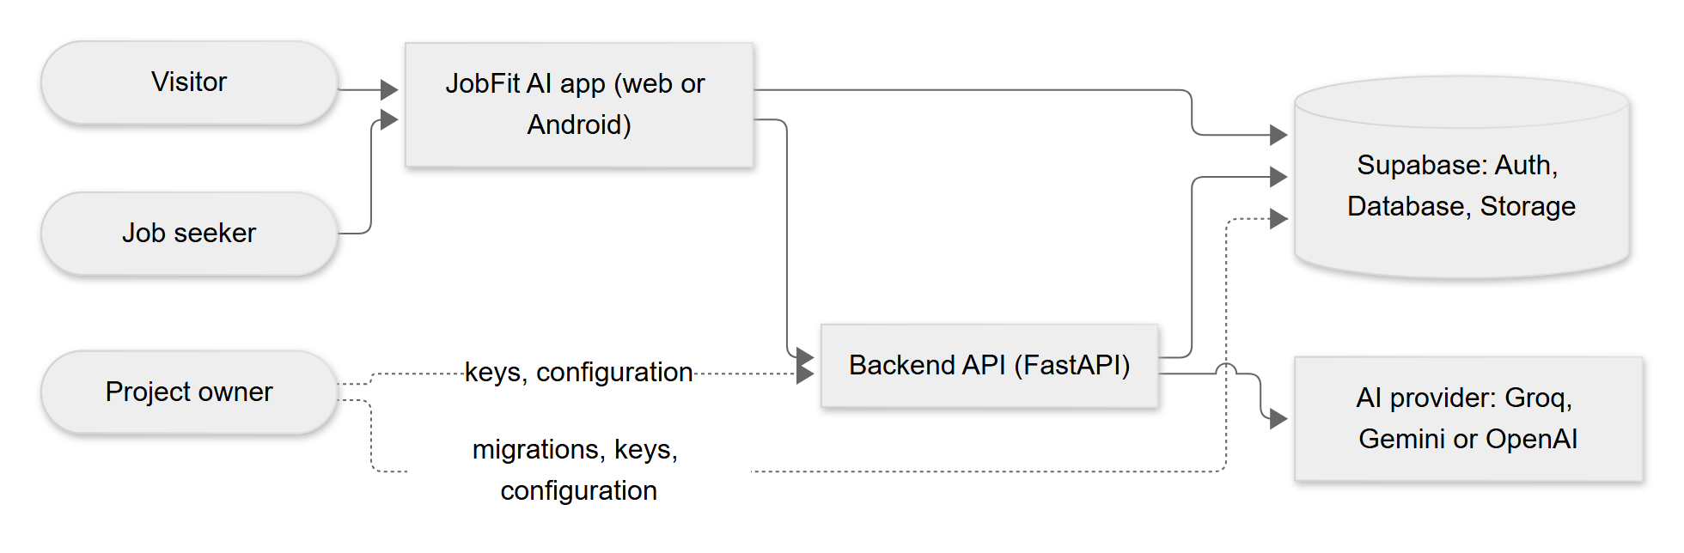
Figure 1. System context
A fuller container view is in 05-architecture.md.

3. Use-case overview
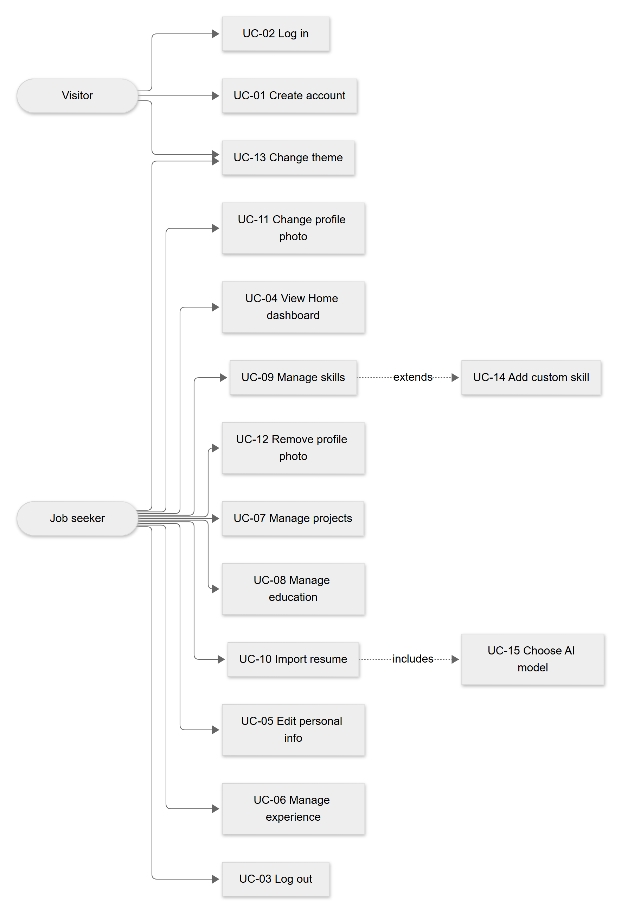
Figure 2. Use-case overview

4. Use-case catalogue
Status for all rows below: UC-01 to UC-04 and UC-13 are Available now (UC-04's completeness ring and activity list are Built, awaiting verification); UC-05 to UC-12, UC-14 and UC-15 are Built, awaiting verification.
ID | Name | Actor | Preconditions | Main flow | Alternative / exception flows | Postconditions
UC-01 | Create account | Visitor | Not logged in; email not yet registered | 1. Choose Sign up. 2. Enter email, password (6 or more characters) and optional name. 3. Press Create account. 4. System creates the account; database trigger creates the profile row. 5. System shows "Account created. Check your email to confirm, then log in." | A1: Invalid email or short password: message under the field, no request sent. A2: Email already registered: "An account with this email already exists...". A3: Network down: "We could not reach the server...". | Account and empty profile exist. Email confirmation may be required (depends on Supabase setting).
UC-02 | Log in | Visitor | Account exists (and is confirmed if required) | 1. Enter email and password. 2. Press Log in. 3. Supabase returns a session. 4. App opens Home. | A1: Wrong details: "That email or password does not look right." A2: Email not confirmed: "Please confirm your email first...". A3: Rate limited: "Too many attempts...". | Session stored on the device; user is on Home.
UC-03 | Log out | Job seeker | Logged in | 1. Tap the log-out icon on Home. 2. System signs out and clears the profile, photo and import-draft stores. 3. App opens the login screen. | A1: Sign-out fails: not handled specially; to be confirmed. | Session removed; in-memory personal data cleared.
UC-04 | View Home dashboard | Job seeker | Logged in | 1. Open Home. 2. System loads profile, section counts, last 5 activities, and calls GET /me. 3. Shows greeting, completeness, quick actions, recent activity, system status. | A1: Profile or counts fail to load: friendly error in the card. A2: Backend unreachable: status row shows "The backend is not reachable...", Retry available. A3: Pull to refresh reloads everything. | None (read only).
UC-05 | Edit personal info | Job seeker | Logged in | 1. Open Profile, Personal info. 2. Edit fields. 3. Press Save. 4. System validates and upserts the profile row. 5. Message "Profile saved." | A1: Validation error: message under the field, nothing saved. A2: Save fails: friendly message above the button. | Profile row updated (including links).
UC-06 | Manage experience | Job seeker | Logged in | 1. Open Experience. 2. Add, edit or delete an entry through the sheet or swipe. 3. System validates, writes, shows a message, refreshes list and counts. | A1: Validation error. A2: Delete is cancelled at the confirmation. A3: Save fails: friendly message. | Experience rows changed; completeness updated.
UC-07 | Manage projects | Job seeker | Logged in | As UC-06 for projects (technologies entered as comma-separated tags). | As UC-06. | Project rows changed.
UC-08 | Manage education | Job seeker | Logged in | As UC-06 for education. | As UC-06. | Education rows changed.
UC-09 | Manage skills | Job seeker | Logged in | 1. Open Skills. 2. Add: search the bank, pick a skill, choose level 1 to 5 and optional years, save. Edit: tap a skill. Remove: swipe, confirm. | A1: Skills bank cannot load: "We could not load the skills list." with retry. A2: Skill already owned: hidden from search; database primary key also rejects duplicates ("That item is already in your profile."). | user_skills rows changed.
UC-14 | Add custom skill | Job seeker | In the Add skill sheet; text not found in the bank | 1. Tap Add "text" as a new skill. 2. Choose level. 3. System calls POST /skills/custom. 4. Backend returns existing or new skill. 5. App adds it to the user's skills. | A1: Name has invalid characters or wrong length: validation error. A2: Backend fails: "We could not create the new skill..." and the user can pick from the list. | Skill exists once in the shared bank; user owns it.
UC-10 | Import resume | Job seeker | Logged in; at least one AI provider configured; PDF/DOCX with text, up to 5 MB | 1. Open Import from resume. 2. UC-15 choose model. 3. Choose file. 4. App checks type and size. 5. App uploads file and model id to POST /profile/import-resume. 6. Server extracts text, asks the AI, runs the anti-invention check, returns a draft. 7. App shows the review; loads existing profile data to detect duplicates. 8. User edits, unticks, chooses Keep/Use for conflicts. 9. User presses Save to profile. 10. App writes the ticked, valid, non-duplicate items. 11. Done screen shows a summary. | A1: Wrong type/size: message before upload. A2: Server errors (see section 8): message and Try again or Choose another file. A3: Empty draft: "We could not find any profile details...". A4: Cannot load current profile: saving paused, Try again. A5: Some writes fail: "Saved x of y items..."; retry saves only the rest. A6: Cancel while reading returns to the file chooser. A7: Discard (after edits, with confirmation) wipes the draft. | Chosen items saved. Draft wiped from memory. Activity log has resume.parsed with counts.
UC-15 | Choose AI model | Job seeker | In the import screen | 1. App calls GET /ai/models. 2. Shows models; unavailable ones disabled and labelled "not set up". 3. Preselects saved choice, else server default, else first available. 4. User may change; the choice is saved on the device. | A1: List cannot load: error and Try again. A2: No provider available: message, upload disabled. | Selected model id passed to UC-10.
UC-11 | Change profile photo | Job seeker | Logged in; migration 0002 applied | 1. Tap avatar. 2. Choose gallery or camera. 3. App checks type (JPEG/PNG/WebP) and size (10 MB). 4. User moves/zooms in the editor. 5. App renders a 512 by 512 JPEG, uploads it to avatars/<user_id>/<timestamp>.jpg, saves the path in the profile, shows it with a signed link, and deletes the previous file. | A1: Wrong type/size: message. A2: Migration missing: "Photo upload is not set up yet...". A3: Upload fails: friendly message; the new file is deleted. | profiles.avatar_path set; old file removed.
UC-12 | Remove profile photo | Job seeker | A photo exists | 1. Tap avatar, Remove photo, confirm. 2. App clears avatar_path, deletes the file. | A1: Cancel at confirmation. A2: Failure: friendly message. | No photo; initials shown.
UC-13 | Change theme | Visitor or job seeker | On Login or Home | 1. Tap the palette icon. 2. Choose a theme. 3. App applies it and stores it on the device. | A1: Storage blocked (private mode): theme applies but is not remembered. | data-theme set; preference saved.

5. Sequence diagrams

5.1 Login
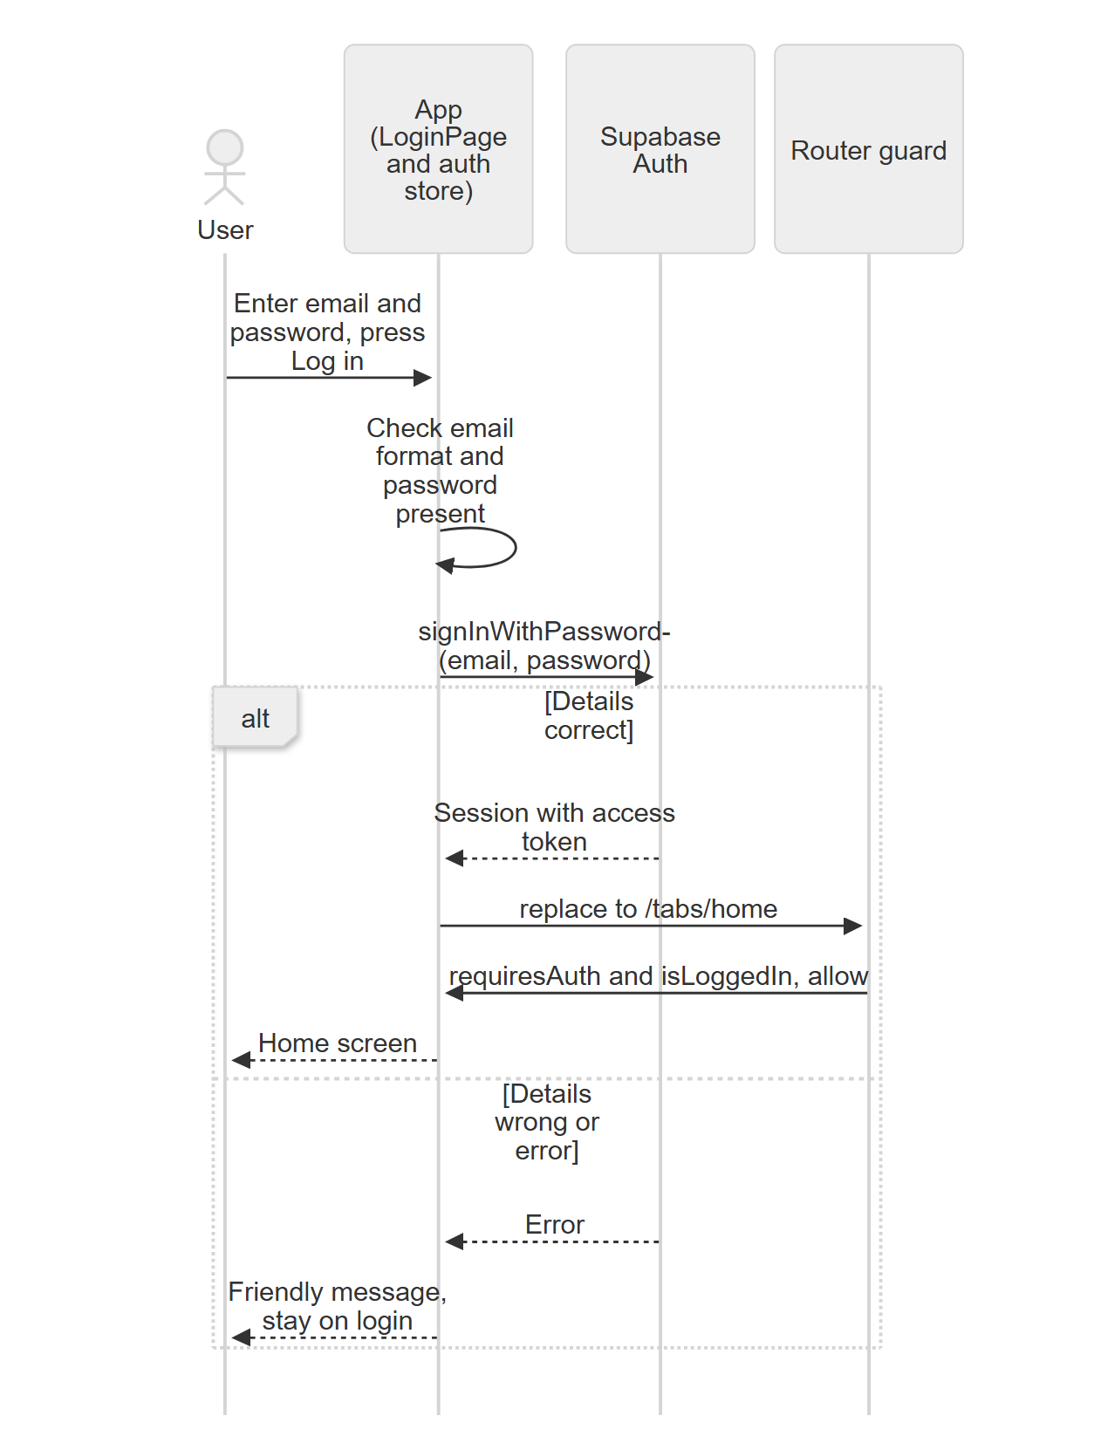
Figure 3. Login
After login, Home calls GET /api/v1/me with Authorization: Bearer <access token>. The backend verifies the token (see 07).

5.2 Resume import
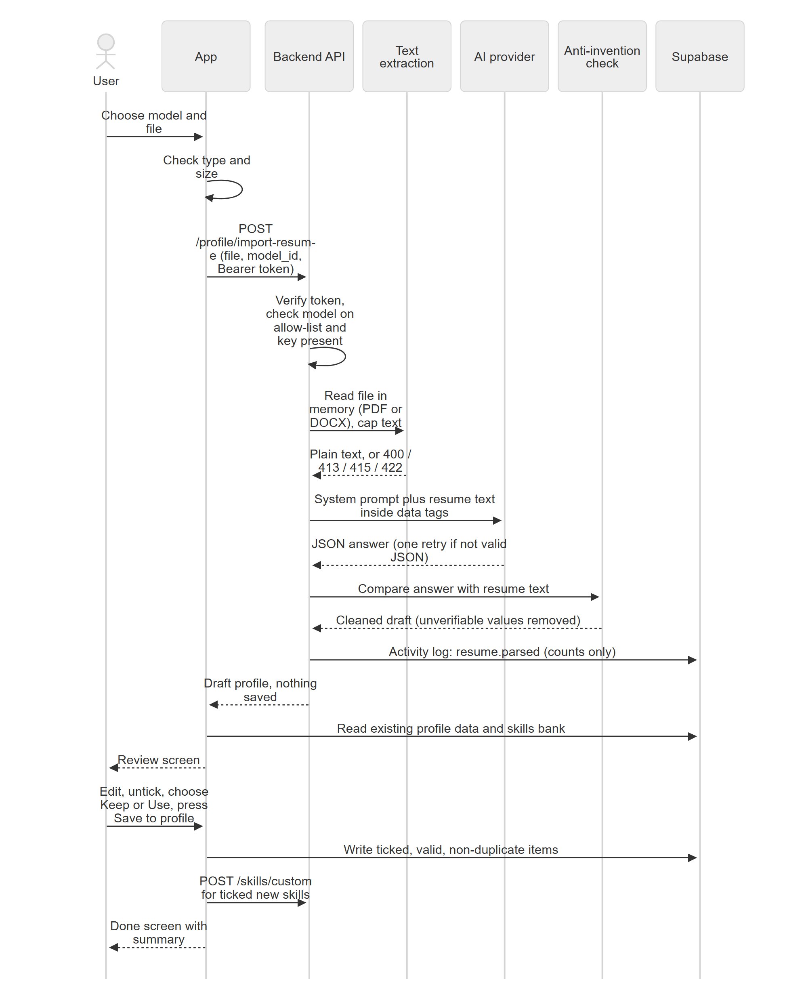
Figure 4. Resume import

6. Review-and-merge rules (flow)

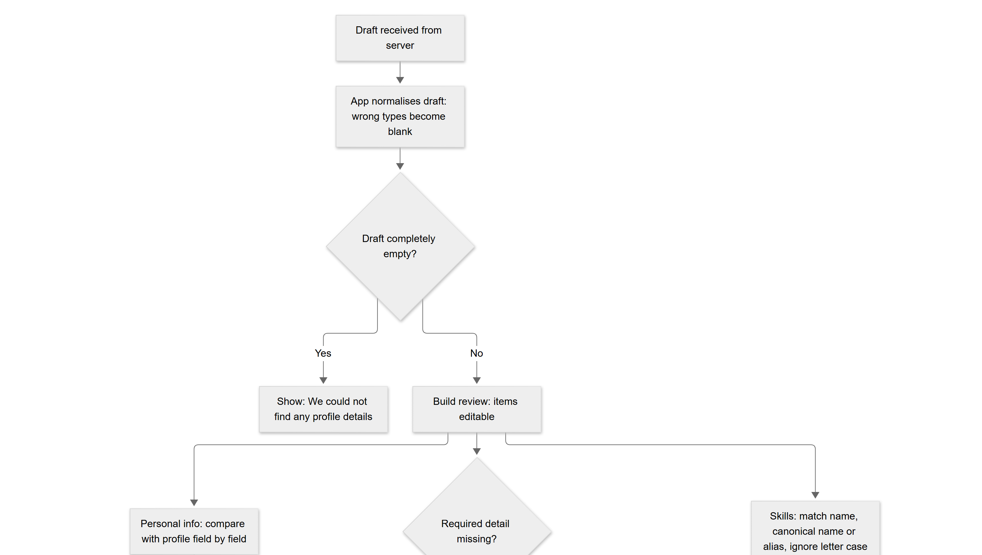
Figure 5. Review-and-merge rules (flow) (part 1 of 3)
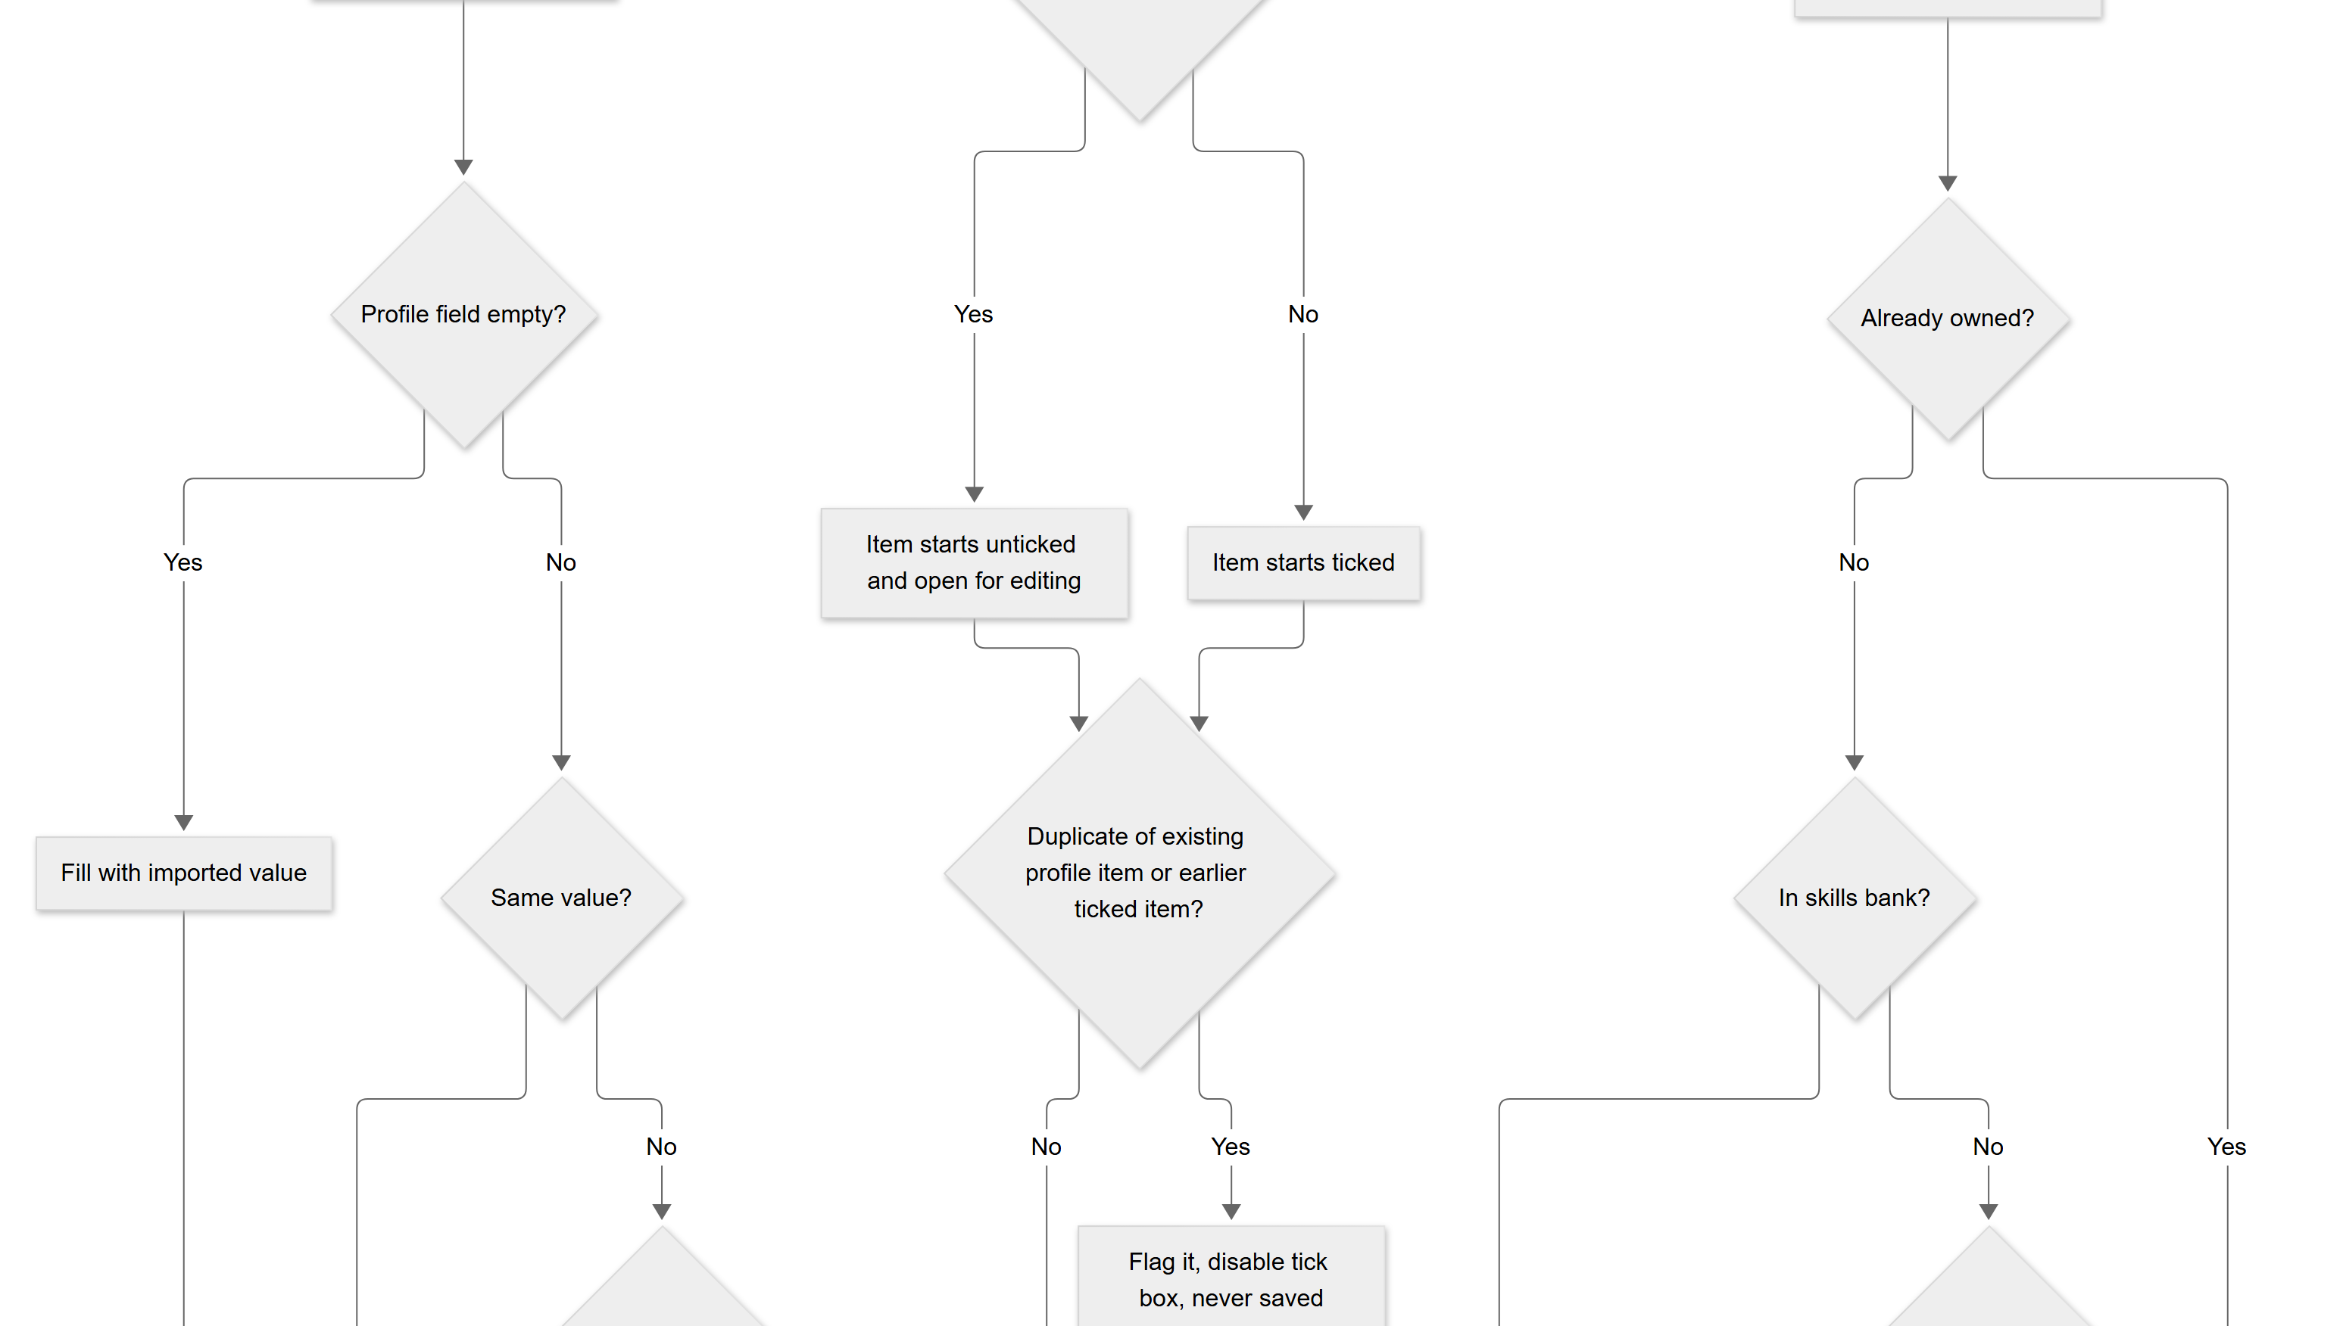
Figure 5. Review-and-merge rules (flow) (part 2 of 3)
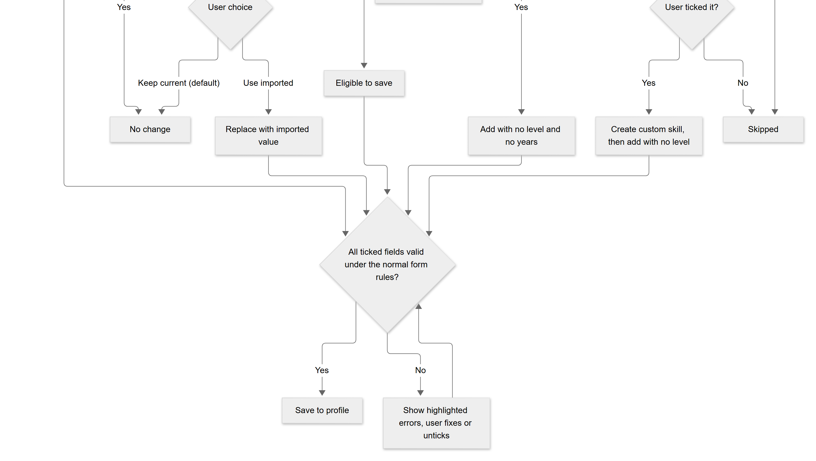
Figure 5. Review-and-merge rules (flow) (part 3 of 3)

7. State of profile completeness
The completeness value is calculated from real data only. There are 8 equal checks (computeCompleteness in frontend/src/services/dashboard.ts).
# | Check | Passes when | Hint shown when it is the next missing step
1 | Full name | Not empty after trimming | Add your full name
2 | Headline | Not empty | Add a short headline
3 | Summary | Not empty | Write a short summary
4 | Phone or location | Phone or location is not empty | Add your phone or location
5 | Experience | At least 1 experience row | Add your first work experience
6 | Education | At least 1 education row | Add your education
7 | Projects | At least 1 project row | Add a project
8 | Skills | At least 1 user skill row | Add your skills
Percentage = rounded (checks passed / 8 x 100). The possible values are 0, 13, 25, 38, 50, 63, 75, 88 and 100. The "next step" is the first failing check in the order above. The tick on the Profile screen's Personal info row requires checks 1 to 4.
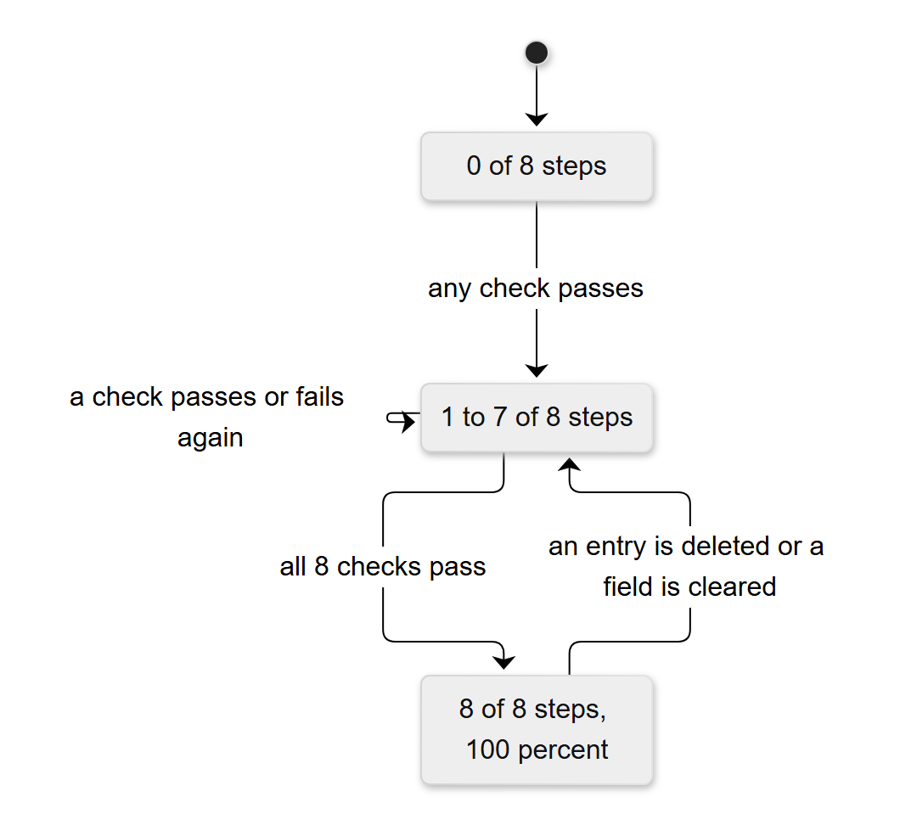
Figure 6. State of profile completeness

8. Business rules
ID | Rule | Where enforced
BR-01 | Each account has exactly one profile record; its id equals the account id. | Database (primary key, trigger)
BR-02 | A user can read and change only their own rows and files. | Database RLS; every query also filters by user id
BR-03 | The AI must not invent skills or experience. Values that cannot be found in the resume text are removed (email, phone, links, month/year dates, years, skills, technologies; "current job" needs a word such as present or current in the text). | resume_parser.py
BR-04 | Imported skills are saved with no level and no years. | importSave.ts
BR-05 | Nothing from an import is saved until the user presses Save to profile. | Backend returns a draft only; app writes after confirmation
BR-06 | Experience duplicate key: company + role + start month (letter case and extra spaces ignored). | importLogic.ts
BR-07 | Education duplicate key: school + degree. | importLogic.ts
BR-08 | Project duplicate key: project name. | importLogic.ts
BR-09 | A skill the user already owns is skipped. | importLogic.ts
BR-10 | An import item missing a required detail (experience: role or company; education: school; project: name) starts unticked. | importLogic.ts
BR-11 | Personal info merge: fill empty fields; if both differ, keep current unless the user chooses Use imported; email is never imported. | importLogic.ts
BR-12 | Imported values that will be saved must pass the same rules as the normal forms. | importLogic.ts
BR-13 | A current job has no end date. | resume_parser.py, importLogic.ts
BR-14 | Experience sort: current jobs first, then by end month, then start month. Projects and others: sort order, then newest created. Education: latest end year first. | profileLogic.ts
BR-15 | A skill added by hand needs a level from 1 to 5. The database allows an empty level (for imported skills). | App forms; migration 0001
BR-16 | A custom skill name is 2 to 60 characters with letters, digits, spaces and . + # - / & _ only. The category is up to 30 characters. | skills.py (API)
BR-17 | A custom skill is stored once: the lowercase, single-spaced name is checked against existing names and aliases first. | services/skills.py
BR-18 | Custom skills are stored in the shared skills bank and are visible by name to all signed-in users. | Migration 0001 (read policy for all signed-in users)
BR-19 | Resume file: PDF or DOCX, 1 byte to 5 MB, real content must match the extension. | resume_text.py
BR-20 | At most 30 PDF pages are read; text is cut at 30,000 characters; fewer than 50 characters of text counts as "no readable text". | resume_text.py
BR-21 | Only models on the server's allow-list can be used. With no model chosen, the default is the first available model in the order Groq, Gemini, OpenAI. | ai_providers.py
BR-22 | If an AI answer is not valid JSON, the request is retried once. HTTP errors are not retried. | ai_providers.py
BR-23 | The draft is limited to 20 experiences, 10 education entries, 20 projects, 60 skills, 12 bullets per experience and 30 technologies per project. | resume_parser.py
BR-24 | Photo: JPEG, PNG or WebP up to 10 MB in; 512 by 512 JPEG out (target at most 1.8 MB; the bucket limit is 2 MB). Each upload gets a new file name; the previous file is deleted. | imageCrop.ts, migration 0002
BR-25 | Profile completeness is 8 equal checks (section 7). | dashboard.ts
BR-26 | Where AI free-text limits and form limits differ, the stricter form rule applies when the user saves (for example bullets over 300 characters must be shortened). | importLogic.ts, resume_parser.py
BR-27 | Activity log rows can only be written by the backend. | Migration 0001 (no write policy)

9. Error handling matrix
Backend errors for resume import, and what the user sees. "Detail" is the message the server sends.
ID | Situation | Detected by | HTTP | Detail (server) | What the app shows
ERR-01 | Missing or invalid login token | API auth | 401 | "Missing bearer token" or "Invalid token: ..." | "Your session has ended. Please log in again."
ERR-02 | Unknown model id | Allow-list | 400 | "Unknown AI model" | "Unknown AI model" (the app shows the server's short sentence; normally the model list prevents this)
ERR-03 | No AI configured | Model resolver | 503 | "AI is not set up on the server" | That text (it is a friendly sentence)
ERR-04 | Chosen provider has no key | Model resolver | 503 | " is not set up on the server" | That text
ERR-05 | No file | Upload reader | 400 | "No file was uploaded" | That text
ERR-06 | Empty file | Upload reader | 400 | "The uploaded file is empty" | That text
ERR-07 | File over 5 MB | Upload reader | 413 | "The file is too large (maximum 5 MB)" | That text
ERR-08 | Wrong type or content | Type check | 415 | "Please upload a PDF or DOCX file." | That text
ERR-09 | Password-protected PDF | PDF reader | 422 | "This PDF is password protected. Please remove the password and try again." | That text
ERR-10 | Damaged file | Text extraction | 422 | "We could not read this file. It may be damaged." | That text
ERR-11 | No readable text (scan) or under 50 characters | Text extraction | 422 | "We could not find readable text in this file. If it is a scanned image, please upload a text-based PDF or DOCX." | That text
ERR-12 | Provider busy / rate limited | Provider layer | 429 | "The AI service is busy right now. Please wait a minute and try again." | That text, with Try again
ERR-13 | Provider quota or billing exhausted | Provider layer | 429 | " has no credit or quota left on this key. Please pick another model." | That text, with Try again
ERR-14 | Provider rejected the key | Provider layer | 502 | " key was rejected. Please check the key on the server." | That text, with Try again
ERR-15 | Provider cannot find the model | Provider layer | 502 | " could not find this model. Please pick another model." | That text, with Try again
ERR-16 | Timeout, other provider error, or unusable answer twice | Provider layer | 502 | "The AI service could not read this resume. Please try again." | That text, with Try again
ERR-17 | Network down at the app | Browser | none | - | "We could not reach the server. Please check your internet connection and try again."
ERR-18 | Draft completely empty | App | none | - | "We could not find any profile details in that file. Please try another resume."
ERR-19 | Custom skill cannot be saved | POST /skills/custom | 500 | "Could not save the skill" | "We could not create the new skill..."
ERR-20 | Custom skill input invalid | Pydantic validation | 422 | Validation list from FastAPI | Not shown raw; the app already validates length first
ERR-21 | Database write fails in the app | Supabase | varies | - | "Something went wrong while saving. Please try again." (or specific messages for duplicates and permission)
ERR-22 | Photo storage not prepared | Supabase | varies | - | "Photo upload is not set up yet - run the database update."
Provider details (response bodies and keys) are never sent to the app. Short reasons for 404 and 429 are written to the server log only.
Related: 08-api-reference.md, 06-data-model.md.

05 – Architecture
Item | Detail
Document | Architecture description
Version | 1.0 draft
Date | 24 October 2026
Status | Draft for review
Audience | Developers and technical stakeholders
Purpose: To explain how JobFit AI is built, why it is built that way, and where each responsibility lives. Everything here was read from the repository on 24 October 2026. Anything not proven by the repository is marked intended or to be confirmed.

1. Overview and rationale
JobFit AI has three parts:
- A mobile-first app (Ionic + Vue 3, packaged for Android with Capacitor, also runs in a browser).
- A small backend API (Python FastAPI).
- Supabase for login, the Postgres database and file storage.
The guiding idea is a clear split of responsibilities:
Kind of work | Where it runs | Why
Simple reads and writes of the user's own data (profile, experience, projects, education, skills, photo) | The app talks directly to Supabase, protected by Row Level Security | Fewer moving parts, faster screens, the database itself guarantees privacy
Anything needing a secret key, file parsing, or an AI call (resume import, adding a shared custom skill, listing AI models) | The backend API | Secrets must never reach the app; the shared skills bank must not be writable by users
This follows the project's frontend rule: simple user data may use the Supabase client directly; AI work, file handling and anything needing the secret key goes through FastAPI.

2. System context (C4 level 1)
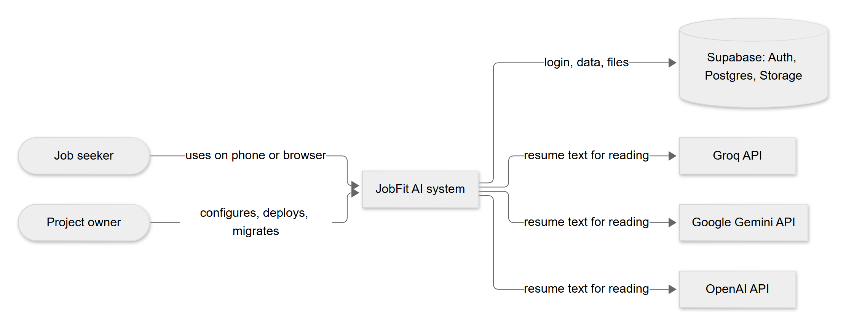
Figure 7. System context (C4 level 1)

3. Containers (C4 level 2)
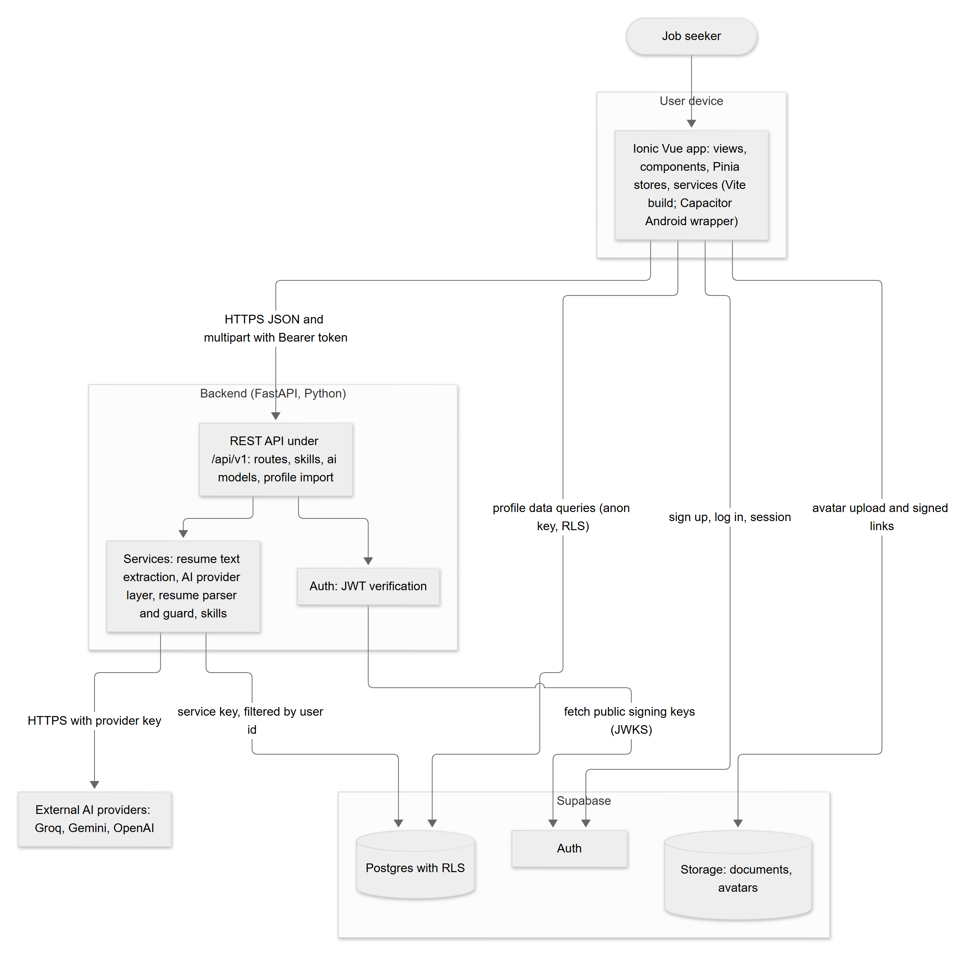
Figure 8. Containers (C4 level 2)

4. Technology stack
Versions are the ranges declared in frontend/package.json and backend/requirements.txt; they are not guaranteed installed versions.
Layer | Technology | Purpose
Frontend framework | Vue 3 (^3.5), Composition API, <script setup lang="ts"> | Screens and logic
UI toolkit | Ionic Vue (@ionic/vue ^9.0.0) | Mobile-style components, navigation, gestures
Native wrapper | Capacitor 8 (core, Android, App, Haptics, Keyboard, Status Bar) | Run the web app as an Android app
Build tool | Vite 8 with Vue plugin and legacy plugin | Dev server and production build
Styling | Tailwind CSS 4 and daisyUI 5 (35 themes) bridged to Ionic colours; custom CSS | Look and feel
State | Pinia | Shared state: auth, profile, avatar, resume import, theme
Routing | @ionic/vue-router with vue-router | Tabs and sub-screens, login guard
Frontend tests | Vitest + jsdom, Vue Test Utils; Cypress configured but only a starter spec exists | Unit tests
Backend framework | Python (3.12 per project notes; the Phase 1 README says 3.11 or newer) with FastAPI (>=0.115), Uvicorn | REST API
Validation and settings | Pydantic v2, pydantic-settings | Request/response models, environment settings
Auth verification | PyJWT with crypto | Verify Supabase tokens
Supabase access | supabase Python client | Server-side database access
HTTP to AI providers | httpx (no provider SDKs) | Provider calls
File reading | pypdf, python-docx, python-multipart | PDF text, DOCX text, uploads
Backend tests | pytest | API and logic tests
Database | Supabase Postgres, extensions vector (pgvector) and pg_trgm | Data, future semantic matching
Auth and storage | Supabase Auth and Storage | Login, files
AI (current) | Groq, Google Gemini, OpenAI (free tiers) for resume import | Read resumes
AI (planned) | Claude API from Phase 3 (variable ANTHROPIC_API_KEY is reserved, unused) | Job parsing, generation
Note on versions: the project notes say "Ionic 8" while package.json declares @ionic/vue ^9.0.0. The declared range is what installs. See 09-roadmap-and-status.md, section 6.

5. Components

5.1 Frontend (frontend/src)
Module | Contents | Responsibility
router/ | Route table, beforeEach guard | /login (guests only); /tabs/... requires login; routes for Home, Profile, five profile sub-screens, Import, Jobs, Tracker
views/ | LoginPage, TabsPage, HomePage, ProfilePage, PersonalInfoPage, ExperiencePage, ProjectsPage, EducationPage, SkillsPage, ImportResumePage, JobsPage, TrackerPage | Screens. Jobs and Tracker show "Coming soon" only
components/ | Form sheets, import review cards, avatar changer/editor/cropper, theme picker, progress ring, empty states and others | Reusable UI parts
stores/ | auth, profile, avatar, resumeImport, theme | Shared state and orchestration
services/ | supabase, api, profile, skills, dashboard, avatar, resumeImport, importSave, aiModels, errors, feedback, haptics, motion, imageCrop | Network calls and pure logic (kept separate so logic can be unit tested)
services/*Logic.ts | profileLogic, importLogic, avatarLogic | Pure functions: validation, sorting, duplicate detection, merge, crop maths
composables/ | useSectionCrud, useIdentity, useCountUp | Shared list/add/edit/delete flow; user name and photo; animated numbers
theme/ | daisy.css, variables.css, ui.css, motion.css, ionicBridge.ts | Themes and the bridge to Ionic colours
Key behaviours:
- services/api.ts attaches Authorization: Bearer <Supabase access token> to backend calls and builds URLs from VITE_API_URL.
- apiUpload sends multipart forms (no manual content type) and throws ApiError(status, detail).
- The Pinia stores resumeImport, profile and avatar are reset at log out so the next person sees nothing.
- The resume import draft is kept only in memory (never in local storage).

5.2 Backend (backend/app)
Module | Responsibility
main.py | Creates the FastAPI app (version 0.1.0), adds CORS, mounts four routers under /api/v1, root route /
api/routes.py | GET /health, GET /me
api/skills.py | POST /skills/custom with Pydantic models
api/ai_models.py | GET /ai/models
api/profile_import.py | POST /profile/import-resume and the draft response models
core/config.py | Settings from environment (.env locally); lists of origins and models
core/auth.py | get_current_user: reads the Bearer token, verifies it (HS256 with secret, or ES256/RS256 through the JWKS URL), requires audience authenticated, exp and sub
db/supabase_client.py | Cached admin client (service key; bypasses RLS) and log_activity (failures never break a request)
services/resume_text.py | Read upload, check type, extract text in memory
services/ai_providers.py | Provider list, allow-list, request building, error mapping, JSON retry
services/resume_parser.py | Prompt, tolerant reshaping of AI output, and the anti-invention guard
services/skills.py | Find or create a custom skill (race-safe)

5.3 Database and storage
Summarised here; details in 06-data-model.md.
- 11 tables created in migration 0001 and one column added in 0002. Only profiles, experiences, projects, education, skills, user_skills and activity_logs are used by the current app. The job, match, document and application tables are prepared for later phases.
- Storage buckets: documents (private, prepared for Phase 4) and avatars (private, 2 MB, JPEG/PNG/WebP).

6. Data flows
Flow | Path
Sign up / log in | App -> Supabase Auth. A database trigger creates the profile row.
Edit profile sections | App -> Supabase Postgres (anon key + user token; RLS; also filtered by user id in code).
Home health check | App -> GET /me -> admin client reads the profile row -> activity log write.
Add custom skill | App -> POST /skills/custom -> admin client inserts into skills -> App then inserts into user_skills directly.
List AI models | App -> GET /ai/models (no provider call).
Resume import | App -> POST /profile/import-resume -> extract text -> AI provider -> guard -> draft to App. App reads existing data from Supabase, then writes the chosen items to Supabase (and calls POST /skills/custom for new skills).
Profile photo | App crops and shrinks in the browser -> uploads to Storage avatars/<user_id>/<timestamp>.jpg -> saves the path in profiles.avatar_path -> asks Storage for a signed link valid for 1 hour and renews it before it expires.

7. Deployment view
The repository contains no deployment configuration (no vercel.json, no Render file, no container file). The following is the intended deployment from the project notes.
Part | Intended host | Status
Frontend (web) | Vercel | Intended; not configured in the repo
Backend API | Vercel or Render | Intended; choice open
Database, Auth, Storage | Supabase (hosted project) | In use for development
Android app | Built locally with Capacitor and Android Studio | Debug build only; release signing not set up
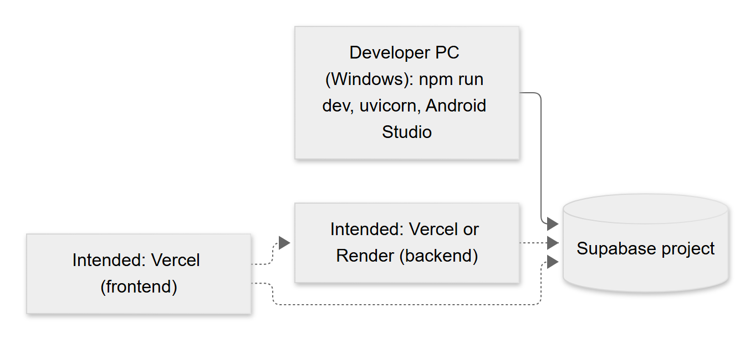
Figure 9. Deployment view

8. Environments and configuration
Only variable names are shown. Never put real values in documents or in source control. .env files are ignored by Git; .env.example files hold placeholders.

8.1 Backend (backend/.env, template backend/.env.example)
Variable | Purpose | Secret?
APP_ENV | Environment name reported by /health (default development) | No
SUPABASE_URL | Supabase project address | No
SUPABASE_SERVICE_KEY | Server-only secret key; bypasses RLS | Yes
SUPABASE_JWT_SECRET | Only for old projects that sign tokens with a shared secret (HS256) | Yes
CORS_ORIGINS | Comma-separated list of allowed app origins | No
ANTHROPIC_API_KEY | Reserved for Phase 3; unused today | Yes
GROQ_API_KEY, GEMINI_API_KEY, OPENAI_API_KEY | One key per AI provider; empty means "not set up" | Yes
GROQ_MODELS, GEMINI_MODELS, OPENAI_MODELS | Comma-separated allow-lists of model ids per provider | No
APP_NAME can also be set (it has a default in code) but is not in .env.example.

8.2 Frontend (frontend/.env, template frontend-files/.env.example)
Variable | Purpose | Secret?
VITE_SUPABASE_URL | Supabase project address | No
VITE_SUPABASE_ANON_KEY | Publishable (anon) key only; never the service key | No (public by design)
VITE_API_URL | Backend base address, must end with /api/v1 | No
These values are baked into the app at build time, so the app must be rebuilt after changing them. See 12-installation-and-operations.md.

9. AI provider layer design
Implemented in backend/app/services/ai_providers.py.
Aspect | Design
Providers | Groq, Google Gemini, OpenAI. Order for defaults: Groq, then Gemini, then OpenAI
Transport | Plain httpx requests; no provider SDKs. Groq and OpenAI share the chat-completions format; Gemini uses its own generateContent format with the key in a header
Model addressing | "<provider>:<model>", for example groq:openai/gpt-oss-120b
Configurable lists | Models come from environment variables, because model names change. Unknown model names are shown with their raw name
Allow-list | resolve_model accepts only ids from the configured lists. An unknown id gives 400; a provider without a key gives 503. The client's string is never forwarded blindly
Availability | A model is available when its provider key is set. GET /ai/models reports this without calling any provider
Default | First available model in provider order; null if none
Output | JSON mode requested (response_format json_object for Groq/OpenAI; responseMimeType application/json for Gemini), temperature 0
Parsing | Lenient: ignores code fences and text around the outermost {...}
Retry | If the answer is not usable JSON, exactly one more attempt. HTTP errors are not retried
Timeout | 60 seconds per request
Error mapping | 401/403 from provider -> 502 "key was rejected"; 429 -> 429 busy, or "no credit or quota" when the provider says quota/billing; 404 -> 502 "could not find this model"; other errors/timeouts -> 502 generic. Provider bodies and keys are never returned
Logging | Server log gets provider name, status code and (for 404 and 429 only) a short provider reason cut to 160 characters. Prompts, resume text and answers are never logged
After the AI layer, resume_parser.py reshapes sloppy output (null instead of lists, numbers as text, wrapper objects) and then applies the anti-invention guard described in 07-security-and-privacy.md.
Default model names in .env.example and config.py at the time of writing are openai/gpt-oss-120b and openai/gpt-oss-20b (Groq), gemini-3.8-flash and gemini-3.5-flash-lite (Gemini), and gpt-4o-mini (OpenAI). Provider model names change over time; whether each is currently valid is to be confirmed by a real call (not done in automated tests).

10. Design decisions and trade-offs
# | Decision | Alternatives | Reason | Trade-off
D-1 | Simple profile data goes straight from the app to Supabase with RLS | Route everything through the API | Fewer endpoints, faster, privacy enforced by the database | Direct writes are not written to the activity log; business rules live in the app
D-2 | AI, file reading and shared-skill writes go through the API | Do them in the app | Keys stay on the server; users cannot write to the shared bank | Needs a running backend
D-3 | Resume import uses free-tier Groq/Gemini/OpenAI, chosen by the user | Anthropic Claude for import | Lower cost during development | Rate limits; free plans may use submitted content; model names change
D-4 | No provider SDKs, plain httpx | Official SDKs | Fewer dependencies; uniform error handling | Provider API changes must be tracked by hand
D-5 | Model lists in environment, plus allow-list | Hard-coded names | Names change often; prevents arbitrary model use | Needs a restart after edits
D-6 | Import returns a draft; the app saves after review | Save directly | User stays in control; supports the "never invent" rule | More screens
D-7 | Server-side anti-invention guard on top of the prompt | Trust the prompt | Small free models are not exact | Free-text fields are not word-for-word verified
D-8 | Imported skills have no level | Estimate a level | Never guess | Extra step for the user
D-9 | Private avatars bucket and signed links | Public bucket | Photos are personal data | Links expire and must be renewed
D-10 | New avatar file name per upload | Overwrite one file | Avoids stale cached images | Old file must be deleted
D-11 | Skills bank is global and read-only for users | Per-user skills | Shared names, future embedding matching | Custom skill names are visible to all users
D-12 | Pure logic in separate *Logic.ts files | Logic in components | Easy unit testing | More files
D-13 | daisyUI themes bridged into Ionic | Ionic-only theme | Many themes with little code | Extra build tooling (Tailwind)

11. Mobile (Capacitor / Android) notes
Topic | Fact from the repository
Wrapper | Capacitor 8 with the Android platform added; no iOS project yet
Build steps | From frontend: npm run build, then npx cap sync android, then run from Android Studio
App identity | capacitor.config.ts still uses the starter values appId: 'io.ionic.starter' and appName: 'frontend'. These must be changed before any release
Permissions | The manifest declares only INTERNET. No camera permission is declared; whether "Take a photo" works on a device is unverified
Cleartext traffic | usesCleartextTraffic="true" is set, so plain http:// works for local development. Remove for release with an HTTPS backend
Emulator networking | Inside the Android emulator, localhost is the emulator itself; use http://10.0.2.2:8000/api/v1 for the backend
Real phone | Use the PC's local network address and start the backend with --host 0.0.0.0
CORS | backend/.env.example allows capacitor://localhost and http://localhost in addition to the Vite ports
Native plugins | Haptics (tap feedback), Keyboard, Status Bar, App
Photo capture | A hidden file input with capture="user" asks the phone for the camera; in a desktop browser it opens a file picker
Related: 08-api-reference.md, 12-installation-and-operations.md.

06 – Data Model
Item | Detail
Document | Data model
Version | 1.0 draft
Date | 24 October 2026
Status | Draft for review
Audience | Developers, database staff, analysts
Purpose: To describe the database tables, how they relate, who may read and write them (Row Level Security), the storage buckets, and the shape of the resume import draft. Source: supabase/migrations/0001_init.sql and 0002_profile_avatars.sql.

1. Overview
- The database is Supabase Postgres. User accounts live in Supabase's own auth.users table.
- Migration 0001 creates the full Phase 1 schema (including tables for later phases), the security rules, one storage bucket and 25 seed skills.
- Migration 0002 adds profiles.avatar_path and the private avatars bucket with its rules.
- Migrations are numbered, written to be safe to run again, and must never be edited after they have been run.
- Migration order matters: run 0001 first, then 0002.
- Extensions enabled: vector (pgvector, for future skill matching) and pg_trgm (fuzzy text search on skill names).

2. Entity list
Entity (table) | Purpose | Used by the app today? | Phase
profiles | One row per user: personal details and photo path | Yes | 1 (photo column in 2)
experiences | Work history | Yes | 1
projects | Projects | Yes | 1
education | Education | Yes | 1
skills | Shared global skills bank | Yes (read; backend writes custom skills) | 1
user_skills | Which skills a user has, with level and years | Yes | 1
activity_logs | Log of actions written by the backend | Yes (Home reads the last 5) | 1
job_posts | Pasted job descriptions and parsed data | No | Planned (3)
match_results | Score, matched skills and gaps per job | No | Planned (3)
generated_docs | Generated resumes and cover letters | No | Planned (3, 4)
applications | Application tracker | No | Planned (5)
Enumerated types: application_status (saved, applied, interview, offer, rejected, ghosted) and doc_type (resume, cover_letter). Both are for later phases.

3. Entity-relationship diagram
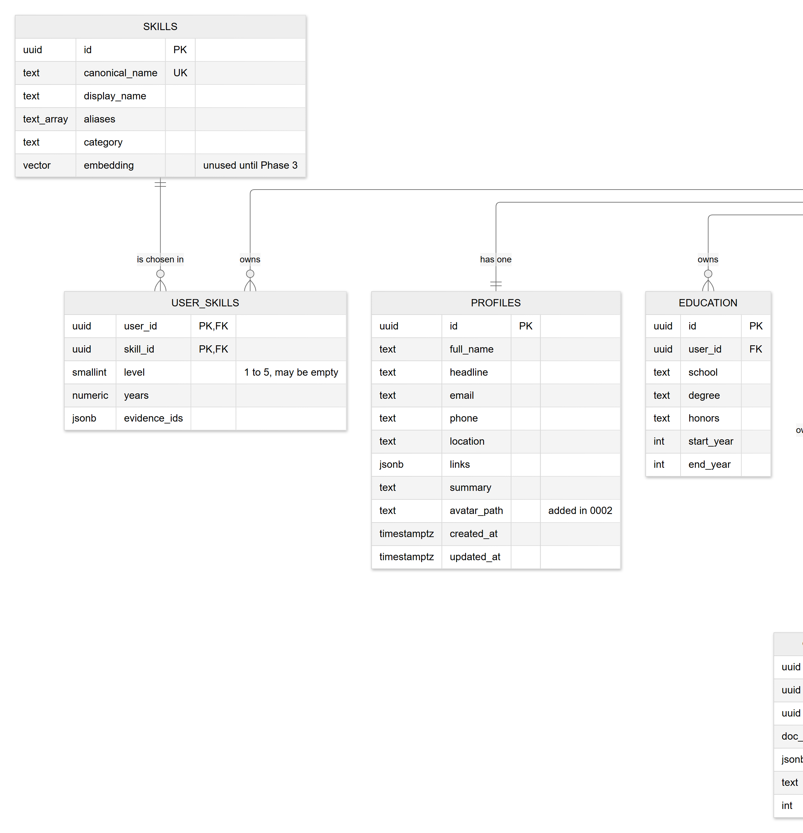
Figure 10. Entity-relationship diagram (part 1 of 2)
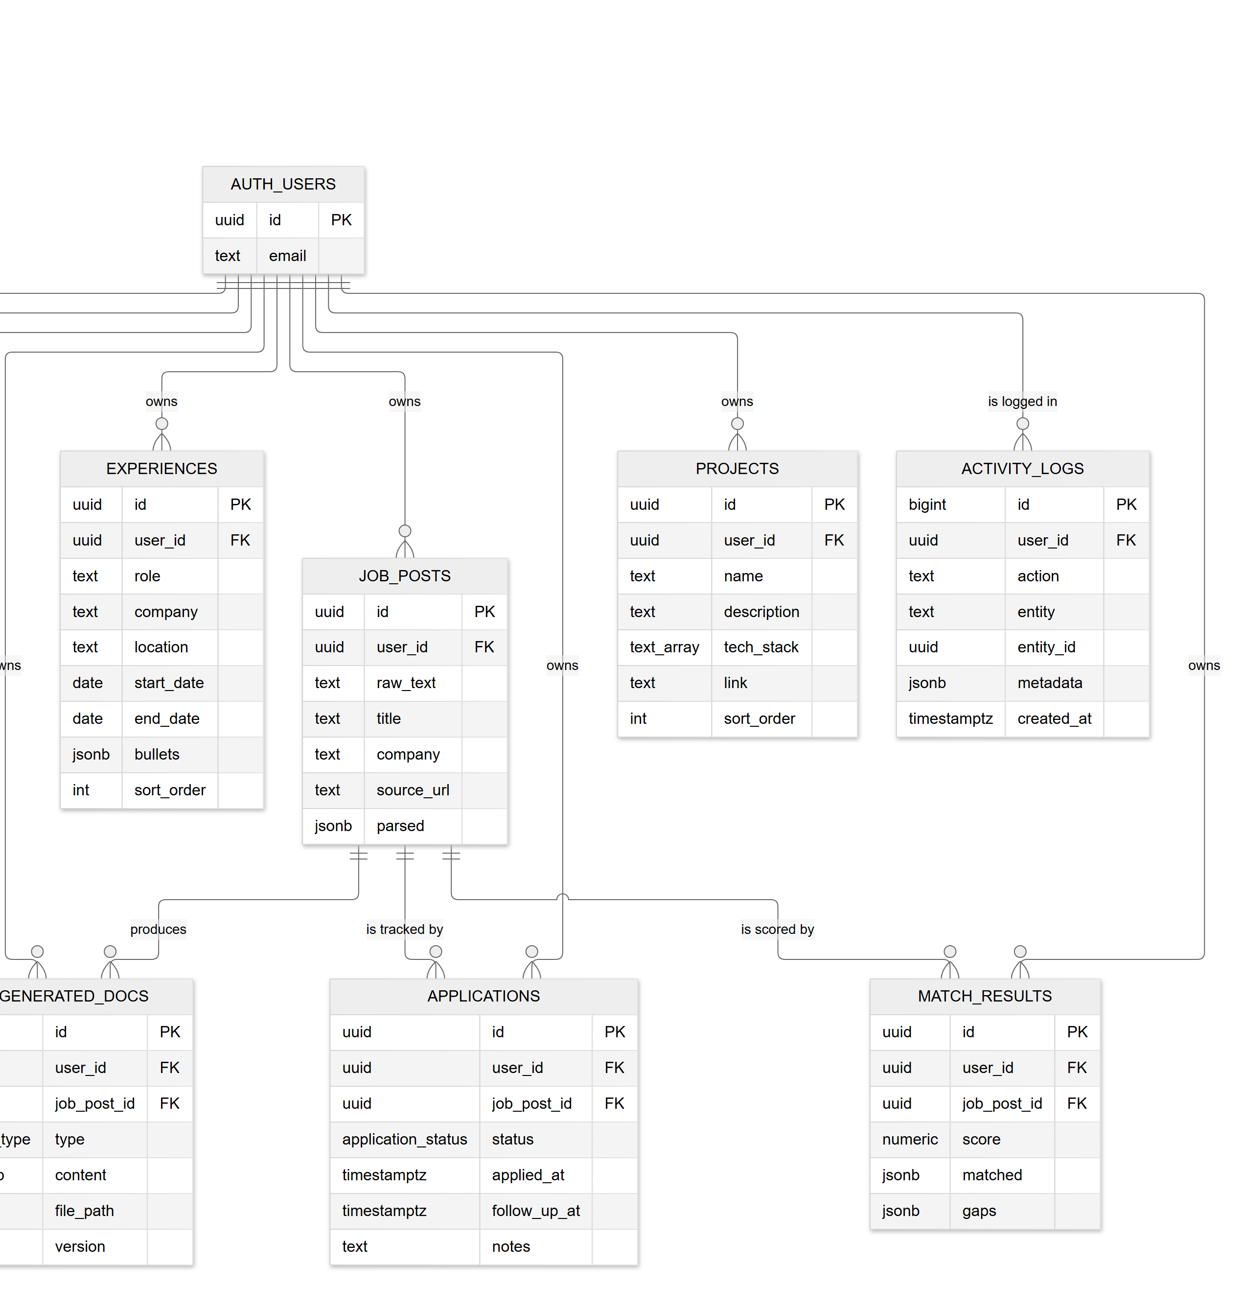
Figure 10. Entity-relationship diagram (part 2 of 2)
In the diagram text_array means a Postgres text[] column. Only the main columns of the future-phase tables are drawn; see section 4 for all columns.

4. Data dictionary
Common pattern: id is a generated UUID; created_at/updated_at are timestamptz defaulting to the current time; updated_at is refreshed by a trigger on profiles, experiences, projects, education and applications. All user-owned tables delete their rows automatically when the user is deleted (on delete cascade).

4.1 profiles
Column | Type | Nullable | Description
id | uuid (PK, references auth.users) | No | Same as the account id
full_name | text | Yes | Name; set from the sign-up name by the trigger (empty text if none)
headline | text | Yes | Short title line
email | text | Yes | Copied from the account at sign-up
phone | text | Yes | Phone
location | text | Yes | City and country
links | jsonb, default {} | No | Web links, keys github, linkedin, website (other keys are kept if present)
summary | text | Yes | Short personal summary
avatar_path | text | Yes | Object path in bucket avatars, <user_id>/<timestamp>.jpg; null means no photo (added by 0002)
created_at, updated_at | timestamptz | No | Timestamps
A database trigger (handle_new_user) inserts the profile row when an account is created.

4.2 experiences
Column | Type | Nullable | Description
id | uuid PK | No | Identifier
user_id | uuid FK | No | Owner
role | text | No | Job title
company | text | No | Employer
location | text | Yes | Place
start_date | date | Yes | First day of the start month (app stores YYYY-MM-01)
end_date | date | Yes | Null means present
bullets | jsonb, default [] | No | List of bullet-point texts
sort_order | int, default 0 | No | Computed by the app so the newest is first (smaller = higher)
created_at, updated_at | timestamptz | No | Timestamps

4.3 projects
Column | Type | Nullable | Description
id | uuid PK | No | Identifier
user_id | uuid FK | No | Owner
name | text | No | Project name
description | text | Yes | Description
tech_stack | text[], default empty | No | Technology tags
link | text | Yes | Web address
sort_order | int, default 0 | No | Order; ties show the newest first
created_at, updated_at | timestamptz | No | Timestamps

4.4 education
Column | Type | Nullable | Description
id | uuid PK | No | Identifier
user_id | uuid FK | No | Owner
school | text | No | School
degree | text | Yes | Degree
honors | text | Yes | Honors
start_year, end_year | int | Yes | Four-digit years
created_at, updated_at | timestamptz | No | Timestamps

4.5 skills (shared bank)
Column | Type | Nullable | Description
id | uuid PK | No | Identifier
canonical_name | text, unique | No | Lowercase matching name, for example vue.js
display_name | text | No | Name shown to users, for example Vue.js
aliases | text[], default empty | No | Other names, for example vue, vuejs
category | text | Yes | Group such as frontend, backend, data, soft-skill
embedding | vector(1536) | Yes | Reserved for Phase 3; unused
created_at | timestamptz | No | Timestamp
Indexes: GIN on aliases and a trigram GIN index on canonical_name. Seed: 25 skills (Python, FastAPI, Laravel, PHP, JavaScript, TypeScript, Vue.js, Ionic, Capacitor, SQL, PostgreSQL, MongoDB, Supabase, pandas, Power BI, Excel, Data Analysis, Docker, Git, REST API, LLM / Generative AI, Automation, Canva, Communication, Leadership).

4.6 user_skills
Column | Type | Nullable | Description
user_id | uuid FK | No | Owner (part of the primary key)
skill_id | uuid FK to skills | No | The skill (part of the primary key, so no duplicates per user)
level | smallint, check 1 to 5 | Yes | Empty for skills imported from a resume until the user sets it
years | numeric(4,1) | Yes | Years of experience (the app allows 0 to 60)
evidence_ids | jsonb, default [] | No | Reserved for linking evidence in later phases
created_at | timestamptz | No | Timestamp

4.7 activity_logs
Column | Type | Nullable | Description
id | bigint identity PK | No | Identifier
user_id | uuid FK | No | Owner
action | text | No | Code such as auth.me_checked, skill.created, resume.parsed
entity, entity_id | text, uuid | Yes | What the action was about
metadata | jsonb, default {} | No | Small facts. For resume.parsed: provider, model, counts per section, file type. Never the resume text
created_at | timestamptz | No | Timestamp (index on user and time)
Only the backend writes this table. Edits made directly by the app (profile, experience, and so on) are not logged today.

4.8 Tables for later phases (not used yet)
Table | Main columns
job_posts | raw_text (required), title, company, source_url, parsed (jsonb)
match_results | job_post_id, score (0 to 100), matched (jsonb), gaps (jsonb)
generated_docs | job_post_id, type (resume or cover_letter), content (jsonb), file_path, version, model, tokens_used, duration_ms
applications | job_post_id, status (default saved), applied_at, follow_up_at, notes; index on status and follow-up date

5. Relationships
From | To | Rule
profiles.id | auth.users.id | One to one; deleted with the account
experiences, projects, education, user_skills, job_posts, match_results, generated_docs, applications, activity_logs .user_id | auth.users.id | Many to one; deleted with the account
user_skills.skill_id | skills.id | Many to one; deleting a skill removes the links
match_results, generated_docs, applications .job_post_id | job_posts.id | Many to one; deleted with the job post

6. Row Level Security (RLS) summary
RLS means the database itself checks, on every query, whether the signed-in user may touch a row. It is switched on for all 11 tables. The check uses the signed-in user's id (auth.uid()).
Table | Policy | Who | What
profiles | "own profile" | signed-in users | All actions, only where id equals their id
experiences, projects, education, user_skills, job_posts, match_results, generated_docs, applications | "own rows" | signed-in users | All actions, only where user_id equals their id
activity_logs | "read own logs" | signed-in users | Read only, own rows. No write policy, so only the backend (service key) can write
skills | "read skills" | signed-in users | Read all rows. No write policy, so only the backend can add skills
The backend's service key bypasses RLS, so every backend query on user data must filter by the user's id (this is a project rule).

7. Storage buckets and path conventions
Bucket | Visibility | Limits | Path convention | Policies (signed-in users, own folder only) | Phase
documents | Private | none set | <user_id>/<job_post_id>/<file>.pdf | Read, delete. No insert policy, so uploads will be made by the backend | Created in 1, used from Phase 4
avatars | Private (forced false by 0002) | 2 MB; JPEG, PNG, WebP | <user_id>/<timestamp>.jpg | Read, insert, update, delete | 2
"Own folder" means the first folder in the path equals the signed-in user's id. The app never uses a public address: it asks Storage for a signed link valid for 3,600 seconds (1 hour) and renews it about 5 minutes before it expires.
The uploaded resume file is not stored anywhere (see section 9).

8. Sample import draft (dummy data)
This is the shape returned by POST /api/v1/profile/import-resume. All values below are fictional. Every key is always present; missing information is null or an empty list.
{
"personal": {
"full_name": "Alex Sample",
"headline": "Junior Web Developer",
"email": "alex.sample@example.com",
"phone": "+1 555 010 0000",
"location": "Sampletown",
"github": "github.com/alexsample",
"linkedin": null,
"website": null,
"summary": "Web developer who builds small business websites."
},
"experiences": [
{
"role": "Web Developer",
"company": "Example Studio",
"location": "Sampletown",
"start_date": "2023-06",
"end_date": null,
"is_current": true,
"bullets": ["Built landing pages for local shops."]
}
],
"education": [
{
"school": "Sample University",
"degree": "BSc Information Technology",
"honors": null,
"start_year": 2019,
"end_year": 2023
}
],
"projects": [
{
"name": "Recipe Finder",
"description": "A small web app to search recipes.",
"tech_stack": ["Vue.js", "JavaScript"],
"link": null
}
],
"skills": ["JavaScript", "Vue.js", "Git"]
}
Notes: dates are YYYY-MM strings; years are integers; the app ignores email when merging personal info.

9. Data retention and ownership notes
Topic | Fact
Ownership | Every user-owned row belongs to one account and is invisible to others. The shared skills table is the one exception: custom skill names are visible to all signed-in users
Deleting an account | All the user's rows are removed automatically (cascade). Storage files are not covered by this cascade; deleting the photo file for a deleted account is to be confirmed. The app has no delete-account screen
Resume file and text | Not stored and not logged. Only the saved, reviewed items remain
Activity logs | Kept until the account is deleted; there is no purge job
Photos | Old photo files are deleted when a new photo is saved or the photo is removed. A failed cleanup can leave an unused file (harmless, private)
Device storage | The browser keeps the login session, the chosen theme (jobfit-theme) and the last AI model choice (jobfit-ai-model). Resume drafts are never written there
Backups and retention periods | Not defined in the repository: to be defined
Related: 07-security-and-privacy.md, 08-api-reference.md.

07 – Security and Privacy
Item | Detail
Document | Security and privacy
Version | 1.0 draft
Date | 24 October 2026
Status | Draft for review
Audience | Clients, security reviewers, developers (sections 1 to 3 are in plain language)
Purpose: To explain how JobFit AI protects personal data (a resume is personal data), what is stored and what is not, what is shared with outside AI companies, and which risks remain. No keys, passwords or .env contents appear in this document.
This is a description of the code as read on 24 October 2026. It is not an independent security audit or a legal compliance review. No penetration test has been done.

1. Plain-language summary
Question | Short answer
Who can see my profile? | Only you. The database checks this on every request.
Is my resume file kept? | No. It is read in memory and thrown away.
Is my resume text kept or logged? | No.
Does my resume text leave the system? | Yes, but only when you import a resume: the text is sent to the AI provider you choose.
Can the AI invent skills for me? | No. The server removes anything it cannot find in your resume, and you review everything before it is saved.
Is my profile photo public? | No. It is private and shown only through a short-lived link.
Are passwords stored by JobFit AI? | No. Login is handled by Supabase Auth.

2. Security model
# | Control | How it works | Evidence
2.1 | Authentication | Supabase Auth handles sign-up, login and sessions (email and password). The app keeps the session on the device and refreshes it automatically. | services/supabase.ts, stores/auth.ts
2.2 | Token verification in the API | Every protected endpoint requires Authorization: Bearer <token>. The API verifies the signature, expiry and subject, and requires audience authenticated. Newer Supabase projects use asymmetric keys (ES256/RS256, fetched from the project's JWKS address); older ones use a shared secret (HS256). Missing or bad tokens get 401. | core/auth.py, test_api.py
2.3 | Route guard in the app | Screens under /tabs require login; signed-in users cannot open the login screen. This is for convenience; real protection is in the database and API. | router/index.ts
2.4 | Row Level Security (RLS) | Enabled on all tables. A signed-in user can read and change only rows whose owner is their own id. Storage rules do the same for folders. | Migrations 0001 and 0002
2.5 | Two kinds of Supabase key | The app uses only the publishable (anon) key. The secret (service) key, which bypasses RLS, is read only by the backend from its environment. | core/config.py, .env.example files
2.6 | Service-key queries are filtered | Backend code that uses the admin client must filter by user id (project rule). Current backend code writes only: activity_logs rows for the caller, shared skills, and a profiles read for the caller. | routes.py, services/skills.py
2.7 | Private buckets, signed URLs | Buckets documents and avatars are private. Photos are shown through a signed link valid for 1 hour. | Migrations; services/avatar.ts
2.8 | Input validation and limits | Pydantic models validate the custom-skill request. Form fields have length limits in the app. Resume upload is limited to 5 MB, 30 pages and 30,000 characters. | api/skills.py, resume_text.py, profileLogic.ts
2.9 | File validation | The extension must be .pdf or .docx, and the content must match: PDFs must start with the PDF signature; DOCX must be a valid zip containing word/document.xml. Oversized DOCX content is refused (guard against zip bombs). Reading stops at 5 MB plus one byte. | resume_text.py, test_resume_import.py
2.10 | Model allow-list | Only models named in the server configuration can be called. A client cannot send an arbitrary model name. | ai_providers.py, test_ai_providers.py
2.11 | Keys never leave the server | AI keys are used only in outgoing requests (Gemini key in a header, not in the web address). Error messages and logs never contain keys, request bodies or provider answers. | test_ai_providers.py (no-leak tests)
2.12 | CORS | Only origins in CORS_ORIGINS may call the API from a browser. | main.py, config.py
2.13 | Friendly errors | Users see short sentences, not stack traces or raw responses. | errors.ts, resumeImport.ts

2.14 Prompt-injection defence
A resume could contain text such as "ignore previous instructions". The defences are:
- The resume text is placed between <resume_text> and </resume_text> tags, and the prompt says that everything inside is data only.
- Look-alike tags inside the resume are removed so the data block cannot be closed early.
- The prompt tells the model to ignore instruction-like text and to extract only what is explicitly written.
- Whatever the model answers is checked again by the anti-invention guard, so injected "skills" that are not in the resume text are dropped.
- The model answers in JSON that is reshaped by code; it cannot trigger actions.
Tests: test_prompt_injection_stays_inside_data_tags and test_injection_text_only_inside_data_tags_in_the_real_request.

3. Privacy and data handling

3.1 What is stored
Data | Where | Notes
Email and login | Supabase Auth | Passwords are handled by Supabase
Profile details | profiles | Name, headline, email, phone, location, links, summary, photo path
Experience, projects, education | Their own tables | As entered or imported and confirmed
Skills | user_skills (and the shared skills bank for names) | Level and years optional
Profile photo | Private bucket avatars | 512 by 512 JPEG
Activity log | activity_logs | Action codes and small facts
Preferences on the device | Browser storage | Theme, last AI model choice, login session

3.2 What is NOT stored
- The uploaded resume file (PDF or DOCX).
- The extracted resume text.
- The AI provider's raw answer.
- The original (uncropped) photo. Cropping and shrinking happen in the browser; only the final JPEG is uploaded.
- Any activity log field containing resume content: resume.parsed keeps only provider, model, counts and file type.

3.3 What is sent to third parties, and when
Recipient | What | When
Supabase | Account data, profile data, photos | Normal use
Groq, Google (Gemini) or OpenAI (only the one you choose) | The system prompt and the text of your resume (up to 30,000 characters). The file itself and your account details are not sent; the text contains whatever is written in your resume, including any contact details | Only when you press to read a resume in Import from resume
Plain-language note shown to users and repeated here: free plans of some AI providers may use submitted content to improve their products. The app does not control this. Users who are concerned should type their profile by hand instead of importing. Each provider's own terms apply; they are not summarised here and should be reviewed by the project owner before real users are invited (to be confirmed).

3.4 Profile photo
The photo is cropped on the device, uploaded as a JPEG to the private avatars bucket in the user's own folder, and shown through a signed link. Removing the photo clears the reference and deletes the file. Each upload uses a new file name; the previous file is deleted after the new one is saved.

4. The anti-invention guard
After the AI answers, clean_draft in resume_parser.py compares the answer with the resume text:
Field | Rule
Email | Must look like an email and appear in the text
Phone | 7 to 15 digits, and the digits must appear in the text's digits
GitHub, LinkedIn, website, project link | Must look like a web address and appear in the text (scheme and www. ignored)
Start/end month | Format YYYY-MM, year 1950 to 2100, and the year must appear in the text
Education years | Whole number 1950 to 2100 that appears in the text
Current job | Allowed only if the text contains a word such as present, current, now, ongoing or today; then the end date is cleared
Skills, project technologies | 2 to 60 characters, must appear in the text as a whole word (so "Go" does not match "Google"); duplicates removed
All text fields | Trimmed, empty becomes null, length clamped (200 short, 1,000 long, 500 per bullet)
Lists | Capped: 20 experiences, 12 bullets each, 10 education, 20 projects, 30 technologies each, 60 skills
Honest limit. Names, job titles, companies, locations, degrees, bullets, descriptions and the summary are not compared word for word with the resume. They rely on the prompt ("copy the original wording") and on the user's review. A model could in theory paraphrase or misplace such text. This is why nothing is saved without review, and why the review screen lets the user edit or untick everything.

5. Shared global skills bank: trade-off
The skills table has no owner. Every signed-in user can read all of it, and custom skills added by anyone are part of it. Consequences:
- A custom skill name (for example "Rust") becomes visible to all signed-in users when they search for skills.
- A user's level and years are in user_skills and are private.
- Only the backend can add skills (users have no write access), and the name is validated (2 to 60 characters; letters, digits, spaces and . + # - / & _).
- Users are warned in this documentation not to type personal information as a skill name. Whether the app itself should show a warning is to be confirmed.
Benefit: one shared vocabulary, no duplicates, and future matching can use it.

6. Data-protection checklist
# | Item | Status
1 | Secrets only in .env files that are not committed (.env, .env.* are ignored; .env.example is kept) | In place
2 | Service key and AI keys absent from the frontend | In place (frontend reads only VITE_ variables with the anon key)
3 | RLS enabled on every table | In place
4 | Private buckets with per-user folder policies | In place
5 | Resume file and text not stored or logged | In place (tested)
6 | Users informed about third-party AI processing before upload | In place (note on the import screen)
7 | Activity log contains no resume content | In place (tested)
8 | Live cross-user isolation test with two real accounts | Not yet done (UAT-29)
9 | Review of each AI provider's data terms | To be confirmed
10 | Privacy policy and terms for users | Not written
11 | Account deletion and data export for users | Not available in the app
12 | Data retention periods and backup policy | To be defined
13 | Migration 0002 applied on the live Supabase project | To be confirmed by the project owner

7. Known risks and mitigations
ID | Risk | Likelihood / impact | Mitigation in place | Recommended next step
R-01 | Resume text processed by a third party that may reuse free-plan content | Medium / Medium | Clear note before upload; user chooses the provider; file not stored | Review provider terms; consider a paid plan or a provider with a no-training policy
R-02 | AI paraphrases or mis-assigns free-text fields | Medium / Medium | Prompt rules; review step; guard for verifiable fields | Optional: extra similarity check for bullets
R-03 | Service key used carelessly, bypassing RLS | Low / High | Project rule to filter by user id; backend writes are few | Add a test that every user-data query filters by user id as the API grows
R-04 | Invalid-token error text echoes the library's reason (Invalid token: ...) | Low / Low | Contains no secrets | Consider a generic message
R-05 | No application-level rate limiting on the API | Medium / Medium | Provider limits and 60-second timeout; login is protected by Supabase | Add per-user rate limits before public release
R-06 | GET /health is public and reports the environment name and whether Supabase/AI are configured | Medium / Low | No secrets or values | Reduce detail in production
R-07 | Android debug settings: usesCleartextTraffic is true and allowBackup is true | Medium / Medium for release | Fine for local development | Switch to HTTPS only and review backup setting before release
R-08 | Capacitor appId/appName are still starter placeholders | Certain / Low | None | Set real values in Phase 7
R-09 | Custom skill names are visible to all users | Medium / Low | Name validation; documented | Optional: moderation or per-user custom skills
R-10 | Free AI tiers rate-limit or change models | High / Low | Friendly busy message; configurable model lists; user can switch provider | Monitor; keep lists current
R-11 | Direct app writes are not in the activity log | Certain / Low | None | Decide whether to log profile edits (project convention says backend actions are logged)
R-12 | Unused photo file left behind after a failed cleanup | Low / Low | Private bucket; cleanup attempted | Periodic cleanup job (optional)
R-13 | Login session is kept in browser storage, readable by script on the same origin | Low / Medium | Standard Supabase behaviour; no v-html or innerHTML use found in the frontend source | Keep dependencies updated; review before release

8. Responsible-use guidance for users
- Only enter facts that are true. You are responsible for what you send to employers.
- Review everything the import suggests; the AI can misread layouts.
- Avoid importing resumes that contain sensitive details you do not want processed by an outside AI company (for example national ID numbers). Remove them first.
- Do not share your login. Log out on shared devices.
- Use a strong, unique password.
- Do not type personal information into skill names, because the names of custom skills are shared.
Related: 05-architecture.md, 06-data-model.md, 08-api-reference.md.

08 – API Reference
Item | Detail
Document | API reference
Version | 1.0 draft
Date | 24 October 2026
Status | Draft for review (API version 0.1.0)
Audience | Developers
Purpose: To document every backend endpoint exactly as implemented, and to list how the app also talks to Supabase directly. All example data is fictional. Tokens and keys are shown only as placeholders.

1. General
Item | Value
Base path | /api/v1 (for example http://localhost:8000/api/v1)
Format | JSON, except the resume import, which is multipart/form-data
Authentication | Authorization: Bearer <SUPABASE_ACCESS_TOKEN> (the user's Supabase session token)
Interactive docs | GET /docs (Swagger UI generated by FastAPI)
Root | GET / returns {"name": "JobFit AI API", "docs": "/docs"} (outside /api/v1)
CORS | Browser calls are allowed only from origins listed in CORS_ORIGINS
Error shape | {"detail": "<message>"}; validation errors (422 from FastAPI) use {"detail": [ ... ]}

1.1 Endpoint summary
Method | Path | Auth | Purpose | Status
GET | /api/v1/health | None | Check that the API is running and configured | Available now
GET | /api/v1/me | Bearer | Prove the token works; return the caller's profile row | Available now
POST | /api/v1/skills/custom | Bearer | Add a skill to the shared bank (or return the existing one) | Built, awaiting verification
GET | /api/v1/ai/models | Bearer | List selectable AI models and availability | Built, awaiting verification
POST | /api/v1/profile/import-resume | Bearer | Read a PDF/DOCX resume and return a draft profile (saves nothing) | Built, awaiting verification

1.2 Errors common to all protected endpoints
Status | Detail | Cause
401 | Missing bearer token | No Authorization: Bearer header
401 | Invalid token: <reason> | Token malformed, expired, wrong audience, wrong signature, or HS256 token while SUPABASE_JWT_SECRET is empty
Every request in the tables below is also covered by "requires token" tests.

2. GET /api/v1/health
Public check used by tools and developers.
- Auth: none
- Request: no parameters
- Response 200:
Field | Type | Meaning
status | string | Always ok
env | string | Value of APP_ENV (default development)
supabase_configured | boolean | True when both the Supabase URL and service key are set
ai_configured | boolean | True when at least one of the Groq, Gemini, OpenAI keys is set
- Example:
{ "status": "ok", "env": "development", "supabase_configured": true, "ai_configured": true }
- Errors: none expected.
- Tests: test_api.py::test_health, test_ai_models.py::test_health_ai_configured_reflects_any_key.

3. GET /api/v1/me
Protected route that proves the app's token is accepted. The Home screen calls it for its "FastAPI backend" status.
- Auth: Bearer
- Request: no parameters
- Response 200:
Field | Type | Meaning
user_id | string (uuid) | The account id from the token
email | string or null | Email claim from the token
profile | object or null | The user's row from profiles (all columns: id, full_name, headline, email, phone, location, links, summary, created_at, updated_at, and avatar_path once migration 0002 is applied), or null
- Example:
{
"user_id": "00000000-0000-0000-0000-000000000000",
"email": "alex.sample@example.com",
"profile": {
"id": "00000000-0000-0000-0000-000000000000",
"full_name": "Alex Sample",
"headline": null,
"email": "alex.sample@example.com",
"phone": null,
"location": null,
"links": {},
"summary": null,
"avatar_path": null,
"created_at": "2026-10-24T08:00:00+00:00",
"updated_at": "2026-10-24T08:00:00+00:00"
}
}
- Errors: 401 as in section 1.2. If Supabase settings are missing on the server, the call fails with an unhandled server error (500); this is a configuration problem (/health shows supabase_configured: false).
- Side effect: writes an auth.me_checked row to activity_logs (so every Home load adds one log row).
- Tests: test_api.py (test_me_requires_token, test_me_rejects_bad_token, test_valid_hs256_token_decodes).

4. POST /api/v1/skills/custom
Adds a skill that is not in the shared bank, or returns the existing one. The app then links the skill to the user itself by writing to user_skills (see section 8).
- Auth: Bearer
- Content type: application/json
- Request body:
Field | Type | Required | Rules
name | string | Yes | Trimmed; 2 to 60 characters; only letters, digits, spaces and . + # - / & _
category | string or null | No | Trimmed; up to 30 characters; an empty string becomes null
- Behaviour: the name is lower-cased with single spaces to make canonical_name. The server looks for an existing skill by canonical name, then by alias. If none exists it inserts one (with empty aliases). If two requests race, the second returns the existing skill. The display name keeps the user's spelling (trimmed).
- Response 200:
Field | Type | Meaning
id | string (uuid) | Skill id
canonical_name | string | Lowercase matching name
display_name | string | Name to show
category | string or null | Category
created | boolean | True when a new skill was created; false when an existing one was returned
- Example request:
{ "name": "Rust", "category": "backend" }
- Example response:
{
"id": "11111111-1111-1111-1111-111111111111",
"canonical_name": "rust",
"display_name": "Rust",
"category": "backend",
"created": true
}
- Errors:
Status | Detail | Cause
401 | see section 1.2 | No or bad token
422 | FastAPI validation list | Name missing, too short/long, bad characters (message: "Skill name may only contain letters, digits, spaces and . + # - / & _"), or category over 30 characters
500 | Could not save the skill | Database failure
- Side effect: when created is true, writes a skill.created activity log row.
- Tests: test_skills.py (9 test functions, some parameterised).

5. GET /api/v1/ai/models
Lists the AI models a user can choose for resume import. It never calls an AI provider and never returns keys.
- Auth: Bearer
- Request: no parameters
- Response 200:
Field | Type | Meaning
default | string or null | Id of the first available model (provider order Groq, Gemini, OpenAI), or null if none
models | array | One item per allowed model
models[].id | string | "<provider>:<model>"; send this back as model_id
models[].provider | groq, gemini or openai | Provider code
models[].provider_label | string | For example Groq, Google Gemini, OpenAI
models[].model | string | Provider's model name
models[].label | string | Friendly name; the raw name when none is known
models[].available | boolean | True when the server has that provider's key
- Example response:
{
"default": "groq:openai/gpt-oss-120b",
"models": [
{
"id": "groq:openai/gpt-oss-120b",
"provider": "groq",
"provider_label": "Groq",
"model": "openai/gpt-oss-120b",
"label": "GPT-OSS 120B",
"available": true
},
{
"id": "openai:gpt-4o-mini",
"provider": "openai",
"provider_label": "OpenAI",
"model": "gpt-4o-mini",
"label": "GPT-4o mini",
"available": false
}
]
}
- Errors: 401 as in section 1.2.
- Tests: test_ai_models.py (9 tests).

6. POST /api/v1/profile/import-resume
Reads a PDF or DOCX resume in memory and returns a draft profile. Nothing is saved to the database and the file is not stored.
- Auth: Bearer
- Content type: multipart/form-data
- Request fields:
Field | Type | Required | Rules
file | file | Yes (else 400) | .pdf or .docx; not empty; at most 5 MB; content must match the extension
model_id | string | No | "<provider>:<model>" from GET /ai/models. Blank or omitted means the server default
- Processing order and limits:
  - Resolve the model: unknown id gives 400; no AI configured gives 503; provider without key gives 503. (This happens before the file is read.)
  - Read the file (up to 5 MB + 1 byte): missing or empty gives 400; too large gives 413.
  - Check type and content: 415 if wrong.
  - Extract text: PDF first 30 pages (password-protected gives 422); DOCX header, paragraphs and tables. Text is tidied and cut at 30,000 characters. Under 50 characters gives 422.
  - Send the prompt and text to the AI (60-second timeout, one retry if the answer is not valid JSON).
  - Reshape and clean the answer (anti-invention guard).
  - Write an activity log row and return the draft.
- Response 200 (ResumeDraftOut): every key is always present.
Field | Type
personal.full_name, headline, email, phone, location, github, linkedin, website, summary | string or null
experiences[] | role, company, location (string or null); start_date, end_date (YYYY-MM or null); is_current (boolean); bullets (list of strings)
education[] | school, degree, honors (string or null); start_year, end_year (integer or null)
projects[] | name, description, link (string or null); tech_stack (list of strings)
skills | list of strings
- Example request (PowerShell with curl.exe):
curl.exe -X POST "http://localhost:8000/api/v1/profile/import-resume" `
-H "Authorization: Bearer <SUPABASE_ACCESS_TOKEN>" `
-F "file=@C:\path\to\sample-resume.pdf" `
-F "model_id=groq:openai/gpt-oss-120b"
- Example response: see the sample draft in 06-data-model.md, section 8.
- Errors:
Status | Detail | Cause
400 | Unknown AI model | model_id is not on the allow-list
400 | No file was uploaded | No file field
400 | The uploaded file is empty | Zero bytes
401 | see section 1.2 | No or bad token
413 | The file is too large (maximum 5 MB) | Over 5 MB
415 | Please upload a PDF or DOCX file. | Wrong extension, or content does not match
422 | This PDF is password protected. Please remove the password and try again. | Encrypted PDF
422 | We could not read this file. It may be damaged. | Corrupt file
422 | We could not find readable text in this file. If it is a scanned image, please upload a text-based PDF or DOCX. | Scan, or under 50 characters of text
429 | The AI service is busy right now. Please wait a minute and try again. | Provider rate limit
429 | <Provider> has no credit or quota left on this key. Please pick another model. | Provider quota or billing
502 | The AI service could not read this resume. Please try again. | Timeout, provider error, unusable answer twice, malformed output
502 | <Provider> key was rejected. Please check the key on the server. | Provider returned 401 or 403
502 | <Provider> could not find this model. Please pick another model. | Provider returned 404
503 | AI is not set up on the server | No provider key at all
503 | <Provider> is not set up on the server | The chosen provider has no key
- Side effect: writes a resume.parsed activity log row with provider, model, counts for experiences, education, projects and skills, and the file type. No resume content.
- Tests: test_resume_import.py (39 test functions, some parameterised) and test_ai_providers.py (16).

7. How the app uses the API
frontend/src/services/api.ts provides:
- api(path, options): JSON calls; attaches the Bearer token; throws Error("API <status>: <body>") on failure.
- apiUpload(path, form, signal): multipart POST; throws ApiError(status, detail).
The base address is VITE_API_URL, which must end with /api/v1.
App function | Endpoint
Home system check (checkApi) | GET /me
fetchAiModels | GET /ai/models
uploadResume | POST /profile/import-resume
createCustomSkill | POST /skills/custom

8. Direct access from the app to Supabase
These operations do not go through the FastAPI backend. They use the Supabase JavaScript client with the publishable key and the user's session. Row Level Security limits each user to their own rows (see 06-data-model.md); the app also adds a user_id filter on its own queries.
Area | Table / service | Operations
Account | Supabase Auth | signUp (with full_name metadata), signInWithPassword, signOut, getSession, auth-state listener
Personal info | profiles | Read own row (full_name, headline, email, phone, location, links, summary); upsert full_name, headline, phone, location, summary, links
Experience | experiences | Select, insert, update, delete (filtered by user_id)
Projects | projects | Select, insert, update, delete
Education | education | Select, insert, update, delete
Skills bank | skills | Select (read only)
My skills | user_skills | Select (joined with skills), insert, update (level, years), delete
Dashboard | experiences, education, projects, user_skills | Count queries (head requests)
Recent activity | activity_logs | Select the newest 5 (id, action, created_at)
Photo reference | profiles | Read and upsert avatar_path
Photo files | Storage bucket avatars | upload (new path, upsert: false, image/jpeg), createSignedUrl (3,600 seconds), remove
Notes:
- The app never writes to skills or activity_logs. Those writes require the backend.
- Because the app writes profile, experience, project, education and skill rows directly, those actions are not recorded in activity_logs.
- The activity log shows only the entries the backend writes: auth.me_checked, skill.created and resume.parsed.
Related: 04-system-analysis-and-design.md, 12-installation-and-operations.md.

09 – Roadmap and Status
Item | Detail
Document | Roadmap and status report
Version | 1.0 draft
Date | 24 October 2026
Status | Draft for review
Audience | Clients, project owner, planners
Purpose: To show honestly where the project stands on 24 October 2026, what Phase 2 delivered, what is known to be limited, what is open, and what should happen next. No target dates have been agreed, so none are given.

1. Phase roadmap
Phase | Name | Scope | Status on 24 October 2026
1 | Foundation | Supabase schema and security rules, FastAPI skeleton, Ionic app, login | Complete (Available now)
2 | Master Profile | Profile, experience, projects, education, skills screens; resume import; profile photo | Built, under verification (the roadmap checklist in CLAUDE.md still shows it as current and unchecked)
3 | AI core | Job description parsing, skill matcher, resume and cover letter generation, validation | Planned - nothing built
4 | Export and editor | DOCX/PDF templates, editor screen, Storage uploads | Planned - nothing built
5 | Tracker and logs | Application tracker, activity logs, analytics dashboard | Planned - nothing built (the Tracker tab only says "Coming soon")
6 | Automation | Share-to-app, follow-up reminders, weekly report | Planned - nothing built
7 | Polish and release | Testing, Android/iOS builds, README with screenshots | Planned - nothing built
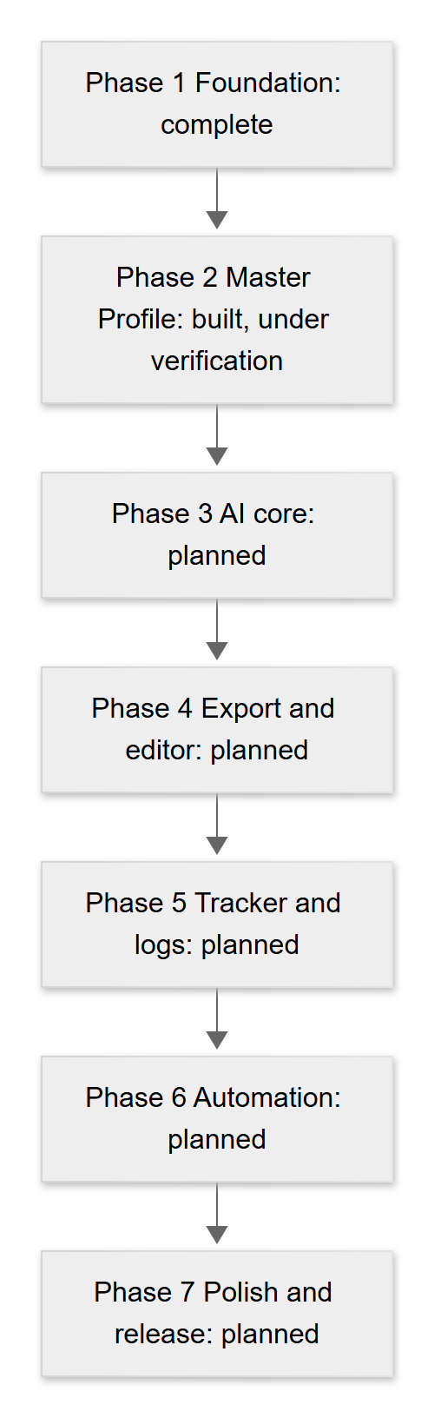
Figure 11. Phase roadmap

2. What Phase 2 delivered

2.1 Screens and features
Area | Delivered
Navigation | Bottom tabs: Home, Profile, Jobs (placeholder), Tracker (placeholder); profile sub-screens keep the tab bar
Home | Greeting, completeness ring (8 checks), next-step hint, quick actions, last 5 activities, system status with retry, pull to refresh
Personal info | Name, headline, phone, location, GitHub/LinkedIn/website, summary, with friendly validation
Experience, Projects, Education | Add, edit, delete (swipe or sheet), automatic ordering, bullet points that can be moved or removed
Skills | Search the shared bank, level 1 to 5, years, edit, remove, "Set level" tag, custom skills
Resume import | Model picker, file box, reading state with Cancel, review of five sections, duplicate flags, merge choices, save summary
Profile photo | Gallery or camera, crop and zoom, private storage, signed links, remove
Themes | 35 daisyUI themes (Light/Dark/All)
Accessibility and motion | Reduced-motion support, labelled controls, large tap targets

2.2 Backend
Item | Delivered
POST /skills/custom | Race-safe creation of shared skills
GET /ai/models | Model list with availability
POST /profile/import-resume | PDF/DOCX reading, three AI providers, anti-invention guard, error mapping
/health | Now also reports ai_configured

2.3 Database
Item | Delivered
Migration 0002 | profiles.avatar_path, private avatars bucket (2 MB; JPEG/PNG/WebP) and four storage policies

2.4 Quality
Last verified automated results: backend 101 tests passing; frontend 177 passing with 1 known stale starter test failing. Details in 10-testing-and-quality.md.

3. Known limitations
Each item was confirmed from the code.
# | Limitation | Where it comes from
L-1 | Scanned or photographed resumes cannot be read; there is no OCR. The user sees a message about text-based files. | resume_text.py (minimum 50 characters of text)
L-2 | Resume limits: 5 MB file, first 30 PDF pages, 30,000 characters sent to the AI. Longer text is cut silently. | resume_text.py
L-3 | Old .doc files are not supported. | resumeImport.ts, resume_text.py
L-4 | Free-tier AI providers have rate limits and quotas; users may see "busy" or "no credit or quota" messages. | ai_providers.py
L-5 | Model names change over time; the configured defaults may stop working (the app then shows "could not find this model"). Current names have not been verified with real provider calls. | .env.example, config.py
L-6 | Free-text fields from the AI (titles, companies, bullets, summary) are not word-for-word verified against the resume. | resume_parser.py
L-7 | The server-side limits for imported text are looser than the app's form limits (for example bullets up to 500 characters on the server, 300 in the form). The user may have to shorten text during review. | resume_parser.py, profileLogic.ts
L-8 | The reading screen says "up to a minute", but the worst case is longer: each provider call can take up to 60 seconds and one retry is allowed. | ImportResumePage.vue, ai_providers.py
L-9 | Camera capture on Android is unverified, and the Android manifest does not declare a camera permission. | AndroidManifest.xml, AvatarChanger.vue
L-10 | Touch gestures (drag and pinch in the photo editor) are covered by unit tests of the maths only, not tested on a device. | imageCrop.spec.ts
L-11 | Edits made directly by the app (profile, sections, skills) are not written to the activity log. The Home "Recent activity" list therefore shows only backend actions. | profile.ts, skills.ts
L-12 | Every Home load adds an auth.me_checked log row, which can crowd the Recent activity list. | routes.py, HomePage.vue
L-13 | Jobs and Tracker tabs are placeholders. The login screen tagline and the Home quick action "Paste a job description" describe a feature that does not exist yet. | LoginPage.vue, HomePage.vue, JobsPage.vue
L-14 | No password reset, account deletion or data export screens were found. | Source review
L-15 | Android project still uses starter appId and appName; only a debug-style setup exists. | capacitor.config.ts
L-16 | iOS is not set up. | No ios folder
L-17 | No deployment configuration exists in the repo. | Source review
L-18 | The documents bucket and the job, match, document and application tables exist but have no screens yet. | Migration 0001

4. Open items, risks, assumptions and dependencies

4.1 Open items
ID | Item | Owner
O-1 | Finish Phase 2 verification with the manual acceptance checklist (UAT-01 to UAT-29) | Project owner
O-2 | Confirm migration 0002 has been run on the live Supabase project | Project owner
O-3 | Rewrite or remove the stale starter test tests/unit/example.spec.ts | Developer
O-4 | Update the roadmap checklist in CLAUDE.md when Phase 2 is accepted | Developer
O-5 | Update the root README.md, which still describes Phase 1 only and refers to the frontend-files/ folder | Developer
O-6 | Resolve the Ionic version difference (project notes say Ionic 8, package.json declares ^9.0.0) | Developer
O-7 | Decide whether profile edits should be written to the activity log | Project owner
O-8 | Run a real resume import with each configured provider to confirm the default model names | Project owner

4.2 Risks
See the full security risk table in 07-security-and-privacy.md, section 7. Project risks:
ID | Risk | Mitigation
PR-1 | Free AI tiers change terms, limits or models | Model lists are configurable; users can switch provider; paid plans are an option
PR-2 | Single developer: schedule and knowledge concentration | This documentation set; small, tested steps
PR-3 | Phase 3 (generation) must keep the "never invent" rule | Reuse the anti-invention approach and add a gaps list and validation step
PR-4 | Real device behaviour (camera, gestures, keyboard) is untested | Add a device test pass before Phase 2 acceptance

4.3 Assumptions and dependencies
Type | Item
Dependency | Supabase project (Auth, Postgres, Storage) available and migrated
Dependency | At least one AI provider key (Groq, Gemini or OpenAI) on the server
Dependency | Node.js and Python toolchains; Android Studio for Android builds
Assumption | Free tiers remain available during development
Assumption | Phase 3 will use the Claude API (the ANTHROPIC_API_KEY setting is reserved)

5. Recommended next steps
- Run the acceptance checklist (10-testing-and-quality.md, section 5) on a real Supabase project, with at least two accounts.
- Apply migration 0002 on the live project and re-test the photo flow.
- Run one real resume import per provider and record the results.
- Fix or remove the stale example.spec.ts test so the frontend test run is fully green.
- Test on an Android device or emulator (camera, gestures, keyboard); add the camera permission if needed.
- Update CLAUDE.md and the root README.md; add screenshots to the user guide.
- Then start Phase 3, beginning with a short design note for job-description parsing, the skill matcher, the "gaps" list and validation of generated text.

6. Documentation notes (inconsistencies found while writing)
# | Observation
1 | CLAUDE.md says Ionic 8; frontend/package.json declares @ionic/vue ^9.0.0.
2 | frontend/package.json shows version 0.0.1; the backend reports 0.1.0. This documentation uses 0.1.0 as the product version.
3 | CLAUDE.md says Python 3.12; the Phase 1 README says Python 3.11 or newer.
4 | backend/.env.example lists more CORS origins than the default inside config.py (the example adds capacitor://localhost and http://localhost).
5 | The root README.md still documents the Phase 1 setup, mentions frontend-files/ and ionic serve on port 8100, and does not mention migration 0002 or the AI keys.
6 | The frontend example env template lives in frontend-files/.env.example; there is no .env.example inside frontend/.

7. Decisions log
Dates come from the repository commit log (local time, UTC+8) or from the project owner. Where no date is known, none is given.
Date | Decision | Reason
23 October 2026 | Start the project with Supabase, FastAPI and Ionic Vue (Phase 1 commits) | Chosen stack for a mobile-first portfolio app
23 October 2026 | Add daisyUI themes with a theme picker in the header | Easy, attractive theming
23 October 2026 | Add the Android platform (Capacitor) | Run on phones
24 October 2026 | Move resume import from Anthropic to Groq, Google Gemini and OpenAI (free tiers, user-selectable) | Cost. The Anthropic key setting is kept reserved for Phase 3
24 October 2026 | Store profile photos in a private avatars bucket with signed links (migration 0002) | Photos are personal data
24 October 2026 | Import returns a draft only; the user reviews before anything is saved; skills are added without a level | Supports the rule that the AI never invents skills or experience
24 October 2026 | UI direction: vibrant but clean | Owner preference for a simple, not over-designed interface with lively colours
Date not recorded | Simple profile data is read and written directly with Supabase (RLS); AI, file reading and shared-skill writes go through the API | Fewer endpoints; secrets stay on the server
Related: 01-product-overview.md, CHANGELOG.md.

10 – Testing and Quality
Item | Detail
Document | Testing and quality
Version | 1.0 draft
Date | 24 October 2026
Status | Draft for review
Audience | Testers, developers, clients (acceptance, section 5)
Purpose: To describe how JobFit AI is tested, what the automated tests cover, how to run them, a manual acceptance checklist for client sign-off, and what has not been verified yet.

1. Test strategy
Level | Approach | Tools | Status
Backend unit and API tests | Test routes with a test client, with the database and AI providers replaced by fakes; test provider calls with a recording fake network | pytest | In place
Frontend unit tests | Test pure logic (validation, sorting, duplicate detection, merge, crop maths, error wording) and stores with mocked network | Vitest + jsdom | In place
Component / screen tests | Mount screens and check behaviour | Vue Test Utils | Not in place (only a stale starter test)
End-to-end tests | Drive a real browser | Cypress | Configured, only a starter spec exists
Manual acceptance (UAT) | A tester follows the checklist in section 5 on a real Supabase project | Browser, Android | Checklist ready; not yet executed
Real-service checks | Real AI provider calls, real Supabase storage upload | Manual | Not yet done
Design choice: logic is kept in plain functions (profileLogic.ts, importLogic.ts, avatarLogic.ts, resume_parser.py) because plain functions are fast and reliable to test.

2. What is covered
Last verified numbers (reported by the project owner's test runs): backend 101 tests passing; frontend 177 passing with 1 known failure (the stale starter test tests/unit/example.spec.ts, which still looks for the text "Ready to create an app?" on a page that no longer shows it). It should be rewritten or removed.

2.1 Backend (backend/tests)
File | Test functions* | What it covers
test_api.py | 4 | Health; /me without a token and with a bad token; HS256 token decoding
test_skills.py | 9 | Create skill; return existing (by name and by alias) without a duplicate; bad characters and lengths; allowed special characters; category length; clean 500 on database failure; token required
test_ai_models.py | 9 | Token required; exact fields; availability follows keys; default is the first available; Groq wins the default; no key material in responses; lists come from environment; /health ai_configured
test_ai_providers.py | 16 | Request shape per provider; key only in the right header; only the chosen provider's key is sent; allow-list and missing-key checks never reach the network; lenient JSON parsing; one retry; no retry for HTTP errors; error messages never contain keys or bodies; 404 and 429 messages
test_resume_import.py | 39 | PDF and DOCX happy paths (including tables); missing fields stay null; hallucinated values dropped; current-job and year rules; invalid dates; length clamps; file size, type and content errors; empty, scanned, short and corrupt files; no AI configured; unexpected AI errors; sloppy output; prompt injection stays inside data tags; log contains counts only; nothing saved to the database; model choice, default and allow-list; provider 429, 5xx, rejected key, timeout, invalid JSON twice; end-to-end through the provider layer
* Counted as test functions; parameterised functions run several times, which is why the reported total (101) is higher than the sum of functions (77).

2.2 Frontend (frontend/tests/unit)
File | Tests* | What it covers
profileLogic.spec.ts | 30 | Text, URL and phone validation; months and years; sorting; bullets and tags; skills search and levels; shared completeness; data error wording
importLogic.spec.ts | 44 | Draft normalisation; required fields; personal-info merge; duplicate detection; skill matching; validation reuse; save plan; summary sentences; skills without a level
resumeImport.spec.ts | 19 | File checks; friendly import errors; upload with mocked network; partial saves with fake writers
aiModels.spec.ts | 19 | Model selection rules; availability; list normalisation; remembered choice; requests; provider-named errors
avatarLogic.spec.ts | 16 | Initials, colour tone, storage paths, signed-link refresh timing, friendly photo errors
imageCrop.spec.ts | 16 | Photo file checks, zoom and offset limits, crop rectangle, pinch distance
avatarStore.spec.ts | 10 | Photo store loading, upload, remove, reset
motion.spec.ts | 10 | Easing, count-up and ring maths, "just reached full"
dashboard.spec.ts | 9 | Completeness, dashboard helpers, friendly errors, activity icons
theme.spec.ts | 4 | Theme store
example.spec.ts | 1 | Stale starter test (fails)
* Test counts per file are from counting it/test calls; the owner's reported total is 178 (177 passing and 1 failing).

3. How to run the tests (Windows PowerShell)
From the project root (C:\Projects\jobfit-ai).

3.1 Backend
cd backend
.venv\Scripts\python -m pytest -q
How to check it worked: the last line reads like 101 passed.

3.2 Frontend unit tests
cd frontend
npm run test:unit -- --run
How to check it worked: Vitest lists the files; at the time of writing, one failure in example.spec.ts is expected.

3.3 Frontend type check and build
cd frontend
npm run build
How to check it worked: the command ends without type errors and creates the dist folder.

4. Accessibility notes
What the code shows (not a formal audit; a full audit is to be confirmed):
- Buttons and icons have text or aria-labels (for example "Log out", "Open your profile", "Change profile photo").
- Errors use role="alert"; status changes use role="status" or aria-live.
- Form fields use visible floating labels, with error text under the field.
- Tap targets are designed to be about 44 pixels or larger.
- Animations stop when the device asks for reduced motion.
- The themes include light and dark choices. Colour contrast in every one of the 35 themes has not been measured.
- The progress ring has a label ("Profile completeness").
- Keyboard use on the web version has not been systematically tested.

5. Manual acceptance checklist (UAT)
Use two test accounts (A and B) on a Supabase project where migrations 0001 and 0002 have been applied and at least one AI provider key is configured. Prepare: a text-based PDF resume, a DOCX resume, a scanned/image PDF, a .doc file, a file over 5 MB, and a JPEG photo. Leave Pass / Fail and Notes empty until tested.
ID | Scenario | Steps | Expected result | Pass / Fail
UAT-01 | Sign up | Login screen, Sign up, enter name, email, password (6+ chars), Create account | Message "Account created. Check your email to confirm, then log in."; profile row exists in Supabase
UAT-02 | Log in | Enter correct details, Log in | Arrive on Home with greeting; opening /login while signed in goes to Home; signed out, opening Home goes to login
UAT-03 | Wrong password | Enter wrong password | "That email or password does not look right."; stay on login
UAT-04 | Personal info | Profile, Personal info; fill all fields including github.com/sample; Save; try a bad phone | "Profile saved."; link stored with https://; bad phone shows message; empty name refused
UAT-05 | Experience | Add a current job; add a past job; edit; delete via swipe and confirm | Messages shown; current job listed first; end month required when not current; counts and Home ring update
UAT-06 | Projects | Add project with technologies "Vue, Git, vue"; edit; delete | Tags saved without duplicates; invalid link refused
UAT-07 | Education | Add entry with end year before start year; correct it; delete | Error "The end year cannot be before the start year."; saved after correction
UAT-08 | Skills from bank | Add skill "Python" level 4 years 2.5 | Skill listed with 4 bars and "Level 4: Advanced · 2.5 years"; already-owned skills hidden from search
UAT-09 | Custom skill | Search a skill not in the bank; add as new; repeat with the same name from account B | Created once; account B receives the existing skill (no duplicate row in skills)
UAT-10 | Edit and remove skill | Tap a skill, change level; swipe left, remove, confirm | Updated and removed; messages shown
UAT-11 | Import: model and PDF | Import from resume; choose a model; choose the text PDF; observe reading; test Cancel once | Model list shows availability; "Reading your resume..." with Cancel; Cancel returns to file box; a second attempt reaches the review
UAT-12 | Import: DOCX | Import the DOCX (with a table if possible) | Review appears with details from paragraphs and table
UAT-13 | Review and edit | Edit a field, untick an item, check the "Will save" line | Edits kept; unticked items not counted; nothing saved yet (check Profile counts)
UAT-14 | Duplicates | Import the same resume twice; save the first time only | On the second import, matching experience, education, project and skills show "Already in your profile" and cannot be saved
UAT-15 | Personal-info conflict | Profile has a different headline; import a resume with another headline | "Your profile has: ..." shown; default Keep current; Use imported replaces only when chosen; email never imported
UAT-16 | No invented data | Compare review with the source file field by field | No email, phone, link, date, skill or technology appears that is not in the file; blanks are "Not found - add it yourself"
UAT-17 | Save and skills without level | Press Save to profile | Done screen with summary; imported skills have "Set level"; Profile counts and Home ring increased; custom skills only if ticked
UAT-18 | Discard | Edit a draft, press Discard | Confirmation shown; after confirming, nothing is saved and the file box returns
UAT-19 | Scanned PDF | Import the scanned PDF | Message about text-based PDF or DOCX; "Choose another file" offered
UAT-20 | Wrong type and size | Choose the .doc file, a .txt file, and the over-5 MB file | Each refused before upload with the specific message
UAT-21 | Photo upload | Profile, tap photo, Choose from gallery, move, zoom, Save photo | Photo appears on Profile and Home; file exists under the user's folder in the avatars bucket
UAT-22 | Photo remove | Tap photo, Remove photo, confirm | Initials return; file removed from the bucket
UAT-23 | Friendly errors | Stop the backend; reload Home | System status shows "The backend is not reachable..."; no raw error text; Retry works after restarting the backend
UAT-24 | Theme | Change theme on Login and Home; close and reopen | Theme applied at once and remembered
UAT-25 | Completeness and Home | Start with an empty profile and add one item per check | Ring moves in equal steps to 100 percent; "Next:" hint follows the order; refresh by pulling down
UAT-26 | Log out | Log out, then log in as account B | Account A's data, photo and any draft are not visible
UAT-27 | Placeholders | Open Jobs and Tracker; use "Paste a job description" | "Coming soon" screens only; no pretend feature
UAT-28 | Mobile layout and Android | Check at 375 pixels wide; build and run on Android emulator or phone (see 12) | Screens usable; bottom tabs not covered; camera option tried and result recorded
UAT-29 | Data isolation | As account B, try to see account A's data (no UI path; check in Supabase with B's login or through the API) | Account B sees no rows or files of account A

6. Known quality gaps (not verified)
# | Gap
Q-1 | No real AI provider calls are made by the automated tests. Real provider behaviour, current model names, rate limits and answer quality are unverified.
Q-2 | Real Supabase storage upload (photo) and the real storage policies are not covered by automated tests.
Q-3 | Touch gestures (drag, pinch) and the camera on real devices are unverified.
Q-4 | No screen-level tests (component or end-to-end). Behaviour such as the review layout, tick boxes, sheets and navigation relies on manual checking.
Q-5 | Live Row Level Security with two real accounts has not been exercised by a test.
Q-6 | One stale frontend test fails (example.spec.ts).
Q-7 | No automated type or lint result is recorded here; run npm run build (type check) before release.
Q-8 | No performance or load testing; no formal accessibility audit; no security penetration test.
Q-9 | Email confirmation behaviour depends on Supabase settings and was not tested here.
Related: 02-requirements-specification.md (traceability), 09-roadmap-and-status.md.

11 – Glossary
Item | Detail
Document | Glossary
Version | 1.0 draft
Date | 24 October 2026
Status | Draft for review
Audience | Everyone
Purpose: To explain, in plain words, the terms used in the JobFit AI documentation. Terms are listed in alphabetical order.

Term | Meaning
Access token | A short-lived digital pass (see JWT) that the app sends to the backend to prove who you are.
Activity log | A list of actions saved by the backend, such as "Resume parsed". The Home screen shows the last five.
Anon key (publishable key) | A public Supabase key that the app may contain. It is safe because database rules (RLS) limit what it can do.
Anti-invention guard | The server check that removes anything the AI returned that cannot be found in your resume text.
API | Application Programming Interface. A set of web addresses the app uses to ask the server to do work.
Application tracker | Planned (Phase 5) screen to follow job applications from saved to offer. Not built yet.
ATS | Applicant Tracking System. Software employers use to receive and filter resumes. "ATS-friendly" means a simple layout that such software can read. Generation of ATS-friendly resumes is planned (Phase 3).
Authentication | Proving who you are, here by email and password through Supabase.
Backend | The server part of JobFit AI (FastAPI). It handles files, AI calls and secret keys.
Bearer token | The way the app sends the access token: in an Authorization: Bearer ... header.
Bucket (storage bucket) | A named container for files in Supabase Storage. JobFit AI uses documents and avatars.
Capacitor | A tool that wraps a web app so it can run as an Android (or iOS) app.
Cascade delete | When a user is deleted, their rows in other tables are deleted automatically.
Changelog | A list of what changed in each version. See CHANGELOG.md.
CORS | A browser safety rule. The backend must list which web addresses (origins) may call it.
Custom skill | A skill you add yourself because it is not in the shared skills bank.
daisyUI | A colour-theme library used to give the app its 35 themes.
DOCX | The Word document format (.docx). Supported for resume import.
Draft (import draft) | The result of reading a resume, shown for review. Nothing is saved until you confirm.
Duplicate detection | Spotting that an imported item is already in your profile, so it is not saved twice.
Environment variable | A named setting (for example a key or an address) kept outside the code, in a .env file or server settings.
FastAPI | The Python framework used for the backend.
Gaps list | Planned. Skills a job asks for that you do not have. They are listed, never added to your resume.
Groq, Google Gemini, OpenAI | The three AI companies whose models can read a resume in the current version.
Ionic | A toolkit of mobile-style screens and buttons used to build the app.
JD (job description) | The text of a job advert. Parsing JDs is planned (Phase 3).
JSON | A simple text format for structured data, used between the app and the server.
JWT | JSON Web Token. The format of the access token. It carries your account id and an expiry time and is signed by Supabase.
JWKS | The public list of keys a server uses to check that a JWT is genuine.
Master Profile | Your single, trusted record of personal info, experience, projects, education and skills.
Migration | A numbered database change file (for example 0002_profile_avatars.sql) run in order.
Model (AI model) | The particular AI system used to read your resume, for example "GPT-OSS 120B".
OCR | Optical Character Recognition: turning a picture of text into real text. Not built, so scanned resumes cannot be read.
pgvector | A Postgres add-on for storing meaning-based number lists. Enabled for future skill matching; unused today.
Pinia | The library the app uses to share data between screens.
Prompt | The instructions and text sent to an AI model.
Prompt injection | An attempt to trick an AI with instructions hidden in the text it reads (for example inside a resume). JobFit AI treats resume text as data only.
Rate limit | A cap on how many requests a service accepts in a short time. Free AI plans have low limits, which causes "busy" messages.
RLS (Row Level Security) | A database rule that lets each user see and change only their own rows.
Service key (secret key) | A powerful Supabase key that bypasses RLS. It exists only on the server and never in the app.
Signed URL | A temporary web address, valid for a short time (1 hour here), that lets the app show a private file such as your photo.
Skills bank | The shared list of skills everyone can search. Custom skills are added to it.
Supabase | The hosted service that provides login, the Postgres database and file storage.
Tab bar | The row of buttons at the bottom of the app: Home, Profile, Jobs, Tracker.
Theme | A set of colours for the app. There are 35, from light to dark.
UAT | User Acceptance Testing: a client or tester checks that the app does what was agreed. See 10-testing-and-quality.md.
Venv (virtual environment) | A private folder of Python packages for the backend, so they do not clash with other projects.
Vite | The tool that runs and builds the web app during development.
Vue | The JavaScript framework used for the app's screens.

12 – Installation and Operations
Item | Detail
Document | Installation and operations guide
Version | 1.0 draft
Date | 24 October 2026
Status | Draft for review
Audience | Technical staff (developers, administrators)
Purpose: To explain how to set up JobFit AI on a Windows PC, configure it, run it, build the Android app, and fix common problems. Commands are for Windows PowerShell. Only variable names are shown; never paste real keys into documents, chat or Git.

1. Prerequisites
Tool | Version | Check with
Git | any recent | git --version
Node.js | 20 LTS or newer | node -v
Python | 3.12 (project notes); the Phase 1 README says 3.11 or newer | python --version
Android Studio | latest (only for Android builds) | open Android Studio
A Supabase project | free tier is enough | Supabase dashboard
At least one AI key | Groq, Google Gemini or OpenAI (only for resume import) | provider dashboard
If PowerShell blocks the Python virtual environment script, run once:
Set-ExecutionPolicy -Scope CurrentUser RemoteSigned

2. Database setup (Supabase)
Run the migrations in order. Never edit a migration after it has been run; add a new numbered file instead.
- Open the Supabase dashboard, then SQL Editor, New query.
- Paste the full contents of supabase/migrations/0001_init.sql and press Run.
- Create another new query, paste supabase/migrations/0002_profile_avatars.sql and press Run.
How to check it worked:
- Table Editor shows profiles, experiences, projects, education, skills (25 rows), user_skills, job_posts, match_results, generated_docs, applications, activity_logs.
- profiles has the column avatar_path.
- Storage shows two private buckets: documents and avatars.
Authentication: keep Email sign-in enabled. For faster testing you may turn Confirm email off, and turn it on again before real users arrive.
Collect from Project Settings: the project address, the publishable (anon) key, and the secret (service) key. The legacy JWT secret is needed only if your project still signs tokens with HS256.

3. Backend setup
cd C:\Projects\jobfit-ai\backend
python -m venv .venv
.venv\Scripts\Activate.ps1
pip install -r requirements.txt
Copy-Item .env.example .env
Open backend\.env in an editor and fill in the values (see section 5). Do not share this file.
Run the tests, then start the server:
.venv\Scripts\python -m pytest -q
.venv\Scripts\python -m uvicorn app.main:app --reload --host 0.0.0.0 --port 8000
How to check it worked:
- Tests end with a line like 101 passed.
- Open http://localhost:8000/api/v1/health. You should see "status": "ok", "supabase_configured": true and, if an AI key is set, "ai_configured": true.
- Open http://localhost:8000/docs for the interactive API documentation.
--host 0.0.0.0 lets other devices on your network (a phone) reach the server. Windows Firewall may ask for permission.

4. Frontend setup
The example environment file for the frontend is kept in frontend-files\.env.example (there is no .env.example inside frontend).
cd C:\Projects\jobfit-ai\frontend
npm install
Copy-Item ..\frontend-files\.env.example .env
Open frontend\.env and fill in the three VITE_ values (see section 5). Then:
npm run dev
How to check it worked: the terminal prints a local address (Vite normally uses http://localhost:5173; read the exact address from the terminal output). Open it: you should see the login screen. Sign up, log in, and check that Home shows "Everything is working." under System status.
Other commands:
npm run build # type check and production build into dist
npm run test:unit -- --run

5. Configuration (variable names only)

5.1 Backend backend\.env
Variable | What to put | Notes
APP_ENV | development | Reported by /health
SUPABASE_URL | Your project address | Same project as the frontend
SUPABASE_SERVICE_KEY | The secret (service) key | Server only. Never in the frontend
SUPABASE_JWT_SECRET | Leave empty unless the project uses legacy HS256 | Without it, HS256 tokens return 401
CORS_ORIGINS | Comma-separated list of app origins | The example allows http://localhost:8100, http://localhost:5173, capacitor://localhost, http://localhost. Add your deployed address later
ANTHROPIC_API_KEY | Leave empty | Reserved for Phase 3; unused
GROQ_API_KEY, GEMINI_API_KEY, OPENAI_API_KEY | Your provider key(s) | Empty means the provider is hidden/"not set up"
GROQ_MODELS, GEMINI_MODELS, OPENAI_MODELS | Comma-separated model names | See section 6

5.2 Frontend frontend\.env
Variable | What to put | Notes
VITE_SUPABASE_URL | Your project address
VITE_SUPABASE_ANON_KEY | The publishable (anon) key only | Never the service key
VITE_API_URL | Backend address ending in /api/v1 | For example http://localhost:8000/api/v1
Important: VITE_ values are fixed into the app when it is built. After changing them, restart npm run dev or rebuild for Android.

6. Configuring AI keys and models
- Create a key in the provider's dashboard (Groq, Google AI Studio for Gemini, or OpenAI). Free tiers have limits.
- Put the key in backend\.env as GROQ_API_KEY, GEMINI_API_KEY or OPENAI_API_KEY. Do not wrap it in extra quotes or spaces.
- Restart the backend. Settings are read once at start-up.
- Check http://localhost:8000/api/v1/health shows "ai_configured": true.
- In the app, open Import from resume: the model list shows your provider's models as available.
Model names change over time. If a provider renames or removes a model, users see "could not find this model". Edit the matching *_MODELS list in backend\.env (comma-separated, exact names from the provider), then restart. Only names in these lists can ever be used. Friendly labels exist for some names (for example GPT-OSS 120B); others show their raw name.
The default order is Groq, then Gemini, then OpenAI: the first available model in that order is preselected.

7. Android (Capacitor)
Prepare frontend\.env for the device:
Where the app runs | VITE_API_URL
Android emulator | http://10.0.2.2:8000/api/v1 (the emulator's name for your PC)
Real phone on the same Wi-Fi | http://<YOUR-PC-LAN-IP>:8000/api/v1 (find the address with ipconfig)
Then, from the frontend folder:
cd C:\Projects\jobfit-ai\frontend
npm run build
npx cap sync android
npx cap open android
In Android Studio, choose an emulator or a connected phone and press Run.
How to check it worked: the login screen appears on the device, and after login Home shows "Everything is working."
Notes:
- Rebuild (npm run build, then npx cap sync android) after every change to frontend\.env or to the code.
- The Android project allows plain http:// (usesCleartextTraffic) for development. Remove this for a release that uses HTTPS.
- capacitor.config.ts still has the starter appId (io.ionic.starter) and appName (frontend). Change them before any release.
- The manifest declares only the internet permission. If "Take a photo" does not work on a device, a camera permission may need to be added (to be confirmed).
- Make sure CORS_ORIGINS includes capacitor://localhost and http://localhost.
- iOS is not set up.

8. Operations tips
Topic | Tip
Restart after changes | Restart uvicorn after any backend\.env change (the --reload option reloads on code changes, not reliably on settings). Restart npm run dev after any frontend\.env change
Health check | GET /api/v1/health is public and shows configuration flags only
Logs | The server prints short messages to its console, such as the provider name and status code of a failed AI call. They never contain resume text or keys
Activity | The activity_logs table shows auth.me_checked, skill.created and resume.parsed rows
Secrets | Before every commit run git status and make sure no .env file is listed. .env files are ignored by Git; .env.example files are not
Migrations | Add a new numbered file for each database change; never edit one that has been run
Quota | Free AI tiers run out. Add keys for a second provider so users can switch
Backups | Not defined in the repository: to be defined

9. Troubleshooting
Symptom | Likely cause | Fix
Home shows "The backend is not reachable. Make sure it is running, then retry." or the browser console shows "Failed to fetch" | Backend not running, wrong VITE_API_URL, or your app's address is missing from CORS_ORIGINS | Start uvicorn; check VITE_API_URL; add the origin to CORS_ORIGINS; restart the backend
API calls go to the wrong path (404) | VITE_API_URL does not end with /api/v1 | Set it to .../api/v1 and restart the frontend
401 "Invalid token" | SUPABASE_URL differs from the app's project, or the project uses legacy HS256 and SUPABASE_JWT_SECRET is empty | Use the same project in both .env files; set the JWT secret if needed; restart
Changes to .env have no effect | The app or server reads settings only at start/build | Restart the backend; restart npm run dev; rebuild for Android
Profile status "We could not find your profile yet." | Migration 0001 not run, or the account was created before it | Run 0001_init.sql; sign up with a new email
"Photo upload is not set up yet - run the database update." | Migration 0002 not run | Run 0002_profile_avatars.sql, then tap the photo again
Import says "No AI provider is set up on the server yet." | No AI key, or the backend was not restarted after adding it | Add a key, restart, check /health
Import says "(Provider) key was rejected" | Wrong, expired or restricted key | Create a new key and update .env
Import says "could not find this model" | The provider renamed the model | Update the *_MODELS list; restart
Emulator cannot reach the backend | localhost means the emulator itself | Use http://10.0.2.2:8000/api/v1; run uvicorn with --host 0.0.0.0; rebuild and sync
Real phone cannot reach the backend | Wrong address, different network, or firewall | Use the PC's LAN address; same Wi-Fi; allow port 8000 in the firewall
Login says "Email not confirmed" | Supabase requires email confirmation | Click the email link, or turn Confirm email off during development
Activate.ps1 is blocked | PowerShell policy | Set-ExecutionPolicy -Scope CurrentUser RemoteSigned
pip install fails | Wrong Python or venv not active | Activate .venv; check python --version
Frontend test run shows one failure in example.spec.ts | Known stale starter test | Rewrite or remove it; see 10-testing-and-quality.md
Related: 05-architecture.md, 08-api-reference.md, 07-security-and-privacy.md.

Changelog
Item | Detail
Document | Changelog
Version | 1.0 draft
Date | 24 October 2026
Status | Draft for review
Audience | Everyone
Purpose: To record notable changes to JobFit AI by version. The format follows Keep a Changelog (Added, Changed, Fixed, and so on). Dates come from the repository commit log (local time, UTC+8). Only what is visible in the repository is listed; no earlier history is invented.
Status labels: see README.md. Phase 1 is Available now. Phase 2 is Built, awaiting verification.

[Unreleased]
Nothing built yet. Planned work (Phases 3 to 7) is described in 09-roadmap-and-status.md.

[0.1.0] - 24 October 2026

Phase 2 - Master Profile (built, awaiting verification) - 24 October 2026

Added
- Database (migration 0002): profiles.avatar_path column; private avatars storage bucket (2 MB limit; JPEG, PNG, WebP); storage policies so each user can read, upload, replace and delete only inside their own folder.
- Backend:
  - POST /api/v1/skills/custom to add a skill to the shared skills bank without creating duplicates.
  - GET /api/v1/ai/models to list selectable AI models and whether each is available.
  - POST /api/v1/profile/import-resume to read a PDF or DOCX resume and return a draft profile (saves nothing).
  - AI provider layer for Groq, Google Gemini and OpenAI (plain HTTP, model allow-list, one retry on invalid JSON, friendly error mapping).
  - Anti-invention guard that removes values not found in the resume text.
  - /health now reports ai_configured.
  - Environment settings for the three AI keys and model lists.
  - New backend tests (backend suite last reported at 101 passing).
- Frontend:
  - Master Profile screens: Personal info, Experience, Projects, Education, Skills (with levels and years, and custom skills).
  - Resume import flow: AI model picker, file box, reading state with Cancel, review screen, duplicate detection, personal-info merge choices, save summary, discard with confirmation.
  - Profile photo: gallery or camera, crop and zoom, private storage with signed links, remove.
  - Home: profile completeness ring (8 checks), next-step hint, quick actions, recent activity, pull to refresh.
  - Profile tab with section rows, counts and ticks.
  - Jobs and Tracker placeholder tabs ("Coming soon").
  - Friendly error wording, haptic feedback, reduced-motion support.
  - New frontend unit tests (suite last reported at 177 passing, 1 known stale starter test failing).

Changed
- Resume import uses free-tier Groq, Google Gemini and OpenAI models chosen by the user, instead of Anthropic, because of cost (decision recorded 24 October 2026; the earlier approach is not visible in the commit history). The Anthropic key setting remains reserved for Phase 3.
- Logging out clears the profile, photo and any import draft held in memory (what Phase 1 cleared before is not visible in the commit history).
- UI direction set to "vibrant but clean".

Known issues
- frontend/tests/unit/example.spec.ts is a stale starter test and fails; it should be rewritten or removed.
- Real AI provider calls, real storage upload and device gestures have not been verified. See 10-testing-and-quality.md.

Phase 1 - Foundation (complete) - 23 October 2026

Added
- Initial project: Supabase schema (migration 0001) with 11 tables, Row Level Security, the private documents bucket and 25 starter skills; automatic profile creation at sign-up.
- FastAPI skeleton: GET /api/v1/health, GET /api/v1/me, Supabase token verification (asymmetric keys and legacy shared secret), activity logging helper, CORS settings.
- Ionic + Vue app: login and sign-up, route guard, Home screen with three system checks.
- Frontend files tracked in the main repository.
- Claude Code project setup (agents, rules, skills).
- daisyUI themes (35) with a theme picker in the header.
- Android platform setup with Capacitor.

Version notes
- The backend API reports version 0.1.0. frontend/package.json still shows 0.0.1; this documentation treats 0.1.0 as the product version.
- Phase 3 will be the first release to add AI job matching and document generation.

