ÇANKAYA UNIVERSITY • CENG 382 WEB DEVELOPMENT

2024 – 2025 Spring

# FINAL PROJECT REPORT

#### **Project Name**: Web Based Classroom Reservation System

**Name, Surname:** Duhan Ayberk Seven

**Student Number:** 202211062

#### 19.05.2025

1. Project Information and Objectives
   1. Project Scope:

The scope of this project is a web-based classroom reservation system that facilitates the management of classroom bookings for educational institutions. It allows instructors to request reservations for classrooms during active terms, and administrators to approve, reject, or manage these reservations. The system also includes features such as term management, user (instructor) management, calendar views, feedback submission, and system logging, all accessible via role-based authentication. It aims to minimize manual scheduling conflicts and ensure efficient classroom utilization.

* 1. Users:

Those who will primarily benefit from and be affected by the system include:

* **Instructors**:
  + Can request classroom reservations during specific time slots.
  + Can view their reservation calendar and history.
  + Can submit feedback for classrooms.
* **Administrators (Admins)**:
  + Manage classroom terms and instructor accounts.
  + Review, approve, or reject reservation requests.
  + View feedback, manage logs, and oversee system activity.
* **System Developers / IT Staff**:
  + Maintain the system infrastructure and logs.
  + Ensure uptime and resolve technical issues.
  1. Objectives:

• The system shall provide **password-protected access** to user-specific content based on role (Admin or Instructor).

• The system shall allow **instructors to submit reservation requests** for classrooms.

• The system shall ensure **conflict-free scheduling**, preventing overlapping reservations in the same classroom.

• The system shall allow **admins to manage academic terms**, including start and end dates.

• The system shall provide **a calendar view** for both instructors and admins to visually track reservations.

• The system shall allow instructors to **cancel or delete their reservations**, based on approval status.

• The system shall log **all actions and errors**, providing visibility into user activities and system exceptions.

• The system shall support **feedback submission and review**, aiding facility improvement.

• The system shall provide **a responsive, user-friendly interface** for seamless access across devices.

1. Project Implementation
   1. Database Diagram:

metin, diyagram, plan, teknik çizim içeren bir resim

Yapay zeka tarafından oluşturulan içerik yanlış olabilir.

* 1. Context Diagram:

diyagram, metin, taslak, çizim içeren bir resim

Yapay zeka tarafından oluşturulan içerik yanlış olabilir.

* 1. Workflow Diagrams
     1. Admin Term Management Workflow Diagram

diyagram, metin, plan, teknik çizim içeren bir resim

Yapay zeka tarafından oluşturulan içerik yanlış olabilir.

* + 1. Admin Review Reservations Workflow Diagram

diyagram, taslak, teknik çizim, plan içeren bir resim

Yapay zeka tarafından oluşturulan içerik yanlış olabilir.

* + 1. Instructor Reservation Request Workflow Diagram

diyagram, teknik çizim, plan, taslak içeren bir resim

Yapay zeka tarafından oluşturulan içerik yanlış olabilir.

* + 1. Login Workflow Diagram

diyagram, plan, teknik çizim, taslak içeren bir resim

Yapay zeka tarafından oluşturulan içerik yanlış olabilir.

* + 1. System Logging Workflow Diagrams

metin, diyagram, ekran görüntüsü, plan içeren bir resim

Yapay zeka tarafından oluşturulan içerik yanlış olabilir.

* + 1. Feedback Submission Workflow Diagram

diyagram, metin, plan, teknik çizim içeren bir resim

Yapay zeka tarafından oluşturulan içerik yanlış olabilir.

1. Project Results
2. Login page: This is the entry point of the application where users (Instructors or Admins) can securely log in using their credentials. The page includes validation and shows error messages when login fails. Login errors are saved in the Activity Logs.

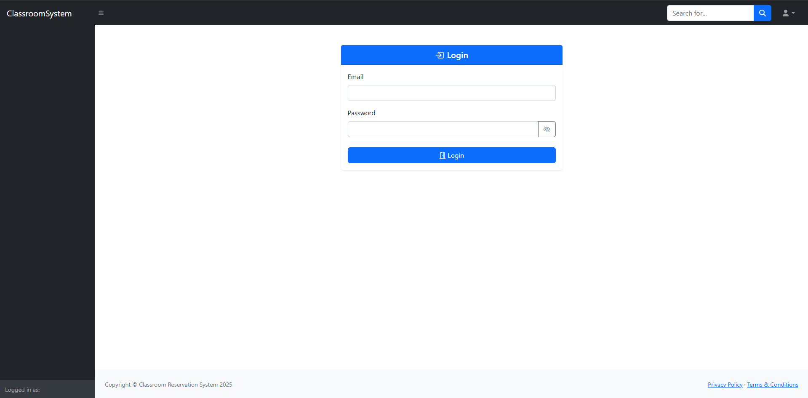

1. Admin Homepage: Displays summarized data such as the number of instructors, classrooms, pending reservations, and active term. Admins can navigate to management sections like terms, users, and reservations from this dashboard . Also at any point Admin can Access Logs page from top right.

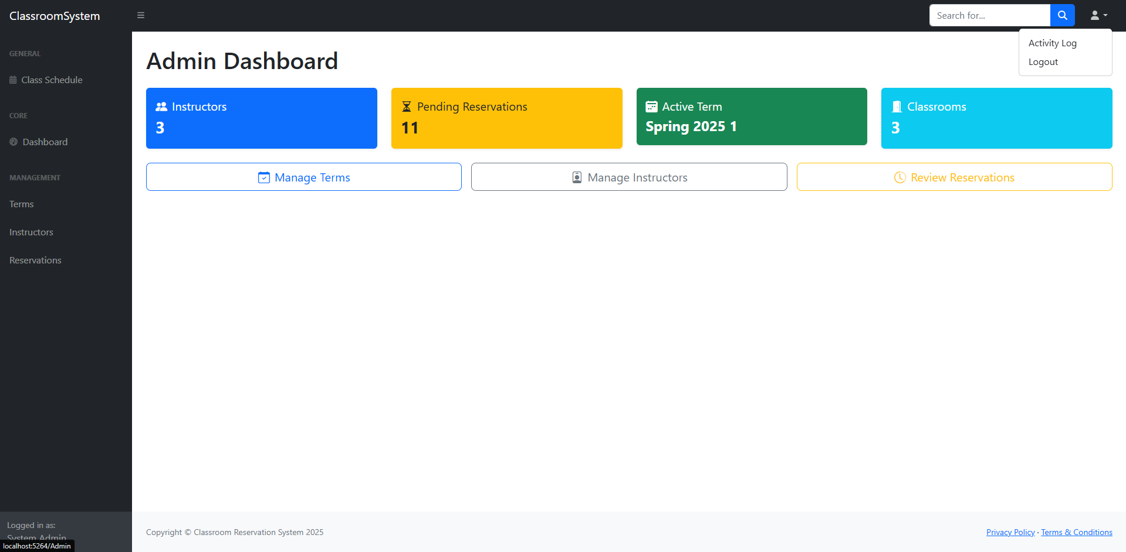

1. Admin Manage Term Page: This page allows the admin to manage academic terms. Admins can add new terms by providing a name, start date, and end date. The system ensures that overlapping terms are not allowed. It also lists all existing terms in a table where each term can be edited or deleted.

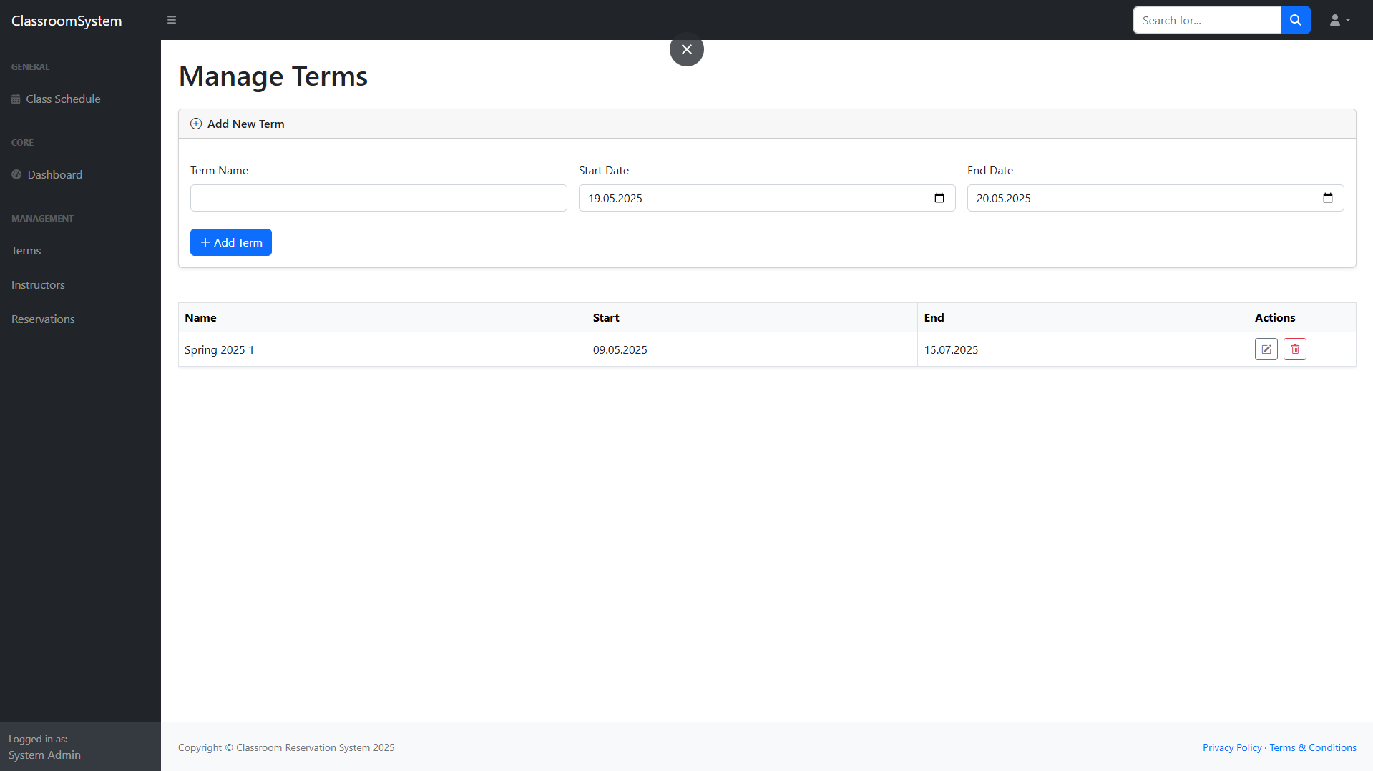

1. Admin Edit Term Page: Allows the admin to update term details such as the name, start date, and end date. It includes date validation and prevents overlapping term conflicts.

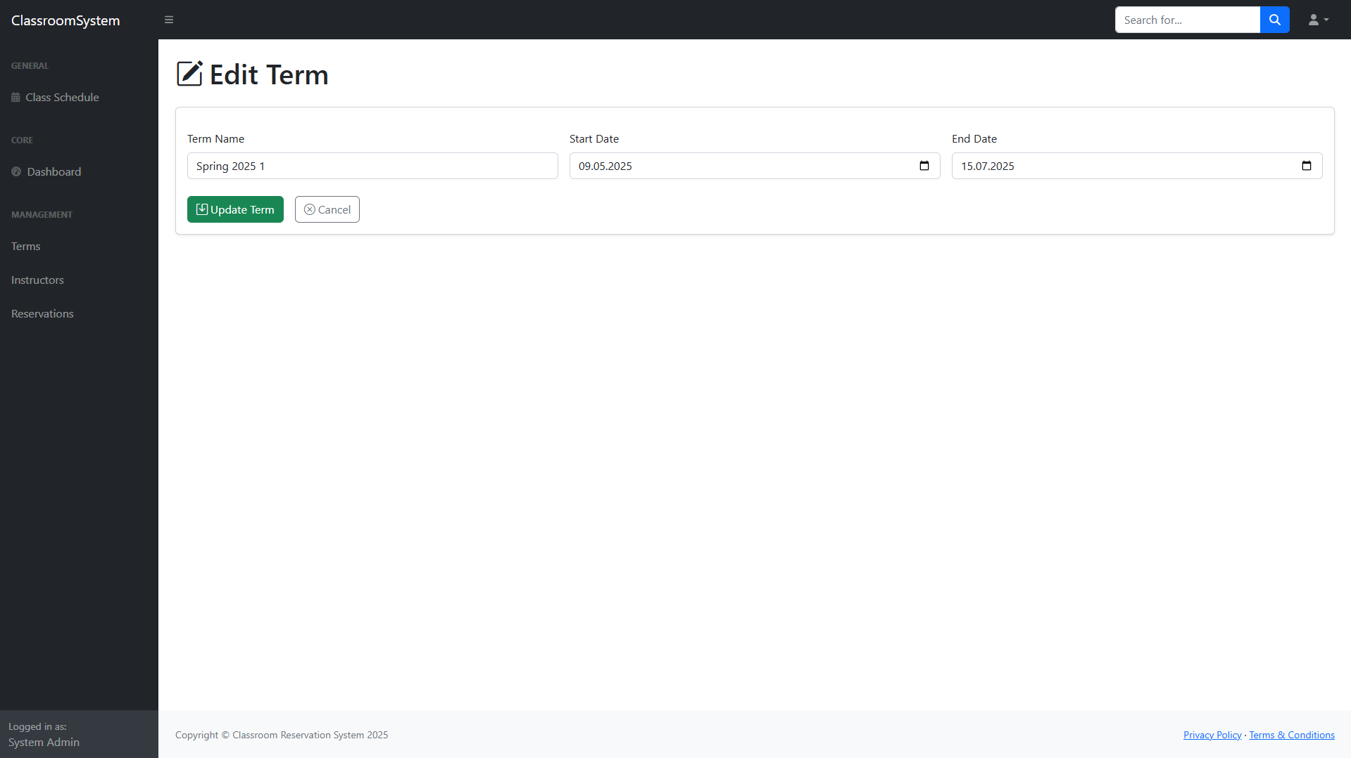

1. Admin Manage Instructors Page: Admin can view all instructors, add new instructors, or delete existing ones. Instructor information includes name, email, and password.

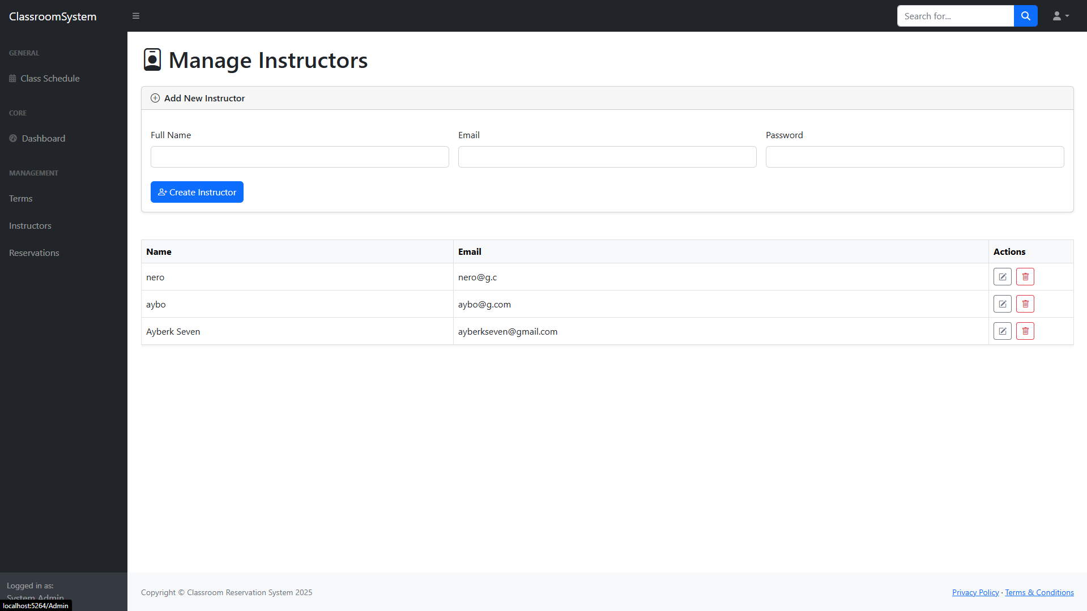

1. Admin Edit Instructors Page: Used to modify an existing instructor's details. Admin can update name, email, or set a new password for the instructor.

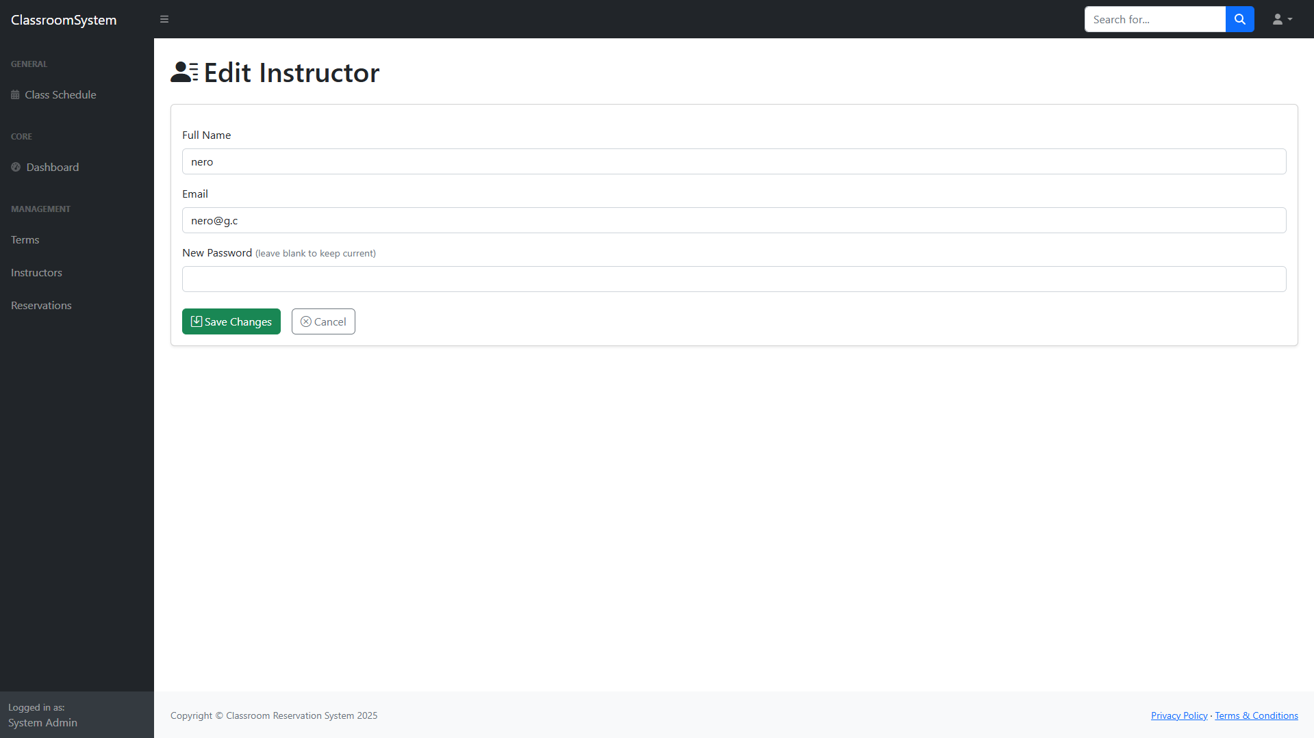

1. Admin Reservations Page: Shows a list of all reservation requests made by instructors. Admins can filter reservations by status and perform actions like approve, reject, delete, or edit with status indicators and conflict/holiday flags. All actions made by admin sends a informative email to the Instructor.

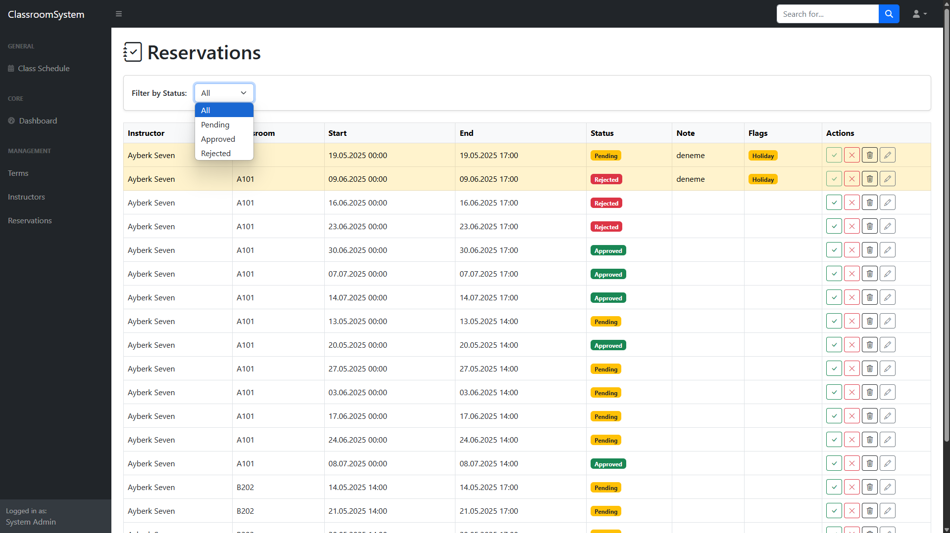

1. Admin Edit Reservation Page: Allows the admin to manually adjust the reservation time, classroom, and optionally auto-approve after editing. Helpful for resolving conflicts.

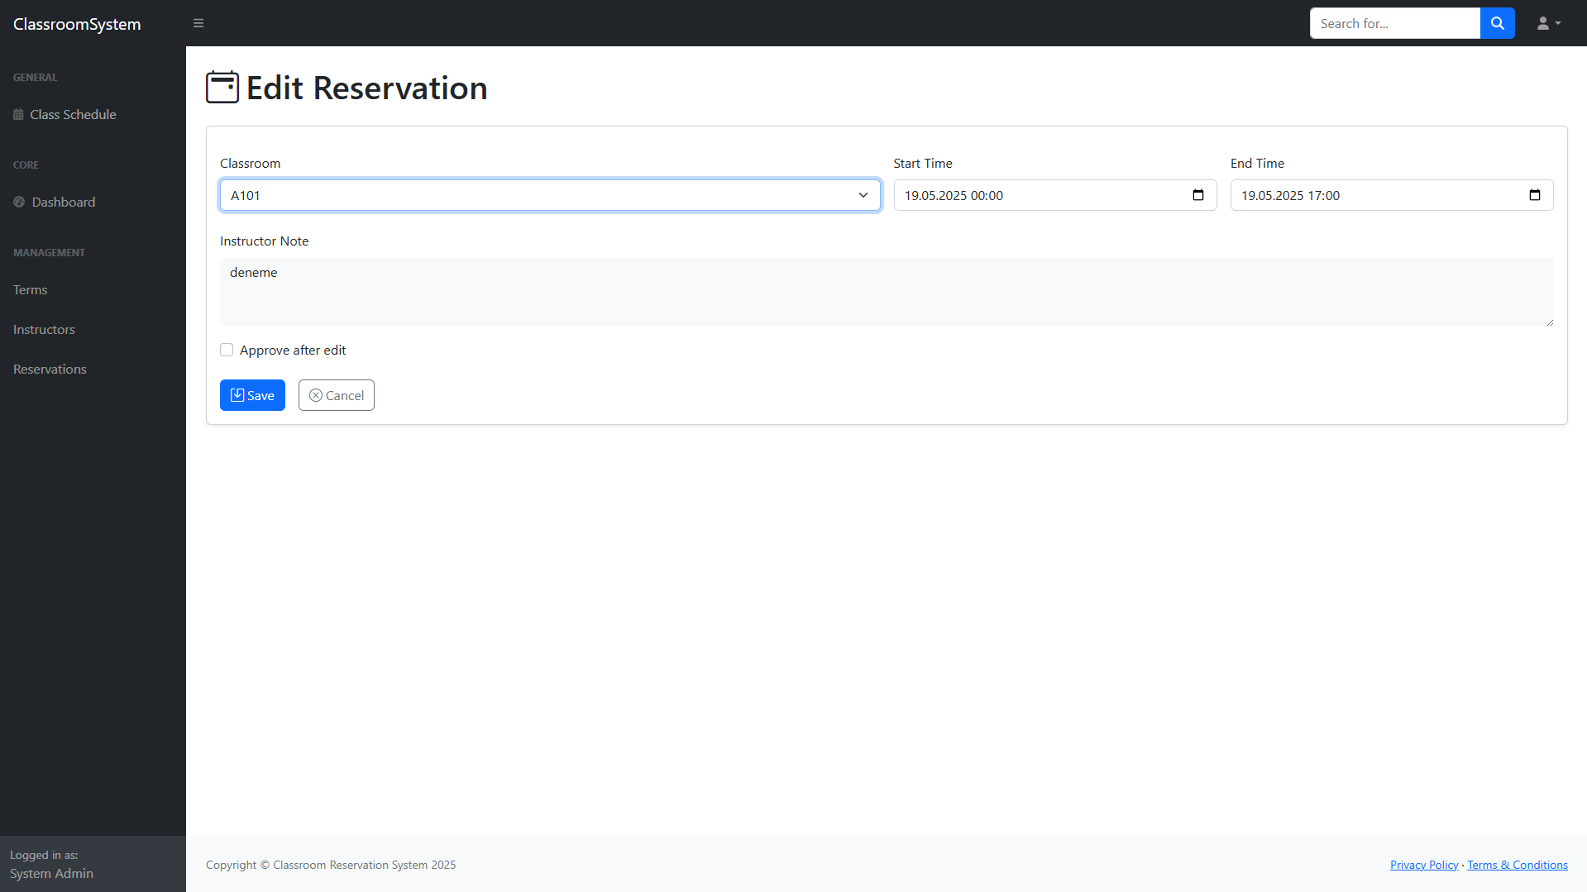

1. Classroom Schedule Page (Admin`s Page also shows Feedback): Provides a full calendar view of reservations for a selected classroom. You can click on a Week to Access a weekly calendar of the week you clicked. If the user is an admin, they can also view aggregated feedback and ratings submitted by instructors for that classroom.

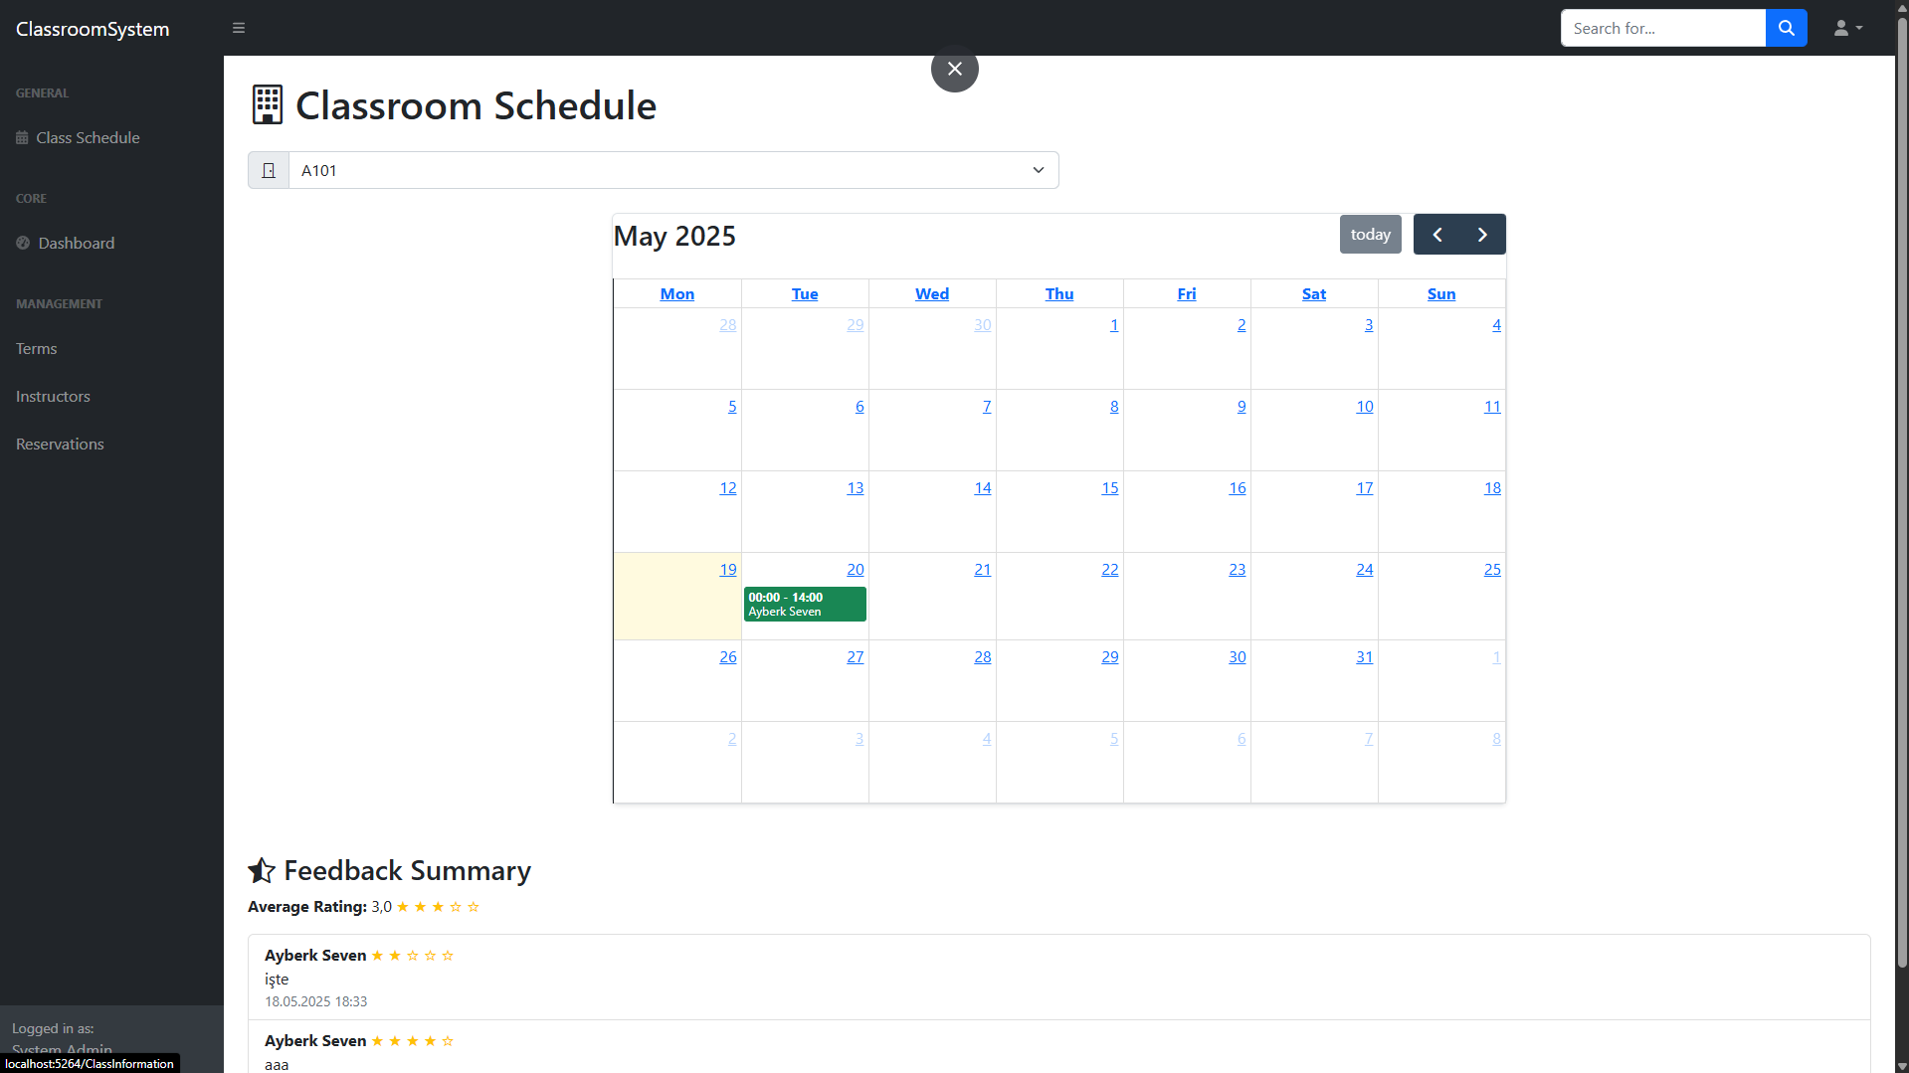

1. Classroom Schedule Page (Weekly): Displays a detailed, weekly view of classroom usage. view who reserved each time slot and click to return to the monthly calendar.

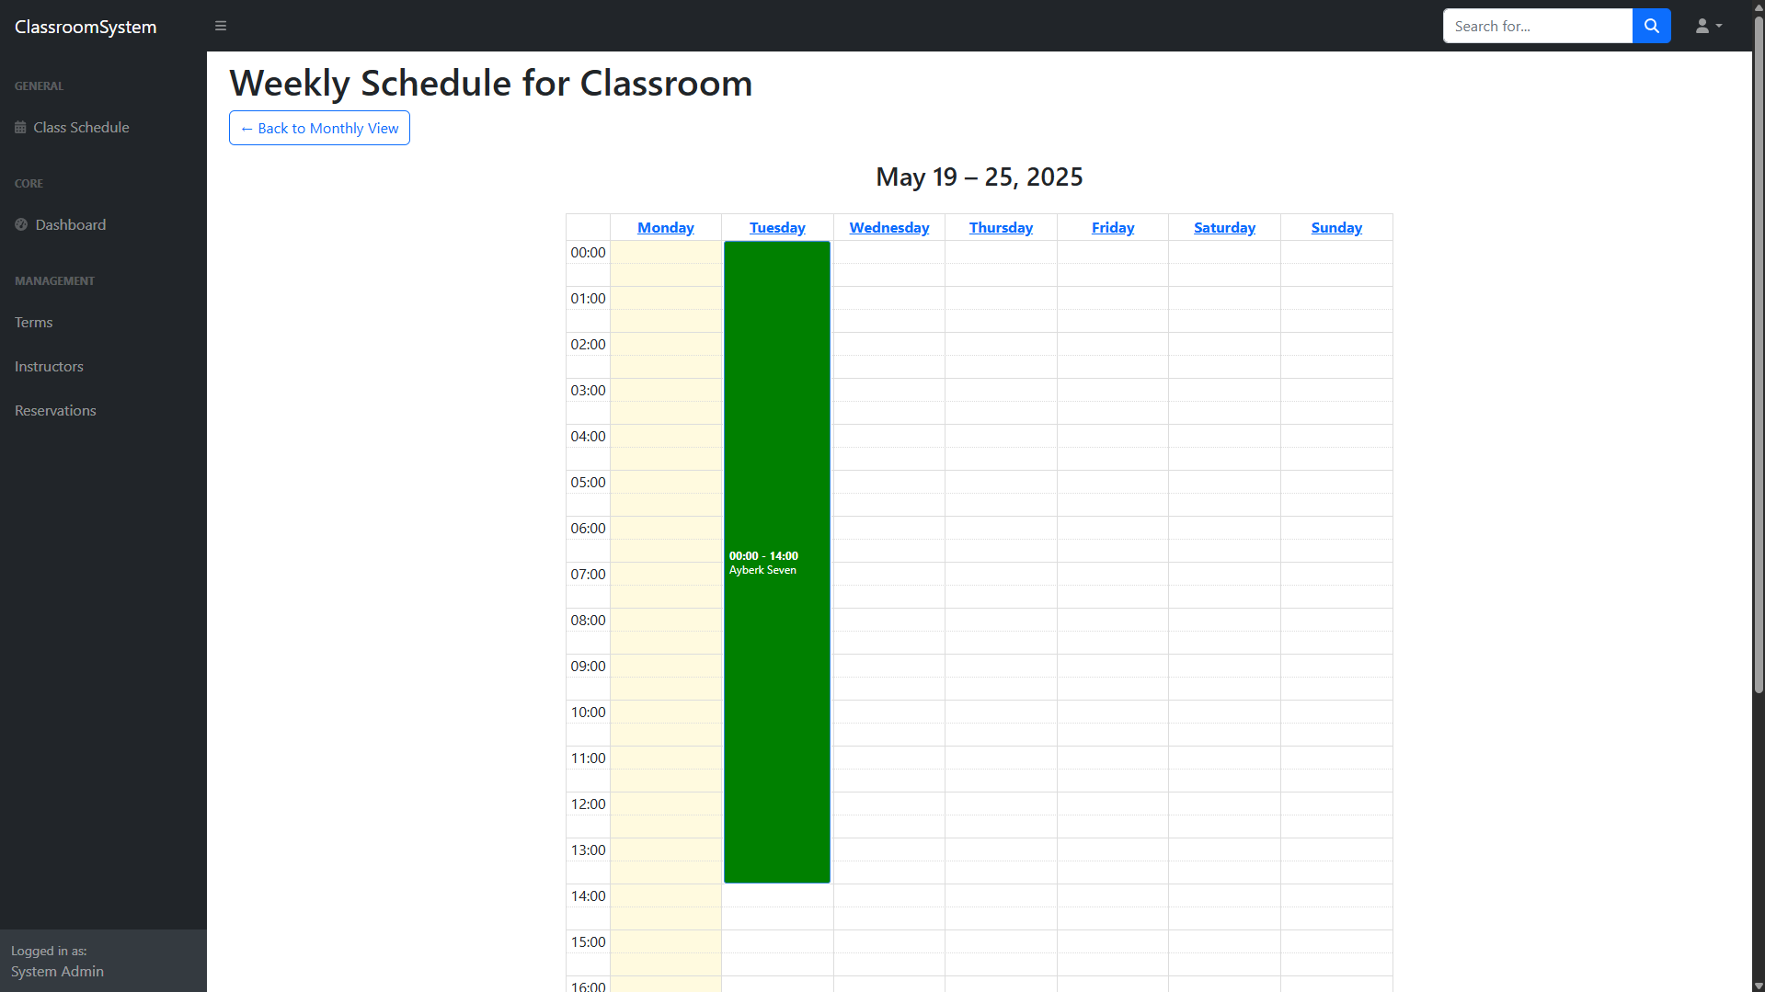

1. Admin Logs Page: Displays system activity logs and error logs. Admins can see which user performed what actions and inspect exception stack traces.

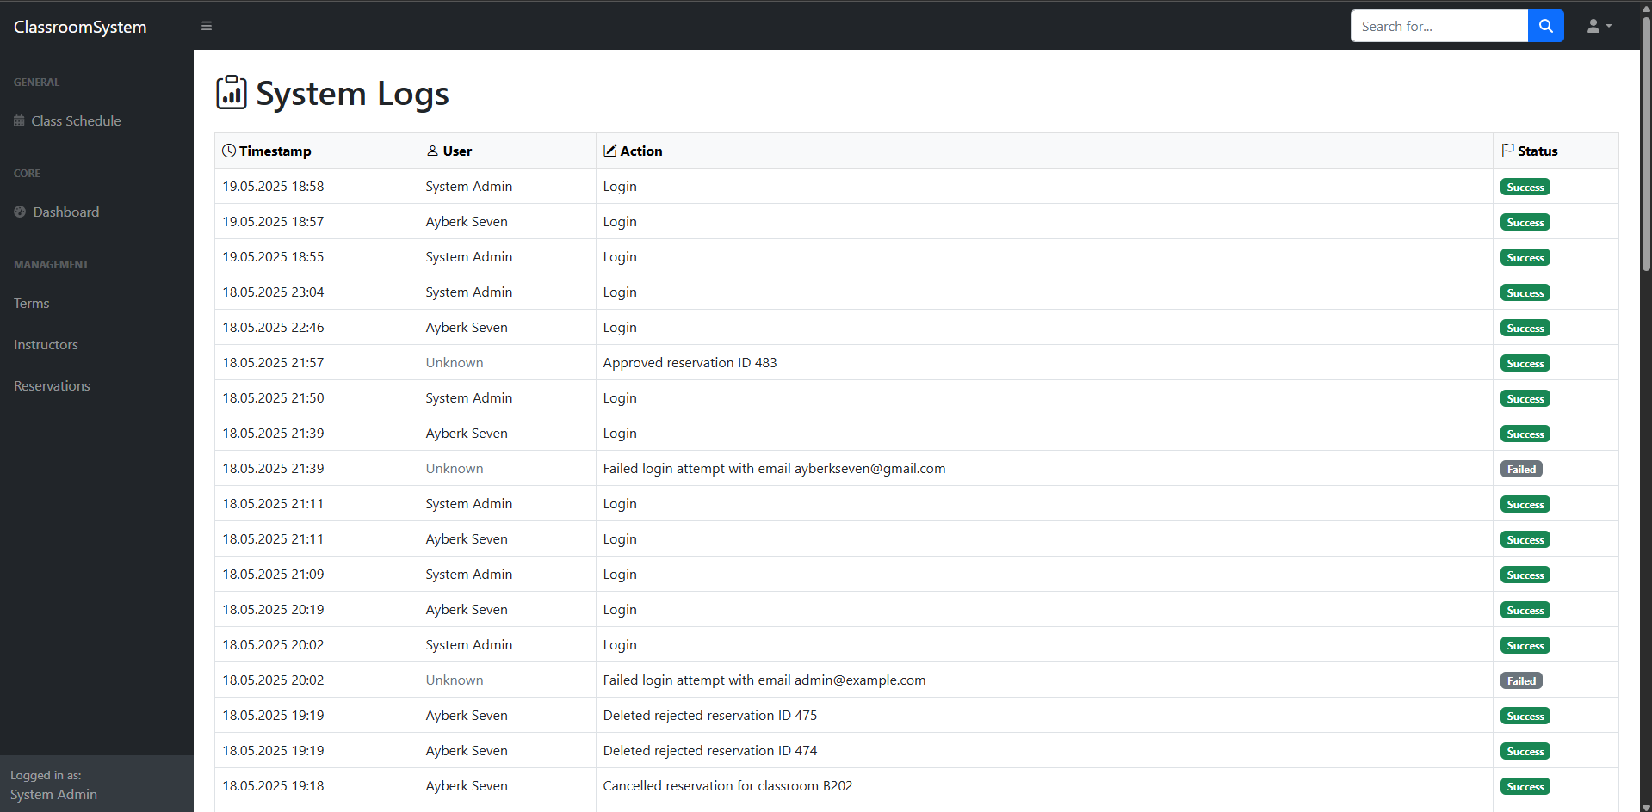

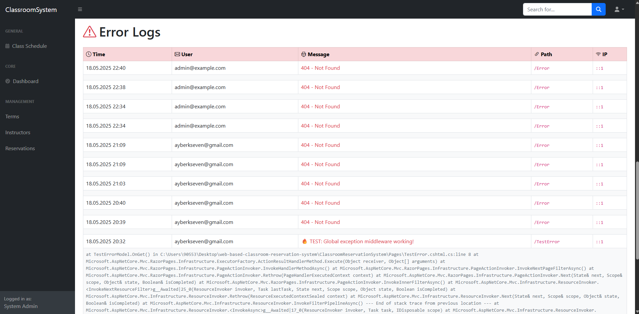

1. User Homepage: After login, instructors land on this dashboard showing statistics such as Active Term, approved and pending reservations, along with quick access buttons to make a reservation, view their calendar, or submit feedback.

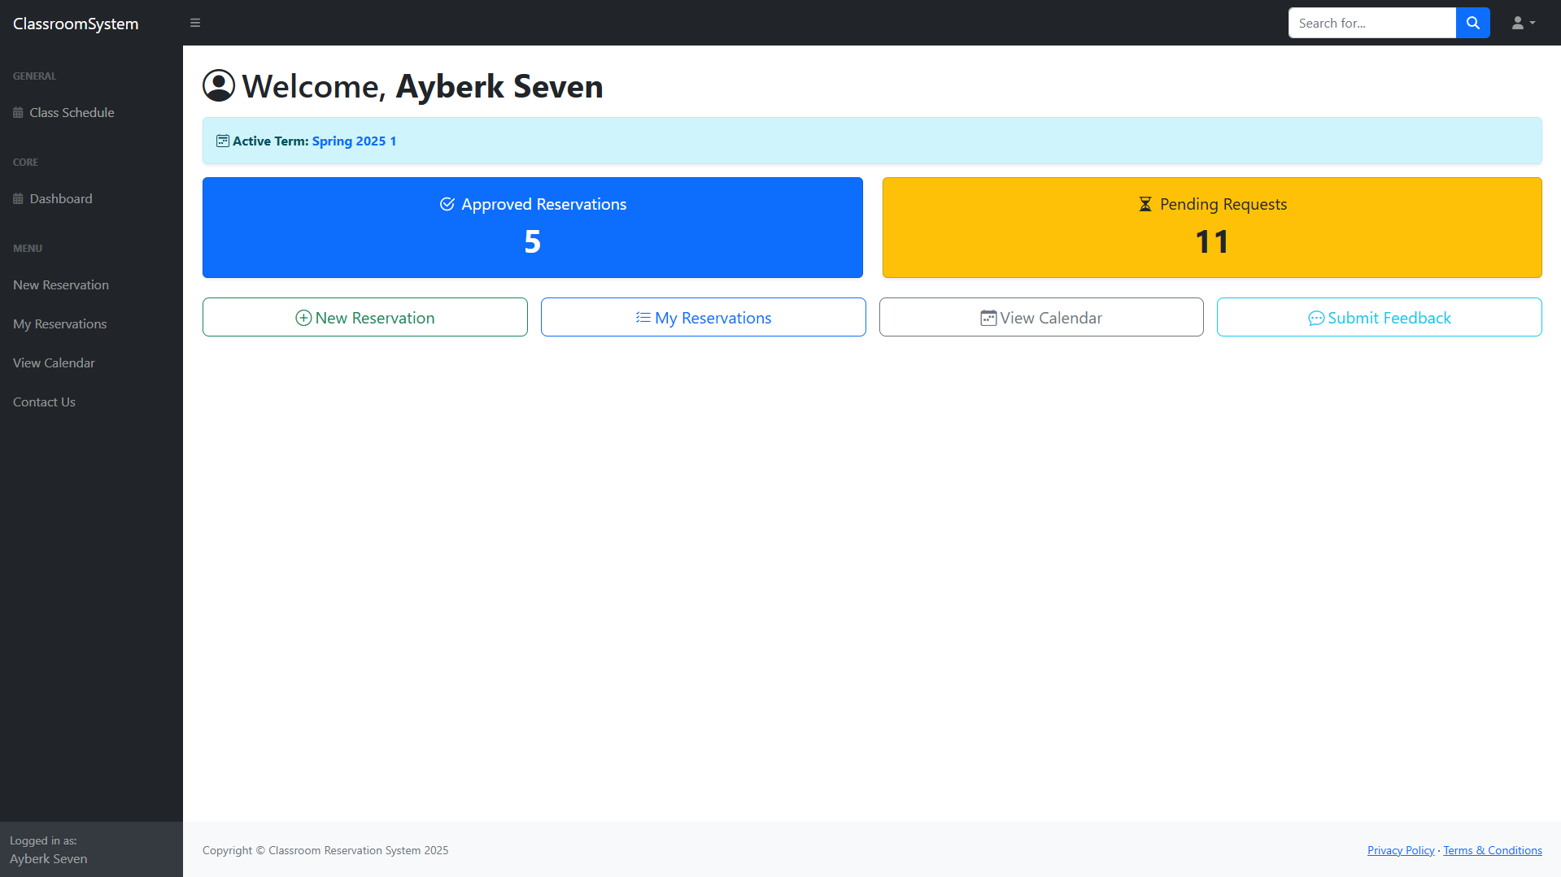

1. User Reservation Request Page: Instructors can select a day of the week and time range to request recurring reservations for a classroom. Conflict warnings and confirmation options are provided.

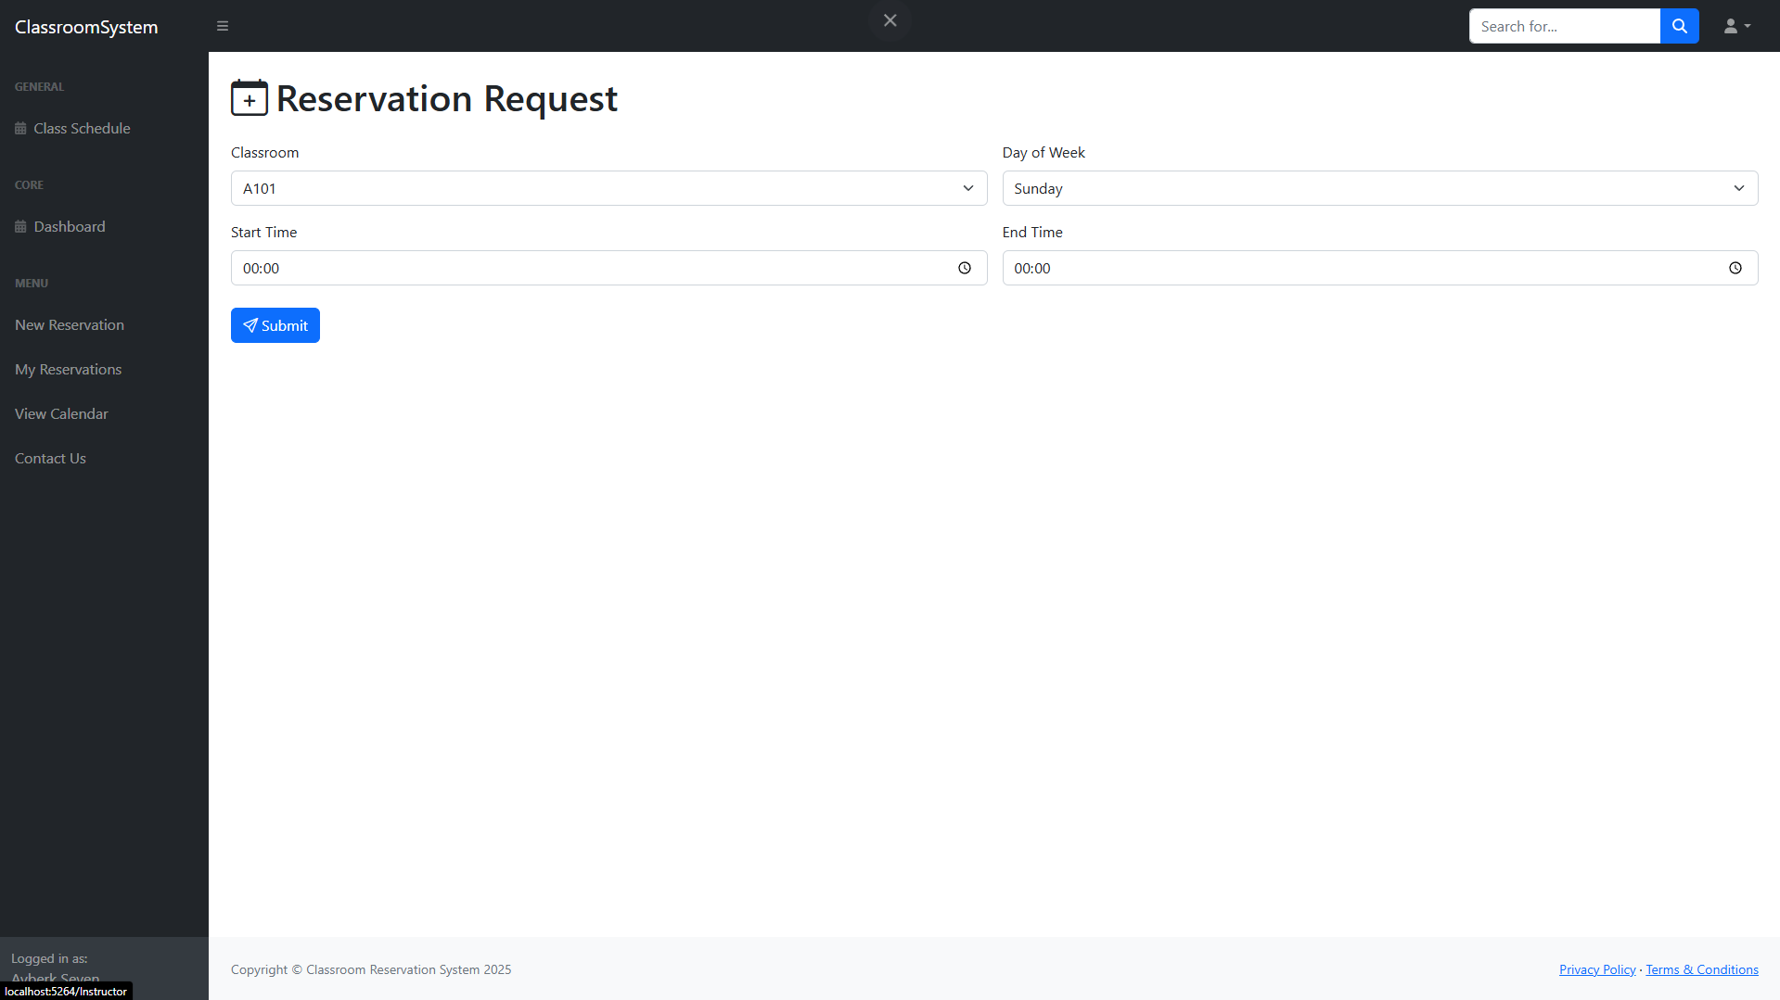

After Warning, User can choose to send the request anyway by checking the “Confirm and proceed anyway” button and send a note for the admin explaining the situation.

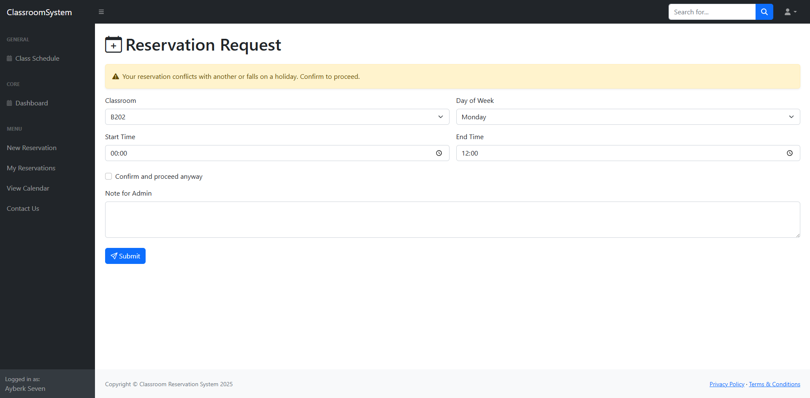

1. User My Reservations Page: Instructors can view their current and past reservations. Pending reservations can be cancelled; rejected reservations can be deleted.

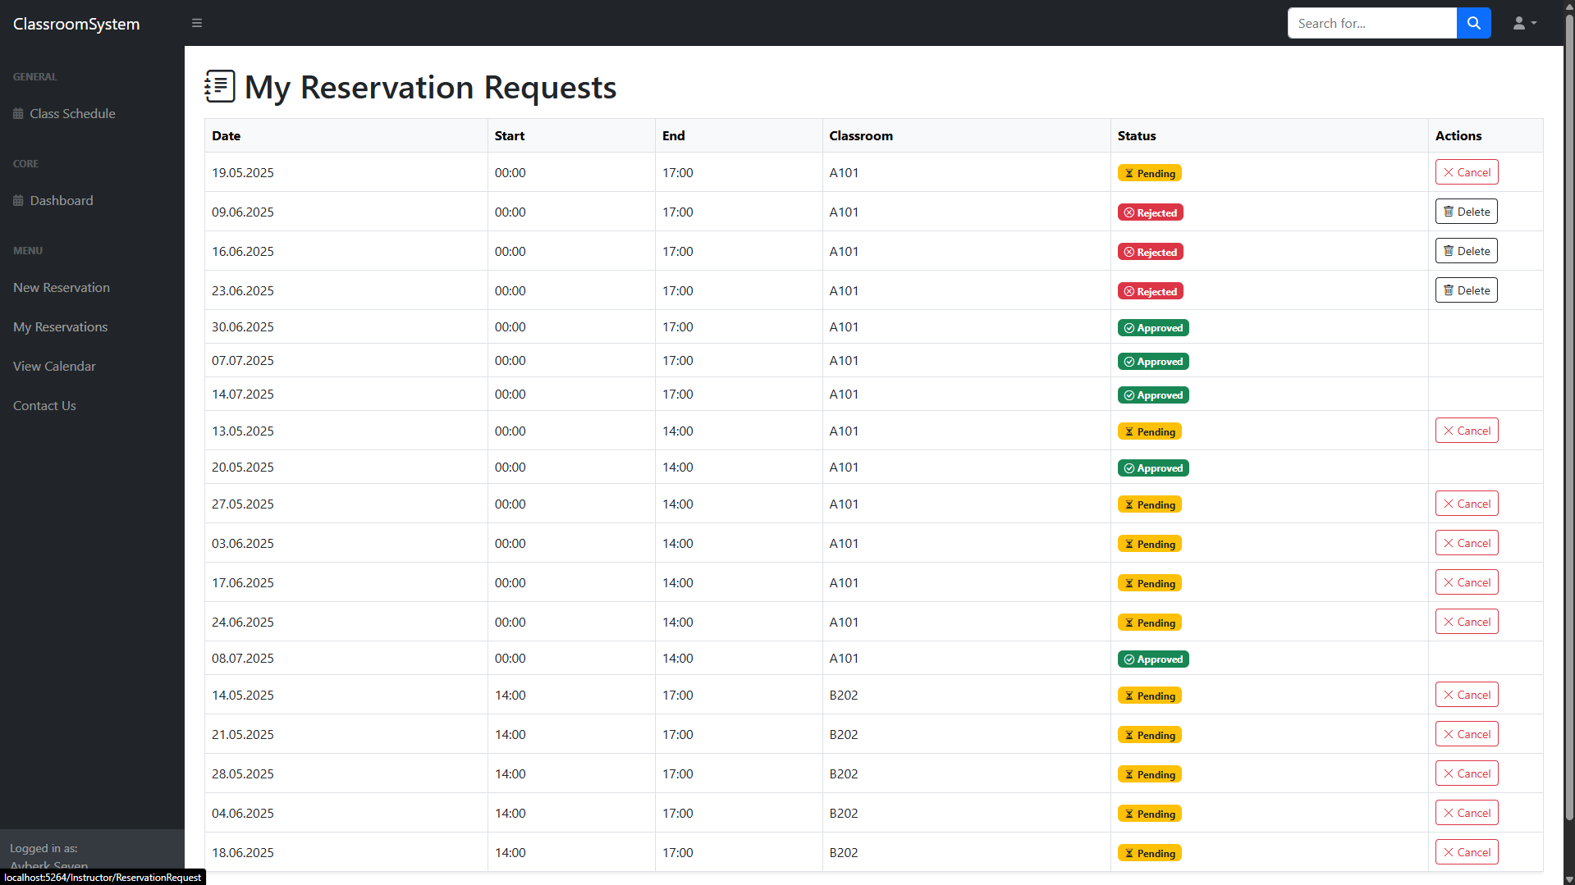

1. User Submit Feedback Page: Instructors can submit feedback for a classroom by selecting it, giving a rating (1–5 stars), and adding optional comments. Admins can later view these in the feedback summary. After a feedback is submitted Admin gets an email about it.

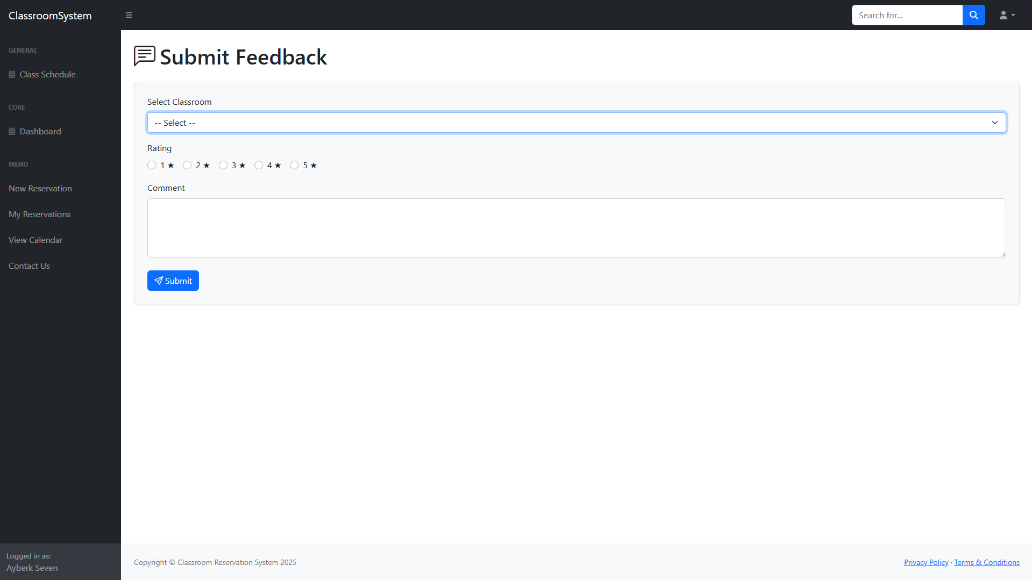

1. Database Examples
   1. Classrooms:

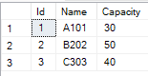

* 1. Users: *Passwords are Hash encrypted.

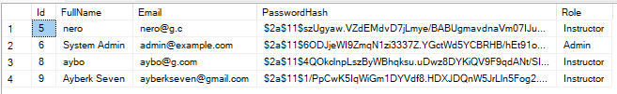

* 1. ErrorLogs:

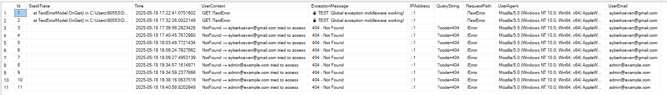

* 1. Feedbacks:

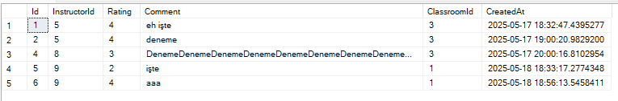

* 1. Reservations:

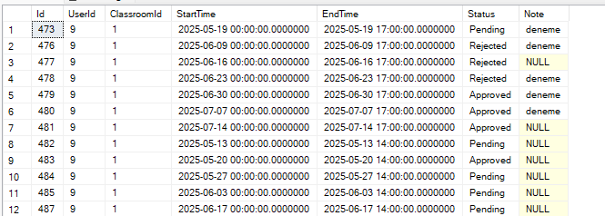

* 1. SystemLogs:

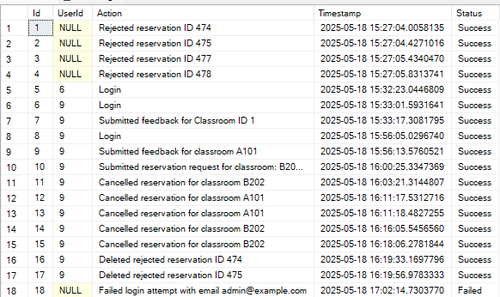

* 1. Terms:



1. Project Demo Link: https://youtu.be/UZBbZNRAXx4