NASA Space-Grant High Power Rocketry Competition
Avionics Team Lead
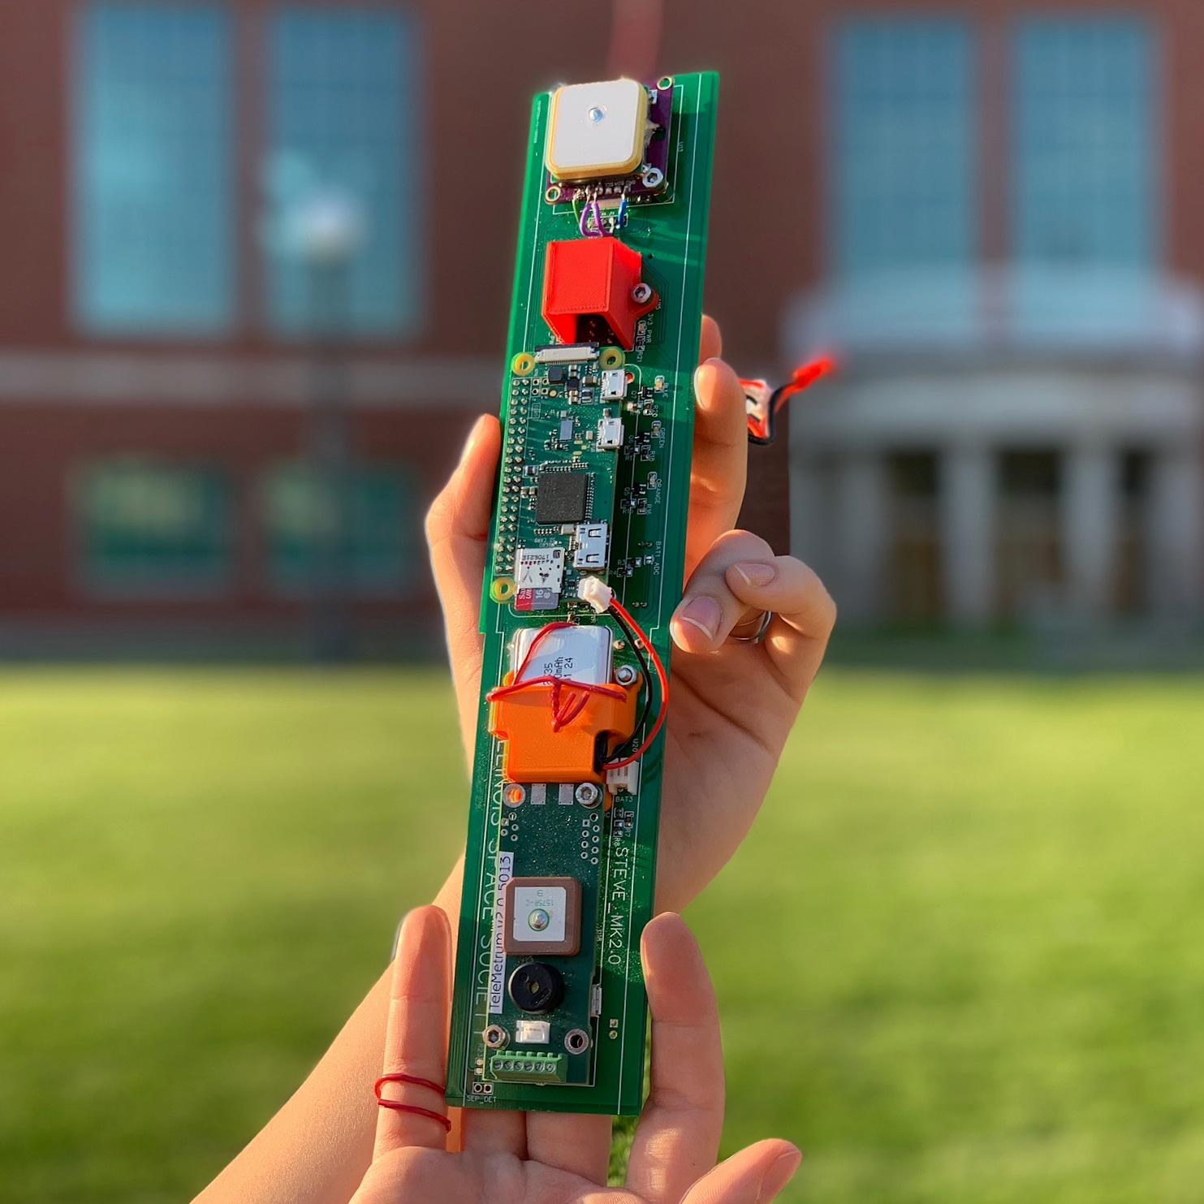
The second and final iteration of the avionics package developed for the competition. The package, nicknamed "Steve", incorporates two IMUs, a barometer, a pitot-static sensor, an ADC, a serial Flash chip, a GPS receiver, and a LoRa transceiver for telemetry.
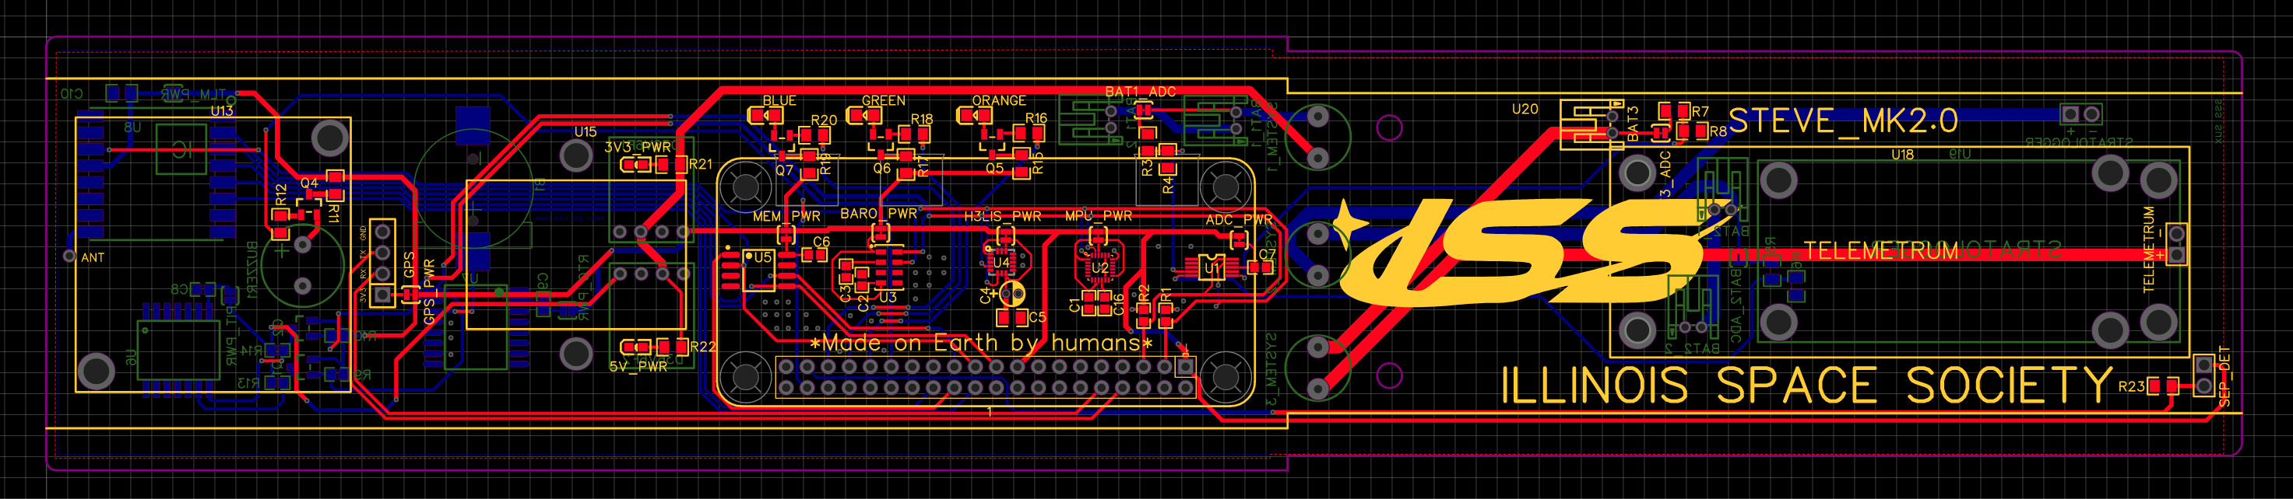
Steve made four flights on our competition rocket “MIN-D” and broke the sound barrier twice.
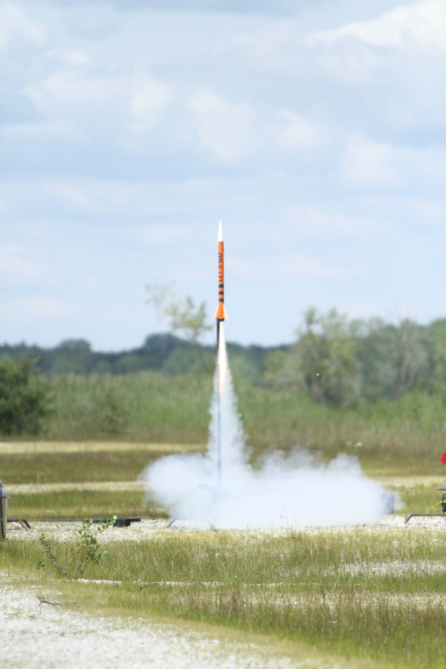

Spaceport America Cup High Power Rocketry Competition
Avionics Team Member
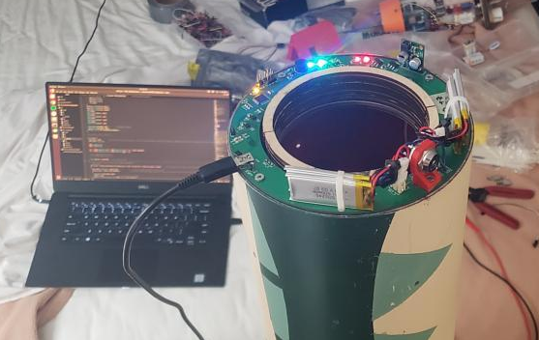
The flight computer I developed, nicknamed "the doughnut", undergoing final software verification before being bolted into the booster tube at our hotel in New Mexico. The system incorporates an Atmega328P micro-controller, two MPU9250 IMU's on the I2C bus, and a W25Q64 Flash IC on the SPI bus.
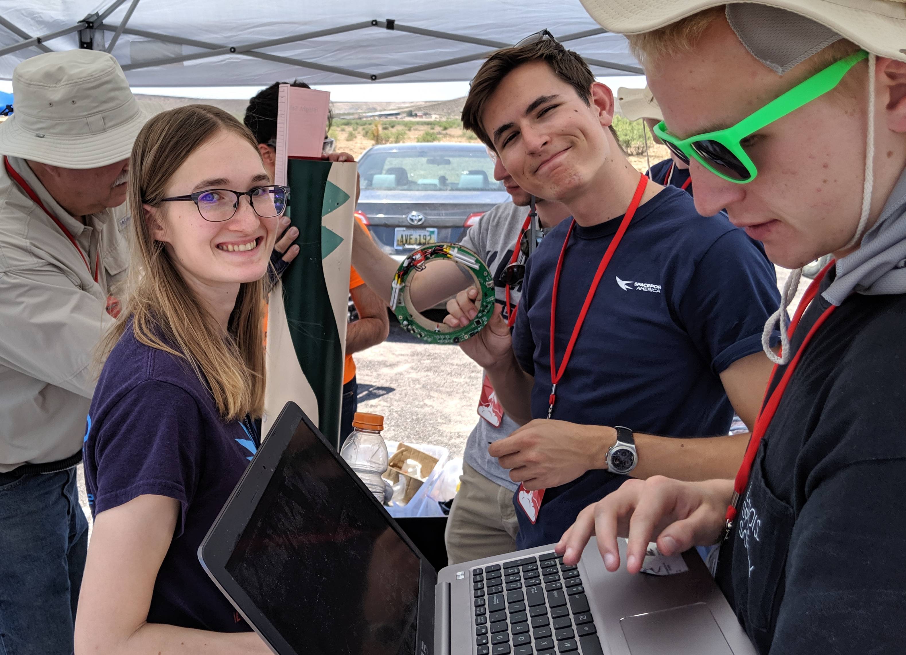

Left: Destiny Fawley, Center: Ayberk Yaraneri (myself), Right: Robert Filipiuk

The avionics team at the competition in Truth or Consequences, New Mexico.

