
Information Technology
Summer Internship Report 2024

Students: Firuza Aghayeva, Banu Alili, Aychin Guliyeva, Israfil Ibrahimov
Group: CE 22.2, CE 22.1

Internship Duration: 10.06.2024-05.07.2024
Report Submission: 13.07.2024

University Supervisor: Aydin Nasirzade, Arzu Gasimzade
Company Supervisor: Farhad Pashayev


Contents
Introduction 3
Institute of Control Systems 3
DATABASE PROJECT 4
Structure 4
Program 4
Back end 4
Front end 5
Result 6
PI CALCULATOR PROJECT 7
Theory 7
Method 7
Program 7
Result 9
Conclusion 10



Introduction
As students in our second year, the internship program was organized at the Institute of Control Systems. Fundamental theoretical and applied problems of management, artificial intelligence technologies and study of social-economic systems are carried out at the ICS (Institute of Control Systems). During the experience, we were instructed to work with various types of drones and figure out some difficult tasks by learning probability theory. Furthermore, our familiarity with the utilization of new technology and its development will greatly influence our future professional lives.
This report consists of two projects. The first one will be about the creation of a database, whereas the second project has been made regarding appraising the value of Pi using timers.

Institute of Control Systems
The Azerbaijan Academy of Sciences established the electro-modeling laboratory in May 1952, which marked the start of the Institute’s construction. When digital calculators were introduced to the Republic in the late 1950s, it stimulated research into programming and computer techniques. As a result, the Computing Center became an independent organization within the Academy of Sciences in 1960. In 1965, the Computing Center altered to the Institute of Cybernetics. The Cybernetics Institute’s name was changed to the "Institute of Administration Systems”. The Institute is made up of 7 departments and 23 laboratories that work in various engineering fields. In these laboratories several projects such as artificial intelligence, flight control systems and so on are carried out by scientists and workers. Moreover, contemporary technologies and facilities have been provided, for example, IMD (Intelligent multi-purpose device for oil production process management) and Information complexes for airports.


DATABASE PROJECT
The first assignment of our internship is to form a simple database. This database will contain initial information about a group of students. With the input taken from a user, the interface will demonstrate the information about the respective person.

Structure
For the given project, the back end will consist of a database manipulated by a programming language, and the front-end part will be a interface which will receive input from user and retrieve data from the base for display accordingly. The back end will be designed with the help of MySQL server and workbench and Python programming language. For the front-end part Tkinter library of Python will be utilized. The Tkinter package (“Tk interface”) is the standard Python interface to the Tcl/Tk GUI toolkit.

Program

Back end
In order to design the back-end part, firstly the mysql.connector is imported. After this step, the “Internship” database is formed, and a table named “Students” is constructed within it. The columns of the table are devised and they will enclose the info such as ID, name, surname, group, specialty, admission year and Internship instructor inside it. Following this step, the table is populated with a list of tuples involving the respective material of the group of students. Finally, commit() is used to ensure that the changes to the database will be saved. The code and the workbench looks like:
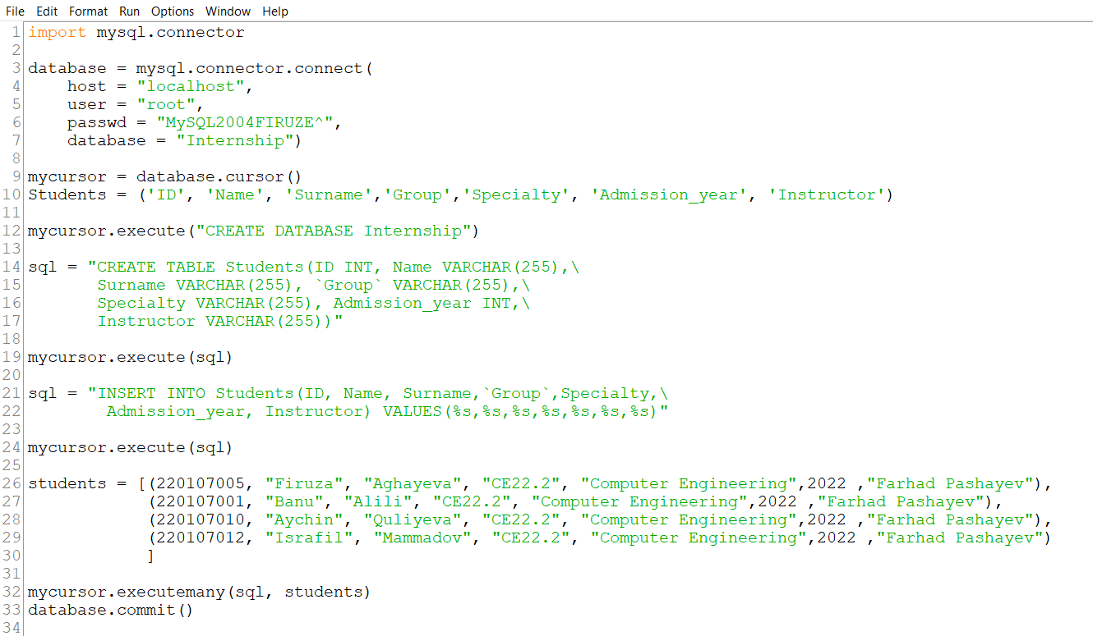


Front end
For designing the front end of this structure, tkinter library is imported. After constructing a form named “Student Database”, essential qualities of the form are determined. The Headers of the form are shaped with labels, and user input is taken with an entry. A button is formed for the execution of the procedure which takes “retrieve” process as an argument for the command part. The “retrieve” process gets the value of the entry, which is the ID of the student, and uses it in the SQL command for finding the corresponding data. Then the information is compiled in a string, which the “text” of a new label will receive as a variable. For the final part, the components of page are packed, and their placement is determined. Final code looks like this:

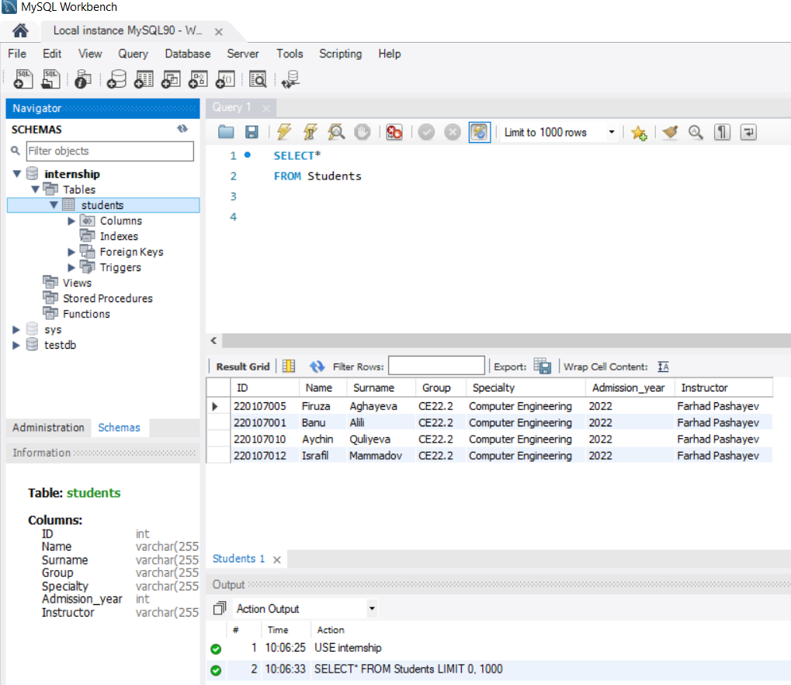
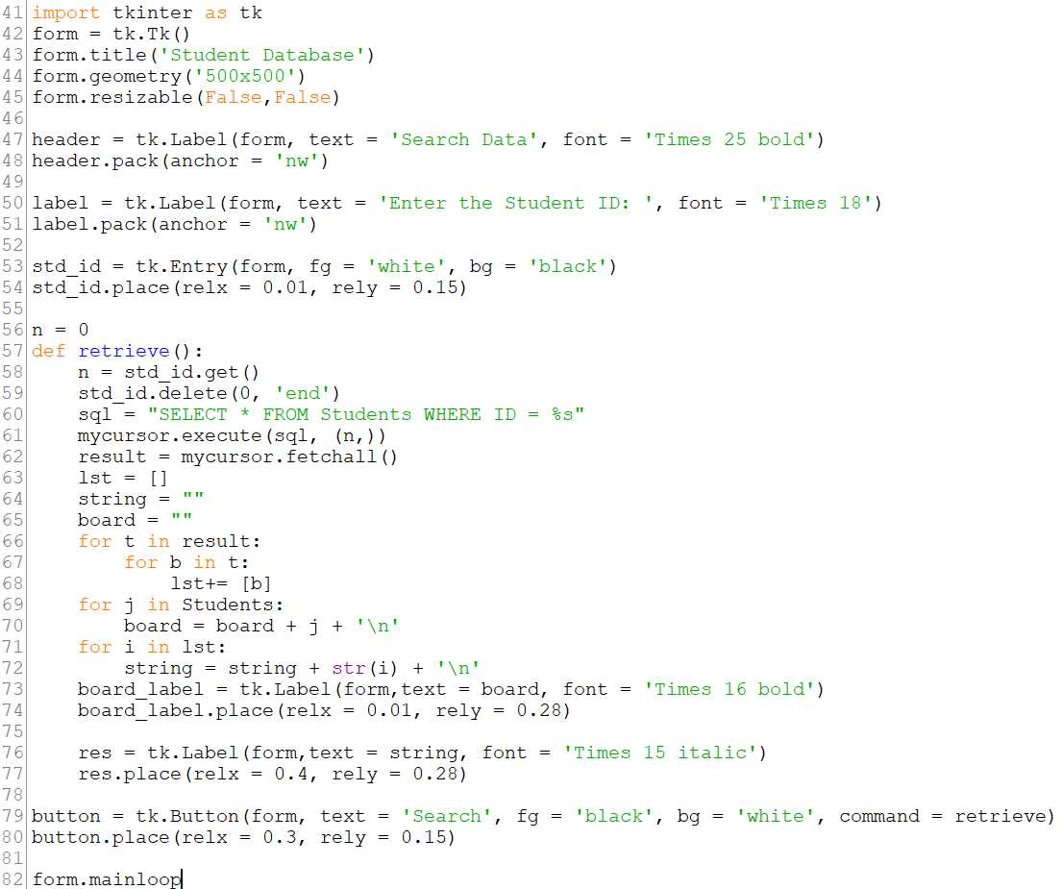

Result
The resulting product is an interface requiring the ID of the student, and exhibiting the information in text form.
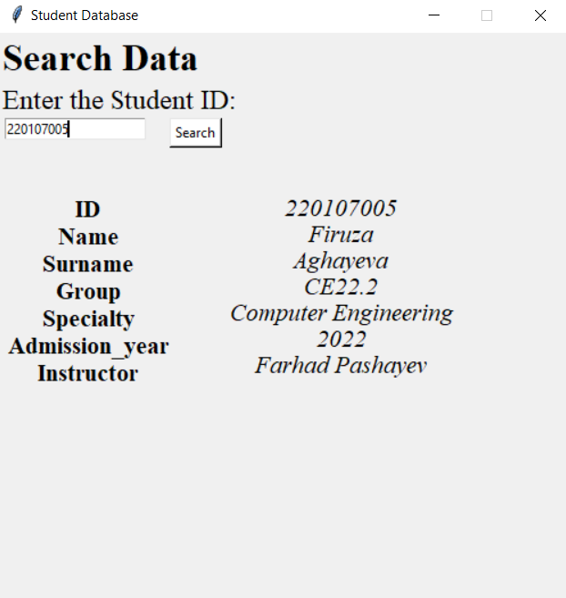

PI CALCULATOR PROJECT
In our second project we were assigned to calculate the pi number using only probability theory. The goal was to measure pi number with desired precision. The options were one-percent, one-hundredth, and one-thousandth precision. We had to write the program in a way that it could work in three ways chosen by user.

Theory
As the goal of this project is to find the value of pi number using only probability, we firstly got knowledge about pi number and statistics, especially probability theory. The pi number itself is the ratio of the length of the circle to its diameter. It is used in various math formulas such as finding the area of circle, volume of sphere, etc. The branch of mathematics that let us to examine uncertain events is known as probability. An event's probability is always in the range of 0 to 1, where 1 denotes that the event will happen surely and 0 suggests the opposite. There are many use cases of probability theory and various formulas related to specific problems. People can be familiar with these use cases because there are different daily life applications of this theory, such as weather forecasting, sports and gaming strategies, and so on.

Method
In this project, we sketch a circle inside a square and plan to find the value of pi considering that the ratio of the areas of the figures is equal to the probabilty of a random point to be inside of the circle surrounded by the square.


$$P=\frac{S_{circle}}{S_{square}}=\frac{πr^{2}}{{\left(2r\right)}^{2}}=\frac{π}{4}, so π=4*P$$
$$P=\frac{C}{S} , so π=4*\frac{C}{S}, where C=\sum{points inside circle}, S=\sum{points inside square}$$



Program
In this project, we used Python programming language. We constructed graphical part of the project with the help of Tkinter library. This library can be utilized to create simple GUI (graphical user interface) apps. To use this library, we firstly import it in our project and start with simple initial steps like creating a window, labels and buttons inside our pi estimator class and place them to relevant parts of the panel. Buttons here are used to choose the precision. User can get the value of pi with their desired precision by clicking one of the three buttons.
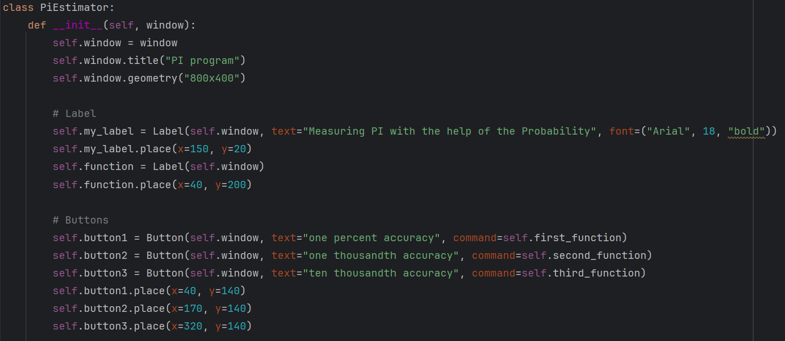
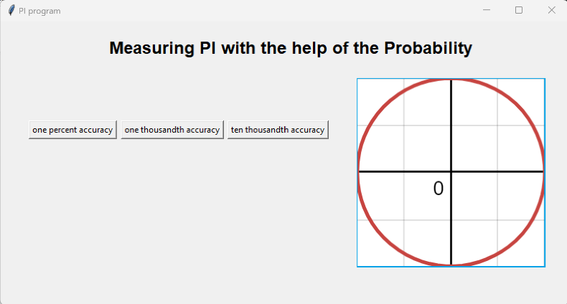
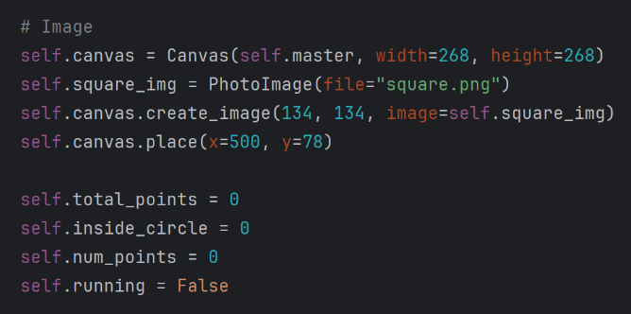
Later, we place the image of the coordinate system where our circle and square are. Random points will be thrown at this picture. After placing the image the Tkinter panel looks like:



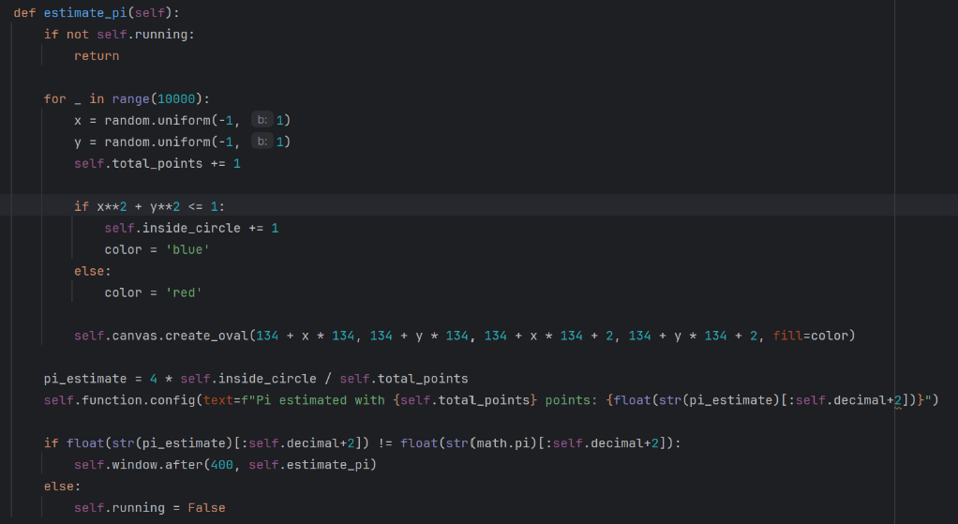
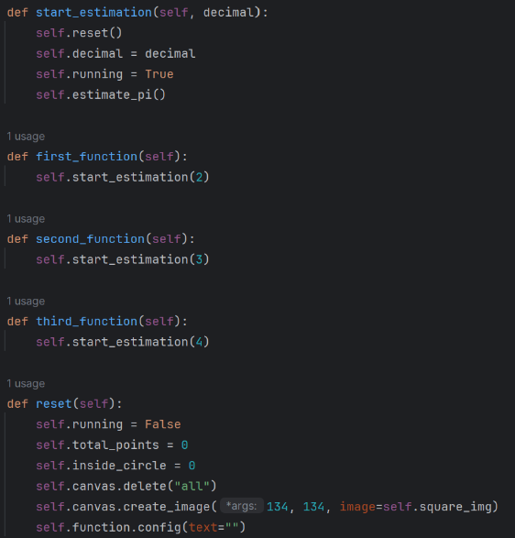

Once one of the buttons is chosen, the program starts to throw random points at the image. It counts C and S (counts of the points inside the circle and square) and calculates the value of pi simultaneously. As one of the three precision is selected, the program will stop when this number of digits after the point which was chosen by the buttons in the estimated pi is equal to the same of real pi value that we use with the help of math library. Once one of the buttons is clicked the program reset itself and starts to work in the same way.

Result
While we executed our program, it calculated pi number correctly in the desired precision. As it uses probability, the count of points varied in each calculation. For example, when the first button was chosen it reached to the correct value after 10000, 30000, 110000 points thrown at the figure in the different executions. Similarly, in the second option the program stopped after 4000, 120000, 7000 points. Finally, in the last precision, as more digits were required after the point, it throwed more dots to get the correct value, including 220000, 350000 and so on.


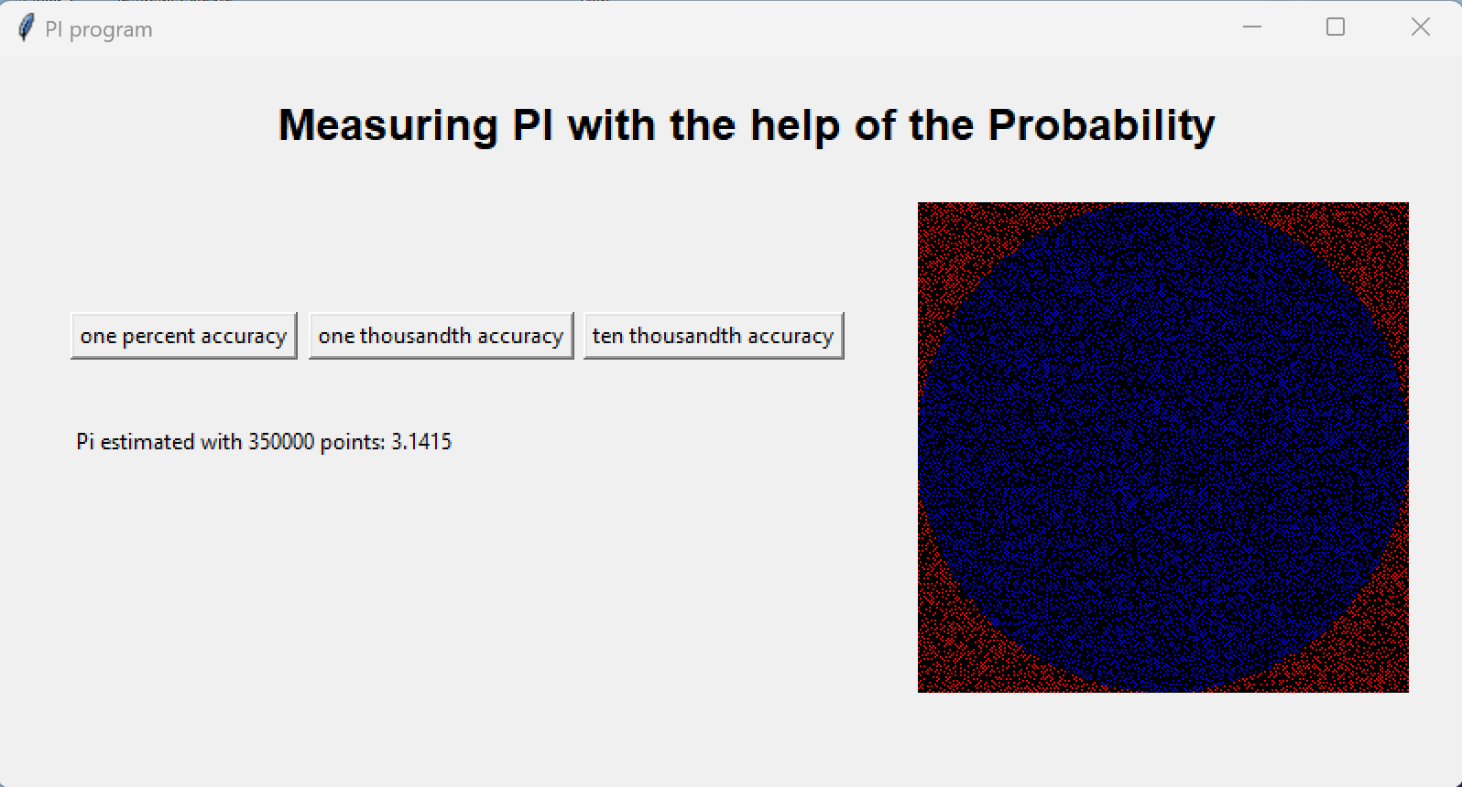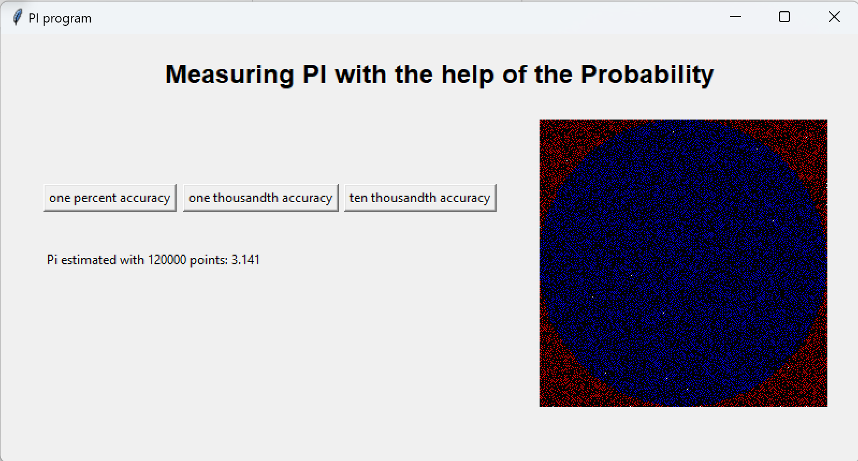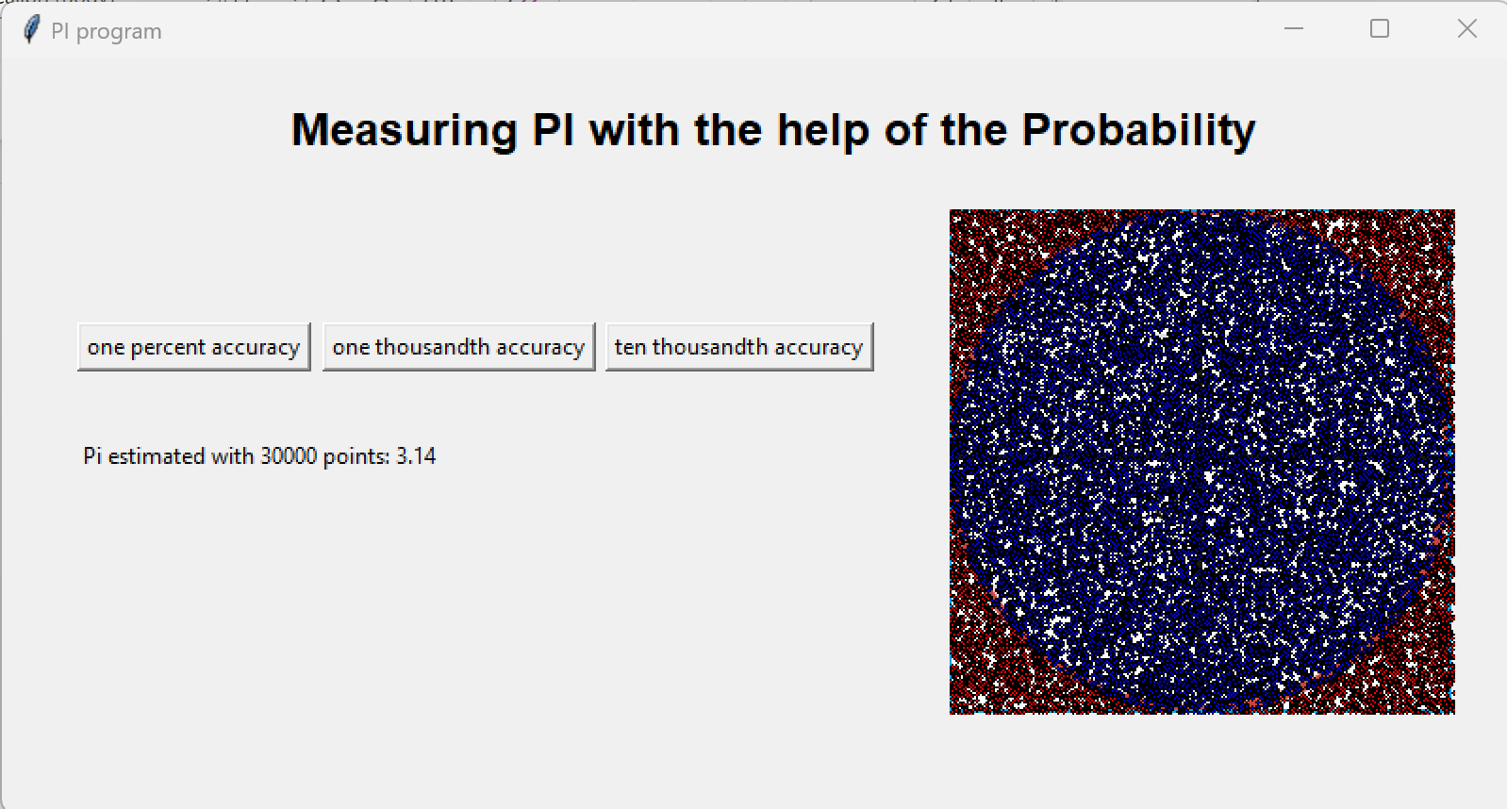

Conclusion
Having highly skilled employees and engineers, we gained large-scale theoretical and practical knowledge in this company. With regard to two projects, we got acquainted with the building of databases and in the second project, the calculation of the Pi value was taught by the instructor. At the end of the internship, all the knowledge about experience has been assimilated by me and my teammates. Hence, with the help of the Python Tkinter program, which identifies the exact value of Pi, it was launched. Additionally, we also constructed a database after completing the internship program using Python and MySQL.

