
Aychin Guliyeva

Aychin Guliyeva
Aychin Guliyeva
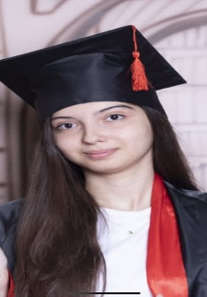

Computer engineering/2nd year

EXECUTIVE SUMMARY
CONTACT INFO

"Success is no accident. It is hard work, perseverance, learning, studying, sacrifice and most of all, love of what you are doing or learning to do.’’


Azerbaijan,Baku

050-518-24-60

aychinguliyeva@gmail.com


WORK EXPERIENCE

- Volunteer in Formula 1
- Volunteer in Azerbaijan Carpet Museum

ACADEMIC BACKGROUND
LANGUAGE

English: Advanced
Azerbaijani: Native
Turkish: Native
Russian:b1

Baku Higher Oil school 2022/2027
Computer Engineering

CERTIFICATES

Technical skills

- Microsoft 360
- Python
- C #
1.Ielts certification
2.SPE certification in the “YOUTH BOOTCAMP

Passion

- Reading
- Music
- Swimming
- Cooking
- Traveling

