

Course Physics
Laboratory Report

Experiment Title: Measuring the electric field strength inside a plate capacitor

Name of student: Guliyeva Aychin
Group number: CE 22.2
Team number: 07

Experiment carried out: 29 March
Lab report submitted: 7 April

Supervisor: Associate Prof.G.Najafov

Synopsis
Our group experiment focuses on measuring the induction voltage in a conductor loop subjected to varying magnetic fields. Following the determination of induction voltages and currents, we will analyze differences and account for any errors encountered during the process.

Introduction
The goal of this experiment is to confirm the phenomenon of electromagnetic induction. In other words, the aim of our laboratory work is to measure the voltages and currents generated due to changes in magnetic fields, known as induction voltages and currents.

Theory
We utilize a coil with N_1 turns, all oriented perpendicular to the magnetic field. As the magnetic flux φ increases, it corresponds to
$$φ=B∙A∙N_{1}$$

When there are changes in the magnetic field and the magnetic flux passing through the coil's area over time, a voltage and a current are induced in the coil. The magnitude and direction of these induced values depend on the manner in which the field changes.
Faraday's law of induction governs this phenomenon:

U=-$\frac{dφ}{dt}$
Hence:
U=-$\frac{dI}{dt}∙μ_{0}∙A∙\frac{N_{2}}{L}∙N_{1}$

This experiment aims to confirm the relationship between the induced voltage U and the rate of change over time dI/dt of the field-coil current I, as well as the area A of the induction coils and the $N_{1}$number of turns of the induction coils. Additionally, it involves the length L and the number of turns $N_{2}$ of a larger cylindrical coil.

Experimental techniques
Apparatus

- 1 Sensor CASSY
- 1 CASSY Lab 2
- 1 Power CASSY
- $μV box$
- Field coil, d=120mm
- Stand for tubes and coils
- Connecting leads 100 cm, blue
- Connecting leads 100cm, red
- PC with Windows XP/Vista/7

Setup and carrying out the experiment:
Initially, a constant rate of change dI/dt is applied to the large coil using Power CASSY. Subsequently, the induction voltage U is recorded while varying the Area A of the induction coils.
- The coil is positioned within the large field coil and linked to the μV box.
- Measurements are conducted over a period of time.
- This procedure is repeated with two additional coils, each with distinct areas.

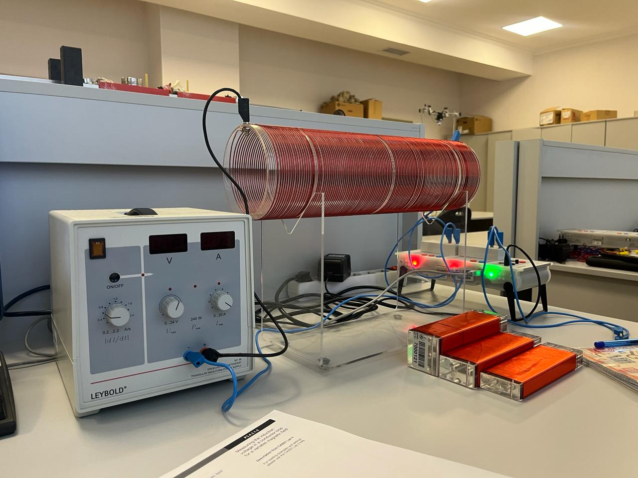

Result
From experience:
Area(m^2) | Measured I(A) | Voltage(v)
0.0025 | 18.80 | -0.276
0.0015 | 12.15 | -0.160
0.0010 | 4.20 | -0.107

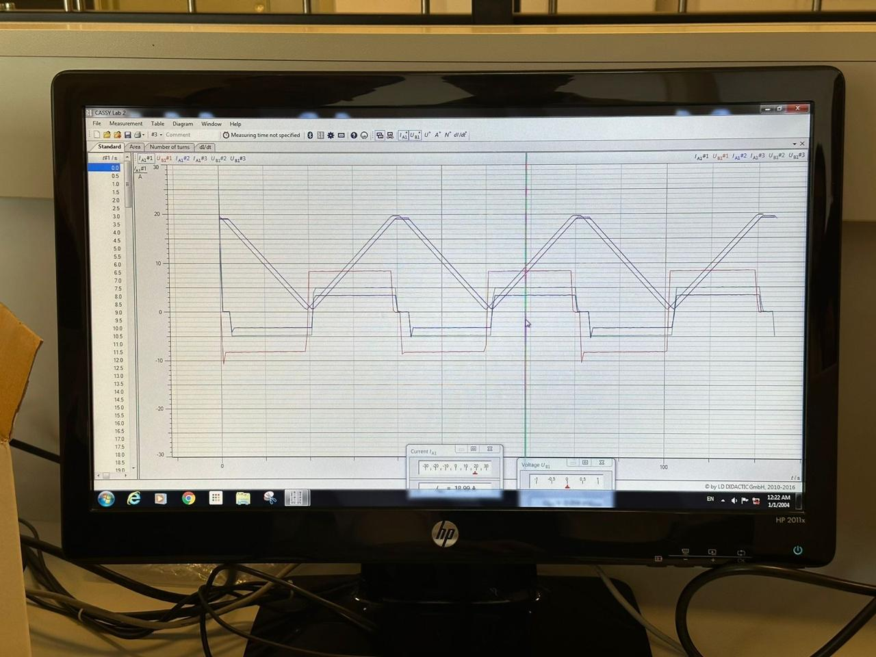

In our experiment, as evidenced by the results presented in Table ,altering the areas of the coils leads to variations in induced voltage. Specifically, employing coils with different areas results in changes to the magnetic flux, thereby causing the induced voltage to either increase or decrease, depending on the area.

Conclusion
In this lab, all calculations and measurements were conducted successfully. This experiment proves to be highly valuable for understanding the principles behind electromagnetic induction.
Top of Form

References
Laboratory leaflets,
BHOS laboratory

