
Course PHYSICS 1
LABORATORY REPORT

Experiment Title: Electromagnetic Oscillations (P3.7.1.1)

Name of the student: Elnur Gadirli
Group number: PAE 22.2
Team Number: 06

Experiment carried out: 15 March 2024
Lab report submitted: 29 March 2024

Supervisor: Associate Prof. G. Najafov
Associate Arzu Qasımzade

Synopsis
The report titled "Electromagnetic Oscillations" serves as a comprehensive exploration of the intricate dynamics of electromagnetic waves. Initially, it offers a detailed overview of the fundamental principles governing these waves, meticulously discussing their inherent properties and intricate behaviors.
Following this introductory section, the report delves into an exhaustive explanation of the experimental methodology employed. It meticulously outlines the specific equipment utilized, the step-by-step procedures followed, and the precise methodologies employed for data collection. Of particular note is the elucidation of the observed phenomenon of damped oscillations, which was a significant aspect of the experimental findings.
Moreover, the report provides an intricate analysis of the data garnered throughout the experiment, including precise measurements related to the oscillation period. This analysis is underpinned by a thorough examination of the mathematical models utilized to characterize the behavior of electromagnetic waves. The report painstakingly details the application of these mathematical frameworks in interpreting and deriving insights from the collected data, thus enriching the understanding of electromagnetic wave dynamics.
Introduction
Electromagnetic oscillations denote the cyclical fluctuations within the electromagnetic field, characterized by alternating electric and magnetic fields propagating through space at the velocity of light. These oscillations manifest when an alternating current (AC) is introduced to an antenna, prompting the electrons within the antenna to oscillate back and forth, consequently generating electromagnetic waves.

The concept of electromagnetic oscillations holds significant importance in the realm of electromagnetism and finds diverse practical applications. For instance, they play a pivotal role in radio and television broadcasting, where these oscillations undergo modulation with audio or video signals to facilitate the transmission of information across extensive distances. Additionally, they serve as the cornerstone of wireless communication technologies, such as cellular networks, which rely on the exchange of electromagnetic waves between mobile devices and base stations.
Theory
In our experiment, we encountered a specific form of oscillation known as damped oscillation, where the energy of an electromagnetic wave gradually diminishes over time. This phenomenon leads to a reduction in the amplitude of the oscillation over time, accompanied by potential alterations in the frequency and wavelength of the wave due to the damping effect. In our experimental setup, we will undertake manual calculations to determine the period using the equation provided below.
$$T=N/t$$

Also, we can calculate the period using another equation below.
$$T=2π\sqrt{LC}$$
in which T is the period, L is the inductivity of the coil, and C is the capacitance of the capacitor.
At the end we will compare the values which are obtained from these two equations.

Setup
Before starting the experiment, we make the system ready by fully decharging the system, to create the oscillations from zero. Additionally, the current oscillations could be observed directly on a pointer instrument or CASSY.

Carrying out the experiment
Throughout the experiment, one individual will be responsible for tracking the number of oscillations, while another participant will utilize a timer to measure the elapsed time. Upon completion, the outcomes, specifically the calculated period values, will be juxtaposed and documented in the results table for comparative analysis.
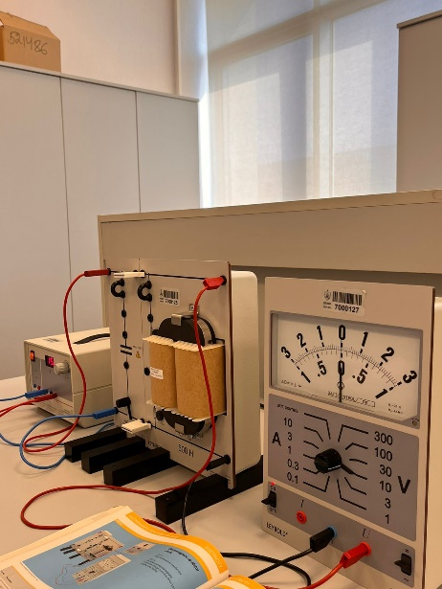
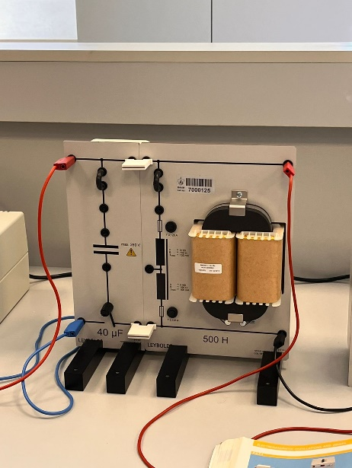

Results
№ | $$N$$ | $$t$$ | $$T_{N/t}$$ | $$T_{LC}$$
1 | 14 | 12.5 | 1.12 | 0.888
2 | 15 | 12.5 | 1.2 | 0.888
3 | 16 | 12.5 | 1.28 | 0.888

Discussion of results
The data provided offers an insightful examination of the contrast between the T values obtained through the utilization of two distinct equations. While our calculations encountered an error along the way, we meticulously engaged in discussions with both our fellow teammates and our supervisor to delve into the root causes of this discrepancy. Through these collaborative deliberations, we sought to gain a comprehensive understanding of the factors contributing to the observed deviation in our results, thus paving the way for further refinement and improvement in our experimental methodologies.
Conclusion
In conclusion, this project proved to be an intriguing endeavor, encompassing a comprehensive exploration into the realm of electromagnetic oscillations. Through diligent analysis and collaboration, our team successfully elucidated the relationships uncovered within the data, shedding light on the intricate nature of electromagnetic oscillations. Moreover, we deepened our understanding of how these phenomena manifest and their significance in practical applications. Despite encountering challenges along the way, our collective efforts enabled us to derive valuable insights, underscoring the importance of hands-on experimentation and collaborative problem-solving in scientific inquiry. Overall, this project not only enriched our knowledge but also underscored the practical relevance of electromagnetism in modern technology and communication systems.
References
Laboratory leaflets
BHOS Laboratory

