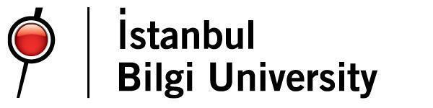

|  |
| --- |
| **SENIOR DESIGN PROJECT – FINAL REPORT** |
| P2021-16 |
| **IDENTIFICATION AND IMPROVEMENT OF FACTORS AFFECTING WORKER PERFORMANCE IN ÖREN KABLO** |
| **By** |
| **Ahmet Kaan DOĞAN** |
| **Ayda AHMETOĞLU** |
| **Hüsniye Ece KURT** |
| **Mustafa Mert KILIÇ** |
| **Sevinç Canan ÖZ** |
|  |
| **Supervised By** |
| **Prof. Fatma Canan ÇİLİNGİR** |
| **Assoc. Prof. Cemal Deniz YENİGÜN** |
| **Department of Industrial Engineering**  **İstanbul Bilgi University**  **2021** |
|  |

|  |  |  |
| --- | --- | --- |
| We hereby certify that this project is our own work, except where indicated by referencing. | | |
| Ahmet Kaan DOĞAN | | …………………………… |
| Ayda AHMETOĞLU | | …………………………… |
| Hüsniye Ece KURT | | …………………………… |
| Mustafa Mert KILIÇ | | …………………………… |
| Sevinç Canan ÖZ | | …………………………… |
|  |  |  |
| This project report is reviewed. | | |
| Prof. Fatma Canan Çilingir  Assoc. Prof. Cemal Deniz Yenigün | (Supervisor)  (Supervisor) | ……………………………  …………………………… |

1. **INTRODUCTION** **8**
   1. **Overview** **8**
   2. **About Ören Kablo** **8**
   3. **Problem Definition** **10**
2. **LITERATURE REVIEW** **11**
   1. **Risk Analysis Method** **12**
      1. **Failure Mode and Effects Analysis (FMEA) Definition** **12**
      2. **Auxiliary Elements Used in FMEA Analysis** **12**
      3. **FMEA Implementation Steps** **13**
   2. **Ergonomic Risk Assessment Tools** **13**
      1. **Ovako Working Posture Analyzing System (OWAS) Method** **13**
      2. **The National Institute for Occupational Safety and Health (NIOSH) Lifting Equation Method** **15**
   3. **Definition of the NIOSH Lifting Equation** **16**
   4. **Work Measurement Techniques** **19**
      1. **Work Sampling Defined** **19**
      2. **When is Work Sampling Appropriate?** **20**
      3. **Work sampling is an 8 step process: [9-10]** **20**
3. **METHODOLOGY** **22**
   1. **FMEA** **22**
   2. **OWAS** **22**
   3. **NIOSH** **22**
   4. **Work Sampling** **23**
4. **METHOD IMPLEMENTATION** **23**
   1. **Data Analysis for Work sampling** **23**
      1. **Determination of Sample Size** **23**
      2. **Determination the Number of Observations Per Day** **24**
      3. **Determination of Performance Rate** **25**
      4. **Determination of Allowances** **26**
   2. **FMEA Implementation** **26**
      1. **Determination of Severity Score** **26**
      2. **Determination of Detection Score** **28**
      3. **Determination of Occurrence Score** **28**
   3. **Calculation of Incorrect Marking Error Occurrence for 2020** **29**
   4. **Calculation of Incorrect Marking Error Occurrence for 2021** **29**
5. **DISCUSSION & RESULTS** **30**
   1. **FMEA** **30**
   2. **OWAS** **32**
   3. **NIOSH** **39**
   4. **WORK SAMPLING** **42**
      1. **Machine Base Observations for EC 400 CAT 6** **44**
      2. **Allowances** **49**
      3. **Finding normal time & Standard Time** **50**
6. **CONCLUSION** **53**
7. **RECOMMENDATIONS** **55**
8. **COVID-19 EXPERIENCES IN OREN CABLE** **56**
9. **REFERENCES** **58**
10. **APPENDIX** **59**
    1. **Work Sampling Sheets** **59**

***LIST OF FIGURES***

*Figure 1.2.a: Scheme of the cable manufacturing process*

*Figure 1.2.b: Scheme of the EC400 CAT 6 U/UTP cable manufacturing process*

*Figure 1.3.a: Fishbone for low worker performance*

*Figure 2.2.1.a: Classification of postures with OWAS*

*Fig. 2.2.1.b: OWAS evaluation and result interpretation*

*Figure 2.2.2.a: Representation of NIOSH Variables*

*Figure2.2.2.b:Representation of Angle*

*Figure 2.3.3.a: Standard Deviation*

*Figure2.3.3.b: Sample size*

*Figure 2.3.3.c: Confidence intervals*

*Figure 2.3.3.d: Normal Time*

*Figure 2.3.3.e: Standard Time*

*Figure 5.2.a: Posture of label pasting on Reel*

*Figure 5.2.b: Posture of reel drag on reel*

*Figure 5.2.c: Roller Cradle*

*Figure 5.2.d: Posture of putting reel-1*

*Figure 5.2.e: Posture of putting reel-2*

*Fig. 5.2.f: Posture of carrying reel-1*

*Fig. 5.2.g: Posture of carrying reel-2*

*Figure 5.2.h: Hydraulic lift*

*Fig. 5.2.i: Posture of measuring*

*Fig. 5.3.a: Posture of lifting reel*

*Figure 5.3.b: Posture of lifting reel to second row*

***LIST OF TABLES***

*Table 2.2.2.a: Interpretation of Lifting Index*

*Table2.2.2.b: Horizontal Multiplier Factor Spreadsheet*

*Table 2.2.2.c: Vertical Multiplier Factor Spreadsheet*

*Table 2.2.2.d: Distance Multiplier Factor Spreadsheet*

*Table 2.2.2.e: Angle Multiplier Factor Spreadsheet*

*Table2.2.2.f: Coupling Multiplier Factor Spreadsheet*

*Table2.2.2.g: Frequency Multiplier Factor Spreadsheet*

*Table 4.1.2.a: Work sampling data collection sheet*

*Table 4.1.3.a: Average daily performance ratings for KULE (KNG-06) machine*

*Table 4.1.3.b: Average daily performance ratings for CAT (KNG-08) machine*

*Table 4.1.4.a: Allowance table Table 4.2.1.a: Severity rating chart*

*Table 4.2.2.a: Detection Ranking Chart*

*Table 4.2.3.a: Occurrence rating chart*

*Table 4.2.3.b: Marking error data for 2020*

*Table 4.2.3.c: Marking error data for 2021*

*Table 4.2.3.d: Part of final FMEA table, marking error*

*Table 5.1.a: Final FMEA Table*

*Table 5.2.a: OWAS application results for label pasting*

*Table 5.2.b: OWAS application results for reel drag*

*Table 5.2.c: Technical specifications of roller cradle*

*Table 5.2.d: OWAS application results for putting reel-1*

*Table 5.2.e: OWAS application results for putting reel-2*

*Table 5.2.f: OWAS application results for carrying reel-1*

*Table 5.2.g: OWAS application results for carrying reel-2*

*Table 5.2.h: Technical specifications for lifting apparatus*

*Table 5.2.i: OWAS application results for measuring*

*Table 5.3.a: NIOSH application results for lifting reel*

*Table 5.3.b: NIOSH application results for lifting reel to first row on the palette*

*Table 5.3.c: NIOSH application results for lifting reel to second row*

*Table 5.3.d: NIOSH application results for lifting reel to third row*

*Table:5.3.e: NIOSH application result after adjustments made*

*Table 5.4.a: Activity categories*

*Table 5.4.b: Allowance values*

*Table 5.4.c: Sample worker data for on**e*

*Table 5.4.1.a : EC 400 CAT 6 observations for KULE (KNG-06) Machine*

*Table 5.4.1.b : EC 400 CAT 6 observations for CAT (KNG-08) Machine*

*Table 5.4.1.c : Working (EC 400 CAT 6) Proportions for KULE (KNG-06) Machine*

*Table 5.4.1.d : Working (EC 400 CAT 6) Proportions for CAT (KNG-08) Machine*

*Table 5.4.1.e : Working & Idle Proportion for Both Machines*

*Table 5.4.1.f : Number of EC CAT 6 Observations for Both Machines*

*Table 5.4.1.g : Total Error Rate for Both Machines*

*Table 5.4.1.h : Error Rate for CAT (KNG-08) Machine*

*Table 5.4.1.i : Error Rate for KULE (KNG-06) Machine for Type of 1000m Reel*

*Table 5.4.1.j : Error Rate for KULE (KNG-06) Machine for Type of 5000m Reel*

*Table 5.4.1.k : Error Rate for KULE (KNG-06) Machine Type of 6000m Reel*

*Table 5.4.2.a : Idle category observations for EC 400 CAT6 for KULE (KNG-06) Machine*

*Table 5.4.2.b : Idle category observations for EC 400 CAT 6 for CAT(KNG-08) Machine*

*Table 5.4.3.a: Normal & standard time for KULE ( KNG-06) machine for type of 1000m EC 400 CAT 6 Reel*

*Table 5.4.3.b : Normal & standard time for KULE ( KNG-06) machine for type of 5000 & 6000 m EC 400 CAT 6 Reel*

*Table 5.4.3.c : Normal & standard time for CAT( KNG-08) machine for type of 500 m EC 400 CAT 6 Reel*

## **INTRODUCTION**

#### **Overview**

Business efficiency relies on multiple variables, such as worker’s productivity,facility planning, production planning, quality of communication, cost control and human-oriented management. All requirements should be considered together in order to be a profitable and productive business and correct solutions should be pursued. Quality is one of the most important details that all companies try to develop and protect. Today, worker performance and environmental factors should be considered in order to maintain this quality. In this study, we will define the problems that we may encounter in the company that we are working on, investigate the causes of these problems and offer the necessary actions.

We picked a cable production company called Ören Kablo to work on and focused on the measuring department which is the final step of the assembly line, due to the firm’s request. In this department, cables are cut according to customers’ specs from bigger reels that were previously manufactured and winded in house.

We decided to pick a sample product to analyse and improve that can set an example for all other cable types. Our analysis on past data revealed that the most demanded cable by customers is EC 400 CAT6 U/UTP and its subcategories.

The factory may lack operator performance efficiency. We have to take into account the operator performances in the measuring department. We can provide performance efficiency to the operator and improve the process by making ergonomic improvements and reducing the speed change. Our main focus will be to increase worker and machine productivity. On the other hand, there are some difficulties about detecting the errors of measuring. Operators and employees could not get used to the system, so systemized data flow into the system could not be possible. These missing data cause the company to have difficulty in identifying the error rates and the reasons behind these errors. We want to detect and prevent possible errors in the measuring department. Another point we will focus on is to reduce the loads on the musculoskeletal systems of the employees and to calculate the standard time with work sampling.

#### **About Ören Kablo**

Ören Kablo is the first coaxial cable manufacturer founded by Rıza Reçber in 1979 and has been operating as a family company since its establishment. Ören Kablo, who carries out its production activities in its manufacturing facilities located in the Silivri Ortaköy Industrial Area, recognizes the broad variety of manufacturing products, for example, signal order links, satellite TV, advanced satellite, fire warning cables, information links, CAT5, CAT6 LAN links and intelligent TV links; and simultaneously, offers to the utilization of its customers the  low fume and flame retarding  adaptations of "halogen free" link, which is otherwise called "flame 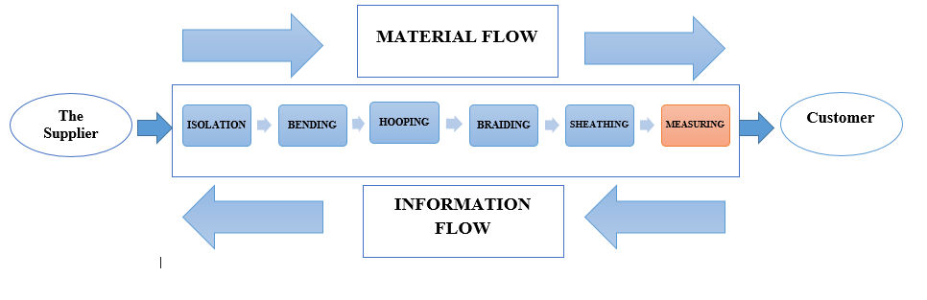resistant link".

*Figure 1.2.a: Scheme of the cable manufacturing process*

Isolation: A plastic protective sheath is covered around the conductive wire in order to prevent the conductive wires from touching each other, to prevent short circuits and to protect the cables from external factors.

Bending: In order to reduce Electromagnetic interference (EMI), radio frequency interference (RFI) and crosstalk on the electronic signal, conductive wires that are isolated are combined with the help of wicks.

Hooping: The materials that distinguish one element from another in cable production are separator tapes and coils. In addition to its function as a separator, aluminium foil or spool is pulled on the outside of the conductive wire in order to take on functions such as fire barrier, moisture barrier and shield.

Braiding: In order to prevent the signals carried by the cable from being affected by electromagnetic disturbances in the environment where the cable is located, to increase the mechanical strength and to provide flexibility, a screen is drawn.

Sheathing: It is the sheath process made to the outside of the cable to protect the cable from external factors.

Measuring: At the end of the whole process, it is the part where the order is cut and packaged in desired sizes. There are 4 types of machines used in the measuring department. One of them is the automatic machine BMAC (KNG-01), the other two are the semi-automatic CAT (KNG-08) and AYMAK (KNG-07), and the last is the manual KULE (KNG-06) machine.

*Figure 1.2.b: Scheme of the EC400 CAT 6 U/UTP cable manufacturing process*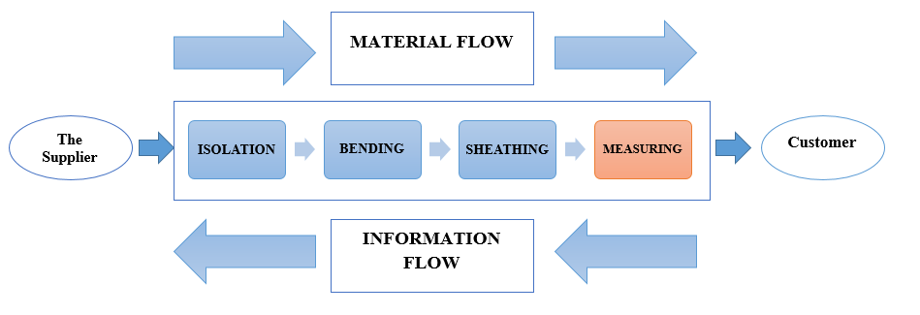

The company supplies its raw materials in line with the order received from the customer before starting the production stages. Then, the conductive (copper) raw material, which is ready to be processed, first enters the insulation line. In this line, a protective insulating sheath is placed over the wire. Then, these sheathed wires are twisted around this wick with the help of an insulating cord to form a round and flexible cable. Then, our twisted cable is covered with a protective sheath by passing to the outer sheath line. As the last process, it is cut to the size requested by the customer, packaged and ready to install.

The outer sheath of 1 meter of the cable we have shown has a weight of 12.52 grams, an insulation weight of 3.71 grams, a copper weight of 17.28 grams, and the weight of the roving 2.76 grams. In total, 1 meter corresponds to 36,271 gr. When we consider it based on kilometres, the total weight of our cable and the weight of our reel is 44 kg/km. Here, the weight of our empty reel turns out to be 7,729 kg.

Empty Reel Weight: Total Weight - Weight of Cable Based on Km

= 44-36,271 = 7,729 kg

#### **Problem Definition**

Firms carry out many studies and developments in order to increase the operator’s efficiency. This requirement has also emerged in Ören Kablo. The management complained about the low performance of the workers and guided us to work in this field. The company, which has been operating as a family company since its establishment, needs improvements in the production process on the way to institutionalization. This requirement has arisen due to low performance of operators, the lack of planning about standardized machine speed variations in the production process and unsuitable ergonomic conditions. As a result of this situation, the purpose of our project is to increase the efficiency of the measurement process in Ören Kablo and the efficiency of the workers working in this field, to increase the satisfaction and to create the most comfortable and optimum working conditions during working hours by analysing the ergonomic factors in detail. Quality of measurements may be related to performance issues. We will also deal with quality problems, one of the factors of performance and productivity. We created a fishbone diagram to understand the reasons for low worker performances in the company. It has been noted that low performance may decrease due to factors such as workers, 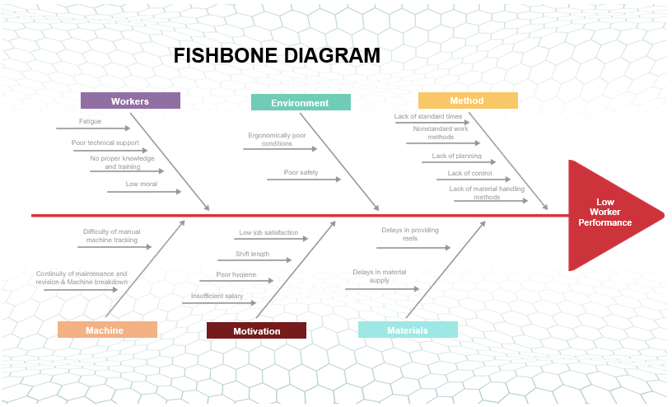environment, machine etc.

*Figure 1.3.a: Fishbone for low worker performance*

## **LITERATURE REVIEW**

Our main focus is to increase operator performance, improve ergonomic factors, and detect and prevent possible errors in the measuring department. Many studies in the literature have shown us that the FMEA technique is used in many companies to detect errors.

In order to determine musculoskeletal risks and take preventive measures, OWAS posture analysis method can be applied for ergonomic evaluation. OWAS is widely used for posture analysis because of its simple application and its suitability for every business.

After the observations done in the company, ergonomic risk analysis methods, standard time and work sampling methods have been used which have been decided as a better method to implement and achieve precise results and reduce the differences between operating speeds of machines.

#### **Risk Analysis Method**

###### **Failure Mode and Effects Analysis (FMEA) Definition**

FMEA is a scientific technique that appeared on November 9, 1949 under the name of "Procedures for the Analysis of Error Type, Effects and Risk", which was made to determine the effects of system errors in the US army. [1]

As can be understood from the name, FMEA technique detects errors and takes preventative measures, which provides a computable and algorithmic perspective; this will form the basis of our article. With this method, errors are investigated down to the root causes that cause these errors. It examines potential errors that may occur from the design phase of a product, including the production phase of that product.

###### **Auxiliary Elements Used in FMEA Analysis**

Item: An “item” is the focusof the FMEA project.

Function: A "function" is what is supposed to be achieved by the object or procedure, usually to a specified output or requirement level.

Failure Mode: A "failure mode" is the manner in which the object or procedure can fail to fulfill the intended purpose and related specifications or produce them.

Effect:An “effect” is the consequence of the failure on the system or end user.

Severity: A “severity” is a ranking number associated with the most serious effect for a given failure mode.

Occurrence: An "occurrence" is a rating number synonymous with the chance that in the object being evaluated, the failure mode and its associated cause will be present.

Detection: A 'detection' is a rating number correlated with the best control from the detection-type controls set, depending on the detection scale criterion.

Cause: A “cause” is the specific reason for the failure, preferably found by asking “why” until the root cause is determined.

Risk Priority Number (RPN): “RPN” is a numerical ranking of the risk of each potential failure mode/cause, made up of the arithmetic product of the three elements:

RPN = Severity * Occurrence * Detection.

If RPN < 40 does not need any regulation.

RPN is between 40 and 100 improvements should be made.

RPN >100, necessary arrangements should be made as soon as possible.

There are four basic types of FMEA in the literature: Design FMEA, Service FMEA, System FMEA and Process FMEA [2]. This study focuses on the "Process FMEA" method. Process FMEA is the analysis made in order to eliminate the types of errors that may occur in the production or assembly processes and to examine why the processes cause this error.

###### **FMEA Implementation Steps**

First of all, the purpose and scope of the study is determined. FMEA technique reveals a team approach as a tool that allows all relevant personnel and units to exchange ideas within the framework of the study [3].

The process to be improved is examined. By analysing the subsystems that make up the error types, the root causes that cause the error are determined and how the error types occur is determined.

After examining the process, a risk assessment is made. In order to eliminate the main causes of the error, RPN values ​​of each main cause are calculated first. Errors with the highest Risk Priority Number will be the first step in intensifying corrective implementations and will continue in turn. Corrective actions are applied sequentially according to the calculated RPN values.

#### **Ergonomic Risk Assessment Tools**

###### **Ovako Working Posture Analyzing System (OWAS) Method**

The Ovako Working Posture Assessment System (OWAS) was formulated in Finland, specifically in the OVAKO OY company, a leading European producer of steel bars and profiles. This system was used to evaluate the workload in the repair process of smelting furnaces.

OWAS is an observational working posture analysis method that helps to determine the load on the musculoskeletal system of the employee and the bad postures caused by the system. OWAS method successfully used in different industrial applications; ergonomic evaluation of the postural load, reducing the load on the musculoskeletal system, development and planning of working environments, working methods, machinery and tools used, occupational health examinations, it is implemented to ensure safety and efficiency. [4]

*Figure 2.2.1.a: Classification of postures with OWAS [5]*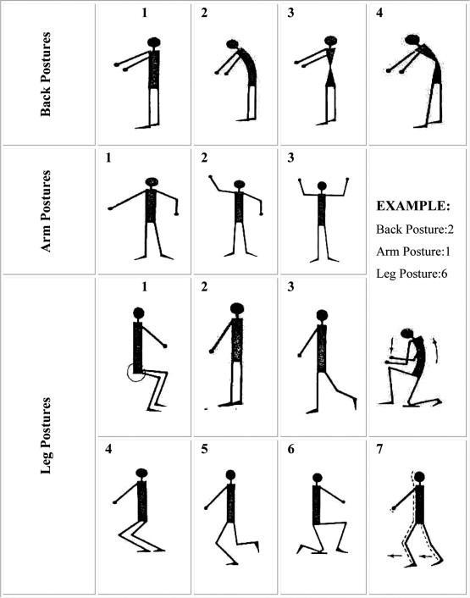

The body postures of the employees are classified according to the power consumed. In the OWAS method, 252 standard stance and load combinations are obtained when 4 back, 3 arm, 7 leg stances and 3 different load levels are taken into account.

|  |  |  |  |  |  |  |  |  |  |  |  |  |  |  |  |  |  |  |  |  |  |  |  |
| --- | --- | --- | --- | --- | --- | --- | --- | --- | --- | --- | --- | --- | --- | --- | --- | --- | --- | --- | --- | --- | --- | --- | --- |
| Back | Arms | Legs | | | | | | | | | | | | | | | | | | | | | |
| 1 | | | 2 | | | 3 | | | 4 | | | 5 | | | 6 | | | 7 | | |
| Load | | | Load | | | Load | | | Load | | | Load | | | Load | | | Load | | |
| 1 | 2 | 3 | 1 | 2 | 3 | 1 | 2 | 3 | 1 | 2 | 3 | 1 | 2 | 3 | 1 | 2 | 3 | 1 | 2 | 3 |
| 1 | 1 | 1 | 1 | 1 | 1 | 1 | 1 | 1 | 1 | 1 | 2 | 2 | 2 | 2 | 2 | 2 | 1 | 1 | 1 | 1 | 1 | 1 |
| 2 | 1 | 1 | 1 | 1 | 1 | 1 | 1 | 1 | 1 | 2 | 2 | 2 | 2 | 2 | 2 | 1 | 1 | 1 | 1 | 1 | 1 |
| 3 | 1 | 1 | 1 | 1 | 1 | 1 | 1 | 1 | 1 | 2 | 2 | 3 | 2 | 2 | 3 | 1 | 1 | 1 | 1 | 1 | 2 |
| 2 | 1 | 2 | 2 | 3 | 2 | 2 | 3 | 2 | 2 | 3 | 3 | 3 | 3 | 3 | 3 | 3 | 2 | 2 | 2 | 2 | 3 | 3 |
| 2 | 2 | 2 | 3 | 2 | 2 | 3 | 2 | 3 | 3 | 3 | 4 | 4 | 3 | 4 | 4 | 3 | 3 | 4 | 2 | 3 | 4 |
| 3 | 3 | 3 | 4 | 2 | 2 | 3 | 3 | 3 | 3 | 3 | 4 | 4 | 4 | 4 | 4 | 4 | 4 | 4 | 2 | 3 | 4 |
| 3 | 1 | 1 | 1 | 1 | 1 | 1 | 1 | 1 | 1 | 2 | 3 | 3 | 3 | 4 | 4 | 4 | 1 | 1 | 1 | 1 | 1 | 1 |
| 2 | 2 | 2 | 3 | 1 | 1 | 1 | 1 | 1 | 2 | 4 | 4 | 4 | 4 | 4 | 4 | 3 | 3 | 3 | 1 | 1 | 1 |
| 3 | 2 | 2 | 3 | 1 | 1 | 1 | 2 | 3 | 3 | 4 | 4 | 4 | 4 | 4 | 4 | 4 | 4 | 4 | 1 | 1 | 1 |
| 4 | 1 | 2 | 3 | 3 | 2 | 2 | 3 | 2 | 2 | 3 | 4 | 4 | 4 | 4 | 4 | 4 | 4 | 4 | 4 | 2 | 3 | 4 |
| 2 | 3 | 3 | 4 | 2 | 3 | 4 | 3 | 3 | 4 | 4 | 4 | 4 | 4 | 4 | 4 | 4 | 4 | 4 | 2 | 3 | 4 |
| 3 | 4 | 4 | 4 | 2 | 3 | 4 | 3 | 3 | 4 | 4 | 4 | 4 | 4 | 4 | 4 | 4 | 4 | 4 | 2 | 3 | 4 |
| INTERPRETATION OF THE RESULTS | | | | | | | | | | | | | | | | | | | | | | | |
| 1-No actions required | | | | | | | | | | | | | | | | | | | | | | | |
| 2-Corrective actions required in the near future | | | | | | | | | | | | | | | | | | | | | | | |
| 3-Corrective actions should be done as soon as possible | | | | | | | | | | | | | | | | | | | | | | | |
| 4-Corrective actions for improvement required immediately | | | | | | | | | | | | | | | | | | | | | | | |

*Fig. 2.2.1.b: OWAS evaluation and result interpretation [6]*

Four risk groups are used to categorize the posture combinations found. The experts' predictions of the health risks posed by each working posture and combination of postures on the musculoskeletal system are used to classify these positions.

**Category 1**: Working postures have no negative consequences for the musculoskeletal system. There is no need for an ergonomic setup for these postures.

**Category 2**: The musculoskeletal system is negatively affected by working postures. Future plans should include required ergonomic arrangements.

**Category 3**: The musculoskeletal system is obviously harmed by working postures. Working stops should make the required ergonomic arrangements as soon as possible.

**Category 4**: The musculoskeletal structure is severely harmed by working postures. The required ergonomic arrangements for these postures should be made right away.

###### **The National Institute for Occupational Safety and Health (NIOSH) Lifting Equation Method**

The National Institute for Occupational Safety and Health (NIOSH) was established in Section 22 of the Occupational Safety and Health (OSH) Act of 1970 and placed in the Department of Health and Human Services (HHS). As the service sector grew in the 1980s, NIOSH led pioneering research on emerging safety and health concerns. These included indoor environmental quality in office buildings, job-related musculoskeletal injuries, work-place violence, latex allergy among health care workers, and risks of occupational exposures to bloodborne pathogens. As the workplace changed, NIOSH continued to adapt its research. [7]

#### **Definition of the NIOSH Lifting Equation**

With the NIOSH lifting equation, we will determine the ergonomic risks of employees during lifting and carrying the reels. The aim is to determine in advance the risk that will cause lower back discomfort due to lifting / lowering.

**Recommended Weight Limit (RWL):** Indicates what is the recommended weight under these conditions.

**RWL** = LC (23) x HM x VM x DM x AM x FM x CM

* LC, the Load Constant,
* HM, the Horizontal Multiplier factor,
* VM, the Vertical Multiplier factor,
* DM, the Distance Multiplier factor,
* AM, the Asymmetric Multiplier factor.
* FM, the Frequency Multiplier factor,
* CM, the Coupling Multiplier factor.

Lifting Index Value Risk Implication Recommended Action

(Exposure Level)

LI ≤1.0 Very Low None in general for the healthy working population

1.0<LI ≤1.5 Low In particular pay attention to low frequency/high load conditions to

extreme or static postures. Include all factors in redesigning tasks or

workstations and consider efforts to lower the LI to values ≤1.0

1.5<LI ≤2.0 Moderate Redesign tasks and workplaces according to priorities to reduce

the LI, followed by analysis of results to confirm effectiveness.

2.0<LI≤3.0 High Changes to the task to reduce the LI should be a high priority.

LI>3.0 Very High Changes to the task to reduce the LI should be made immediately.

For Any level

of Risk/Exposure Identify any workers who may have special needs or vulnerabilities in lofting tasks and assign

or design the work accordingly. Training workers on recognizing and eliminating material

handling hazards is regarded as beneficial. Limiting the weight to be lifted, to less than the

Reference Mass may also be considered.

*Table 2.2.2.a: Interpretation of Lifting Index [8]*

**Lifting Index (LI):**  Shows how high the risk is.

**Horizontal Location of the Hands (H):** Distance of hands on the load from midpoint between ankles

|  |  |  |
| --- | --- | --- |
| HM = 1 | for | H<=25 cm |
| HM = 25/H | for | 25 cm < H <=63 cm |
| HM = 0 | for | 63 cm > H |

*Table2.2.2.b: Horizontal Multiplier Factor Spreadsheet*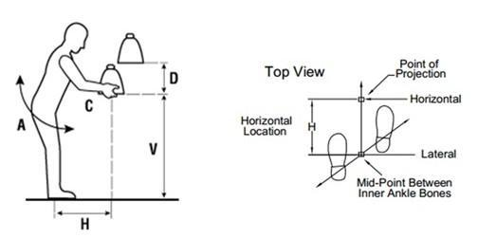

*Figure 2.2.2.a: Representation of NIOSH Variables*

**Vertical Location of the Hands (V):** Starting height of the hands from the ground.

|  |  |  |
| --- | --- | --- |
| VM = 1- (0.003*(|V-75|)) | for | V<=175 cm |
| VM = 0 | for | V >175 cm |

*Table 2.2.2.c: Vertical Multiplier Factor Spreadsheet*

**Distance(D):** Vertical travel distance of the lift.

|  |  |  |
| --- | --- | --- |
| DM = 1 | for | D<=25 cm |
| DM = 0.82+(4.5/D) | for | 25 cm < D<=175 cm |
| DM = 0 | for | 175 cm >D |

*Table 2.2.2.d: Distance Multiplier Factor Spreadsheet*

**Asymmetric Angle (A):** Angle of the load in relation to the body.

|  |  |  |
| --- | --- | --- |
| AM =(1-0.0032*A) | for | A <=135° cm |
| AM = 0 | for | A >135° cm |

*Table 2.2.2.e: Angle Multiplier Factor Spreadsheet*

*Figure2.2.2.b: Representation of Angle*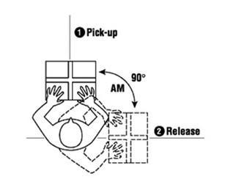

**Coupling (C):** Quality of the grasp or handhold based on the type of handles available.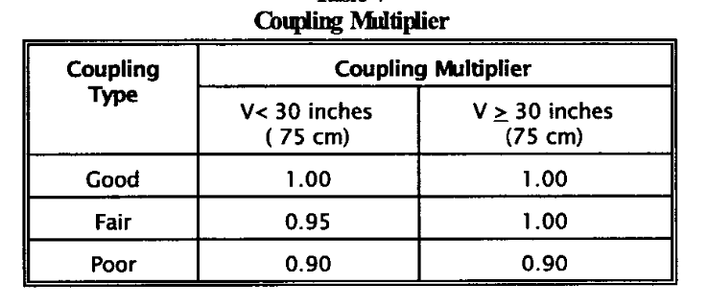

*Table2.2.2.f: Coupling Multiplier Factor Spreadsheet*

**Frequency (F):** Time between lifts or frequency of lifting.

|  |  |  |  |  |  |  |
| --- | --- | --- | --- | --- | --- | --- |
| Frequency Multiplier Table | | | | | | |
| Frequency Lifts/min | Work Duration | | | | | |
| ≤ 1 | | > 1 but ≤ 2 Hours | | > 2 but ≤ 8 Hours | |
| V < 30 | V ≥ 30 | V < 30 | V ≥ 30 | V < 30 | V ≥ 30 |
| ≤ 0.2 | 1.00 | 1.00 | .95 | 95 | .85 | .85 |
| 0.5 | .97 | .97 | .92 | .92 | .81 | .81 |
| 1 | .94 | .94 | .88 | .88 | .75 | .75 |
| 2 | .91 | .91 | .84 | .84 | .65 | .65 |
| 3 | .88 | .88 | .79 | .79 | .55 | .55 |
| 4 | .84 | .84 | .72 | .72 | .45 | .45 |
| 5 | .80 | .80 | .60 | .60 | .35 | .35 |
| 6 | .75 | .75 | .50 | .50 | .27 | .27 |
| 7 | .70 | .70 | .42 | .42 | .22 | .22 |
| 8 | .60 | .60 | .35 | .35 | .18 | .18 |
| 9 | .52 | .52 | .30 | .30 | .00 | .15 |
| 10 | .45 | .45 | .26 | .26 | .00 | .13 |
| 11 | .41 | .41 | .00 | .23 | .00 | .00 |
| 12 | .37 | .37 | .00 | .21 | .00 | .00 |
| 13 | .00 | .34 | .00 | .00 | .00 | .00 |
| 14 | .00 | .31 | .00 | .00 | .00 | .00 |
| 15 | .00 | .28 | .00 | .00 | .00 | .00 |
| > 15 | .00 | .00 | .00 | .00 | .00 | .00 |

*Table2.2.2.g: Frequency Multiplier Factor Spreadsheet*

**Load (L):** Determine the weight of the object lifted.

#### **Work Measurement Techniques**

For determining standard time, following methods have been examined:

* Direct time study (DTS)
* Predetermined motion time system (PMTS)
* Standard data systems (SDS)
* Work sampling

Two of these are evaluated as appropriate to our work environment:

* Work sampling
* Direct time study (DTS)

After a detailed discussion with the supervisors of this research, we decided that work sampling fits best to this project; considering the company preferences and available conditions.

###### **Work Sampling Defined**

Work sampling is a technique that utilizes a predefined number of instantaneous observations in a period, of a process/workers/machines. It is a statistical technique for determining the proportions of time spent by subjects in various defined categories of activity.

▪ Subjects = workers, machines

▪ Categories of activity = setting up a machine, producing parts, idle, etc.

▪ For statistical accuracy

▪ Observations must be taken at random times

▪ Period of the study must be representative of the types of activities performed by the subjects

###### **When is Work Sampling Appropriate?**

When sufficient time is available to perform the study,

When several weeks usually required for a work sampling study,

When multiple subjects,

When work sampling suited to studies involving more than one subject,

When long cycle times for the jobs covered by the study,

When nonrepetitive work cycles,

When jobs consist of various tasks rather than a single repetitive task.

###### **Work sampling is an 8 step process: [9-10]**

**Defining the purpose and target:**

Defining a purpose and then detecting the related work equipment and workers.

**Determining the workflow types:**

Defining the workflow types and their detailed explanation.

**Route planning:**

Planning the trip in the field, on a map.

**Determine observation amount / sample size:**

With a determined error rate, calculating the sample size with the given formula.

N: Number of observations desired (sample size)

z: The number of standard deviations at the desired level of confidence

p: Occurrence rate in the sample

q: The rate of not being in the sample

h: Absolute error amount (sample size accuracy limits, precision)

σ : Standard deviation of the element distribution

*Figure 2.3.3.a: Standard Deviation* 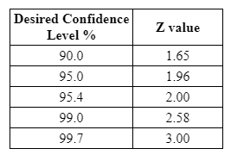

*Figure2.3.3.b: Sample size* *Figure 2.3.3.c: Confidence intervals*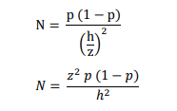

**Determine random observation times:**

Generating random numbers and converting them to date/hour and using it as the individual observation times.

**Do the observations as planned:**

Observation phase

**Pre-evaluation:**

If the p value is acceptable, continue to evaluation; if not, determine new values and repeat again

**Evaluation:**

Evaluate the final results of the work sampling process.

Analyst judges the performance or pace of the worker relative to the definition of standard performance used by the organization

* Standard performance PR = 100%
* Slower pace than standard PR < 100%
* Faster pace than standard PR > 100% 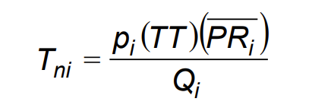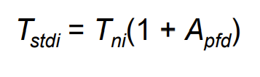

*Figure 2.3.3.d: Normal Time* *Figure 2.3.3.e: Standard Time*

## **METHODOLOGY**

#### **FMEA**

The company's measuring department is the last department of the production line. It is possible to detect many errors here and it is the last detection part of the error as the finished product is out of production. According to the feedback received from the company, we applied the FMEA technique in the measuring department to detect and prevent the problems encountered in this department. For the FMEA part, we determined the new error types we received and asked the experts to rate these error types’ severity and detection scores. Since the company has started to keep more smooth and healthy data in the last months compared to the previous months, we easily obtained the occurrence values. We found the RPN values ​​that are important to us by processing them together with the detection and severity values ​​we received from the experts. The RPN values ​​for incorrect marking, sheath surface dirt / rough, open on sheath surface, color tone difference error types are excessive and precautionary measures should be taken.

#### **OWAS**

While applying the OWAS method, we determined the appropriate angles and took photos of the operators during our company visits to determine the postures (back, arm, leg and weight) required to apply the OWAS method. Then analyzed the collected data with software. OWAS analysis was evaluated according to figures *2.2.1.a* and *2.2.1.b*, the positions were evaluated and the risk priority numbers were determined. With the classification of the results, the need for improvement has been proven; the company has been informed and recommendations have been made.

#### **NIOSH**

We applied the equation to the MT (Carrying reel) process of the operators to determine if lifted weights damage the postures and find the RWL (recommended weight limit). This equation is not viable for processes involving dragging and walking.

We intended to use oxygen consumption to determine the energy expenditure of the workers during shifts but because of the pandemic followed by a lockdown, we couldn’t conduct this study.

For the application of the NIOSH equation, we first took measurements which are vertical distance, horizontal distance, angle etc. (*Figure 2.2.2.a*). Then we formulised our values accordingly to put them in the main equation, which gave the RWL value. Then, dividing the reel weight to RWL resulted in the LI. This LI value shows if the process of reel carrying is convenient or not.

#### **Work Sampling**

Another topic that has worked on is to find the standard time for 2 machines (CAT and KULE) that have been worked on. After the literature survey, work sampling has been decided as the best fitting method to use in this case (jobs consist of various tasks instead of one repetitive task). One reason to pick this method is that the labour in the measuring department is separated into multiple processes (i.e. labeling, measuring, reel placing etc.). Because of the covid-19 pandemic and lockdown that came after, we had limited time to research and work sampling’s research phase was quicker than direct time study. Instead of using direct time study and determining the machine up-times with a stopwatch, we used a pre-prepared template to write down the results of the observed machines in random times and in an unordered fashion.

Two observed machines have different characteristics. The CAT machine has been used mostly on small reels and shorter measurements, whereas KULE has been used mostly on larger reels and longer measurements (e.g. 1000m and over). Thus, different calculations are conducted on these 2 different machines.

After testing whether the number of observations was sufficient by determining an error rate for our observations, we started our standard time operations. We did the necessary procedures for the EC 400 CAT 6 cable and found our standard times with the allowance values ​​we determined. During the cutting of 5000m and 6000m cables, we detected an error input and realized that it did not give us the correct values. We pulled the standard times for this length of cables from 1000m with a simple ratio.

## **METHOD IMPLEMENTATION**

#### **Data Analysis for Work sampling**

###### **Determination of Sample Size**

In the first week, we went to the factory and made 124 observations. We observed the cases where CAT 6 cable was processed in the working category 39 times. Thus, we calculated the number of observations we need to make by taking our p-value 39/124 = 0.31.

According to the information we have obtained from the company, our confidence interval is 95%. So we found a sample size value of n, taking the error rate as 5% that gave accurate results which was acceptable, thus we concluded the observation phase. Detailed observation tables that include the relevant data can be found in the appendix.

Values used to calculate observation amount:

* *p=0.31*
* *z= 0.95*
* *h=0.05*

*(See in Table2.3.3.b, Table 2.3.3.c)*

P * (1-P) * Z² / H² = (0.3145) * (1-0.3145) * (1.96²) / (0.05²)

= (0.2156) * (3.8416) / (0.0025) = 331.30 ≌ 332 number of observations.

###### **Determination the Number of Observations Per Day**

Daily observation amount calculated by dividing total observation amount to 7 (332 / 7 ≌ 48). Activities shown in template (*Table 4.1.2.a)* categorised as working or idle. (M, MT, ME, MAT, GH, GMH, MAG, MS as working category & MB, IB, MA, K, MAB as idle category). Operators have been assigned to machines and data that related to machines has entered the template accordingly. 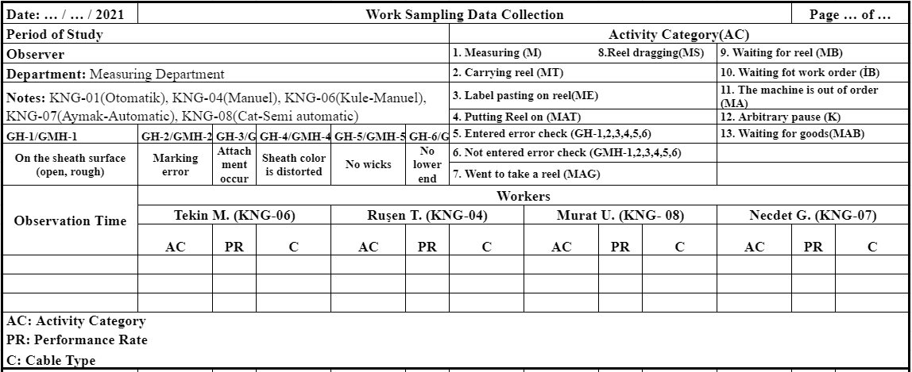

*Table 4.1.2.a: Work sampling data collection sheet*

To test if the observation amount is enough, machine-based observations have started. We collected data from the machines (KNG-05, KNG-06, KNG-07, KNG-08) on randomly selected hours, starting from a different machine each time, randomly. We pulled the data related to EC 400 CAT6 processing from all observations.

###### **Determination of Performance Rate**

Another parameter to decide was performance rates. We rated the workers considering the workers’ physical working speeds, compared to reference normal speeds (PR = %100).

We let the performance rate of the operator working on semi-automatic machines %100 due to the judgement of stationary and inactive labour-time while measuring and labelling processes (M, ME), since the operator cannot have a performance that varies with the machine speed, we fixed the performance rate for the jobs we specified. During these processes, workers were waiting near the machine to process’ completion. Yet things were different on the manual machine. During the processes, operators had to actively use the machine while measuring (M), thus performance rates were given in accordance with the machine speed. Performance rates given considering the working speed for the machine-unrelated processes such as reel dragging or carrying (MS, MT, MAT, MAG). Performance rates were set in 5 step increments like 85, 90, 95. Results categorised in this manner.

Performance Rate for KULE (KNG-06):

* On the manual machine KULE (KNG-06), we let the normal speed of the operator (85 meter / minute) as 100% performance rate. As for operation ME (Label pasting on reel) has constant speed, performance rate is 100%. Other activities’ (such as MT, MAT, MS and so) performance rate have been proportional to the normal speed of the workers.

|  |  |  |  |  |  |
| --- | --- | --- | --- | --- | --- |
| **Machine: KULE (KNG-06)** | **11.02.21** | **24.02.21** | **25.02.21** | **03.03.21** | **Average Performance Rate** |
| **Working** | 110 | 110 | 100 | 100 | **105** |

*Table 4.1.3.a: Average daily performance ratings for KULE (KNG-06) machine*

Performance Rate for CAT (KNG-08):

* Only difference of the Kule machine is because of it’s being a semi-automatic, performance rate of it has taken constant 100% for the measuring process.

|  |  |  |  |  |  |
| --- | --- | --- | --- | --- | --- |
| **Machine: CAT (KNG-08)** | **09.02.21** | **02.03.21** | **03.03.21** | **08.03.21** | **Average Performance Rate** |
| **Working** | 100 | 110 | 95 | 100 | **100** |

*Table 4.1.3.b: Average daily performance ratings for CAT (KNG-08) machine*

###### **Determination of Allowances**

Another parameter needed for work sampling was allowances. Situations mentioned in the table considered and percentages given accordingly. We took our allowance values ​​from the ILO’s tables that are in the course notes and adjusted them according to the operators and gave the following values:

|  |  |  |
| --- | --- | --- |
|  | **KULE(KNG-06)** | **CAT (KNG-08)** |
| Energy Output | 0.0% | 6.0% |
| Posture | 1.0% | 1.0% |
| Notions | 5.0% | 0.0% |
| Visual Fatigue | 2.0% | 0.0% |
| Thermal Conditions | 0.0% | 0.0% |
| Atmospheric Conditions | 0.0% | 0.0% |
| Other Influences of Environment | 1.0% | 1.0% |
| Personal Time | 2.5% | 2.5% |
| Delays | 5.4% | 0.0% |
| **Total** | 16.9% | 10.5% |

*Table 4.1.4.a: Allowance table*

This table shows the allowances of workers during shifts. We found total allowances 16.9% and 10.5% for KULE (KNG-06) and CAT (KNG-08) machines. We will use these allowance values in our standard time calculations.

#### **FMEA Implementation**

Since we were able to work in the company and as a result of the firm's efforts to keep detailed and regular data, we made additions and strikes in our FMEA table for this period. Some error types were removed from the table and ratings were updated as a result of interviews with company experts. We will explain our calculation methods for occurrence values ​​below.

###### **Determination of Severity Score**

We made a rating for the table of severity according to the feedback we received from company experts. We worked like this in the past period. We only updated the degrees for this period.

|  |  |  |  |
| --- | --- | --- | --- |
| Effect | CRITERION: Intensity of Impact This rating is a potential error ultimate customer of its kind and / or cause production / assembly failure It happens when it happens. Ultimate customer must come first. If both come true the high one  Use the severity value.  (Customer Effect) | CRITERION: Severity of Impact  This rating is a potential the ultimate customer of the error type and / or cause production / assembly failure. It happens when it happens. Final customer always has the first degree. If both if it happens, the higher the violence Use the value.  (Production / Assembly Effect) | Degree |
| Dangerous | Safety related malfunction, not in compliance with laws a malfunction. Error any warning occurs without. | Or the operator (machine or equipment) can endanger itself without warning. | 10 |
| Serious | Safety related malfunction, not in compliance with laws a malfunction. The error occurs with a warning. | Or the operator (machine or equipment) by giving a warning can throw. | 9 |
| Immense | Product can become unusable and loses function. | The entire production can be scrapped and can take over 1 hour to be reworked. | 8 |
| Considerable | Product is usable but with a low performance. Consumer satisfaction substantially reduced. | Part of the product may be scrapped and can take up to 1 hour to be reprocessed. | 7 |
| Important | Product is usable but ease of use and compliance components are unavailable. Consumer satisfaction reduced. | Very little of it could be scrapped and repair could take a short time. | 6 |
| Minor | Product is usable but ease of use and compliance components work with low performance. Consumer is not content. | The product is reprocessed without being scrapped. | 5 |
| Inferior | Low impact on product performance or process. Defect can be detected by many consumer (%75) | The product is reprocessed without being scrapped. | 4 |
| Insignificant | Insignificant effect on product performance or process. Defect can be detected by some consumer (%50) | The product is reprocessed without being scrapped. | 3 |
| Negligible | Negligible impact on product performance or process. Defect can be detected by few consumer (%25) | There is no problem with the product to be scrapped. Processed again if required | 2 |
| No Effect | Does not affect product performance or process. | It has little or no effect on the process. | 1 |

*Table 4.2.1.a: Severity rating chart*

###### **Determination of Detection Score**

We made a rating for the table of detection according to the feedback we received from company experts. We worked like this in the past period. We only updated the degrees for this period.

|  |  |  |
| --- | --- | --- |
| DETECTION | CRITERION | DEGREE |
| Nearly Impossible | Existing controls cannot detect the error | 10 |
| Too Hard | Existing controls have reduced chance of detection | 9 |
| Hard | Existing controls have a hard time to detect the error | 8 |
| Very Low Probability | Existing controls have little ability to detect the type of error | 7 |
| Low Probability | Existing controls might detect the error with a low chance | 6 |
| Medium Probability | Existing controls may detect the error | 5 |
| More than Medium | Existing controls have slightly more ability to detect the type of error | 4 |
| High | Existing controls have high ability to detect the type of error | 3 |
| Very High | Existing controls have very high ability to detect the type of error | 2 |
| Almost Certain | The ability of existing controls to detect the type of error is almost certain. | 1 |

*Table 4.2.2.a: Detection Ranking Chart*

###### **Determination of Occurrence Score**

We obtained our occurrence table as a result of our literature search. We think it is also suitable for our own work.

|  |  |  |
| --- | --- | --- |
| ERROR RATE CLASSIFICATION | ERROR RATE IN EVERY 1000 METERS | DEGREE |
| Too High: Continuous Error | More than 100 in a 1000 | 10 |
| 50 in a 1000 | 9 |
| High: Frequent Error | 20 in a 1000 | 8 |
| 10 in an 1000 | 7 |
| Medium Frequency Error | 5 in an 1000 | 6 |
| 2 in an 1000 | 5 |
| Low Frequency Error | 1 in an 1000 | 4 |
| 0.5 in an 1000 | 3 |
| Too Low Frequency Error | 0.2 in an 1000 | 2 |
| Less than 0.01 in a 1000 | 1 |

*Table 4.2.3.a: Occurrence rating chart*

#### Calculation of Incorrect Marking Error Occurrence for 2020

During this period, we created our occurrence rating based on the more detailed and accurate data we received from the company. We can see below how the occurrence degree is calculated for the marking error. We also calculated occurrence values ​​of other error types in this way.

*Table 4.2.3.b: Marking error data for 2020*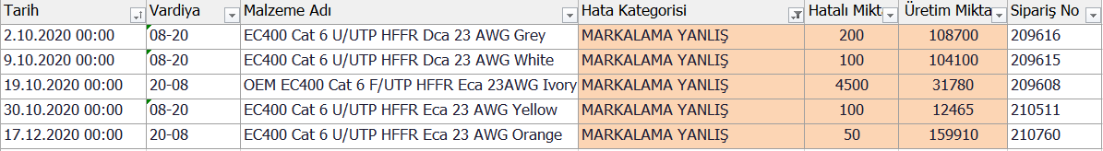

209616 work order had 200 m marking error in the morning shift,

209615 work order had 100 m marking error in the morning shift,

209608 work order had 4500 m marking error in the night shift,

210511 work order had 100 m marking error in the morning shift,

210760 work order had 50 m marking error in the night shift,

Total defective amount (m) = 4.950

Total production (m) = 705.307

Occurrence = 4.950/705.037 = 0.007

This occurrence value we found corresponds to the value of 6 in our occurrence table.

#### Calculation of Incorrect Marking Error Occurrence for 2021

*Table 4.2.3.c: Marking error data for 2021*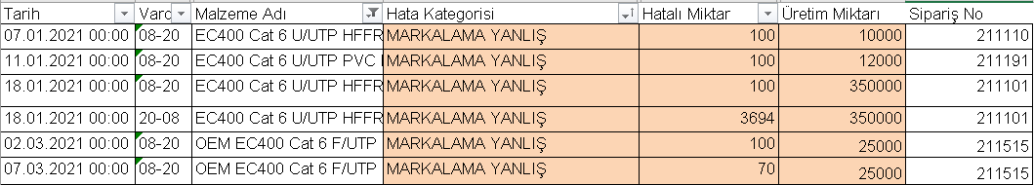

211110 work order had 100 m marking error in the morning shift,

211191 work order had 100 m marking error in the morning shift,

211101 work order had 3794 m marking error in the night shift,

211515 work order had 170 m marking error in the morning shift,

Total defective amount (m) = 4.164

Total production (m) = 634.000

Occurrence = 4164 / 634000 = 0.007

This occurrence value we found corresponds to the value of 6 in our occurrence table.

In order to see how the scores are applied to our final FMEA table, we wanted to specify a part of our FMEA table here just for the marking error.

|  |  |  |  |  |  |  |  |  |  |  |
| --- | --- | --- | --- | --- | --- | --- | --- | --- | --- | --- |
| **Potential**  **Types of Errors** |  |  | **Current State** | | | | | | |  |
| **Incorrect Quantity (m) 2020** | **Incorrect Quantity (m) 2021** | **Severity** | **Occurrence 2020** | **Occurrence 2020** | **Occurrence 2021** | **Occurrence 2021** | **Detection** | **RPN 2020** | **RPN 2021** |
| **Marking Error** | 4950 | 4164 | 7 | 0.007 | 6 | 0.007 | 6 | 3 | 126 | 126 |

*Table 4.2.3.d: Part of final FMEA table, marking error*

**Marking Incorrect RPN 2020** = S*O*D = 7 * 6 * 3 = 126

**Marking Incorrect RPN 2021** = S*O*D = 7 * 6 * 3 = 126

## **DISCUSSION & RESULTS**

#### **FMEA**

After conducting our extensive research on the types of errors we received from the company, we found the number of meters of the total production that these errors occurred and gave the occurrence values. Then we scored severity and detection parts in line with the information we received from the company experts, and found our relevant RPN values ​​as follows:

|  |  |  |  |  |  |  |  |  |  |
| --- | --- | --- | --- | --- | --- | --- | --- | --- | --- |
| **Process/ Step** | **Potential**  **Types of Errors** |  |  | **Current State** | | | | |  |
| **Incorrect**  **Quantity (m) 2020** | **Incorrect Quantity (m) 2021** | **Severity** | **Occurrence 2020** | **Occurrence 2021** | **Detection** | **RPN 2020** | **RPN 2021** |
| **M**  **E**  **A**  **S**  **U**  **R**  **E**  **M**  **E**  **N**  **T** | **Marking Incorrect** | 4950 | 4164 | 7 | 6 | 6 | 3 | 126 | 126 |
| **Sheath Surface Dirt / Rough** | 2600 | 10000 | 7 | 6 | 8 | 7 | 294 | 392 |
| **Open on Sheath Surface** | 1100 | 11450 | 7 | 5 | 8 | 7 | 245 | 392 |
| **Cable Attachment** | 4000 | 0 | 8 | 6 | 1 | 2 | 96 | 16 |
| **No Wick** | 20 | 0 | 6 | 1 | 1 | 4 | 24 | 24 |
| **Colour Tone Difference** | 150 | 16570 | 6 | 1 | 8 | 4 | 24 | 192 |
| **Forgetting to Put Out the Lower Ends** | 5986 | 10090 | 6 | 7 | 8 | 2 | 84 | 96 |
|  | **Total Production (m)** | 705037 | 634000 |  |  |  |  |  |  |

*Table 5.1.a: Final FMEA Table*

**Reasons and Solution Offers for Errors**

1- Marking Incorrect: An error occurs as a result of an incorrect operator typing into the printer. Operator carelessness and negligence. They enter the marking information (Senkron ERP) to the system from the design department. Operators get the marking information from the system, trying to minimize the error in this way. Intermediate control staff in the quality control department should check frequently during sheath pulling.

2- Sheath Surface Dirt / Rough: It can be sourced from raw materials. As a result of the incorrect entry of the operator, temperature error or incorrect wall thickness may occur in the extruder lines. By attaching a piece like a sieve to the end of the raw material, it is tried to clean the dirt formed in the raw material. The operator should be given the necessary machine and raw material training. Raw material measurements should be made in the incoming quality control tests for newly arrived raw materials. A PVC Test Extruder (30 and 45) machine can be recommended.

3- Open on Sheath Surface: It is caused by raw materials. It is caused by similar reasons with dirt and roughness defects. By attaching a piece like a sieve to the end of the raw material, it is tried to clean the dirt formed on the raw material.

4- Cable Attachment: Originating from the isolation stage or the twisting stage, by the operator. Training and seminars should be given to increase the operator's attention and awareness of the problems that arise as a result of their mistakes.

5- Colour Tone Difference: Dye is thrown into the raw material according to the dye code and the amount is adjusted, it may occur due to the operator's inability to adjust the amount. It may be due to the mixing of the paint existing in the previous production with the paint in the new production. Operators' attention can be increased.

6- Forgetting to Put Out the Lower Ends: Lower end removal process; when there is attached production in the bending phase or in the isolated phase, these ends are removed from the edge of the reel. In order to control the quality of the additional part, the broken part, the end must be removed.A wage cut is applied to workers, in the 3rd warning. Holes are drilled in the edges of the reels to remove the attachments.

7- No Wick: This type of error is almost never encountered. For this reason, there is no need for a suggestion or change.

#### **OWAS**

Different analysis conducted based on our work sampling activity categories (*Table 4.1.2.a*) (e.g. labelling, measuring, putting the reel on etc.).

**Label pasting on reel (ME)**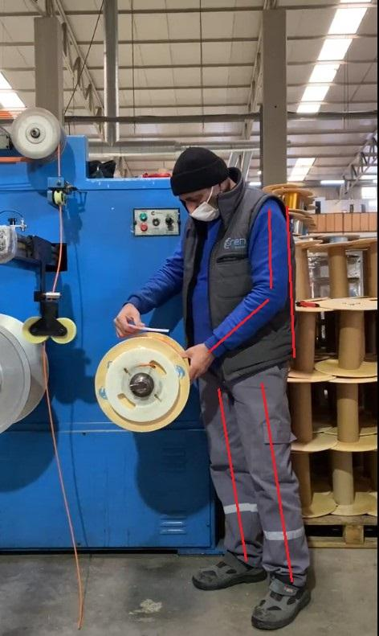

*Figure 5.2.a:* *Table 5.2.a:*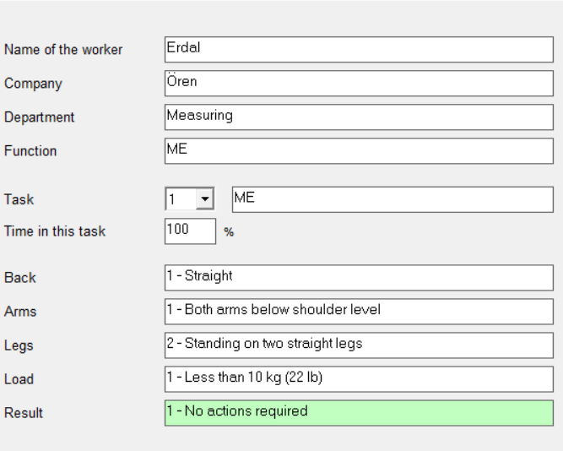

*Posture of label pasting on Reel OWAS application results for label pasting*

ME is a process where the labels are attached after the measuring end. Rating for back is calculated as **1 (standing straight)**. For arms, the rating is again **1 (both arms are at shoulder level)**. Legs have the rating of **2 (standing on two straight legs)**. Finally, the weight rating is **1 (under 10kg)** because the reel is still attached to the machine and does not impose any weight on the worker. According to these ratings, results are categorised as **Category 1** which states there’s no need to take immediate precautions.

**Reel Drag (MS)**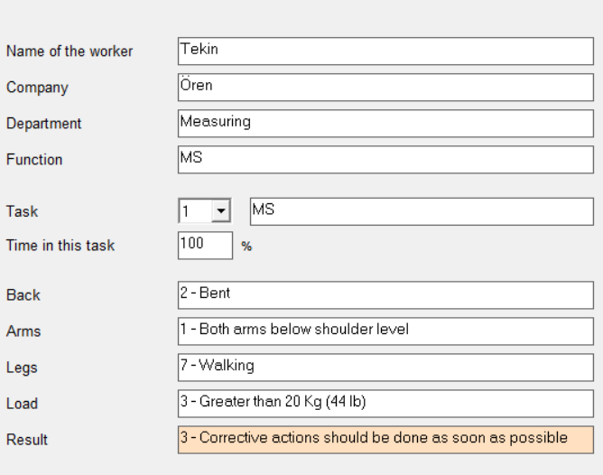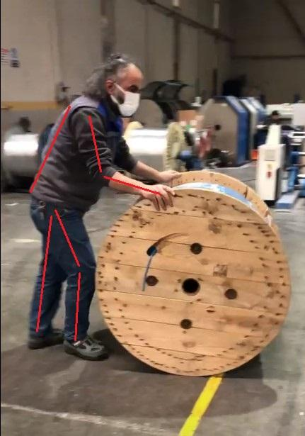

*Figure 5.2.b:* *Table 5.2.b:*

*Posture of reel drag on reel OWAS application results for reel drag*

For analysis made for the reel dragging process, rating for back is calculated as **2 (bent)**. For arms, the rating is again **1 (both arms are at shoulder level).** Legs have the rating of **7 (walking)**. Finally, the weight rating is **3 (greater than 20 kg)** because the reel is still not attached to the machine and the worker carries the entire load. According to these ratings, results are categorised as **Category 3** which states there’s corrective actions should be done as soon as possible.

Recommendation for Dragging the Reel

In order to reduce the load on the musculoskeletal system of the worker in the process of dragging the reel, we recommend the use of a simple carrying apparatus (*Figure 5.2.c*) called the roller cradle. The reel to be transported is placed in this apparatus in a short time such as 15-20 seconds and can be carried easily with a very little pushing force.

*Table 5.2.c: Technical specifications of* *Figure 5.2.c: Roller Cradle[11]*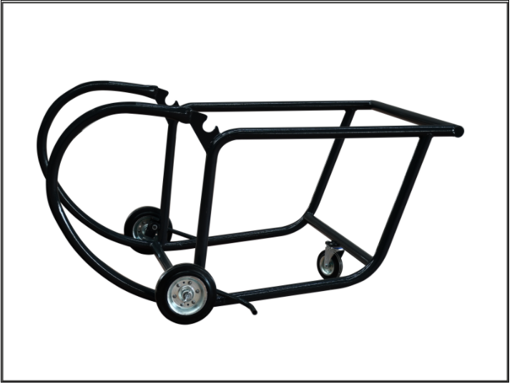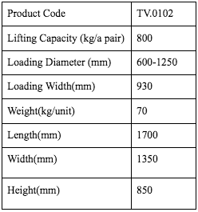

*roller cradle*

**Putting Reel on (MAT)**

We examined the putting reel on activity in two different situations.

* MAT-1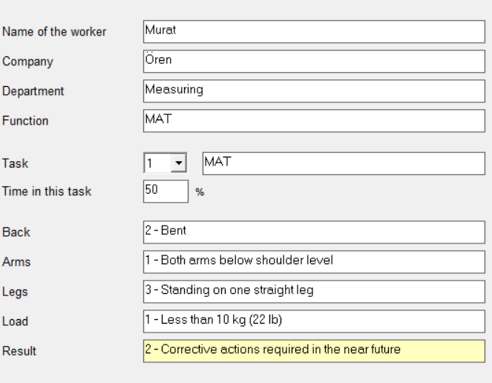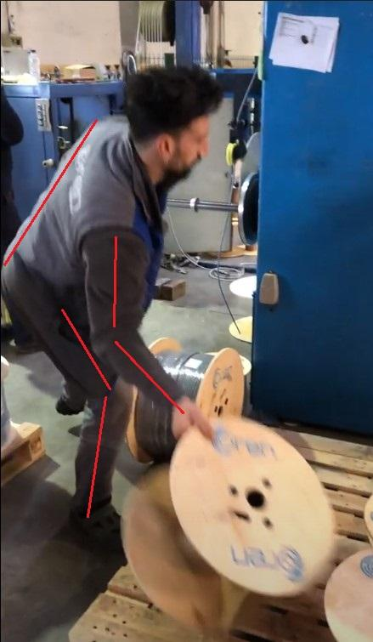

*Figure 5.2.d: Posture of putting reel-1* *Table 5.2.d: OWAS application results for putting reel-1*

For the first analysis made by putting the reel on process, rating for back is calculated as **2 (bent)**. For arms, the rating is again **1 (both arms are at shoulder level)**. Legs have the rating of **3 (standing on one straight leg)**. Finally, the weight rating is **1 (under 10kg)** because the empty reel applies a low degree of weight to the worker. According to these ratings, results are categorised as **Category 2** which states there’s corrective actions required in the near future.

* MAT-2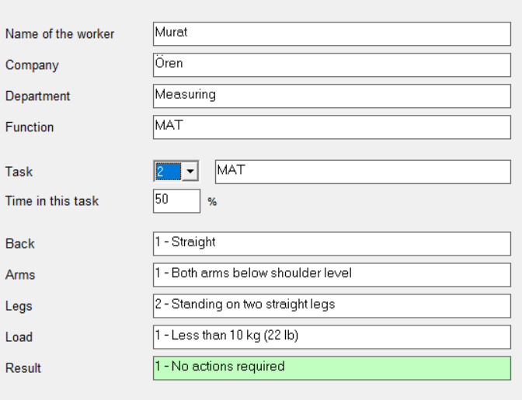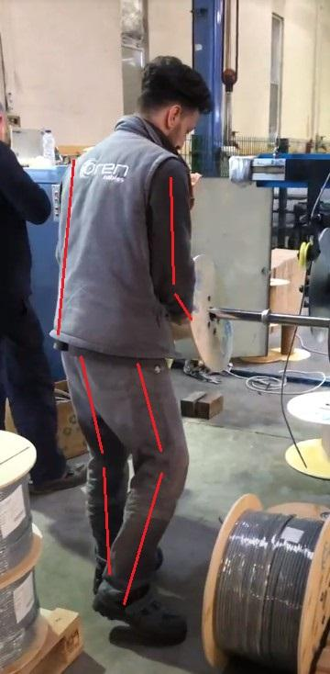

*Figure 5.2.e: Posture of putting reel-2* *Table 5.2.e: OWAS application results for*

*putting reel-2*

For the second analysis made by putting the reel on process, rating for back is calculated as **1 (standing straight)**. For arms, the rating is again **1 (both arms are at shoulder level)**. Legs have the rating of **2 (standing on two straight legs)**. Finally, the weight rating is **1 (under 10kg)** because the empty reel applies a low degree of weight to the worker. According to these ratings, results are categorised as **Category 1** which states there’s no need to take immediate precautions.

**Carrying the Reel (MT)**

We examined the carrying of the reel in two different situations.

* MT-1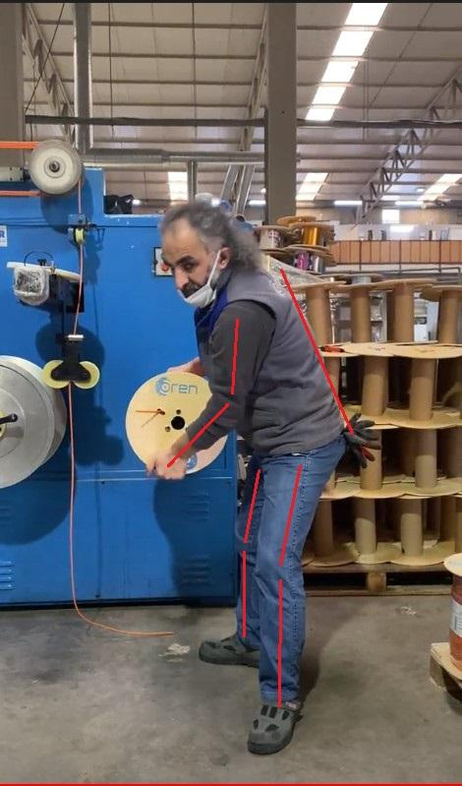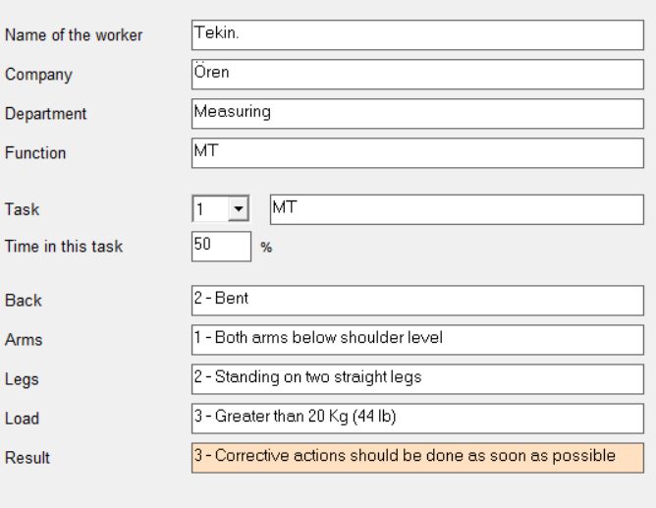

*Fig. 5.2.f: Posture of carrying reel-1* *Table 5.2.f: OWAS application results for*

*carrying reel-1*

For the first analysis made carrying the reel process, rating for back is calculated as **2 (bent)**. For arms, the rating is again **1 (both arms are at shoulder level)**. Legs have the rating of **2 (standing on two straight legs)**. Finally, the weight rating is **3 (greater than 20 kg)** because the worker carries the entire load. According to these ratings, results are categorised as **Category 3** which states there’s corrective actions should be done as soon as possible.

* MT-2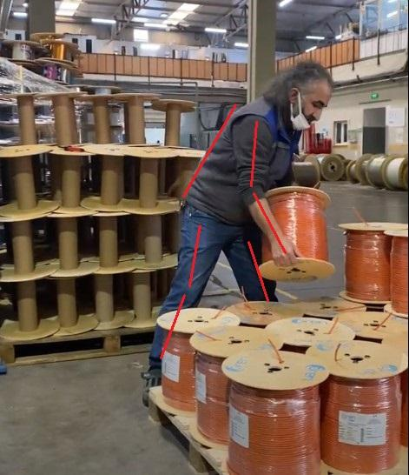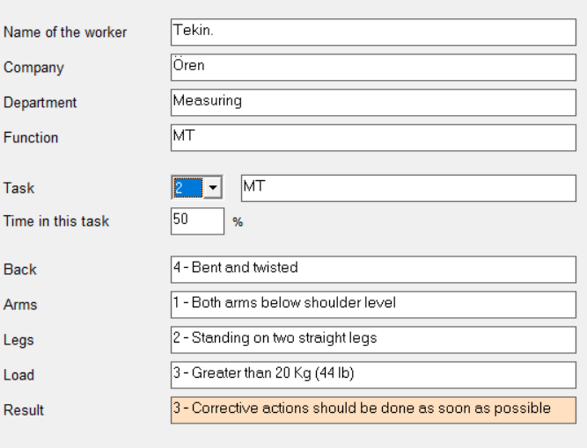

*Fig. 5.2.g: Posture of carrying reel-2* *Table 5.2.4.g: OWAS application results for*

*carrying reel-2*

For the second analysis made carrying the reel process, rating for back is calculated as **4 (bent and twisted)**. For arms, the rating is again **1 (both arms are at shoulder level)**. Legs have the rating of **2 (standing on two straight legs)**. Finally, the weight rating is **3 (greater than 20 kg)** because the reel is not attached to the machine and the worker carries the entire load. According to these ratings, results are categorised as **Category 3** which states there’s corrective actions should be done as soon as possible.

Recommendation for Carrying the Reel

We must ensure that the employee's back stays straight in order to reduce the load on the back. For this reason, we want the pallet to be adjusted according to the height that the worker will place, and in this way we want to reduce the load on the back. For this reason, we recommend placing a lifting device (*Figure 5.2.h*) under the pallet. For each placement height, the pallet will be raised or lowered, thereby reducing the amount of load on the back. We will see the effects of this proposition more clearly in the NIOSH implementation.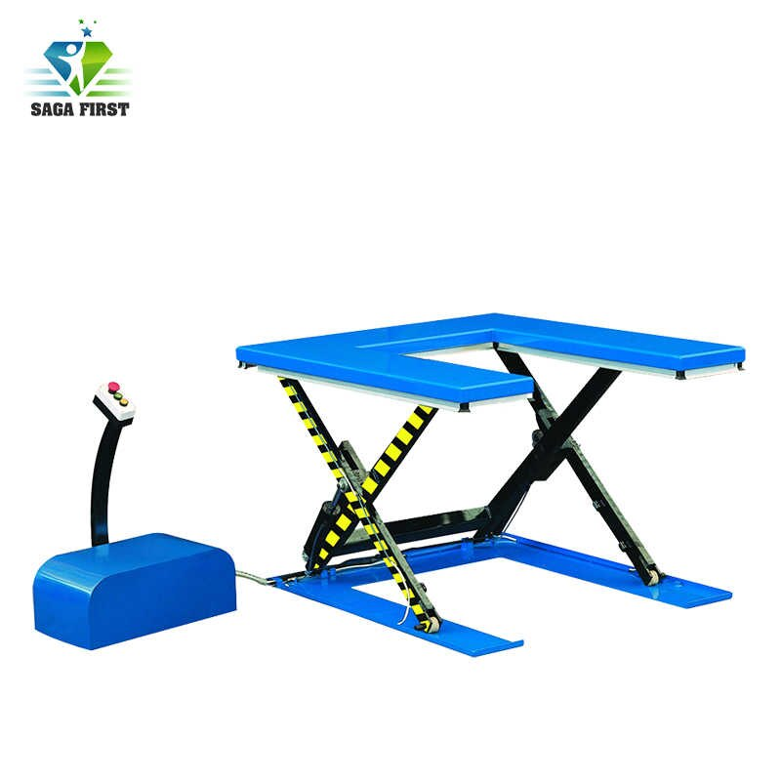

*Figure 5.2.h: Hydraulic lift [12]*

When we shared this recommended lifting device and the predicted results with the company officials, positive feedback was obtained. It was stated that this application can be implemented. This product can be found on websites for 1800 dollars. However, we think it can be manufactured at a more affordable price.

|  |  |  |  |  |
| --- | --- | --- | --- | --- |
| **Model** |  | **UL600** | **UL1000** | **UL1500** |
| **Load capacity** | **Kg** | **600** | **1000** | **1500** |
| **Platform size LxW** | **Mm** | **1450x985** | **1450x1140** | **1600x1180** |
| **Net weight** | **Kg** | **207** | **280** | **380** |

*Table 5.2.h: Technical specifications for lifting apparatus*

**Measuring(M)**

*Fig. 5.2.i: Posture of measuring* *Table 5.2.i: OWAS application results for*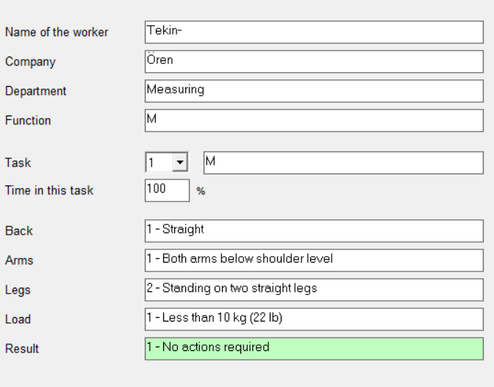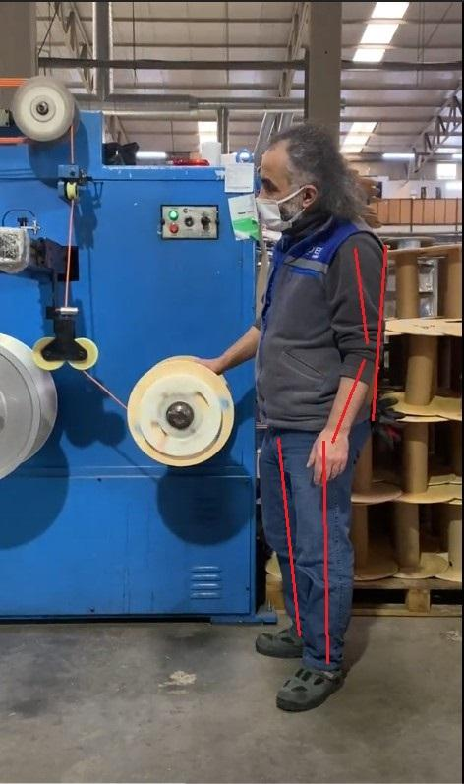

*measuring*

For the analysis made measuring process, rating for back is calculated as **1 (standing straight)**. For arms, the rating is again **1 (both arms are at shoulder level)**. Legs have the rating of **2 (standing on two straight legs)**. Finally, the weight rating is **1 (under 10kg)** because the reel is still attached to the machine and does not impose any weight on the worker. According to these ratings, results are categorised as **Category 1** which states there’s no need to take immediate precautions.

#### **NIOSH**

We examined the NIOSH equation for 4 separate cases. The NIOSH equations of removing the reel from the mechanism and then placing it on the 1st, 2nd and 3rd rows on the pallet were examined.

*Fig. 5.3.a: Posture of lifting reel* *Table 5.3.a: NIOSH application results for*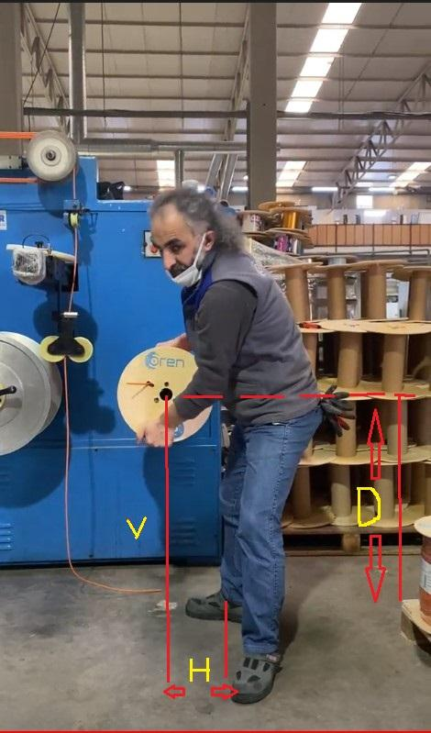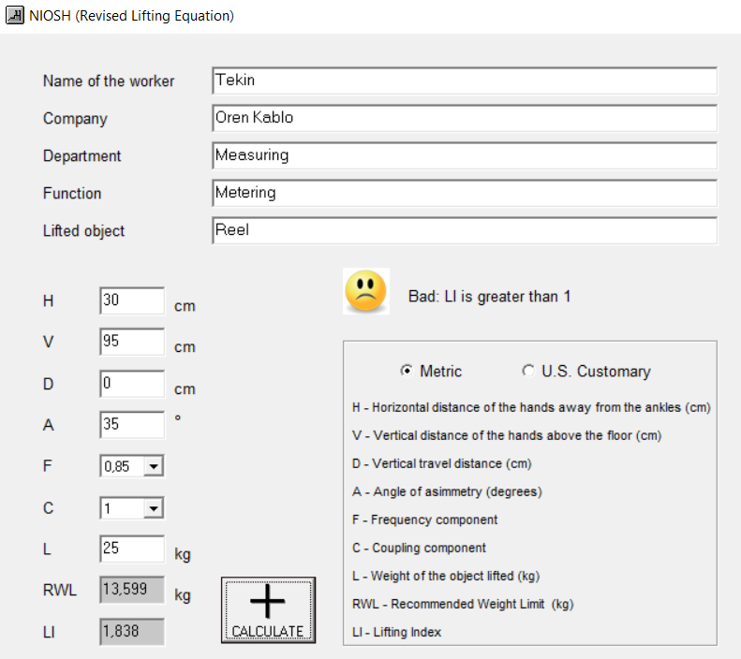

*lifting reel*

We can see the measurements we made for the removal of the reel from the mechanism and the results we obtained in figure 1, the RWL was determined as 13.6 kg, so our LI value was 1.838. As a result of our literature research, these values ​​can neither be considered as risky or risk-free. We can say that it has a moderate risk level. Necessary arrangements can be made.

* Calculating LI value for First row on the palette: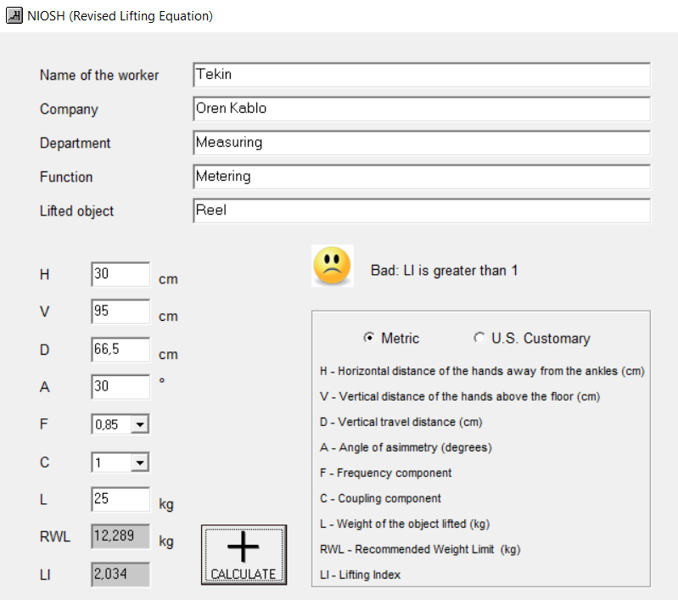

*Table 5.3.b: NIOSH application results for lifting reel to first row on the palette*

We see that our RWL value is 12.289 and our LI value is 2.034, as we have a high displacement in reel placement to the first row on the pallet, which indicates a high degree of risk. The necessary arrangements should be made as soon as possible.

* Second row on the palette: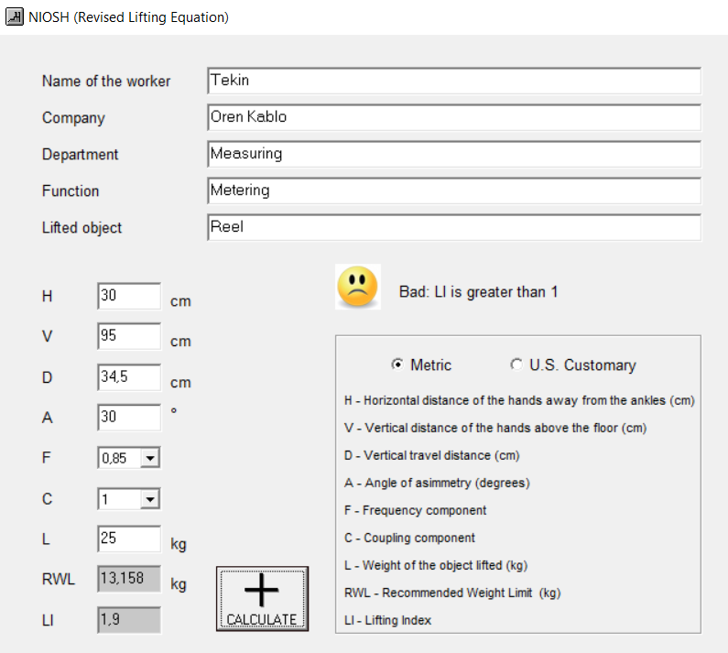

*Figure 5.3.b: Posture of lifting* *Table 5.3.c: NIOSH application results for lifting*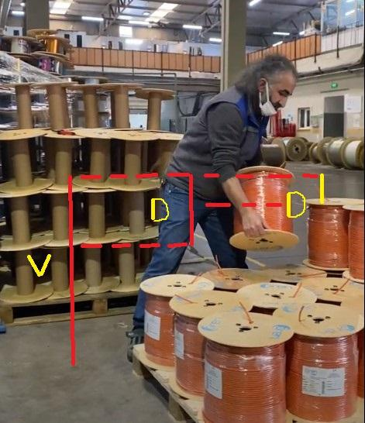

*reel to second row reel to second row*

We see that our RWL value is 13,158 for reel placement in the second row on the pallet, and our LI value is 1.9, which indicates a medium risk. Necessary arrangements can be made.

* Third row on the palette: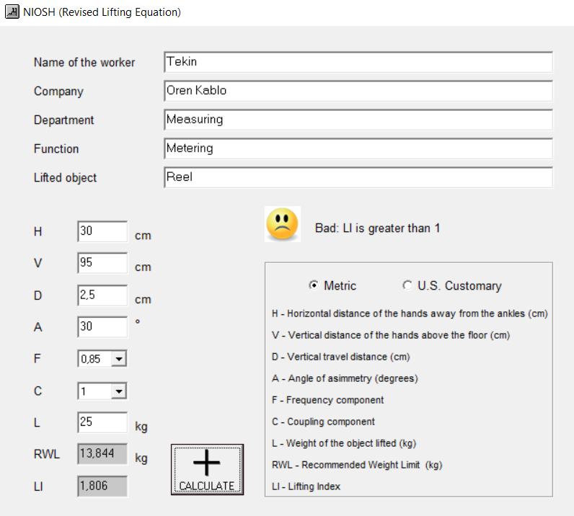

*Table 5.3.d: NIOSH application results for lifting reel to third row*

We see that our RWL value is 13,844 for reel placement in the third row on the pallet and our LI value is 1.806, which indicates a medium risk. Necessary arrangements can be made.

* After adjustments are made:

*Table:5.3.e: NIOSH application result after adjustments made*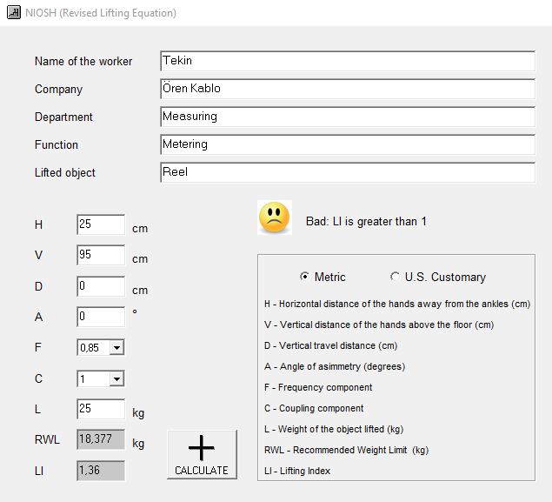

In order to reduce the displacement to zero, we need to match the height at which the reel will be placed with our vertical height. For this, we recommend a lifting device as we recommend in the OWAS application. This lifting apparatus (*Figure 5.2.h*) to be placed under the pallet will adjust the height of the pallet according to where the reel will be placed. On the other hand, we want to minimize our risk by reducing the stress on the musculoskeletal system by reducing the horizontal distance, which is an important variable. For this reason, our displacement will always be 0 and we will reduce our horizontal distance from 30 cm to 25 cm. After these changes, our RWL value rises to 18.377 and our LI value rises to 1.36, which shows us a low risk. It has been proven that, in some cases, situations that may be included in the high risk category can be reduced to the low risk category if the changes we recommend are implemented.

#### **WORK SAMPLING**

Our work sampling study took 4 weeks. During these 4 weeks, we made 1515 observations by visiting the shop floor 429 times, covering 7 working days, and we observed the CAT 6 cable process 216 times in these days. Detailed observation tables that include the relevant data can be found in the appendix.

|  |  |  |  |
| --- | --- | --- | --- |
| **ACTIVITY CATEGORY** | **# OF OBS. FOR EC400 CAT 6** |  | **# OF OBS. FOR ALL CABLES** |
| M (Measuring) | 121 | 180 | 592 |
| MT (Carrying reel) | 12 | 64 |
| ME (Label pasting on reel) | 31 | 298 |
| MAT (Putting Reel on) | 12 | 67 |
| MAG (Went to take a reel) | 2 | 11 |
| MS (Reel dragging) | 2 | 4 |
| MB (Waiting for a reel) | 0 | 33 | 6 |
| IB (Waiting for work order) | 0 | 116 |
| MA (The machine is out of order) | 0 | 67 |
| K (Arbitrary pause) | 21 | 133 |
| MAB (Waiting for goods) | 12 | 153 |
| GH-1 (Entered error check- On the sheath surface (open, rough)) | 0 | 3 | 0 |
| GH-2 (Entered error check- Marking error) | 0 | 0 |
| GH-3 (Entered error check- Attachment occur) | 0 | 0 |
| GH-4 (Entered error check- Sheath color is distorted) | 1 | 1 |
| GH-5 (Entered error check- No wicks) | 0 | 0 |
| GH-6 (Entered error check- No lower end) | 0 | 0 |
| GMH-1 (Not entered error check- On the sheath surface (open, rough)) | 2 | 4 |
| GMH-2 (Not entered error check- Marking error) | 0 | 0 |
| GMH-3 (Not entered error check-Attachment occur) | 0 | 0 |
| GMH-4 (Not entered error check- Sheath color is distorted) | 0 | 0 |
| GMH-5 (Not entered error check- No Wick) | 0 | 0 |
| GMH-6 (Not entered error check- No lower end) | 0 | 0 |
| **TOTAL** | **216** |  | **1.515** |
| **Total number of visits to shop floor** |  |  | **429** |

*Table 5.4.a: Activity categories*

* Greens and magentas are included in working activities.
* Oranges are included in idle activities.

*Table 5.4.1.a* shows our processing on both EC 400 CAT 6 and other cables.

|  |  |
| --- | --- |
| **All Cables** | |
| Personal Allowances | 8.78% |
| Delay Allowances | 22.57% |

*Table 5.4.b: Allowance values*

We have:

* 133 K (Arbitrary pause) in 1515 observations for all cables.

So, personal allowances is 133 / 1515 = 8.78%

* Delays are (MB + IB + MA + MAB) / Total Obs. = (6 + 116 + 67 + 153) / 1515 = 22.57%. Values above 15% signals a problem and needs intervention by the planning department of the company.

We think these problems are causing overtime;

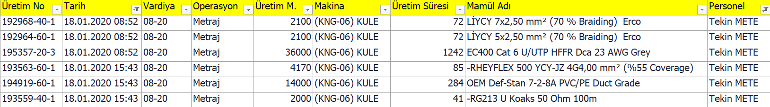*Table 5.4.c**: Sample worker data for one day*

In *Table 5.3.e*, we want to show that sometimes operators work overtime and we assume that causes inefficiency and increase in error rate. For example:

72+72+1242+85+41+284 = 1796 minutes ≅ 30 hours, Tekin M. worked for 30 hours.

###### **Machine Base Observations for EC 400 CAT 6**

Below are the representations of observations for each machine, daily.

|  |  |  |  |  |  |
| --- | --- | --- | --- | --- | --- |
| **Machine: KULE(KNG-06)** | 11.02.21 | 24.02.21 | 25.02.21 | 03.03.21 | **Total** |
| M (Measuring) | 15 | 7 | 17 | 7 | 46 |
| MT (Carrying reel) | 0 | 1 | 0 | 0 | 1 |
| ME (Label pasting on reel) | 0 | 2 | 1 | 4 | 7 |
| MAT (Putting Reel on) | 1 | 2 | 1 | 1 | 5 |
| MAG (Went to take a reel) | 0 | 0 | 0 | 0 | 0 |
| MS (Reel dragging) | 0 | 0 | 1 | 0 | 1 |
| MB (Waiting for a reel) | 0 | 0 | 0 | 0 | 0 |
| IB (Waiting for work order) | 0 | 0 | 0 | 0 | 0 |
| MA (The machine is out of order) | 0 | 0 | 0 | 0 | 0 |
| K (Arbitrary pause) | 4 | 0 | 5 | 2 | 11 |
| MAB (Waiting for goods) | 7 | 1 | 2 | 2 | 12 |
| GH-1 (Entered error check- On the sheath surface (open, rough)) |  |  |  | 2 | 2 |
| GMH-4 (Not entered error check- Sheath color is distorted) |  |  | 1 |  | 1 |
|  |  |  |  |  |  |
| **Number of Observations** | 58 | 62 | 56 | 63 | **239** |

*Table 5.4.1.a: EC 400 CAT 6 observations for KULE (KNG-06) Machine*

* EC 400 CAT 6 Cable in the KULE (KNG-06) machine was seen on 11.02.2021, 24.02.2021, 25.02.2021, 03.03.2021 dates with a total of 239 number of observations for all cables.

|  |  |  |  |  |  |
| --- | --- | --- | --- | --- | --- |
| **Machine : CAT (KNG-08)** | 09.02.21 | 02.03.21 | 03.03.21 | 08.03.21 | **Total** |
| M (Measuring) | 12 | 25 | 19 | 19 | 75 |
| MT (Carrying reel) | 2 | 2 | 4 | 3 | 11 |
| ME (Label pasting on reel) | 7 | 5 | 8 | 4 | 24 |
| MAT (Putting Reel on) | 2 | 0 | 3 | 2 | 7 |
| MAG (Went to take a reel) | 0 | 0 | 0 | 2 | 2 |
| MS (Reel dragging) | 0 | 0 | 1 | 0 | 1 |
| MB (Waiting for a reel) | 0 | 0 | 0 | 0 | 0 |
| IB (Waiting for work order) | 0 | 0 | 0 | 0 | 0 |
| MA (The machine is out of order) | 0 | 0 | 0 | 0 | 0 |
| K (Arbitrary pause) | 1 | 2 | 7 | 0 | 10 |
| MAB (Waiting for goods) | 0 | 0 | 0 | 0 | 0 |

|  |  |  |  |  |  |
| --- | --- | --- | --- | --- | --- |
| **Number of Observations** | 66 | 61 | 63 | 63 | **253** |

*Table 5.4.1.b: EC 400 CAT 6 observations for CAT (KNG-08) Machine*

* EC 400 CAT 6 Cable in CAT (KNG-08) machine was seen on 09.02.2021, 02.03.2021, 03.03.2021, 08.03.2021 dates with a total of 253 number of observations for all cables.

**Daily Working & Idle Observations for Kule (KNG-06) Machine**

|  |  |  |  |  |  |
| --- | --- | --- | --- | --- | --- |
| **Machine: KULE (KNG-06)** | 11.02.21 | 24.02.21 | 25.02.21 | 03.03.21 | **Total** |
| Working | 0.28 | 0.19 | 0.38 | 0.22 | **0.26** |
| Idle | 0.19 | 0.02 | 0.13 | 0.06 | **0.10** |

*Table 5.4.1.c: Working (EC 400 CAT 6) Proportions for KULE (KNG-06) Machine*

Daily working and idle ratios have been found. Below is a sample calculation for 11.02.21. Rest of the table has been filled similarly.

On 11.02.2021 total working activities (green ones) were 16 in 58 (*Table 5.4.1.a)* observations. So, the working proportion for that day is 16 / 58 = 0.2759 ≌ 0.28. Idle proportion is 11 / 58 = 0.1897 ≌ 0.19.

Total working activities (green ones) are 16+12+21+14 = 63 in 239 (*Table 5.4.1.a)* observations. So:

* Working proportions for KULE (KNG-06) machineis 63 / 239 = 0.2636 ≌ 0.26
* Idle is 11+ 1 + 7 + 4 = 23 / 239 = 0.096 ≌ 0.10.

|  |  |  |  |  |  |
| --- | --- | --- | --- | --- | --- |
| **Machine :CAT (KNG-08) Semi-Automatic** | 09.02.21 | 02.03.21 | 03.03.21 | 08.03.21 | **Total** |
| Working | 0.35 | 0.52 | 0.56 | 0.48 | **0.47** |
| Idle | 0.02 | 0.03 | 0.11 | 0.00 | **0.04** |

*Table 5.4.1.d : Working (EC 400 CAT 6) Proportions for CAT (KNG-08) Machine*

Total working activities (green ones) are 23 + 32 + 35 + 30 = 120 in 253 observations (*Table 5.4.b*). So:

* Working proportions for Kule Machines (KNG-06) is 120 / 253 = 0.474 ≌ 0.47
* Idle is 1 + 2 + 7 = 10 / 253 = 0.039 ≌ 0.04.

|  |  |
| --- | --- |
| **121** | M (Measuring) |
| **12** | MT (Carrying reel) |
| **31** | ME (Label pasting on reel) |
| **12** | MAT (Putting Reel on) |
| **2** | MAG (Went to take a reel) |
| **2** | MS (Reel dragging) |
| **0** | MB (Waiting for a reel) |
| **0** | IB (Waiting for work order) |
| **0** | MA (The machine is out of order) |
| **21** | K (Arbitrary pause) |
| **12** | MAB (Waiting for goods) |
| **1** | GH-1 (Entered error check- On the sheath surface (open, rough) |
| **2** | GMH-4 (Not entered error check- Sheath color is distorted) |

|  |  |
| --- | --- |
| **TOTAL** |  |
| Working | 0.37 |
| Idle | 0.07 |

*Table 5.4.1.e: Working & Idle Proportion for Both Machines*

* Total working activities is 121 + 12 + 31 + 12 + 2 + 2+ 1 + 2 = 183 in 492 observations. So, the working proportion is 183 / 492 = 0.372 ≌ 0.37 for both machines.
* Idle proportion is 21 +12 = 33 / 492 = 0.067 ≌ 0.07.

|  |  |  |  |  |  |  |  |  |
| --- | --- | --- | --- | --- | --- | --- | --- | --- |
| **Date** | **09.02** | **11.02** | **24.02** | **25.02** | **02.03** | **03.03** | **08.03** | **TOTAL** |
| **Number of Obs.** | 66 | 58 | 62 | 56 | 61 | 126 | 63 | 492 |
|  | CAT | KULE | KULE | KULE | CAT | KULE &  CAT | CAT |  |

*Table 5.4.1.f: Number of EC 400 CAT 6 Observations for Both Machines*

The table shows the dates when the EC 400 CAT 6 cable was put into operation. While the operations related to EC 400 CAT 6 cable were observed in one machine on 9, 11, 24, 25 February and 2, 8 March, it was observed in two machines on 3 March. For this reason, the number of observations (63 + 63 = 126) has been collected for both machines separately.

* EC 400 CAT 6 observations for both machines.
* Only on 03.03.2021 both machines were working.

**Finding Error Rates for CAT (KNG-08) & KULE (KNG-06) Machine by Observation Numbers**

|  |  |  |  |  |  |
| --- | --- | --- | --- | --- | --- |
|  | P | (1-P) | P*(1-P) | N |  |
|  | 0.370 | 0.630 | 0.233 | 492 | 492 |
| H2 | 0.0018 | 0.0427 |  |  |  |
| Z2 | 3.84 |  |  |  |  |

*Table 5.4.1.g: Total Error Rate for Both Machines*

With 95% confidence interval and 492 observations. As shown in the *Table 5.4.1.e* process ratios for both machines have taken 0.37

* We have as P * (1-P) * / N = 0.233 * 3.84 / 492 = 0.0018 =
* So, the square root of it gives us an error rate √0,0018 = 0.0427 ≌ 0.04.

After the processes and observations, we include a four percent error rate in our EC 400 CAT 6 observations.

**Error Rate for CAT (KNG-08) Machine Type of 500m Reel**

|  |  |  |  |  |  |
| --- | --- | --- | --- | --- | --- |
|  | P | (1-P) | P*(1-P) | N |  |
|  | 0.474 | 0.526 | 0.249 | 253 | 253 |
| H² | 0.0038 | 0.0615 |  |  |  |
| Z² | 3.84 |  |  |  |  |

*Table 5.4.1.h: Error Rate for CAT (KNG-08) Machine*

With 95% confidence interval and 253 observations. We took the ratio 0.474 for working of the CAT (KNG-08) machine as shown in *Table 5.4.1.d.*

* We have as P *(1-P) * / N = 0.249 * 3.84 / 253 = 0.0038 =
* So, the square root of it gives us an error rate.= 0.0615 ≌ 0.06.

We include a six percent error rate in our EC 400 CAT 6 observations.

After the processes and observations, if we assumed a 5% error, then the observation amount would be 383. However, under the pandemic restrictions we didn’t have a healthy research environment.

**Error Rate for KULE(KNG-06) Machine Type of 1000m Reel**

|  |  |  |  |  |  |
| --- | --- | --- | --- | --- | --- |
|  | P | (1-P) | P*(1-P) | N |  |
|  | 0.276 | 0.724 | 0.200 | 58 | 58 |
| H² | 0.0132 | 0.1150 |  |  |  |
| Z² | 3.84 | 0.12 |  |  |  |

*Table 5.4.1.i: Error Rate for KULE (KNG-06) Machine for Type of 1000m Reel*

As we show in the table (*Table 5.4.1.a*), we processed our working rate as 15 + 1 = 16/58 = 0.276 for the KULE (KNG-06) machine on 11.02.21 (We only took the date as reference 11.02.2021 because the 1000-meter reel was metered that day). Metering operations are carried out on 1000, 5000, 6000 meters of reels in the tower machine. In order to find more reliable data in our standard time processes, we have taken into account both our operations and our observations separately for reels of different lengths with 95% confidence interval and 58 observations.

* We have as P *(1-P) * / N = 0.200 * 3.84 / 58 = 0.0132 =
* So, the square root of it gives us an error rate.= 0.1150 ≌ 0.12.

As a result of the observations and procedures, we include twelve percent error rate in our EC 400 CAT 6 observations.

**Error Rate for KULE(KNG-06) Machine Type of 5000m Reel**

|  |  |  |  |  |  |
| --- | --- | --- | --- | --- | --- |
|  | P | (1-P) | P*(1-P) | N |  |
|  | 0.294 | 0.706 | 0.208 | 119 | 119 |
| H² | 0.0067 | 0.0819 |  |  |  |
| Z² | 3.84 | 0.08 |  |  |  |

*Table 5.4.1.j: Error Rate for KULE (KNG-06) Machine for Type of 5000m Reel*

With 95% confidence interval and 119 observations. As we show in *Table 5.4.1.a*, our working rate was 17 + 1 + 1 + 1 + 1 & 7 + 4 + 1 +2 = 35/119 = 0.294 ≌ 0.29 for the KULE (KNG-06) machine on 25.02.21 and 03.03.21 (only because 5000m reel is measured in those days).

* We have as P * (1-P) * / N = 0.208 * 3.84 / 119 = 0.0067 =
* So the square root of it gives us an error rate.= 0.0819 ≌ 0.08.

As a result of the observations and procedures, we include eight percent error rate in our EC 400 CAT 6 observations.

**Error Rate for KULE (KNG-06) Machine Type of 6000m Reel**

|  |  |  |  |  |  |
| --- | --- | --- | --- | --- | --- |
|  | P | (1-P) | P*(1-P) | N |  |
|  | 0.194 | 0.806 | 0.156 | 62 | 62 |
| H² | 0.0097 | 0.0983 |  |  |  |
| Z² | 3.84 | 0.10 |  |  |  |

*Table 5.4.1.k : Error Rate for KULE (KNG-06) Machine Type of 6000m Reel*

With 95% confidence interval and 62 observations. As we have shown in *Table 5.4.1.a*, we have processed our working rate of 24.02.21 (only because 6000m of reel is measured per day) for KULE (KNG-06) machine as 7+ 1 + 2 + 2 = 12/62 = 0.194*.*

* We have as P * (1-P) * / N = 0.806 * 3.84 / 62 = 0.0097 =
* So, the square root of it gives us an error rate.= 0.0983 ≌ 0.10

As a result of the observations and procedures, we include ten percent error rate in our EC 400 CAT 6 observations.

###### **Allowances**

In the tables below, we can see the realization frequencies of the idle activities for the KULE (KNG-06) and CAT (KNG-08) machines during the observations. For example, out of a total of 58 observations made on 11.02.2021, 4 were shown as arbitrary pause (K) and 7 as waiting for goods (MAB). The remainder of the table is also filled in as indicated according to the results of the observations.

|  |  |  |  |  |  |
| --- | --- | --- | --- | --- | --- |
| **Machine: KULE (KNG-06)** | 11.02.21 | 24.02.21 | 25.02.21 | 03.03.21 | Total |
| MB (Waiting for a reel) | 0 | 0 | 0 | 0 | 0 |
| IB (Waiting for work order) | 0 | 0 | 0 | 0 | 0 |
| MA (The machine is out of order) | 0 | 0 | 0 | 0 | 0 |
| K (Arbitrary pause) | 4 | 0 | 5 | 2 | 11 |
| MAB (Waiting for goods) | 7 | 1 | 3 | 2 | 13 |
| Number of Observations | 58 | 62 | 56 | 63 | KULE |

*Table 5.4.2.a: Idle category observations for EC 400 CAT 6 for KULE (KNG-06) Machine*

*Table 5.4.2.a* shows the idle categories for KULE (KNG-06) machine.

From the table:

* Personal allowance (K) on total is 4 + 5 + 2 = 11 / 239 = 4.6%
* Delays on total are (MB + İB + MA + MAB) 7 + 1 + 3 + 2 = 13 / 239= 5.4%

|  |  |  |  |  |  |
| --- | --- | --- | --- | --- | --- |
| **Machine : CAT (KNG-08)** | 09.02.21 | 02.03.21 | 03.03.21 | 08.03.21 | Total |
| MB (Waiting for a reel) | 0 | 0 | 0 | 0 | 0 |
| IB (Waiting for work order) | 0 | 0 | 0 | 0 | 0 |
| MA (The machine is out of order) | 0 | 0 | 0 | 0 | 0 |
| K (Arbitrary pause) | 1 | 2 | 7 | 0 | 10 |
| MAB (Waiting for goods) | 0 | 0 | 0 | 0 | 0 |
| Number of Observations | 66 | 61 | 63 | 63 | CAT |

*Table 5.4.2.b: Idle category observations for EC 400 CAT 6 for CAT(KNG-08) Machine*

*Table 5.4.2.b* shows the idle categories for CAT (KNG-08) machine.

From the table:

* Personal allowances (K) on total is 1 + 2 + 7 = 10 / 253 = 4.0%
* Delays on total are (MB + İB + MA + MAB) 0 / 239 = 0%.

We found the percentage of personal needs in proportion to total is 4.6% and 4.0% instead of 2.5% -which is the standard- for KULE (KNG-06) and CAT (KNG-08) machines respectively. This is how we can explain the low performance caused by lack of supervision.

###### **Finding normal time & Standard Time**

|  |  |
| --- | --- |
| **KULE (KNG-06)** | **Reel (1000m)** |
| P (Proportion) | 0.26 |
| TT (Total time) | 2880 min |
| PR (Average Performance Rating) | 1.05 |
| Total measurement | 80000 m |
| Q (total measurement in km) | 80 km |
| Tn (Normal time) | 9.806 min |
| Tstd (Standard time) | 9.947 min |

*Table 5.4.3.a: Normal & standard time for KULE (KNG-06) machine for type of 1000m EC 400 CAT 6 Reel*

*Table 5.4.3.a* shows the normal time and standard time values found for the EC 400 CAT 6 cable with 1000, 5000 and 6000 meters of metering for the KULE (KNG-08) machine. However, we encountered error checks during the metering process on 5000 and 6000 meters reels. These checks also gave us incorrect values for our standard time calculations. Since we do not have the chance to make any more observations, we first calculated our standard time calculations for a 1000 meter reel. After that, we estimated the standard times for 5000 and 6000 meters reels based on that 1000 meter reel, which yielded more realistic results. For 1000 meters:

* P = 0.26 EC 400 CAT 6 working activity on all days for the KULE machine *(Table 5.4.1.c.)*
* TT = 48 hr * 60 min = 2880 min total observation time
* PR = 1.05 Average performance rate for all days (*Table 4.1.3.a)*
* Total measurement = (10unit * 1000m + 8 unit * 5000m + 5 unit * 6000m) = 80,000m
* Q = (80,000m * 1 km / 1000 m) = 80 km
* Tn = ((TT * PR * P) / Q ) = ( (2880 * 1.05 * 0.26 ) / 80 ) = 9.806 min
* Tstd = (Tn / ( 1 - Allowances [*Table 2.3.3.c*]) ) = ( 9.806 / ( 1 - 0.0169) ) = 9.947 min
* Standard time of a 1000 m reel in KULE (KNG-08) machines is 9.947 minute per (1000m) reel.

|  |  |  |
| --- | --- | --- |
| **KULE (KNG-06)** | **Reel (5000m)** | **Reel (6000m)** |
| Tn (Normal time) | 49.03 min | 58.84 min |
| Tstd (Standard time) | 49.87 min | 59.85 min |

*Table 5.4.3.b: Normal & standard time for KULE ( KNG-06) machine for type of 5000 & 6000 m EC 400 CAT 6 Reel*

The *Table* *5.4.3.b* shows the normal and standard times of the 5000 and 6000 meter reels in the KULE (KNG-06) machine.

* To calculate normal times:

5000: 9.806 min* 5000 m / 1000 m = 49.03 minute

6000: 9.806 min * 6000 m / 1000 m = 58.836 minute

* To calculate standard times:

5000: 9.974 min * 5000 m / 1000 m = 49.87 minute

6000: 9.974 min * 6000 m / 1000 m = 59.844 minute

* Standard time of the 5000 m reel in KULE (KNG-08) machines is 49.87 minute per (5000m) reel.
* Standard time of the 6000 m reel in KULE (KNG-08) machines is 59.844 minute per (6000m) reel.

|  |  |
| --- | --- |
| **CAT (KNG-08)** | **Reel (500m)** |
| P (Proportion) | 0.47 |
| TT (Total time) | 2880 min |
| PR (Average Performance Rating) | 1 |
| R (Number of Reel) | 206 unit |
| Q (total measurement in km) | 103 km |
| Tn (Normal time) | 6.63 min |
| Tstd (Standard time) | 6.70 min |

*Table 5.4.3.c: Normal & standard time for CAT( KNG-08) machine for type of 500 m EC 400 CAT 6 Reel*

* P = 0.47 CAT (KNG-08) working activity on all days for the CAT(KNG-08) machine *(Table 5.4.1.d)*
* TT = 48 hr * 60 min = 2880 min total observation time
* PR = 1.00 Average performance rate for all days (*Table 4.3.1.b*)
* Q = (206 reel * 500 m* (1km/ 1000m) ) = 103 km
* Tn = ((TT * PR * P) / Q ) = ( (2880 * 1 * 0.47 ) / 103) = 6.63 min
* Tstd = (Tn / ( 1 - Allowances [*Table 2.3.3.c*]) ) = (6.63 / ( 1 - 0.0105) ) = 6.70 min
* Standard time of 500m reel in CAT (KNG-08) Machines is 6,70 minutes per (500m) reel.

In the observations we made for the CAT (KNG-08) machine in a total of 4 days (09.02.2021, 02.03.2021, 03.03.2021, 08.03.202), we calculated the production process of the 500 m type of reels according to the data we pulled from the planning. The total made is 41 + 54 + 57 + 4 = 156 reels. We extracted the information that these 156 reels were metered for 1309 minutes, and this gave us the information that each reel was completed in 1309/156 = 8.39 ≌ 9 minutes.

For the KULE (KNG-06) machine, we calculated the production process of the 1000 m type of reels according to the data we pulled from the planning, in the observations we made in one day (11.02.2021). The total made is 10 reels. We extracted the information that these 10 reels were metered in 123 minutes from the data we have, and this gave us the information that each machine was completed in 123/10 = 12.3 ≌ 13 minutes.

We have seen that the metering operations for both CAT (KNG-08) and KULE (KNG-06) machines are higher than the standard times. We clearly see that the reason for this inefficiency is due to idle times such as arbitrary pause (K) and waiting for goods (MAB) during the day.

## 

## **CONCLUSION**

Before carrying out our work in the metering department for our project, all employees in both that department and the planning department were met one by one. The content and purpose of our project was explained. After these interviews and permits, the necessary measurements and photographs were taken and all the operations were carried out after these steps. In all our works, we aimed to solve the inefficiency of the company in the metering department and to protect the health of the workers, and we made some suggestions in line with the results we found by working on this subject.

While doing our FMEA studies, we categorized the errors that occurred during manufacturing. We have formed our severity and detection rating for these error categories based on the tables we have specified in our literature. For our occurrence rating, we calculated the occurrence values ​​over the data recorded by the company and took our occurrence values ​​corresponding to these values ​​from our occurrence table, which we specified in the literature. As a result of these ratings, we have seen that marking errors, dirt on the sheath surface, roughness and open, cable color differences are problems that need to be resolved. Based on these results, we offered our solutions.

For the error that is open, dirt, and rough in the surface, the operator should be given the necessary machine and raw material training. Raw material measurements should be made in the incoming quality control tests for newly arrived raw materials. A PVC Test Extruder (30 and 45) machine can be recommended. For the other error types, training and seminars should be given to increase the operator's attention and awareness of the problems that arise as a result of their mistakes.

In order to examine the postures of employees in OWAS studies, we made examinations by separating them according to our categories in the work sampling. These categories are; label pasting on reel, reel dragging, putting reel on, carrying the reel and measuring. We took the photos, videos and measurements required to carry out the OWAS study during our company visits. Afterwards, as mentioned in the literature, we examined the back, arm and leg postures of the employees and the loads they were exposed to. We made a rating on our evaluation table stated in the literature and presented our suggestions in sections where posture problems exist.

We advocate using a basic carrying equipment (Figure 5.2.c) called the roller cradle to lessen the strain on the worker's musculoskeletal system while dragging the reel.To lessen the weight on the back, we must ensure that the employee's back remains straight when carrying the reel. As a result, we want the pallet to be changed according to the height at which the worker will lay it, reducing the load on the back.For this reason, we recommend placing a lifting device (*Figure 5.2.h*) under the pallet. For each placement height, the pallet will be raised or lowered, thereby reducing the amount of load on the back.

Since the NIOSH equation only focuses on lifting an object, we used this equation for our reel lifting part. We analyzed this part under 4 headings: lifting the reel, placing it in the first, second and third rows on the pallet. We obtained the photos, videos and measurements required for the application of the equation during our company visits. As a result of applying the variables obtained from the measurements to the equation, our recommended weight limit for the lifting part of the reel is 13.59 kg and our LI value is 1.838. According to this value, we evaluate this situation as medium risk. For the case of placing the reel on the first pallet, our RWL value is 12,289 kg and our LI value is 2.034, which is in the high risk category. For the case where the reel is placed on the second pallet, we evaluate our RWL value as 13.15 and our LI value as 1.9. This shows that there is a medium risk. Our RWL value for the placement of the reel on the third pallet is 13.844 and our LI value is 1.806 and we can consider it as a medium risk.

To achieve zero displacement, we must match the height at which the reel will be put with our vertical height. We propose a lifting device for this, like we do in the OWAS application.This lifting apparatus (Figure 5.2.h), which will be positioned under the pallet, will adjust the height of the pallet based on the location of the reel. On the other hand, we wish to reduce the stress on the musculoskeletal system by minimizing the horizontal distance, which is an essential variable. For this reason, our displacement will always be 0 and we will reduce our horizontal distance from 30 cm to 25 cm. After these changes, our RWL value rises to 18.377 and our LI value rises to 1.36, which shows us a low risk. It has been proven that, in some cases, situations that may be included in the high risk category can be reduced to the low risk category if the changes we recommend are implemented.

Based on the information we obtained from our observations and data, we saw that a worker sometimes worked for more than 30 hours. While such hours of working could be shown as a cause of inefficiency in itself, we could also say that this reason was also related to the waiting times of the operators. As we have shown in the allowance tables, we found the workers' personal allowances (K) as 8.78% , delay allowances (MB + IB + MA + MAB) as 22.57%, which should not have been more than 15%. These values ​​are more than 15%, so the presence of delays causes overtime.

Another conducted study was work sampling. Purpose of this study is finding standard time with random observations of the workers and machines, then categorising it. We did two instances of calculations because the machines were working with different sizes and measures of wire. Our observations took 4 weeks and the standard times calculated resulted differently than what we pulled from the data for 1000, 5000 and 6000 meters reels, which showed the processes are happening with delay.

3 different sizes of reels are processed on the KULE machine (1000, 5000, 6000). We calculated standard time for each of these sizes, however there was some error handling during the measuring of the 5000 and 6000 meters reels, which means the worker slows down the machine and works at a slow pace. Thus, standard time calculations for these sizes of reels gave falsy results. With no more observation chance, we estimated the standard time of 5000 and 6000 meters cables from the 1000 meter reel.

On the KULE machine, standard time for a 1000 meter reel was calculated 9.947 minutes, however pulled data showed 12.3 minutes for the same operation. Same appeared for the CAT machine. Calculated standard time was 6.7 minutes yet the data showed 8.39 minutes.

We have seen that the metering operations for both CAT (KNG-08) and KULE (KNG-06) machines are higher than the standard times. We clearly see that the reason for this inefficiency is due to idle times such as arbitrary pause (K) and waiting for goods (MAB) during the day.

## **RECOMMENDATIONS**

Following section includes some deductions and suggestions to those who want to conduct studies that follow similar methods.

First difficulty we met was the insufficient data structure. Study we conducted had to be consistent and correct. We utilised the incomplete data with maximum care and evaluated the accuracy of the results of this study and how consistent and realistic the problems encountered in the company were reflected in our work. Company experts’ opinions were both guiding and certifying at this point. That’s how we overcame the difficulties that originated from working with incomplete data.

Company started to improve data collection after this project began, which was important for the FMEA part of this project. Because of that, there were no problems related to incompleteness of the data. This provided a solid ground for FMEA study, which yielded consistent and concrete results. We’d like to emphasise the importance of data that is kept correctly and complete is essential for studies.

Our study shows that most of the tardiness is caused by other departments that come before the measuring department. Main reason for the sheath imperfections are production processes, that’s why studies like FMEA should be conducted in other departments (e.g. sheath, isolation, bending etc.)

Methods we implemented took a lot of time and we couldn’t conduct a study that included the pulse rates of workers. This study should be a complementary work for the work sampling’s oxygen intake part.

Another important inference that all our studies show us is that the human factor is one of the most important. We can examine this factor in 2 ways; The first is the health problems that the working conditions may cause on the operators, the second is that the errors caused by the carelessness of the operators are a very common situation and this should be solved. Also we believe that these two problems create a cause-effect relationship between each other.

## **COVID-19 EXPERIENCES IN OREN CABLE**

As in all over the world, some measures were taken in Ören Kablo within the scope of Covid-19. Requirement to wear a mask, distance rules in common areas, fire controls when entering the factory are some of these. In addition to these (although not very often on the blue collar side), disinfectants are placed in the work areas.Although Ören is a cable company, from the moment you enter the factory, there is a lack of air or any cable, burns, etc. you do not encounter the smell. This is due to the high factory height and also to the extremely good ventilation system of the factory.However, despite all these precautions, we observed that there were some defects and non-compliance at times.

As part of our work, we had to go to the field and observe all the time, and after a while we had the chance to observe the working styles of the employees in their most natural state.In this way, we have seen that some rules are not followed. It was one of the most important events that caught our attention, not only for the metering department, but also that employees in almost all departments did not wear their masks correctly (sometimes never).We could not come to a conclusion as to whether this was due to the inadequate training provided by the factory under Covid-19 or a deliberate situation by the employees. However, whatever the reason, incorrectly worn masks may have bad consequences for the factory in the future.

Another situation that draws our attention as a result of our observations is smoking inside the factory. This situation, which we observed only in one worker, is not only a threat to Covid-19, but also poses a great danger to wooden reels, cables and other tools in the factory.

Another situation that we see not being followed is the distance rule in common areas. The company has determined the rules of distance with certain signs to common areas such as the cafeteria and has drawn some boundaries. For example, it was written and clearly stated which of the chairs around the tables should remain empty. However, at times (both blue collar and white collar) these writings are ignored. In addition, although attention was paid to the use of masks in the service and cars used by white-collar and blue-collar, no changes were made in capacity utilization.

As seen in many people, the rules brought by the pandemic turn into boredom after a while and reduce the determination to comply with the rules. This situation has been observed in many employees who have to work within a certain working hour every day. Some of the rule violations we mentioned above may seem like small things, but as the whole world deals with this pandemic, these violations can turn into greater dangers for the factory. Certain measures can be taken for this. For example, every employee can handle the contamination situation more safely, at least for himself and other employees, as a corona test every 2 weeks.

## **REFERENCES**

[1] [Arabian-Hoseynabadi, H., Oraee, H., & Tavner, P. J. (2010). Failure Modes and Effects Analysis (FMEA) for wind turbines. *International Journal of Electrical Power & Energy Systems*, *32*(7), 817–824. https://doi.org/10.1016/j.ijepes.2010.01.019](https://doi.org/10.1016/j.ijepes.2010.01.019)

[2] Stamatis, D. H. (2003). *Failure mode and effect analysis FMEA from theory to execution*. ASQC Quality Press.

[3][Chrysler Co., Ford Motor Co. and General Motors Co. (1995) Potential Failure Mode and Effects Analysis (FMEA): Reference Manual. https://www.lehigh.edu/~intribos/Resources/SAE_FMEA.pdf. 23.03.2017](https://www.lehigh.edu/~intribos/Resources/SAE_FMEA.pdf.).

[4] Taylor & Francis. (1986). *The ergonomics of working postures: the proceedings of the First International Occupational Ergonomics Symposium, Zadar, Yugoslavia, 15-17 April 1985*.

[5] Loupajarvi T., Ergonomic analysis of workplace and postural load, ergonomics, Longman Publishers, United Kingdom, 1990.

[6] Mahachandra, M., Prastawa, H., & Susilo, D. Y. (2018). Working posture analysis of sweet whey powder handling at CV Cita Nasional warehouse using OVAKO Working Posture Analysis (OWAS). *SHS Web of Conferences*, *49*, 02013. https://doi.org/10.1051/shsconf/20184902013

[7] Howard, J. (2020). NIOSH: A Short History. *American Journal of Public Health*, *110*(5), 629–630. <https://doi.org/10.2105/ajph.2019.305478>

[8] Fox, R. R., Lu, M.-L., Occhipinti, E., & Jaeger, M. (2019). Understanding outcome metrics of the revised NIOSH lifting equation. *Applied Ergonomics*, *81*, 102897. <https://doi.org/10.1016/j.apergo.2019.102897>

[9]Timur, H., (1984), İş Ölçümü, İş Planlaması, Verimlilik, Türkiye ve Orta Doğu Amme İdaresi Enstitüsü Yayınları, [Business Measurement, Business Planning, Productivity, Turkey and the Middle East Public Administration Institute Publications] No: 207, Ankara.

[10]MPM-REFA, (1988),İş Etüdü Yöntem Bilgisi, Veri Saptamanın Temel Kavramları, [Work Study Methodology, Basic Concepts of Data Identification] , MPM Publications, 2nd Book, Ankara.

[11]“Makara Taşıma Ve Açma Arabası: Kablo Makarası Kaldırma Ekipmanları.” *Makara Taşıma Ve Açma Arabası | Kablo Makarası Kaldırma Ekipmanları*, www.temhamakine.com/u-103-makara-tasima-ve-acma-arabasi.html.

[12]“1800.0US $: U Tipi Hidrolik Makaslı Kaldırma Platformu Malzeme Taşıma Kaldırma Tezgahları: Hydraulic Lift: Table Lift Scissor Lift - AliExpress.” *Aliexpress.com*, tr.aliexpress.com/item/32611397194.html.

## **APPENDIX**

#### **Work Sampling Sheets**

**09/02/2021**

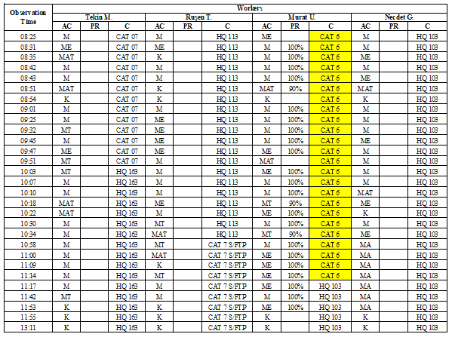

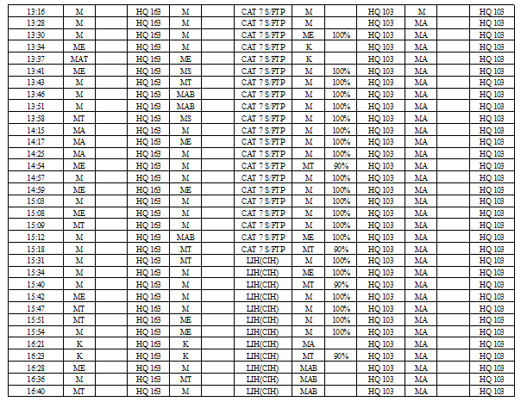

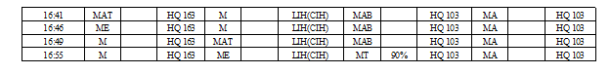

**10/02/2021**

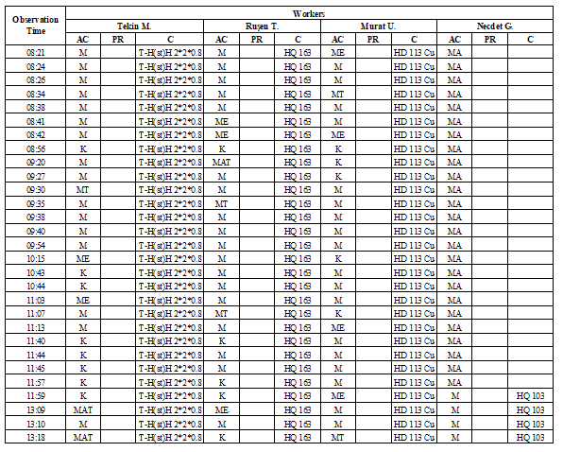

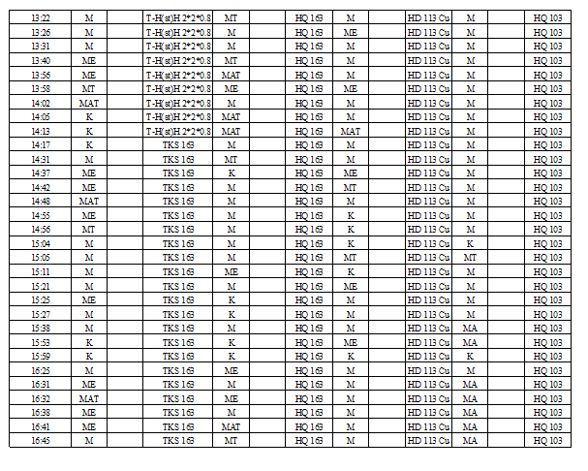

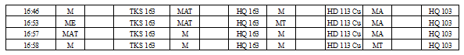

**11/02/2021**

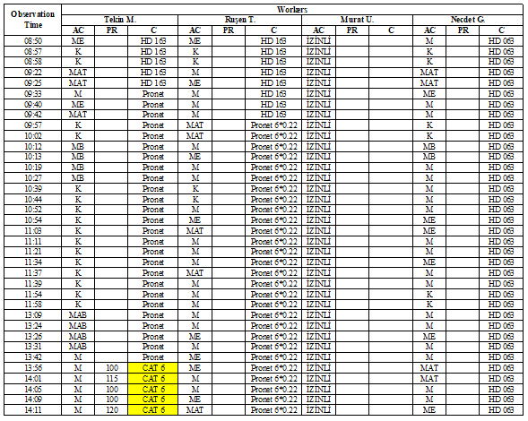

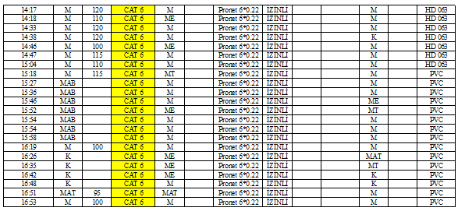

**24/02/2021**

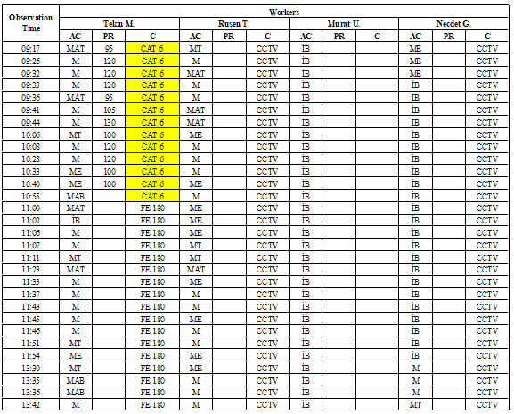

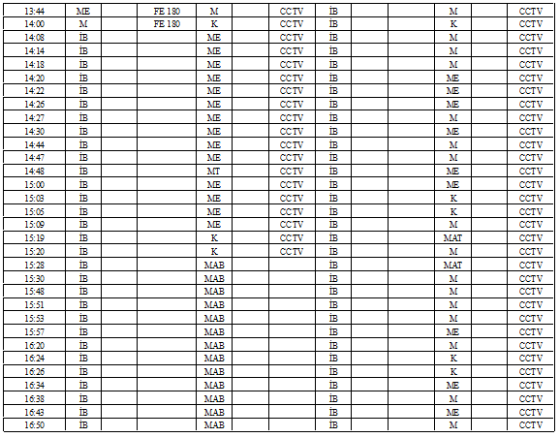

**25/02/2021**

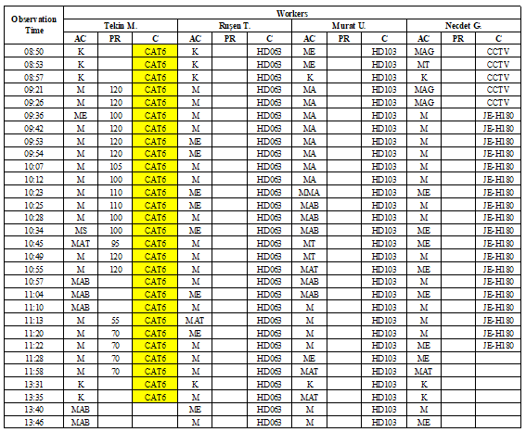



**02/03/2021**

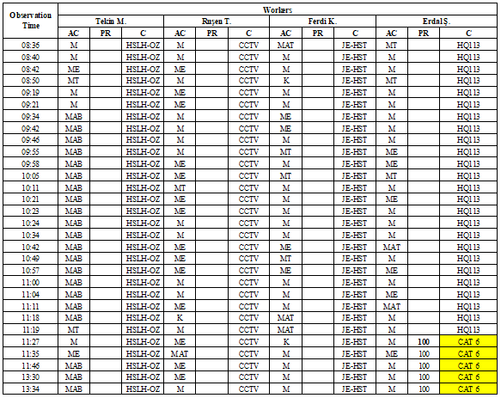

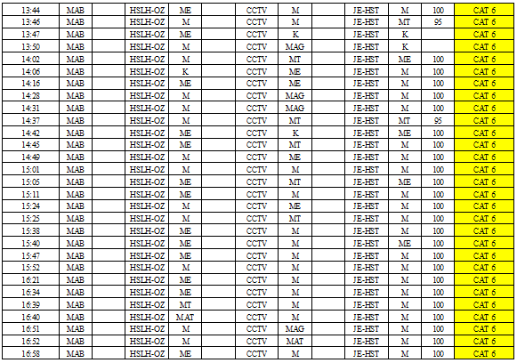

**03/03/2021**

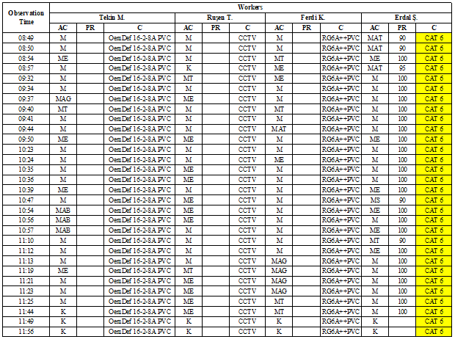

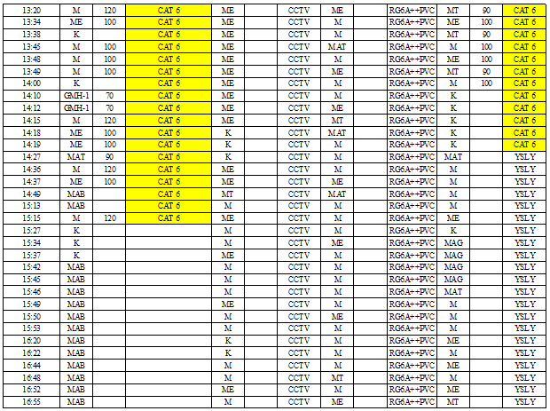

**08/03/2021**

