Name(s):

**Fill in all sections – These are today’s notes**

**Student Learning Objectives for a Shell & Tube Heat Exchanger**

1. Identify flow patterns, inlets and outlets, and regions of counter, cross, and parallel flow.
2. Understand the difference between flow area and heat transfer area.
3. Determine experimental heat transfer rates.
4. Identify geometrical parameters used in heat-transfer correlations.
5. Determine the Reynolds number for the tube and shell sides.
6. Understand competing effects of design parameters on performance, including baffle spacing.
7. Calculate a correlated heat transfer coefficient and understand why it differs from a measured value.

**Before Starting the Digital Experiment**

Assuming hot fluid on the tube side and cold on the shell side, draw the expected flow patterns on the LCDLM cartridge using dry erase markers. Copy them onto the schematic labeling inlets and outlets of hot and cold fluids.

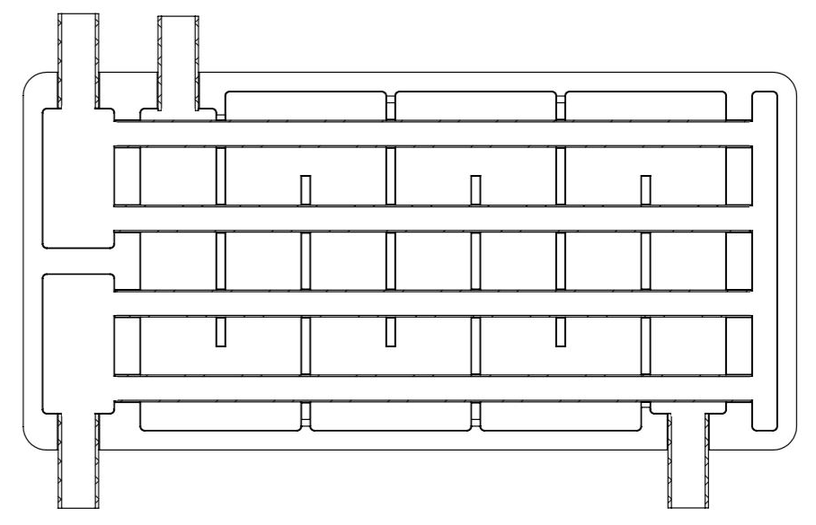

**Determine and record the following quantities, based on your LCDLM**

Number of tubes: Number of baffles: 

Number of tube passes: Number of shell passes: 

**Understanding Flow Paths and Measuring Heat Transfer Rate/Heat Duty**

***Experiment 1***

1. Assemble your LCDLM according to the set-up video and fully open both inlet valves.
2. Fill the inlet beakers, tube side with hot water and shell side with cold water.
3. Record temperatures of the *cold*, then hot water in Table 1.
4. Turn on both pumps simultaneously. When *hot and cold water reach the outlet beakers*, ***start a timer***
5. ***Before*** the inlet beakers are empty, turn off the pumps and ***stop timing*** simultaneously.
6. Measure and record the temperatures of the *hot*, then cold water *immediately after flow is stopped*.
7. Measure and record the volume of water in the hot and cold *outlet* beakers.

Table 1. Experimental data.

| Expt. # | Tube Side (Hot) | | | Shell Side (Cold) | | | time (s) |
| --- | --- | --- | --- | --- | --- | --- | --- |
| (°C) | (°C) | V (mL) | (°C) | (°C) | V (mL) |
| 1 |  |  |  |  |  |  |  |

1. If needed, **update your diagram on page 1** with the correct flow patterns for the hot and cold fluid.

***Experiment 2: Effect of Temperature Driving Force on Heat Transfer Rate***

1. Pour the water from the outlet beakers back into the corresponding hot and cold inlet beakers.
2. Repeat steps c-g of Experiment 1 and record results in Table 2

Table 2. Experimental data.

| Expt. # | Tube Side (Hot) | | | Shell Side (Cold) | | | time (s) |
| --- | --- | --- | --- | --- | --- | --- | --- |
| (°C) | (°C) | V (mL) | (°C) | (°C) | V (mL) |
| 3 |  |  |  |  |  |  |  |

**Driving Force for Heat Exchange**

1. The heat transfer rate depends on the ***temperature difference between the hot and cold fluids***. Describe how the temperature difference between the hot and cold fluid changed from Experiment 1 to Experiment 2.



1. Was the temperature change of the cold fluid (difference between outlet and inlet temperature) higher in Experiment 1 or Experiment 2?



1. The experimental heat transfer rate can be calculated with an energy balance on the cold fluid, shown below, where is the mass flow rate of the cold water, the heat capacity, and the temperature difference between the cold outlet and inlet fluid.
2. Based on your answers to Questions 2 and 3 and considering the energy balance equation above, what is the relationship between the heat transfer rate () and the temperature difference between the hot and cold fluids? Does a higher temperature difference result in a higher or lower heat transfer rate?



**Heat Exchanger Flow Patterns**

In the shell and tube heat exchanger, three types of flow occur:

1. Parallel flow: hot and cold fluid flow in ***same*** direction.
2. Counter flow: hot and cold fluid flow in ***opposite*** direction.
3. Cross flow: cold fluid flows ***perpendicular*** to hot fluid.
4. Refer to your LCDLM and the image below. For each of the circled regions, identify whether parallel, counter, or cross flow is occurring. *Hint: trace the paths of the hot and cold fluid through the exchanger.*













**Flow Areas in the Heat Exchanger**

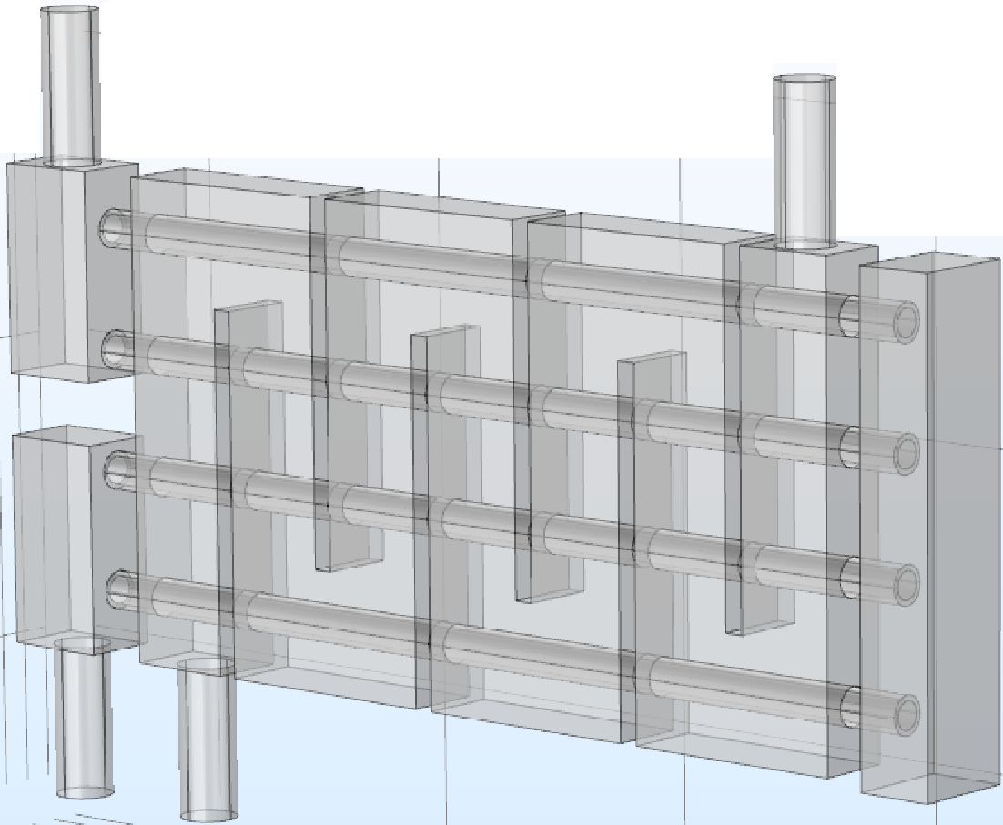

1. Referencing the schematic above and the diagram below, write a formula for the *cross flow area*, (represented by diagonal lines), on the shell side. Blue arrows represent cold water flow direction.

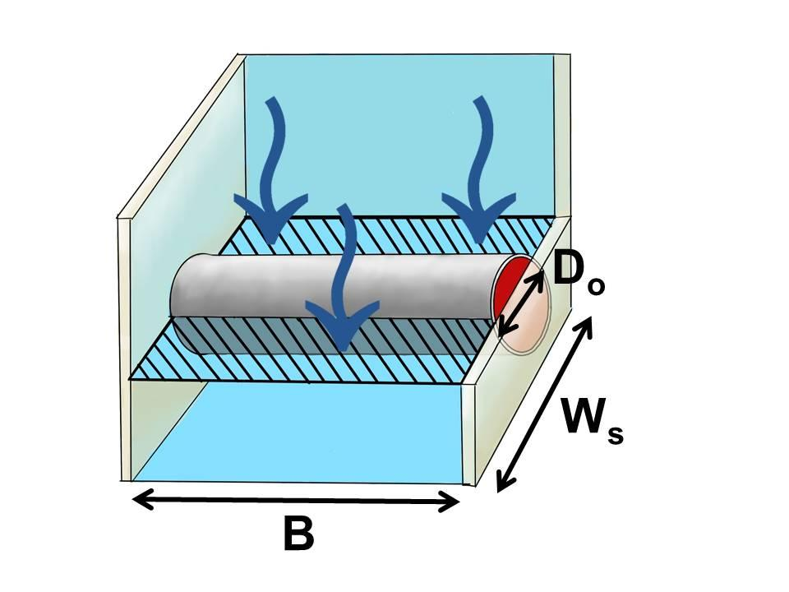





1. Referencing the schematic below, write a formula for *baffle window* *flow area, Ab* (represented by diagonal lines),on the shell side.

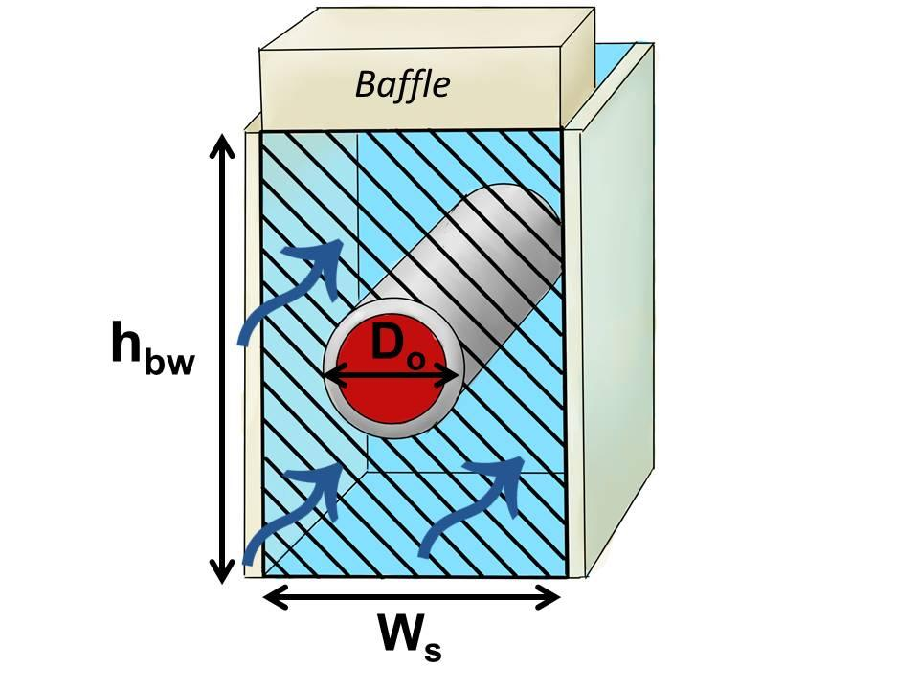



**Determining the Theoretical Heat Transfer Rate**

We can calculate ***theoretical*** overall heat transfer rate using a correlated heat transfer coefficient (*Uo*), the area available for heat transfer (, the log mean temperature difference (, and a correction factor (F).

1. Why must we include a correction factor, , for the log mean temperature difference. Hint: consider how changing flow patterns in Question 6 affect heat transfer. Also, look at the LCDLM and consider how cold fluid on the shell side passes tubes containing differing temperature hot fluid as the cold fluid flows across the two passes of tubes.



1. What area is used for? How is this different than the areas in Questions 7 and 8? Consider where heat transfer from the hot to cold fluid occurs.



1. The overall heat transfer coefficient, *Uo*, depends on individual shell and tube side heat transfer coefficients which ***increase with Reynolds number***. Looking at the LCDLM, how will decreasing the baffle spacing, B, affect the shell side Reynolds number and heat transfer rate?



1. From your experimental data, how will you determine the velocity used to calculate the tube-side Reynolds number? Consider that flow is split between two tubes per pass.



1. In determining the velocity for the shell side Reynolds number you divide volumetric flow rate by a cross sectional area. Considering your answers to questions 7 and 8, why must we use an average velocity? Is the cross sectional area on the shell side constant?



**Homework Problems** Due:

**Reference Information for Shell and Tube Heat Exchanger DLM**

* Tube length: L = 138 mm
* Tube type: ¼” BWG No. 20
* Tube dia. outer, *Do* = 6.35 mm (0.25 in)
* Tube dia. inner, *Di* = 4.572 mm (0.18 in)
* Tube material: stainless steel 304
* Number of tube passes, Np = 2
* Baffle thickness: 2 mm
* Number of tubes per pass, Nt = 2
* Baffle spacing: B = 18 mm
* Shell width: Ws = 10 mm
* Shell height: 82 mm
* Baffle window height: hbw = 21 mm

**Experimental Heat Duty**

* + - 1. Calculate the rate of heat rejection for the hot fluid () and the rate at which the cold fluid receives heat () using your experimental data for Experiments 1 and 2. All physical properties should be calculated at the average fluid temperature.

| Expt. # | h [*W*] | c [*W*] |
| --- | --- | --- |
| 1 |  |  |
| 2 |  |  |

* + - 1. Compare the heat rejection rate of the hot fluid for Experiments 1 and 2. Which is highest and why?

**Predicted Heat Transfer Rate**

* + - 1. Calculate the tube side heat transfer coefficients for your experimental conditions. The velocity, of the fluid through tube can be found as follows:

The Reynolds number can be found with the equation below:

The tube side heat transfer coefficient can be found using the Sieder-Tate correlation for the Nusselt number (neglecting viscosity differences between the fluid at the wall and the bulk fluid):

| Expt. # | Tube Side | | |
| --- | --- | --- | --- |
|  |  |  |
| 1 |  |  |  |
| 2 |  |  |  |

* + - 1. Calculate the shell side heat transfer coefficients for your experimental conditions.

where:

The weighted average mass velocity, defined below, is used in the shell side Reynolds number:

| Expt. # | Shell Side | | |
| --- | --- | --- | --- |
|  |  |  |
| 1 |  |  |  |
| 2 |  |  |  |

5. Calculate the log mean temperature difference () and the heat transfer areas using the formulas below:

| Expt. # | [*°C*] |  |  |
| --- | --- | --- | --- |
| 1 |  |  |  |
| 2 |  |

6. Using the figure below and your experimental temperature differences, determine, (the log mean temperature difference correction factor) for each experiment

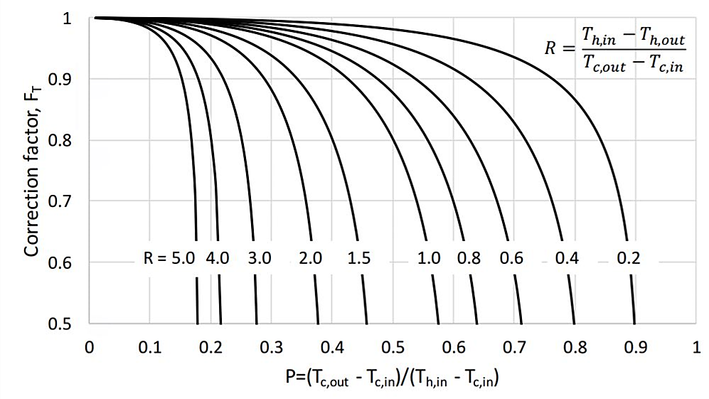

| Expt. # |  |
| --- | --- |
| 1 |  |
| 2 |  |

7. Calculate the theoretical and experimental overall heat transfer coefficients for each experiment using the formulas below.

| Expt. # |  |  |
| --- | --- | --- |
| 1 |  |  |
| 2 |  |  |

8. Compare the predicted heat transfer rate to the measured heat transfer rate for each experiment. If the values do not agree, list some possible reasons.

| Expt. # |  |  |
| --- | --- | --- |
| 1 |  |  |
| 2 |  |  |

Reasons for difference in predicted vs. measured heat transfer rate. Hint: consider temperature driving force issues and evaportative cooling effects as hot fluid exits the DLM into the beaker.

**Conceptual Question**

9. What is the purpose of including baffles on the shell side of the heat exchanger? Consider the effects on velocity, Reynolds number, turbulence, and elimination of flow channeling on the shell side in the heat exchanger.