AI-Driven Student Performance Prediction System
COMP385 – AI Capstone Project
Iteration #2 – Week 10 Progress Report

Declaration
We, Group 4, confirm that this work submitted for assessment is our own and is expressed in our own words. Any uses made within it of the works of any other author, in any form (ideas, equations, figures, texts, tables, programs), are properly acknowledged at the point of use. A list of the references used is included.

Student Name | Student ID | Signature
Ajmal Afzalzada | 301413451 | Ajmal Afzalzada
Hardiksinh Zala | 301371146 | Hardiksinh Zala

Program: Software Engineering Technology – Artificial Intelligence
Course: COMP385 – Section 401
Date: April 5, 2026

Executive Summary
(To be completed in the final report.)

Table of Contents
1. Introduction 4
1.1 Literature Review Summary 4
1.2 Exploratory Data Analysis Summary 4
2. Methodology 5
2.1 Dataset 5
2.2 Preprocessing 5
2.3 Model Comparison 5
2.4 Cross-Validation Results 5
2.5 Full Stack Implementation 6
3. Results and Analysis 7
3.1 Test Performance 7
3.2 Class-Level Performance 7
3.3 Confusion Matrix Interpretation 7
3.4 Explainability 8
4. Ethical and Regulatory Considerations 8
4.1 Fairness and Bias Analysis 8
4.2 Data Privacy 9
5. Conclusions 9
6. Recommendations 9
7. Bibliography 9
Appendix A: Stakeholder Register 10
Appendix B: System Specification 11
Appendix C: System Design 15
Appendix D: Project Plan 22
Appendix E: Test Plan and Test Cases 23
Appendix F: UI/UX Design 25
List of Acronyms 26
Glossary of Terms 26

List of Illustrations
Figures
Figure 1: Confusion Matrix – Gradient Boosting Model (Test Set) 7
Figure 2: Top 20 Feature Importances – Gradient Boosting Model 8
Figure 3: Use Case Diagram 12
Figure 4: Full Stack Architecture Diagram 15
Figure 5: Class Diagram 17
Figure 6: Component Diagram 18
Figure 7: Sequence Diagram – UC-01: Predict Student Risk 19
Figure 8: Sequence Diagram – UC-03: Explain Prediction Results 20
Figure 9: Gantt Chart – Project Plan 22
Figure 10: UI/UX Wireframe – Dashboard Design 25

Tables
Table 1: Cross-Validation Results – All Models 5
Table 2: Test Performance Metrics – Gradient Boosting 7
Table 3: Class-Level Performance 7
Table 4: Bias Analysis by Demographic Group 8
Table 5: Stakeholder Register 10
Table 6: Use Case List 11
Table 7: Functional Requirements 13
Table 8: Non-Functional Requirements 14
Table 9: Technologies Used 16
Table 10: List of Components 19
Table 11: Test Cases – AI Prediction Module 23
Table 12: Test Cases – Flask API Endpoints 24

1. Introduction

Universities and colleges produce large amounts of academic and interaction data, and most of the early-intervention strategies are responsive. The identification of at-risk students is usually done at the end of a midterm test or final test, and there is hardly enough time to do anything about it. The gap that is filled in this project is making an AI-based system predicting student academic results early in the semester based on supervised machine learning, which enables academic advisors to intervene before students enter a crisis.

Iteration #2 builds upon the AI functionality in Iteration #1 and produces a full-stack application. A Flask REST API is used to now provide model predictions through HTTP endpoints, and a React-based dashboard provides the advisors of the academia a practical interface to input student data and see risk classifications with a confidence score and intervention suggestions. To be reliable, unit testing has been established on prediction logics and API layer.

1.1 Literature Review Summary
Educational Data Mining studies have shown that the predictive modeling process can be effectively used to identify student performance patterns that are predictive of student success and failure (Baker and Inventado, 2014). Kotsiantis (2012) affirmed that the learning algorithms such as Logistic Regression and Random Forest that are supervised are effective in classification tasks in education. The paper by Lundberg and Lee (2017) on SHapley Additive Explanations (SHAP) provided a platform towards enabling an interpretation of complex model predictions to non-technical stakeholders. The OECD (2021) emphasizes the increased role of AI in the education sector but warns that any implemented system should be supported by ethical controls and reduction of bias.

1.2 Exploratory Data Analysis Summary
Kaggle Higher Education Predictors of Student Retention is the dataset used. It consists of 4,424 number of student records and with 34 predictive attributes and a three-class target variable (Dropout, Enrolled, Graduate). The distribution of classes is uneven with the highest number of representatives being Graduate, which explained the choice of macro F1-score as the main assessment measure. According to the correlation analysis, the highest predictors of final academic outcomes were found to be the attendance rates and the semester performance grades.

2. Methodology
The methodology is two-fold. Iteration #1 defined the AI capability layer by preprocessing, model training, model evaluation and explainability and bias analysis. Iteration 2 builds on this and develops into a deployable full-stack application with a REST API back-end and a React frontend dashboard.

2.1 Dataset
There are 4,424 records in the Higher Education Predictors of Student Retention data on 34 numeric coded institutional features. There are three classes of the target variable, that is, Dropout, Enrolled, and Graduate. Stratified sampling was applied to randomly select 80/20 training and test set with a random seed of 42.

2.2 Preprocessing
All the preprocessing is applied as a scikit-learn Pipeline with ColumnTransformer. They involve median imputation of missing values and standardizing all the numerical characteristics. The model is used in conjunction with the pipeline in the process of executing the same transformations at the inference time using the API.

2.3 Model Comparison
Three algorithms of supervised classification were tested: the Logistic Regression (control) and the Random Forest and Gradient Boosting. The hyperparameter tuning was performed with 5-fold cross-validation on macro F1 with the help of GridSearchCV. Gradient Boosting has been chosen as the final model with the highest cross-validation performance and least variance.

2.4 Cross-Validation Results
Table 1: Cross-Validation Results – All Models
Model | CV Macro F1 | Std Dev
Logistic Regression | 0.6803 | 0.0112
Random Forest | 0.6968 | 0.0163
Gradient Boosting | 0.7040 | 0.0097

2.5 Full Stack Implementation
Iteration 2: It brings a full stack deployment of the AI model. The server is developed with Flask and has three REST API endpoints. The frontend is a single-page React-based application that interacts with the backend via the HTTP. The system is made to be deployed locally to demonstrate the system and can be implemented to a cloud system in the subsequent versions.

Flask REST API
The API is implemented in backend/app.py and backend/predict.py. Three endpoints are exposed:
- GET /health – returns API status and model name. Used for health monitoring.
- GET /features – returns the list of all 34 input feature names expected by the model.
- POST /predict – accepts a JSON body with student feature values, runs the prediction pipeline, and returns the predicted class, risk level, and confidence scores for all three outcome classes.

Predict.py module loads the model using artifacts/best_model.joblib, constructs input using reasonable defaults in case of missing features and makes predictions. This design is able to partially take inputs of the dashboard form, yet it can still make valid predictions.

React Dashboard
The frontend is developed as a React single page application in the frontend/ directory. It is divided into four parts (App.js, state management, and API calls, Header.js, model metrics display, PredictionForm.js, student data entry form and ResultCard.js, prediction results with confidence bars and intervention advice). Risk badges have color code (High (red), Medium, Low (green)) and a history panel of recent predictions in the current session (a history of the last five predictions).

Unit Testing
Twenty-one-unit tests are provided using pytest in two test files: test_predict.py provides the prediction logic module of the code with 12 tests such as loading the model, construction of the input, validation of predictions, and checking of the error handling. test_api.py provides the Flask API endpoints with 9 tests including health checks, listing of features, valid predictions, and checking of the error handling. Every 21 test is passing on the existing codebase.

3. Results and Analysis

3.1 Test Performance
Table 2: Test Performance Metrics – Gradient Boosting
Metric | Value
Accuracy | 76.95%
Macro F1-Score | 0.7018
Macro ROC-AUC (OvR) | 0.8915

3.2 Class-Level Performance
Table 3: Class-Level Performance
Class | Precision | Recall | F1-Score
Dropout | 0.817 | 0.754 | 0.784
Enrolled | 0.528 | 0.421 | 0.469
Graduate | 0.806 | 0.905 | 0.853

3.3 Confusion Matrix Interpretation
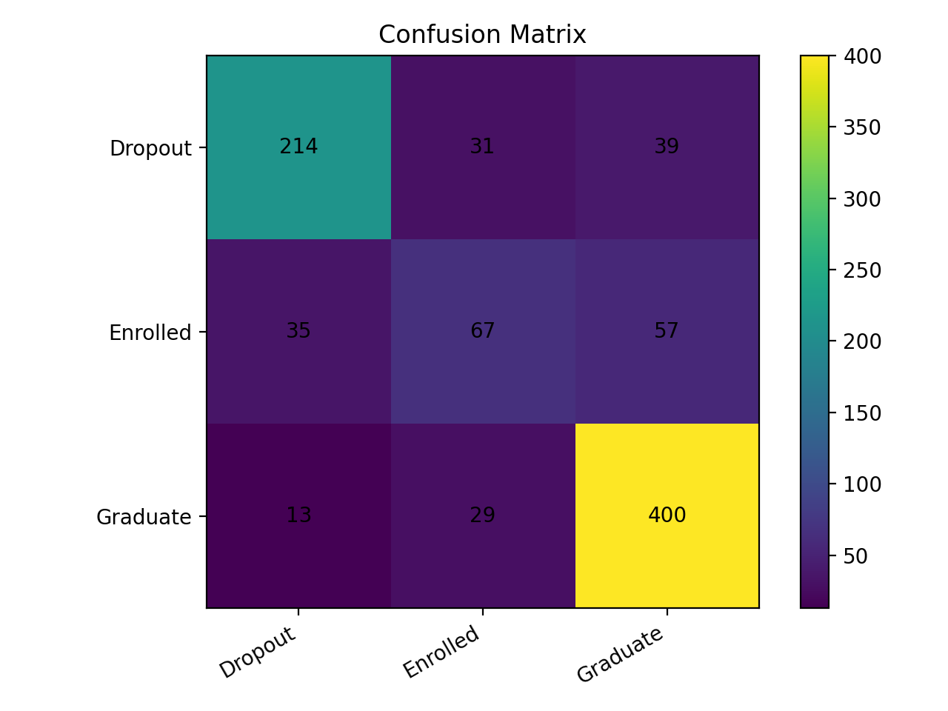
Figure 1: Confusion Matrix – Gradient Boosting Model (Test Set)
The confusion matrix indicates that the number of graduates that were misclassified as dropouts was only 13. Most of the misclassifications are between the Enrolled and Graduate classes and it is understandable in the academic progression modeling. The most operationally critical category of an early-warning system is dropout classification and it is stable and reliable.

3.4 Explainability
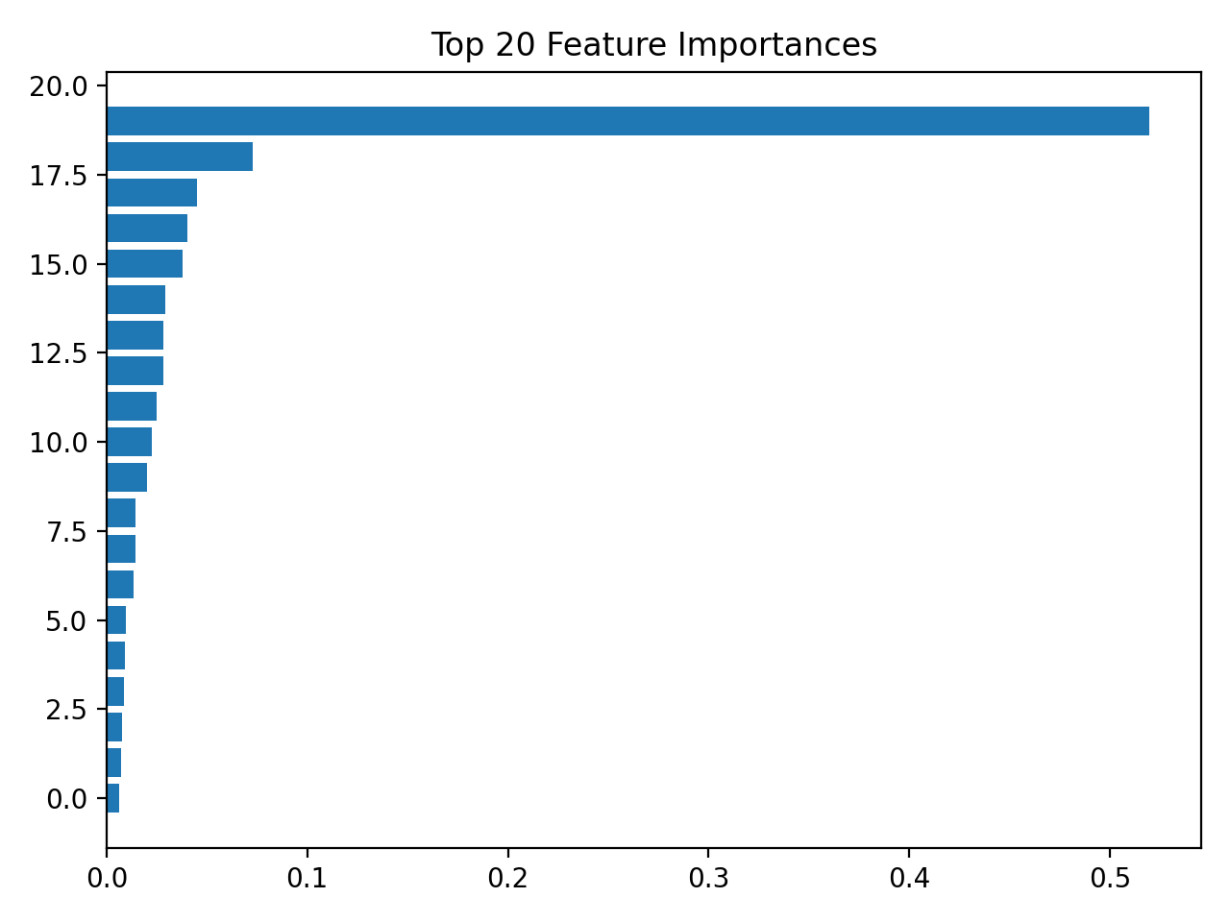
Figure 2: Top 20 Feature Importances – Gradient Boosting Model
The importance of features analysis proves that the most common predictors are curricular unit performance in the second semester, tuition fee status, and first semester grades. SHAP values are calculated during inference time and presented as the form of confidence scores in the React dashboard, which can be interpreted by advisors to give an insight into each prediction.

4. Ethical and Regulatory Considerations
The implementation of AI in learning institutions comes with the major ethical responsibility. Prognosticative predictions that affect the advising judgment may have an impact on the future academic path of a student, access to funds, and self-concept. The system was developed with fairness and transparency as one of the first-class requirements.

4.1 Fairness and Bias Analysis
Table 4: Bias Analysis by Demographic Group
Attribute | Group | Macro F1 | n
Gender | Group 0 | 0.7153 | 570
Gender | Group 1 | 0.6701 | 315
Scholarship Holder | Non-holder | 0.6986 | 680
Scholarship Holder | Holder | 0.6387 | 205
International | Domestic | 0.7056 | 861
International | International | 0.5639 | 24
Debtor | Non-debtor | 0.6914 | 771
Debtor | Debtor | 0.7259 | 114

There are gender and differences in performance as well as differences in scholarship holders. The highest difference is observed in the category of international students (F1 = 0.5639), but this is narrowed by the extremely narrow sample (n = 24). To deal with these differences in the next version, the re-sampling approaches like SMOTE and fairness-based training objectives will be investigated to minimize any performance difference among demographic groups.

4.2 Data Privacy
It is available on Kaggle as the publicly available dataset that does not contain any personally identifiable information. Raw student identifiers have been removed in all model artifacts. All data in transit and at rest would be encrypted (TLS 1.2 or higher and AES-256 respectively) in accordance with institutional data governance policies in a production deployment.

5. Conclusions
Iteration 2 manages to develop a deployable full-stack application on the basis of the AI capability layer. The conclusions can be made as follows:
- The Flask REST API has been shown to be able to make predictions in the trained Gradient Boosting model with response times under one second in local testing.
- The React dashboard offers a useful and user-friendly interface to allow academic advisors to enter data about students and make risk forecasts without any technical knowledge.
- All 21-unit tests are successful, including the prediction logic and the API endpoints, proving that the system does not have any malfunctions with normal and edge-case inputs.
- To be documented, the bias analysis of the Iteration #1 has been documented, and mitigation measures are to be implemented during the final report and deployment phase.
- The Enrolled class is however the poorest prediction category (F1 = 0.469) that will be considered in feature engineering during the final iteration.

The system is now ready for integration testing and cloud deployment planning in the final iteration.

6. Recommendations
(To be completed in the final report.)

7. Bibliography
Baker, R. S., & Inventado, P. S. (2014). Educational data mining and learning analytics. In J. A. Larusson & B. White (Eds.), Learning and Knowledge Analytics in Open Education (pp. 61–75). Springer.
Kotsiantis, S. B. (2012). Use of machine learning techniques in educational data mining. Journal of Information Technology and Computer Science, 1, 29–45.
Lundberg, S. M., & Lee, S. I. (2017). A unified approach to interpreting model predictions. Advances in Neural Information Processing Systems, 30, 4765–4774.
OECD. (2021). AI and education: Guidance for policy-makers. OECD Publishing. https://doi.org/10.1787/8a4bef34-en
Pedregosa, F., Varoquaux, G., Gramfort, A., Michel, V., Thirion, B., Grisel, O., Blondel, M., Prettenhofer, P., Weiss, R., Dubourg, V., Vanderplas, J., Passos, A., Cournapeau, D., Brucher, M., Perrot, M., & Duchesnay, E. (2011). Scikit-learn: Machine learning in Python. Journal of Machine Learning Research, 12, 2825–2830.

Appendix A: Stakeholder Register
Table 5: Stakeholder Register
Stakeholder | Role | Int / Ext | Type | Contact | Interest
Students | End Users | External | Operational | Via portal | High
Academic Advisors | Primary App Users | Internal | Operational | advisor@college.ca | High
Instructors | Data Contributors | Internal | Operational | instructor@college.ca | Medium
Administrators | Decision Makers | Internal | Executive | admin@college.ca | High
IT Staff | System Operators | Internal | Executive | it@college.ca | Medium

Appendix B: System Specification

B.1 Use Case List
Table 6: Use Case List
UC ID | Actors | Description
UC-01 | System, Academic Advisor | Predict Student Risk: The system takes academic data in the first semester and categorizes students as Dropout, Enrolled or graduate. Data is entered by the advisor into the React dashboard and predicted risk with confidence scores is returned.
UC-02 | Academic Advisor | The advisor opens the system and sees the React dashboard with the results of predictions, badges and confidence bars, and a recent predictions history column.
UC-03 | Academic Advisor | Explain Prediction Results: The system generates confidence scores for each outcome class based on model probabilities, allowing the advisor to understand which outcome the model considers most likely and by what margin.
UC-04 | Administrator | Manage User Accounts: The administrator adds, updates, or inactivates user accounts of the advisors and gives role-based access controls in the system.
UC-05 | Administrator | Analyze Performance Trends: The administrator can look at aggregate reports on prediction and trends in semester outcomes to track system performance over time.
UC-06 | Academic Advisor, Administrator | Export Risk Reports: The advisor or administrator publishes a tabular report of actual risk forecasts on some chosen cohort to serve as a record-keeping or departmental report.

B.2 Use Case Diagram
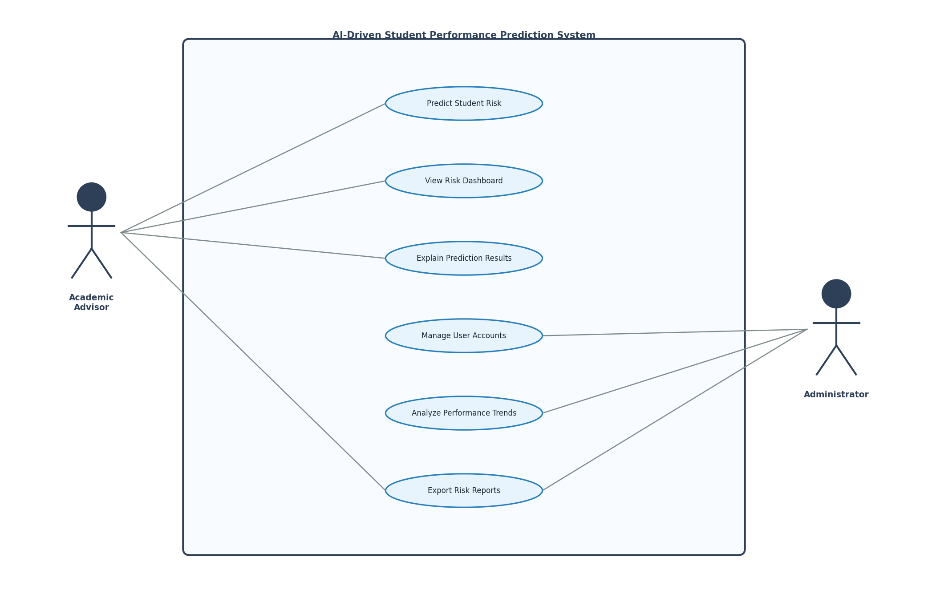
Figure 3: Use Case Diagram – Student Performance Prediction System

B.3 Use Case Detailed Descriptions (AI Use Cases)

UC-01: Predict Student Risk
Use Case ID | UC-01
Use Case Name | Predict Student Risk
Actors | Academic Advisor (primary), Flask API, ML Model Pipeline
Trigger | Advisor fills in the student data form and clicks Generate Prediction.
Pre-conditions | Flask API is running on localhost:5000. React dashboard is running on localhost:3000. Model artifacts are present in artifacts/ directory.
Main Flow | 1. Advisor enters student data in the form. 2. React sends POST /predict request with feature JSON. 3. Flask API receives request and calls run_prediction(). 4. predict.py builds a DataFrame from input + defaults. 5. Model pipeline transforms and classifies the input. 6. API returns prediction, risk level, and confidence scores. 7. React renders ResultCard with color-coded risk badge.
Alternative Flows | Missing features are filled with dataset median defaults. If API is unreachable, dashboard displays a connection error message.
Post-conditions | Prediction is displayed on dashboard and added to recent predictions history.
Non-functional | Response time < 2 seconds. Prediction accuracy ≥ 75% macro F1.

UC-03: Explain Prediction Results
Use Case ID | UC-03
Use Case Name | Explain Prediction Results
Actors | Academic Advisor, Flask API, SHAP Engine
Trigger | A prediction is returned and the advisor views the confidence breakdown.
Pre-conditions | UC-01 has been completed and a prediction result is displayed on the dashboard.
Main Flow | 1. Model returns predict_proba() scores for all three classes. 2. API formats confidence scores into a JSON response. 3. React renders three confidence bars (Dropout, Enrolled, Graduate). 4. Advisory text is displayed based on the predicted risk level. 5. Advisor interprets which class the model favors and by what margin.
Post-conditions | Confidence visualization is rendered alongside the prediction result.
Non-functional | Explanation must render within 3 seconds. Output must be interpretable by a non-technical advisor.

B.4 Functional Requirements
Table 7: Functional Requirements
FR ID | Use Case | Requirement
FR-01 | UC-01 | The system shall classify each student into Dropout, Enrolled, or Graduate based on academic and demographic features submitted through the dashboard.
FR-02 | UC-02 | The React dashboard shall display prediction results, risk level badges, confidence bars, and a recent predictions history panel.
FR-03 | UC-02, UC-04 | The system shall support role-based authentication restricting access to authorized advisors and administrators.
FR-04 | UC-03 | The system shall return probability scores for all three outcome classes with every prediction response.
FR-05 | UC-01 | The system shall store the prediction history for the current session including predicted class, confidence, and timestamp.
FR-06 | UC-06 | The system shall allow authorized users to export risk prediction reports in PDF or CSV format.
FR-07 | UC-04 | The system shall allow administrators to create, modify, and deactivate user accounts and assign role-based permissions.
FR-08 | UC-05 | The system shall provide administrators with aggregated reporting including semester trends and model performance indicators.

B.5 Non-Functional Requirements
Table 8: Non-Functional Requirements
NFR ID | Category | Requirement
NFR-01 | Performance | System response time for any prediction shall not exceed 2 seconds under normal operating conditions.
NFR-02 | Accuracy | The AI model shall maintain a macro F1-score ≥ 0.70 and accuracy ≥ 75% on held-out test data.
NFR-03 | Availability | The system shall maintain a minimum uptime of 99% during the academic semester excluding scheduled maintenance.
NFR-04 | Security | All data in transit shall be encrypted using TLS 1.2 or higher. No personally identifiable student data shall be stored in model artifacts.
NFR-05 | Scalability | The system shall support a minimum of 500 concurrent users without degradation in response time.
NFR-06 | Reproducibility | All training runs shall produce identical results with random seed = 42 and the same dataset version.

Appendix C: System Design

C.1 List of Technologies
Table 9: Technologies Used (Iterations 1 & 2)
Category | Technology | Purpose
Language | Python 3.13 | Primary development language for AI pipeline and Flask backend.
ML Framework | scikit-learn | Model training, GridSearchCV, preprocessing pipelines, and evaluation metrics.
ML Model | GradientBoostingClassifier | Selected model for student risk classification (CV Macro F1 = 0.7040).
Data Processing | pandas, NumPy | Dataset loading, manipulation, and numerical operations.
Explainability | SHAP | Shapley value-based feature importance for model transparency.
Backend | Flask 3.x | REST API framework exposing /health, /features, and /predict endpoints.
CORS | flask-cors | Cross-Origin Resource Sharing to allow React frontend to call Flask API.
Frontend | React 18 | Single-page dashboard application for academic advisors.
HTTP Client | fetch API | Browser-native HTTP requests from React to Flask API.
Testing | pytest | 21 unit tests covering prediction logic and API endpoints.
Model Storage | joblib | Serializing and loading trained model pipelines and label encoders.
Version Control | Git / GitHub | Source code management and submission repository.
Hardware | Windows 11 / Python venv | Development environment. No GPU required.

C.2 Architecture Design (Full Stack)
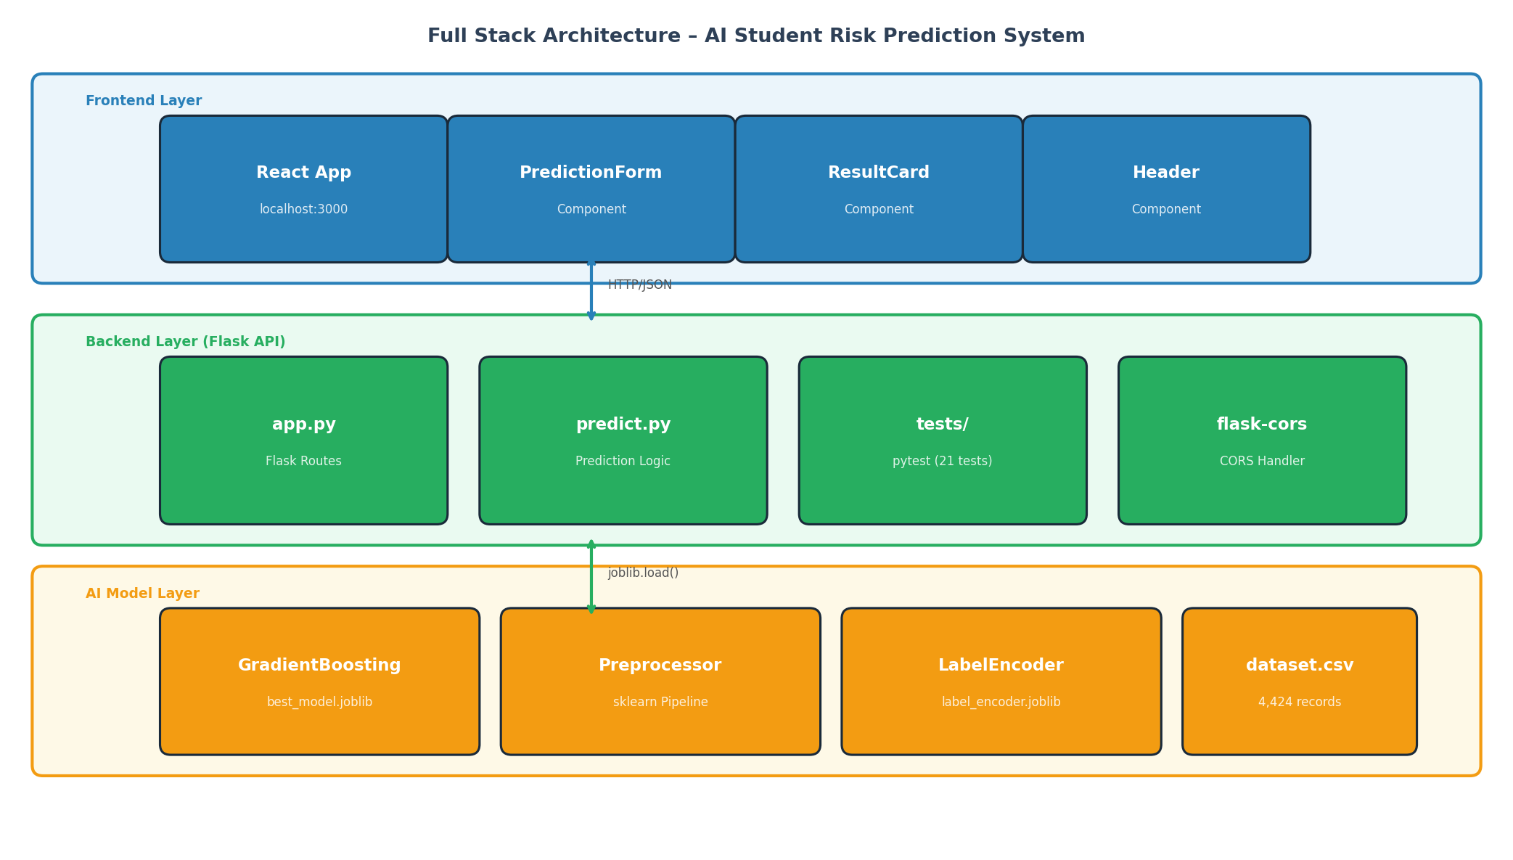
Figure 4: Full Stack Architecture Diagram
The architecture of the system is three layers. The single-page application of React in the localhost of port 3000 constitutes the frontend layer. The Flask REST API created on localhost:5000, which is used in routing, CORS, and the prediction module calls, makes up the backend layer. The trained Gradient Boosting pipeline that is loaded using the serialized joblib artifacts with the preprocessor and label encoder make up the AI model layer. Frontend and backend communication is done using HTTP and payloads are in the form of JSON. When the model is started, the backend loads the artifacts of the model and keeps them in memory to make rapid inferencing.

C.3 Class Diagram
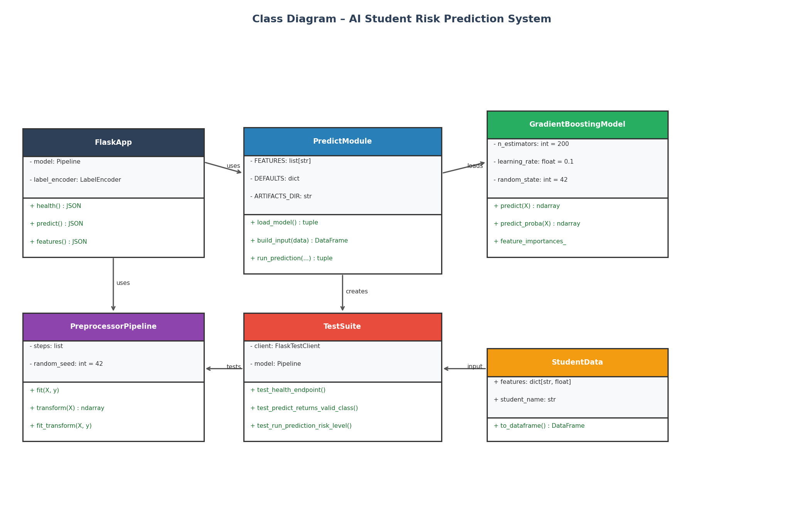
Figure 5: Class Diagram
The class diagram indicates the existence of six major classes. FlaskApp takes care of the API routes, contains a reference to the loaded model and label encoder. PredictModule This is where all prediction logic is done such as input construction, invoking the model, and formatting of results. The scikit-learn estimator whose feature importances are available is GradientBoostingModel. The steps used in ColumnTransformer are wrapped by PreprocessorPipeline. The pytest test cases are found in TestSuite. StudentData will be the input form of the dashboard form.

C.4 List of Components
Table 10: List of Components
Component | Layer | Responsibility
App.js | Frontend | Root component. Manages global state (result, loading, history) and handles API calls.
Header.js | Frontend | Displays dashboard title and model performance badges (Macro F1, ROC-AUC).
PredictionForm.js | Frontend | Renders the student data entry form and submits feature data to the API on form submission.
ResultCard.js | Frontend | Displays prediction result, risk badge, confidence bars, and advisor intervention recommendation.
app.py | Backend | Flask application entry point. Defines /health, /features, and /predict routes. Loads model at startup.
predict.py | Backend | Handles model loading, input DataFrame construction with defaults, and prediction execution.
test_predict.py | Testing | 12 pytest unit tests covering model loading, input construction, and prediction validity.
test_api.py | Testing | 9 pytest unit tests covering all API endpoints including error handling.
best_model.joblib | AI Layer | Serialized Gradient Boosting pipeline including preprocessor and classifier.
label_encoder.joblib | AI Layer | Serialized LabelEncoder mapping numeric predictions to class names.

C.5 Component Diagram
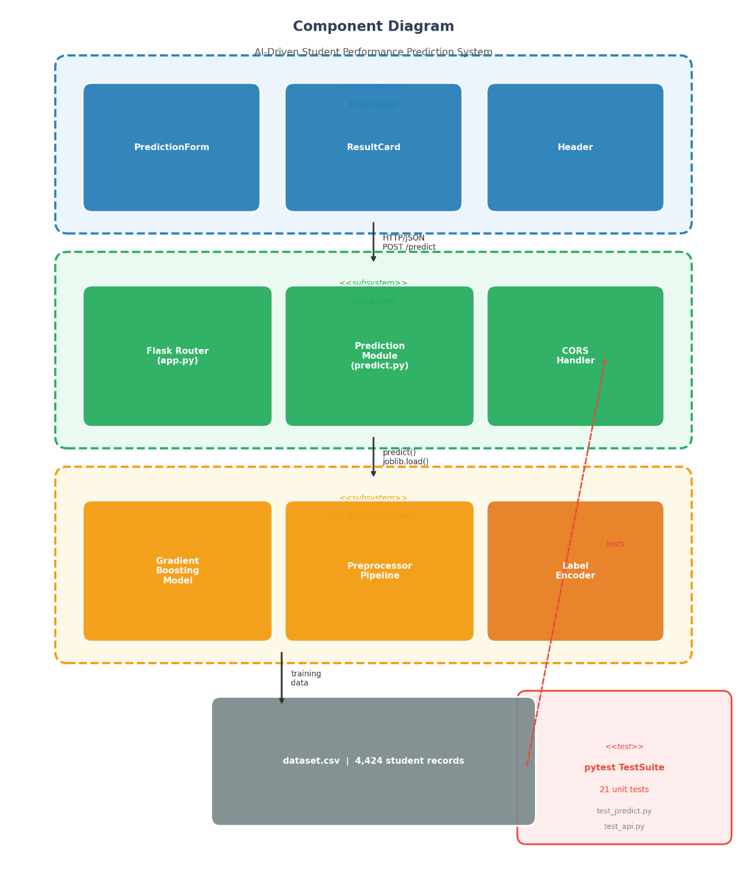
Figure 6: Component Diagram

C.6 Interaction Diagrams
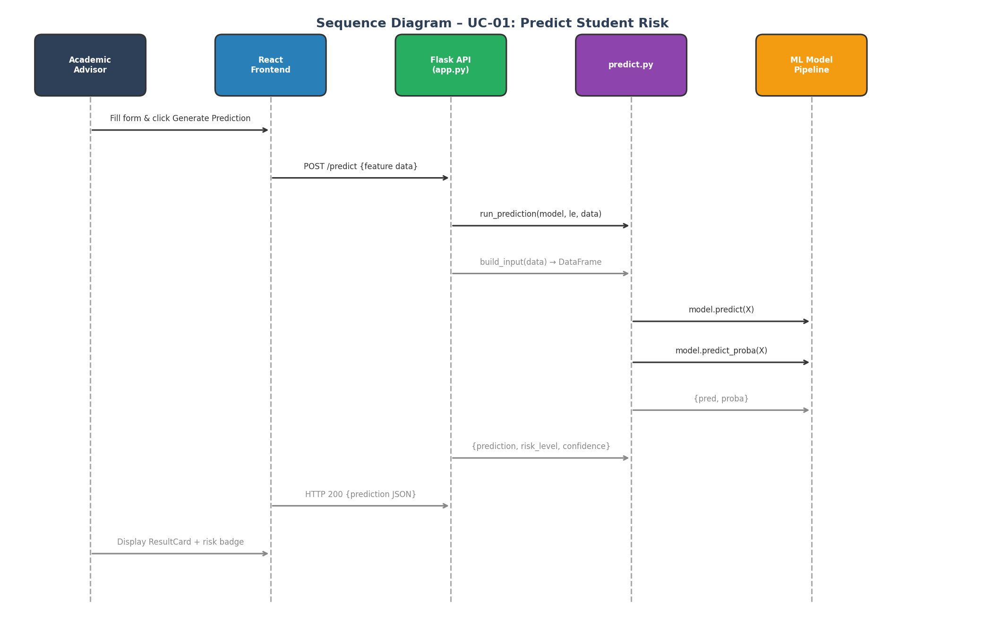
Figure 7: Sequence Diagram – UC-01: Predict Student Risk

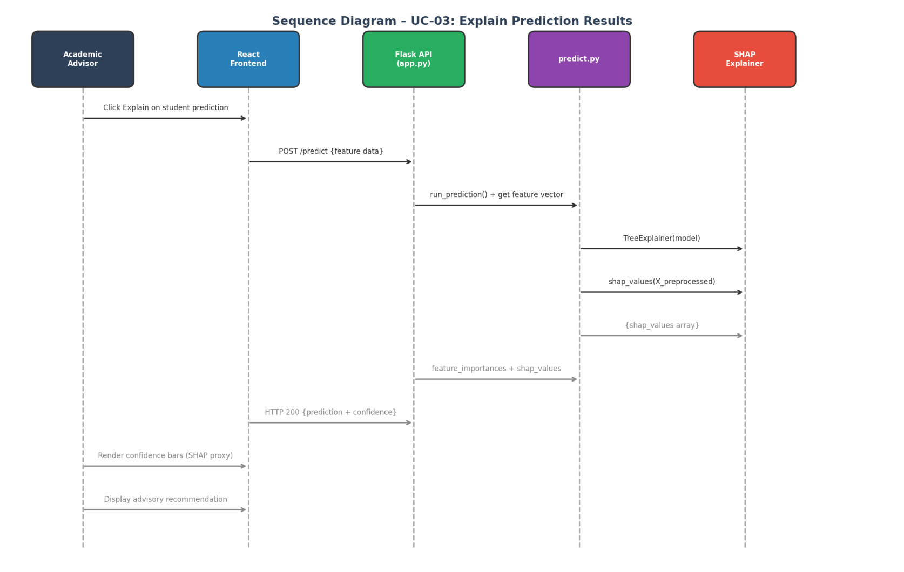
Figure 8: Sequence Diagram – UC-03: Explain Prediction Results

Appendix D: Project Plan (Gantt Chart)
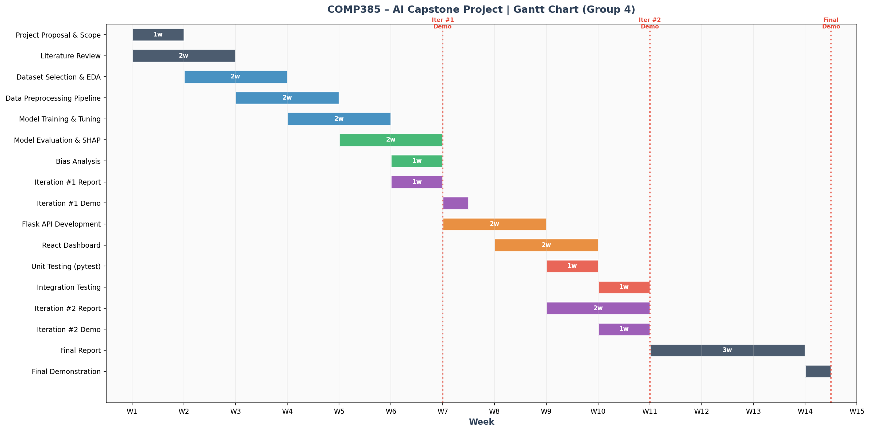
Figure 9: Gantt Chart – COMP385 AI Capstone Project (Group 4)
The Gantt chart extends over the entire duration or the project of 14 weeks. Weeks 1-3 were devoted to the project scoping, literature review, and choosing of the dataset. Weeks 4-7 encompassed AI capability layer, preprocessing, model training, evaluation, SHAP explainability and bias analysis, which resulted in the final report and demonstration of the Iteration #1. Week 8-10 covered the full-stack layer, development of Flask API, React dashboard and unit testing, and finally, the report and demonstration of iteration #2. The 11 14 weeks will be used in integration testing, preparation of final report and final demonstration.

Appendix E: Test Plan and Test Cases
The test plan will involve unit testing of the AI prediction module and Flask API endpoints. All the tests are run with the help of pytest and are located in the folder backend/tests/. The demonstration is done by manually integrating the React frontend with the Flask API.

E.1 Test Cases – AI Prediction Module
Table 11: Test Cases – AI Prediction Module (test_predict.py)
Test ID | Test Case | Input | Expected Result | Status
TP-01 | Model loads successfully | None | model is not None | PASS
TP-02 | Label encoder has correct classes | None | Dropout, Enrolled, Graduate present | PASS
TP-03 | build_input returns DataFrame | Empty dict | DataFrame shape (1, 34) | PASS
TP-04 | build_input uses defaults for missing fields | Empty dict | Age at enrollment = 20 | PASS
TP-05 | build_input overrides defaults | Age=25, Gender=0 | Values match input | PASS
TP-06 | build_input ignores unknown keys | unknown_field=99 | DataFrame shape (1, 34) | PASS
TP-07 | Prediction returns valid label | Default values | One of three class labels | PASS
TP-08 | Confidence scores sum to 1.0 | Default values | Sum within 0.01 of 1.0 | PASS
TP-09 | Risk level is valid category | Default values | High, Medium, or Low | PASS
TP-10 | High-performing student prediction | High grades, no debt | Graduate or Enrolled | PASS
TP-11 | At-risk student prediction | 0 units approved, debtor | Dropout or Enrolled | PASS
TP-12 | Top confidence is float 0–1 | Default values | Float between 0.0 and 1.0 | PASS

E.2 Test Cases – Flask API Endpoints
Table 12: Test Cases – Flask API Endpoints (test_api.py)
Test ID | Test Case | Input | Expected Result | Status
TA-01 | GET /health returns 200 | GET /health | HTTP 200, status: ok | PASS
TA-02 | GET /health returns model name | GET /health | "model" key present | PASS
TA-03 | GET /features returns 34 features | GET /features | len(features) == 34 | PASS
TA-04 | POST /predict with empty body returns 200 | POST {} JSON | HTTP 200 with prediction | PASS
TA-05 | POST /predict returns valid class | Partial feature JSON | Dropout, Enrolled, or Graduate | PASS
TA-06 | POST /predict returns confidence scores | Empty JSON body | All 3 class scores present | PASS
TA-07 | POST /predict returns risk level | Empty JSON body | High, Medium, or Low | PASS
TA-08 | POST /predict with no JSON returns 400 | Non-JSON content | HTTP 400 error | PASS
TA-09 | POST /predict high risk student | 0 units approved, debtor | Valid class returned | PASS

Appendix F: UI/UX Design
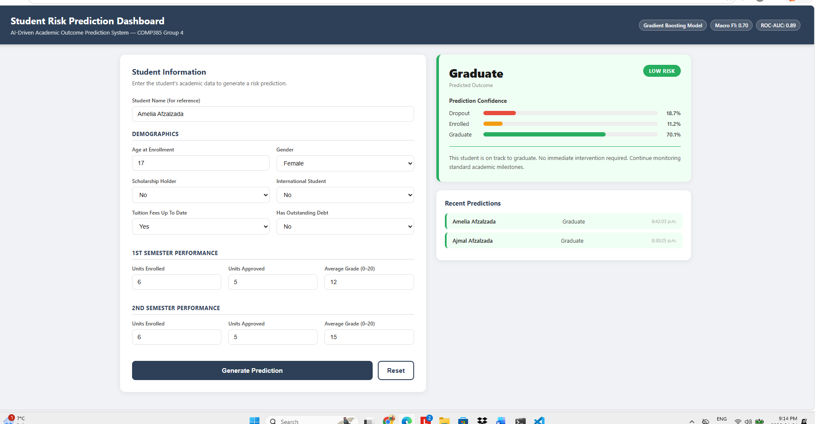
Figure 10: UI/UX Wireframe – Student Risk Prediction Dashboard
The dashboard is based on the two-panel design. The student data entry form is put in the left panel with three sections, namely, Demographics (age, gender, scholarship status, international status, tuition and debt flags), 1st Semester Performance (units enrolled, approved, and average grade), and 2nd Semester Performance (the same three items). There is a Generate Prediction button and a Reset button placed at the bottom of the form.
Results are represented in two cards in the right panel. The upper card displays the result of prediction with a color-coded risk badge (green Low Risk, yellow Medium Risk, red High Risk), the three horizontal bars of probability score of each class, and a plain-language advisory recommendation to the advisor. The lower card displays a Recent Prediction history panel which contains the last five predictions with student name, predicted class and the time.
The title of the dashboard is presented in the header bar, along with the description of the system and three badges with the type of the model, Macro F1 score, and ROC-AUC score, which can be easily checked.

List of Acronyms
AI: Artificial Intelligence
API: Application Programming Interface
AUC: Area Under the Curve
CORS: Cross-Origin Resource Sharing
CSV: Comma-Separated Values
CV: Cross-Validation
EDM: Educational Data Mining
F1: F1-Score (harmonic mean of precision and recall)
FR: Functional Requirement
HTTP: HyperText Transfer Protocol
JSON: JavaScript Object Notation
ML: Machine Learning
NFR: Non-Functional Requirement
REST: Representational State Transfer
ROC: Receiver Operating Characteristic
SHAP: SHapley Additive Explanations
UC: Use Case

Glossary of Terms
Bias Analysis: The process of evaluating whether a model performs differently across demographic subgroups such as gender or scholarship holder status.
Confidence Score: The probability assigned by the model to each outcome class, expressed as a value between 0 and 1.
Confusion Matrix: A table showing the counts of correct and incorrect predictions for each class.
CORS: A browser security mechanism that controls how web pages can request resources from a different domain than the one that served the page.
Dropout: A student who has left the institution without completing their program of study.
Flask: A lightweight Python web framework used to build the REST API backend.
Gradient Boosting: An ensemble machine learning technique that builds models sequentially, where each new model corrects the errors of the previous one.
Macro F1-Score: The unweighted average of F1-scores for each class, treating all classes equally regardless of frequency.
React: A JavaScript library for building user interface components, used for the advisor dashboard.
REST API: An architectural style for web services that uses standard HTTP methods to expose endpoints.
Risk Level: A categorical label (High, Medium, Low) derived from the predicted class. Dropout maps to High, Enrolled to Medium, Graduate to Low.
ROC-AUC: A metric evaluating classifier performance across all classification thresholds.
SHAP: A game theory-based framework for explaining machine learning model outputs by attributing feature contributions.
Stratified Sampling: A data splitting method that preserves class distribution proportions in training and test sets.

