AI for Medicine – Project Report
Prof. Stefano Diciotti – University of Bologna
Academic Year: ____________________
Student Name: ______________________
Degree Program: ____________________
Submission Date: ____________________
Note: The report should be concise but complete. Typical length: 8–10 pages.

1. Project Title
Enter a clear and descriptive title.
Stroke Prediction from Tabular Health Records: a Comparison of Four Supervised Classifiers under Severe Class Imbalance

2. Problem Statement
Describe the medical or biological problem addressed by this project. Why is it relevant? What is the scientific or clinical motivation?
Stroke is the second leading cause of death worldwide and a major cause of long-term disability. Early identification of patients at elevated risk is therefore of clear clinical value: it enables targeted lifestyle counselling, closer follow-up and, when indicated, prophylactic pharmacological treatment. The variables routinely collected during a general check-up — age, blood pressure, glucose level, BMI, smoking history — are precisely the ones used in this study, which makes such a model attractive for primary-care screening rather than for in-hospital decision support.

3. Objective of the Study
State the specific objective. What are you trying to predict, classify, segment, or analyze?
The objective of this project is to build and evaluate a binary classifier that, given the tabular health record of a patient, estimates the probability that the patient will experience a stroke. Four families of supervised models — Logistic Regression, Random Forest, XGBoost and a Support Vector Machine — are compared on a held-out test set and ranked primarily by ROC-AUC, with PR-AUC and recall used as secondary criteria given the strong class imbalance of the dataset.

4. Dataset Description
Name and source of the dataset (e.g., MedMNIST, PhysioNet, Kaggle).
- Number of samples
- Type (image, signals, tabular data) and description of data
- Available labels (diagnosis, classes, target variables)
- Issues such as class imbalance or noise
Healthcare Stroke Dataset, publicly available on Kaggle (Fedesoriano, 2021). Tabular, one row per patient.
- Number of samples: 5110 patients.
- Number of predictors: 10 (3 continuous, 5 categorical, 2 binary).
- Target: stroke (binary, 0 = no stroke, 1 = stroke).
- Class imbalance: 4.87% of the patients are positive — a 1:19 ratio that drives every modelling decision in the rest of the report.
- Missingness: only the BMI column has missing values, affecting 3.93% of rows; all other columns are fully populated.
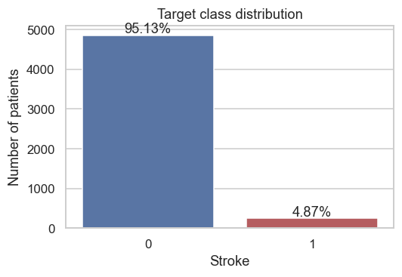

5. Data Preprocessing
Detail how the data was processed before training the model:
- Data cleaning, normalization, dimensionality reduction, etc.
All preprocessing is implemented as a scikit-learn ColumnTransformer wrapped inside a Pipeline so that it can be refit on each cross-validation fold without leaking statistics across folds.
- Patient id is dropped — it carries no clinical signal and would let tree-based models memorise rows.
- The literal string 'N/A' in the BMI column is parsed as a true missing value (NaN) at load time.
- Numerical features (age, average glucose level, BMI) are imputed with the training-fold median and then standardised; standardisation is required by Logistic Regression and SVM and is harmless for trees.
- Categorical features (gender, marital status, work type, residence, smoking status) are one-hot encoded with handle_unknown='ignore' so the model degrades gracefully on previously unseen categories.
- The two binary flags (hypertension, heart_disease) pass through the ColumnTransformer unchanged.

6. Avoiding Data Leakage
Explain how the pipeline avoids data leakage. For example:
- Proper separation of training and test data
- Feature selection and normalization are performed within the training folds
- No peeking at the test set during model design or tuning
Data leakage was prevented through three concrete design choices:
- Train/test separation. A single stratified hold-out set (20% of the data) is created at the very beginning. The test set is touched exactly once — for the final evaluation reported in Section 8 — and never used during model selection or hyper-parameter tuning.
- Preprocessing inside a Pipeline. The imputer's median and the scaler's mean/std are fit only on the training portion of each cross-validation fold. The validation fold is transformed using those statistics but never contributes to them.
- Hyper-parameter search inside the same Pipeline. GridSearchCV clones the entire Pipeline before fitting on every fold, so the preprocessing step is refit per fold rather than fit once on the whole training set.

7. Machine Learning Pipeline
- Models used (e.g., Random Forest, CNN, Logistic Regression)
- Validation techniques (e.g., k-fold, stratified hold-out)
- Evaluation metrics (accuracy, AUC, precision/recall, etc.)
- Regularization, feature selection, hyperparameter tuning
Four classifiers were compared, each wrapped in the same preprocessing Pipeline:
- Logistic Regression (L2-regularised, class_weight='balanced'): an interpretable baseline whose standardised coefficients are directly readable as risk factors.
- Random Forest (class_weight='balanced'): captures non-linear interactions and provides impurity-based feature importances.
- XGBoost (scale_pos_weight set to the negatives/positives ratio): the modern gradient-boosting baseline for tabular data.
- SVM with RBF kernel (class_weight='balanced', probability=True): a non-linear reference point.
Model selection uses 5-fold stratified cross-validation on the training set, with ROC-AUC as the inner scoring metric. The grid ranges are deliberately small because with only ~250 positive training cases, finer grids would chase noise. The reported best_cv_auc values, together with the selected hyper-parameters, are summarised in the following table.
model | best_cv_auc | best_params
LogisticRegression | 0.8392 | C=0.1
XGBoost | 0.8301 | learning_rate=0.05, max_depth=3, n_estimators=200
RandomForest | 0.8240 | max_depth=6, n_estimators=200
SVM | 0.8101 | C=0.5, gamma=scale

8. Results
Present key results (preferably in a table or with figures):
- ROC curve, confusion matrix, performance scores
- Comparison of different models, if applicable
Held-out test-set metrics for the four tuned models are reported below. ROC-AUC is the primary ranking metric; PR-AUC and recall are reported because they better reflect performance on the minority (stroke) class.
model | ROC-AUC | PR-AUC | Recall | Precision | F1
LogisticRegression | 0.8423 | 0.2648 | 0.8000 | 0.1384 | 0.2360
XGBoost | 0.8394 | 0.2507 | 0.7800 | 0.1548 | 0.2583
RandomForest | 0.8226 | 0.2359 | 0.7600 | 0.1352 | 0.2296
SVM | 0.8095 | 0.1749 | 0.7800 | 0.1331 | 0.2274
The strongest model on the test set is LogisticRegression (ROC-AUC = 0.8423, PR-AUC = 0.2648, recall = 0.8000). The ROC and PR curves below confirm that all four classifiers perform well above chance but trade precision for recall, which is the intended behaviour for a screening tool.
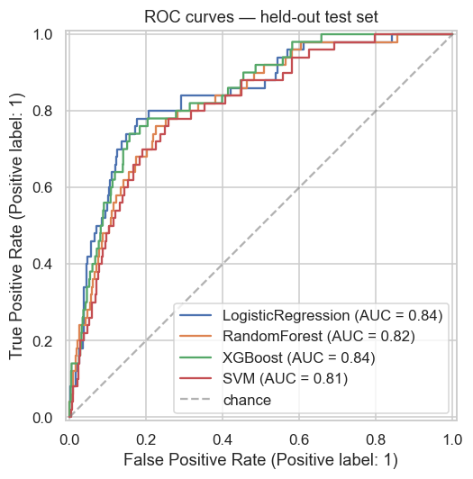
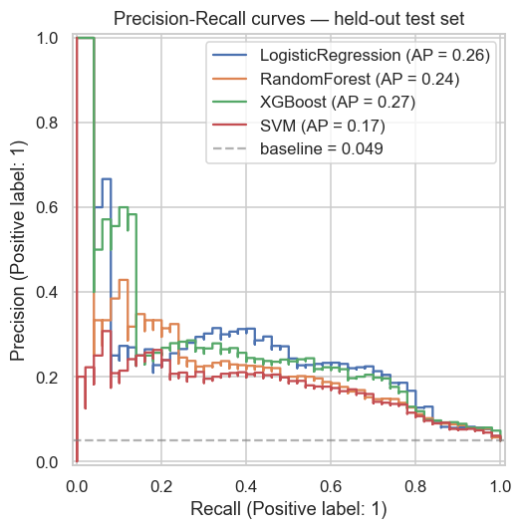
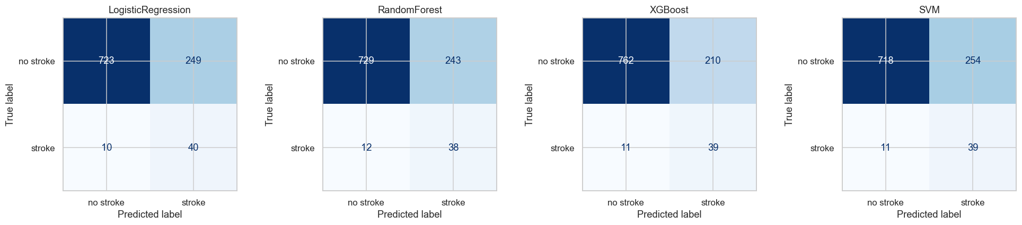
Feature importances and Logistic Regression coefficients agree on age as the dominant predictor, followed by average glucose level and the hypertension / heart-disease flags.
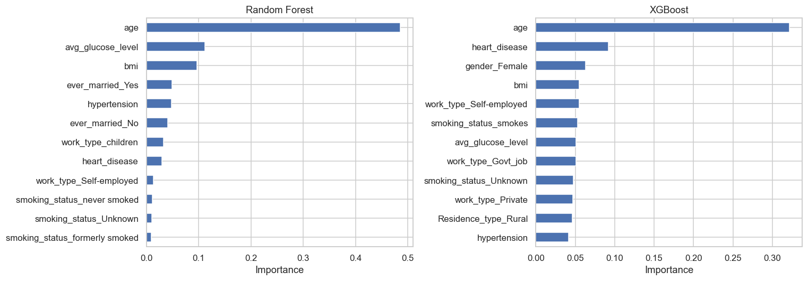
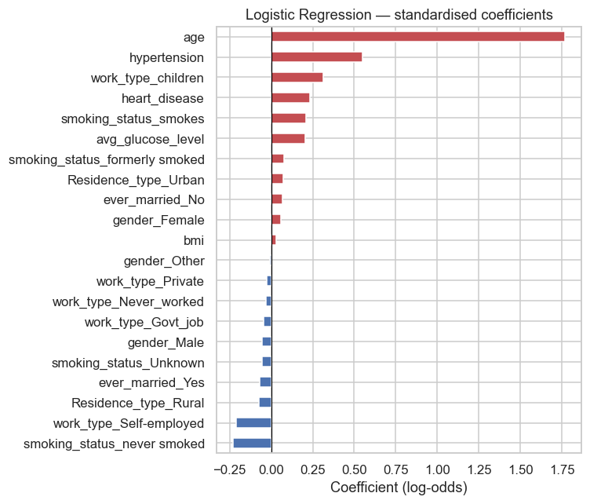

9. Discussion
- Interpretation of results
- Limitations
The results have to be interpreted in the light of the dataset's limitations:
- Class imbalance. With only ~5% positive cases, even after weighting the loss the precision of the positive class remains low; the model is best used as a triage step that flags patients for a more thorough clinical evaluation, not as a stand-alone diagnostic tool.
- Sample size. Around 250 positives in the training set means CV AUC differences smaller than ~0.01 are within sampling noise and should not be interpreted as model superiority.
- Population. The Kaggle dataset does not document the recruitment protocol; demographic biases (e.g. age distribution, ethnicity) may not match the population on which the model would be deployed.
- Static features. The dataset captures a single snapshot per patient; longitudinal information (trends in glucose, BMI, blood pressure) is likely to carry additional predictive value.

10. Conclusions and Future Work
- Short conclusions
- Ideas for future improvement or next steps
Within the limits of the dataset, the LogisticRegression model delivers a useful ranking of stroke risk from routine tabular health-record variables. The clinical signal is dominated by age, average glucose level and the hypertension / heart-disease flags, which is consistent with the published epidemiology of stroke.
Natural next steps for future work include:
- External validation on an independent cohort.
- Threshold calibration tuned to a clinically meaningful operating point (e.g. fix recall ≥ 0.8 and report the resulting precision).
- Inclusion of longitudinal features, where available.
- Investigation of demographic subgroup fairness — performance stratified by age, sex and residence type.
- Use of explainability tools (e.g. SHAP) to surface per-patient drivers of the predicted risk.

11. Ethics and Data Privacy
Describe how ethical and privacy considerations were addressed in the project.
- Confirm that the dataset used is publicly available and permitted for academic or research use.
- State any licenses or usage restrictions attached to the data or to any third-party code used.
If applicable, include a reference to the data source's license or terms of use.

The dataset is publicly distributed on Kaggle and is provided for educational and research use. No identifying information is present in the file: the only identifier column is a synthetic patient id, which we drop at load time. No data was collected, transmitted or shared as part of this project.
Because the dataset's recruitment protocol is not documented, the model produced here is unsuitable for direct clinical deployment. Any downstream use should be preceded by external validation on a population that matches the intended deployment setting and by a fairness analysis across demographic subgroups.

12. Code and Reproducibility
- Name of the Python notebook (.ipynb) developed in Google Colab
- Any notes for reproducing the results (dependencies, instructions)
All code is contained in the Jupyter notebook `notebook/stroke_prediction.ipynb`, which is compatible with Google Colab — its first cell installs the dependencies listed in `requirements.txt`. A single RANDOM_STATE constant controls every source of randomness in the pipeline, so a clean re-run produces identical figures and identical metric values. The supporting `src/report_writer.py` module generates this report from the notebook outputs and is invoked from the final cell.

13. References
Include all relevant references cited in the report.
You can use any standard citation format (e.g., APA, IEEE) consistently throughout the document.

Fedesoriano (2021). Stroke Prediction Dataset. Kaggle. https://www.kaggle.com/datasets/fedesoriano/stroke-prediction-dataset
Pedregosa, F. et al. (2011). Scikit-learn: Machine Learning in Python. Journal of Machine Learning Research, 12, 2825-2830.
Chen, T. and Guestrin, C. (2016). XGBoost: A Scalable Tree Boosting System. In Proceedings of the 22nd ACM SIGKDD International Conference on Knowledge Discovery and Data Mining.
World Health Organization (2020). The top 10 causes of death. https://www.who.int/news-room/fact-sheets/detail/the-top-10-causes-of-death

