**Team 1A CA Project**

**Shopping Cart Web Application using ASP.NET MVC**

Introduction

The main objective of this project is to develop a working shopping web application using ASP.NET MVC Framework. In the developed Shopping application the user can register, registered user can login, search for products, add products to cart, view products in the cart, remove from cart, check out, view purchase history and log out.

**New user regiatration** has been added as a additional functionality to this application.

Database Schema

We used **ADO.NET** to create this application. The database is created in SQL Management Server using script and the records are seeded into the respective table using queries.  Our database schema will look like the following:

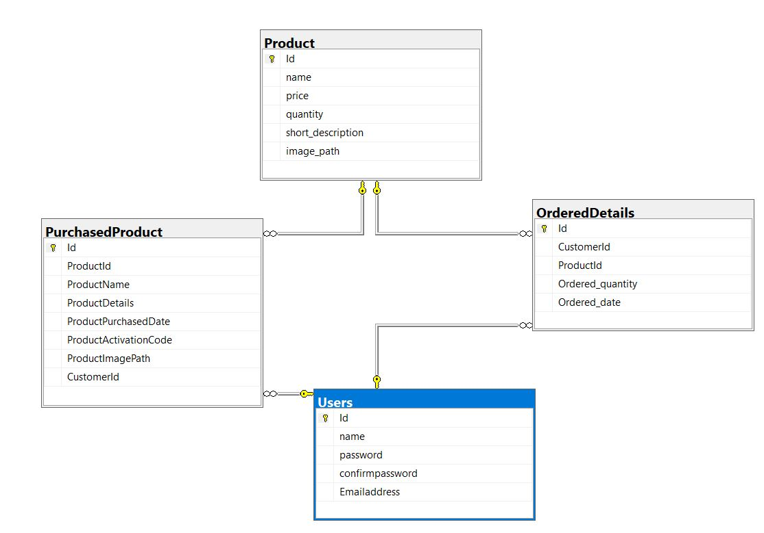

**Web Features**

This holds the features implemented as per the requirement and also the other features to improve the website.

**Part 1**

* **Login**

Login functionality is developed for the already registered users. Users can search for the product without logging in as a guest user. Once the user clicks the “Login” button, login page opens with text boxes for Username and Password. Sessions to store the user details and Partial Views for header, search and product gallery are created. Validation is done for each input field in the Login page. “ComputeSHA256” function is written to store the password in an encrypted format into the database.

* **List Products**

All the products from the database are listed in the gallery page once the user opens the application. Each product card contains Product name, Product description, Price and a Add to Cart button. Product gallery page is created as a separate partial view to make the display easier even after search.

* **Search**

Search bar is placed in the gallery page so that un-registered users can also make use of this functionality. User can enter the text to search and press “enter” button to get the search results and clear the search bar to view all the products. This functionality is done by retrieving all the products in the database by matching the words in the search bar with the database. The search can be done regardless of user input upper or lower case, as well as characters in between the words

* **Add To Cart**

This functionality helps customers to choose products from the gallery page through one simple click on the “Add To Cart” button, which is quick and accurate. The number besides the Cart icon (on the top-right part of the webpage) will increase once the button is clicked, adding more product. Each click is stored in a session to view the products in the **View cart** page.

* **View Cart**

Users use this functionality to view the items in the cart by clicking “cart” icon in the top right. User can also see the number of items in the cart near the cart icon. User can see the Product details, quantity, Price, Total price in the View cart page. Quantity can be edited by the user and the total price changes with respect to quantity. Total price will be computed based on the quantity times price. This page has “continue shopping” button to back to the product gallery page and “check out” button to proceed with the checkout process.

* **Manage Activation Codes**

Activation code is generated using GUID for each product ordered. It is maintained in a list to display in the Purchase history page. The activation code is unique for each quantity of the product.

* **View Purchase History**

After check out, user is navigated to the “Purchase History” page. It shows the order details with the Activation code for each product ordered along with the date it has been ordered. There is a dropdown box for each product, in the event that user purchased multiple quantity of the product

* **Logout**

Logged in users use this functionality to exit his/her account. Once they click “Logout”, their identity will be changed as guest and the shopping cart will be empty and they can still see the gallery page to continue the product search.

By logging out, the sessions will be cleared and when they log in again, the cart will be empty. We can improve this functionality by storing the cart details in a database to maintain the cart details when they log in again.

**Part 2**

* **New User Registration**

New user can register in the registration page to sign up. New user details will be added to the customers table in the database, so that they can login again using the same credentials.

Client-side validation is used to ensure that username must have input,

When the user login again, credentials will be validated with the customer details in the database.

During registration process, there are remote validation in place to ensure that the username and email address are unique. In the event that the username or email is already been used. The user will be prompt for a new registration

We like to expand our application by adding Forgot Password functionality, sending alert messages to the user incase of suspicious access and so on as the additional functionality

Live Demo

Please find the link for live demo: https://www.youtube.com/watch?v=LSjbnBuGrmg

Conclusion

This report elaborates the detailed information on the Shopping Web Application we developed and its requested behavior. As a conclusion, the application performs well along with its additional functionalities

Submitted by:

Aye Moe Phyu - E0457825

Ngik Guo Ming - E0457839

Suwetaa Ramesh - E0457811

Wang Xuezhi - E0457838