Stock Market Closing Price Analysis
IBM · Intel · Cisco · General Electric · Dow Jones Industrial Average
Dataset period: 03 September 2010 – 01 October 2010 | 20 trading observations

Executive Summary
This report examines 20 daily observations of closing prices for four US-listed equities and the Dow Jones Industrial Average. Over the observed window, IBM recorded the strongest price-only change (+6.32%), while CSCO recorded the weakest (+4.13%). These are historical sample results, not forecasts or investment recommendations.

1. Data and Methodology
Source: user-provided ClosingStockPrices.xlsx, Data worksheet. Dates are sorted chronologically. Daily simple returns are calculated as (Pₜ/Pₜ₋₁ − 1) × 100; total sample returns use first and last recorded prices. Volatility is the sample standard deviation of daily percentage returns. Correlations use pairwise daily returns. Normalized prices set the first observation to 100. No dividends, inflation adjustments, transaction costs, or corporate-action corrections were independently verified.
Data quality: IBM: 0 missing; INTC: 0 missing; CSCO: 0 missing; GE: 0 missing; DJ Industrials Index: 0 missing.

2. Performance Summary
Asset | First close | Last close | Total change | Daily volatility
IBM | 127.58 | 135.64 | +6.32% | 0.81%
INTC | 18.43 | 19.32 | +4.83% | 1.30%
CSCO | 21.04 | 21.91 | +4.13% | 1.21%
GE | 15.39 | 16.36 | +6.29% | 1.26%
DJ Industrials Index | 10,447.93 | 10,829.68 | +3.65% | 0.68%
Note: Price levels of the Dow Jones index are not directly comparable with individual share prices. Total change is price-only and measured over the available sample.

3. Visual Exploration
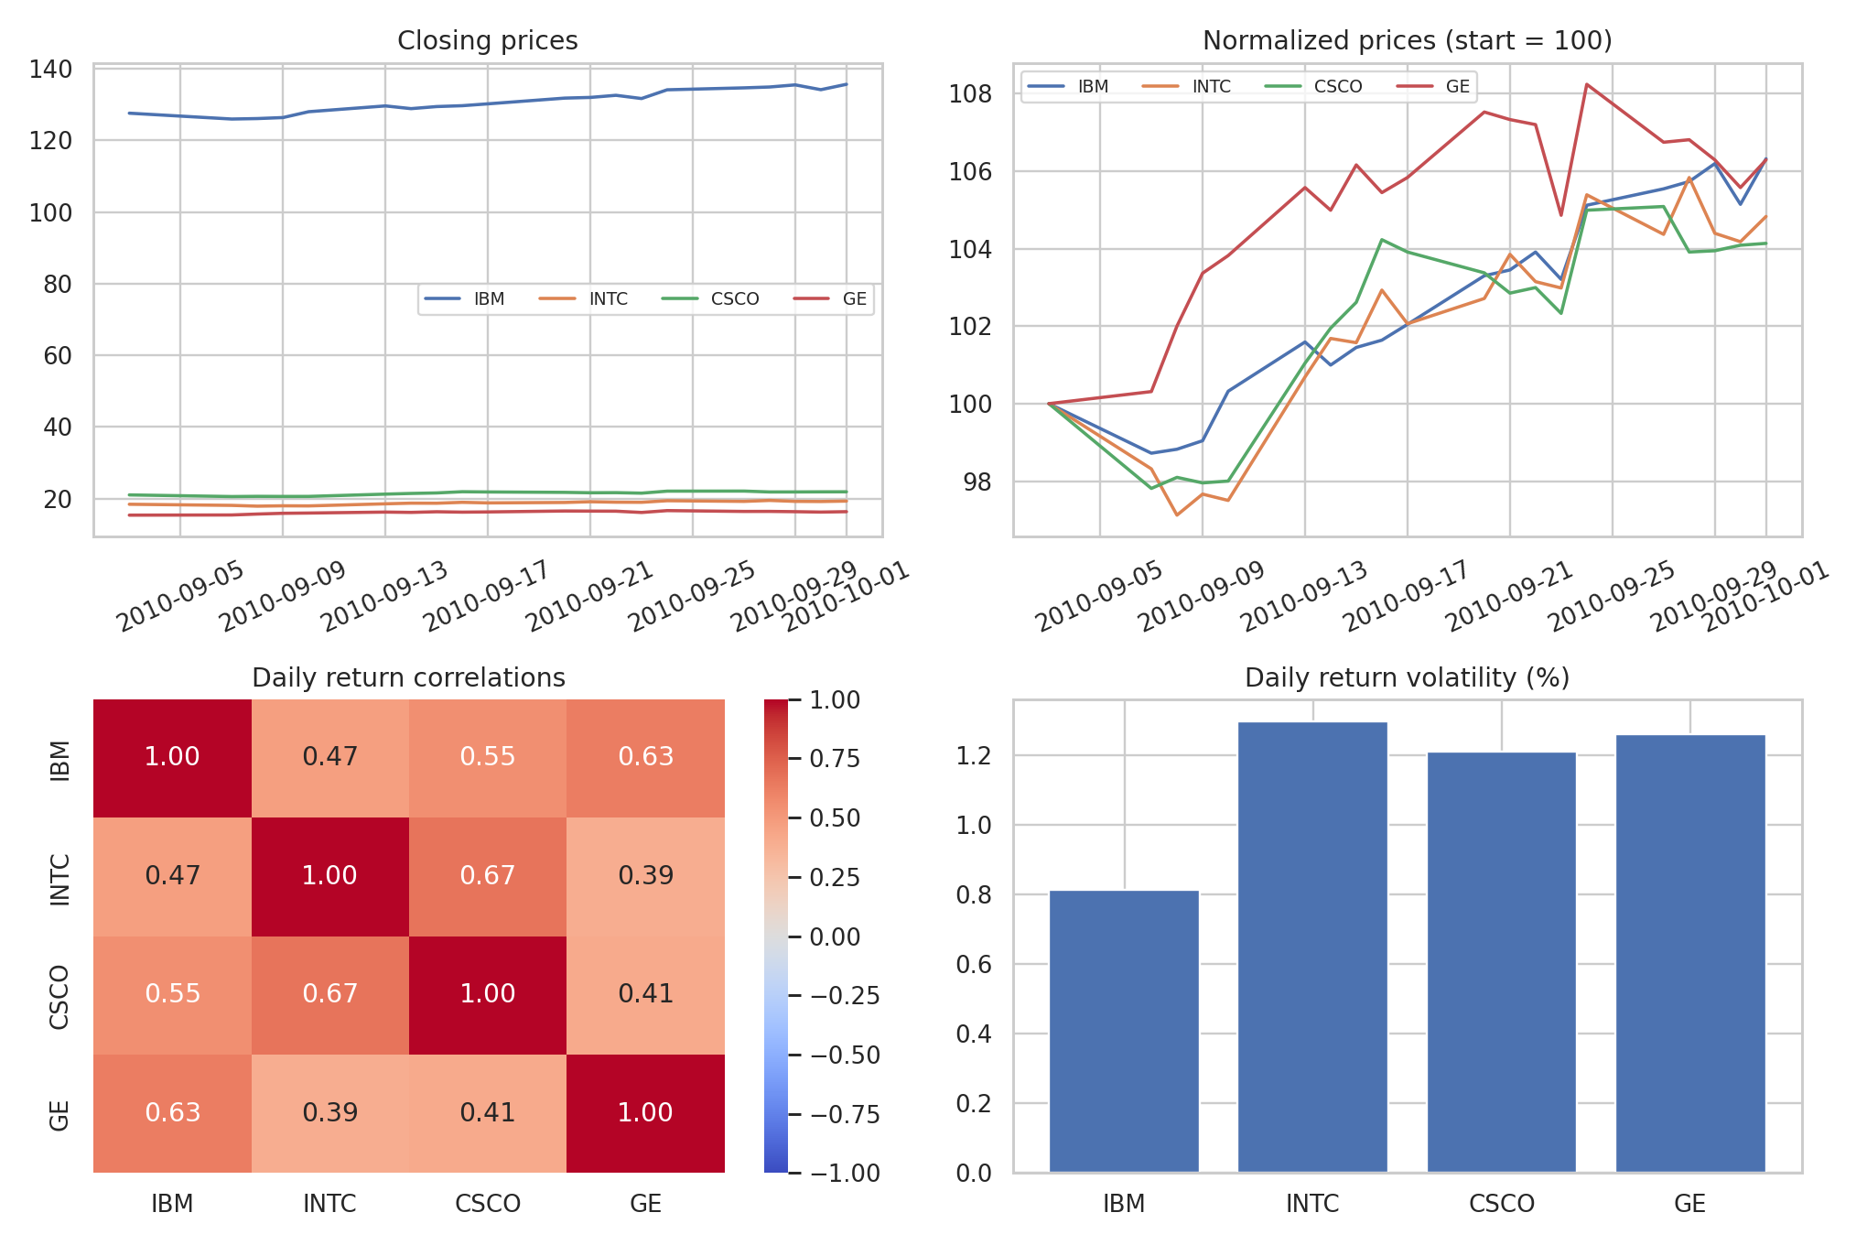
Figure 1. Raw closing-price trends, rebased performance, return correlations and daily volatility for the four stocks.

4. Key Findings
- Performance: IBM had the largest sample price increase (+6.32%). The ranking reflects this specific historical period only.
- Risk: INTC had the highest sample daily volatility (1.30 percentage points), while IBM had the lowest (0.81).
- Co-movement: The strongest pairwise daily return correlation was INTC–CSCO (0.67).
- Benchmark: The Dow Jones index changed +3.65% over the same sample; this is a descriptive comparison, not a risk-adjusted performance assessment.

5. Limitations and Next Steps
The sample is short, so its correlations and volatility estimates may be unstable. The file does not establish whether prices are adjusted for stock splits or dividends. The report therefore avoids claims about total shareholder returns, causality, or future market direction. A useful extension is to estimate market beta for each stock by regressing its daily return on the Dow Jones daily return, then evaluate statistical uncertainty and model assumptions.

Conclusion
The analysis demonstrates a reproducible workflow from Excel ingestion and cleaning to exploratory visualization, descriptive risk metrics, and benchmark comparison. Normalized price plots are preferable to raw-price plots for comparing relative movements, while return-based statistics are more appropriate for volatility and correlation analysis.

