
Human-Centred AI Masters December 2025
THES H6011 Research Thesis, 30 Credits

Fairness in Cardiovascular Disease Prediction Models
Aye Chan Moe



A thesis submitted in the partial fulfilment for the
Masters in Science in Human-Centred Artificial Intelligence

in the
Faculty of Computing, Digital and Data
School of Enterprise Computing and Digital Transformation

Main Supervisor: Lecturer, Dr. Fernando Perez Tellez,
School of Enterprise Computing and Digital Transformation, TU Dublin

Lecturer, Dr. Rajesh Jaiswal,
School of Enterprise Computing and Digital Transformation, TU Dublin

I hereby certify that the material, which I now submit for assessment on the programmes of study leading to the award of Master of Science, is entirely my own work and has not been taken from the work of others except to the extent that such work has been cited and acknowledged within the text of my work. No portion of the work contained in this thesis has been submitted in support of an application for another degree or qualification to this or any other institution.



Aye Chan Moe May 5, 2025

This research aims to analyse the application of machine learning methodologies to predict the risk of cardiovascular disease (CVD) through an empirical healthcare dataset. Cardiovascular diseases claim the position of leading deaths globally, arising mostly from avoidable risk factors like hypertension, smoking, and obesity. Timely predicting CVDs will allow for urgent intervention, thereby improving the prognosis for patients. This work focuses on building predictive models and analysing their performance metrics. Four machine learning models were developed and assessed, namely Logistic Regression, Random Forest, eXtreme Gradient Boosting (XGBoost), and Multi-Layer Perceptron (MLP). The study involves bias detection among vulnerable demographics like gender and age by way of established fairness measures. Cross-validation and hyperparameter tuning were used to enhance model performance, while interpretability techniques were implemented to explain model predictions. The results demonstrate trade-offs between performance and bias and provide further insights into the inner workings of the various algorithms involved in health-related predictive modelling.

Keywords
Cardiovascular Disease (CVD), Logistic Regression, Random Forest, XGBoost, Multi-Layer Perceptron (MLP)

My sincere thanks to the lecturers and coordinators of the Programme in Human-Centred Artificial Intelligence at TUD for their guidance and support throughout this project. I am especially grateful for the feedback and encouragement received during the preparation of this research. I would also like to extend my thanks to my fellow students for their critical discussions and views, which contributed significantly to the accomplishment of this research.

CVD – Cardiovascular Disease
RF – Random Forest
MLP – Multi-Layer Perceptron
AI – Artificial Intelligence
ML – Machine Learning
EHR – Electronic Health Record
XGBoost – eXtreme Gradient Boosting
CNN – Convolutional Neural Network
LSTM – Long Short Term Memory
SHAP – SHapley Additive exPlanations
SPD – Statistical Parity Difference
DI – Disparate Impact
EOD – Equal Opportunity
AOD – Average Odds Difference

Introduction
The cardiovascular disease (CVD) has become the leading cause of death worldwide, accounting for 17.9 million deaths a year [1]. This is largely because CVD requires sustained medical attention, and CVD patients are frequently readmitted into hospitals, thereby exerting pressure upon healthcare systems. With health records becoming increasingly digitized, the use of ML can greatly predict readmissions and assist in proactive healthcare interventions.

Background Information
Data-driven approaches are increasingly being used in the healthcare field to ensure improved patient outcomes. Predictive analytics, especially ML algorithms, have been found to be effective in anticipating medical situations like hospital readmissions [2]. Anticipating if a cardiovascular disease patient is at risk of readmission may help optimize resources and provide good quality of care. However, an ML method may unintentionally take into account or mirror biases of society present in healthcare data, hence creating ethical problems.

Motivation
The motivation for this project arises from the essentiality of building intelligent systems that not only furnish precise predictions but also respect the principle of human-centred artificial intelligence. While several models were adapted for clinical prediction purposes, assessing models for bias and fairness is vital to avert the perpetuation of extant inequalities. Furthermore, transparency became the foremost issue – how does one understand it, especially in domains such as healthcare?

Scope of the Research
This paper concentrates on ML being used to predict hospital readmissions for cardiovascular patients based on electronic health record (EHR) data. It looks into model performance, potential biases on gender and age, and assesses the concepts of fairness without adapting the data or algorithms to reduce bias. Besides, the explainability methods are also studied to explain the model decisions following human-centred AI principles.

Problem Description - Relevance to Human-Centric AI
The real challenge is to predict hospital readmission among cardiovascular patients accurately from structured patient data. The human-aided AI viewpoint places emphasis on being able to open the model up under examination for reasons of ethics related to the consequences of things predicted and equity in the decision-making processes for healthcare. In this way, it aligns with the goals of the Human-Centred AI Master's aimed at developing AI that serves human beings in a responsible and fair manner.

Research Questions and Objectives
The key research questions guiding this study are:
- How can bias in healthcare risk prediction models be measured and identified across various demographic groups?
- What explainability tools can be implemented to make the prediction results of the models interpretable?
The objectives are:
- Train and evaluate multiple ML models (Logistic Regression, Random Forest, XGBoost, MLP).
- Detect and analyse biases using fairness metrics across gender and age.
- Use explainability techniques to assess model interpretability.
- Evaluate and compare models using standard performance metrics.

Structure of the Thesis
The structure of this dissertation is organized to guide the reader through a comprehensive analysis of machine learning for hospital readmission prediction in cardiovascular patients. The first chapter introduces the research topic, motivation, and objectives. Chapter 2 presents a literature review covering the application of machine learning in healthcare, fairness and bias in AI, and explainability methods. Chapter 3 outlines the dataset used, including preprocessing steps and exploratory data analysis. Chapter 4 describes the modelling approach, hyperparameter tuning, and model evaluation processes. In Chapter 5, the results of model performance, fairness metrics, and interpretability analyses are presented, providing a critical discussion of the findings in relation to human-centred AI principles. Finally, Chapter 6 concludes the thesis by summarizing the key insights and suggesting directions for future work.

For hospital readmission prediction has been a focal area in healthcare informatics, with an increasing focus placed on ML methods to predict patient readmission shortly after discharge. The big data era in healthcare, driven by EHRs, has opened up the avenues for researchers and clinicians to improve the care process with predictive models and reduce cost implications [2].

Cardiovascular Disease and Readmission
Being among the foremost causes of morbidity and mortality globally, CVD, including heart failure, myocardial infarction, and coronary artery disease, mostly tend to cause unplanned readmissions, weighing heavily on patients and health systems. Studies have shown that if high-risk patients can be identified in time, many avoidable readmissions can be diminished with improved outcomes [3].

Machine Learning in Healthcare

Machine learning is largely accepted for predictive analytics in medical fields, as it detects complex patterns in data. Typical occurrences include logistic regression, decision trees, random forests, support vector machines, neural networks, and ensemble methods [4]. These algorithms possess the capability to deal with high-dimensional data and are most applicable for classification problems like predicting hospital readmissions.

In the field of prediction within the healthcare domain, logistic regression is very much a baseline model, usually because of its simplicity and interpretability (Sperrin et al., 2015). Due to their excellent performance and in dealing with nonlinear relationships, random forests and gradient boosting machines like XGBoost have been gaining popularity [5]. Neural networks have lately been increasingly viewed as a great way to model the complex interactions involved in patient data, wherein MLPs are still a very worthy candidate [4].

Hospital Readmission Prediction Studies
Under recent developments in ML, better readmission prediction models appear to directly benefit from enhanced prediction techniques. Deep learning and ensemble methods tend to perform well on large-scale EHR data. For instance, Nguyen et al. (2022) used a hybrid deep learning architecture combining CNN and LSTM networks to predict 30-day readmission with an AUC of 0.83 in a national database of heart failure patients [6].
Similarly, Choi et al. (2023) designed a federated learning setup, which protected patient privacy while improving prediction performance across multiple hospital sites [7]. Their XGBoost-based algorithm produced competitive performances without centralizing any patient data, offering hope to privacy-preserving methods in sensitive fields such as healthcare.
Another presently conducted study performed by Sharma et al. (2021) implemented a wide and deep learning model to learn low and high-level feature interactions, providing better prediction for cardiovascular patient readmission. The findings evidenced how feature engineering and model architecture are factors in clinical ML tasks [8].
In a systematic review, Zhao et al. (2022) reviewed over 50 recent ML models applied to hospital readmission prediction and concluded that ensemble models, e.g., Random Forest or XGBoost, stand out against traditional ones like logistic regression, especially if run on large data and heterogeneous datasets [9].
Despite performance improvements, many of these studies still neglect to assess fairness and interpretability, highlighting the research gap this project aims to address.

Fairness and Bias in Predictive Models
Bias in machine learning prevents certain subpopulations from being treated fairly, especially in such sensitive domains as medicine. Studies showed that a widely commercialized algorithm underestimated the health needs of Black patients, thus asking for some ethical considerations [10]. A few fairness metrics such as Statistical Parity Difference (SPD), Equal Opportunity Difference (EOD), and Disparate Impact (DI) have been proposed to quantify bias [11].
Even if bias detection tools are available, achieving fairness remains very difficult, especially with sensitive attributes correlated with medical risk factors. Given this, models must be evaluated not just on their accuracy but also on their fairness across different demographic groups, such as gender and age.

Explainability and Trust in AI Systems

Interpretability of machine learning models is crucial for clinical adoption. Black-box models such as neural networks have usually been accurate but remain untrustworthy due to their lack of transparency. Thus, methods like SHapley Additive exPlanations (SHAP) exist to explain a prediction by allocating an importance value to each feature [12]. Explanations help clinicians establish certainty around the output of the models and assist them in building an AI-assisted decision-making process.

Data Collection
The dataset used in this project has been taken from Kaggle, which is a famous data science competition and dataset hosting platform. This "Cardiovascular Disease Dataset" comprises medical examination records, anonymized for nearly 69,000 patients. Each record has 13 clinical features such as age, gender, cholesterol, blood pressure, BMI, smoking, activity, and alcohol consumption, among others, with the binary target variable of cardiovascular disease with or without.
The dataset was made public to assist in the building and testing of predictive models for cardiovascular risk classification. Due to its large size, balanced class target distribution, and variety of health-related variables, it offers a rich ground for machine learning research.
For this project, the data was downloaded from the Kaggle website and imported into Python via the pandas package. Then the dataset was preprocessed and explored, all in preparation for building machine learning models. Since the dataset is free of any personally identifiable information, it can safely be used in academic and research settings without any ethical considerations.

Data Description
Each record in the dataset includes both clinical and lifestyle variables, enabling a multifaceted analysis of patient health profiles.
The dataset contains thirteen features and 1 binary target (cardio), indicating the presence (1) or absence (0) of cardiovascular diseases. The main features are briefly described below:
Demographic Features:
- age: The patient's age, expressed in days (later to be converted into years for easier interpretation).
- gender: Biological sex (1 = Female, 2 = Male).
Physical Measurements:
- height: Height in centimeters.
- weight: Weight in kilograms.
- ap_hi: Systolic blood pressure.
- ap_lo: Diastolic blood pressure.
Biochemical Indicators:
- cholesterol: Cholesterol levels (1 = normal, 2 = above normal, 3 = well above normal).
- gluc: Glucose levels (the same scale as cholesterol).
Lifestyle Habits:
- smoke: Smoking status (1 = smoker, 0 = non-smoker).
- alco: Alcohol consumption (1 = consumer, 0 = non-consumer).
- active: Physical activity (1 = active, 0 = inactive).
Target Variable:
- cardio: Binary cardiovascular disease indicator (1 = has CVD, 0 = no CVD).
These features provide a realistic foundation and major clinical factors to develop predictive models. Demographic, clinical, and behavioural factors set up the basis for model bias consideration among sensitive subgroups, particularly gender and age, concerning the fairness analysis of this study.
Before proceeding with model training, data preprocessing was carried out by converting units (e.g., age in years), feature creation (e.g., create BMI feature from height and weight), and identifying implausible values (e.g., negative or excessively high blood pressure readings). These were important steps to ensure the accuracy and reliability of the analyses that followed.

Data Insights and Visualisation

Descriptive Statistics and Class Balance
An initial statistical summary was done to understand the overall structure of the dataset. After converting the original 'age' feature unit of days to a more comprehensible unit of years and engineering the feature BMI from height and weight, it can be seen that the dataset consisted mainly of middle-aged adults. The BMI values hovered around overweight levels, in line with risk factors for cardiovascular disease.
A distribution on the target variable (cardio) shows that roughly 51% of the patients in the dataset carry the cardiovascular disease label, thus making it a balanced classification case. Such a balance is quite ideal for training classification algorithms without applying any over/under-sampling methods.

Class | Description | Percentage
0 (No CVD) | No cardiovascular disease | 48.64%
1 (CVD) | Cardiovascular disease present | 51.36%
Table 1. Class Distribution of Target Variable

Such balancing of the classes makes the training of a model unbiased toward the dominant class and allows for fairer, reliable evaluation metrics like precision, recall, and F1-score.

Thus, the makeup of the dataset supports fair model training and analysis, especially pertinent to determining whether the prediction performance is affected along demographic or clinical sub-group indices.

Feature Distributions and Outlier Detection
Before building a model, analysing the distributions of individual features and spotting outliers or anomalies will ensure fair learning of the data. Inconsistencies in data could truly interfere with the robustness of training or cause skewness of evaluation.
- Age and BMI
Age was transformed from days into years for interpretability. Most patients fall within the age range of 30 to 65 years, describing a middle-aged to elderly population.

Statistics | Age (year) | BMI
Mean | 53.3 | 27.5
Median | 54 | 26.5
Minimum | 30 | 13.5
Maximum | 65 | 85.8
Standard Deviation | 6.8 | 5.2
Table 2. Summary Statistics of Age and BMI
BMI was used as a synthetic variable to quantify obesity. The unrealistic and extreme values from height and weight were treated as outliers and replaced with median value, and then BMI feature was recalculated. The values are mostly in the allowed healthy-to-overweight range.
- Blood pressure (Systolic and Diastolic)
There has been wide variability between blood pressures ap_hi (systolic) and ap_lo (diastolic). Referring to some medical guidelines (for example, from WHO):
- Systolic blood pressure considered normal: 90–140 mmHg
- Diastolic blood pressure considered normal: 60–90 mmHg
Then the problem arises in the dataset where some records were assigned values well outside or invalid, such as:
- Systolic greater than 250 mmHg, or less than 90 mmHg

- Diastolic above 150 mmHg, or less than 50 mmHg
Those values were treated as outliers and removed from the dataset as they are not realistic.
These preprocessing steps were essential for reducing model distortion and preventing skewed learning based on erroneous data.

Subgroup Analysis: Gender and Age
In order to analyze demographic disparities for CVD presence in terms of gender and age groups, the study performed a subgroup analysis. Such insights are of great importance to fairness-aware machine learning, with the goal that the models should never treat any population subgroup disadvantageously.
- Gender-Based Analysis
The dataset contains a notable imbalance in gender representation:

Gender | Label | Propotion
1 | Female | ~61.4%
0 | Male | ~38.6%
Table 3. Gender Distribution
Further breakdown by CVD presence reveals interesting trends:
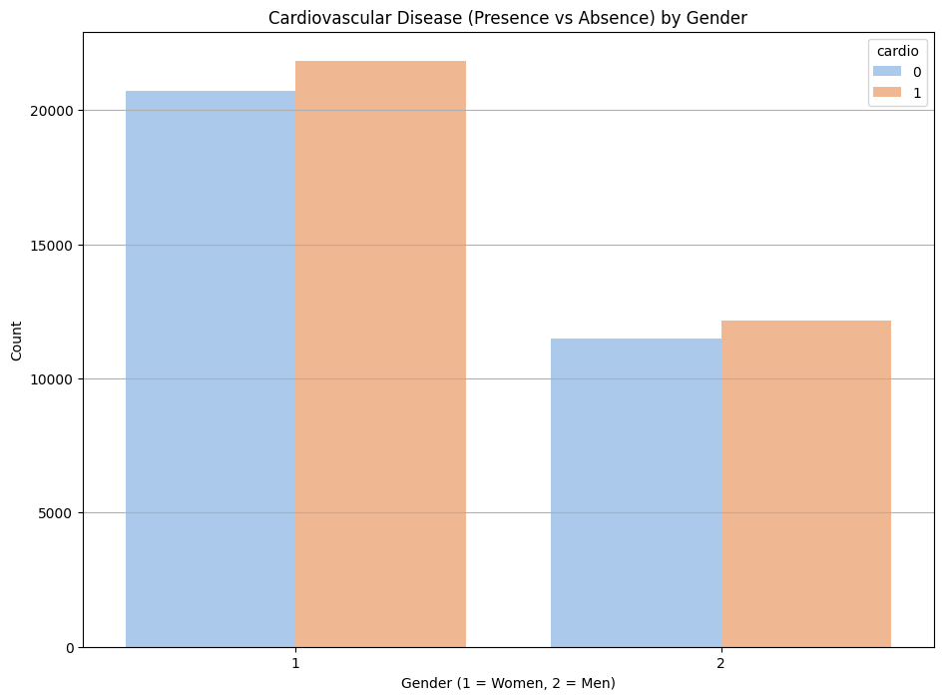
Figure 1. Cardiovascular Disease Distribution by Gender
From the above figure:
- In both male and female groups, more patients were diagnosed with CVD than not.
- However, the absolute number of female CVD cases is higher, largely due to overrepresentation of women in the dataset.
- This gender inequity demands evaluation of model performance at the subgroup level to verify equal quality of prediction has been provided to both sexes.
- Age-Based Analysis
Patients were grouped by age in yearly bins (ages 30 to 65) to analyze how CVD risk varies with age.
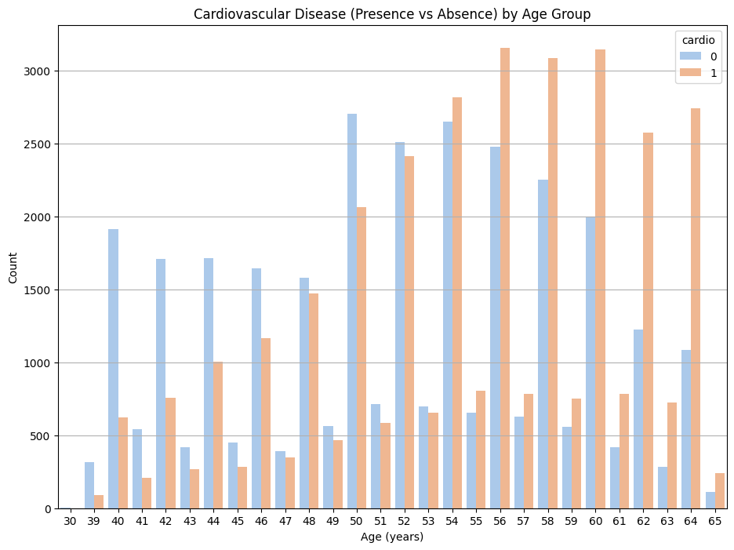
Figure 2. Cardiovascular Disease Distribution by Age
From the above figure:
- The prevalence of CVD increases with age and especially after age 50.
- From patients between the ages of 60-65, positive cases of CVD (label 1) become the dominant class.
- For younger age groups, mainly between 30-45, more cases appear negative (label 0), but these are under-represented.

This distribution pattern confirms medical knowledge that CVD risk increases with age. However, it also presents a modeling challenge: if this imbalance is not handled well, ML models may poorly generalize to younger patients as they see fewer instances of their feature pattern during training. Hence, one must test the model on stratified metrics by age to confirm that predictions remain fair and accurate across age groups.

Cardiovascular Disease Prevalence by Risk Factors

Categorical variables were compared with the target class (Cardio) to understand the relationship between CVD and main medical or lifestyle-related risk factors. The comparison shows the disproportionate link of certain health indicators, behaviors, or factors with CVD.

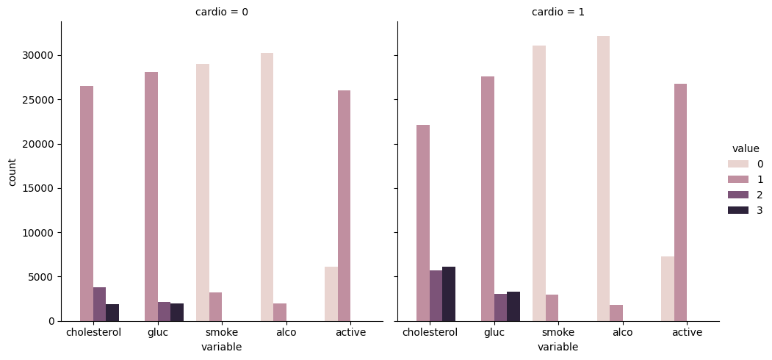
Figure 3. Cardiovascular Disease Distribution by Risk Factors
- Cholesterol and Glucose Levels
A sharp difference is observed between the patients with and without CVD in their cholesterol and glucose values.
- Patients with high cholesterol (3) and elevated glucose (2/3) appear more frequently in the CVD-positive group.
- This further confirms clinical knowledge that strong cardiovascular risk comes with metabolic syndrome.
- Smoking and Alcohol Consumption
Smoking and Alcohol Consumption appear to be generally common, but then one would assume that their usage is a bit more pronounced among CVD-negative subjects:
- While smoking (value = 1) prevails to a degree, it appears that CVD patients engage less in this activity within this dataset.
- Alcohol usage (alco = 1) also tends to decrease slightly among CVD-positive individuals, which could have been correlated with medical advice given after diagnosis or could be a reporting bias.
Overall, these visual and statistical patterns support the clinical relevance of the dataset and establish a foundation for training interpretable and fairness-aware models. These insights will also guide the inclusion of features in model development and the assessment of model bias across health behaviour strata.

This chapter develops machine-learning models for CVD prediction based on structured health data. The project was to compare the predictive performance of different algorithms and determine their fairness over demographic subgroups. In total, four models were selected: Logistic Regression, Random Forest, XGBoost, and MLP, due to their popularity and efficiency in healthcare analytics.
The rationale for the models and the tuning procedure of hyperparameters are then presented, along with the evaluation framework. Particular attention is given to ensuring consistency in training procedures and measuring both traditional performance metrics and fairness-related behaviour.

Model Selection and Development
The project developed four supervised models trained to predict cardiovascular disease (CVD). Model choice was grounded both on previous healthcare-related studies and complementary strengths in model interpretability, generalization, or non-linear modelling capacity.
- Logistic Regression
Logistic Regression was employed as the baseline method for its interpretability and long-standing use in medical statistical studies and epidemiology. It relates the log odds of an event happening with linear attributes, giving a distinct insight into the direct contribution by features. For example, the Logistic Regression coefficients might transparently shed light on direct risk factors such as age, cholesterol, or blood pressure, which is essential from the healthcare perspective, wherein predictions must be explainable.
- Random Forest
Random Forest, an ensemble learning method, is capable of non-linear relationships and automatic capture of interaction features. Using multiple decision trees built on bootstrap samples combined with their prediction votes, Random Forest reduces over-fitting and improves the accuracy of prediction. Its feature importance measures also offer some degree of interpretability to support the fairness and transparency of clinical applications.
- XGBoost
XGBoost is an efficient implementation of gradient boosting with regularization, early stopping, and advanced tree-pruning for performance and computational efficiency. It has been heavily used in healthcare data science and is always among the best-performing models on tasks involving structured data. XGBoost is very capable of handling class imbalances and non-linear patterns, which puts it in a very good position in handling tabular medical datasets like the one we used in this work.
- Muti-Layer Perceptron (MLP)
MLP is a fully connected feedforward neural network capable of realizing decision boundaries of high complexity. The MLPs teach patterns and interactions that are often much more involved, especially when dealing with bigger data sets with higher feature diversity but are typically less interpretable than linear or tree-based models. They began to be used increasingly in EHR analysis because of their flexibility and ability to model non-linear phenomena [4].
Each model is trained on the preprocessed dataset, where the engineered BMI feature is also considered. This model evaluation used stratified cross-validation to ensure class distribution remained the same in the training and validation splits.
Before training, the following steps were applied:
- Standardization of continuous features (e.g., age, ap_hi, BMI)
- Splitting into 80% training and 20% testing datasets using stratified sampling.
In the implementation, logistic regression, random forest, and MLP were developed using Scikit-learn, and for the gradient boosting, XGBoost with its own optimized API was used. Evaluation consistency was maintained throughout training and testing so that one can compare the models under multiple aspects- that is, performance versus fairness.

Hyperparameter Tuning
In order to maximize model performance and avoid overfitting, hyperparameter tuning was performed by means of Grid Search with 5-fold cross-validation. The hyperparameter tuning process wished to ensure a maximum increase of the F1-score of the models, which becomes an essential metric in healthcare-related classification scenarios, where clinical risk is attached to both false positives and false negatives.
Logistic Regression: For Logistic Regression, the hyperparameters for tuning included those for regularization strength and solver stability. The selected optimal configuration used a regularization parameter C = 10 with L2 regularization and the LBFGS solver. This combination balanced variance against simplicity, providing stability and interpretability to the classification task.
Random Forest: For the Random Forest model, we found that a set of 200 trees (n_estimators) performed best, with a max depth of 10, min samples split 5, and 'sqrt' maximum number of features considered at each split, so predictive power gets balanced against generalization and thus minimizes the problem of overfitting on the training data.
XGBoost: Tuning of XGBoost concentrated on learning dynamics and complexity of trees. The best configuration was a learning rate of 0.1, a maximum depth of trees of 3, 200 estimators, and a subsample of 0.8. The evaluation metric was defined as log loss, and label encoding was disabled for compatibility purposes. In this setting, the model performed well prediction-wise while maintaining reasonable regularization.
Multi-Layer Perceptron (MLP): The MLP classifier was tuned for architectural simplicity and stability in convergence. The best model found included one hidden layer with 64 neurons, with ReLU activation, L2 regularization (alpha) set at 0.0001, and an initial learning rate of 0.01. The model was then allowed to train for a maximum of 500 iterations, carrying a balance between complexity and training time.
Once parameter tuning was completed, the final models were trained on the entire training set and evaluated on a hold-out test set to ensure fair comparison under optimized conditions.

Model Evaluation
After training the four models with the best hyperparameters, test set performance was evaluated. The evaluation used traditional classification metrics of accuracy, precision, recall, and F1-score to assess prediction ability, coupled with initial observations on fairness across demographic subgroups.
- Classification Performance
The table below summarizes the performance of each model on the test set:

Model | Accuracy | Precision | Recall | F1-Score
Logistic Regression | 72.24% | 72.47% | 72.24% | 72.20%
Random Forest | 72.62% | 73.04% | 72.62% | 72.54%
XGBoost | 73.10% | 73.25% | 73.10% | 73.09%
MLP Neural Network | 72.99% | 73.01% | 72.99% | 72.99%
Table 4. Performance Metrics of Models
Overall, XGBoost gave the highest accuracy and F1-score and, therefore, became the best performer. An MLP exhibited balanced performance but slightly better recall than the tree-based models. Logistic regression showed good precision but underperformed slightly in recall, especially for the positive class (CVD). Random forest had a good trade-off between precision and recall, just behind XGBoost.
- Confusion Metrics
Each model's confusion matrix serves to indicate the prediction balance among the number of true positives (TP), false positives (FP), true negatives (TN), and false negatives (FN).

Model | True Negatives | False Positives | False Negatives | True Positives
Logistic Regression | 4854 | 1506 | 2090 | 4503
Random Forest | 4993 | 1367 | 2180 | 4413
XGBoost | 4847 | 1513 | 1971 | 4622
MLP Neural Network | 4675 | 1685 | 1814 | 4779
Table 5. Confusion Metrics of Models

These matrices highlight the recall trade-offs. MLP generated fewer false negatives, therefore recognizing more true CVD instances, very crucial consideration in medical screening jobs. More false negatives occurred through Logistic Regression, impacting the sensitivity.

- Feature Importance and Interpretability

This analysis used feature importance for explainability in the tree-based models (Random Forest, XGBoost), coefficient magnitude for Logistic Regression, and permutation importance for MLP Neural Network. Systolic blood pressure (ap_hi), age and cholesterol were among the top contributors across models. Levels of glucose and BMI were also important predictors, aligning with clinical beliefs. Lifestyle variables (smoking, alcohol usage, activity) had somewhat less weight but still mattered. This interpretability gives confidence that models learn from medically meaningful features, not some spurious correlations.

- Feature Selection and Model Retraining
Each model was retrained repetitively using the top 4 features, 6 features, 8 features and 10 features. The retrained models exhibited minimal drop in accuracy, with some models having had increased recall and generalizability, and reduced complexity, facilitating deployment and explainability.
This attaints to validate that not every feature is of equal importance and that omitting lower-impact variables can increase or at least maintain the model's robustness, especially in sensitive areas such as healthcare.

Results
Building on the effects of dimensionality reduction on model performance, each model was retrained on the top 4, 6, 8, and 10 features from each selection method chosen, and model-based importance rankings. The idea behind this analysis was to understand whether it is possible to get similar predictive performance with fewer variables, an important step toward building lean, interpretable models suitable for clinical applications.
Logistic Regression showed steady improvements up to 8 features, beyond which performance gains plateaued.
Top N Features | Accuracy | Precision | Recall | F1-score
4 | 71.56% | 71.72% | 71.56% | 71.54%
6 | 72.15% | 72.40% | 72.15% | 72.11%
8 | 72.27% | 72.51% | 72.27% | 72.23%
10 | 72.17% | 72.40% | 72.17% | 72.13%
Table 6. Performance Metrics of Logistic Regression Model with top features
Random Forest maintained high performance throughout and achieved its best results using 10 features.

Top N Features | Accuracy | Precision | Recall | F1-score
4 | 72.69% | 72.95% | 72.69% | 72.65%
6 | 72.99% | 73.29% | 72.99% | 72.94%
8 | 72.83% | 73.26% | 72.83% | 72.76%
10 | 73.00% | 73.31% | 73.00% | 72.95%
Table 7. Performance Metrics of Random Forest Model with top features
XGBoost performed consistently well, with best results achieved using 8 or 10 features.

Top N Features | Accuracy | Precision | Recall | F1-score
4 | 72.83% | 72.99% | 72.83% | 72.81%
6 | 73.11% | 73.24% | 73.11% | 73.10%
8 | 73.31% | 73.44% | 73.31% | 73.30%
10 | 73.31% | 73.44% | 73.31% | 73.30%
Table 8. Performance Metrics of XGBoost Model with top features
MLP Neural Network also demonstrated strong performance with 8 features, showing minimal degradation when reducing from the full feature set.
Top N Features | Accuracy | Precision | Recall | F1-score
4 | 72.58% | 72.68% | 72.58% | 72.57%
6 | 72.72% | 72.83% | 72.72% | 72.72%
8 | 73.01% | 73.05% | 73.01% | 73.01%
10 | 72.86% | 72.91% | 72.86% | 72.86%
Table 9. Performance Metrics of MLP Model with top features
Overall, the findings show that all models maintain nearly full predictive performance when only the top 8 features are used. This facilitates the development of simplified, less intricate models without compromising accuracy.

Discussion

This section is devoted to a complete analysis of the machine learning models' findings on the cardiovascular disease (CVD) prediction task. It critically reflects on the results presented in Section 5.1, evaluates the underpinning research questions, and considers fairness, interpretability, and model limitations from a human-centred AI point of view.

Recap of Research Questions

The study was guided by two primary research questions:
- How can bias in healthcare risk prediction models be measured and identified across various demographic groups?
- What explainability tools can be implemented to make the prediction results of the models interpretable?
These questions were addressed through subgroup fairness analysis and the use of model interpretability techniques such as feature importance, mutual information ranking, and model coefficient analysis.

Summary of Findings

The outcomes suggested that four models did fairly well with accuracies of more than 72% and the F1-scores around the same. XGBoost slightly better than the other models with an F1-score of 73.09%, while MLP was close at 72.99%.In contrast, Logistic Regression and Random Forest, which gave slightly less performance on the overall metric, offered some insight on model transparency and how features interact.
Crucially, reducing the feature set to the top 8 did not really degrade performance. This suggests leaner models based on a few relevant clinical features may be both sufficiently accurate and quick to compute. It also supports the principle of parsimony and makes these models understandably deployable in clinical settings.
In class-specific behaviour, the MLP attained the highest recall (72.99%) for the positive class, meaning it was better at catching patients with CVD. This is most relevant in healthcare, as false negatives produce missed diagnoses and poor outcomes. In contrast, Logistic Regression recorded lower recalls, but by its linear nature and clear output for coefficients was easily interpretable.

Fairness across subgroups

To explore RQ1, four fairness metrics were computed across gender and age groups:
- Statistical Parity Difference (SPD)
- Disparate Impact (DI)
- Equal Opportunity Difference (EOD)
- Average Odds Difference (AOD)
These metrics collectively evaluate whether the models show bias in terms of outcomes (SPD/DI) and true positive rates (EOD/AOD).

Gender-based Fairness:
Model | SPD | DI | EOD | AOD
Logistic Regression | 0.0056 | 1.0122 | -0.0414 | 0.0089
Random Forest | 0.0097 | 1.0222 | -0.0085 | 0.0130
XGBoost | 0.0054 | 1.0115 | -0.0169 | 0.0088
MLP Neural Network | 0.0073 | 1.0147 | -0.0221 | 0.0107
Table 10. Fairness Metrics of Models for Gender
All models showed minor statistical disparity (SPD < 0.01) and Disparate Impact close to 1, thereby signaling fairness in predictions toward male and female patients. However, the Logistic Regression, with the highest EOD value (-0.0414), was less sensitive to the rate of true positives for one gender subgroup when compared to the other subgroup. In contrast, MLP and XGBoost were more consist in all metrics, indicating a better balance for fairness.
Age-based Fairness:
Model | SPD | DI | EOD | AOD
Logistic Regression | -0.0075 | 0.9839 | 0.0077 | -0.0152
Random Forest | -0.0019 | 0.9958 | 0.0065 | -0.0084
XGBoost | 0.0115 | 1.0243 | 0.0322 | 0.0033
MLP Neural Network | 0.0140 | 1.0281 | 0.0319 | 0.0060
Table 11. Fairness Metrics of Models for Age
Fairness over age groups showed slightly more variability. MLP and XGBoost recorded small but nonetheless notable Equal Opportunity Differences (around 0.03), suggesting that recall diverges for younger versus older patients. As for Logistic Regression and Random Forest, they again showed more stable values of EOD. However, the lower recall for Logistic Regression implies there is a risk that its fairness is bought at the cost of sensitivity.

Overall, the fairness results do not indicate any major violations but do point to the presence of subtle imbalances, particularly with regard to recall, which deserve further consideration. These differences might translate into real disparities in care if, for example, a model systematically underidentifies CVD risk in an age or gender group in the clinical setting.

Explainability and Trust

In order to tackle RQ2, the study incorporated both model-specific and model-agnostic interpretability tools. Logistic Regression provided the most direct interpretability via coefficients, allowing clinicians to have an unambiguous understanding of how features, such as age or cholesterol levels, affected the expected outcome.

Random Forest and XGBoost, tree-based models, gave feature importance rankings that confirmed clinically validated risk factors to be paramount. SHAP (SHapley Additive Explanations) was then used to provide very fine-grain, instance-specific explanations about how individual predictions were reached. The SHAP visualizations then could be used to identify features that have consistent model behaviour versus those that are potential sources of unfairness by looking at differences between demographic subgroups.

While less interpretable, MLP models sustained stable performance when reduced to 8 core features, indicating that it was generalizing well rather than overfitting random noise on irrelevant attributes. The core problem is, however, the lack of interpretability by design, thus making it unlikely to have been deployed in a high-stakes environment such as healthcare without SHAP or other explainability aids.

Human-Centred AI Considerations

The purpose of human-centred AI is to provide those systems that not only perform well but do so with fairness, transparency, and in ethical harmony with stakeholder needs. This work supports that objective by:

- Using fairness metrics for monitoring group-level equity

- Keeping the model complexity at a minimum without compromising performance

- Giving priority to the interpretability and transparency of models

One interesting insight was that all the considered models produced more or less competitive results. In terms of fairness and robustness, however, XGBoost and MLP seemed to outshine the rest. Where transparency was a key issue, Logistic Regression remained a very good alternative. These trade-offs are crucial for medical applications—i.e., a model that may be interpretable but is slightly less accurate can take precedence over a black-box model with slightly higher predictive performance.

Limitations

Some limitations were identified in this study:

- Race and ethnicity were not included in the dataset since these attributes are important for analyses of fairness at a more granular level.

- Only standard fairness metrics were applied; causal or counterfactual fairness was not investigated.

- The analysis only looked into gender and age; intersectional subgroup fairness (e.g., older women) was not assessed.

- No fairness-enhancing interventions were used (e.g., reweighting, adversarial debiasing), and models were evaluated "as is."

Future works should address some of these limitations by including richer datasets and testing fairness-aware algorithms that enforce explicit disparity reduction.

self-appraisal
This project successfully investigated the use of machine learning models for predicting cardiovascular disease and checking for fairness across demographic subgroups. The modelling pipeline has been implemented end-to-end, with a clear focus on performance, bias, and explainability. Additional fairness-aware algorithms (e.g., adversarial debiasing or reweighing) would be tested if it were to be repeated to further mitigate subtle disparities.
I am satisfied with the outcomes and how they aligned with the technical implementation, as well as with the human-centred AI principles advocated by the programme.

This research has shown machine learning for the prediction of CVD with an emphasis on fairness, transparency, and human-centred design. It compares four supervised models—namely, Logistic Regression, Random Forest, XGBoost, and Multi-Layer Perceptron—with respect to predictive performance and fairness across demographic subgroups based on gender and age. The inclusion of interpretability tools increases the applicability of the models in clinical decision-making environments.

From the findings, it was made clear that all models had strong predictive performance, with accuracies and F1-scores above 72% for all cases. When it comes to metrics overall, XGBoost performed the best by a thin margin. MLP came in second in terms of metrics; it gained the highest recall, which makes it the best model for identifying the true positive CVD cases. Logistic Regression and Random Forest were a little behind in raw performance but are considerable in terms of understanding and robustness in cases where interpretability matters.

One of the most powerful contributions of the project consists of showing that a reduced set of top-ranked features for building core models mostly containing age, systolic blood pressure, BMI, cholesterol, and glucose can equally perform compared to full-feature models. This has practical implications, for example, in clinic settings wherein the reduction of input requirements reduces overhead, cost, and noise.
Future Work

Here are proposed strategies for future avenues of investigation, based on the insights this study procured:

Fairness-Aware Training: Implementing methodologies such as reweighing, adversarial debiasing, or post-processing corrections to remedy model bias wherever possible.

Intersectional Fairness Analysis: Extending the scope of fairness evaluation for different intersectional subgroups, such as elderly women or young males, to provide greater insight into hidden disparities.

Clinician-in-the-Loop Systems: AI systems that can build clinical feedback loops to provide greater interpretability, accountability, and utility.

External Validation: Validation of models using data from different populations or healthcare systems to test for generalizability and robustness.

To conclude, this project underscores the necessity of building fair and explainable AI systems into healthcare. Because of the balance of performance with interpretability and ethical alignment, these models remain as promising candidates for responsible CVD risk prediction, provided they are deployed with monitoring, stakeholder input, and regulatory awareness as a lateral necessity.

- World Health Organization. (2021). Cardiovascular diseases (CVDs).
- Rajkomar, A., Dean, J., & Kohane, I. (2019). Machine learning in medicine. New England Journal of Medicine, 380(14), 1347–1358.
- Benjamin, E. J., Muntner, P., Alonso, A., Bittencourt, M. S., Callaway, C. W., Carson, A. P., ... & Virani, S. S. (2019). Heart disease and stroke statistics—2019 update: a report from the American Heart Association. Circulation, 139(10), e56–e528.
- Shickel, B., Tighe, P. J., Bihorac, A., & Rashidi, P. (2018). Deep EHR: A survey of recent advances in deep learning techniques for electronic health record (EHR) analysis. IEEE Journal of Biomedical and Health Informatics, 22(5), 1589–1604.
- Chen, T., & Guestrin, C. (2016, August). XGBoost: A scalable tree boosting system. In Proceedings of the 22nd ACM SIGKDD International Conference on Knowledge Discovery and Data Mining (pp. 785–794).
- Nguyen, P. A., Tran, T. H., & Hoang, T. (2022). A hybrid deep learning approach for predicting 30-day hospital readmission among heart failure patients. IEEE Access, 10, 98564–98575.
- Choi, H., Park, Y., & Kim, H. (2023). Privacy-preserving hospital readmission prediction using federated XGBoost. Journal of Biomedical Informatics, 141, 104375.
- Sharma, R., Ghosh, A., & Bhattacharya, S. (2021). Predicting cardiovascular readmissions using wide and deep learning. Computer Methods and Programs in Biomedicine, 200, 105895.
- Zhao, Y., Ma, X., & Zhang, X. (2022). A systematic review of machine learning models for predicting hospital readmissions. BMC Medical Informatics and Decision Making, 22(1), 45.
- Obermeyer, Z., Powers, B., Vogeli, C., & Mullainathan, S. (2019). Dissecting racial bias in an algorithm used to manage the health of populations. Science, 366(6464), 447–453.
- Barocas, S., Hardt, M., & Narayanan, A. (2019). Fairness and machine learning. fairmlbook.org.
- Lundberg, S. M., & Lee, S.-I. (2017). A unified approach to interpreting model predictions. In Proceedings of the 31st International Conference on Neural Information Processing Systems (pp. 4765–4774).

