MealIQ - Stage 2 Implementation Report
EECS3311 Software Design, York University. Repository: https://github.com/Ayech14/MealIQ
MealIQ is a planning aid, not medical or dietary advice.

1. Project overview and implementation status
MealIQ is an AI agent for meal planning and grocery optimization. It serves a home cook who has to balance nutrition goals, allergies and dietary rules, food preferences, what is already in the pantry, a weekly grocery budget, and how much time each day allows for cooking.
The application is written in Java 21 with Maven, as the instructor required on October 30, 2026. It replaces a first Python implementation started in Period 1 (see Section 4, C01).
Interfaces. Both interfaces call the same MealPlanningFacade in-process:
- GUI: a JavaFX desktop app (./mealiq-gui) with a sidebar of pages. It opens on Home, where the agent's check-up proposes the next step, followed by Ask the agent, Meal plan, Pantry, Recipes, Groceries and Profile.
- CLI: a picocli command line (./mealiq). Commands: ask, profile, pantry, recipes, plan, grocery, ingredients, setup.
AI integration.
- The agent uses OpenAI gpt-5.4-mini-2026-03-17 through the OpenAI Java SDK's Responses API, with strict JSON-schema output, behind the provider-neutral LLMClient interface.
- The model is pinned in the local .env file.
Agent behaviour.
- Tool selection: the LLM chooses tools in a loop bounded by MAX_TOOL_STEPS. The tools are recipeSearch, nutritionAnalysis, groceryList and substituteIngredient. ToolManager rejects invalid calls and returns the error to the LLM as its next observation.
- Ranking: deterministic planning strategies rank the candidates, and the LLM chooses among them and explains the choice.
- Memory: the agent keeps a short memory of earlier decisions.
- What the LLM never does: it never calculates nutrition, prices or quantities, and never changes stored data. Every proposal is validated deterministically, previewed, and applied only after the user confirms, through a Command that can be undone.
Data.
- Nutrition: USDA FoodData Central SR Legacy, curated to 146 ingredients.
- Prices: Statistics Canada average retail prices (table 18-10-0245-01, August 2026) for 63 of those ingredients.
- Recipes: 30 curated seed recipes built only from catalogue ingredients.
- Storage: PostgreSQL through hand-written JDBC repositories, with H2 in PostgreSQL mode for tests.
Working functionality. All 13 Stage 1 features (F01-F13) and two new features (N01, the Assistant; N02, the agent check-up on Home) work in the CLI and the GUI. Every AI feature was run against the real OpenAI API and a real PostgreSQL database during development (Section 6).
Limitations and incomplete parts:
- No external recipe provider. ExternalRecipeAdapter from Stage 1 is not implemented: recipe search covers the 30 curated recipes plus recipes the AI generates and the user saves (C13).
- Partial prices. About half the catalogue has no Statistics Canada price, so cost estimates are lower bounds shown as $x+. The budget is enforced only when known prices alone exceed it (C17).
- Portions of one or two servings. Portions are sized deterministically up to two servings per meal (C32), so a very high calorie target can still be missed on some days. This is reported as a warning, never hidden.
- Plan generation can fail on tight constraints. The agent now sees, for each time-limited day, only the recipes that fit (C33), but with very few matching recipes a plan can still fail validation after its one retry. Nothing is saved and every violation is listed.
- Untested GUI handlers. JavaFX event handlers have no automated tests. The facade operations they call are tested, and every screen was rendered and inspected (Section 6).
- Launch scripts. ./mealiq and ./mealiq-gui are shell scripts for macOS and Linux. On Windows, the README shows the equivalent java command.

2. Feature to implementation mapping
Package prefix: io.github.ayech14.mealiq. Every feature is reached through application/MealPlanningFacade; the CLI commands are in presentation/cli, and the GUI screens are in presentation/gui.
ID and name | Stage 1 | Status | Implemented classes/files and responsibilities | Key methods | Patterns | Type | Video
F01 User goals and preferences | F01 | Implemented | ProfileService validates ranges and contradictions, saves, publishes changes; UserProfile; DietRules (supported diets, known allergens); JdbcProfileRepository | updateProfile, validate, preferenceWarnings, publish | Facade, Observer | Deterministic | pending
F02 Pantry inventory management | F02 | Implemented | PantryService matches everyday names to catalogue ingredients, builds and stores items, publishes PANTRY_CHANGED; Pantry (availableQuantity, shortfall, take); JdbcPantryRepository | matchIngredients, makeItem, updateItem, removeItem, expiredItems | Facade, Observer | Deterministic | pending
F03 Recipe search and recommendation | F03 | Modified (C13) | AgentController.recommendRecipe builds the context; MealPlanningAgent.recommendRecipes runs the tool loop; ToolManager, RecipeTool; PlanningStrategy ranks; ConstraintValidator re-checks every result | recommendRecipes, runToolLoop, rankRecipes, validateRestrictions | Strategy, Factory Method, Adapter, Facade | Hybrid | pending
F04 AI recipe generation | F04 | Implemented | MealPlanningAgent.generateRecipe with a schema listing only allowed catalogue ingredients; PromptBuilder.buildRecipePrompt; deterministic checks with one retry; AgentController re-validates; saved as GENERATED | generateRecipe, recipeProblems, saveGeneratedRecipe | Adapter, Facade | Hybrid | pending
F05 Weekly meal-plan generation | F05 | Implemented | MealPlanningAgent.createPlanProposal gathers candidates per meal type (widening over-narrow searches), ranks them and lets the LLM fill slots from per-day lists; PortionService.sizePortions; ProposalValidator + ConstraintValidator.validatePlan; one retry with violations; MealPlanService.createFromProposal | generateWeeklyPlan, createPlanProposal, sizePortions, validate, validatePlan | Strategy, Factory Method, Facade, Adapter | Hybrid | pending
F06 Nutrition analysis | F06 | Implemented | NutritionService scales per-100 g USDA values by grams; NutritionTool exposes it to the agent; daily totals shown against targets | calculateNutrition, dailyTotals, analyze | Facade | Deterministic | pending
F07 Grocery-list generation | F07 | Implemented | GroceryService.generateList sums every meal's needs, combines units safely, subtracts usable pantry stock once; GroceryTool | generateList, consolidate, refreshForPlan, project | Facade | Deterministic | pending
F08 Grocery-list optimization | F08 | Implemented | GroceryService.optimizeList prices items with StatCanPriceDataSource; BudgetService.evaluate gives the shortfall and cost drivers; over budget leads to AgentController.resolveBudgetConflict (cheaper meals, previewed) | optimizeList, evaluate, resolveBudgetConflict, proposeChange | Adapter, Facade, Command | Hybrid | pending
F09 Ingredient substitution | F09 | Implemented | SubstitutionTool.findCandidates filters catalogue substitutes by the profile; the LLM picks; SubstituteIngredientCommand applies a recipe variant | requestSubstitution, proposeSubstitution, validateChange, execute, undo | Command, Facade | Hybrid | pending
F10 Natural-language plan modification | F10 | Implemented | MealPlanningAgent.proposeChange (replace, clarify or no change); ProposalValidator + ConstraintValidator.validateChange; held in pendingChanges until confirmChange; MealPlanService.executeChange/undoLastChange | interpretModification, proposeChange, confirmChange, undoLastChange | Command, Facade, Adapter | Hybrid | pending
F11 Cooking-time-aware planning | F11 | Implemented | TimeAwareStrategy ranks by the day's limit; ConstraintValidator.validateTime; UpdatePlanConstraintCommand adapts a day to a new limit | rank, validateTime, execute | Strategy, Factory Method, Command | Hybrid | pending
F12 Budget-aware planning | F12 | Implemented | BudgetStrategy ranks by known cost; BudgetService.estimateCost uses pantry stock once; plans over budget on known prices are rejected | rank, estimateCost, evaluate, validatePlan | Strategy, Factory Method | Hybrid | pending
F13 Dynamic plan adaptation | F13 | Implemented | MealPlanImpactObserver and GroceryListImpactObserver react to published changes; PlanImpactAssessor finds affected meals; MealPlanningAgent.proposeAdaptation replaces only those | publish, onPlanRelevantChange, assessImpact, recordImpact, getPendingImpact, adaptPlan | Observer, Command, Facade | Hybrid | pending
N01 Assistant (typed requests) | New | New (C30) | MealPlanningAgent.interpretRequest maps a message to one of 12 actions with arguments; MealPlanningFacade.ask runs the matching use case; pantry and profile updates wait for confirmUpdate; AssistantView, AskCommand | interpretRequest, ask, confirmUpdate | Facade, Adapter | AI-based routing over hybrid features | pending
N02 Agent check-up (Home) | New | New (C35) | MealPlanningFacade.checkup looks at the profile, plan, pending impacts, pantry expiry and budget and returns Checkup with suggestions; each suggestion carries the request the agent runs if the user accepts; HomeView | checkup | Facade, Observer (reads recorded impacts) | Deterministic detection, AI-based action after confirmation | pending

How the classes collaborate.
- F01: The Profile tab or profile set builds a UserProfile. MealPlanningFacade.updateProfile calls ProfileService.updateProfile, which validates every field, rejects unsupported diets and unknown allergens (a hard constraint must never be silently ignored), saves through ProfileRepository, and publishes one PlanRelevantChange per kind of change (PROFILE_CHANGED, BUDGET_CHANGED, TIME_LIMIT_CHANGED).
- F02: PantryService.makeItem checks the ingredient against the catalogue and the unit and amount, and reports every bad field at once. updateItem saves and publishes PANTRY_CHANGED. Expired items stay listed but count as zero stock. Using the pantry before a profile exists creates a default profile first (ensureProfile).
- F03:
  - AgentController.recommendRecipe builds a PlanningContext (profile, pantry, request text).
  - In runToolLoop, the LLM answers with a next_action (tool name, arguments, reason).
  - ToolManager.execute checks the call and runs RecipeTool, which never returns recipes that break the profile.
  - The strategy chosen by DefaultPlanningStrategyFactory ranks the candidates.
  - The LLM picks up to three and explains the choice, using only the facts in the prompt.
  - The controller validates each pick again.
  - Filters the user set explicitly (--max-minutes, for example) hold whatever arguments the LLM chose.
- F04:
  - The recipe schema enumerates the catalogue ingredients the profile allows, so an allergen cannot be produced.
  - recipeProblems checks what the schema cannot express: every amount must be weighable, and the meal type, time limit and required or excluded ingredients must match.
  - A failing draft is retried once with its problems, then declined.
  - The controller re-validates restrictions.
  - The user previews the recipe before it is saved.
- F05:
  - createPlanProposal lets the LLM search for each meal type, and searches automatically for any type it skipped.
  - The strategy ranks candidates per type, and the LLM assigns them to slots (MealSlots).
  - ProposalValidator checks structure: stored recipes, meal types, dates, each slot filled once, no recipe twice in a day.
  - ConstraintValidator.validatePlan checks allergies, diet, per-day time and budget as limits, and nutrition targets as warnings.
  - An invalid proposal is retried once with its violations. Only a valid plan is saved, as the profile's active plan.
- F06: NutritionService.calculateNutrition converts each ingredient quantity to grams with catalogue weights and scales its per-100 g USDA values. Missing data marks the summary incomplete instead of estimating (D09).
- F07: GroceryService.generateList scales each meal's ingredients to its servings. It combines units of the same ingredient by exact conversion, or by catalogue weight; otherwise the lines stay separate. It then subtracts pantry stock with Pantry.take, so stock is used once.
- F08: optimizeList prices each item to buy, through the PriceDataSource adapter. BudgetService.evaluate compares the total with the weekly budget scaled to the plan's length, and names the three biggest costs. When the plan is over budget, plan cheaper (or "Make cheaper", or the Assistant) asks the agent for cheaper replacements. They are previewed and applied as commands.
- F09:
  - SubstitutionTool.findCandidates returns catalogue substitutes the profile allows and does not dislike.
  - The LLM chooses one per ingredient.
  - The change becomes a recipe variant for every planned meal that uses the ingredient.
  - It is validated, previewed, and applied by SubstituteIngredientCommand, which undo reverses.
- F10:
  - proposeChange lists the plan and the candidates the agent's searches found.
  - The LLM answers replace (day, meal type, recipe), clarify (one question) or no_change.
  - The change is validated as a whole, held as pending, and shown as a preview.
  - confirmChange accepts only a change this controller proposed, once.
  - MealPlanService.executeChange builds the commands, saves the plan, and stores the change for undo.
  - The grocery list is refreshed.
- F11: TimeAwareStrategy ranks recipes against the limit for the plan's day, and over-limit recipes rank last. Plans and changes that exceed a day's limit are rejected. When a limit tightens, adaptation replaces only the meals over it, as UpdatePlanConstraintCommand.
- F12: BudgetStrategy scores recipes by known cost per serving, scaled by the share of priced ingredients, so unknown prices never make a recipe look cheap. BudgetService.estimateCost uses pantry stock once across the plan's meals. A plan or change whose known prices exceed the budget is rejected.
- F13:
  - PantryService and ProfileService publish changes. The observers only do fast, deterministic work (D06): GroceryListImpactObserver marks the list stale, and MealPlanImpactObserver asks MealPlanService.assessImpact which meals now break a rule or use an ingredient that ran out, and records the cause.
  - The interfaces show an impact notice.
  - adaptPlan asks the agent for the smallest change, limited to the affected meals.
- N01:
  - interpretRequest gives the LLM the user's situation (profile, pantry, plan, earlier decisions) and the list of actions.
  - The answer is schema-constrained: the action is an enum, pantry ingredients must be catalogue names, and diets and allergens must be supported values.
  - MealPlanningFacade.ask runs the matching use case with its normal checks.
  - Pantry and profile updates are previewed and applied by confirmUpdate.
  - When no stored recipe fits, generation is offered (UC03 step 5a).

3. Implemented design patterns
Six patterns from Stage 1 are implemented. All files are under src/main/java/io/github/ayech14/mealiq/.
Strategy (matches Stage 1).
- Problem: recipes must be ranked by different policies (nutrition goal, cooking time, cost) without the agent knowing how each one scores.
- Roles: planning/PlanningStrategy is the strategy interface (configure, score, rank). NutritionGoalStrategy, TimeAwareStrategy and BudgetStrategy are concrete strategies. MealPlanningAgent.rankRecipes is the client.
- Why it helps: each policy is a separate, unit-tested class (PlanningStrategyTest), and a new policy needs no change to the agent.
- Difference from Stage 1: score is public and rank is a default method, so the ordering rules (score, then time, then name) live in one place.
Factory Method (matches Stage 1).
- Problem: the agent needs the right strategy for a planning mode, configured with the user's profile, without depending on concrete classes.
- Roles: planning/PlanningStrategyFactory is the creator: strategyFor(context) calls the factory method createStrategy(mode), then configure(profile). DefaultPlanningStrategyFactory is the concrete creator. The strategies are the products.
- Why it helps: a new instance per request means strategies never share state.
Command (matches Stage 1; extended, see C24).
- Problem: plan changes proposed by the LLM must be separate from their effect, applied only after confirmation, and undoable.
- Roles:
  - commands/PlanChangeCommand is the command interface (execute, undo, describe, swaps).
  - ReplaceMealCommand, SubstituteIngredientCommand and UpdatePlanConstraintCommand are concrete commands. CompositeCommand is a macro command for changes that touch several meals.
  - MealPlan is the receiver (replaceMeal).
  - MealPlanService is the invoker: executeChange, undoLastChange, and createCommand, which builds commands from a PlanChange.
- Why it helps: the agent can only propose; the plan changes only through commands; each applied change can be undone.
- Difference from Stage 1: the swaps are stored in the database, so undo works across CLI sessions.
Observer (matches Stage 1).
- Problem: pantry and profile changes must flag the affected plan and grocery list without the services knowing about plans or the agent.
- Roles:
  - events/PlanRelevantChangePublisher is the subject interface, implemented by PantryService and ProfileService.
  - PlanImpactObserver is the observer interface. MealPlanImpactObserver and GroceryListImpactObserver are concrete observers.
  - ObserverList handles notification and isolates a failing observer.
  - Subscription happens in MealPlanningFacade.subscribeObservers.
- Why it helps: observers do only deterministic work, so updates stay fast and never call the LLM (D06).
Facade (matches Stage 1; the API layer was removed, see C02).
- Problem: two interfaces (GUI and CLI) must reach the same use cases with identical rules.
- Roles: application/MealPlanningFacade is the facade. The subsystem is AgentController, the services and the repositories. The clients are MealPlanningCLI and its commands, and MealPlanningGUI and its views.
- Why it helps: no business logic exists in the interfaces, and both give the same results.
Adapter (matches Stage 1 for the LLM and prices; no recipe adapter, see C13).
- Problem: domain code must not depend on a provider SDK or a data file format.
- Roles:
  - llm/LLMClient is the target. ProviderLLMAdapter is the adapter, and the OpenAI Java SDK client is the adaptee. SDK types, errors and refusals are mapped to LLMException kinds. ScriptedLLMClient is a test implementation of the same target.
  - integration/PriceDataSource is the target, and StatCanPriceDataSource adapts the Statistics Canada price table, converting units with catalogue weights.

Updated UML diagrams
The use-case, class and sequence diagrams were updated to the Java implementation. They show JavaFX and picocli on the facade with no HTTP layer, the OpenAI adapter, the Statistics Canada price adapter, PortionService, PlanImpactAssessor, CompositeCommand, the assistant and check-up types, the two history repositories, and the new features N01 and N02. The UMLet sources and full-size PNG exports are in docs/stage1/diagrams; class-diagram-complete.png shows all 94 classes in one model.

Class diagram: architecture, agent and integrations.
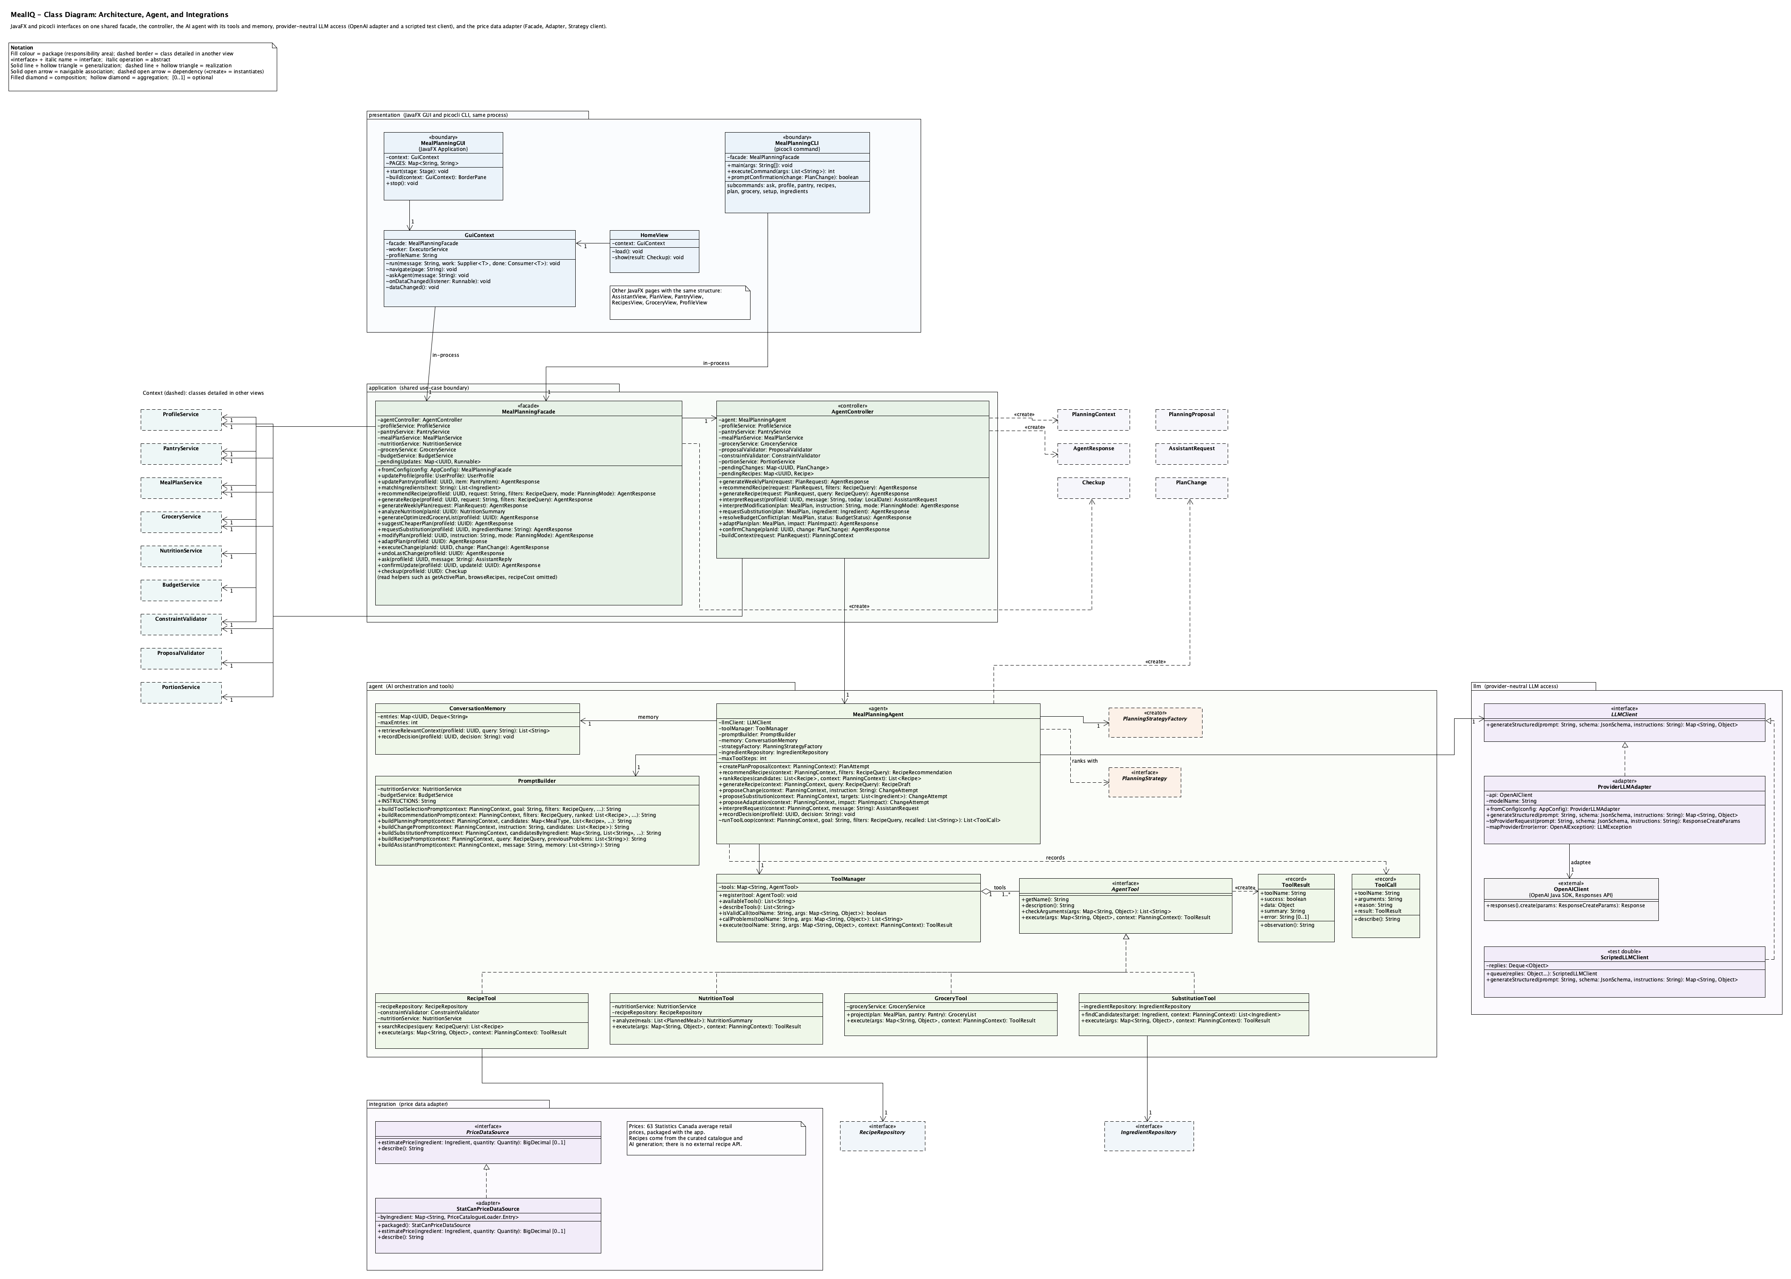

Class diagram: deterministic services and design patterns.
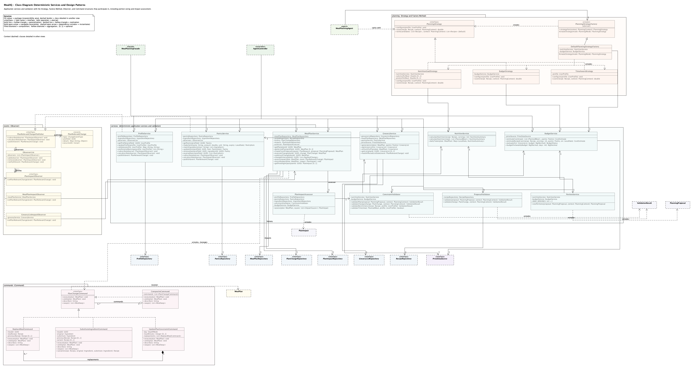

Class diagram: domain entities and value objects.
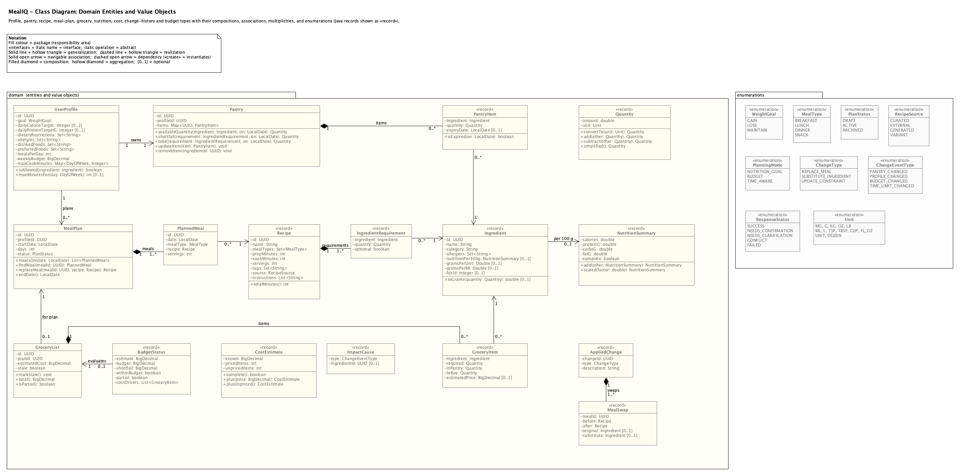

Class diagram: agent contracts and persistence.
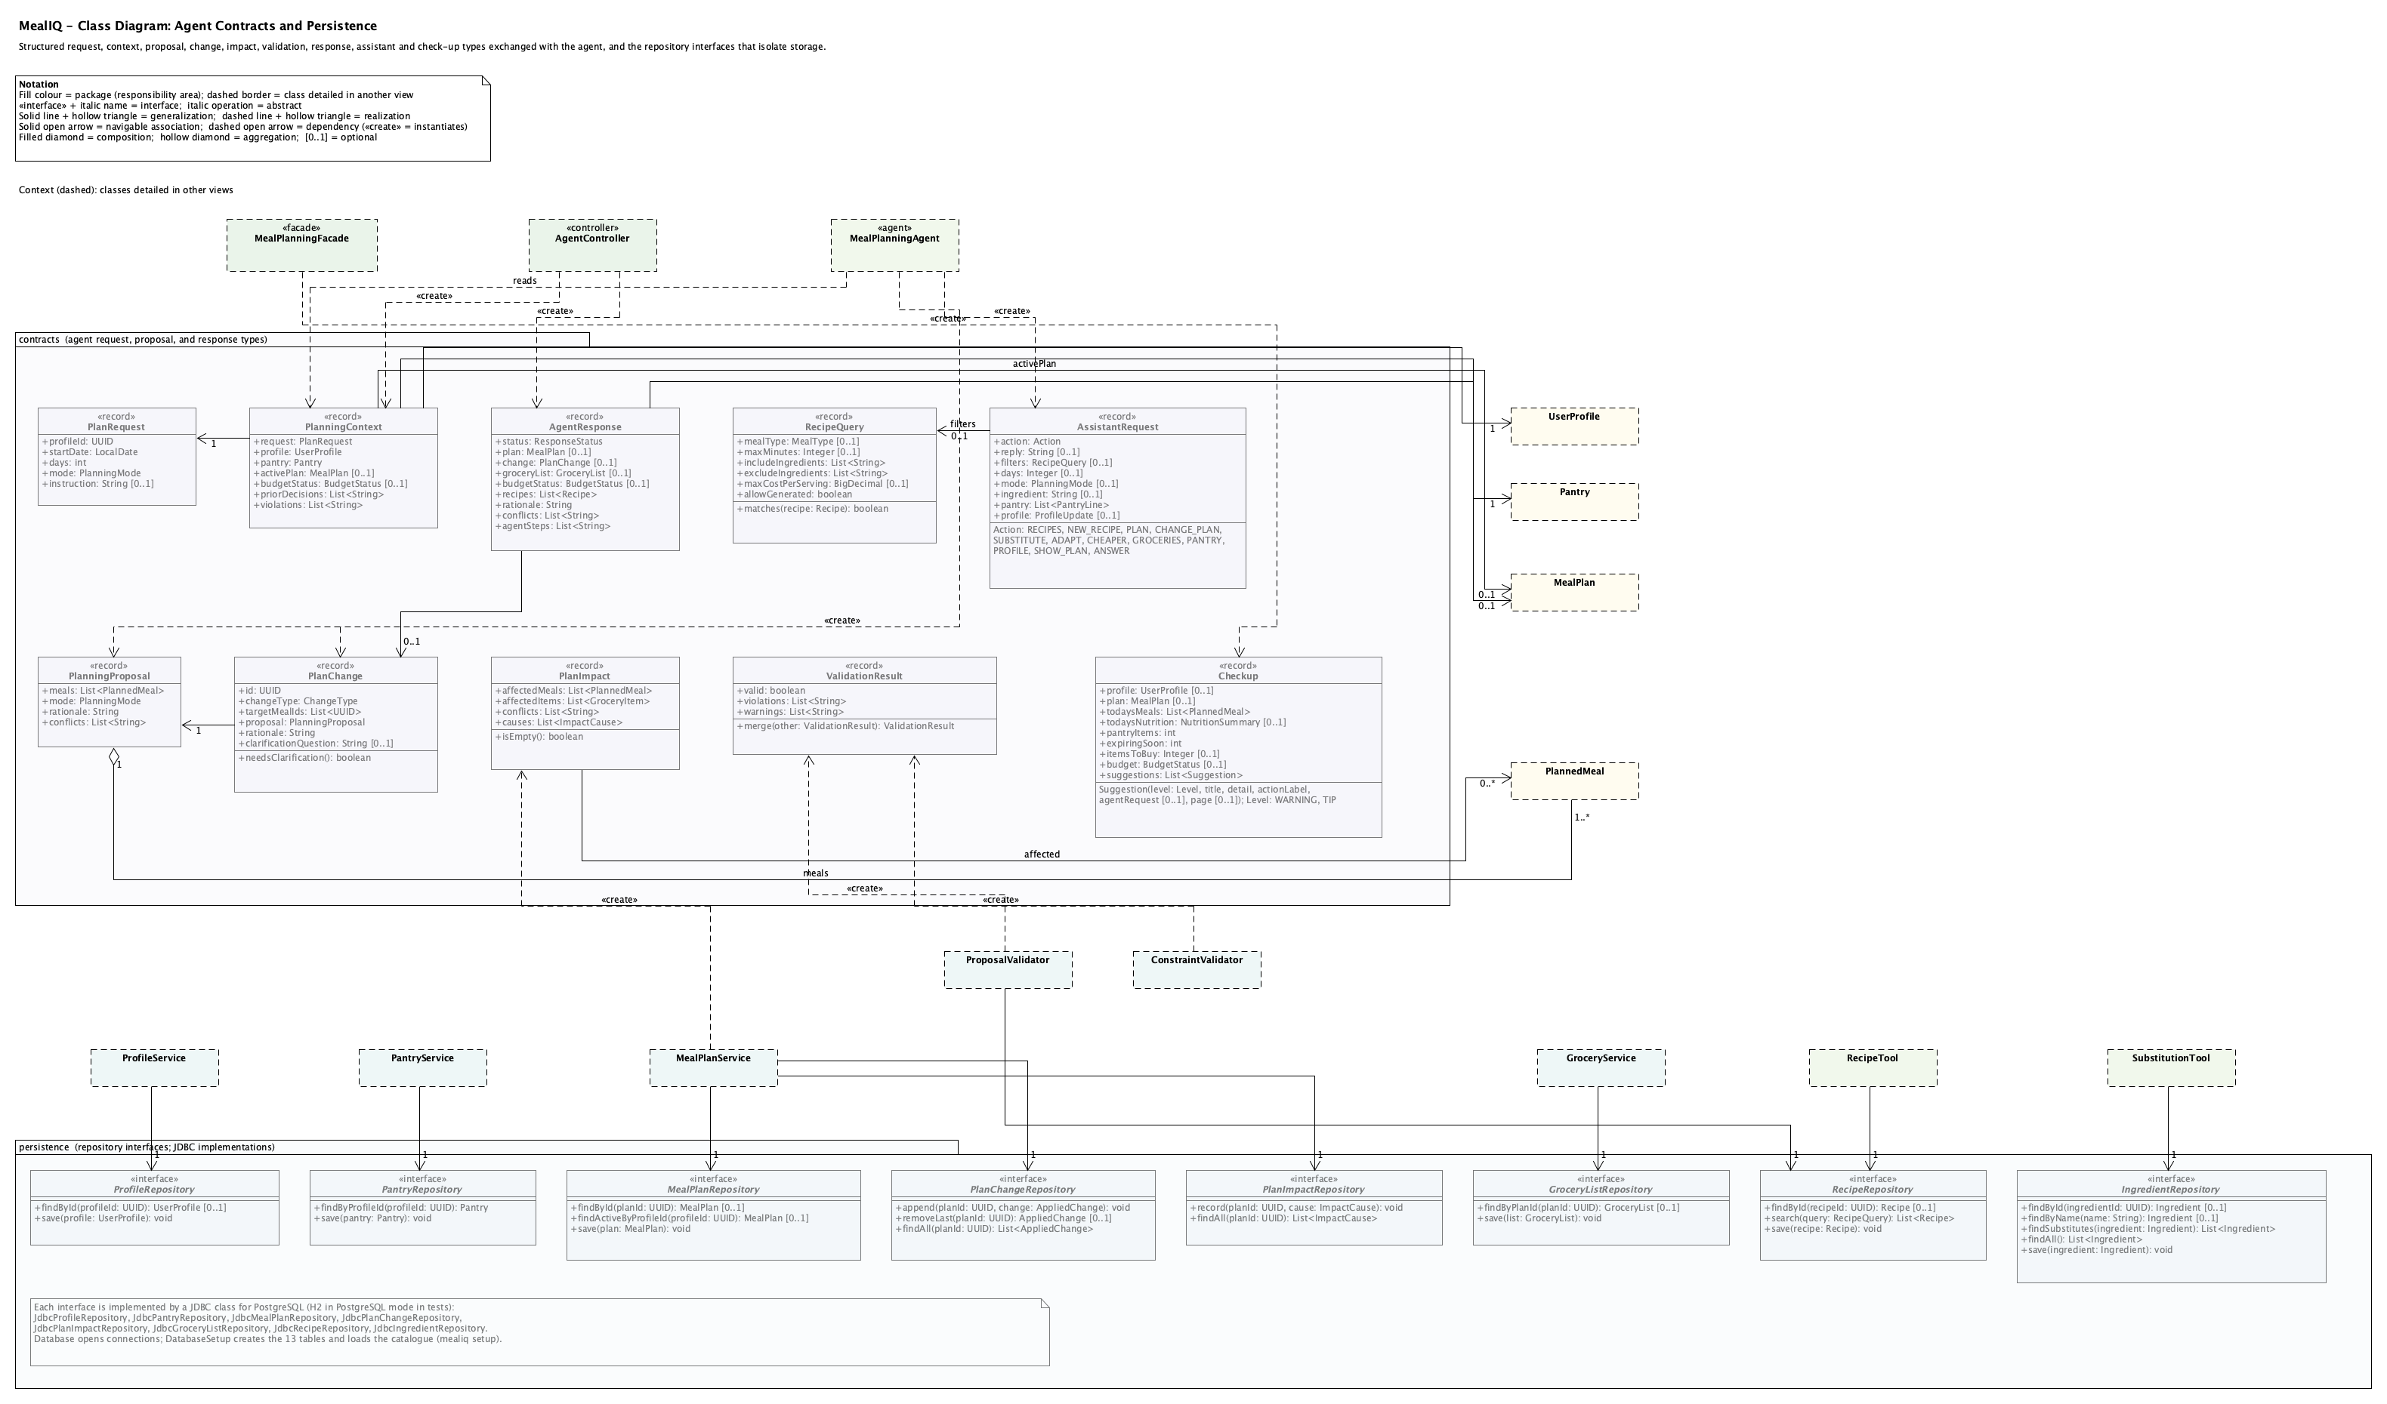

Use-case diagram (N01 and N02 added).
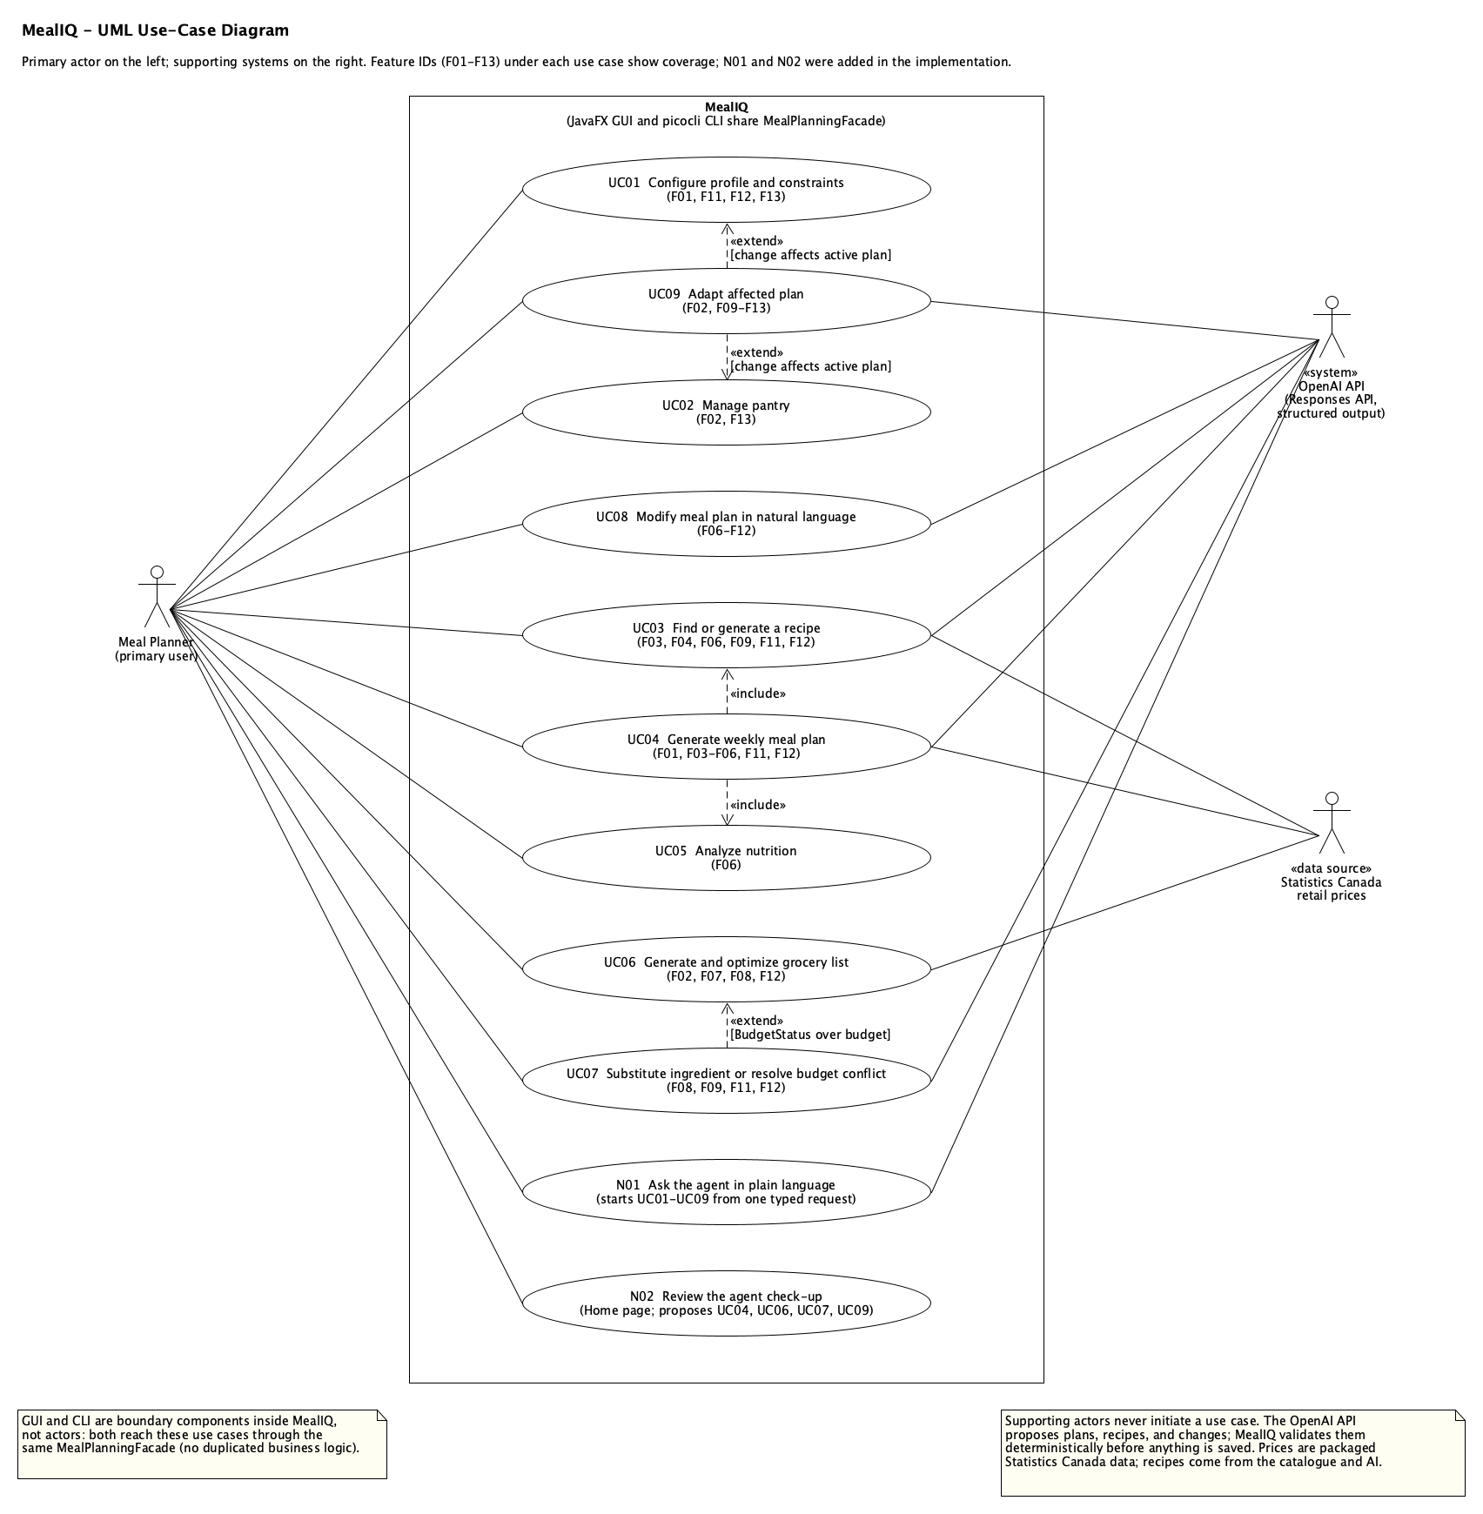

SD01: generate a weekly meal plan (automatic searches and portion sizing added).
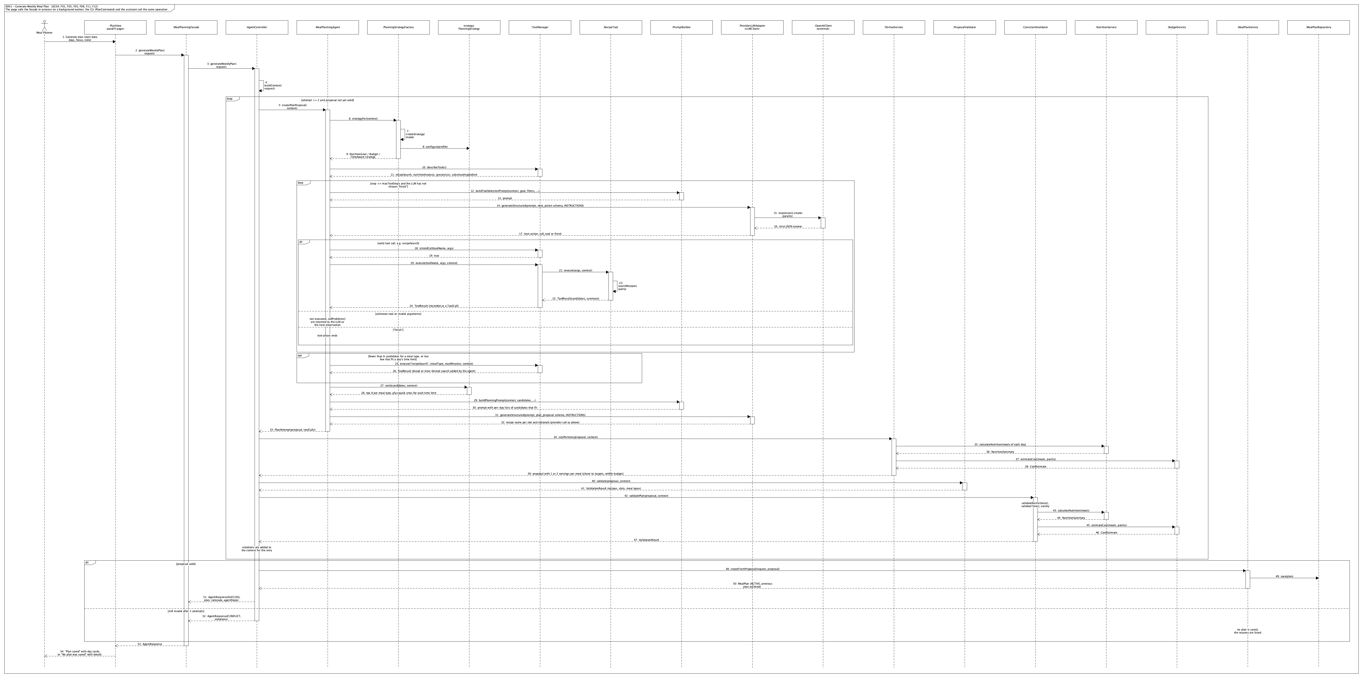

SD02: generate and optimize the grocery list.
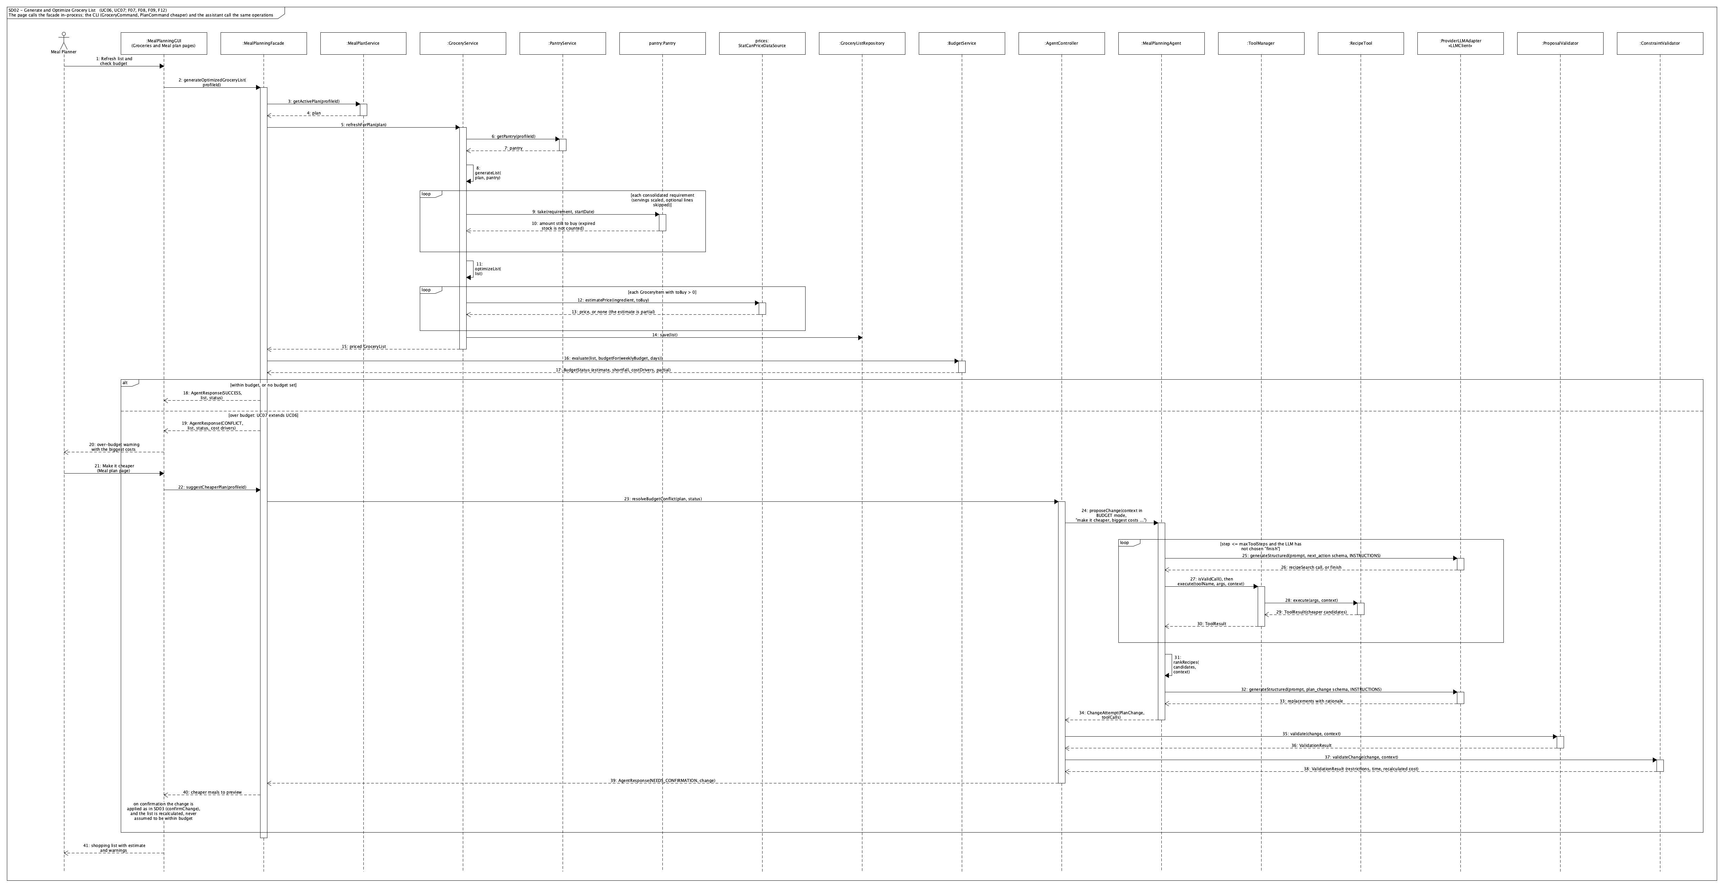

SD03: modify the plan in natural language.
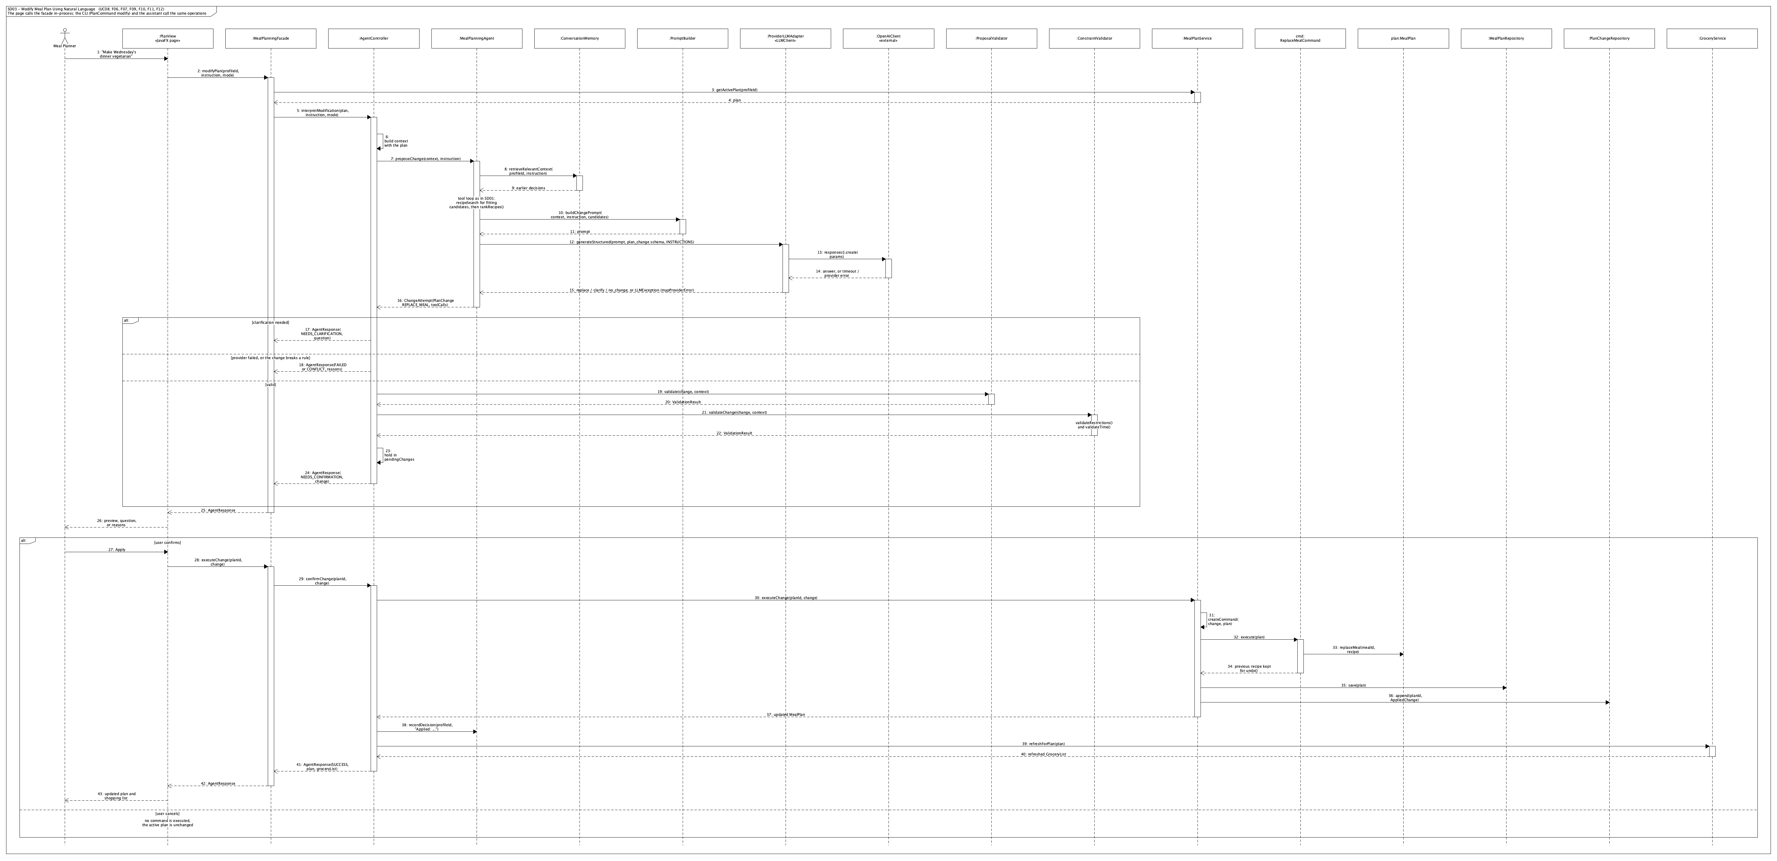

SD04: adapt the plan after a pantry or constraint change.
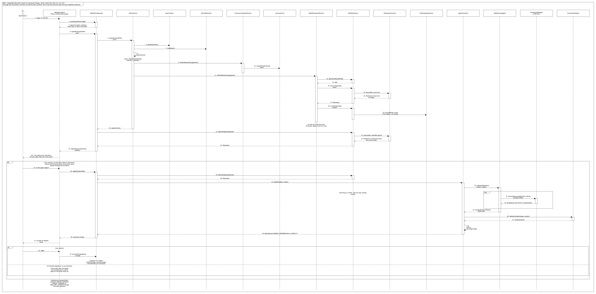

SD05: find or generate a recipe (external recipe provider removed).
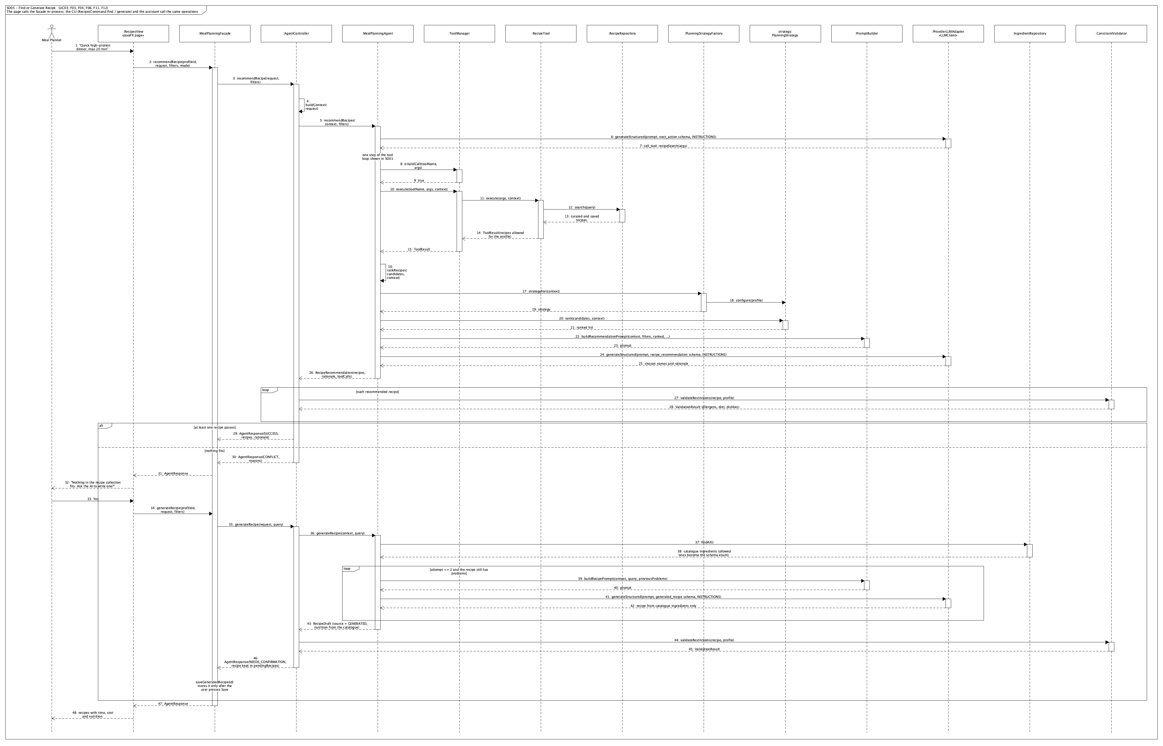

4. Changes and rationale
Each change is recorded as Original design -> Implemented change -> Reason -> Impact.
ID | Original design | Implemented change | Reason | Impact
C01 | Python, FastAPI, React, Typer, SQLAlchemy, Pydantic, pytest | Java 21, Maven wrapper, JavaFX, picocli, JDBC, Jackson, JUnit 5. The Python code (commits up to 756701c) was replaced layer by layer from Oct 30 | The instructor required Java on Oct 30, 2026 | Same architecture and class names. All layers rewritten; Stage 1 technology references updated
C02 | GUI reaches the facade through MealPlanningApi (HTTP) | GUI and CLI call MealPlanningFacade in-process; no API layer | A JavaFX desktop app runs in the same process, so HTTP adds no value (D02 kept its intent: one shared boundary) | MealPlanningApi removed; MealPlanningGUI has no apiBaseUrl
C03 | Facade with 11 operations | Additional read and helper operations: getProfile, getPantry, pantryItem, removePantryItem, searchIngredients, findRecipe, recipeNutrition, recipeCost, browseRecipes, getActivePlan, dailyNutrition, changeHistory, pendingImpact, ensureProfile, localProfileId | The interfaces must display state, and a local single-user app selects profiles by name | Facade remains the only entry point
C04 | LLMClient.generateStructured(prompt, schema) | Adds an instructions parameter; schema is a JsonSchema class that builds strict schemas and validates answers | Fixed system guidance is separate from the prompt; every client, including the test client, guarantees schema-valid answers | ScriptedLLMClient added for tests (D08)
C05 | AgentTool.execute(args) | execute(args, context); tools also provide description() and checkArguments() | Tools need the profile and pantry to filter results; ToolManager.isValidCall needs per-tool argument checks | ToolResult gained a text summary used as the LLM observation; ToolCall records each step
C06 | recommendRecipes returns List<Recipe>; createPlanProposal returns PlanningProposal | Records RecipeRecommendation, PlanAttempt, ChangeAttempt, RecipeDraft return results plus tool calls | The tool calls are shown to the user ("How I did it") and used in tests | AgentResponse gained agentSteps
C07 | Tool loop arguments as an object | next_action schema carries arguments as a JSON string | OpenAI strict structured output cannot express free-form objects | ToolManager parses and checks them; invalid JSON is an observation
C08 | PromptBuilder with five prompt methods | Prompts for tool selection, recommendation, planning, change, substitution, recipe and assistant; shared INSTRUCTIONS | Each agent operation needs its own context; every number in a prompt comes from deterministic services | Costs per serving and the budget appear in prompts (C17)
C09 | UserProfile field validation not specified for allergens | Unknown allergy tags are rejected; DietRules.knownAllergens | An allergy that matches no catalogue tag would never be enforced (D04) | GUI uses checkboxes for diets and allergens
C10 | Pantry requires an existing profile | ensureProfile creates a default profile on first pantry use | Users filled the pantry first and hit a database error | Found in user testing
C11 | Recipe data from curated and external sources | 30 curated seed recipes (catalogue/recipes.json) using only catalogue ingredients, loaded by mealiq setup | Every recipe must have complete USDA nutrition (D09) | RecipeCatalogueLoader; tests check every diet tag against the diet rules
C12 | DatabaseSetup not in the design | mealiq setup creates missing tables and loads ingredients and recipes; idempotent | A reproducible local database | 13 tables in db/schema.sql
C13 | ExternalRecipeAdapter / RecipeDataSource for an external recipe API | Not implemented; search covers curated and saved generated recipes | Time; external ingredients would need matching to the catalogue (D09) to keep nutrition exact. F04 covers gaps | F03 modified; the Adapter pattern is still implemented for the LLM and prices
C14 | Planning strategies return rank only | PlanningStrategy.score public, rank default; UNSCORED for unmeasurable fits | Shared ordering rules; testable scores | Strategy pattern unchanged in role
C15 | PlanningStrategyFactory as interface | Abstract class whose strategyFor creates and configures | The factory method keeps creation and configuration together | Factory Method unchanged in role
C16 | BudgetService.estimateCost returns a Decimal | Returns CostEstimate (known cost, priced and unpriced counts); estimateRecipeCost, evaluate, budgetFor | Many ingredients have no public price; unknown prices must never be guessed | Costs shown as $x+
C17 | Price source unspecified | StatCanPriceDataSource with 63 Statistics Canada prices, rebuilt by scripts/build_prices.py; units whose meaning differs (head vs leaf) left out | Real, citable public data | Budget ranking and checks work on known prices
C18 | ConstraintValidator without dependencies | Takes NutritionService and BudgetService; validatePlan, validateChange, validateTime, validateRestrictions | Plan checks need nutrition and cost | Optional ingredients and dislikes give warnings only
C19 | Cooking-time limit semantics open | The limit applies to each meal on that day | Matches validateTime(meal, profile) | Over-limit meals are violations
C20 | Meal slots by meals per day not specified | MealSlots: 1 = dinner, 2 = lunch and dinner, 3 = plus breakfast, more = snacks; one serving per meal | Deterministic slot structure for validation | Limitation on calorie targets (Section 1)
C21 | Plan variety not specified | Same recipe twice on one day is a violation; more than twice in a plan is a warning | A real run produced the same dish four times | Found in a real OpenAI run
C22 | MealPlanService.createFromProposal(proposal) | createFromProposal(request, proposal) saves the plan as active and archives the previous one | The proposal does not carry the profile and dates | One active plan per profile
C23 | MealPlanService.history: Deque<PlanChangeCommand> in memory | Applied changes are stored in table plan_changes (AppliedChange, MealSwap, PlanChangeRepository); undo rebuilds the commands | Each CLI command is a new process, so in-memory history would be lost | Undo works across sessions and interfaces
C24 | Three commands | Adds CompositeCommand (macro) and PlanChangeCommand.swaps() | One confirmed change may touch several meals and must undo as a unit | Command pattern extended, not replaced
C25 | Substitution edits a recipe | SubstituteIngredientCommand.variant creates a stored recipe variant (RecipeSource.VARIANT) hidden from search | Plans reference recipes by ID; the original recipe must stay unchanged for other meals and undo | New enum value
C26 | MealPlanService.pendingImpacts in memory | Impact causes stored in table plan_impacts (ImpactCause); getPendingImpact recomputes the impact from the current state | Survives between CLI commands; a fixed problem disappears and returns after an undo | New PlanImpactAssessor; PlanImpact gained causes
C27 | Observers call MealPlanService and GroceryService | Same, plus PlanImpactAssessor for the deterministic checks; the grocery list becomes stale only on pantry changes | Profile changes do not change what must be bought | Observer pattern unchanged in role
C28 | AgentController fields | Adds pendingChanges, pendingRecipes, GroceryService; methods generateWeeklyPlan, recommendRecipe, generateRecipe, interpretModification, requestSubstitution, resolveBudgetConflict, adaptPlan, confirmChange, interpretRequest | Confirmation of changes and generated recipes; budget alternatives | Matches SD01, SD03, SD04, SD05 flows
C29 | MealPlanningGUI with show methods | JavaFX app with tabs; showPlan, showChangePreview in PlanView, showGroceryList in GroceryView; background worker for AI calls | JavaFX structure; the window must not freeze during AI calls | GuiContext, Ui, MealIQDesktop launcher
C30 | Not in Stage 1 | New feature N01, the Assistant: MealPlanningAgent.interpretRequest, AssistantRequest (12 actions), MealPlanningFacade.ask/confirmUpdate, AssistantView (first GUI tab), mealiq ask | User testing found the form-based GUI hard to use and not agent-like; one typed request can now drive every feature | Adds an AI routing step in front of existing use cases; all checks and confirmations unchanged
C31 | ConversationMemory retrieval not specified | Keeps the newest entries per profile in memory; keyword match, else the most recent | Sufficient for follow-up requests in one session | Memory does not persist across CLI processes
C32 | One serving per planned meal | New PortionService sizes each meal at 1 or 2 servings after the LLM chooses recipes, moving each day closer to its calorie and protein targets while known costs stay within budget | A real 7-day plan for 3000 kcal and 160 g protein could not get near the target with one serving per meal; portion sizing is arithmetic, which the LLM must not do (D01) | AgentController.generateWeeklyPlan calls it before validation; CLI and GUI show "x2" portions
C33 | Candidates per meal type only | The planning prompt lists, for each time-limited day, only the candidates that fit its limit; quick candidates are always included; the LLM is told not to filter searches by pantry items; when its searches find too few recipes, the agent adds a broad search (and a time-limited one) automatically | In a real run the LLM added every pantry item as an include filter (2-4 candidates left), and placed 40-minute recipes on 20-minute days, so the plan was rejected twice | The same 7-day plan passed on the first attempt in a real run
C34 | Pantry needs exact catalogue names | PantryService.matchIngredients maps everyday names: plurals ("eggs") to one ingredient, general names ("beef") to every kind; the GUI asks which kind, filters the list as you type, and hands unknown names to the agent; the assistant asks which kind instead of guessing; the CLI error lists the kinds | User testing: "beef" was rejected and the list did not narrow while typing | Only exact or plural names are saved without a question
C35 | Not in Stage 1 | New feature N02: MealPlanningFacade.checkup and Checkup (today's meals, pantry and grocery status, suggestions), shown on the GUI Home page; accepting a suggestion sends its request to the agent | User testing: the app felt like a chatbot that waits to be asked; an agent should notice problems (plan no longer fits, expired items, over budget) and propose the fix | Detection is deterministic; every change still goes through the agent's preview and confirmation (D03)
C36 | MealPlanningGUI (tabs, C29) | Sidebar navigation with a Home page and a shared stylesheet (mealiq.css); the Plan page shows day cards, a clear status after generating (saved automatically when every check passes, or not saved, with details folded away) and the change actions on one card | User testing: the plan screen was confusing (no visible save step, about 30 lines of output in a text box) and the look was not engaging | GuiSnapshots renders all seven pages

5. AI tools and collaboration log

AI tools and models
Tool or platform | Model | Used for | Tokens and cost
Claude Code (desktop app, Code tab) | Claude Opus 5.5 (claude-opus-5-5) | Java port of every layer; agent, tools, strategies, commands, observers, validators, CLI, GUI; tests; data scripts (USDA catalogue, Statistics Canada prices); real-run verification; this report | Claude Pro subscription (fixed monthly price; no per-token charge). Claude Code does not report a per-project token total; the main implementation session's context reached about 860,000 tokens before compaction
OpenAI API (runtime LLM of MealIQ) | gpt-5.4-mini-2026-03-17 | The agent's tool selection, choices, explanations, recipe generation and request interpretation at run time, and the development test runs | Total from the OpenAI usage dashboard: to be added

Representative interactions
Task | Input from the team | AI contribution | Human contribution | Outcome
Switch to Java | Instructor requirement (Oct 30) | Proposed the stack (JavaFX, picocli, JDBC, OpenAI Java SDK) keeping the Stage 1 classes; ported layer by layer with tests | Decided to follow the requirement and keep the Stage 1 design | Commits b22fc7f to 8d96a77
API key safety | First project with an API key | Explained .env, .gitignore, spending limits and key revocation; verified the ignore rule; ran one small real call without printing the key | Created the key and .env locally, set a spending limit | Model name verified by a real structured-output call
Commit cadence | Weekly minimum of 5 code commits | Grouped work into one meaningful step per commit, naming feature IDs | Decided when to commit and pushed | Every period above the minimum (Section 6)
Grocery prices | Budget features needed real prices | Proposed Statistics Canada table 18-10-0245-01, asked before downloading, built a reproducible script and left mismatched units unpriced | Approved the download | 63 priced ingredients, citable
Agent quality from real runs | Real OpenAI runs during development | Found and fixed: unknown prices making all costs unknown, the same dish four times in a plan, candidate lists hiding vegetarian dinners, "a dozen eggs" stored as 144 | Reviewed the runs and the fixes | Fixes C16, C21, and the assistant schema (C30)
GUI usability | Hands-on test with screenshots: database error on the pantry, free-text allergies, a dead end in recipe search, "doesn't feel like AI" | Fixed the defects; offered three directions and the cost of each | Chose fixes plus an Assistant tab | New feature N01, checkboxes, friendly errors
Plan failures and agent feel | Second hands-on test: a 7-day plan rejected twice, "beef" rejected, a confusing plan screen, a request for a sidebar and home page, and "an AI agent, not a chatbot" | Traced the failures in the agent steps to over-narrow searches, missing per-day time filtering and fixed portions; redesigned the GUI and added a proactive check-up | Reported the problems with screenshots and decided the order of work | C32-C36, new feature N02; the same plan passed on its first attempt

6. Development and verification summary

Weekly commit summary (Toronto time)
Period | Code commits | Commits
1: Oct 20-26 | 6 (Python implementation, replaced in Period 2) | 37e87c6, 1ef239a, f6cd3e9, 90d685e, 267a167, 3a9b1af
2: Oct 27-Nov 2 | 8 | 756701c, b22fc7f, cd8f536, 91af3ae, 2258b50, 920fcb2, 8d96a77, fd07f1a
3: Nov 3-9 | 14 | 2941ad5, 569cddf, 7032343, 5ebc720, 56ec44e, 17faa1c, ae14036, 16795b1, 3f4d9b9, b0797c1, 06e2277, 9b91d05, b67e319, cfaddd3

Checks performed
- Automated tests: 369 JUnit 5 tests (one PostgreSQL test class is skipped unless a test database is configured). They cover domain values and units, repositories (as contract tests run on H2 and PostgreSQL), the catalogue and price data, every service and validator, the strategies, the commands, the agent loop driven by ScriptedLLMClient (valid, invalid and malformed tool calls, the step limit, filters the LLM cannot widen, fallbacks), the controller and facade flows, and the CLI commands end to end. The build compiles with -Xlint:all and no warnings.
- Real runs: every AI feature was run through the CLI against the real OpenAI API and PostgreSQL 16:
  - recipe recommendation
  - generation
  - 2- and 3-day plans (including budget mode with a rejected first attempt)
  - typed changes with confirmation and undo
  - substitution
  - adaptation after a tighter time limit and after running out of an ingredient
  - priced grocery lists
  - a full Assistant conversation from an empty database
  - a 7-day plan with 20-minute limits on Friday to Sunday, 3000 kcal and 160 g protein, which passed on its first attempt with portions sized up (C32, C33)
  - "I have 2 pounds of beef" through the Assistant, which asked whether it was ground beef or beef sirloin (C34)
- GUI: every page was rendered off-screen with test data (GuiSnapshots) and inspected, and the real app was launched against PostgreSQL without errors. Clicking through the pages by hand was done by the team, not by an automated test.

Important defects found and corrected
- An allergy typed as "peanuts" was saved but matched no catalogue tag, so it would never be enforced. Unknown allergens are now rejected (C09).
- One unknown price made whole recipe costs unknown, which disabled budget ranking. Costs are now lower bounds (C16).
- A real plan repeated one dish four times. Repeating a recipe within a day is now a violation (C21).
- The agent's change candidates were cut to the top 16 overall, hiding the vegetarian dinners a request needed. The agent now sees all results of its own searches.
- In-memory undo history and pending impacts did not survive between CLI commands. They are now persisted (C23, C26).
- Using the pantry before saving a profile caused a database error. A profile is now created automatically (C10).
- "A dozen eggs" was stored as 12 dozen, and "rice" was not matched. Assistant pantry lines are now limited to catalogue names, with explicit amount rules (C30).
- A recipe search with no matches ended without a next step. Generation is now offered.
- A 7-day plan was rejected twice: searches filtered by pantry items left 2-4 candidates, and 40-minute recipes were placed on 20-minute days (C33). One serving per meal could not reach 3000 kcal (C32).
- "beef" was rejected in the pantry because only exact catalogue names were accepted (C34).

Remaining limitations
See Section 1. In addition, ConversationMemory is per process, so a follow-up such as "ground beef" to the agent's question works in the GUI session but not across separate CLI commands.

7. Demonstration index
Feature | Interface | Video segment
F01 User goals and preferences | GUI and CLI | pending
F02 Pantry inventory management | GUI and CLI | pending
F03 Recipe search and recommendation | GUI and CLI | pending
F04 AI recipe generation | GUI and CLI | pending
F05 Weekly meal-plan generation | GUI and CLI | pending
F06 Nutrition analysis | GUI and CLI | pending
F07 Grocery-list generation | GUI and CLI | pending
F08 Grocery-list optimization | GUI and CLI | pending
F09 Ingredient substitution | GUI and CLI | pending
F10 Natural-language plan modification | GUI and CLI | pending
F11 Cooking-time-aware planning | GUI and CLI | pending
F12 Budget-aware planning | GUI and CLI | pending
F13 Dynamic plan adaptation | GUI and CLI | pending
N01 Assistant | GUI and CLI | pending
N02 Agent check-up | GUI | pending

