**Baby mammoth remains discovered**

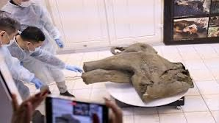

Russian scientists are showing off the remarkably well-preserved remains of a young mammoth from some 50,000 years ago, which was found in the permafrost-covered region of Yakutia.

The female mammoth has been nicknamed "Yana" after the river basin in which it was discovered this summer.

Studies are now being carried out to work out her exact age at death, estimated at “one year old or a bit more”.