**World's First Nuclear Fusion Power Plant Being Built in Virginia**

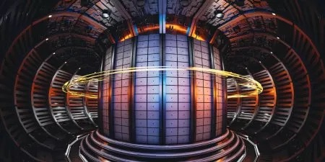

Commonwealth Fusion Systems (CFS), a spinout from Massachusetts Institute of Technology, announced plans on Tuesday to build the world's first grid-scale commercial nuclear fusion power plant in Chesterfield County, Virginia.

The ARC, (Affordable, Robust, Compact) fusion reactor plant will be located at the James River Industrial Park and aims to revolutionize clean energy production.

"This is a historic moment," Bob Mumgaard, Chief Executive Officer and co-founder of CFS, said in a statement. "In the early 2030s, all eyes will be on Chesterfield County as the birthplace of commercial fusion energy."

The plant is expected to generate 400 megawatts of electricity, enough to power approximately 150,000 homes or large industrial facilities.