**NASA probe makes closest ever pass by the Sun**

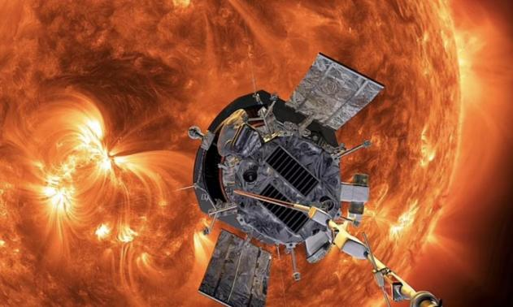

NASA's Parker Solar Probe made history by flying closer to the Sun than any other spacecraft, with its heat shield exposed to temperatures over 1,700 degrees Fahrenheit.

Launched in 2018, the probe is on a seven-year mission to deepen scientific understanding of the Sun and help forecast space-weather events that can impact Earth.

The spacecraft's historic flyby occurred at a distance of 3.8 million miles from the Sun, marking the first of three record-setting close passes expected in the coming years.