**BYD contractor denies ‘slavery-like conditions’ claims by Brazilian authorities**

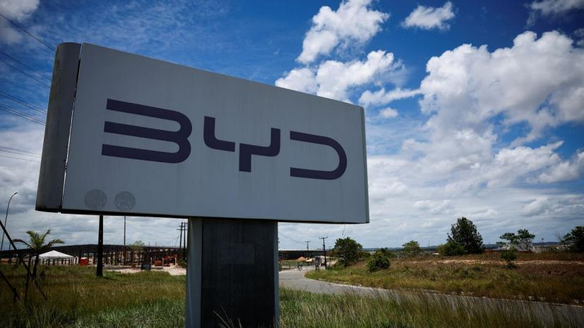

Jinjiang Group, a contractor for giant Chinese electric vehicle maker BYD, said Thursday that Brazilian authorities’ portrayal of its employees as “enslaved” was inconsistent with the facts and that there were translation misunderstandings.

Brazilian labor authorities said Wednesday that they had found 163 Chinese nationals working in “slavery-like conditions” at a construction site for a BYD-owned factory in Brazil’s Bahia state. BYD said then that it had cut ties with the firm that hired the workers and was working with authorities.

“Being unjustly labeled as ‘enslaved’ has made our employees feel that their dignity has been insulted and their human rights violated, seriously hurting the dignity of the Chinese people. We have signed a joint letter to express our true feelings,” Jinjiang said on its official Weibo account.

Their statement was reposted by Li Yunfei, general manager of branding and public relations at BYD, on his own Weibo account. He accused “foreign forces” and some Chinese media of “deliberately smearing Chinese brands and the country, and undermining the relationship between China and Brazil.”