**South Korea votes to impeach acting president Han Duck-soo**

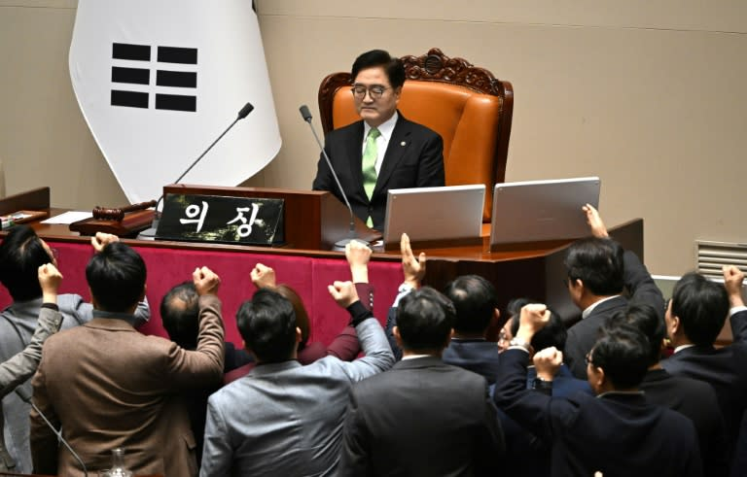

South Korea has voted to impeach its acting president Han Duck-soo, two weeks after parliament voted to impeach its President Yoon Suk Yeol.

A total of 192 lawmakers voted for his impeachment, more than the 151 votes needed for it to succeed.

Prime minister Han took over the role after President Yoon was impeached by parliament following his failed attempt to impose martial law on 3 December.

The opposition first filed an impeachment motion against Han on Thursday after he blocked the appointment of three judges that parliament had chosen to oversee Yoon's case.

Korea's Constitutional Court is typically made up of a nine-member bench. At least six judges must uphold Yoon's impeachment in order for the decision to be upheld.

There are currently only six judges on the bench, meaning a single rejection would save Yoon from being removed.

The opposition had hoped the three additional nominees would help improve the odds of Yoon getting impeached.

This is the first time an acting president has been impeached since South Korea became a democracy.

Finance minister Choi Sang-mok is set to replace Han as acting president.

Han was supposed to lead the country out of its political turmoil, but opposition MPs argued that he was refusing demands to complete Yoon's impeachment process.

Like Yoon, Han's impeachment will need to be confirmed by the constitutional court, which has 180 days to rule on whether the impeachment should be upheld.