**Toyota To Build Lexus EV Plant In China**

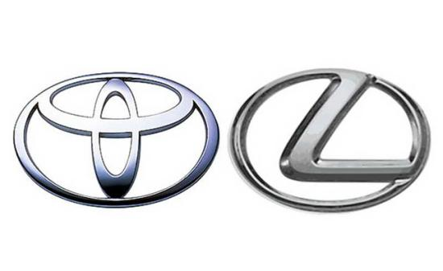

Toyota plans to build an electric vehicle factory in Shanghai for its luxury Lexus brand, media reports said on Tuesday, at a time when many foreign automakers are struggling in China.

The world's top-selling automaker aims to bring the factory online around 2027 and will operate it without a local partner, Japan's Nikkei business daily said, citing sources.

That would make it the first Japanese vehicle factory of its kind in China, according to the Nikkei.

Public broadcaster NHK said Toyota hoped that building the new plant would help it catch up in the Chinese market.

China overtook Japan as the biggest vehicle exporter last year, helped by its dominance in EVs, a sector where Japanese firms have lost ground by focusing on hybrid vehicles.

Lacklustre consumer spending and tough competition in several markets is making life hard for many automakers.

But Toyota's strategy to offer a range of vehicles, including hybrids, has paid off in markets such as the United States.

The planned Shanghai factory would mainly produce Lexus models, the Nikkei said, adding that Toyota mostly sells Japanese-made Lexus vehicles in China.