**Why is Indonesia moving its capital city?**

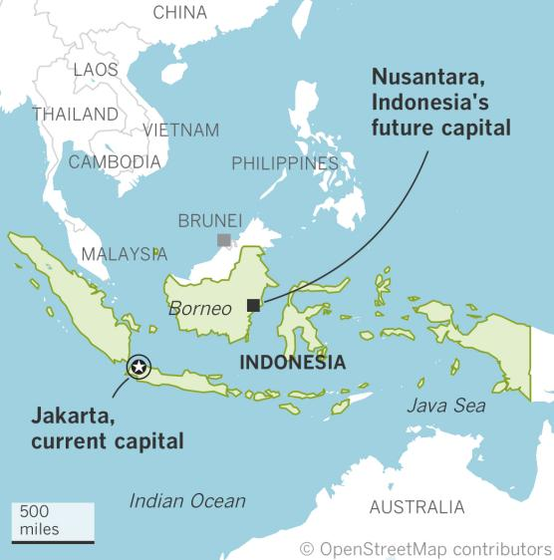

The idea of moving Indonesia’s capital away from Jakarta has existed since the first days of Indonesia’s independence.

The primary driver for this move is the potentially irretrievable impact of land subsidence in Jakarta, caused by rapid urbanisation and excessive groundwater extraction. Jakarta is one of the fastest sinking cities in the world. Many commercial and residential areas, especially in the north of the city, have already been destroyed due to flooding which has also been exacerbated by climate change. Some areas are sinking by as much as 25cm per year and estimates suggest large swathes of the city could be fully submerged by 2050.

Other motivations for the relocation are related to spreading the distribution of wealth and activity more evenly throughout Indonesia, the economy of which has historically been centred on the island of Java.

And so in 2019, the country’s president announced a bold plan to carve a new capital, located in East Kalimantan, on the island of Borneo, out of the rainforest 800 miles away across the Java Sea. He named the city Nusantara — or “archipelago” — for the 17,508 islands that make up the world’s fourth-most populous nation.