**Trump supports immigration visas backed by Musk**

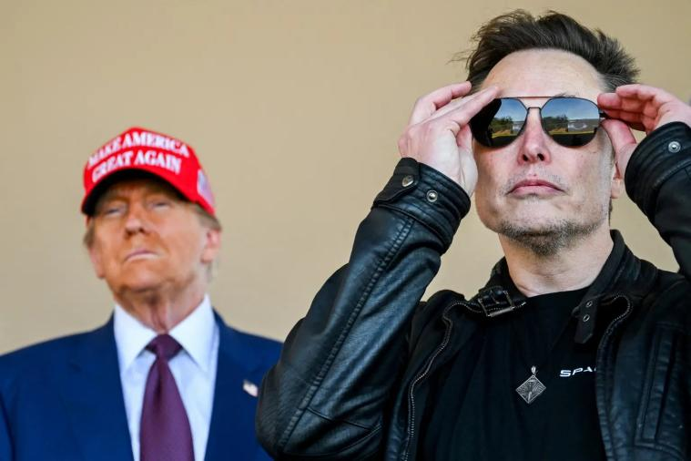

President-elect Trump told The Post Saturday he supports immigration visas for highly skilled workers, appearing to side with Elon Musk in the roiling intra-MAGA debate on the issue.

“I’ve always liked the visas, I have always been in favor of the visas. That’s why we have them,” Trump said by phone, referring to the H-1B program, which permits companies to hire foreign workers in specialty occupations.

“I have many H-1B visas on my properties. I’ve been a believer in H-1B. I have used it many times. It’s a great program,” added Trump, who restricted access to foreign worker visas in his first administration and has been critical of the program in the past.

Musk and other tech barons argued this week that the H-1B visa program is critical to ensuring American companies can find highly skilled labor which may not be easily available in the U.S. labor force and must be expanded.

MAGA hardliners want Trump to follow through with his promise to promote US workers and impose tougher restrictions on immigration.

Trump’s Saturday comments come a day after Musk vowed to go to “war” on the issue, telling one mocking opponent to go “f–k yourself.”