**William, King Charles Hold Meetings As Abdication Looms**

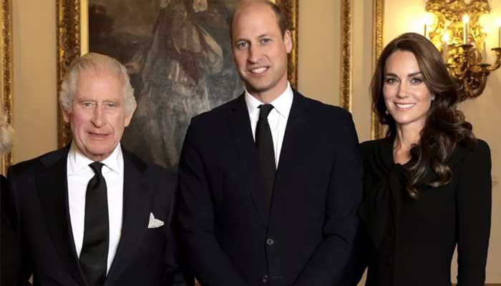

Prince William is reportedly holding private meetings with King Charles III to discuss the future of the throne as speculation grows over an impending abdication.

Buckingham Palace announced that the king was diagnosed with an undisclosed form of cancer in February. His treatment is believed to be ongoing.

The possibility of his first-born son stepping into his role sooner than expected has been a topic of discussion over the last few months.