**Answer 1:**

**Step 1: Calculate the time spent on each task in the base system**

Since the system handles **10,000 accesses per second**, the time per request is:



Breaking it down:

* Processing time: **0.00002 sec** (20%)
* Disk access time: **0.00003 sec** (30%)
* Network transfer time: **0.00005 sec** (50%)

**Step 2: Performance Improvement for Each Option**

1. **Option 1: Upgrading Disk to 40MB/sec**
   * Disk speed doubles → Disk time reduces by **50%**
   * New disk access time = **0.000015 sec**
   * New total time: **0.000085 sec**
   * New performance: **11,765 accesses/sec**
2. **Option 2: Upgrading Processor to 800MHz**
   * CPU speed increases **1.6x** → Processing time reduces to **0.0000125 sec**
   * New total time: **0.0000925 sec**
   * New performance: **10,811 accesses/sec**
3. **Option 3: Upgrading Both Disk & Processor**
   * New processing time: **0.0000125 sec**
   * New disk time: **0.000015 sec**
   * New total time: **0.0000775 sec**
   * New performance: **12,903 accesses/sec**

**Step 3: Cost-Performance Analysis**

| **Option** | **Performance Gain** | **Additional Cost** | **Cost per 1,000 accesses/sec** |
| --- | --- | --- | --- |
| **Option 1 (Disk)** | **1,765** | **$1,000** | **$567** |
| **Option 2 (Processor)** | **811** | **$800** | **$987** |
| **Option 3 (Both)** | **2,903** | **$1,500** | **$517** |

**Step 4: Conclusion**

* **Option 3 (Both Upgrades) gives the best performance (12,903 accesses/sec) and the lowest cost per 1,000 accesses ($517).**
* **Option 1 (Disk Upgrade) is slightly less cost-effective but still better than Option 2.**
* **Option 2 (Processor Upgrade) is the least cost-effective.**

**Final Recommendation:**

**Option 3 is the best choice** because it provides the highest performance increase for the lowest cost per additional access.

-------------------------------------------xxxxx------------------------------------------

**Answer 2:**

**Step 1: Generalized Speed-Up Formula**

Amdahl’s Law is typically:



However, due to interdependency, we modify the formula:

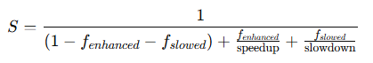

where:

* **f enhanced​** = fraction of tasks that are sped up
* **f slowed​** = fraction of tasks that are slowed down
* **speedup** = factor by which the enhanced tasks speed up
* **slowdown** = factor by which the slowed-down tasks slow down

**Step 2: Speed-Up Equations for Each Option**

1. **Option A (Enhancing A, dependency slows down 2f_A)**

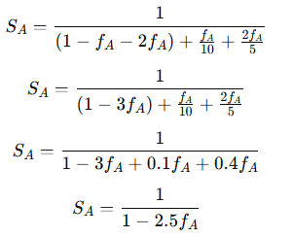

**2.Option B (Enhancing B, dependency slows down 0.5f_B)**

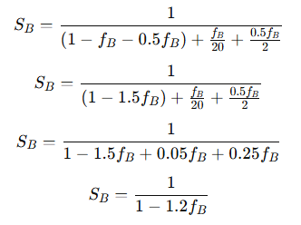

1. **Option C (Enhancing A, dependency slows down f_A)**

SS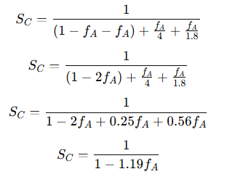

**Step 3: Choosing the Best Option**



* + The denominator decreases quickly, meaning speed-up drops fast as **f A** increases.
  + Large slowdown impact, making it less effective.



* + The best balance between speed-up and slowdown.
  + Even with a high **f B** the performance does not degrade significantly.



Similar to Option B, but provides **less improvement** than Option B.

**Final Recommendation:**

**Option B is the best choice** because:

* It provides the highest speed-up **(20× improvement for B)** while minimizing slowdown.
* The fraction of instructions that get slowed down **(0.5f_B)** is much smaller than in other cases.
* The overall performance gain is **more stable** compared to the other options.

--------------------------------------------xxxxx-------------------------------------

**Question:**

A laboratory is evaluating three different computer systems for its workload, which consists of three programs with relative usage:

* **Program 1:** 45%
* **Program 2:** 35%
* **Program 3:** 20%

The execution times (in seconds) for each program on the three systems are as follows:

| **Programs** | **System 1** | **System 2** | **System 3** |
| --- | --- | --- | --- |
| **Program 1** | 1.0 sec | 2.0 sec | 1.5 sec |
| **Program 2** | 10.0 sec | 7.0 sec | 5.0 sec |
| **Program 3** | 5.0 sec | 3.0 sec | 4.0 sec |

The cost of each system is:

* **System 1:** $8,000
* **System 2:** $5,000
* **System 3:** $6,500

**(1) Which system provides the best performance for the laboratory?**

**(2) Considering the costs, which system is the best choice based on cost-performance analysis?**

**Answer:**

**Step 1: Calculate the Weighted Execution Time for Each System**

To determine which system is the fastest, we calculate the **weighted execution time** for each system using:



where:

* w1=0.45 , w2=0.35, w3=0.20 (weights based on usage)
* T1​,T2​,T3​ are execution times for each program

**System 1:**

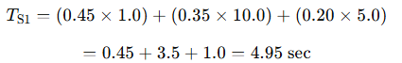

**System 2:**

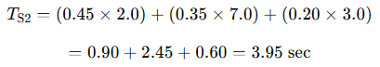

**System 3:**

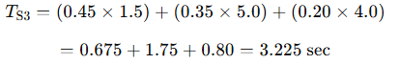

**Step 2: Identify the Best Performance System**

* **System 1:** 4.95 sec
* **System 2:** 3.95 sec
* **System 3:** **3.225 sec (Best performance)**

💡 **System 3 has the lowest weighted execution time, meaning it provides the best performance.**

**Step 3: Cost-Performance Analysis**

We now compute the **cost per performance unit**, using:

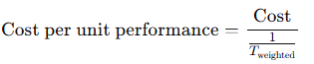

or simply:

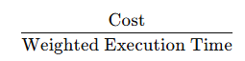

| **System** | **Execution Time (sec)** | **Cost ($)** | **Cost per sec ($/sec)** |
| --- | --- | --- | --- |
| **System 1** | 4.95 sec | $8,000 | **$1,616/sec** |
| **System 2** | 3.95 sec | $5,000 | **$1,266/sec** |
| **System 3** | 3.225 sec | $6,500 | **$2,015/sec** |

**Step 4: Choose the Best System Based on Cost-Performance**

* **System 3 has the best performance**, but it is the most expensive per unit of performance ($2,015/sec).
* **System 2 offers the best cost-performance ratio**, providing good performance at a much lower cost ($1,266/sec).

**Final Recommendation:**

✅ **System 2 is the best choice** because it balances performance and cost most effectively. While System 3 is the fastest, its cost-performance ratio makes it less attractive compared to System 2.