\*\*EE488 - Computer Architecture

Homework Assignment #2

Student ID: 20293

Name: Aye Myat Thiri Khin

1. Stack Architecture and Virtual MachinesStack Architecture and Reverse Polish Notation (RPN)A stack-based architecture processes instructions using a last-in, first-out (LIFO) approach. Instead of relying on registers for computation, it pushes and pops values onto a stack. This method is commonly used in expression evaluation, such as Reverse Polish Notation (RPN).

For example, consider the arithmetic expression:(3 + 4) \* 5In RPN format: \*\*3 4 + 5 \*\*\*

Step-by-step evaluation using a stack:

Push 3 onto the stack.

Push 4 onto the stack.

Apply + operator: Pop 4 and 3, compute 3 + 4 = 7, and push 7 onto the stack.

Push 5 onto the stack.

Apply \* operator: Pop 5 and 7, compute 7 \* 5 = 35, and push 35 onto the stack.

The final result on the stack is 35.

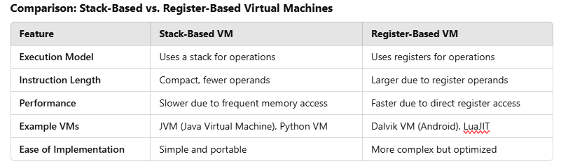

2. Processor Design Metrics & BenchmarkingProcessor Design MetricsA processor's performance is influenced by several key metrics:

Clock Speed (GHz): Determines how fast a processor executes instructions.

Instructions per Cycle (IPC): Measures how many instructions are executed per clock cycle.

Power Efficiency (Watt per Performance): Balances performance with energy consumption.

Cache Size: Affects how quickly the processor accesses frequently used data.

Scalability & Parallelism: Determines support for multi-core and multi-threading.

Benchmarking Tools

Benchmarking tools are used to measure processor performance in real-world applications. Common tools include:

SPEC CPU: Measures integer and floating-point performance.

Geekbench: Evaluates CPU performance for single-core and multi-core tasks.

Cinebench: Tests rendering performance using CPU computation.

PassMark: Compares processors using a variety of workloads.

These benchmarks help users and engineers make informed decisions about hardware performance and efficiency.