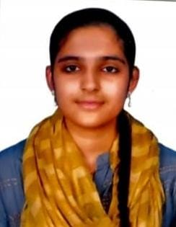Ayesha Tahoora

CSD Intern

Email ID: 2406721@cognizant.com

Mobile: +917892799960

Address: R&R Ladies Hostel, Egattur, Chennai-600032, Tamil Nadu.

LinkedIn: https://www.linkedin.com/in/ayesha-tahoora/

**CAREER OBJECTIVE**

Looking forward to contribute to a growth-oriented company by applying my skills and continuously learning to add value to the team and organization.

**WORK EXPERIENCE**



**CSD Intern | April 2025 – Present**

Currently undergoing training program on ADM DotNet Standard where I’m learning .Net, C#, Entity Framework Core and Bootstrap, gaining strong core and technical knowledge in these courses.

**ACADEMIC QUALIFICATION**

* **Cambridge Institute of Technology North Campus, Bangalore.**

BE, Computer Science and Engineering | Dec 2021 – 2025 | CGPA – 8.5

* **MES BRS PU College, Bangalore.**

Class 11TH & 12TH PUC | 2019 – 2021 | 92%

* **Deva Matha Central School, Bangalore.**

SSLC | 2019 | CGPA –8.0

**PROFESSIONAL SKILLS**

* Software skills known: Working knowledge in MS Office, VS Code and community, GitHub .
* Programming skills known: Python, Java, C#, SQL, HTML.
* Adapting to any environment or culture.
* Ability of willingness to learn new things.
* Ability to work independently or as a part of a team.
* Hard worker and has the ability to motivate myself and others.
* Good at oral and written communication

**PROJECT WORK**

* **Bank Loan Management System**

This system is designed to automate HR tasks, making the process more efficient and error-free. It allows HR managers to focus on strategic tasks by reducing the time spent on administrative tasks. The Employee Management System is a crucial tool for any organization aiming to streamline its HR operations.

**WORKSHOPS & CERTIFICATIONS**

* Completed Internship in Machine Learning in Python from Corizo, Bangalore.
* Completed deep dive into Python libraries and application projects.

**PERSONAL DETAILS**

* Languages known : English, Kannada, Hindi.
* Domain Interests : Programming and Development.
* Hobbies : Cooking, Travelling, Singing.