Daniel Ayer
DS681

Image-to-Video Semantic Retrieval

via

Object Detection

In this project we used a bank of query images to identify items in a source video. The source video was segmented into 1 second frames. Each frame had the YOLO26n model detect objects within the frame. These results were then stored in a DataFrame. Each row of this DataFrame stored information about each one second frame. A bank of test images were analyzed using YOLO26n. Video segments from the original video containing those items were identified and collated into YouTube embed URLs.
Th system identified 5 objects within the query image set that were also in the source video. This produced 84 independent video clips, with at least 16 being misidentified as ‘airplane’ or ‘boat.’

Infrastructure

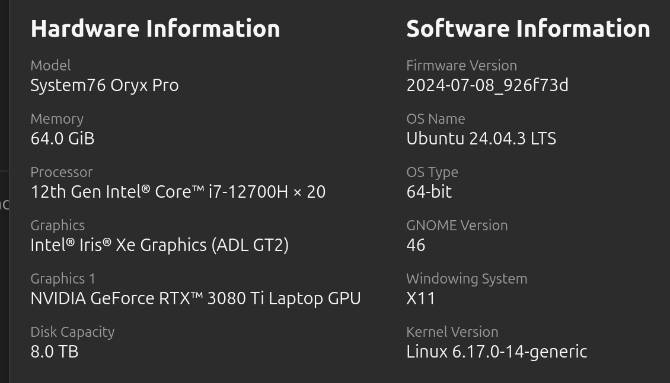 | The project was run on Ubuntu 24.04.3 LTS using NVIDIA GeForce RTX 3080 Ti Laptop GPU.

YOLO26n (You Only Look Once)

The detector chosen for this project was YOLO26n. YOLO was used in the demo code, and a cursory search for detectors showed YOLO26n to be the best off the shelf option available. The detector was loaded from Hugging Face and fine tuned on the ‘carparts-seg.yaml’ dataset. The YOLO26n model loads locally and updates a local .pt file as it goes. The final trained YOLO26N model was used for the remainder of the project.

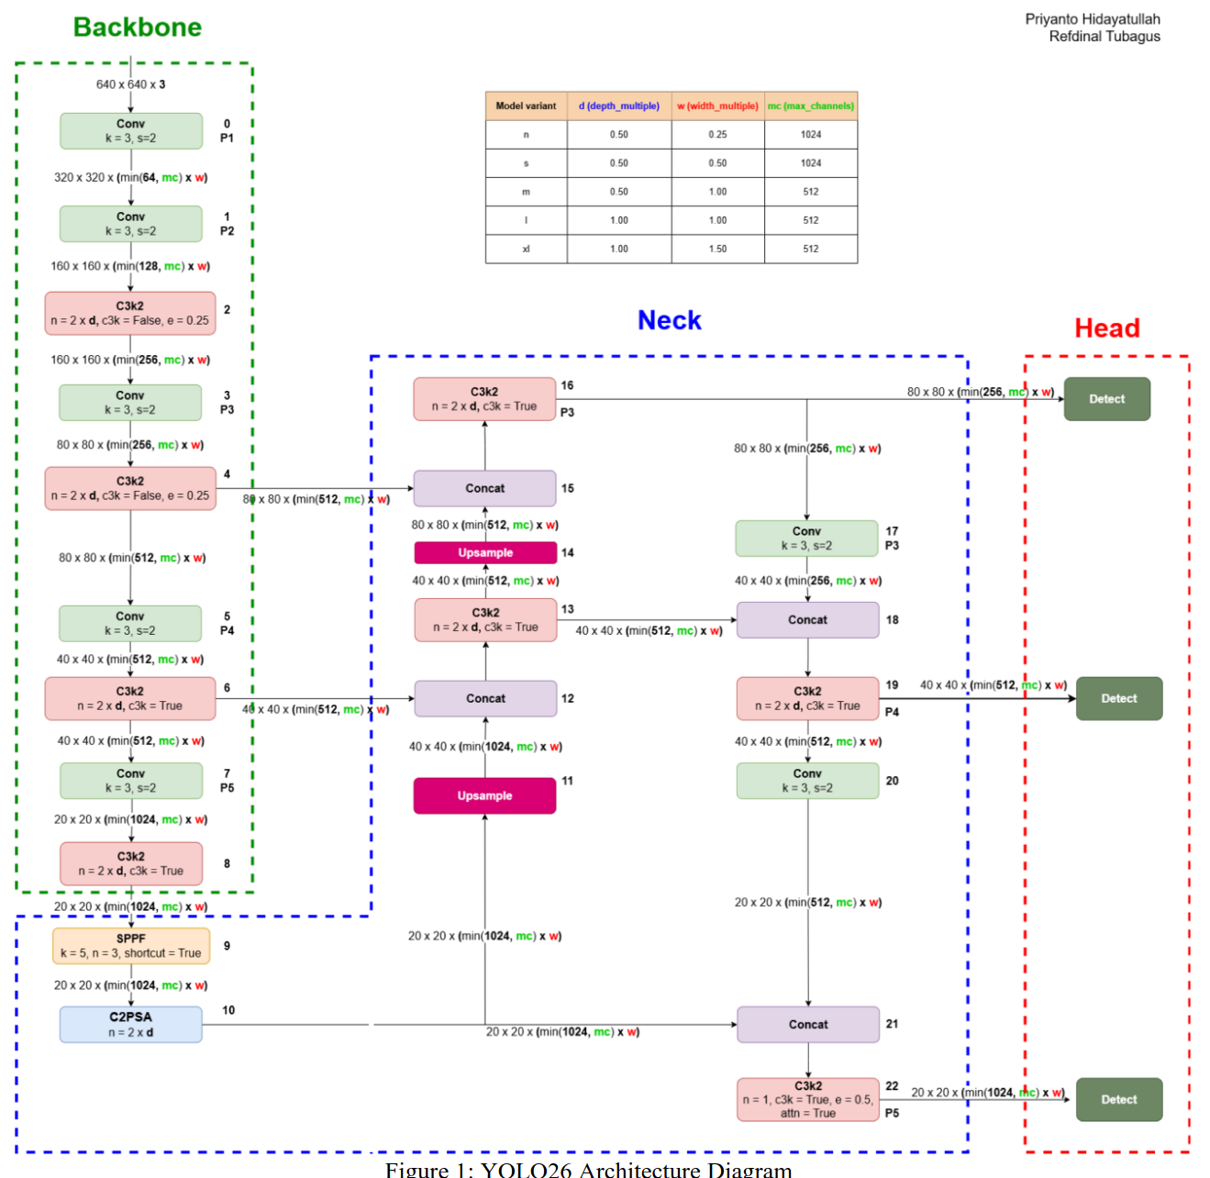 | The YOLO26 architecture is broken into 3 components: Backbone, Neck, and Head.  Backbone: The Backbone consists of 26 Convolutional Layers. These are in flavors of standard Conv Layer, Specialized Conv Layers, and Spatial Pyramid Pooling layers for feature extraction.  Neck: The Neck consists of 9 layers of Convolution, Up-sampling, and Concatenating layers.  Head: The Head consists of the 5 layers consisting of Concatenating, Convolution, and Detect layers for final detection.
YOLO26 Architecture Diagram

Video Sampling Strategy

The original video was split into 559, 1 second captures referred to here as ‘frames.’ This was accomplished using ffmpeg and yt-dlp as described in the assignment. The download and parsing of the source video was a pre-processing offline step in respect to this project. The frames were then run through YOLO26n, and the results stored in a DataFrame (‘df_boxes’) for further analysis.
Each row of the DataFrame represented information about the frame in question. The ‘time_index’ of the frame, the ‘class_label’ found within the frame, the ‘xyxy’ coordinates of the bounding box, and the ‘confidence_score’ for the box. This was then saved as ‘df_boxes.csv’.
This created a DataFrame of each 1 second frame of the video. Each row described what was found in the frame, what time the frame represents in the original video, location of the bounding box around the object in the frame, and the confidence associated with the box. Multiple objects within the frame would each be recorded in their own row.
The logic behind the strategy was to attempt a relatively exhaustive sampling within our computational limits. A split of 1 second per frame was chosen to attempt to accurately sample the video without creating unduly large storage overhead, and while limiting the information loss from or aliasing caused by the sampling window time frame.
The compute infrastructure available was more than adequate to run the project with this level of image processing.

Image_to_Video Matching Logic

The query image database came from ‘aegean-ai/rav4-exterior-images’. The trained model was loaded and used to process each image in the query image set. These identifications returned a string representing the object located in the sample image. Since we used the same detector again, this string became our identifier. We then found all instances in the df_boxes DataFrame which has this ‘class_label’.
We identified video segments containing the query image objet by calculating the difference between frame timestamps. A difference of more than 1 second resulted in almost 660 independent video segments. This is due to multiple objects being detected in single frames, allowing for more video segments than seconds in the original video. A plot was created to identify the number of segments created by differing ‘delta_t’. ‘delta_t’ is the length of time the object must be absent before the video is considered discontinuous.

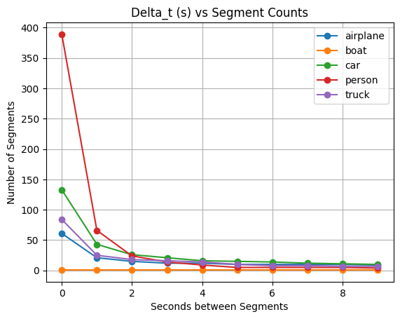 | Here, we see the plot of how many segments each delta_t produces. A delta_t of 2 was chosen as it begins the asymptotic like leveling off of the Number of Segments for each series. It also reduces the number of total clips to process significantly.

Each class represents an object detected in the query image. All query images in the query image set were run. A playlist of YouTube video segments was created for each class. A dictionary of form {class_{i}:{url₁, …, url_{n}} was created for each object class detected. This was then saved as a JSON file, ‘playlist.json’. Each url represents an embed url with a start and stop variable to delineate the clip. Each clip represents a series of frames in which the detector identified the query image class object.

Failure Cases and Limitations

The detector identified ‘airplane’, and ‘boat’ objects that were not included in the original source video. It was detected ‘car’ and ‘truck’ even though one vehicle was present in the source video throughout. These can safely be collapsed into one category.
The project produced many single second video clips. Adjusting hyperparameters to identify the ideal number of clips of minimum length was challenging. In the end clips of too short duration were removed.
The YouTube embed format did not work on my system. I was able to spot-verify the time indexes manually.

https://docs.ultralytics.com/models/yolo26/
https://github.com/ultralytics/assets/releases/download/v0.0.0/carparts-seg.zip
https://arxiv.org/abs/2602.14582

