Daniel Ayer
DS 685

Assignment 2

My repo URL is:
This startup script should outline the mechanisms of the system: | 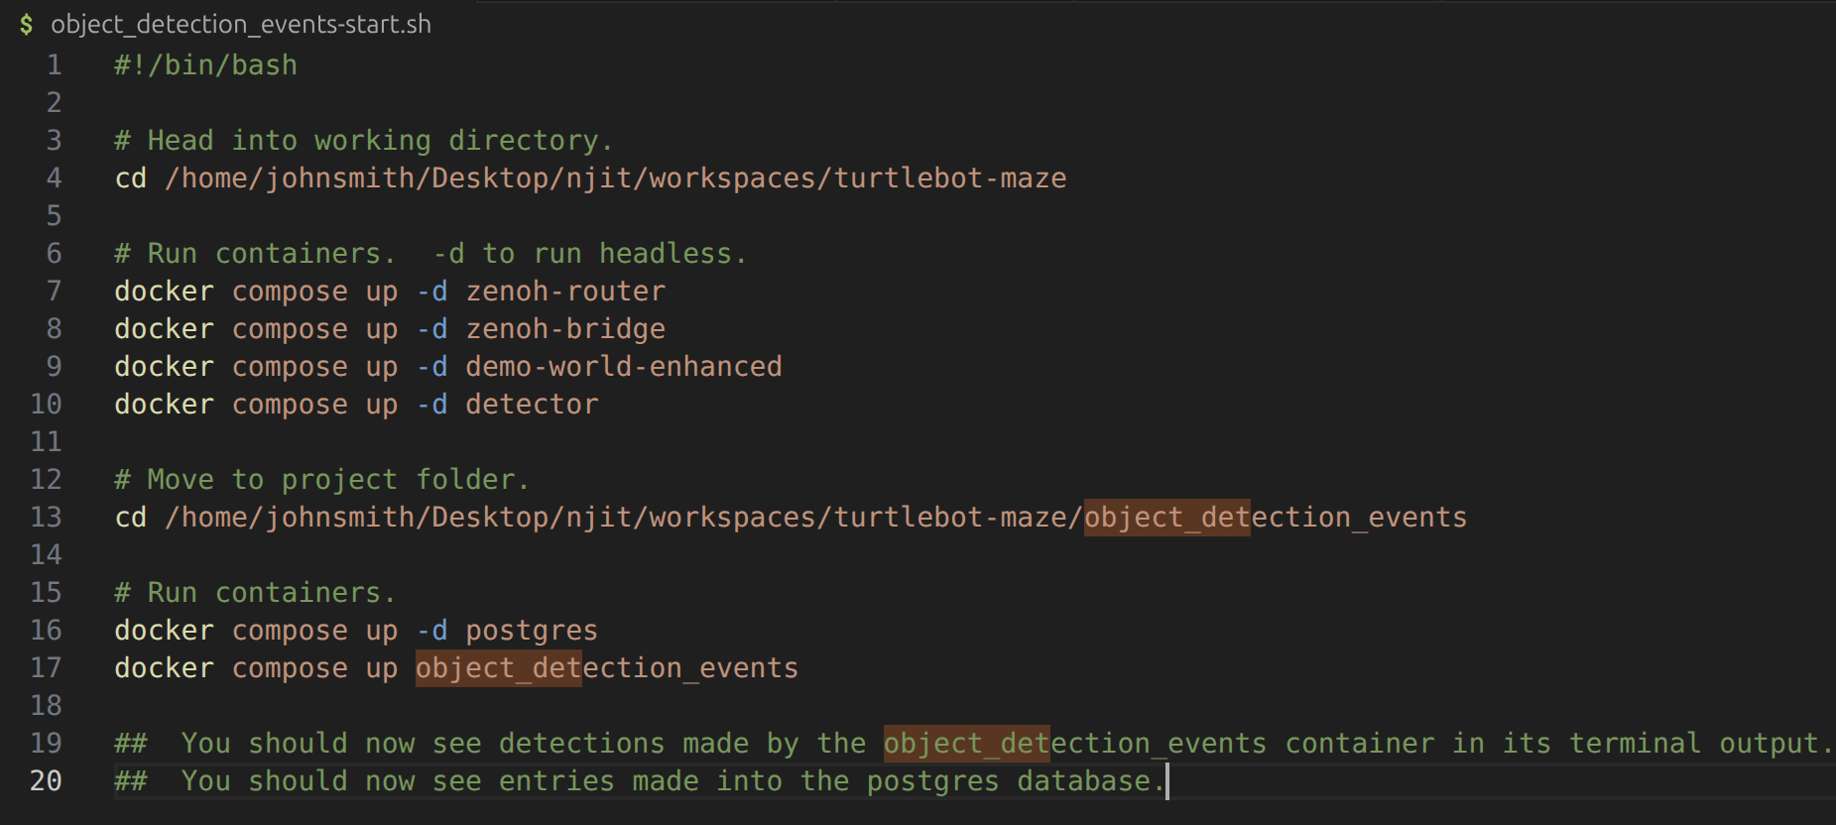

Deliverables:

Detector
The detector used was the supplied detector container. The professor said we could use all the demo-* containers and their published Zenoh topics.
This can be found in: detector/object_detector.py.

Zenoh Publisher Logic
The publisher logic is as follows: A detection is made by the detector container and is published to Zenoh as JSON to topic: maze/{robot_id}/detections/v1/{event_id}.
This code can be found in: object_detection_events/object_detection_events.py .

Zenoh Ingest Worker
The worker subscribes to maze/**/detections/v1/*, parses the topic, and writes to a postgreSQL database detections_db. I sued a docker container pulldown for postgres to create the db. The supplied schema createion SQL was used to create the schema and the Zenoh topic JSON.
This code can be found in: bject_detection_events/object_detection_events.py .

world_assets.md
This file is located at: object_detection_events/world_assets.md .

Histogram
A sort of ‘brute’ script was written to visualize the output of the postgres detections table to create the histogram. Due to time constraints the workflow was:
1) Export detections table to csv.
2) Open in Libre Office Calc (Ubuntu Excel Option).
3) The column for class was copied and used to create a script. It is a hard coded list. This file does not dynamically generate the histogram from the postgres table. This is a refactor goal, but due to time constraints ‘good enough’ has prevailed.
This code can be found at: plot_it.py.

