Daniel Ayer
DS685

Assignment 3 - Semantic Graph and Semantic Re-Localization
https://github.com/AyerDaniel/turtlebot-maze

Deliverables
- pgvector + AGE schema
- Embedding generator
- Graph builder
- Semantic relocalizer
- Demo report with success and failure analysis

pgvector + AGE Schema
AGE Schema
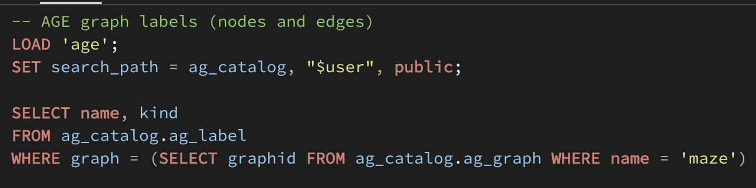 | 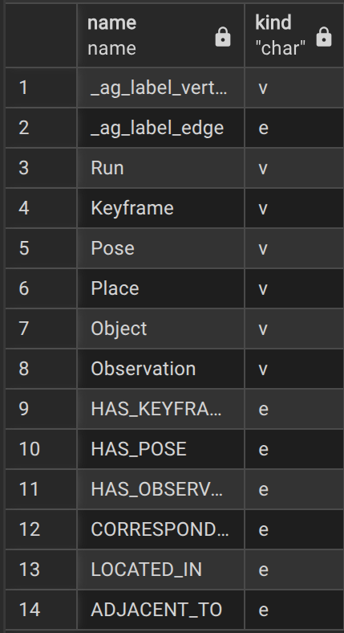

Pgvector Schema
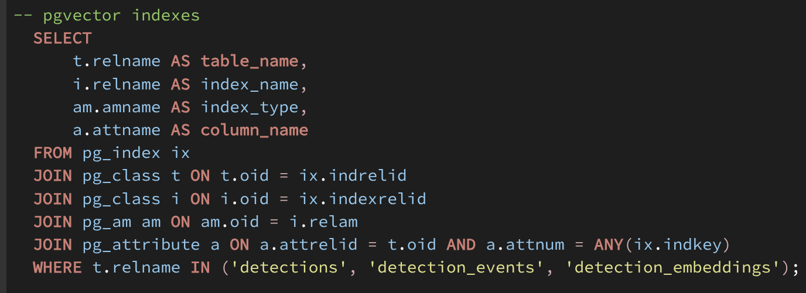 | 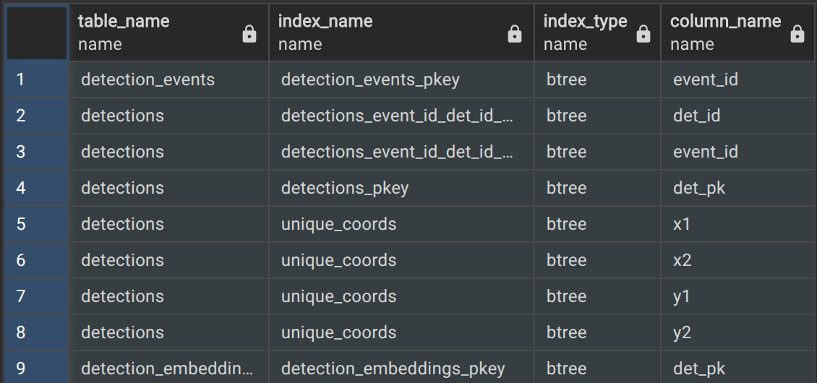

Relational Tables Schema
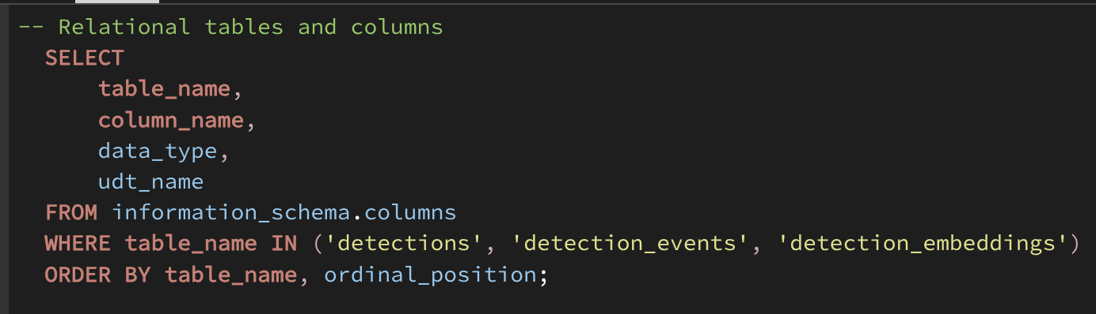  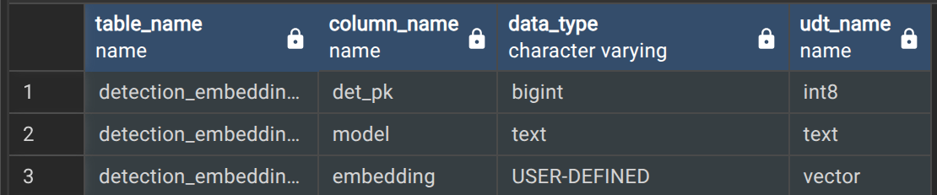 | 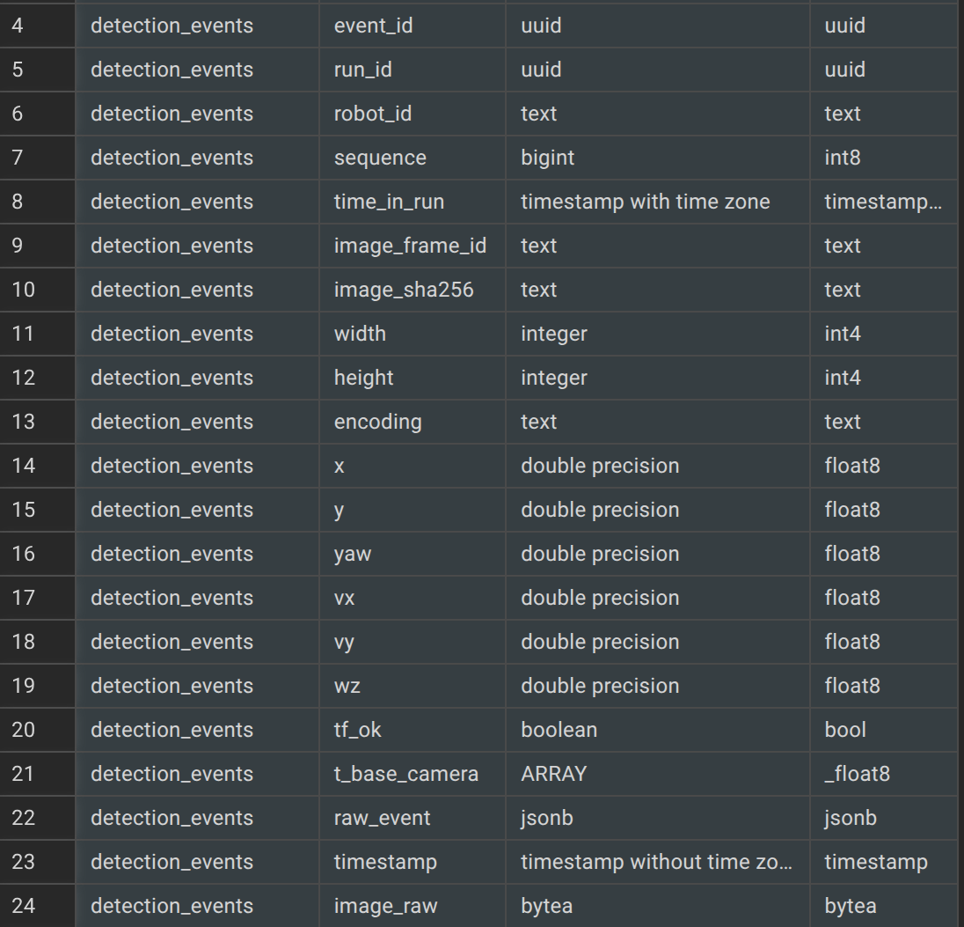  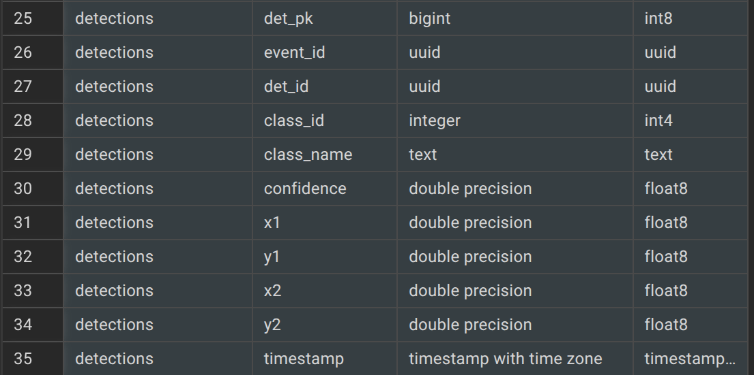

Embedding Generator

Detection was made using YOLOv8n as per assignment. The camera image is sampled, adjusted to meet criteria with PIL, and then detection is made. Keyframes lacking detections are embedded as a whole image. Detections are embedded as cropped images. Ideally, this will semantically segregate the object detections from the non-object embeddings in the embedding space.
Embeddings were generated using CLIP ViT-B/32. This yields a 512 dimensional vector embedding for each image sent through the encoder. Cropped images and full images are run through PIL before embedding.
Embeddings were stored in detection_embeddings (regardless of detections or not). The graph keyframe nodes contains the keyframe_id, and a series of tables allows us to track everything together.
Graph Builder
The graph building process proved problematic. If I had time to do the assignment again I would build everything very differently. However, eventually the graph was able to be built. There is vestigial code from pervious assignments here, but the core process is as follows:
An image is received from the camera. The ‘odom’ Zenoh topic supplies the map location for the bot. If the location has not changed by 1.5m and the image has not rotated by 15 deg the image is discarded. If we have moved sufficiently to warrant a new keyframe then the image is run through the YOLO detector.
A keyframe and pose node are created, and an observation node as well if a detection is made. Object fusion is confusing, but I think I did it right. When an observation node is needed then all existing Object nodes matching that class are queried. Cosine similarity is used to evaluate which embedded object is most similar to our embedded object. Euclidean distance measure is used to judge which is closest to the robot. If there is no match a new Object node is created. If there is a match we update the mean x and y measures.
Online DBSCAN proved to be too difficult. We sample the world every 0.5m, and we look for neighbors every 0.5m. There is some confusion about what qualifies as a ‘keyframe.’ Beginning with no observations and stepping out 0.5m at a time with a 1.5m neighbor sweep means that we would grow out one group indefinitely. Therefore, I opted for OFFLINE dbscan.
My DBSCAN runs every tenth SLAM pose received. Every pose has a default grouping of ‘-1.’ Every tenth SLAM DBSCAN uses the detections to create groupings. Every cluster of detected objects forms a group. DBSCAN then walks out from those groups to classify nearby frames as belonging to which group.
Groups have an eps of 1.5m, with every group needing at least 3 samples. Euclidean metric defines groups. Group assignment was achieved using KD-tree. Pose nodes then record which dbscan group the node is assigned to. SQL query provided spatial coords and group assignment for each keyframe.

Gazebo RVIZ Map
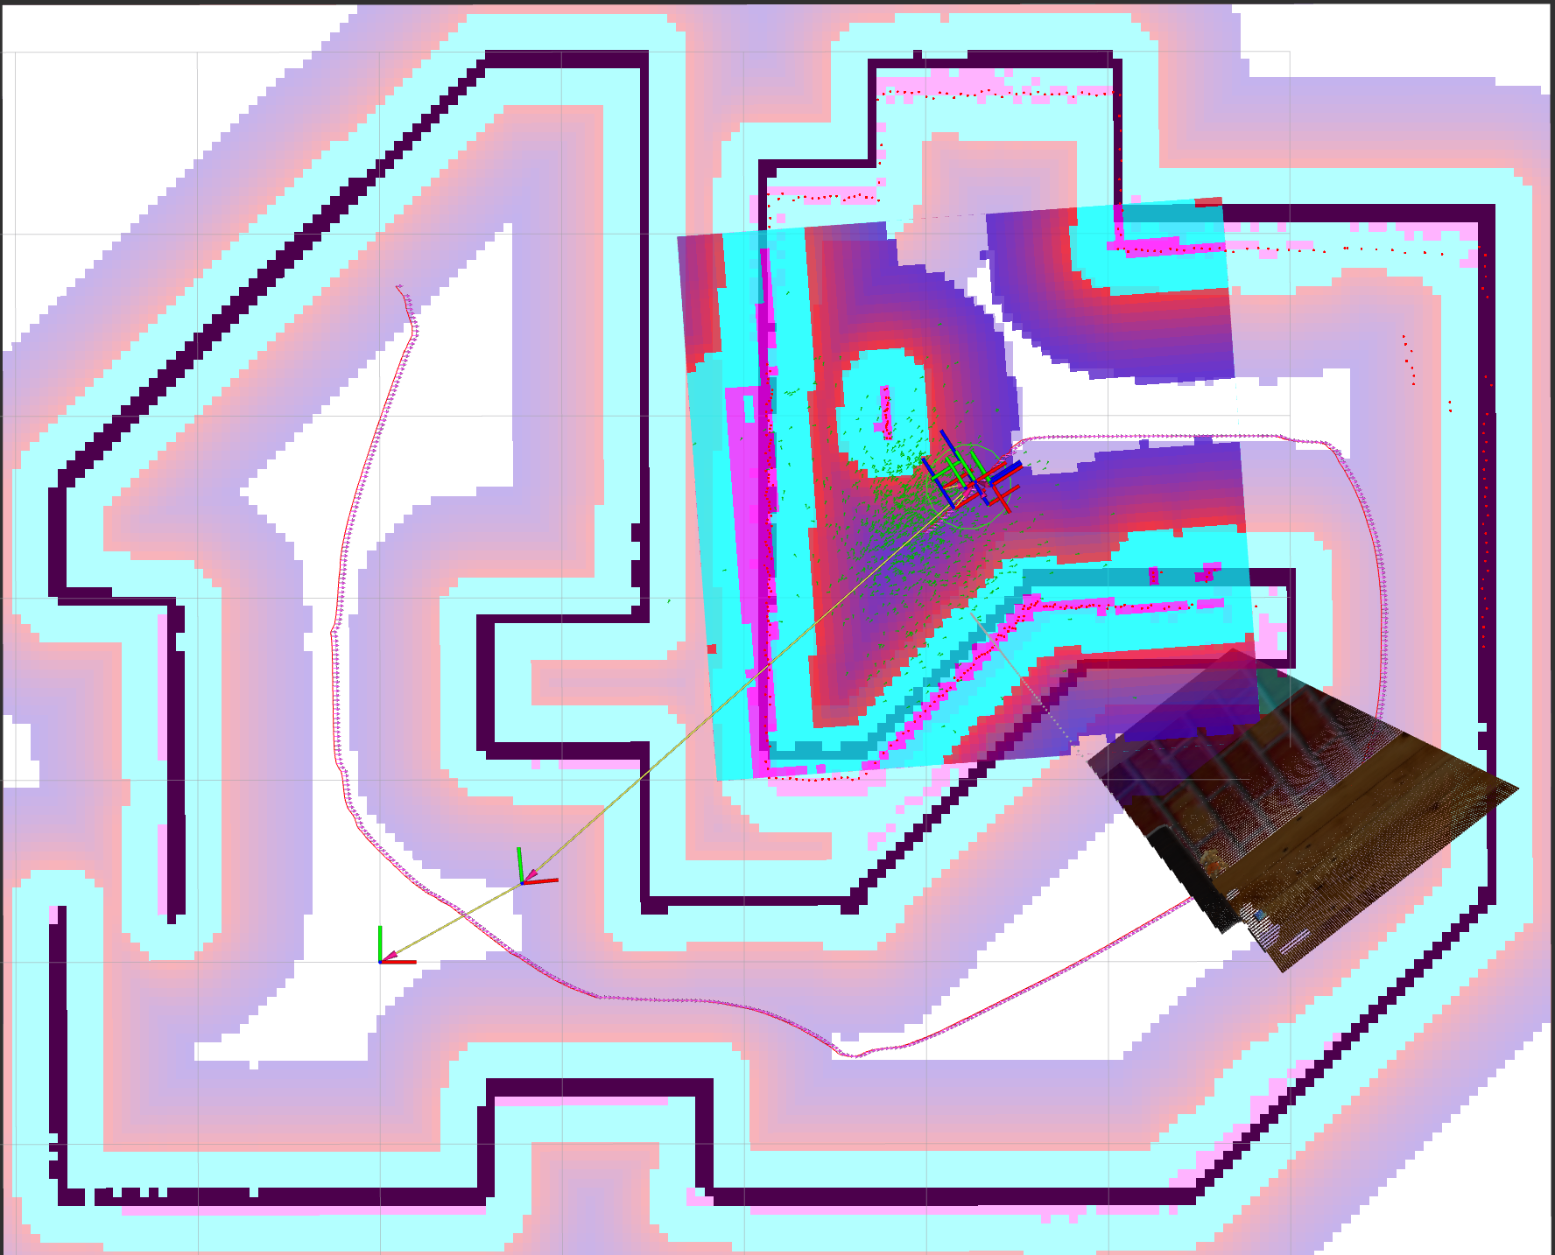
We identified 4 groups, though their location was not as accurate as we would have liked. We can see the keyframe spatial coords relatively match the path of the robot. If we had more time I would program a methodical mapping of the space.
Place nodes were constructed per cluster. All keyframes are linked to one place, here their DBSCAN group assignments. Adjacency edges were assigned to frames within 3m of each other.

Relocalization
The original data structure for the turtlebot class was poorly designed. I had self.data[] as an accessible space for all callbacks to check. However, I tried instituting multithread processing, and race conditions proved confounding. My idea was to have the bot attempt to relocalize while mapping; one on each thread. If no map existed the relocalization would just not work, but not stop the bot. Once the map was built any subsequent attempts would work. In this way the bot doesn’t have to decide if it has a map.
Relocalization is performed after each successful keyframe is written tot he db. First, knn was run on the just gathered embeddings and any embeddings in the embedding space. Embeddings are stored in ‘detection_embeddings.’ The top 10 nearest neighbors by cosine similarity are selected.
Each matched detection provides a dbscan group from the graph. Each group’s points aaggregate their similarity scores. The top contenders are ranked and the top three selected. Since we just wrote to the db we still have the spatial coords of the keyframe for ground truth. Though, these are not entirely accurate to the location of the robot, they are sufficient as a measure of accuracy to some degree.
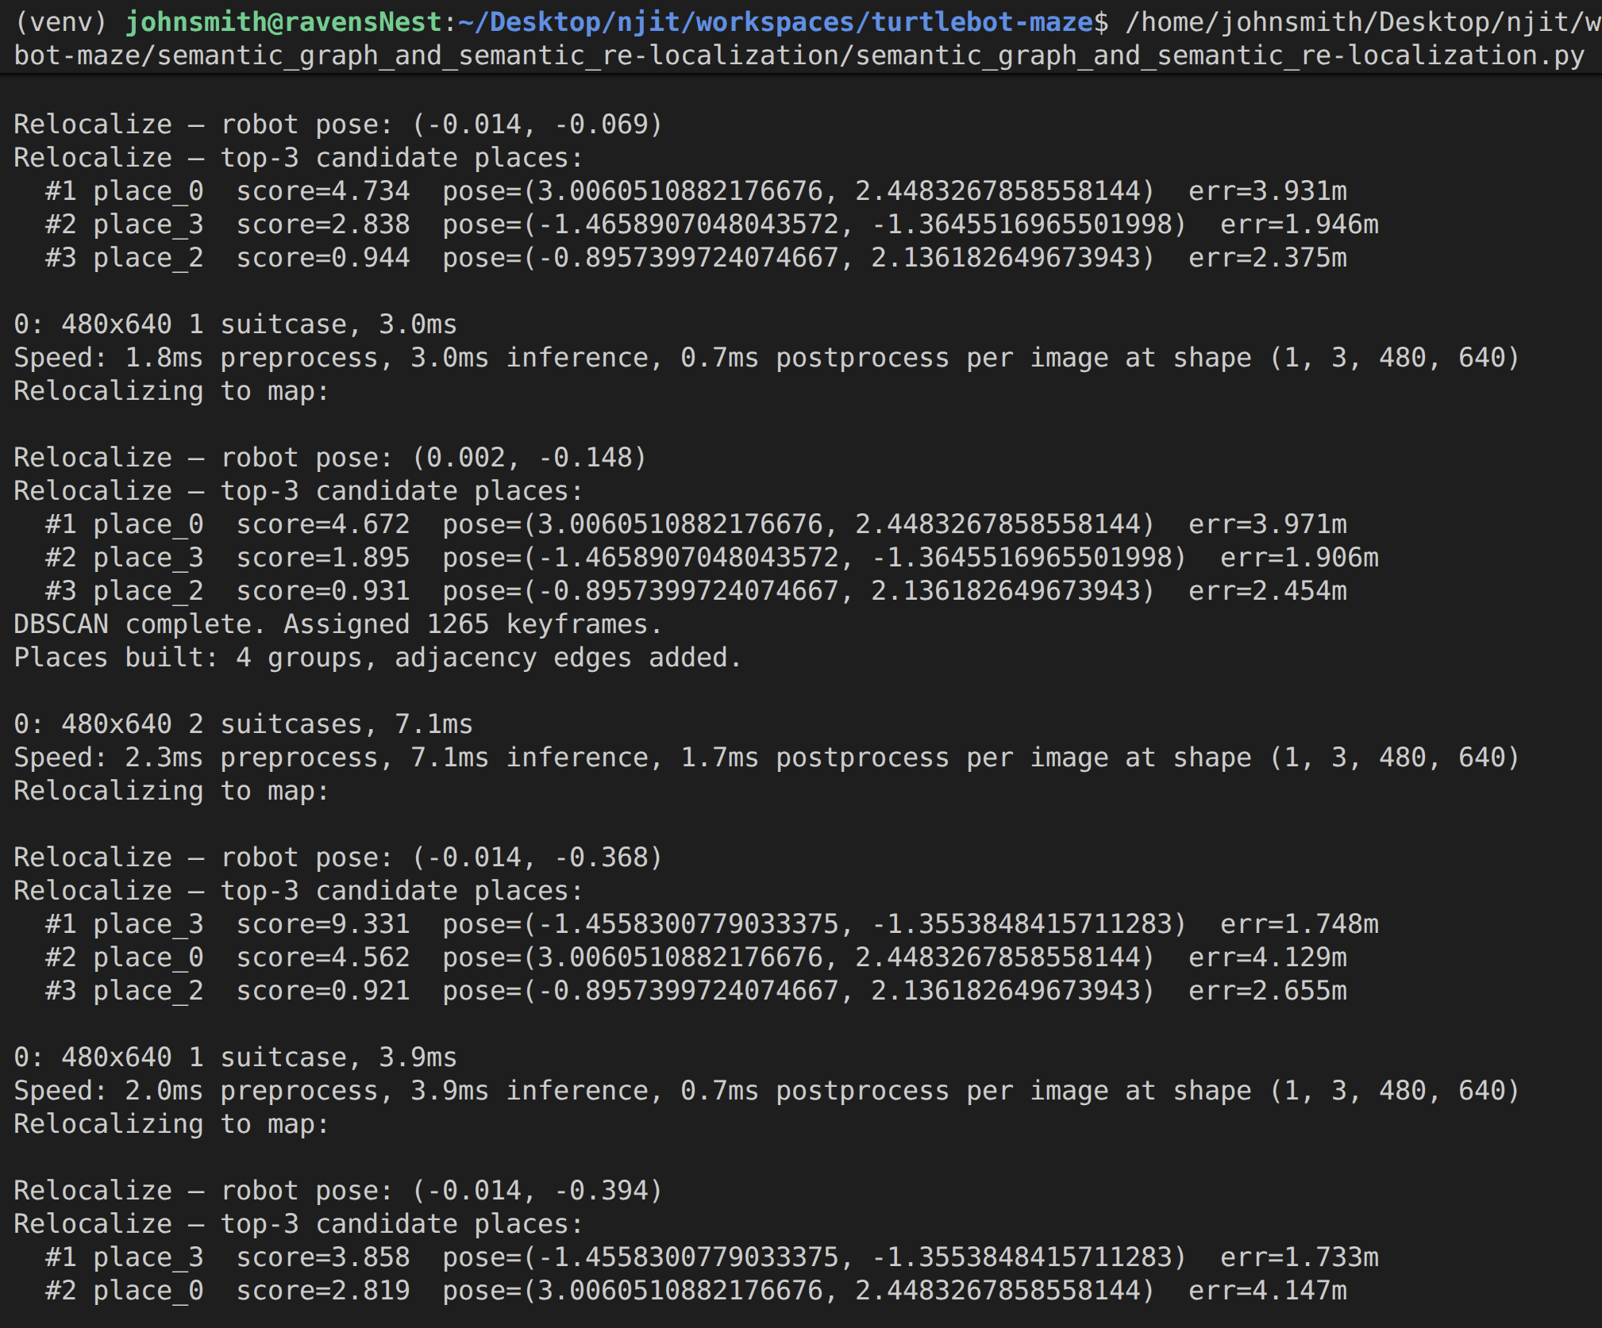

Success / Failure
The project should be massively refactored. However, given the first blush over the assignment I’d say we had some good successes. The detections were inaccurate, though that is probably due to Gazebo’s sdf based objects differing from the training set used for YOLO. The objects are not photorealistic, and the some are beyond the camera’s field of view. The person for instance was accurately identified form the leg alone as the rest of the person was out of frame.
Multithreading also created race conditions that were unforseen. I really got out over my skiis with the multithreading option. Relocalization ran well, though had a higher error than I would have liked. The keyframes appear to all line up in a single path the bot took. Though I did make several runs my lack of finesse with using Rviz meant I couldn’t really get the bot to explore every nook and cranny. The groupings also did not align with where the object clusters were. In fact, one room seems to have no keyframes at all.
This is most likely due to the path the bot took and the race conditions described before preventing real time and smooth sampling. Despite our attempts to create unique keyframes we actually recorded 1,288 keyframes. Most have the same coordinates as the others. This is most likely due to multiple pass throughs of the bot along the same back and forth path. The 1.5m window can become out of phases if the total path the bot traverses back and forth is not an integer value of 1.5.

Discussion
The assignment was highly complex. I’m not sure I was able to fully understand each part, and thus errors propagated. I definitely feel like I can build this anew with much more understanding of how everything fits together.
The main challenge here was to create everything from de novo. Of course having access to the map itself beforehand would reduce our errors. Despite our keyframe gates keyframe propegation exploded beyond what we intended. However, at 1,288 keyframes we stopped recording new. This indicates that some uniqueness checks did finally work. They simply did not keep the framecount as low as intended.

