Final Project Report
Coding Dream Blog



Project Supervisor
Adnan Asif

Submitted By
F220778EAB (bc190408737)

Software Projects & Research Section,
Department of Computer Sciences,
Virtual University of Pakistan



CERTIFICATE

This is to certify that Ayesha Nudrat (F220778EAB (bc190408737) has worked on and completed their Software Project at Software & Research Projects Section, Department of Computer Sciences, Virtual University of Pakistan in partial fulfillment of the requirement for the degree of BS in Computer Sciences under my guidance and supervision.

In our opinion, it is satisfactory and up to the mark and therefore fulfills the requirements of BS in Computer Sciences.

Supervisor / Internal Examiner

Adnan Asif
Supervisor,
Software Projects & Research Section,
Department of Computer Sciences
Virtual University of Pakistan

___________________
(Signature)

External Examiner/Subject Specialist
<<External Supervisor Name>>

_______________
(Signature)

Accepted By:

__________

EXORDIUM

In the name of Allah, the Compassionate, the Merciful.

Praise be to Allah, Lord of Creation,
The Compassionate, the Merciful,
King of Judgment-day!

You alone we worship, and to You alone we pray for help,
Guide us to the straight path

The path of those who You have favored,

Not of those who have incurred Your wrath,
Nor of those who have gone astray.

DEDICATION

I dedicate this project to Allah Almighty my creator, my strong pillar, my source of inspiration, wisdom, knowledge and understanding. He has been the source of my strength throughout this program and on His wings only have I soared.
This project I also dedicate to my parents who have never failed to give us financial and moral support, for giving all our needs during the time we developed my project and for teaching us that even the largest task can be accomplished if it is done one step as a time.
This project is especially dedicated to the Supervisor, Adnan Asif who helped and guided us to successfully complete this project work.
We dedicate this Project to all the people who have worked hard to help us complete this project.

Ayesha Nudrat ---------------------------

ACKNOWLEDGEMENT

While I was preparing this project, various information that I found helped me in web development and database and I am glad that I was able to complete this project and understand many things. Through preparation of this web development project was an immense learning experience and I inculcated many personal qualities during this process like responsibility, punctuality, confidence and others.
I would like to thank to my Creator Allah who supported me all the time, cleared my doubts and gave me confidence on me that I can do this project and to my parents who also played a big role in finalization of my project file. I am taking this opportunity to acknowledge their support and I wish that they keep supporting me like this in the future.
A project is a bridge between theoretical and practical learning and with this thinking I worked on the project and made it successful due to timely support and efforts of all who helped me.
Once again, I would like to thank my friends also for their encouragement and help in designing and making my project creative. I am in debt of all these. Only because of them I was able to create my project and make it good and enjoyable experience.

Ayesha Nudrat ---------------------------

PREFACE

In the preparation of this project (Web Development), Subject CS 619 of Bachelor Degree in Computer Science, I have precisely demarcated all the important points. I have made my best possible efforts to remove all the errors. It is a great pleasure for me to thank Allah Almighty and also thank to all those valuable suggestions that have been given to me by Adnan Asif. I must thank the almighty for this inspiration and guidance as well as my parents who directed me to complete this project Report.

The whole report has been classified into the three chapters:
CHAPTER NO. 1
Gathering & Analyzing info
CHAPTER NO. 2
Designing the project
Chapter no.3
Development

Ayesha Nudrat Ayesha Nudrat ---------------------------
TABLE OF CONTENTS

CHAPTER NO. 1
gathering & Analyzing info 9

1.1 Introduction …………………………………………………… 9
1.2 purpose ……………………………………………………………….9
1.3 scope …………………………………………………………………9
1.4 definitions, acronyms and ABBREVIATIONS ………….10

1.5 Project requirements ………………………………………….11

1.5.1 Functional Requirements ……………………………………………11

1.5.2 Non-Functional Requirements …………………………………….12

1.6 use cases and usage SCENARIOS …………………………….13

1.6.1 Use Case Diagrams ……………………………………………………14

1.6.2 Usage Scenarios …………………………………………………….15

1.7 Development Methodology ……………………………………28

1.7.1 Chosen Methodology …………………………………………………….31

1.7.2 Reasons for Chosen Methodology ………………………………….31
1.7.2 Work Plan (Gantt Chart) ……………………………………………. 33
1.7.2 Project Schedule (Submission Calendar) ……………………. 33

CHAPTER NO. 2
designing the project 34

2.1 INTRODUCTION ………………………………………………………………………34
2.2 purpose …………………………………………………………………………………34
2.3 scope ………………………………………………………………………….35
2.4 definitions, acronyms and ABBREVIATIONS ………………………… 35
2.5 Architectural Representation (Architecture Diagram) ………. 37

2.6 Dynamic Model: Sequence DIAGRAMS ……………………………………39

2.7 Object Model/Logical Model: Class DIAGRAM ……………………… 47

2.8 Database Model (Database Diagram) ……………………………………….49

2.9 Graphical User Interfaces ………………………………………………………50

Chapter no.3
DEvelopment 54
3.1 Development plan (Architecture Diagram) …………………………………54

<<Dear Students, you have to take special care of page numbers, which are written against each Chapter and sub headings. You have to mention your own page numbers and correct one against each document heading. Make proper table of contents. Remember that if there are any new headings or you have included more headings in your documents then you also have to write these in table of contents and modify table of contents according to your documents material>>

<<Dear Students, before starting each chapter the following would be the title page for each chapter on a separate page>

CHAPTER # 1 Gathering & Analyzing Info

Introduction

Project Domain / Category
Web Application

Abstract / Introduction
A blog is an online informational website displaying information about anything with the latest information/posts appearing at the top. Bloggers are individuals who love sharing their knowledge with others.
They post on various topics from arts, home designs, Computer Hardware, Programming, carpentry, and finance articles etc. So, the main purpose of a blog is to connect you to the relevant audience.
The more frequent and better your blog posts are, the higher the chances for your website to get searched and visited by your target audience.
Tools:
HTML, CSS, Boot Strap Java Script, Python, PHP, MySQL
Editors (Visual Studio Code, Dream viewer, Notepad++) etc.
Note: (Word Press Not allowed)
Databases: Any DBMS

Purpose

The proposed project of Coding Dream Blog will be used by the Blogger (Admin) to post article related to coding. Users can view the post and put comments or ask questions. The Blogger (Admin) will post articles about coding using the Coding Dream Blog project as recommended. Viewers of the post have the option to comment or ask questions.

Scope of Project:

A blog is a website that provides online information about anything, with the most recent articles or information appearing first. People who love to share their knowledge with others are bloggers. They publish articles on a range of subjects The likelihood that your target audience will search for and visit your website increases with the frequency and quality of your blog postings. The Blogger (Admin) will post articles about coding using the Coding Dream Blog project as recommended. Viewers of the post have the option to comment or ask questions.

Definitions, Acronyms and Abbreviations

Definitions

Software requirements specification (SRS)
Is a document that describes what the software will do and how it will be expected to perform.

Blog
Is an online informational website displaying information about anything with the latest information/posts appearing at the top.

Functional requirements
Functional requirements define what a product must do, what its features and functions are.

Nonfunctional requirements
Nonfunctional requirements describe the general properties of a system. They are also known as quality attributes.

Actors: The users that interact with a system.

Use-case diagrams:
Describe the high-level functions and scope of a system.

Abbreviations
CDB CODING DREAM BLOG
(SRS) Software requirements specification

Acronyms
Primary, alternate, contingency and emergency (PACE) is a methodology used to build a communication plan.

Project requirements

Functional Requirements:

Functional requirements define what a product must do, what its features and functions are.

Blogger (Admin):

- Admin can Login/Logout
- Change password/retrieve lost password
- Edit Registration details
- Admin will be able to Create/Delete and Update Posts
- Admin will be able to sort in any order by date or topic etc.
- Admin will be able to manage comments on post (View/Edit/Delete/block)
- Search posts on the basis of different criteria
- Mange any advertisement on the blog
- Admin can reply user questions.
- Admin can verify/validate the Register user’s reply on any post.
- Admin can view the best answers on the basis of stars given.

Register User/Visitor:

- User can use Sign Up page to register
- Change Password/Retrieve lost password
- View/Edit Registration Info (Personal Details)
- Read posts
- Registered users will be able to create Posts as well, which will be shown after Admin Verification.
- Put comments on any post.
- Reply to questions on any posts.
- Can get best options to buy from the Admin.
- User can be able to give feedback / stars to replies.

Non – Functional Requirements:

Nonfunctional requirements describe the general properties of a system. They are also known as quality attributes.

Access Security:
The degree to which the system is protected against malicious errors and intrusions from both internal and external sources.

Accessibility:
Refers to how simple a system is to use for users with the broadest
variety of abilities.

Availability:
Refers to how consistently the system can operate during regular
Business hours.

Confidentiality:
How successfully does the system safeguard private information and
Restrict access to only those who need it?
Efficiency:
A term used to describe how successfully a software system manages capacity, throughput, and response time.
Integrity:
How accurately, authentically, and without corruption the data are kept
by the software system.
Reliability:
The degree to which a software system regularly completes the required
tasks without error.
Safety:
Refers to how successfully the system guards against harm to people or
the environment. How effectively the software system can survive.

Use Cases and Usage Scenarios

Use Case Diagram(s):

The scope and high-level functions of a system are described in use-case diagrams. The interactions between the system and its actors are also depicted in these diagrams. Utilize-case diagrams show what the system does and how the actors use it, but they do not show how the system works within.

There are the 4 main components of a use case diagram
- System.
- Actors.
- Use cases.
- Relationships.

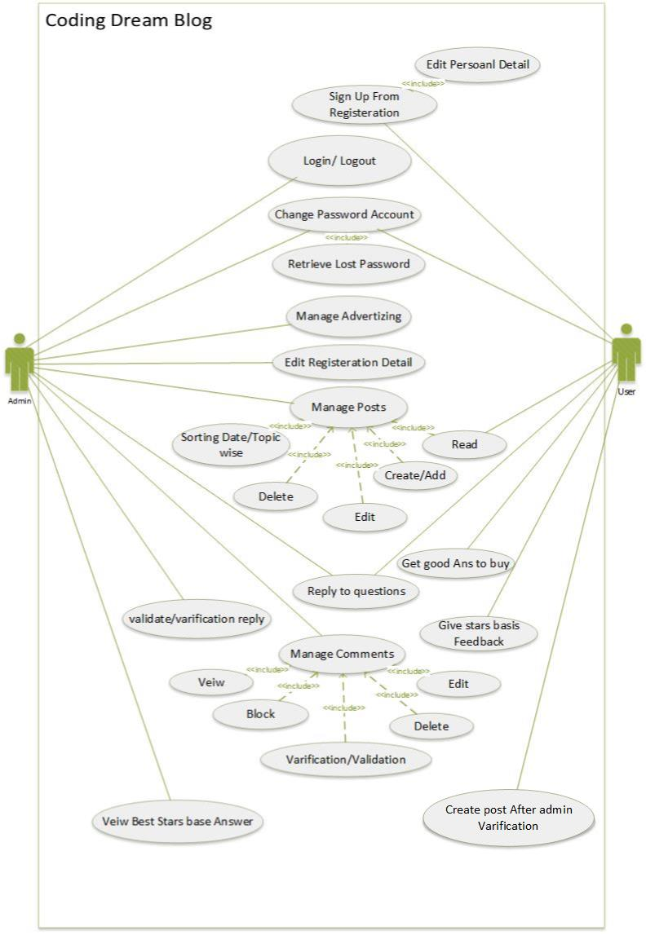

Usage Scenarios:

Use Case 01

Use Case title | Sign Up from Registration
Use case ID | 01
Sequences Of Task | User will register into web first.
Description | The users will need to register with the application using his/her email address. This will help user to use next all features of website.
Actor | User
Pre-Condition | User will have proper email address and mobile number for registration.
Post condition | None
Author | F220778EAB (bc190408737)
Exception | Already Register User  Unfilled Registration Detail

Use Case 02

Use Case title | Login / Logout
Use case ID | 02
Sequences Of Task | Admin will register into web first.
Description | The admin will need to register with the application using his/her email address. This will help Admin to use next all features of website.
Actor | Admin
Pre-Condition | User will have proper email address and mobile number for registration.
Post condition | None
Author | F220778EAB (bc190408737)
Exception | Wrong Password  Invalid Email Adress

Use Case 03

Use Case title | Change password Account
Use case ID | 03
Sequences Of Task | For Changing Password User and admin firstly login  Lost password will be gain from email and mobile number
Description | The users and admin can change password and gain lost password
Actor | User and Admin
Pre-Condition | For changing first login and for retrieve valid email and number
Post condition | None
Author | F220778EAB (bc190408737)
Exception | Invalid user id, Email and number

Use Case 04

Use Case title | Manage Advertising
Use case ID | 04
Sequences Of Task | Admin will login first.  Manage Advertising
Description | Admin mange any advertisement on the blog
Actor | Admin
Pre-Condition | User will have properly login in blog
Post condition | None
Author | F220778EAB (bc190408737)
Exception | None

Use Case 05

Use Case title | Manage Posts
Use case ID | 05
Sequences Of Task | Admin will login first on Blog  Create posts/ update posts  Delete posts  update posts  Read posts  Sorting Posts according to Date / Topic Wise
Description | Admin will be able to Create/Delete and Update Posts.  Admin will be able to sort in any order by date or topic etc.
Actor | Admin
Pre-Condition | Admin will have properly login in blog
Post condition | None
Author | F220778EAB (bc190408737)
Exception | None

Use Case 06

Use Case title | Manage Comments
Use case ID | 06
Sequences Of Task | Admin will login first on Blog  Manage comments  view comments, edit comments, delete comments, create comments, block comments, verification and validation comments
Description | Admin will be able to manage comments on posts (View/Edit/Delete/block)
Actor | Admin
Pre-Condition | Admin will have properly login in blog
Post condition | None
Author | F220778EAB (bc190408737)
Exception | None

Use Case 07

Use Case title | Create Post after admin verification
Use case ID | 07
Sequences Of Task | user will register first on Blog  send post to admin  Wait for verification/ validation  Posts will be shown if admin allow  Posts will not be shown if admin not allow
Description | Registered users will be able to create Posts as well, which will be shown after Admin Verification
Actor | User
Pre-Condition | User will have properly register in blog
Post condition | Wait for Admin verification and validation
Author | F220778EAB (bc190408737)
Exception | None

Use Case 08

Use Case title | Reply to Question
Use case ID | 08
Sequences Of Task | user will register first on Blog  Admin will login properly on the blog  Admin and user reply to another questions
Description | User can Reply to questions on any posts and Admin can reply user questions.
Actor | User and Admin
Pre-Condition | User and Admin will be properly register and login  in blog
Post condition | None
Author | F220778EAB (bc190408737)
Exception | None

Use Case 09

Use Case title | Verify and validate User Reply
Use case ID | 09
Sequences Of Task | Admin will login first on Blog  Admin validate and verify user reply  Admin allow user will be able to put comment  Admin not allow user will be not be able to put comment
Description | Admin can verify/validate the Register user’s reply on any post
Actor | Admin
Pre-Condition | Admin will be properly login in blog
Post condition | None
Author | F220778EAB (bc190408737)
Exception | None

Use Case 10

Use Case title | Give stars basis Feedback
Use case ID | 10
Sequences Of Task | User will be register first on Blog  Give stars basis Feedback according to experience good or bad
Description | User can be able to give feedback / stars to replies.
Actor | User
Pre-Condition | None
Post condition | None
Author | F220778EAB (bc190408737)
Exception | None

Use Case 11

Use Case title | View best star basis Answer
Use case ID | 11
Sequences Of Task | Admin will be Login on Blog  View stars basis Feedback or Answer
Description | Admin can view the best answers on the basis of stars given
Actor | Admin
Pre-Condition | Admin will be login
Post condition | None
Author | F220778EAB (bc190408737)
Exception | Missing reviews were removed for policy violations like spam or inappropriate content

Use Case 12

Use Case title | Get good option to buy
Use case ID | 12
Sequences Of Task | User will be register on Blog  Search good recommendation to buy  Admin allow user to see good recommendation for buy
Description | User Can get best options to buy from the Admin.
Actor | user
Pre-Condition | User will be register
Post condition | User able to see good recommendation
Author | F220778EAB (bc190408737)
Exception | None

Use Case 13

Use Case title | Edit Registration Details
Use case ID | 13
Sequences Of Task | Admin will be login on the blog  Admin Edit the Registration Detail according to need
Description | Admin can Edit Registration details
Actor | Admin
Pre-Condition | None
Post condition | None
Author | F220778EAB (bc190408737)
Exception | None

Development Methodology

Build-and-fix model

It is unfortunate that many products are developed using what is known as the build-and fix model. In this model the product is constructed without specification or any attempt at design. The developers simply build a product that is reworked as many times as necessary to satisfy the client. This model may work for small projects but is totally unsatisfactory for products of any reasonable size.

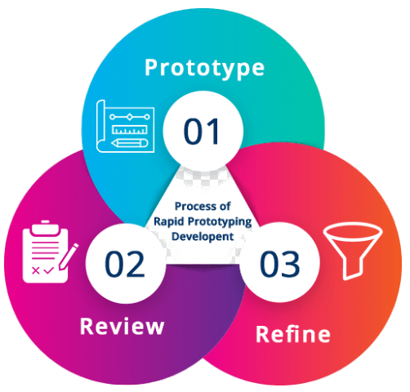

Rapid prototyping model

The Rapid Prototyping Model is used to overcome issues related to understanding and capturing of user requirements. In this model a mock-up application is created “rapidly” to solicit feedback from the user. Once the user requirements are captured in the prototype to the satisfaction of the user, a proper requirement specification document is developed and the product is developed from scratch.
An essential aspect of rapid prototype is embedded in the word “rapid”. 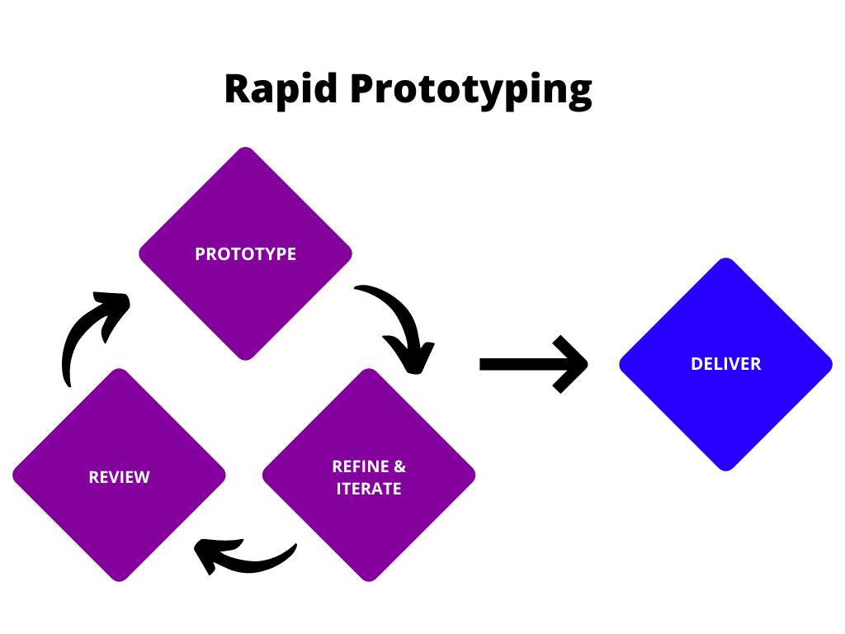
Spiral model:

This model was developed by Barry Boehm. The main idea of this model is to avert risk as there is always an element of risk in development of software. For example, key personnel may resign at a critical juncture, the manufacturer of the software development may go bankrupt, etc.

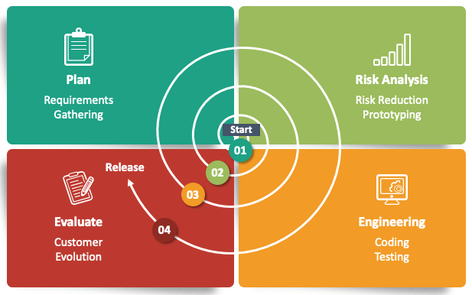

Waterfall Model:

It goes to the cycle of analysis, design, coding, testing, and maintenance. The simplest version of the waterfall methodology is called the "waterfall" methodology.

- By consulting the system with users, the systems services, constraints and goals are defined.
- The requirement is classified into hardware and software systems. It gives overall architecture of the system.
- The system is installed and gives to practical use. The system checks the errors, corrected them and improves it.

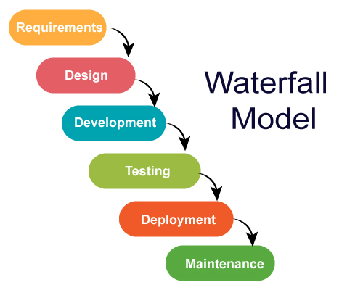

Chosen Methodology

I have studied many methodologies I adopted Vu Process Model for my project. As University also guides us that you must use vu process model for project and this model full fill all the project requirements. So, I choose Vu Process Model. The detail of Vu Process Model is under:

Vu Process Model

The VU Process Model combines the waterfall and spiral methodologies. The term "hybrid approach to system development" is often used.

It consists of five stages including:

- Requirement Definition
- System and Software Design
- Implementation and Unit Testing
- Integration and System Testing
- Operation and Maintenance

The system's objectives, services, and constraints are decided upon during the requirement phase after user consultation. The planning step involves a coordinated effort to identify all potential obstacles and design a strong plan to overcome each. This stage often involves a lot of brainstorming between the client and the software development team. It enhances system quality and reduces risks and errors.

Reasons for Chosen Methodology

The main justifications for using the VU Process Model for our project are listed below.

- Our project is broken up into several sections that we must finish in order and submit to our supervisor.
- If problems are discovered, he advises us to fix them and improve our project.
- Due to its spiraling nature, this procedure will be used.
- When the first phase is completed and approved by our supervisor, we go on to the next.
- Due to the waterfall nature of the VU Process model, this will be done.
- As a result, both models are suppressed in a single form, which will serve as our VU process model.

- Since each step is completed in order, it will produce a result that is error-free.

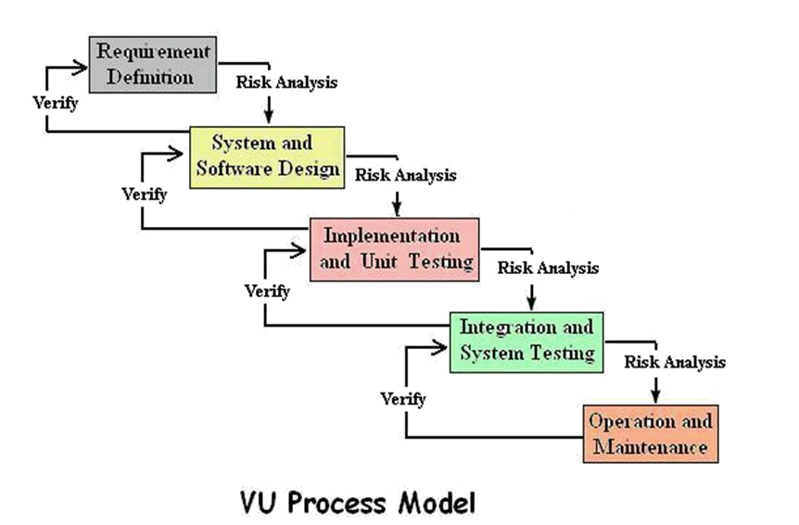

Work Plan (Gantt Chart)

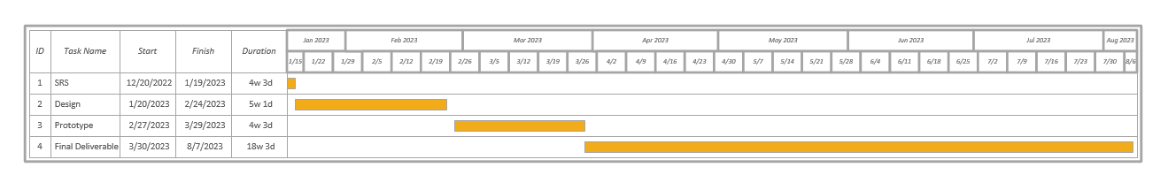

Project Schedule (Submission Calendar)

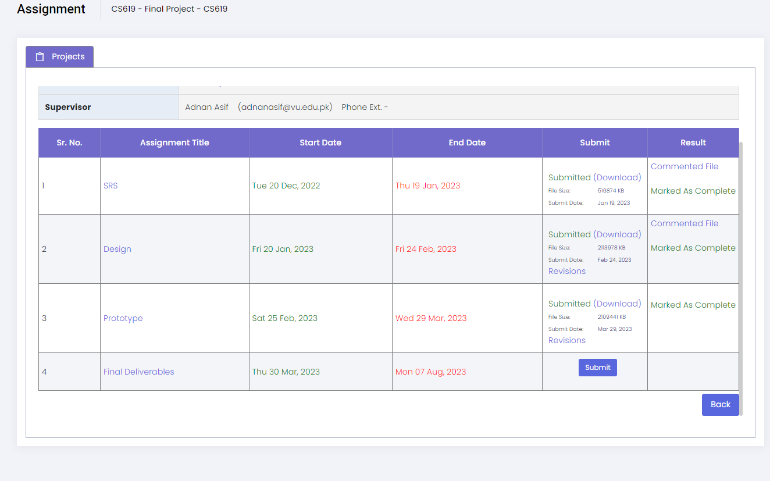

CHAPTER # 2 Designing the Project

Introduction

This document includes Entity relationship diagram, Sequence diagram, Architecture diagram, Class diagram, Database diagram, Interface diagram and test cases of the Blog Coding Dream Blog.
A software design document is a piece of documentation that describes the structure of a software system and its different functionally specific components.

purpose

Clear requirements:
With adequate documentation, we may eliminate discrepancies and disputes regarding the specifications. Every team member is familiar with the requirements.
Product architecture and design:
These documents give us a comprehensive perspective of what the product looks like and a better understanding of what the client or user can expect from their product.
A new person can work on the project too:
A new project participant can get up and running quickly by reading the documentation. Developers must therefore keep the documentation updated in line with any modifications made to the hardware or software.
Everything is clearly stated:
This documentation helps you grasp how the product functions on every level. Every feature is explained in detail.
Effective Communication:
We maintain strong communication with each team member involved in the project/software through documentation. helpful in understanding each member's expertise and function.
Scope

A Design Document of the website development scope of work is a document that web developers send to clients looking to contract their website design and development services. The scope of work document usually includes information on project summary, project scope, deliverables, project schedule, cost, and key assumptions.

Definitions, acronyms and abbreviations

Definitions

software design document
A software design document is a piece of documentation that describes the structure of a software system and its different functionally specific components.

Entity Relationship (ER) Diagram
An Entity Relationship (ER) Diagram is a type of flowchart that illustrates how “entities” such as people, objects or concepts relate to each other within a system.

Sequence diagram
A sequence diagram is a Unified Modeling Language (UML) diagram that illustrates the sequence of messages between objects in an interaction

Architectural diagram
An architectural diagram is a visual representation that maps out the physical implementation for components of a software system.

3-Tier Architecture
The three levels present in this architecture are Physical level, Conceptual level and External level.

Class diagram
A class diagram is a visual representation of class objects in a model system, categorized by class types.

Design documentation
Design documentation is a collection of documents that cover all of the most important aspects of your product or service design

Good UI design
Good UI design includes usability, impressive color palettes, engaging layout, and adherence to UI design conventions.

Acronyms

3TA stands for 3-Tier Architecture

Class diagram structure Diagram

(UID) will ultimately craft the high-fidelity version of the design, which is also referred to as a comprehensive layout, or “comp”.

TC&P stands for Test Cases and Procedures

Abbreviations

DD stands for Design Document.

Entity relationship diagram (ERD)

ER (Entity- Relationship)

Unified Modeling Language (UML)

DDD Database Design Diagram

User interface (UI)

User interface designer (UID)

TC, Test Case (testing methodology).

Architectural Representation (Architecture Diagram)

Architecture Design Diagram
An architectural diagram is a visual representation that maps out the physical implementation for components of a software system. It shows the general structure of the software system and the associations, limitations, and boundaries between each element.

Three-tier architecture

Three-tier architecture, which separates applications into three logical and physical computing tiers, is the predominant software architecture for traditional client-server applications.
In this coding Dream Blog Project, the tiers have different names but perform similar functions:
- The web server is the presentation tier and provides the user interface. This is usually a web page or web site, such as Coding Dream Blog where the user and admin see the posts about coding adds Posts, or creates an account etc. The content can be static or dynamic, and is usually developed using HTML, CSS and JavaScript.

- The application server corresponds to the middle tier, housing the business logic used to process user inputs. To continue the Coding Dream Blog Project, this is the tier that use important queries. This layer often developed using PHP.

- The database server is the data or backend tier of a web application. It runs on database management software, such as MySQL.

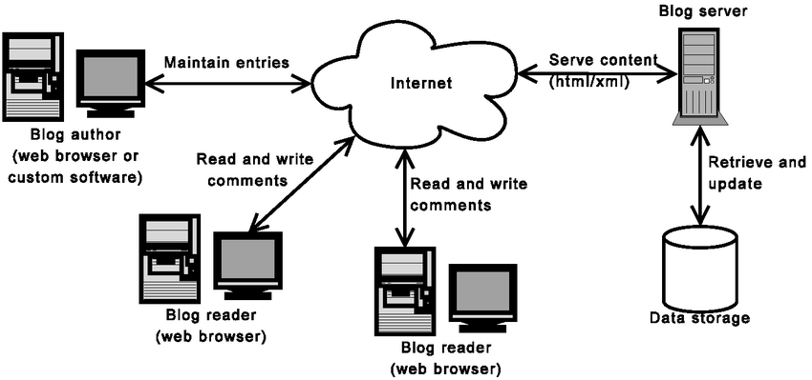
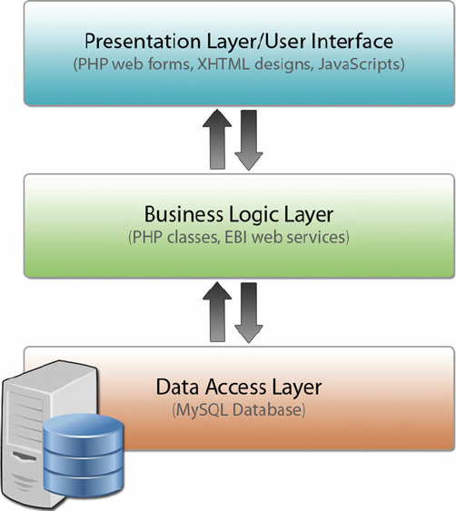

Dynamic Model: Sequence Diagrams

Sequence Diagrams
A sequence diagram is a Unified Modeling Language (UML) diagram that illustrates the sequence of messages between objects in an interaction. A sequence diagram consists of a group of objects that are represented by lifelines, and the messages that they exchange over time during the interaction.

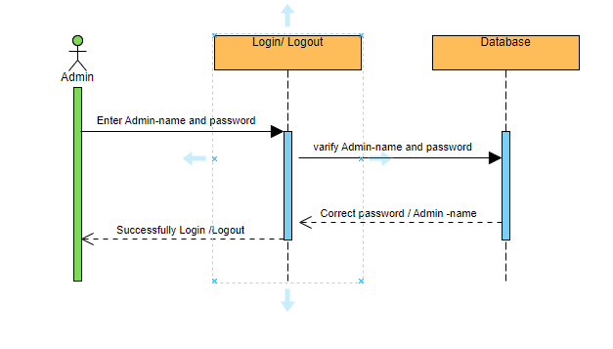

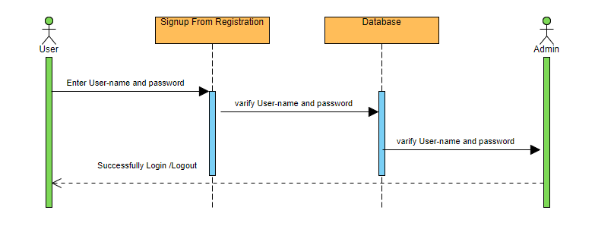

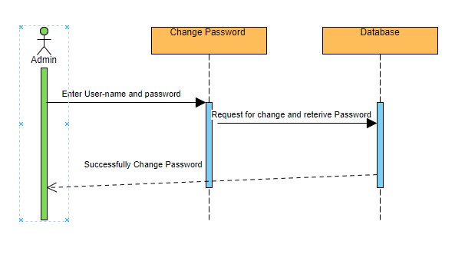

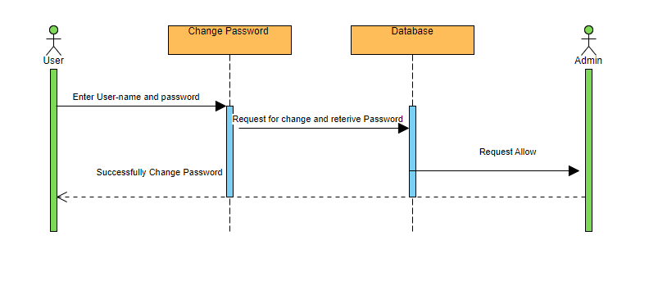

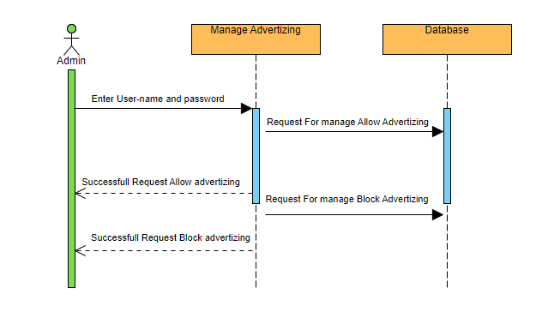

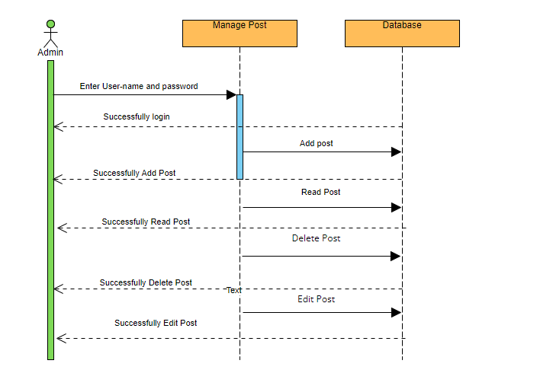
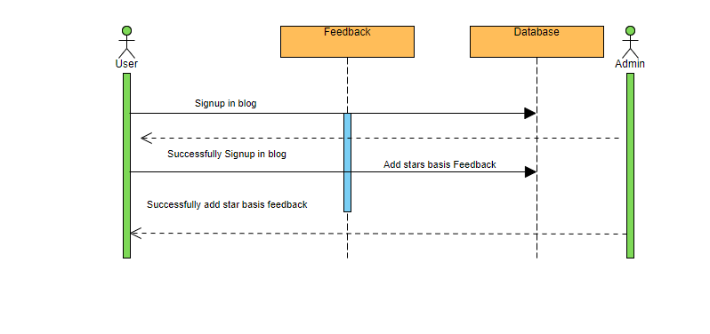
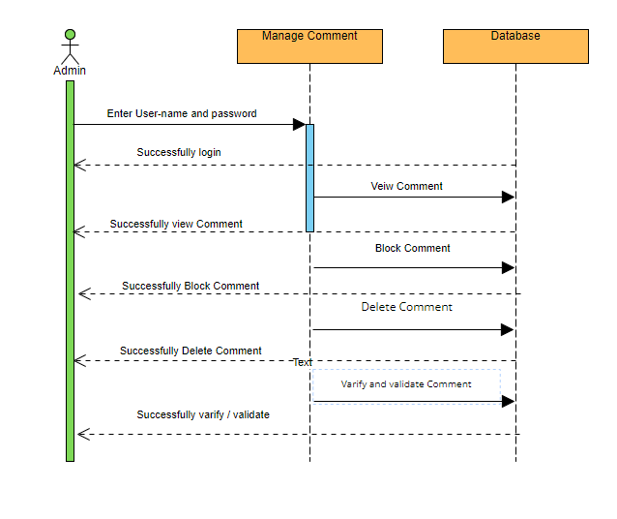

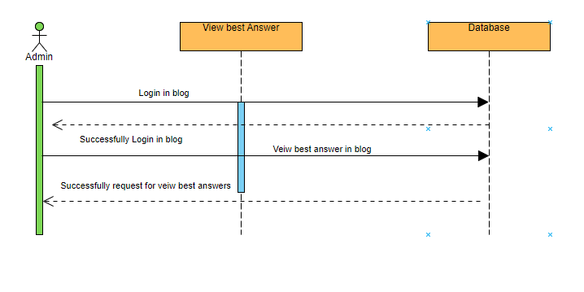

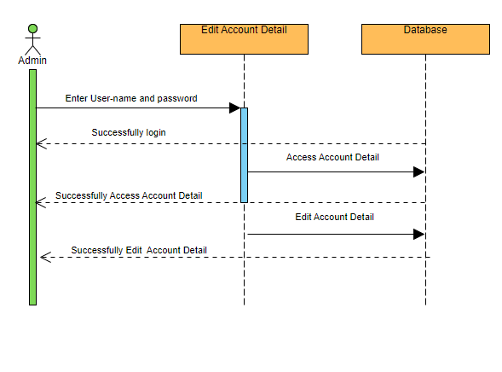
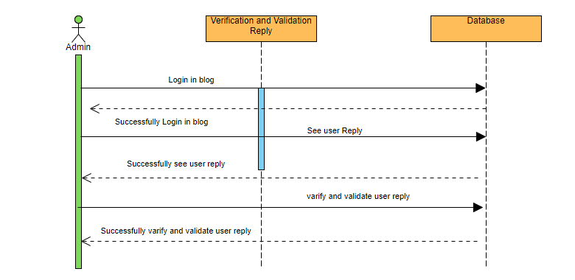

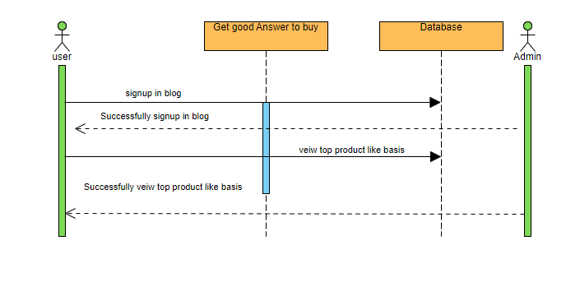
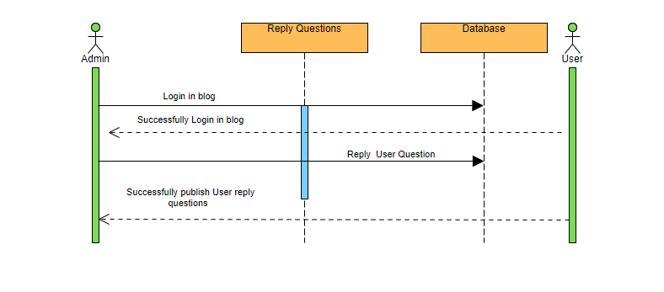

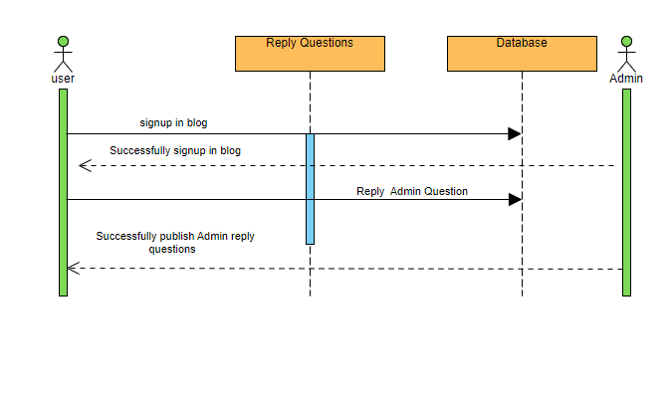

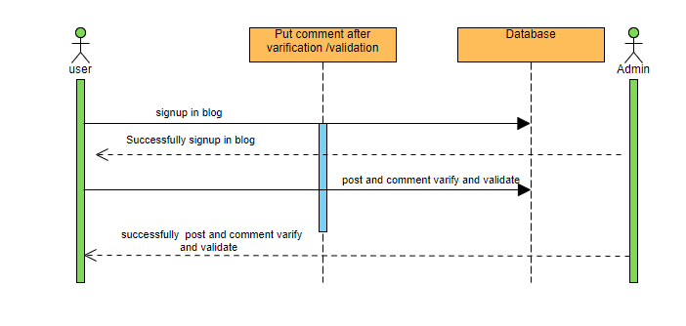

Object Model/Logical Model:
Class Diagram

Class Diagram

A class diagram is a visual representation of class objects in a model system, categorized by class types. Each class type is represented as a rectangle with three compartments for the class name, attributes, and operations. Objects are represented as ovals that contain class names inside class name compartments.

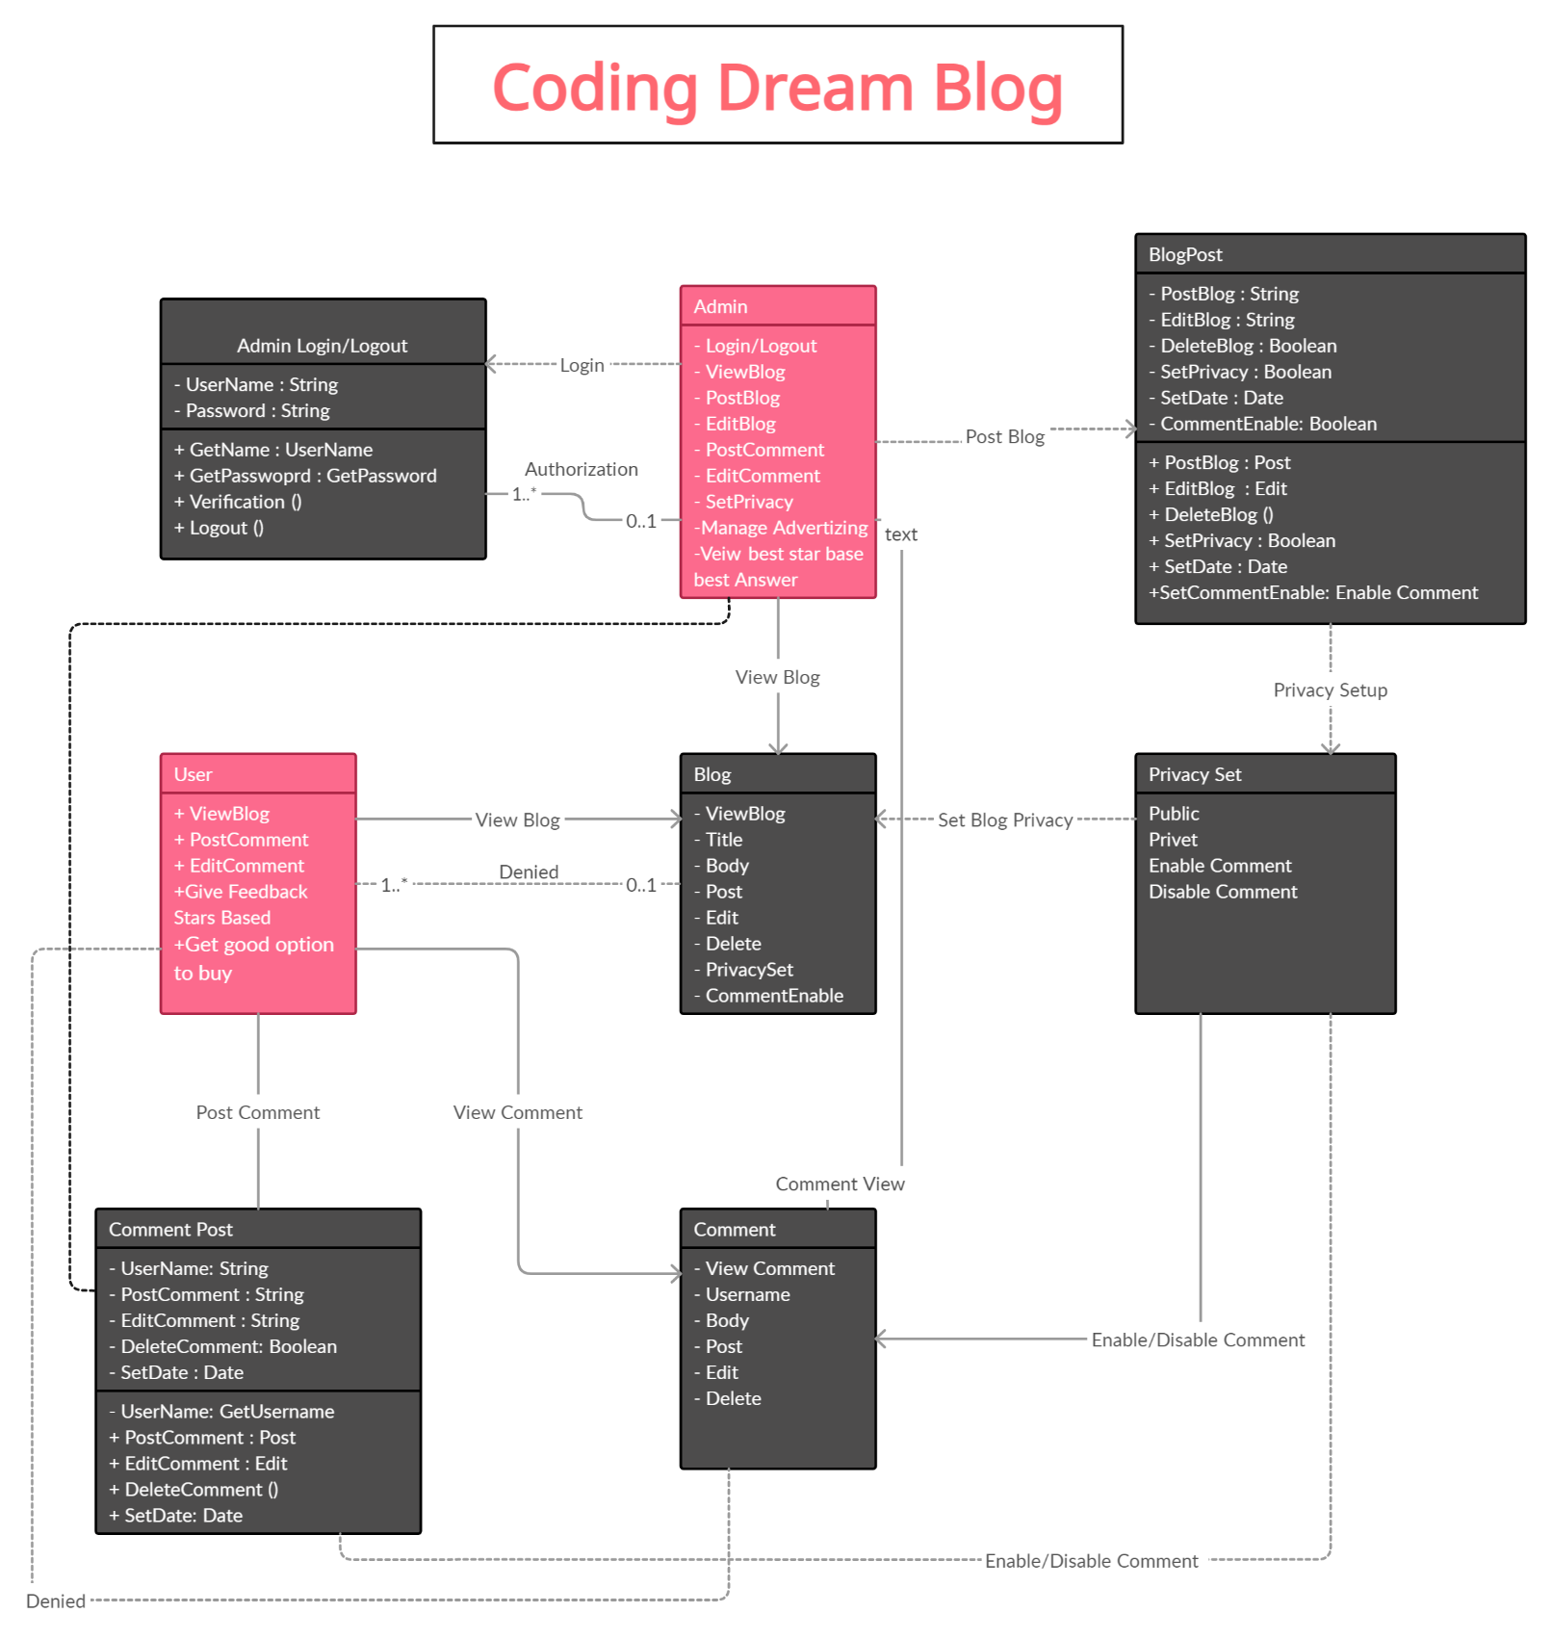

Database Model (Database Diagram)

Database diagrams graphically show the structure of the database and relations between database objects. To generate a diagram, we need a data source, a schema, or a table.
To create relations between database objects, consider using primary and foreign keys.

Five Major Components of a Database

The five major components of a database are
- Hardware
- Software
- Data
- Procedure
Database access language.

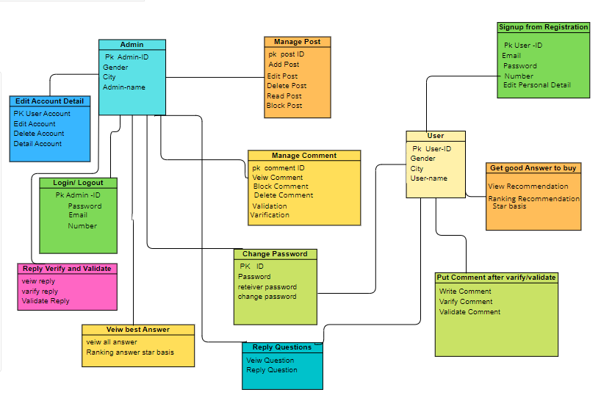

Graphical User Interfaces

User interface (UI) design is about building interfaces with a focus on styling and interactivity. User Interface (UI) Design focuses on anticipating what users might need to do and ensuring that the interface has elements that are easy to access, understand, and use to facilitate those actions. UI brings together concepts from interaction design, visual design and information architecture.
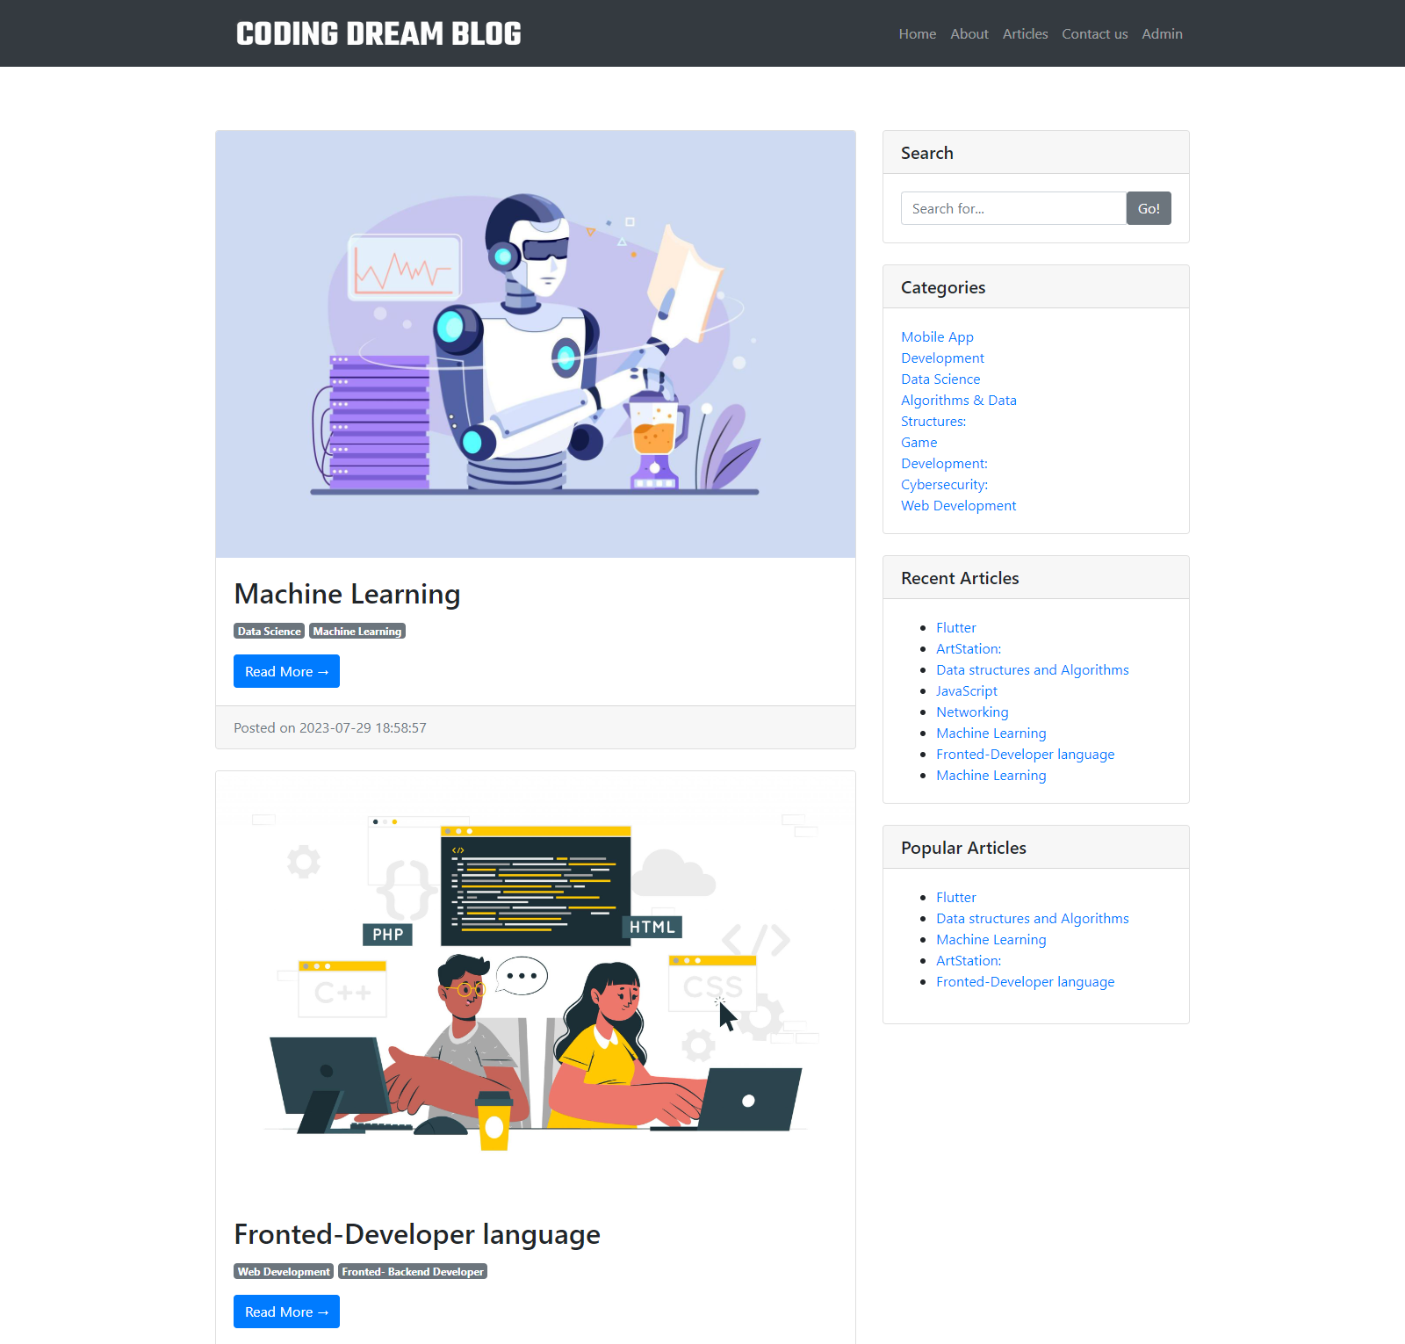

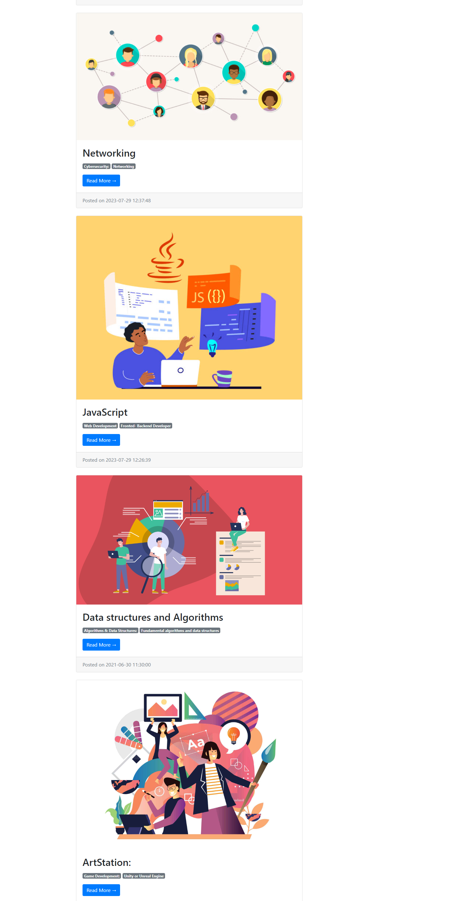

CHAPTER # 3 Development Plan

Architecture Design Diagram
An architectural diagram is a visual representation that maps out the physical implementation for components of a software system. It shows the general
structure of the software system and the associations, limitations, and boundaries between each element.

Three-tier architecture

Three-tier architecture, which separates applications into three logical and physical computing tiers, is the predominant software architecture for traditional client-server applications.
In this coding Dream Blog Project, the tiers have different names but perform similar functions:
- The web server is the presentation tier and provides the user interface. This is usually a web page or web site, such as Coding Dream Blog where the user and admin see the posts about coding adds Posts, or creates an account etc. The content can be static or dynamic, and is usually developed using HTML, CSS and JavaScript.
- The application server corresponds to the middle tier, housing the business logic used to process user inputs. To continue the Coding Dream Blog Project, this is the tier that use important queries. This layer often developed using PHP.
- The database server is the data or backend tier of a web application. It runs on database management software, such as MySQL.

REFERENCES

Software Engineering-I CS504
Delivered by Dr. Fakhar Lodhi
Lecture 03: Requirement Engineering-1
Requirement Engineering
Business Requirements
Use case Creating
Relationship in use case

http://www.tomsplanner.com/
http://gantto.com/
https://www.tomsplanner.com/?template=example
http://www.projectperfect.com.au/info_define_the_scope.php

Software Engineering-II CS605
Lecture No. 3 Software Lifecycle Models Lecture No. 4 Incremental Models Lecture No. 5 Object-Oriented Lifecycle Models

Web Development CS605
Lecture No 41: Layers and Tiers
Lecture No 42: Expression Languages
Analysis and Designing Phase by Virtual University of Pakistan

References Links:

https://www.lucidchart.com/pages/ER-diagram-symbols-and-meaning
http://creately.com/blog/diagrams/er-diagrams-tutorial/
http://www.tutorialspoint.com/dbms/dbms_generalization_aggregation.htm
http://www.aw-bc.com/info/riccardi/database/Riccardi_ch4.PDF
https://en.wikipedia.org/wiki/Entity%E2%80%93relationship_model
http://www.cs.sfu.ca/CourseCentral/354/jpei/slides/ER-diagram.pdf
http://www.slideshare.net/anniyappa/entity-relationship-modelling

References Links:
http://www.tutorialspoint.com/uml/uml_interaction_diagram.htm
http://www.sparxsystems.com/resources/uml2_tutorial/uml2_sequencediagram.html
http://www.smartdraw.com/sequence-diagram/
http://creately.com/diagram-

“To err is human, but to really foul things up you need a computer.” - Paul Ehrlich

Software Engineering-I CS504
Delivered by Dr. Fakhar Lodhi
Lecture 07: Object Oriented Analysis and Design

Software Engineering-I CS504
Delivered by Dr. Fakhar Lodhi
Lecture 11: Software Verification and validation

Reference:
http://www.databasejournal.com/features/msaccess/article.php/10895_3388551_3/MS-Access-for-the-Business-Environment-MS-Access-as-a-Documentation-Tool-Database-Diagramming.htm

References:
http://dotnetguts.blogspot.com/2007/10/basics-of-sql-server-2005.html

APPENDIX

Structural Developments in Tall Buildings: Current Trends and Future Prospects
Mir M. Ali & Kyoung Sun Moon
Pages 205-223 | Received 08 May 2007, Accepted 13 Jun 2007, Published online: 09 Jun 2011
Download citation https://doi.org/10.3763/asre.2007.5027
https://en.wikipedia.org/wiki/Software_development

Categories:
C-Class vital articles
Wikipedia level-5 vital articles
Wikipedia vital articles in Technology
Wikipedia level-5 vital articles in Technology
Wikipedia C-Class level-5 vital articles
Wikipedia C-Class vital articles in Technology
C-Class software articles of High-importance
C-Class Computing articles
High-importance Computing articles
C-Class software articles
Top-importance software articles
All Software articles
C-Class Computer science articles
Top-importance Computer science articles
Computing articles needing attention
All Computing articles
C-Class software articles of Top-importance
Unknown-importance Computing articles
Software articles needing attention
Computer science articles needing attention
WikiProject Computer science articles
C-Class Systems articles
High-importance Systems articles
Systems articles in software engineering
Systems articles needing attention
WikiProject Systems articles

