Student Name – Matriculation Number: Ayesha Begum – A0227071M

GitHub repository: <https://github.com/Ayesh02/Task1B>

**Task 1.4: deploy a local k8s cluster**

Instructions on how to run the Docker container:

* Run “**kind create cluster --name kind-1 --config k8s/kind/cluster-config.yaml**”
* Run “**kubectl cluster-info**”
* Run “**kubectl get nodes**”

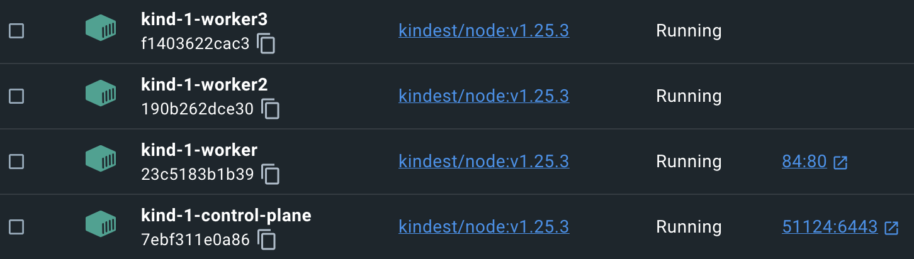

**Task 1.5: deploy your Task1A Docker image to Kubernetes as a Deployment with 3 replicas exposed by a Service object**

Instructions on how to run the Docker container:

* Add cluster-config.yaml, backend-deployment.yaml and backend-service.yaml files
* Run “**kind create cluster --name kind-task1a --config k8s/manifests/k8s/cluster-config.yaml**”
* Run “**kubectl cluster-info**”
* Run “**kubectl get nodes**”
* Run “**kubectl apply -f k8s/manifests/k8s/backend-service.yaml**”
* Run “**kubectl get svc**”

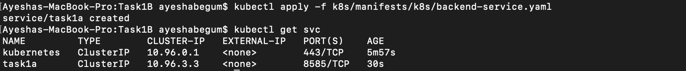

**Task 1.6: deploy an ingress controller and an Ingress that allows you to connect to the Deployment/Service from your browser**

Instructions on how to run the Docker container:

* Run “**kubectl apply -f https://raw.githubusercontent.com/kubernetes/ingress-nginx/main/deploy/static/provider/kind/deploy.yaml**”
* Run “**kubectl -n ingress-nginx get deploy -w**”
* Run “**kubectl apply -f k8s/manifests/k8s/backend-ingress.yaml**”
* Run “**kubectl get ingress**”
* Browse “[**http://localhost:85/task1a**](http://localhost:85/task1a)”

*Not sure where it went wrong..*